An expedient and eco-friendly approach for multicomponent synthesis of dihydropyrano[2,3-c]pyrazoles using nano-Al₂O₃/BF₃/Fe₃O₄ as reusable catalyst.
Elaheh Babaei and Bi Bi Fatemeh Mirjalili∗
Department of Chemistry, College of Science, Yazd University, Yazd. P. O. Box 89195-741, Iran, E-mail:fmirjalili@yazd.ac.ir. Tel.: +983531232672, Fax: +98 3538210644

Spectral data for some pyranopyrazoles

6-Amino-4-(4-chlorophenyl)-3-methyl-1,4-dihydropyrano[2,3-c]pyrazole-5-carbonitrile (P1):
P1
White solid. M.p ¹HNMR (400 MHz, DMSO-d₆)/δ (ppm): 1.81 (s, 3H), 4.65 (s, 1H), 6.96 (s, 2H), 7.21 (d, J = 8 Hz, 2H), 7.39 (d, J = 8 Hz, 2H), 12.16 (s, 1H).; ¹³C NMR (100 MHz, DMSO-d₆)/δ ppm: 161.38, 155.18, 143.97, 136.15, 131.71, 130.51, 129.85, 128.94, 121.15, 97.67, 57.19, 36.03, 10.22.
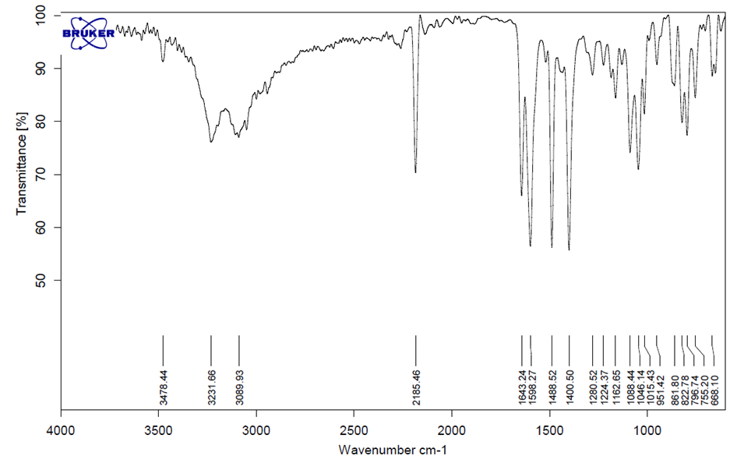

The FT-IR spectrum of product (P1)
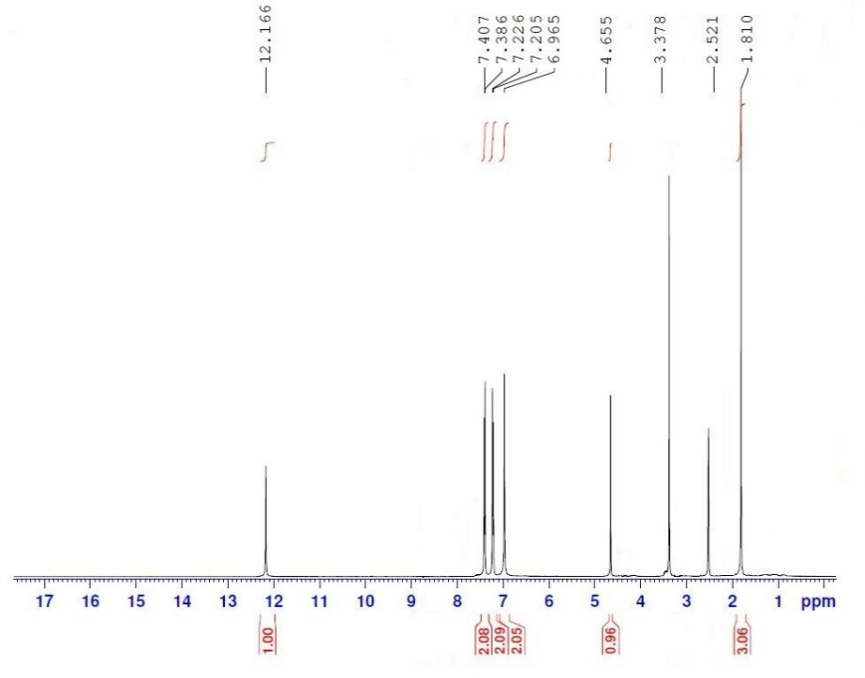

The ¹H NMR (400 MHz) spectrum of product (P1)

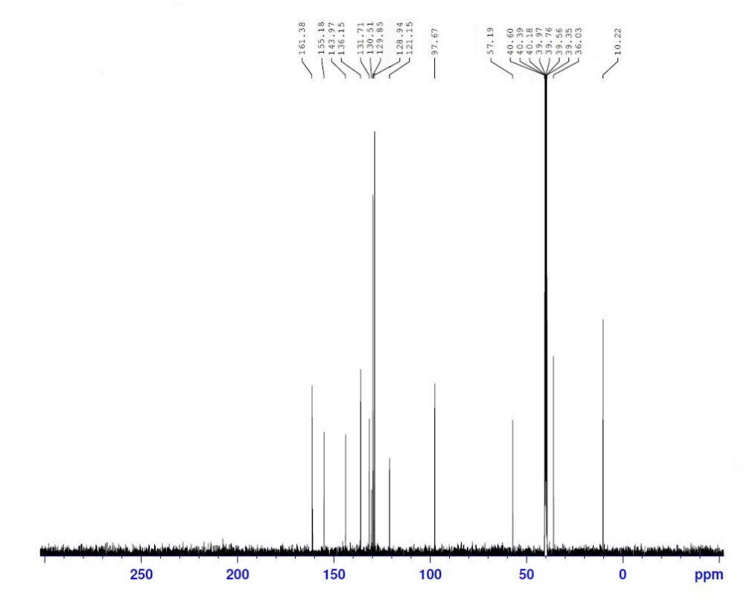

The ¹³C NMR (100 MHz) spectrum of product (P1)

6-Amino-4-(furan-2-yl)-3-methyl-1,4-dihydropyrano[2,3-c]pyrazole-5-carbonitrile (P2))

Cream solid. M.p. 225-227 °C. FT- IR (ATR) /ῡ (cm⁻¹⁾ = 3346, 3167, 2186, 1646, 1599, 1491, 1402, 1069, 1041, 1008, 746, 656.; ¹H NMR (250 MHz, Acetone-d₆) δ/ ppm: 1.94 (s, 3H), 4.75 (s, 1H), 6.15-6.17 (m, 1H), 6.32-6.34 (m, 1H), 6.92 (br s, 2H), 7.49-7.51 (m, 1H), 12.14 (s, 1H). ¹³C NMR (100 MHz, DMSO-d₆)/δ ppm: 161.96, 156.19, 155.29, 142.75, 136.31, 121.08, 110.72 106.12, 95.59, 54.43, 30.28, 10.05.
P2

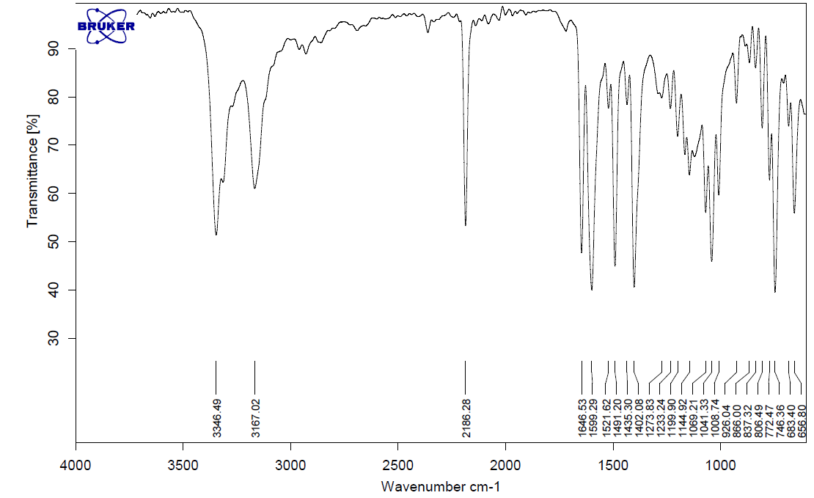

The FT-IR spectrum of product (P2)

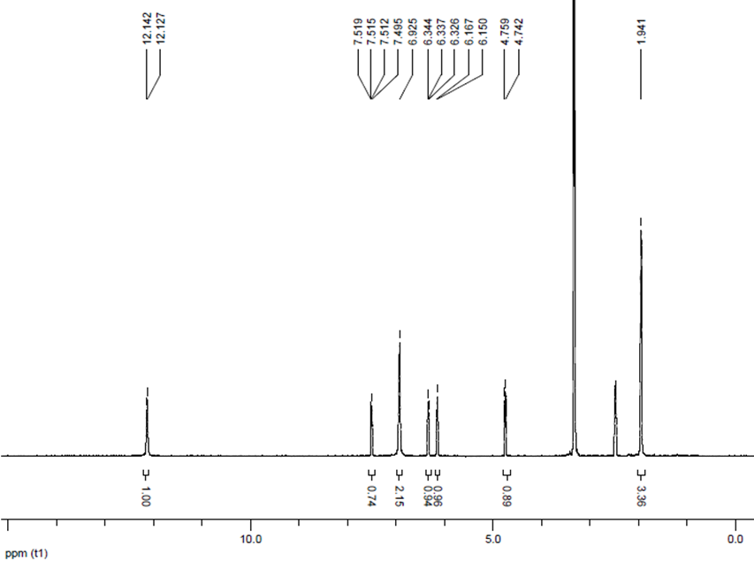
The ¹H NMR (250 MHz) spectrum of product (P2)

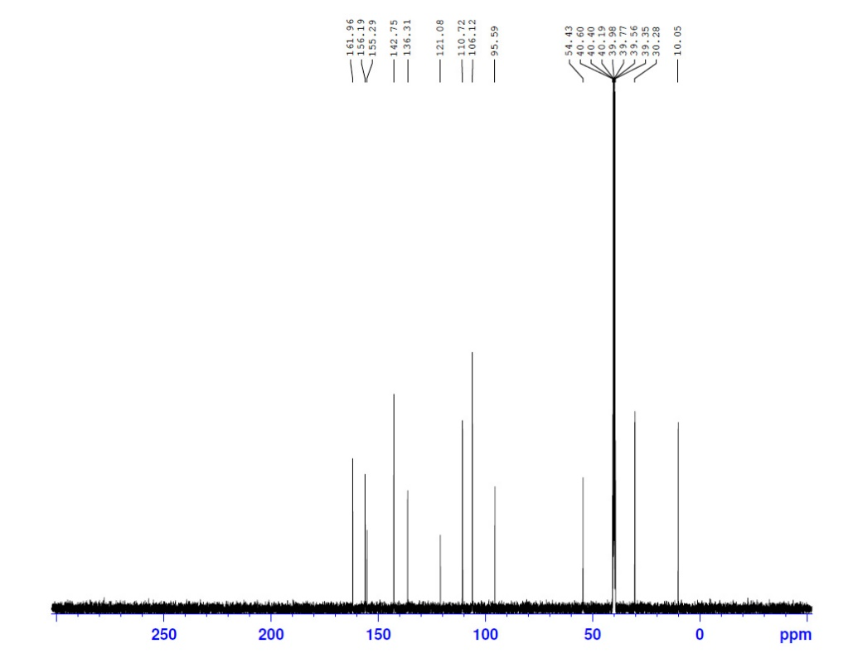

The ¹³C NMR (100 MHz) spectrum of product (P2)

6-Amino-3-methyl-4-phenyl-1,4-dihydropyrano[2,3-c]pyrazole-5-carbonitrile (P3)
White solid. M.p. 238-239 °C. FT- IR (ATR)/ ῡ (cm⁻¹): 3372, 3311, 3170, 2191, 1647, 1595, 1488, 1044, 744.; ¹HNMR (400 MHz, DMSO-d₆)/δ (ppm): 1.86 (s, 3H), 4.67 (s, 1H), 6.95 (s, 2H), 7.25 (br s, 2H), 7.30 (br s, 1H), 7.40 (br s, 2H), 12.18 (s, 1H).
P3
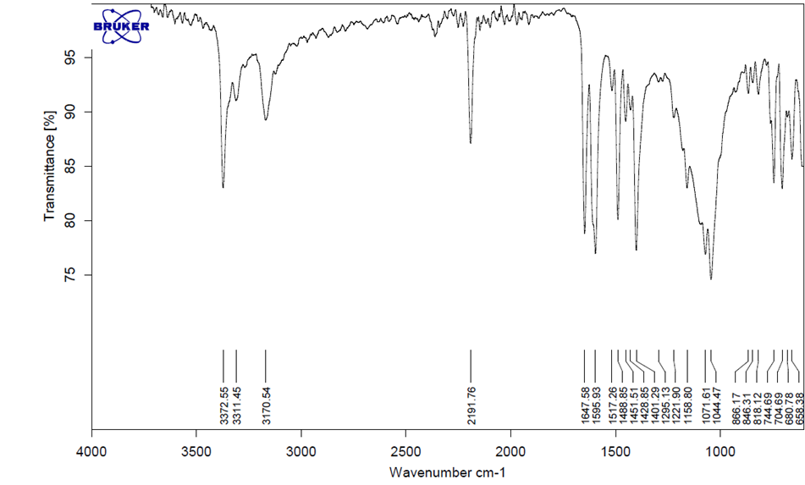

The FT-IR spectrum of product (P3)

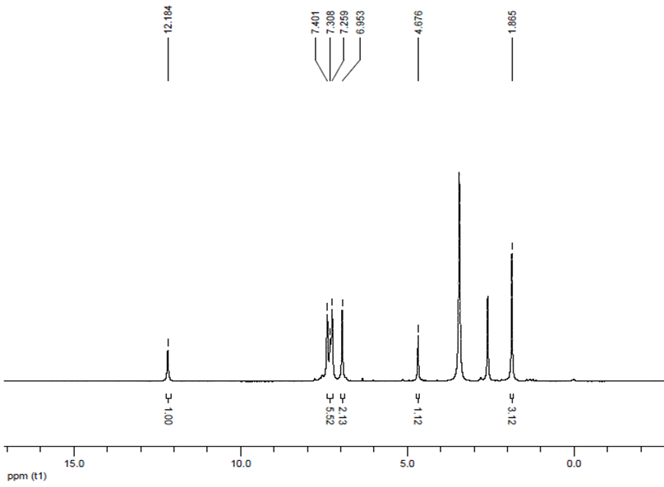
The ¹H NMR (400 MHz) spectrum of product (P3)

6-Amino-4-(2,4-dichlorophenyl)-3-methyl-1,4-dihydropyrano[2,3-c]pyrazole-5-carbonitrile (P4) : Pale yellow solid. M.p. 200-202 °C. FT- IR (ATR)/ ῡ(cm⁻¹): 3482, 3243, 3115, 2186, 1638, 1587, 1491, 1408, 1100, 1052, 866, 741.; ¹HNMR (400 MHz, DMSO-d₆)/δ ppm: 1.85 (s, 3H), 5.13 (s, 1H), 7.07 (s, 2H), 7.29 (d, J = 8 Hz, 1H), 7.47 (dd, J = 8.4 Hz, J = 2 Hz, 1H), 7.65 (d, J = 2.4 Hz, 1H), 12.23 (s, 1H).; ¹³C NMR (100 MHz, DMSO-d₆)/δ ppm: 161.30, 154.88, 140.07, 135.44, 132.81, 132.10, 128.83, 128.02, 120.25, 96.32, 55.21, 33.07, 9.53.

P4

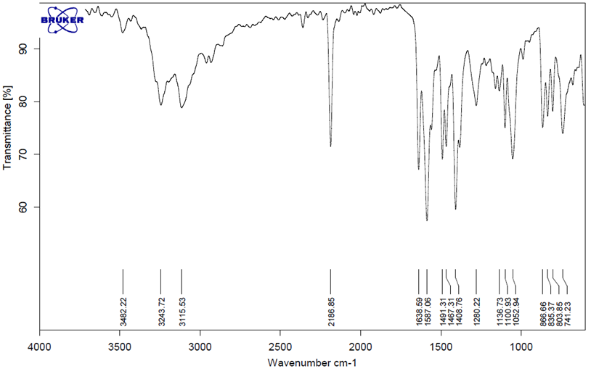
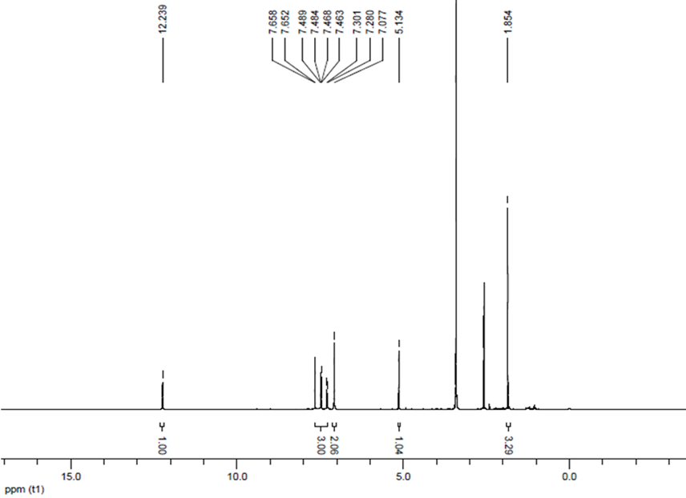
The FT-IR spectrum of product (P4)

The ¹H NMR (400 MHz) spectrum of product (P4)
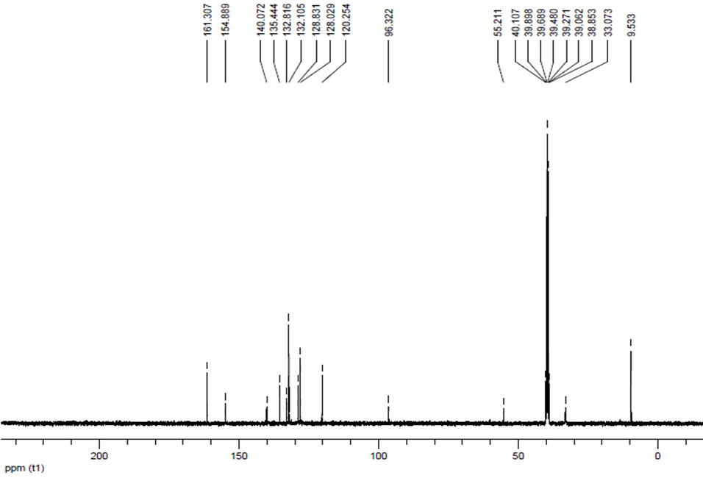

The ¹³C NMR (100 MHz) spectrum of product (P4)
6-Amino-3-methyl-4-(3-nitrophenyl)-1,4-dihydropyrano[2,3-c]pyrazole-5-carbonitrile (P5) (Table 3, entry 6) :White solid. M.p. 218-220 °C. FT- IR (ATR)/ ῡ(cm⁻¹): 3484, 3231, 3120, 2190, 1645, 1597, 1519, 1491, 1410, 1351, 733. ¹HNMR (400 MHz, DMSO-d₆)/δ (ppm): 1.82 (s, 3H), 4.89 (s, 1H), 7.08 (s, 2H), 7.64 -7.70 (m, 2H), 8.04 (s, 1H), 8.13-8.15 (d, J = 8 Hz, 1H), 12.23 (s, 1H).; ¹³C NMR (100 MHz, DMSO-d₆)/δ ppm: 161.63, 155.17, 148.36, 147.32, 136.38, 134.88, 130.47, 122.33, 121.01, 97.15, 56.59, 36.11, 10.25.

P5
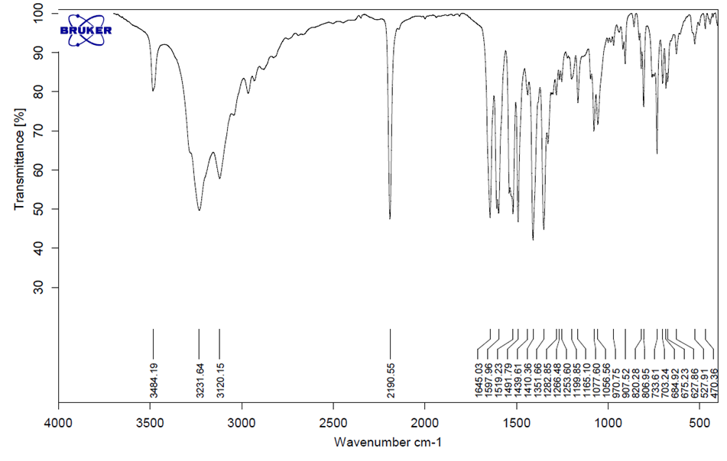
The FT-IR spectrum of product (P5)

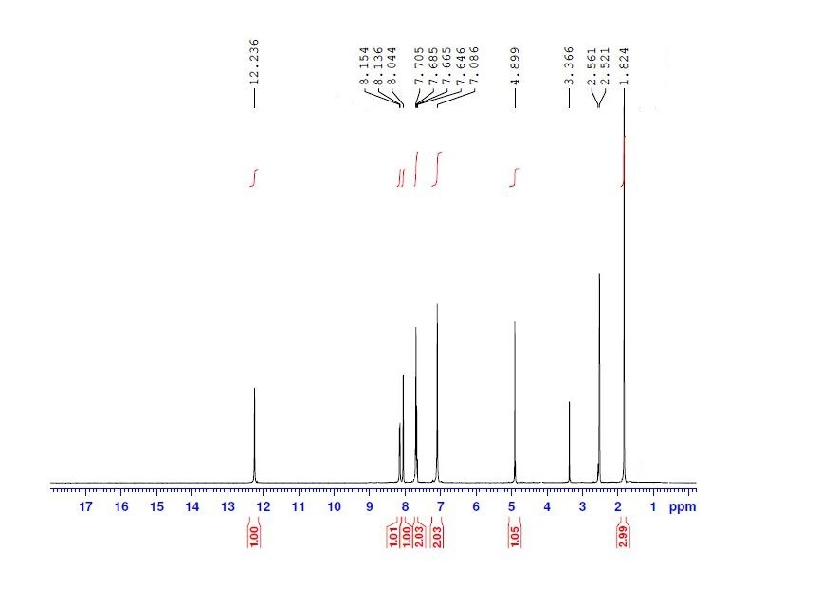

The ¹H NMR (400 MHz) spectrum of product (P5)
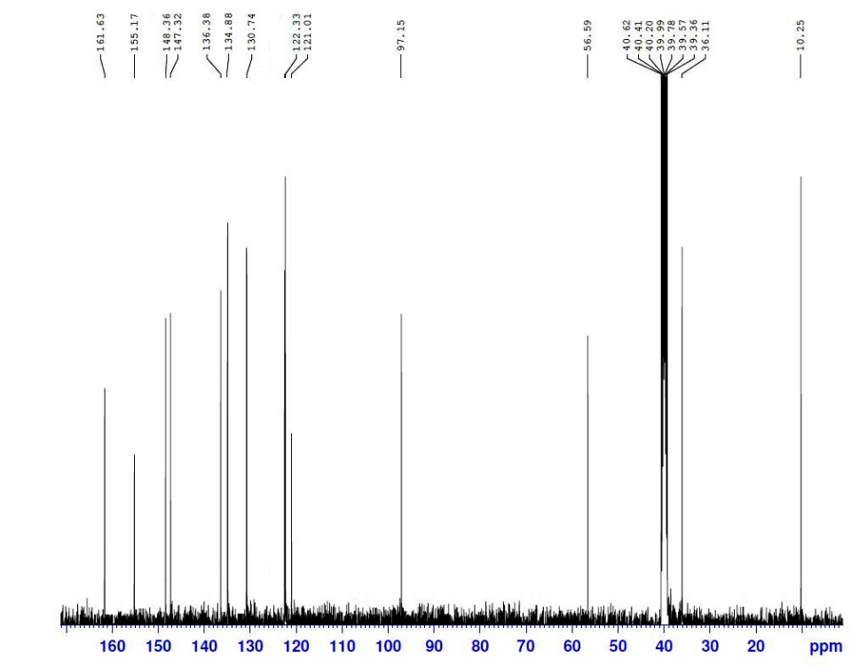
The ¹³C NMR (100 MHz) spectrum of product (P5)
6-Amino-4-(4-hydroxyphenyl)-3-methyl-1,4-dihydropyrano[2,3-c]pyrazole-5-carbonitrile (P6)
Cream solid. M.p. 222-224 °C. FT- IR (ATR)/ ῡ(cm⁻¹): 3372, 3304, 3127, 2173, 1645, 1594, 1510, 1489, 1441, 1404, 1189, 1166, 1041, 809. ¹H NMR (250 MHz, Acetone-d₆)/ δ(ppm): 1.74 (s, 3H), 4.44 (s, 1H), 6.65 (dd, J=7.5 Hz, J=3.7 Hz, 2H), 6.76 (br s, 2H), 6.91 (dd, J=7.5 Hz, J=3.7 Hz, 2H), 9.27 (s, 1H), 12.02 (s, 1H).; ¹³C NMR (100 MHz, DMSO-d₆)/δ ppm: 161.10, 156.49, 155.22, 135.98, 135.24, 128.92, 121.40, 115.58, 98.54, 58.21, 35.95, 10.24.

P6

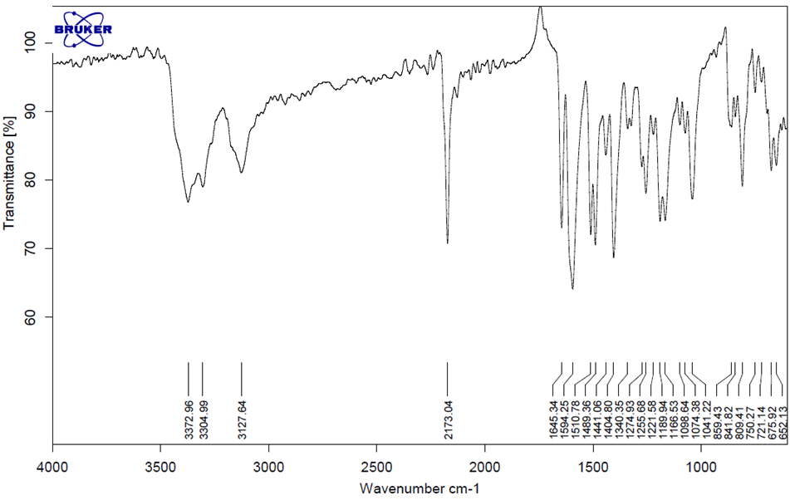

The FT-IR spectrum of product (P6)
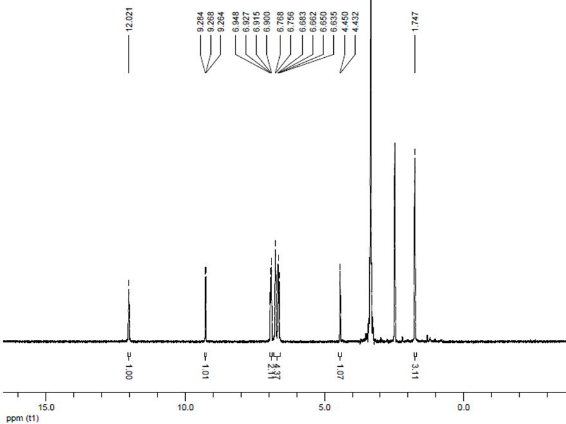
The ¹H NMR (250MHz) spectrum of product (P6)

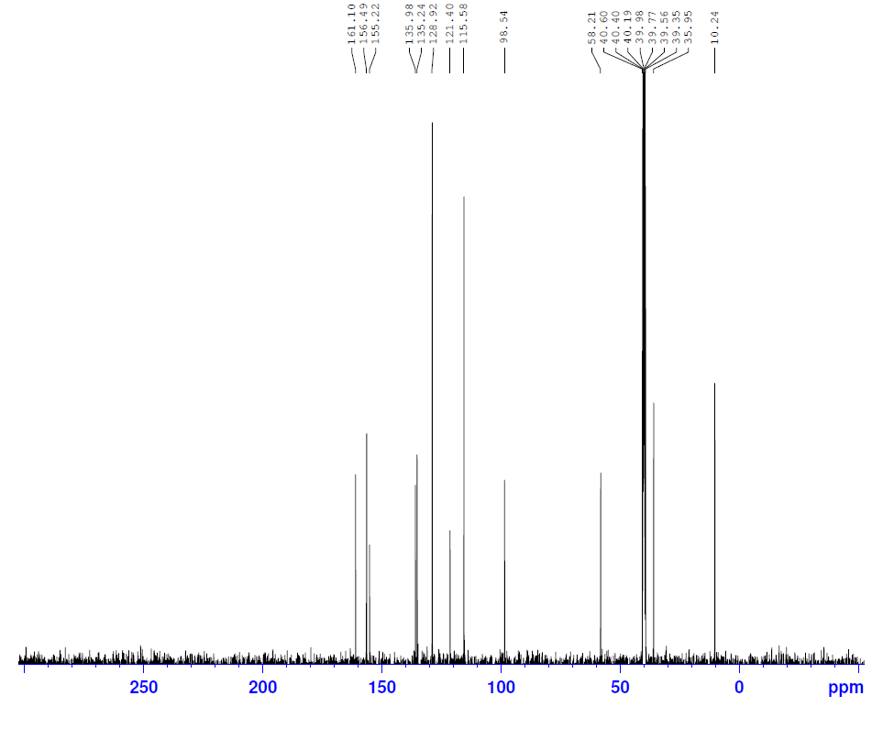

The ¹³C NMR (100 MHz) spectrum of product (P6)

6-Amino-3-methyl-4-(p-tolyl)-1,4-dihydropyrano[2,3-c]pyrazole-5-carbonitrile (P7):
Cream solid. M.p. 172-174 °C. FT- IR (ATR)/ ῡ(cm⁻¹): 3377, 3317, 3193, 3023, 2925, 2190, 1607, 1597, 1489, 1400, 1044, 864.; ¹H-NMR(400 MHz, DMSO-d₆)/ δ ppm: 1.84 (s, 3H), 2.33 (s, 3H), 4.60 (s, 1H), 6.89 (s, 2H), 7.10 (d, J = 8 Hz, 2H), 7.17 (d, J = 8 Hz, 2H), 12.13 (s, 1H).

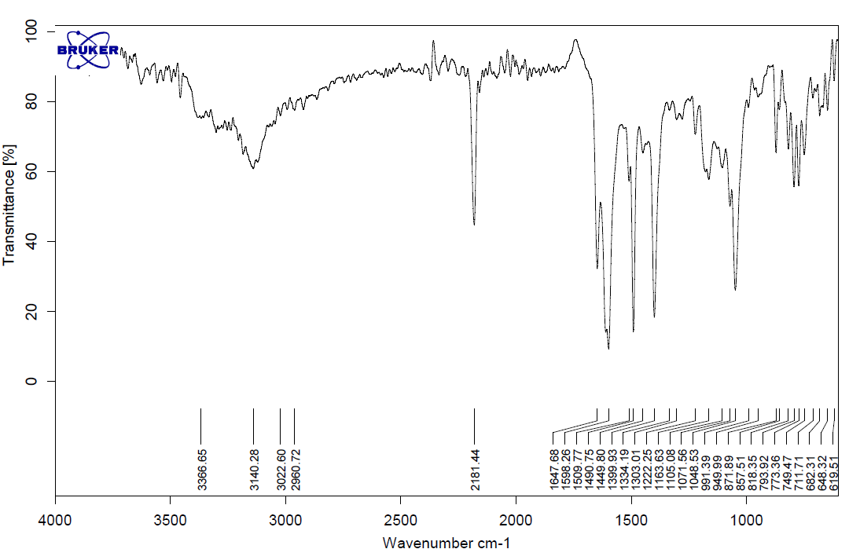
P7

The FT-IR spectrum of product (P7)
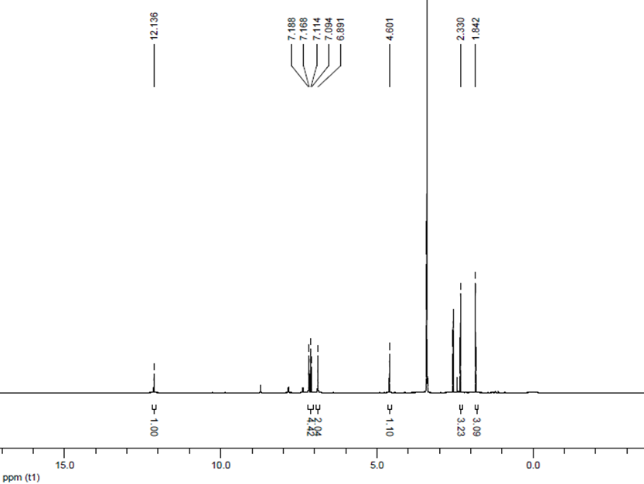
The ¹H NMR (400 MHz) spectrum of product (P7)
6-Amino-3-methyl-4-(4-nitrophenyl)-1,4-dihydropyrano[2,3-c]pyrazole-5-carbonitrile (P8)
White solid. M.p. 239-242 °C. FT- IR (ATR)/ ῡ(cm⁻¹): 3475, 3227, 3106, 2195, 1646, 1592, 1513, 1399, 1348, 1163, 1109, 810, 744.; ¹H-NMR(400 MHz, Acetone-d₆)/ δ ppm: 2 (s, 3H), 4.88 (s, 1H), 6.30 (br s, 2H), 7.55 (d, J = 8 Hz, 2H), 8.23 (d, J = 8 Hz, 2H), 11.43 (s, 1H). ¹³CNMR (100 MHz, DMSO-d₆)/δ ppm: 161.62, 155.15, 152.59, 146.85, 136.36, 132.19, 129.32, 124.38, 120.98, 97.04, 56.37, 36.36, 10.22.
P8
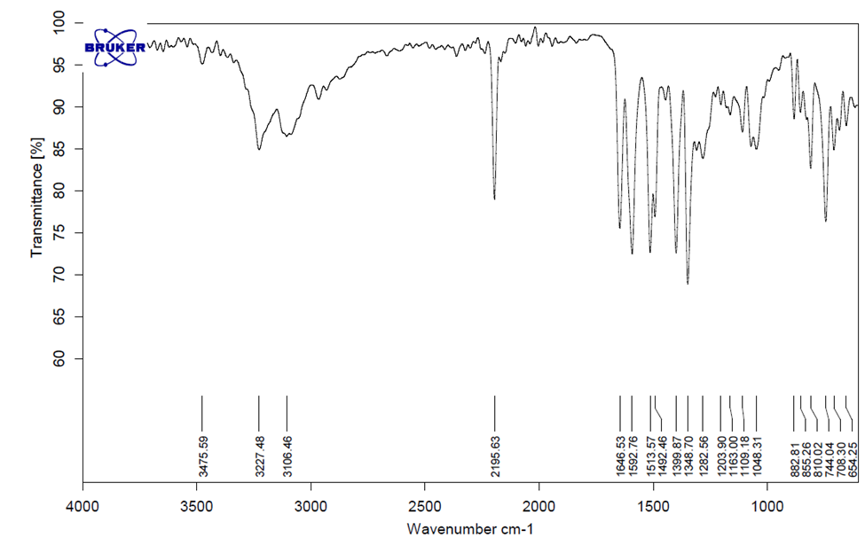
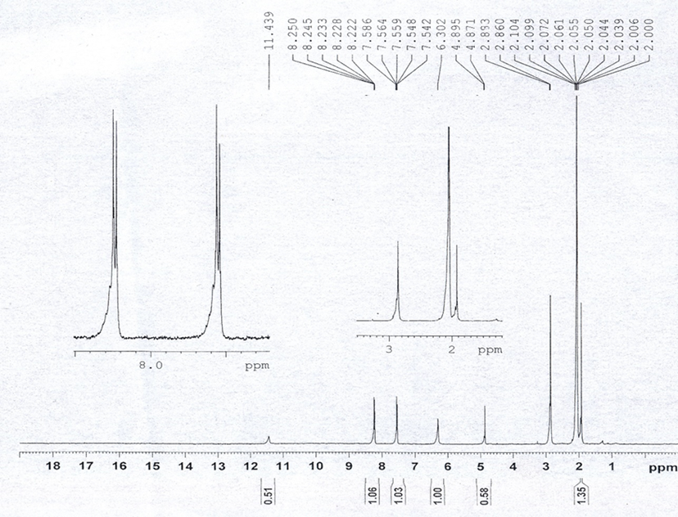
The FT-IR spectrum of product (P8)

The ¹H NMR (400 MHz) spectrum of product (P8)

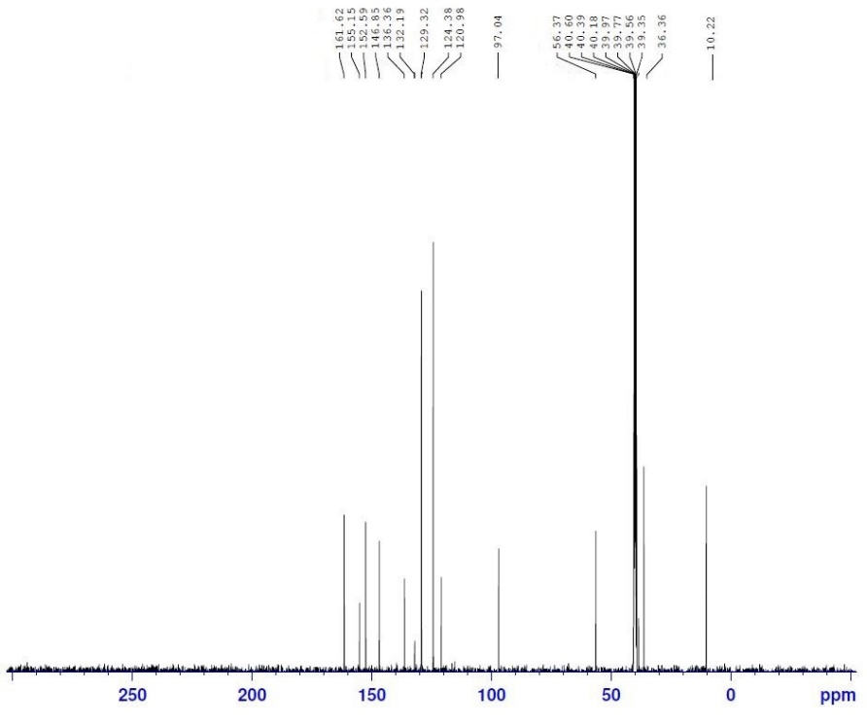

The ¹³C NMR (100 MHz) spectrum of product (P8)
6-Amino-4-(4-bromophenyl)-3-methyl-1,4-dihydropyrano[2,3-c]pyrazole-5-carbonitrile (P9)
Cream solid. M.p. 179-180 °C. FT- IR (ATR)/ ῡ(cm⁻¹): 3481, 3415, 3155, 2181, 1639, 1597, 1486, 1397, 1278, 1040, 789. ¹H-NMR (400 MHz, DMSO-d₆) / δ ppm: 1.81 (s, 3H), 4.64 (s, 1H), 6.96 (s, 2H), 7.16-7.14 (d, J = 8 Hz, 2H), 7.54-7.52 (d, J = 8 Hz, 2H), 12.16 (s, 1H).; ¹³C NMR (100 MHz, DMSO-d₆)/δ ppm: 161.40, 155.18, 144.40, 136.16, 132.51, 131.86, 130.70, 121.16, 120.24, 97.60, 57.12, 36.10, 10.24.
P9
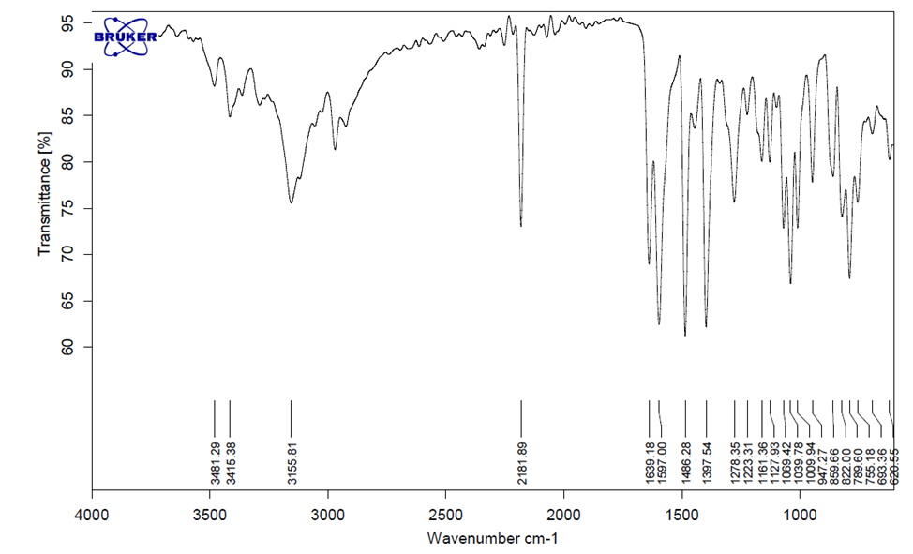
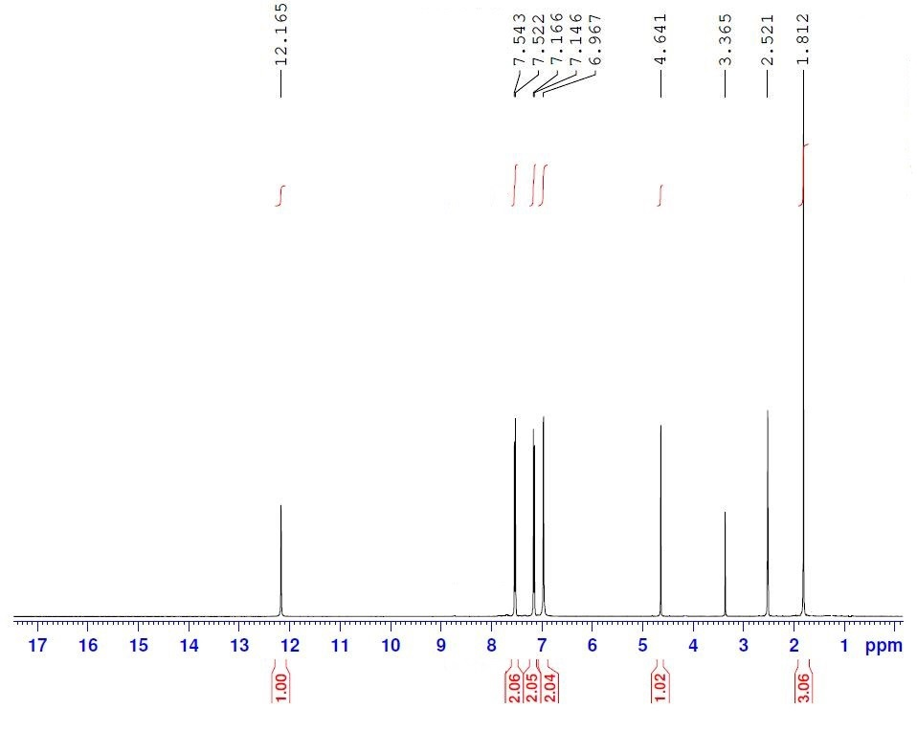
The FT-IR spectrum of product (P9)

The ¹H NMR (400MHz) spectrum of product (P9)

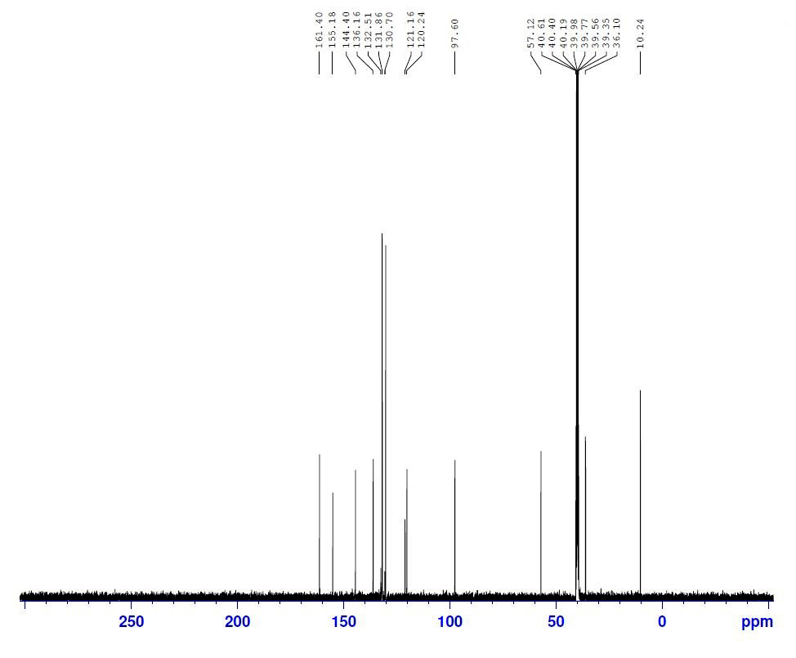
The ¹³C NMR (100 MHz) spectrum of product (P9)

6-Amino-4-(3,4-dihydroxyphenyl)-3-methyl-1,4-dihydropyrano[2,3-c]pyrazole-5-carbonitrile (P10): Brown solid. M.p. 225-227 °C. FT- IR (ATR)/ ῡ(cm⁻¹): 3460, 3249, 3135, 2181, 1627, 1595, 1491, 1337, 1265, 1049, 755.; ¹H NMR (250 MHz, DMSO-d₆)/ δ ppm: 1.78 (s, 3H), 4.35 (s, 1H), 6.42-6.45 (m, 2H), 6.61 (dd, J = 7.5 Hz, J = 1.5 Hz, 1H), 6.75 (s, 2H), 8.70 (s, 1H), 8.82 (s, 1H), 12.02 (s, 1H). ¹³C NMR (100 MHz, DMSO-d₆)/δ ppm: 161.06, 155.21, 145.67, 144.52, 136, 121.44, 118.75, 115.61, 115.04, 98.62, 58.31, 36.14, 10.26
P10
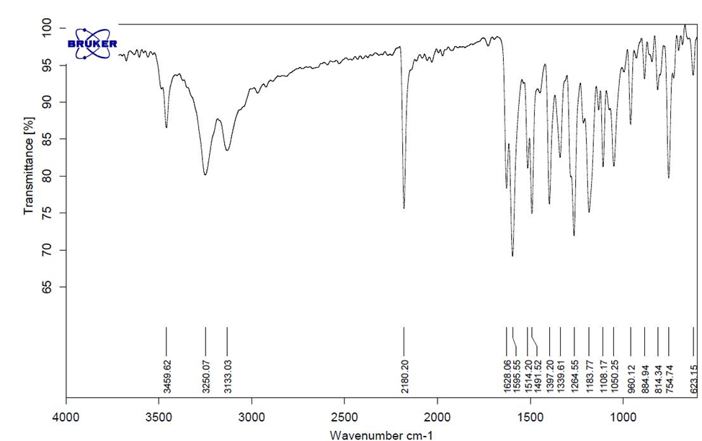
The FT-IR spectrum of product (P10)
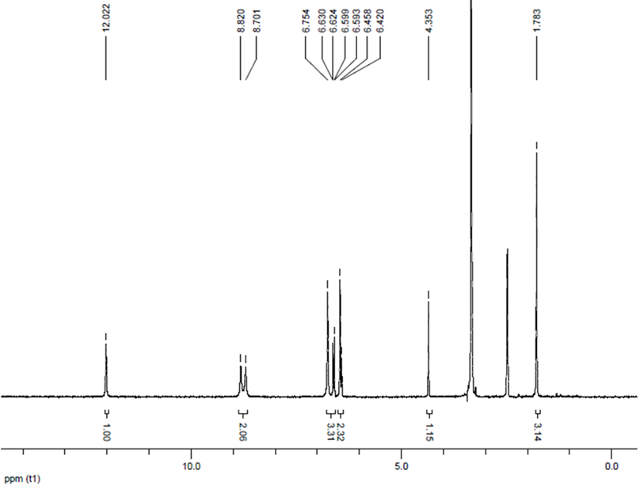
The ¹H NMR (250 MHz) spectrum of product (P10)

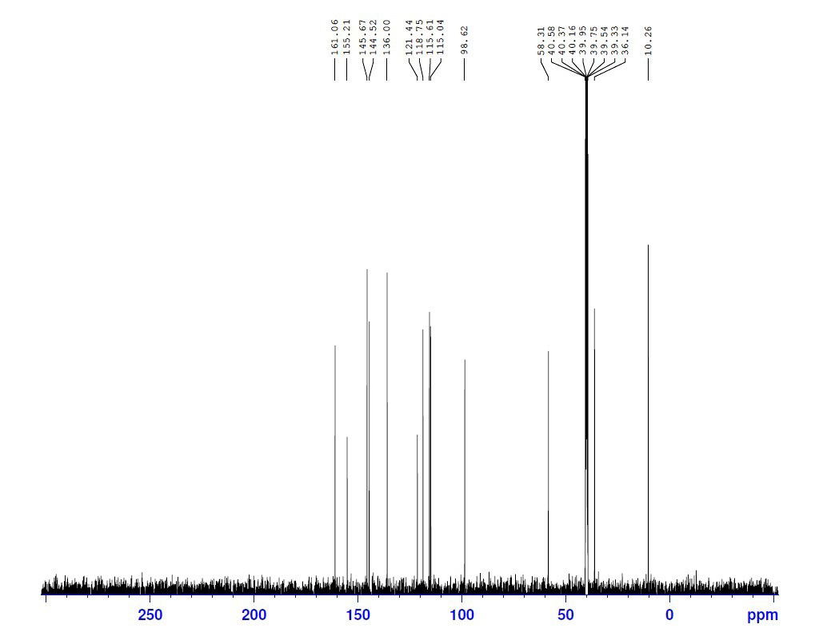

The ¹³C NMR (100 MHz) spectrum of product (P10)

6-Amino-4-(2-methoxyphenyl)-3-methyl-1,4-dihydropyrano[2,3-c]pyrazole-5-carbonitrile (P11)
Yellow solid. M.p. 196-198 °C. FT- IR (ATR)/ ῡ(cm⁻¹ ): 3372, 3310, 3155, 2194, 1655, 1615, 1598, 1484, 1246, 1156, 1104, 1023, 751.; ¹HNMR (400 MHz, DMSO-d₆)/ δ ppm: 1.88 (s, 3H), 3.87 (s, 3H), 5.60 (s, 1H), 6.89 (s, 2H), 6.99 (t, J = 7.2, 1H), 7.06-7.10 (m, 2H), 7.27-7.31 (m, 1H), 12.09 (s, 1H).; ¹³C NMR (100 MHz, DMSO-d₆)/δ ppm: 161.44, 156.30, 155.04, 134.99, 132.07, 128.58, 127.87, 120.86, 120.78, 111.25, 97.79, 56.30, 55.53, 29.09, 9.47.
P11

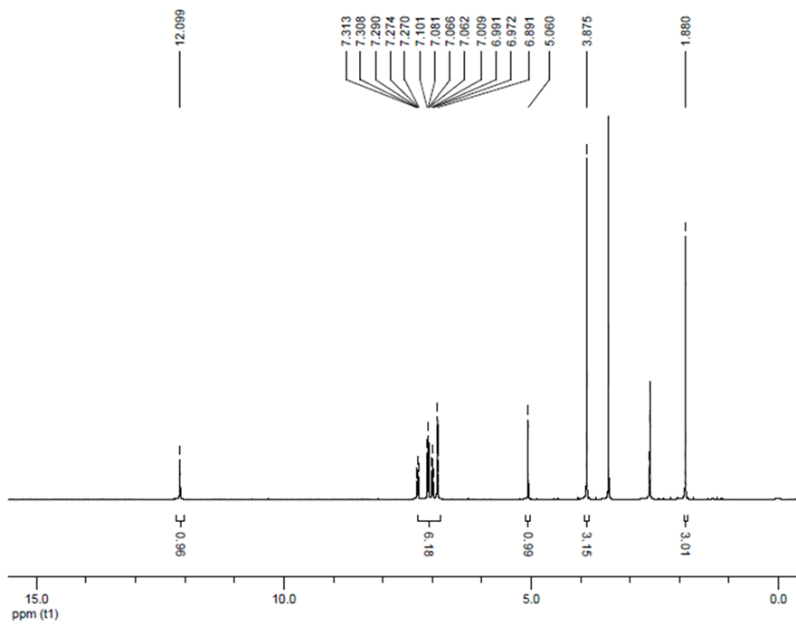
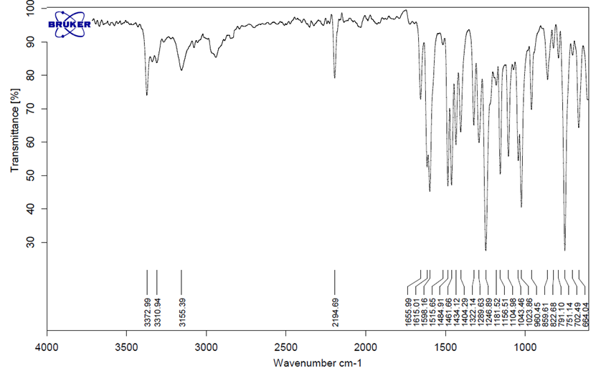
The FT-IR spectrum of product (P11)
The ¹H NMR (400 MHz) spectrum of product (P11)

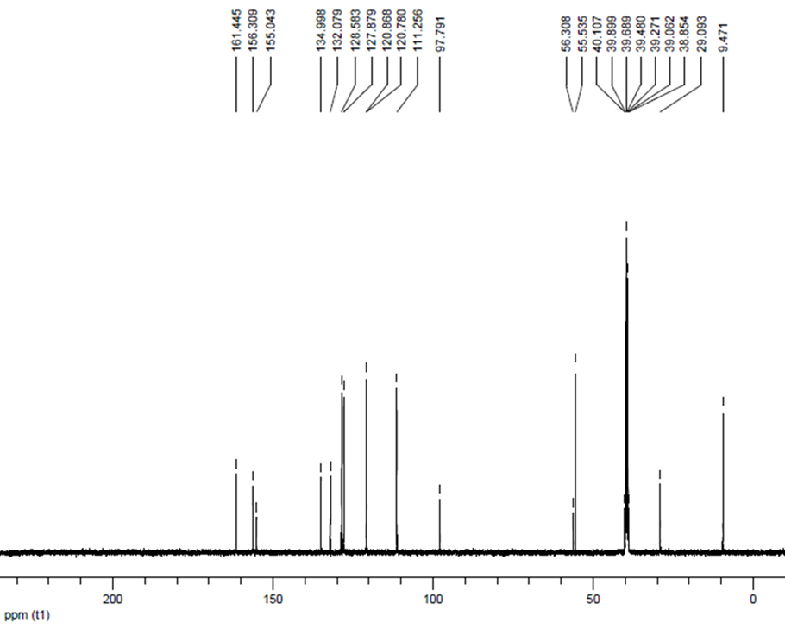
The ¹³C NMR (100 MHz) spectrum of product (P11)

6-Amino-4-(4-hydroxy-3-methoxyphenyl)-3-methyl-1,4-dihydropyrano[2,3-c]pyrazole-5-carbonitrile (p12)
Orange solid. M.p. 212-213 °C. FT- IR (ATR)/ ῡ(cm⁻¹): 3487, 3407, 3325, 3218, 3131, 2195, 1656, 1601, 1509, 1263, 1028, 745. ¹H-NMR (400 MHz, DMSO-d₆)/ δ ppm: 1.83 (s, 3H), 3.73 (s, 3H), 4.51 (s, 1H), 6.57 (s, 1H), 6.73-6.71 (d, J = 8 Hz, 2H), 6.83-6.88 (m, 2H), 9.73(s, 1H), 12.07 (s, 1H). ; ¹³C NMR (100 MHz, DMSO-d₆)/δ ppm: 161.17, 155.19, 147.79, 145.70, 136.05, 123.99, 120.23, 115.94, 112.05, 110.42, 98.37, 58.04, 55.97, 36.31, 10.32.
p12
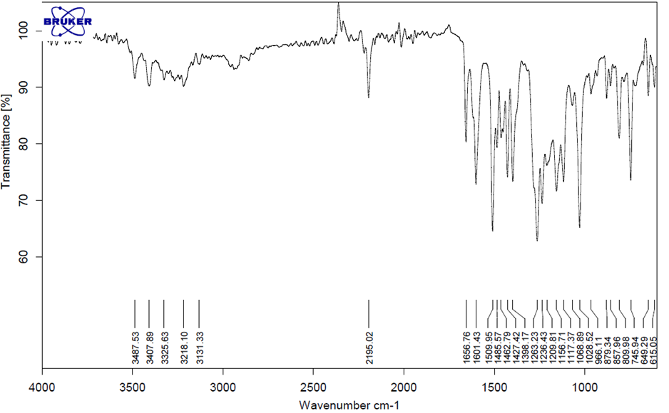

The FT-IR spectrum of product (p12)

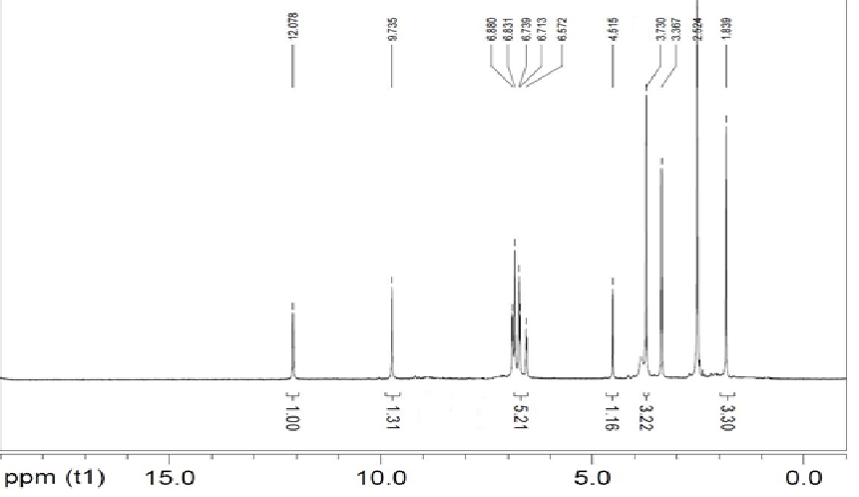
The ¹H NMR (400MHz) spectrum of product (p12)
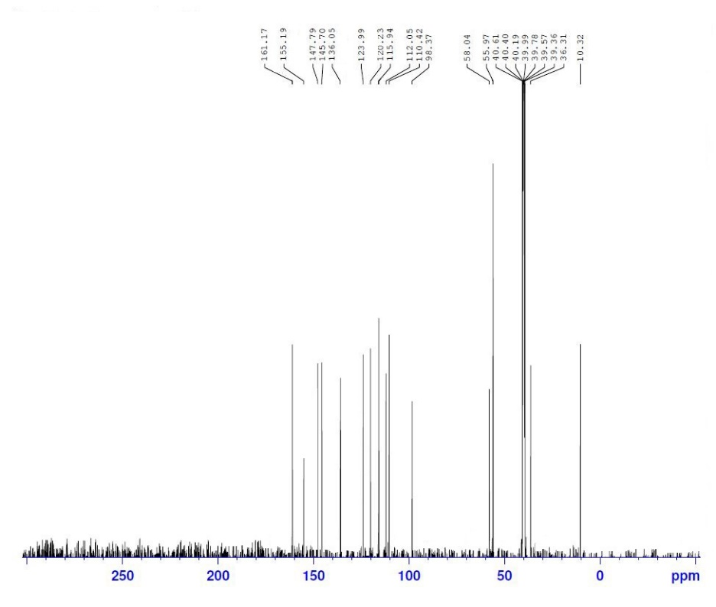
The ¹³C NMR (100 MHz) spectrum of product (p12)

6-Amino-4-(4-fluorophenyl)-3-methyl-1,4-dihydropyrano[2,3-c]pyrazole-5-carbonitrile (p13)
White solid. M.p. 222-224 °C. FT- IR (ATR)/ ῡ (cm⁻¹): 3478, 3228, 3117, 2194, 1638, 1596, 1505, 1404, 1224, 1096, 827. ¹H-NMR(400 MHz, DMSO-d₆)/ δ ppm: 1.80 (s, 3H), 4.65 (s, 1H), 6.93 (s, 2H), 7.15 (t, J = 8 Hz, 2H), 7.20-7.24 (m, 2H), 12.14 (s, 1H).; ¹³C NMR (100 MHz, DMSO-d₆)/δ ppm: 162.62, 161.30, 160.21, 155.17, 141.16, 136.10, 129.86, 121.20, 115.76, 97.97, 57.51, 35.90, 10.21.
p13
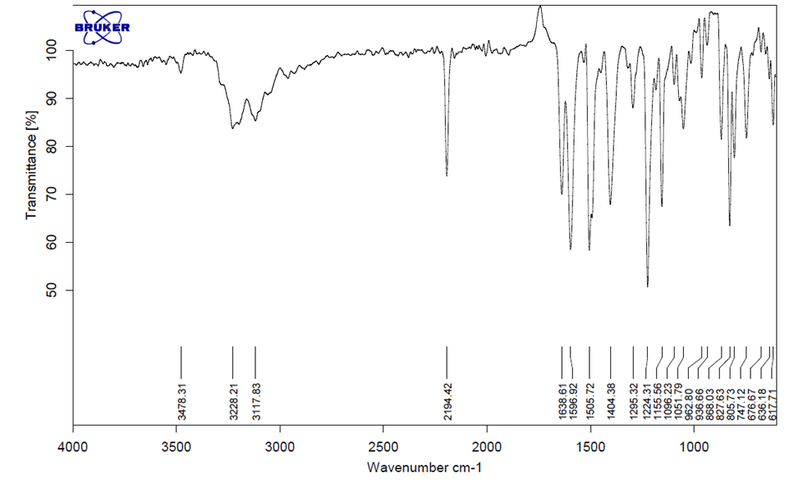
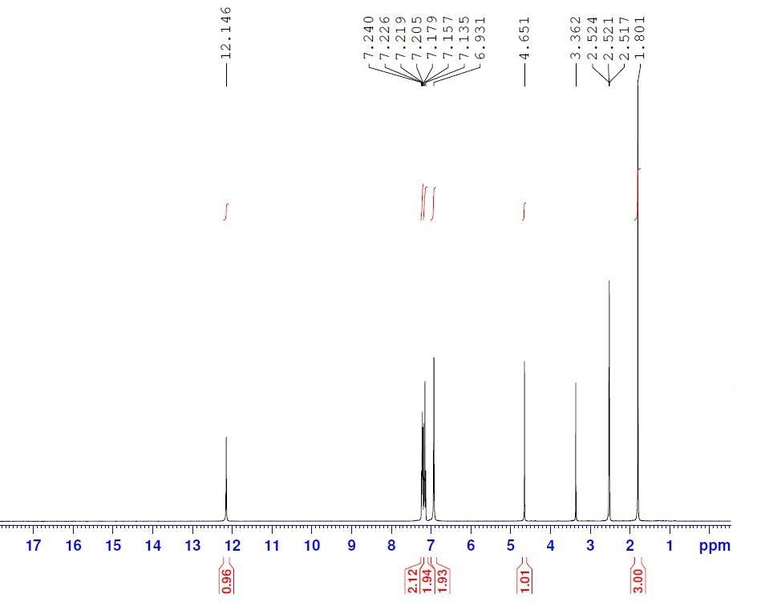
The FT-IR spectrum of product (p13)
The ¹H NMR (400MHz) spectrum of product (p13)

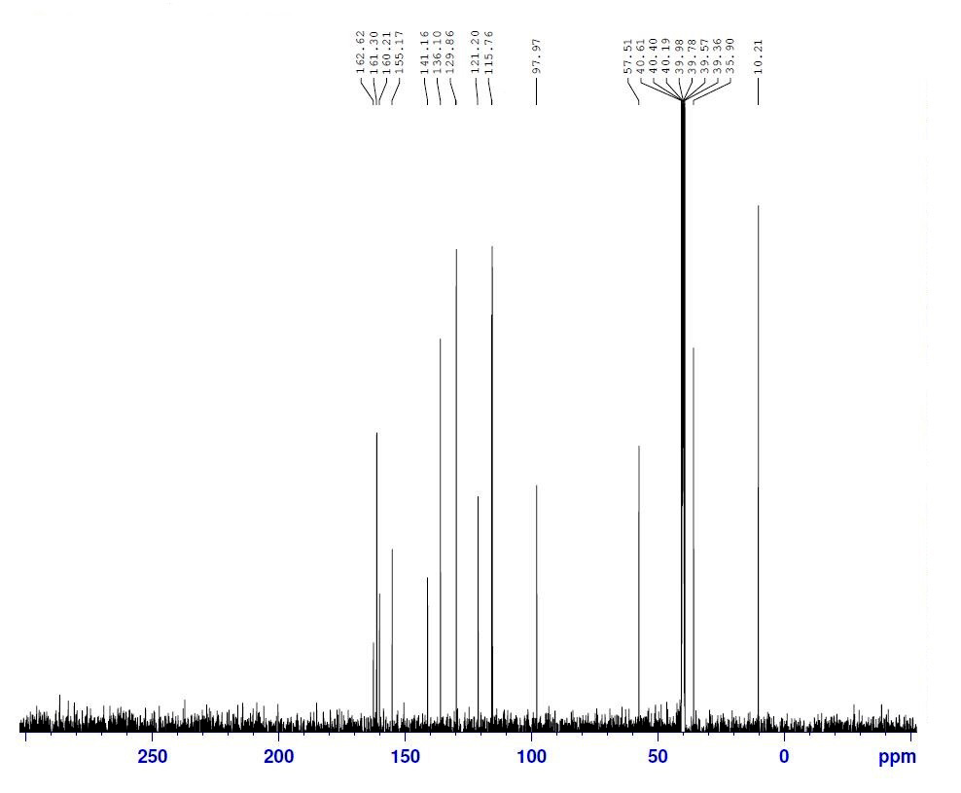

The ¹³C NMR (100 MHz) spectrum of product (p13)

