Online Appendix
For the article:
Hospitalisations for infections by age and sex: Register-based study of Danish children 1977-2014
by
Jacob W W Larsen, Anders F Sørensen, Aksel K G Jensen, Anja Poulsen, Lise Gehrt, Christine S Benn, Signe Sørup

Outline
aTable 1. Three most common ICD-8 and ICD-10 diagnoses for each infection category.
aFigure 1. Distribution of “Other infections” on diagnoses in different age groups.
aFigure 2. Admission rates for infections by age and sex for “Other infections”, excluding secondary diagnoses irrelevant to hospitalisation
aResults. Admission for infections according to age and sex in different time-periods,
different seasons and for different durations of admissions
aFigure 3. Rates of admissions for all infections according to age and sex for time-periods
aFigure 4. Rates of admissions for infections according to age and sex for seasons
aFigure 5. Rates of admissions for infections of different durations by age and sex

aTable 1. Three most common ICD-8 and ICD-10 diagnoses for each infection category
 | All ages |  | Less than 1 year |  | 1-4 years |  | 5-14 years
 | icd 8 | icd 10 | icd 8 | icd 10 | icd 8 | icd 10 | icd 8 | icd 10
Most common URTI | Acute nasopharyngitis (460.99) | Acute obstructive laryngitis (J05.0) | Acute nasopharyngitis (460.99) | Acute nasofaryngitis UNS (J00.9) | Acute laryngitis (pseudocroup) (464.01) | Acute obstructive laryngitis (J05.0) | chronic tonsillitis recidivans (500.02) | Chronic tonsillitis (J35.0)
Second most common URTI | Acute laryngitis (pseudocroup) (464.01) | Acute nasofaryngitis UNS (J00.9) | Acute otitis media purulenta (381.01) | Acute obstructive laryngitis (J05.0) | Acute nasopharyngitis (460.99) | Acute tonsillitis UNS (J03.9) | Acute tonsillitis (463.09) | Acute obstructive laryngitis (J05.0)
Third most common URTI | Otitis media catarrhalis (381.00) | Acute suppurative otitis media (H66.0) | Acute laryngitis (pseudocroup) (464.01) | Acute suppurative otitis media (H66.0) | Otitis media catarrhalis (381.00) | Acute suppurative otitis media (H66.0) | Otitis media catarrhalis (381.00) | Acute tonsillitis UNS (J03.9)
Most common LRTI | Pneumonia, unspecified (486.99) | Pneumonia unspecified (J18.9) | Pneumonia, unspecified (486.99) | Acute bronchitis, unspecified (J20.9) | Pneumonia, unspecified (486.99) | Pneumonia unspecified (J18.9) | Pneumonia, unspecified (486.99) | Pneumonia unspecified (J18.9)
Second most common LRTI | Acute bronchitis, asthmatic (46602) | Acute bronchitis, unspecified (J20.9) | Acute bronchitis, asthmatic (46602) | Respiratory syncytial virus pneumonia (J12.1) | Acute bronchitis, asthmatic (46602) | Acute bronchitis, unspecified (J20.9) | Influenza, unspecified (470.99) | Acute bronchitis, unspecified (J20.9)
Third most common LRTI | Acute Bronchitis (466.00) | Respiratory syncytial virus pneumonia (J12.1) | Acute Bronchitis (466.00) | Pneumonia unspecified (J18.9) | Acute Bronchitis (466.00) | Respiratory syncytial virus pneumonia (J12.1) | Acute bronchitis, asthmatic (46602) | Lobar pneumonia, unspecified (J18.1)
Most common GII | Acute gastroenteritis, infectious (009.20) | Infectious gastroenteritis and colitis, unspecified (A09.9) | Acute gastroenteritis, infectious (009.20) | Infectious gastroenteritis and colitis, unspecified (A09.9) | Acute gastroenteritis, infectious (009.20) | Infectious gastroenteritis and colitis, unspecified (A09.9) | Acute gastroenteritis, infectious (009.20) | Infectious gastroenteritis and colitis, unspecified (A09.9)
second most common GII | Diarrhoea (009.99) | Viral intestinal infection, unspecified (A08.4) | Diarrhoea (009.99) | Viral intestinal infection, unspecified (A08.4) | Diarrhoea (009.99) | Viral intestinal infection, unspecified (A08.4) | Acute gastroenteritis and colitis, infectious (009.29) | Viral intestinal infection, unspecified (A08.4)
Thirds most common GII | Acute gastroenteritis and colitis, infectious (009.29) | Rotaviral enteritis (A08.0) | Acute gastroenteritis and colitis, infectious (009.29) | Rotaviral enteritis (A08.0) | Giardiasis lambliasis (007.19) | Rotaviral enteritis (A08.0) | Diarrhoea (009.99) | Salmonella enteritis (A02.0)
Most common "Other infections" | Viral disease, unspecified (079.99) | Viral infection, unspecified (B34.9) | Viral disease, unspecified (079.99) | Viral infection, unspecified (B34.9) | Viral disease, unspecified (079.99) | Viral infection, unspecified (B34.9) | Pyelinephritis and cystopyelitis, (590.19) | Viral infection, unspecified (B34.9)
Second common "Other infections" | Pyelinephritis and cystopyelitis, (590.19) | Acute tubulointerstitial nephritis, unspecified (N10.9) | Septicaemia (038.99) | Acute tubulointerstitial nephritis, unspecified (N10.9) | Pyelinephritis and cystopyelitis, (590.19) | Acute tubulointerstitial nephritis, unspecified (N10.9) | Infectious mononucleosis (075.09) | Acute cystitis (N30.0)
Third common "Other infections" | Septicaemia (038.99) | Acute cystitis (N30.0) | Pyelinephritis and cystopyelitis, (590.19) | Unspecified acute conjunctivitis (H10.3) | Measles (055.09) | Acute cystitis (N30.0) | Viral disease, unspecified (079.99) | Acute tubulointerstitial nephritis, unspecified (N10.9)

aFigure 1. Distribution of “Other infections” on diagnoses in different age groups.

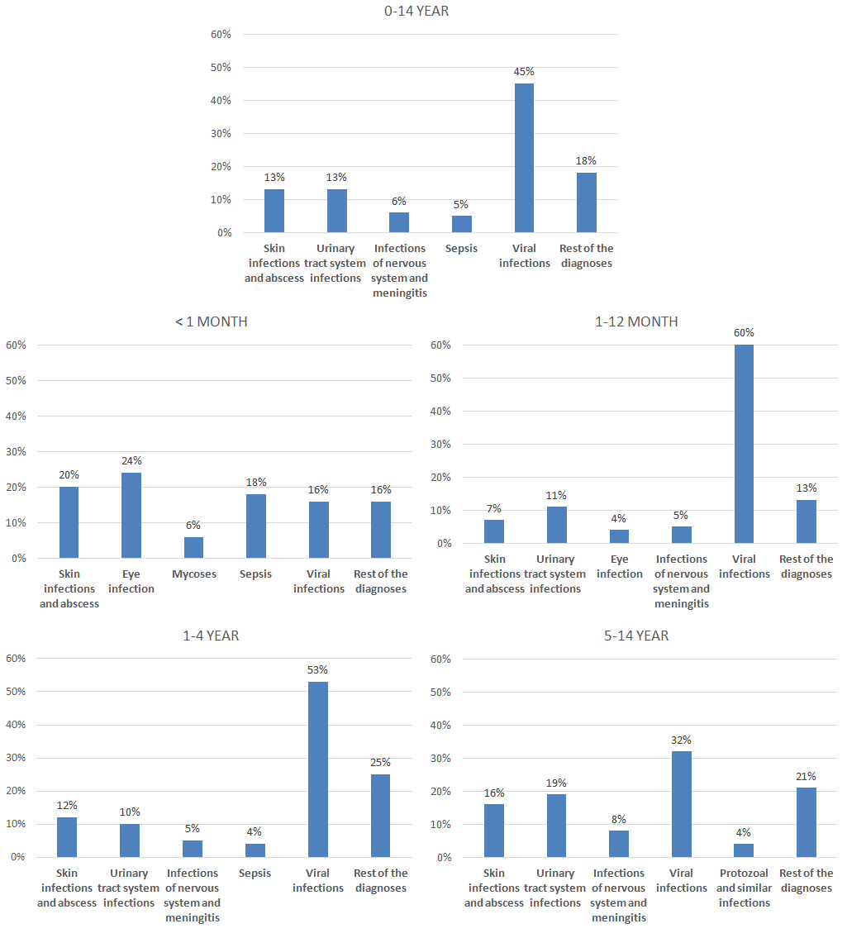
Note: The Distribution shown in the different age groups are based on the five most frequent infectious disease groups for each age group and the rest of the admissions are collected in the group “rest of the diagnoses”.

aFigure 2. Admission rates for infections by age and sex for “Other infections”, excluding secondary diagnoses. Rates of admissions for “Other infections” (A). Male-female rate ratio by age for “Other infections” (B).
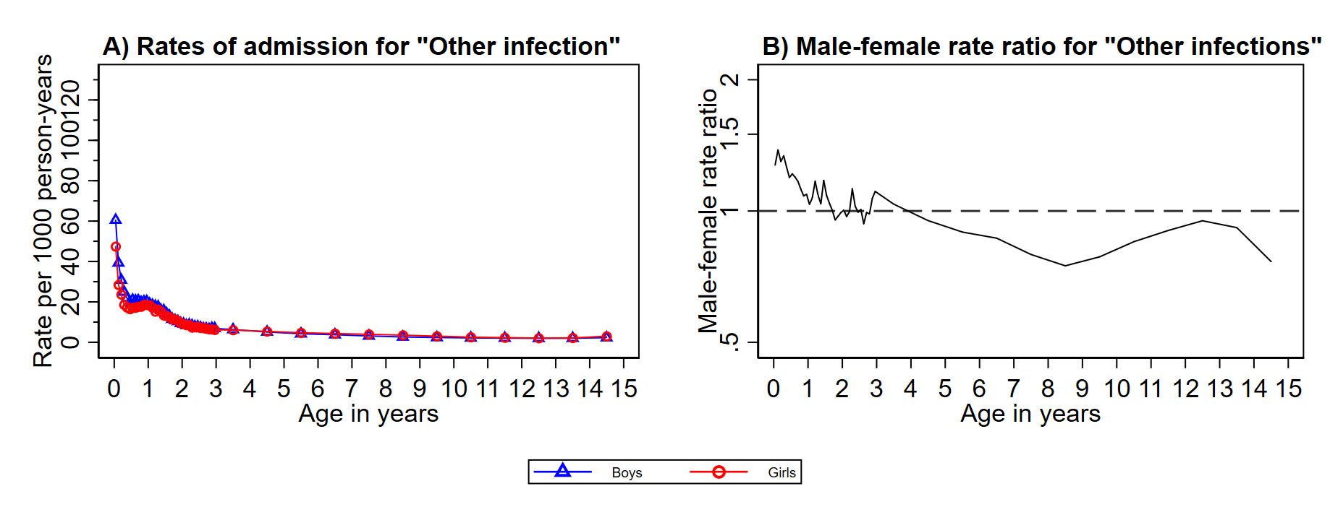

aResults
Admission for infections according to age and sex in different time-periods
Comparing the admissions for all infections for boys and girls in different time-periods (aFig. 3A-H), mainly shows the same tendencies as the combined results for 1977-2014 (fig. 3A-B in the article). In more recent time-periods, the trough between the first and second peak was observed at an older age, as was the second peak (aFig. 3A-D).

Admission for infections according to age and sex in different seasons
The absolute rates of admission for infections for both sexes were generally highest during winter and lowest during summer (aFig. 4A-D). Peaks and troughs in the rate of admissions, as well as male-female rate ratio, roughly followed the same patterns in all seasons (aFig. 4A-H) as described for the combined results of all seasons (fig. 3A-B in the article)

Duration of admission for infections according to age and sex
The highest absolute rate of admission in 3+ days of admission was observed at age 0 months, (boys, 147.1 /1000 person-years; girls, 115.0 /1000 person-years) (aFig. 5D). For shorter durations, the highest absolute rates were around 10-13 months for both sexes (aFig. 5A-C). Boys had the highest admission rate until 13 years of age for admissions with a duration of 0 days, 11 years for duration of 1 days, 10 years for durations of 2 days and 7 years for 3+ days admission (aFig. 5E-H).

aFigure 3. Rates of admissions for all infections according to age and sex for time-periods; 1977-1984 (A), 1985-1993 (B), 1994-2003 (C) and 2004-2014 (D), and male-female rate ratio according to age for; 1977-1984 (E), 1985-1993 (F), 1994-2003 (G) and 2004-2014 (H).
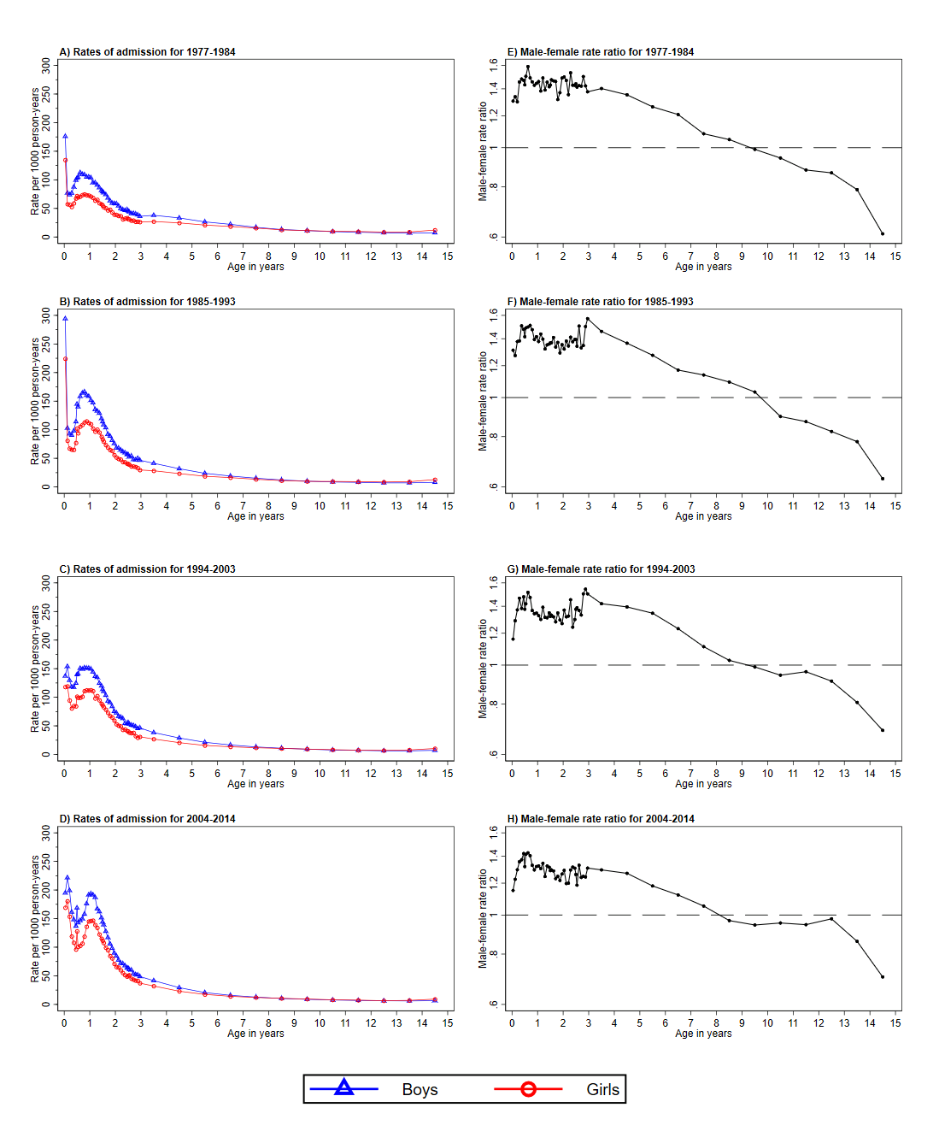

aFigure 4. Rates of admissions for infections according to age and sex for winter (A), spring (B), summer (C) and autumn (D), and male-female rate ratio according to age for winter (E), spring (F), summer (G) and autumn (H).
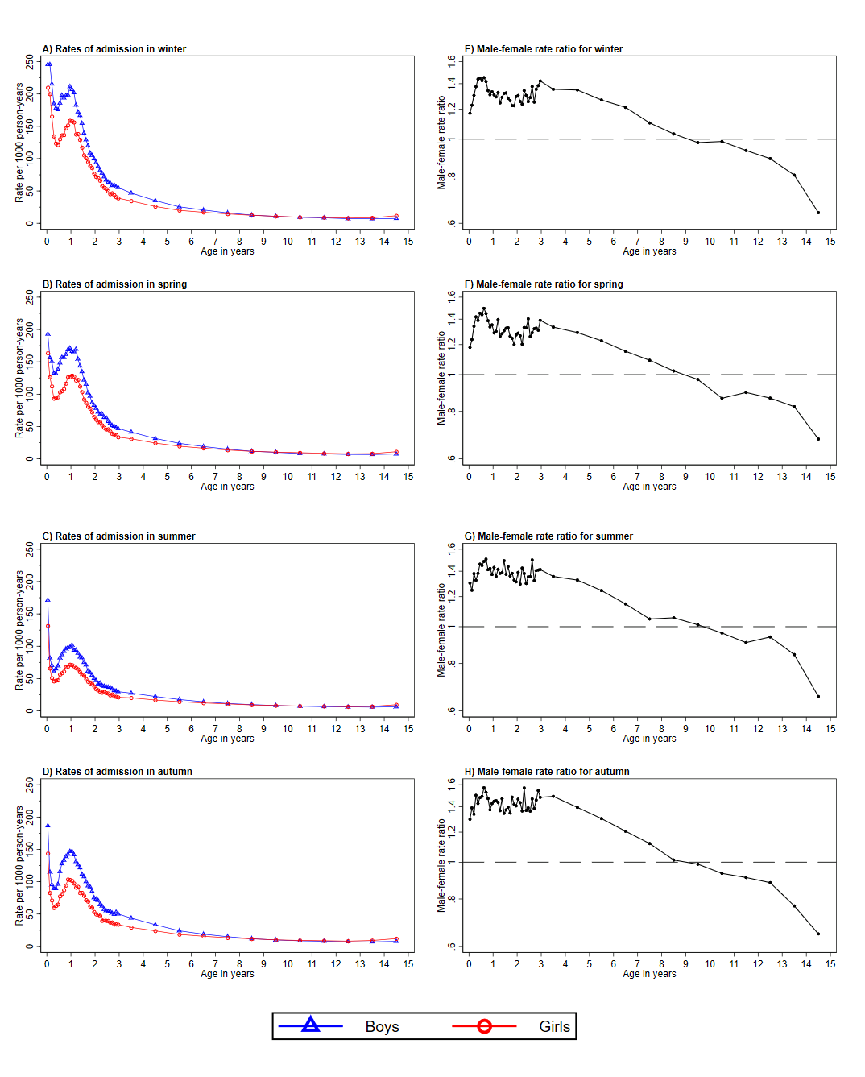
Note: winter, December-February; spring, March-May; summer, June-August; autumn, September-November.

aFigure 5. Rates of admissions for infections by age and sex for 0 days of admission (A), 1 days of admission (B), 2 days of admission (C), 3+ days admission (D). Male-female rate ratio according to age for 0 days of admission (E), 1 days of admission (F), 2 days of admission (G), 3+ days admission (H).
