**Synthesis of Pyrano[2, 3-d]Pyrimidine-2,4(3H)-dione Derivatives Based-on Curcumin using NiCo2O4@OCMC@Zn(BDC) Nanocomposite as a Novel and Efficient Catalyst**

Maryam Sadat Hojjat Najafi a, Mohammad Ali Ghasemzadeh*,a , Mohammad Dakhili b

*aDepartment of Chemistry, Qom Branch, Islamic Azad University, Qom, I. R. Iran.*

*bDepartment of Microbiology, Qom Branch, Islamic Azad University, Qom, I. R. Iran*

*Tel.: +98 253-7780035; Fax: +98 253-7780003*

E-mail address: Ghasemzadeh@qom-iau.ac.ir

**5-(4-chlorophenyl)-6-((E)-3-(4-hydroxy-3-methoxyphenyl)acryloyl)-7-((E)-4-hydroxy-3-methoxystyryl)-1,3-dimethyl-1,5-dihydro-2H-pyrano[2,3-d]pyrimidine-2,4(3H)-dione (4a)**

Yellow solid, m.p 243–245°C. IR (KBr, cm-1): 3433 (O-H), 2960 (-CH3), 1743 (C=O), 1678 (C=O, amide), 1601 (C=C), 1425 (C=C), 1379 (-CH3): 1H NMR (DMSO-*d*6, 250 MHz) δ: 2.82 (3H, s, NCH3), 2.95 (3H, s, NCH3), 3.64 (3H, s, OCH3)**,** 3.78 (3H, s, OCH3), 5.25 (1H, s, CH), 6.07-7.26 (14H, m, HC=CH, Ar-H), 9.11 (1H, s, OH), 9.67 (1H, s, OH). 13C NMR (DMSO-*d6*, 62.5MHz): 43.56, 46.33, 47.97, 49.96, 56.04, 60.24, 61.38, 107.71, 110.22, 111.54, 111.94, 115.97, 119.42, 120.16, 120.73, 124.16, 126.05, 126.48, 127.52, 129.00, 129.20, 130.06, 130.64, 132.40, 133.11, 135.93, 140.15, 141.03, 143.95, 146.90, 147.94, 148.31, 149.62. MS (EI) (m/z): 629.06 (M+), Anal. Calcd. for C34H29ClN2O8: C 64.92, H 4.65, N 4.45. Found C 67.80, H 4.69.

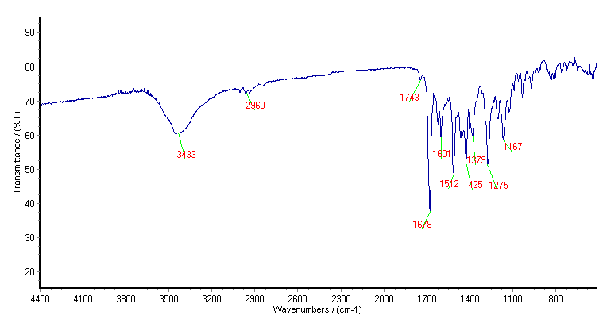



**Figure S1:** FT-IR spectrum of compound 4a.

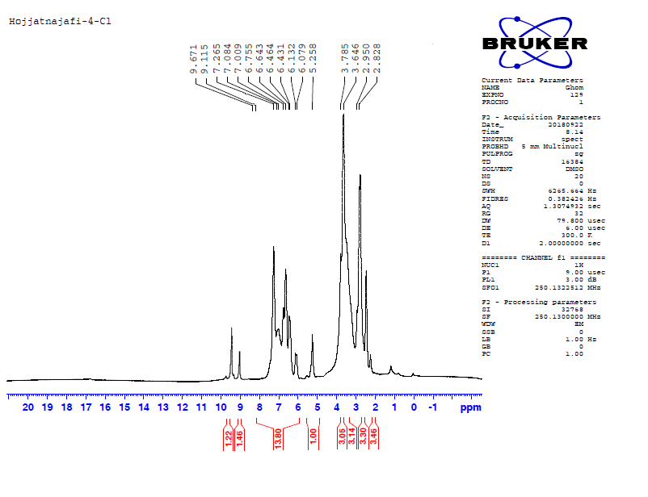



**Figure S2:** 1H-NMR spectrum of compound 4a.

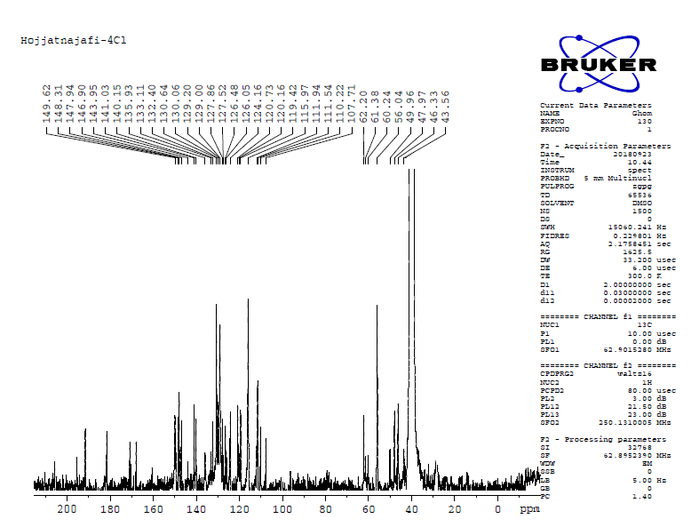



**Figure S3:** 13C-NMR spectrum of compound 4a.

**7-4-(6-((E)-3-(4-hydroxy-3-methoxyphenyl)acryloyl)-7-((E)-4-hydroxy-3-methoxystyryl)-1,3-dimethyl-2,4-dioxo-1,3,4,5-tetrahydro-2H-pyrano[2,3-d]pyrimidin-5-yl)phenyl nitrate (4b)**

Yellow solid, m.p 215-217°C, IR (KBr, cm-1): 3444 (O-H), 1682 (C=O), 1599 (C=C), 1518 (NO2), 1425 (C=C), 1352 (NO2). 1H NMR (DMSO-*d6*, 250MHz) *δ*: 2.64 (3H, s, NCH3), 2.75 (3H, s, NCH3), 3.65 (3H, s, OCH3)**,** 3.80 (3H, s, OCH3), 5.48 (1H, s, CH), 6.07 (1H, d, =C-H, *J*=14Hz), 6.12 (1H, d, =C-H, *J*=14Hz), 6.46-7.53 (12H, m, ArH), 9.11 (1H, s, OH), 9.65 (1H, s, OH). 13C NMR (DMSO-*d6*, 62.5MHz) δ: 40.89, 43.46, 46.81, 47.81, 50.59, 56.07, 60.21, 61.17,62.19, 101.29, 111.73, 116.03, 119.22, 120.09, 121.51, 123.56, 124.36, 126.32, 126.77, 127.44, 129.83, 130.43, 141.14, 141.48, 144.62, 147.01, 147.93, 148.39,150.01, 150.31, 167.61, 168.93, 170.61, 181.56. MS (EI) (m/z): 655.18 (M+), Anal. Calcd. for C34H29N3O11: C 62.29, H 4.46, N 6.41. Found C 62.27, H 4.43, N 6.39.

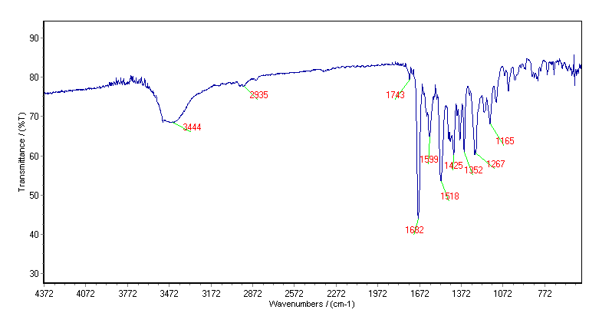



**Figure S4:** FT-IR spectrum of compound 4b.

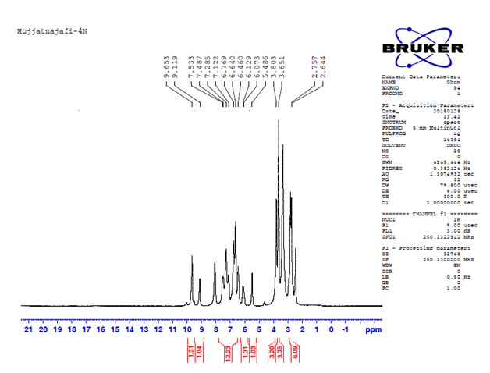



**Figure S5:** 1H-NMR spectrum of compound 4b.

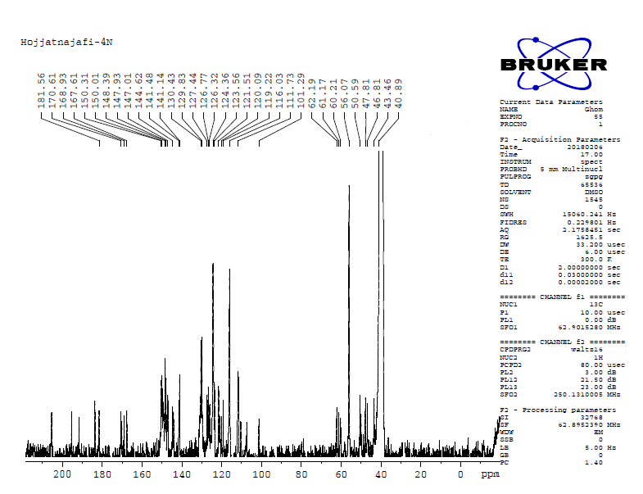



**Figure S6:** 13C-NMR spectrum of compound 4b.

**3-(6-((E)-3-(4-hydroxy-3-methoxyphenyl)acryloyl)-7-((E)-4-hydroxy-3-methoxystyryl)-1,3-dimethyl-2,4-dioxo-1,3,4,5-tetrahydro-2H-pyrano[2,3-d]pyrimidin-5-yl)phenyl nitrate(4c)**

Yellow solid, m.p 198–201°C. IR (KBr, cm-1): 3417 (OH),1745 (C=O), 1682 (C=O), 1518 (NO2), 1429 (C=C),1601 (C=C).: 1H NMR (DMSO-*d*6, 250 MHz) δ: 2.82 (3H, s, NCH3), 2.94 (3H, s, NCH3), 3.52 (3H, s, OCH3), 3.78 (3H, s, OCH3), 5.50 (1H, s, CH), 6.22 (1H, d, =C-H*, J*=15Hz), 6.40-6.43 (2H, d, =C-H*, J*=8Hz), 6.47 (1H, s, =C-H), 6.64-6.92 (3H, m, =C-H, ArH), 7.08-7.98 (7H, m, Ar-H, =C-H), 9.14 (1H, s, OH), 9.67 (1H, s, OH). 13C NMR (DMSO-*d*6, 62.5MHz): 56.07, 60.40, 61.34,62.27, 107.34, 110.45, 111.57, 111.94, 116.00, 119.62, 120.08, 120.76, 122.92, 123.60, 124.41, 126.02, 126.36, 127.24,127.59, 129.11, 130.56, 130.93, 135.14, 135.66, 139.23, 141.42, 143.46, 144.17, 146.98, 147.97, 148.25, 149.49, 150.01, 150.31. MS (EI) (m/z): 655.18 (M+), Anal. Calcd C34H29N3O11: C 62.29, H 4.46, N 6.41, Found C 62. 25, H 4.43, N 6.39 .

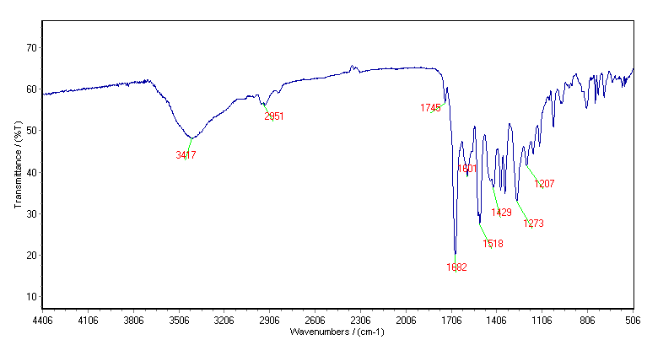



**Figure S7:** FT-IR spectrum of compound 4c.

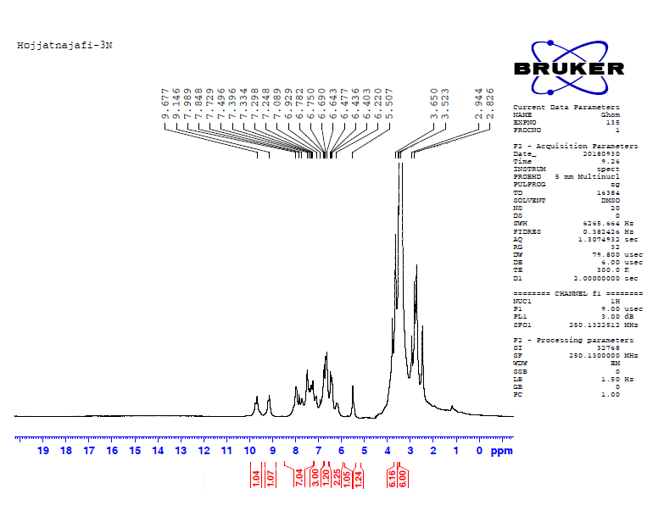



**Figure S8:** 1H-NMR spectrum of compound 4c.

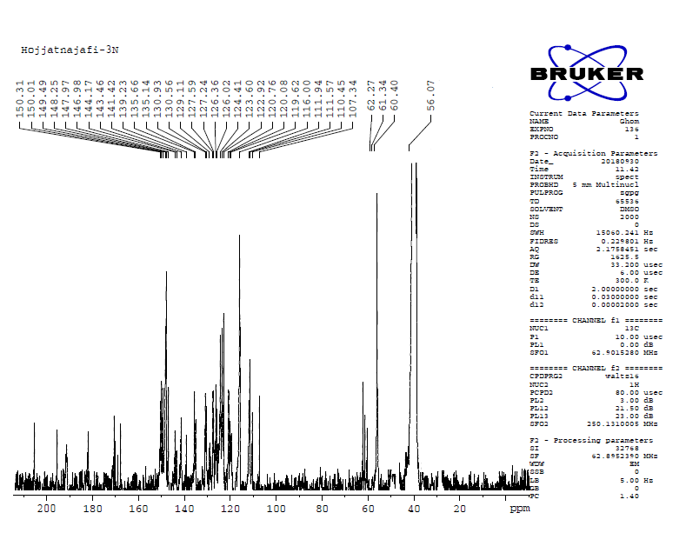



**Figure S9:** 13C-NMR spectrum of compound 4c.

**5-(2,4-dichlorophenyl)-6-((E)-3-(4-hydroxy-3-methoxyphenyl)acryloyl)-7-((E)-4-hydroxy-3-methoxystyryl)-1,3-dimethyl-1,5-dihydro-2H-pyrano[2,3-d]pyrimidine-2,4(3H)-dione (4d)**

Yellow solid, m.p 213–224°C, IR (KBr, cm-1): 3462 (OH), 1676 (C=O), 1601 (C=C), 1508 (C=C), 1427 (C-C), 1275 (-CH3). 1H NMR (DMSO-*d6*, 250MHz) *δ*: 2.47 (3H, s, NCH3), 2.94 (3H, s, NCH3), 3.64 (3H, s, OCH3)**,** 3.76 (3H, s, OCH3), 5.41 (1H, s, CH), 6.06 (1H, d, =C-H, *J*=15.1Hz), 6.44 (1H, d, =C-H, *J*=16Hz), 6.52 (1H, s, =C-H), 6.62 (1H, d, =C-H, *J*=16Hz), 6.74-6.81 (3H, m, =C-H), 7.07-7.10 (2H, d, *J*=7.5Hz, Ar-H), 7.62-7.65 (1H, d, *J*=7.5Hz, Ar-H), 7.68-7.71 (2H, d, *J*=7.5Hz, Ar-H), 7.72 (1H, s,Ar-H), 9.08 (1H, s, OH), 9.80 (1H, s, OH). 13C NMR (DMSO-*d6*, 62.5MHz) δ:39.23, 39.56, 39.90,50.23, 40.56, 40.88,46.18, 55.89, 59.47, 108.20, 109.76, 112.20, 116.01, 117.32, 121.0, 124.67, 126.02, 127.93, 128.23, 129.15, 133.65, 137.52, 142.95, 146.73, 147.85, 148.50, 150.42, 161.79, 162.48, 168.26, 179.80, 184.36, 187.89, 197.62. MS (EI) (m/z): 662.12 (M+), Anal. Calcd. for C34H28Cl2N2O8: C 61.55, H 4.25, N 4.22. Found C 61.52, H 4.20, N 4.20.

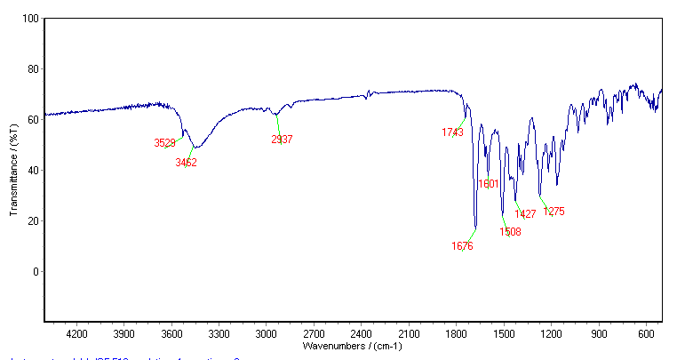



**Figure S10:** FT-IR spectrum of compound 4d.

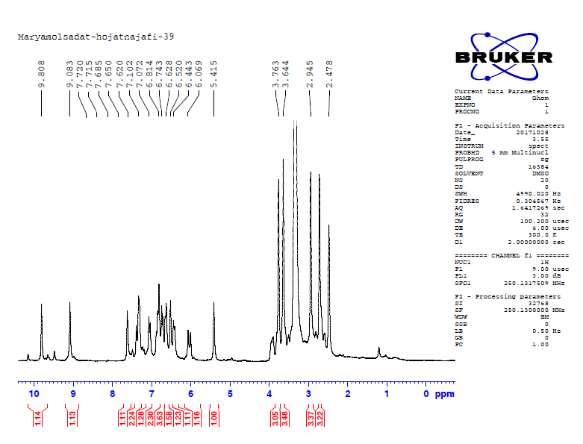



**Figure S11:** 1H-NMR spectrum of4d

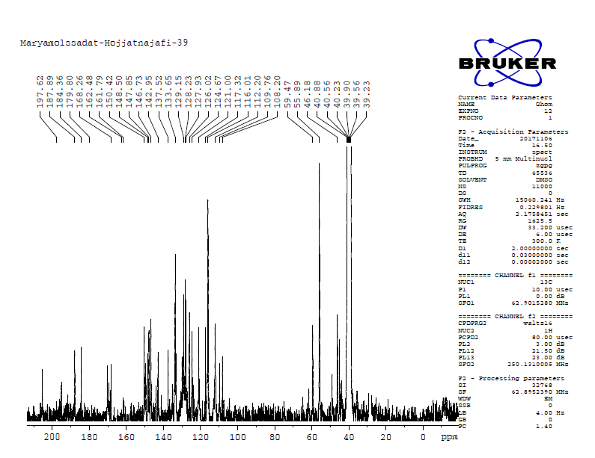



**Figure S12:** 13C-NMR spectrum of compound 4d.

**4-(6-((E)-3-(4-hydroxy-3-methoxyphenyl)acryloyl)-7-((E)-4-hydroxy-3-methoxystyryl)-1,3-** **dimethyl-2,4-dioxo-1,3,4,5-tetrahydro-2H-pyrano[2,3-d]pyrimidin-5-yl)benzonitrile (4e)**

Yellow solid, m.p 244–246°C. IR (KBr, cm-1):3448 (OH), 2233 (CN), 1676 (C=O), 1601 (C=C), 1508 (C=C),1427 (C=C), 1271 (-CH3): 1H NMR (DMSO-*d*6, 250 MHz) δ: 2.83 (3H, s, NCH3 ), 2.95 (3H, s, NCH3 ), 3.36 (3H, s, OCH3), 3.80 (3H, s, OCH3 ), 5.40 (1H, s, CH), 6.07-6.13 (1H, d, =C-H, *J*=15.25Hz), 6.39-6.42 (1H, d, =C-H*, J*=7.75Hz), 6.64-6.98( 7H, m, ArH), 7.26-7.32 (2H, d, ArH, *J*=15Hz), 7.38 (1H, s, Ar-H), 7.42 (1H, s, Ar-H), 7.68 (1H, s, Ar-H), 9.11 (1H, s, OH), 9.67 (1H, s, OH). 13C NMR (DMSO-*d6*, 62.5MHz) δ: 56.02, 60.05, 61.18, 62.11, 107.33, 110.53, 111.46, 111.94, 116.00, 118.67, 118.82, 119.33,120.13, 120.76, 124.42, 126.02, 126.37, 127.31, 127.59, 129.36, 129.99, 132.85, 133.15, 141.38, 142.53, 144.12, 146.94, 147.95, 148.36, 149.53,150.01, 150.29, 167.73, 168.95. MS (EI) (m/z): 619.20 (M+), Anal. Calcd. for C35H29N3O8: C 67.84, H 4.72, N 6.78. Found C 67.80, H 4.69, N 6.73.

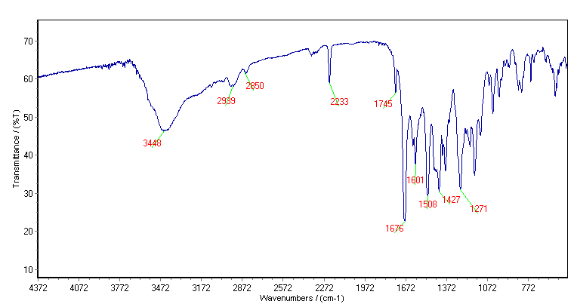**Figure S13:** FT-IR spectrum of compound 4e.



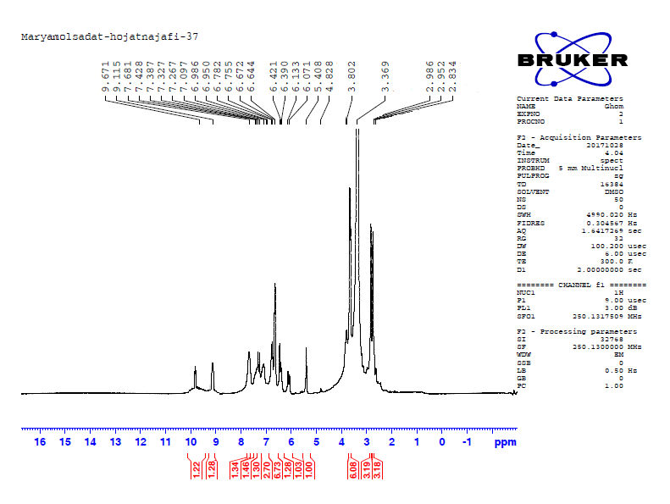



**Figure S14:** 1H-NMR spectrum of compound 4e.

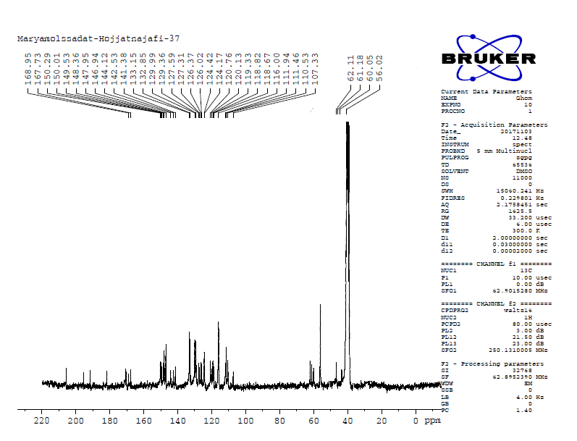



**Figure S15:** 13C-NMR spectrum of compound 4e.

**6-((E)-3-(4-hydroxy-3-methoxyphenyl)acryloyl)-7-((E)-4-hydroxy-3-methoxystyryl)-5-(3-hydroxyphenyl)-1,3-dimethyl-1,5-dihydro-2H-pyrano[2,3-d]pyrimidine-2,4(3H)-dione (4f)**

Yellow solid, m.p 239–243°C. IR (KBr, cm-1): 3427 (O-H), 2935 (Ar-H), 1736 (C=O), 1676 (C=O), 1601 (C=C), 1452 (C=C), 1275 (-CH3).: 1H NMR (DMSO-*d6*, 250 MHz) δ: 2.89 (3H, s, NCH3), 2.93 (3H, s, NCH3), 3.62 (3H, s, OCH3), 3.64 (3H, s, OCH3), 5.04 (1H, s, CH), 6.47-7.35 (14H, m, Ar-H, =C-H.), 9.45 (2H, bs, 2OH), 9.65 (1H, s, OH). 13C NMR (DMSO-*d*6, 62.5MHz):42.93, 43.72, 46.45, 48.30, 49.37, 55.98, 61.74, 111.86, 114.12, 114.67, 115.16, 115.95, 118.28, 119.54, 120.22, 120.68, 122.24, 124.21, 126.09, 126.64, 128.13, 129.26, 130.03, 140.77, 142.32, 144.02, 146.71, 147.46, 147.93, 148.36, 149.82, 157.31, 158.05, 167.9. MS (EI) (m/z): 610.20 (M+), Anal. Calcd C34H30N2O9: C 66.88, H 4.95, N 4.59. Found C 66.85, H 4.92, N 4.55.

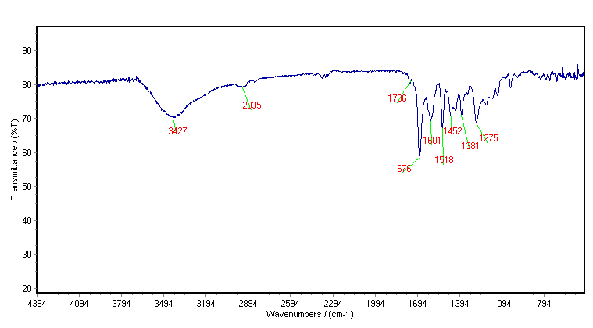



**Figure S16:** FT-IR spectrum of compound 4f.

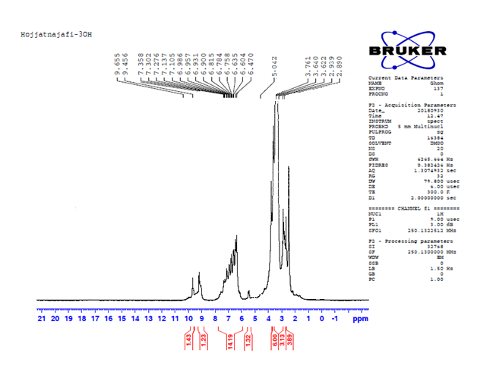



**Figure S17:** 1H-NMR spectrum of compound 4f.

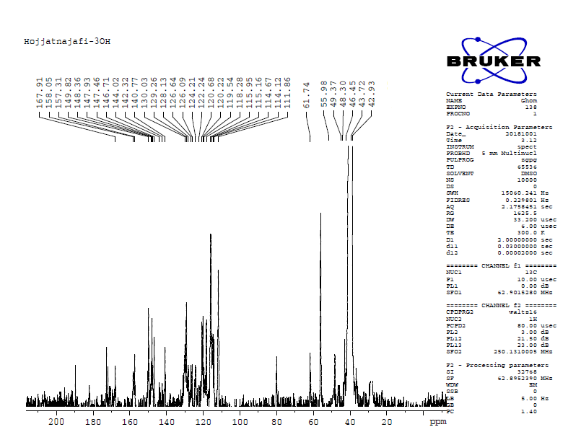**Figure S18:** 13C-NMR spectrum of compound 4f.



**5-(4-bromophenyl)-6-((E)-3-(4-hydroxy-3-methoxyphenyl)acryloyl)-7-((E)-4-hydroxy-3-methoxystyryl)-1,3-dimethyl-1,5-dihydro-2H-pyrano[2,3-d]pyrimidine-2,4(3H)-dione(4g)**

Yellow solid, m.p 233–234°C. IR (KBr, cm-1): 3419 (O-H), 3014 (Ar-H), 2958 (-CH3), 1745 (C=O), 1676 (C=O), 1601 (C=C), 1379 (-CH3): 1H NMR (DMSO-*d*6, 250 MHz) δ: 2.82 (3H, s, NCH3), 2.96 (3H, s, NCH3) 3.65 (3H, s, OCH3), 3.80 (3H, s, OCH3), 5.25 (1H, s, CH), 6.07-6.13 (1H, d, =C-H. *J*=15Hz), 6.40-7.39 (12H, m, HC=CH, Ar-H), 7.41 (1H, s, Ar-H), 9.09 (1H, s, OH), 9.06 (1H, s, OH). 13C NMR (DMSO-*d*6, 100 MHz):48.01, 49.99, 56.04, 56.04, 60.22, 61.31,62.15 107.67, 110.17, 111.55, 111.99, 115.98, 119.41, 120.15, 120.72, 120.98, 121.75, 124.21, 126.06, 126.50, 127.53, 127.84, 128.97, 130.39, 130.97, 131.94, 136.36, 140.56, 141,06, 143.97, 146.90, 147.95, 148.32, 149.63, 149.95. MS (EI) (m/z): 672.11 (M+), Anal. Calcd C34H29BrN2O8: C 60.63, H 4.34, N 4.16. Found C 60.60, H 4.30, N 4.13.

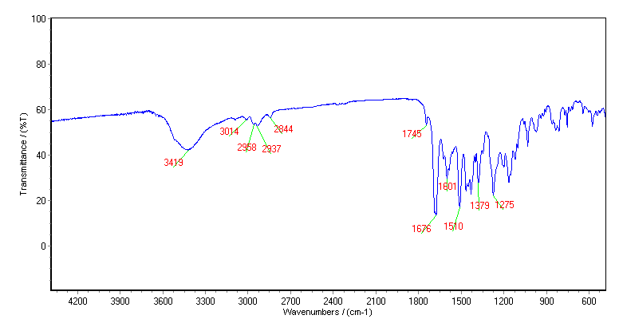



**Figure S19:** FT-IR spectrum of compound 4g.

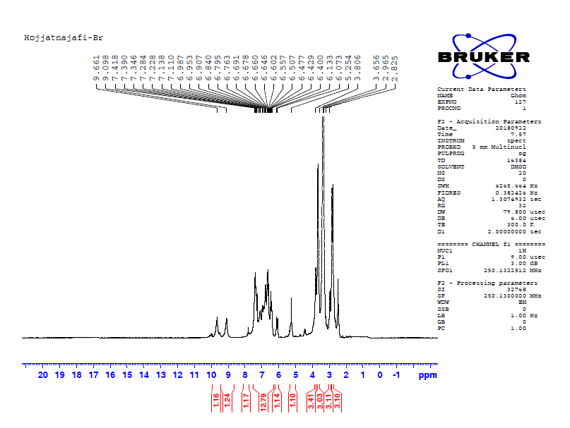  
**Figure S20:** 1H-NMR spectrum of compound 4g.



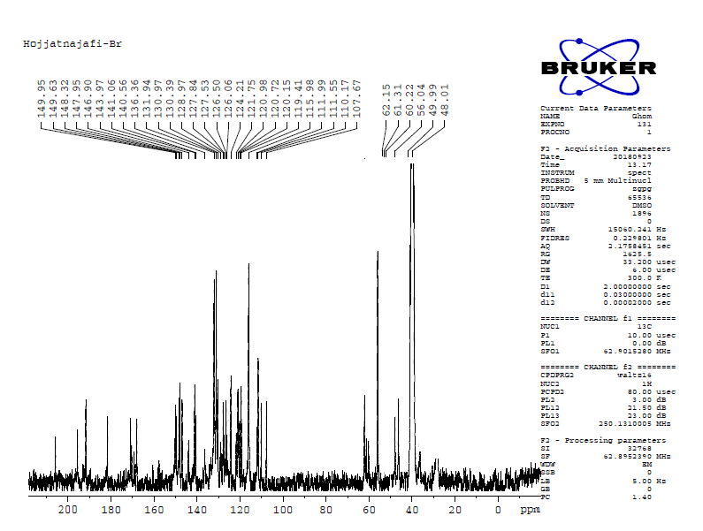



**Figure S21:** 13C-NMR spectrum of compound 4g.

**6-((E)-3-(4-hydroxy-3-methoxyphenyl)acryloyl)-7-((E)-4-hydroxy-3-methoxystyryl)-5-(4-methoxyphenyl)-1,3-dimethyl-1,5-dihydro-2H-pyrano[2,3-d]pyrimidine-2,4(3H)-dione(4h)**

Yellow solid, m.p 243–245°C. IR (KBr, cm-1): 3419 (O-H), 3012 (Ar-H), 1674 (C=O), 1431 (C=C), 1275 (-CH3).: 1H NMR (DMSO-*d*6, 250MHz) δ: 2.83-2.95 (6H, d, NCH3), 3.67 (3H, s, OCH3)**,** 3.78 (3H, s, OCH3), 5.14 (1H, s, CH), 6.12-6.18 (1H, d, =C-H*, J*=15.25Hz), 6.40-7.08 (11H, m, HC=CH, Ar-H), 7.26-7.32 (2H, d,=C-H*, J*=15.25 Hz), 9.07 (1H, s, OH), 9.62 (1H, s, OH). 13C NMR (DMSO-*d6*, 62.5MHz):28.69, 36.65, 39.24,39.57,40.24, 40.56, 45.99, 48.33, 55.40, 55.92, 62.32, 108.25, 110.25, 111.60, 114.36, 115.89, 119.54, 120.69, 123.99, 126.62, 128.24, 129.18, 129.77, 132.74, 140.64, 146.78, 147.93, 148.28, 149.81, 158.74, 168.30, 171.21, 181.84, 191.37. MS (EI) (m/z): 624.21 (M+), Anal. Calcd for C35H32N2O9: C 67.30, H 5.16, N 4.48. Found C 67.28, H 5.13, N 4.45.

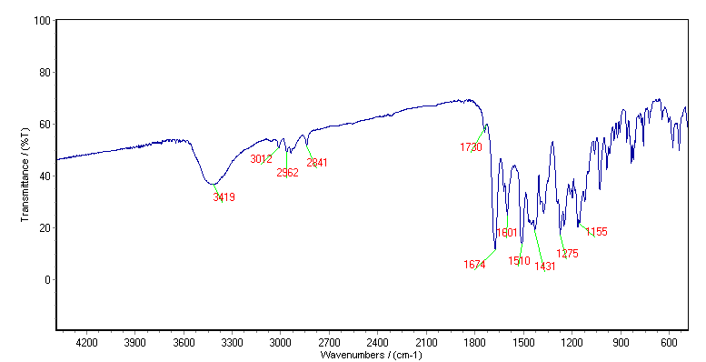



**Figure S22:** FT-IR spectrum of compound 4h.

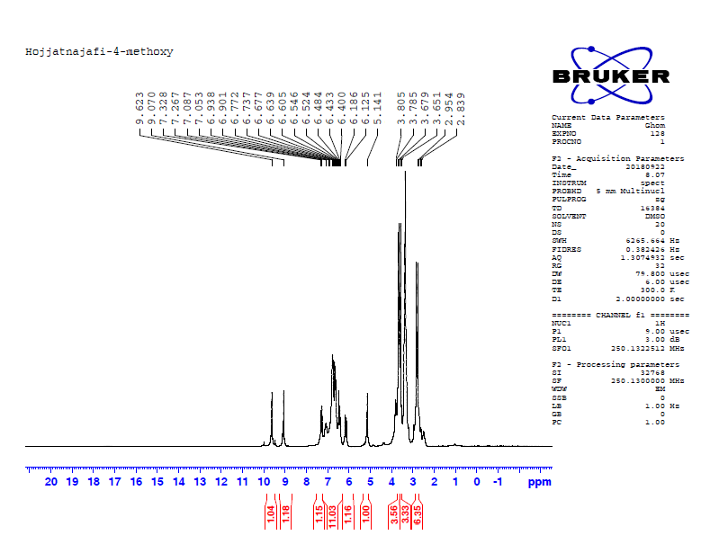



**Figure S23:** 1H-NMR spectrum of compound 4h.

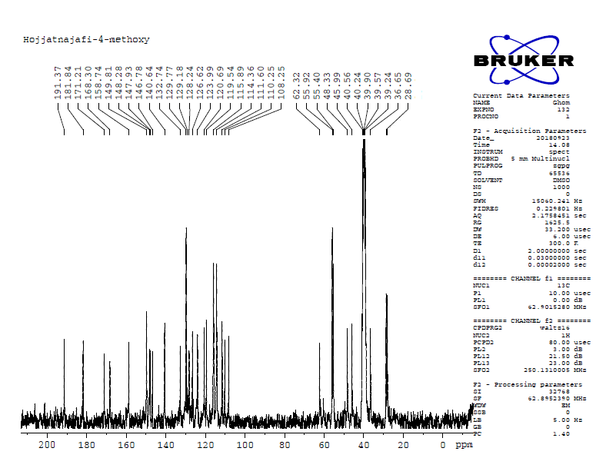



**Figure S24:** 13C-NMR spectrum of compound 4h.