Agar: a natural and environmentally-friendly support composed with copper oxide nanoparticles for the green synthesis of 1,2,3–triazoles
Ali Maleki*, Morteza Panahzadeh, Reza Eivazzadeh-keihan
Catalysts and Organic Synthesis Research Laboratory, Department of Chemistry, Iran University of Science and Technology, Tehran 16846-13114, Iran
*Corresponding author. E-mail: maleki@iust.ac.ir; Fax: +98-21-73021584; Tel: +98-21-73228313

^{Characterization Data:}

1-Benzyl-4-phenyl-1H-1,2,3-triazole
White powder. Mp: 128-130 °C. ¹H NMR: (500 MHz, CDCl₃): δ: 5.60 (s, 2H, CH₂), 7.33-7.35 (m, 3H, H_{aromatic}), 7.4-7.44 (m, 5H, H_{aromatic}), 7.68 (s, 1H, 5-H), 7.81-7.83 (d, 2H, H_{aromatic}).

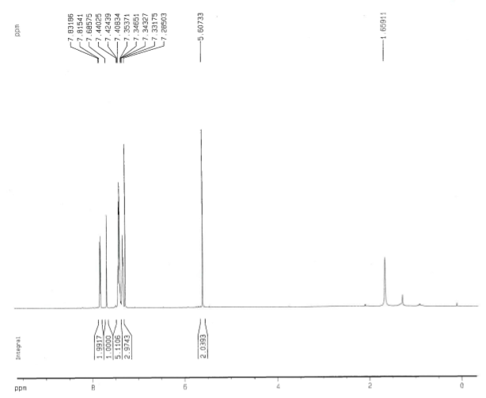
Figure 1. ¹H NMR spectrum of the product.

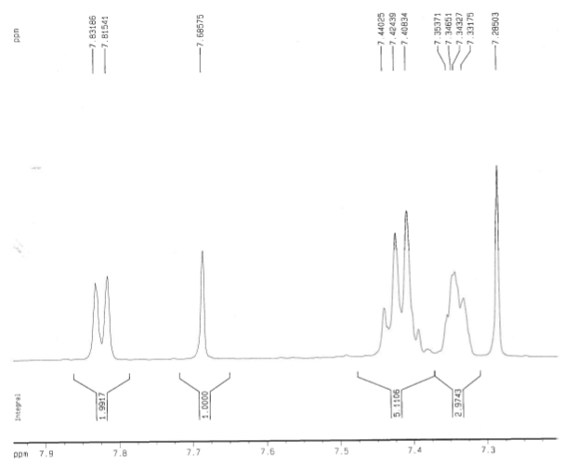
Figure 2. Expanded ¹H NMR spectrum of the product.

