Supplemental Table 1: HPLC-UV conditions for aldehydes analysis.

Instrument: | Agilent 1200 HPLC, diode array detector
Column: | Kromasil 100-5C18 4.6mm x 250mm column
Mobile Phase: | A: Water
 | B: Acetonitrile
Column Temp: | 25ºC
Flow rate: | 1.0 mL/min
Injection Volume: | 10µL
Detection: | 360 nm
Gradient: | Time (min) | Acetonitrile (%)
 | 0 | 60
 | 7 | 60
 | 20 | 100

Supplemental Table 2: GC-MS conditions for charcoal tube analysis.

Instrument: | Agilent GC/MS, GC/FID 6890/5973
Column Identification: | DB-5MS, 0.25mm ID x 30m x 0.25µm
Injector Temperature: | 250ºC
Source Temperature: | 250ºC
Temperature Program: | 40ºC (hold for 3 min)
 | 10ºC/min to 280ºC
 | 280ºC (hold for 3 min)
Split Injection: | 10:1 ratio, 12 mL/min
Injection Volume: | 1µL
Scan Range: | 35-350 amu
Carrier Gas: | Helium
Run Time: | 30 min

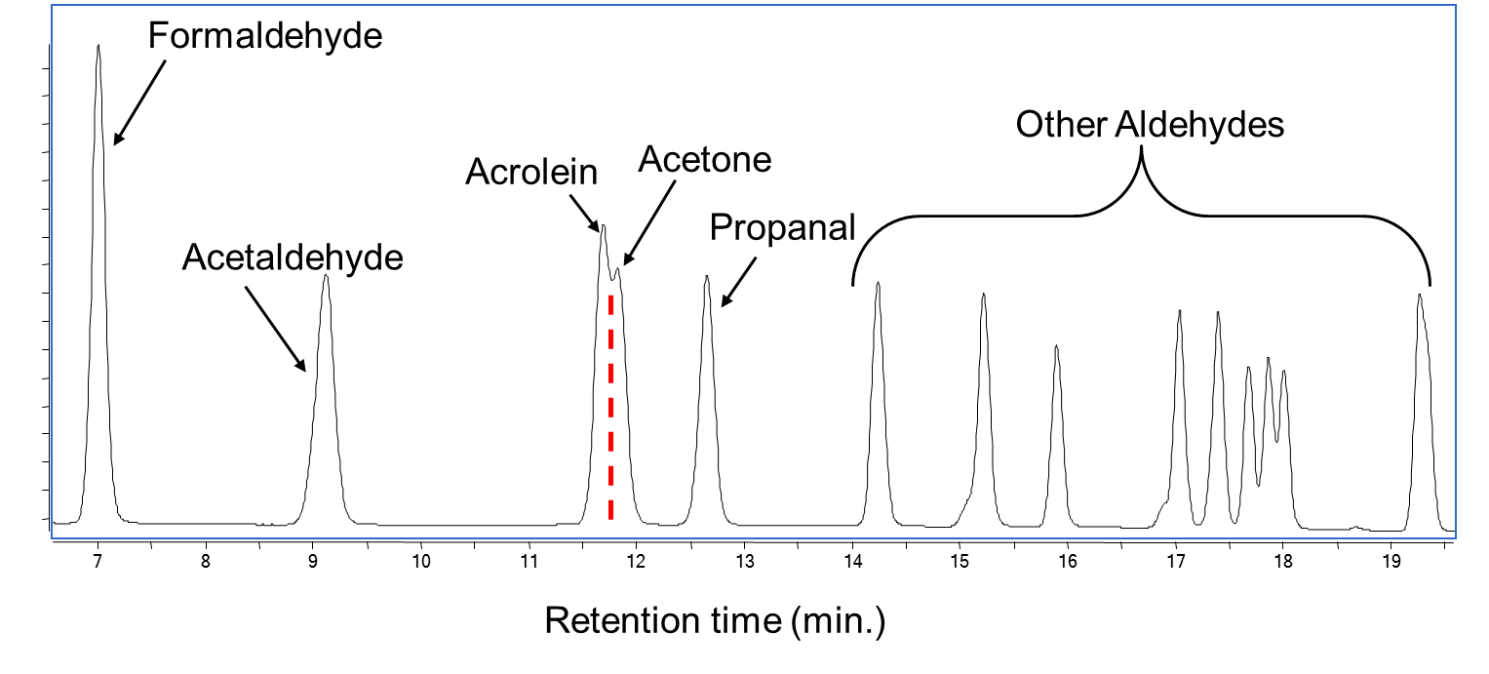
Supplemental Figure 1: Representative HPLC-UV chromatogram for analysis of aldehyde standard solution.

