**Supplementary Data**

**Synthesis of 9-Phenyl-*β*-carboline derivatives and Molecular Crystal Structure of 9-phenyl-*β*-carboline**

Ramu Meesalaa*, Mohd Nizam Mordia, Sharif Mahsufi Mansora and Mohd Mustaqim Roslib

aCentre For Drug Research, Universiti Sains Malaysia, Minden, 11800, Penang, Malaysia

Fax: +604-6568669; Tel.: +604-6533888 Ext. 2145; E-mail: cu_ram@yahoo.co.in

bX-ray Crystallography Unit, School of Physics, Universiti Sains Malaysia, 11800, Penang, Malaysia

1H NMR of **2a**:

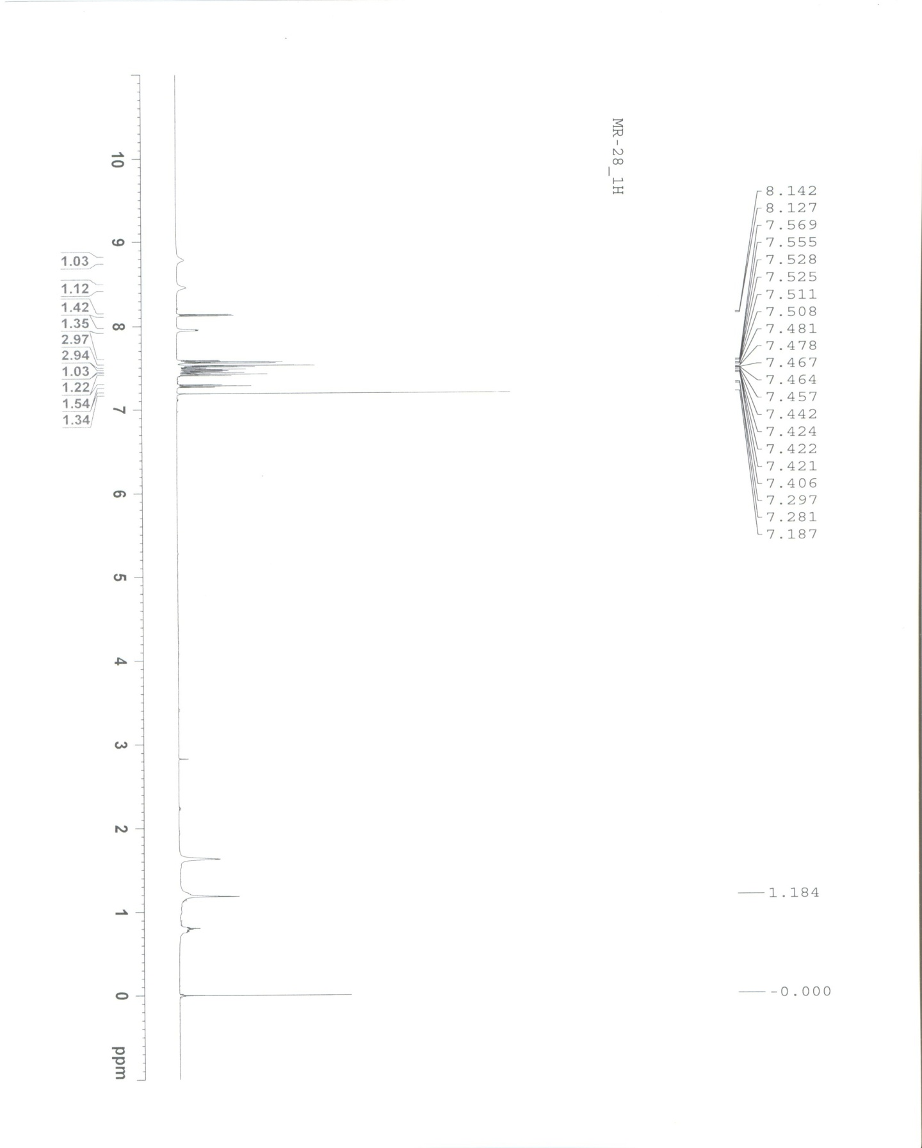

13C NMR of **2a**:

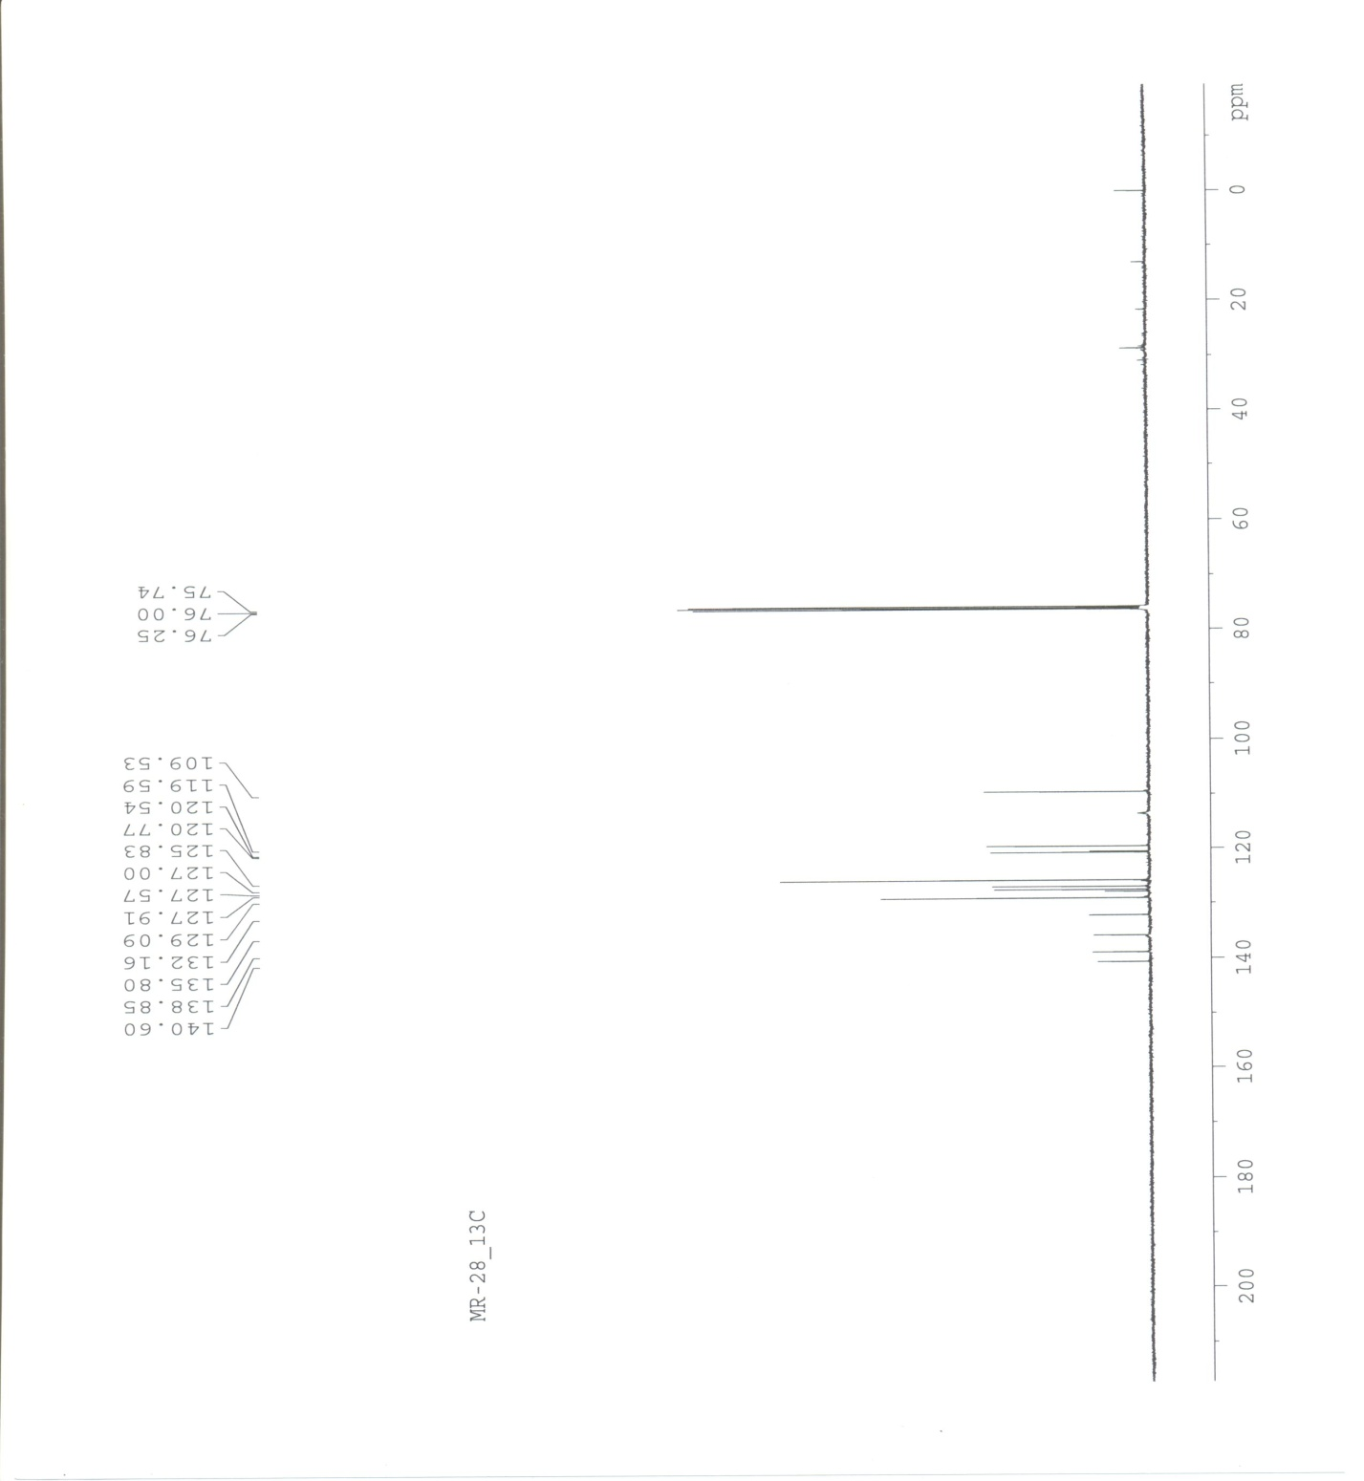

1H NMR of **2b**:

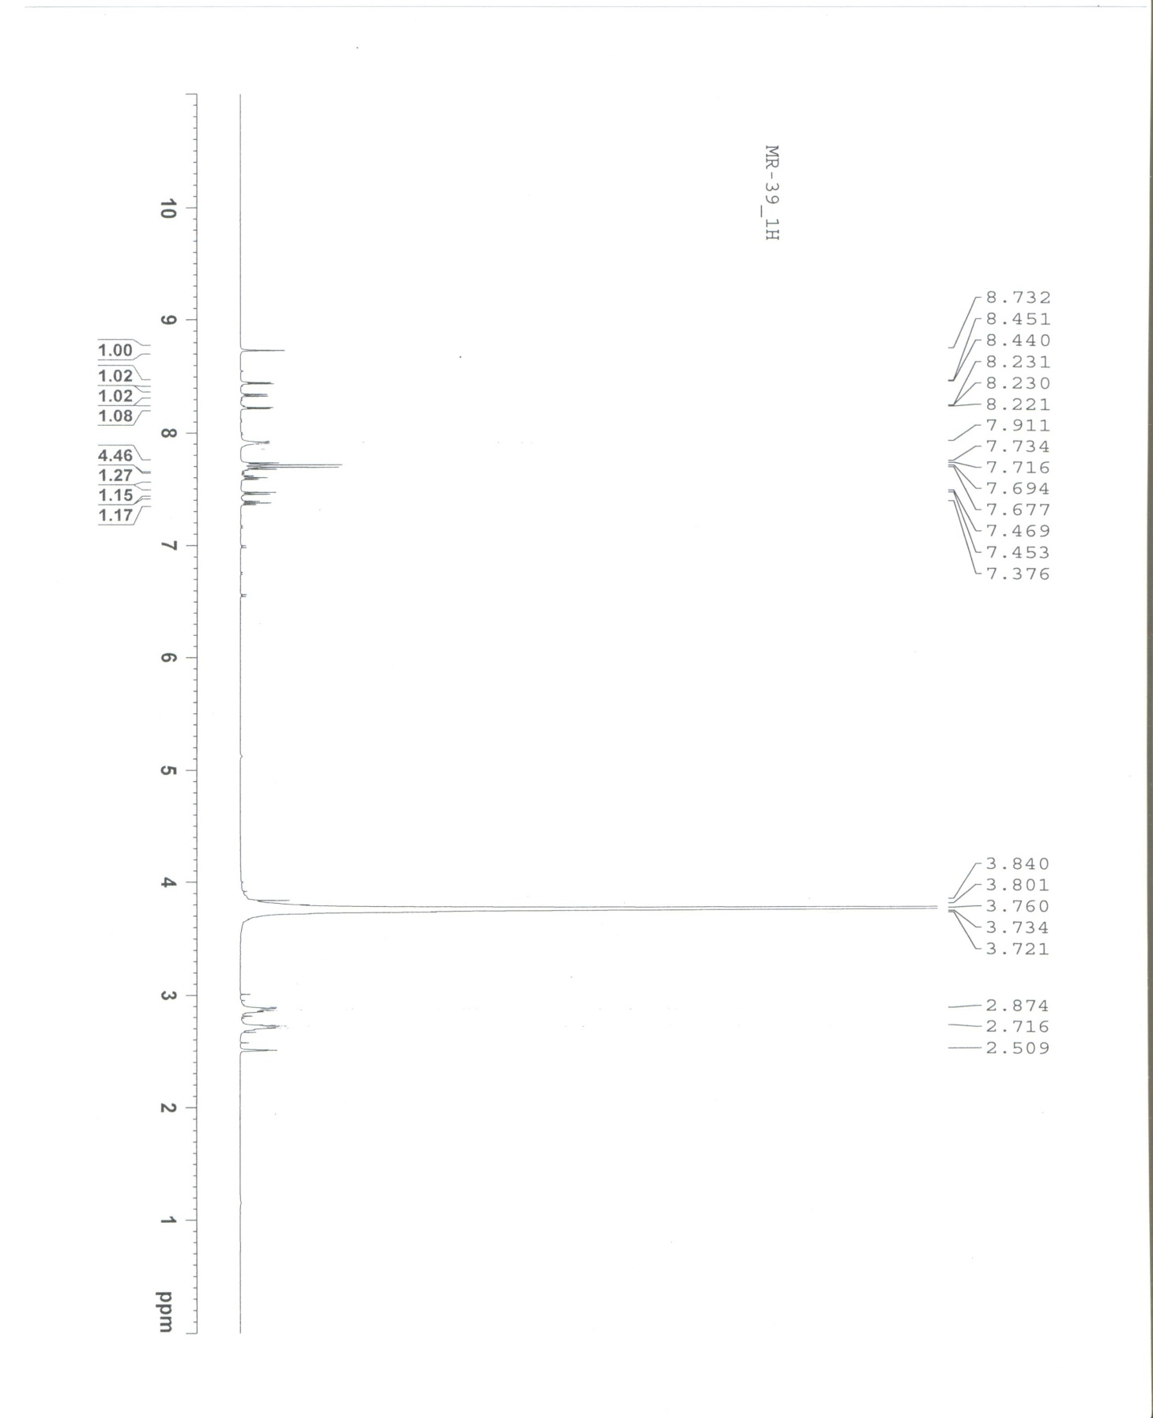

13C NMR of **2b**:

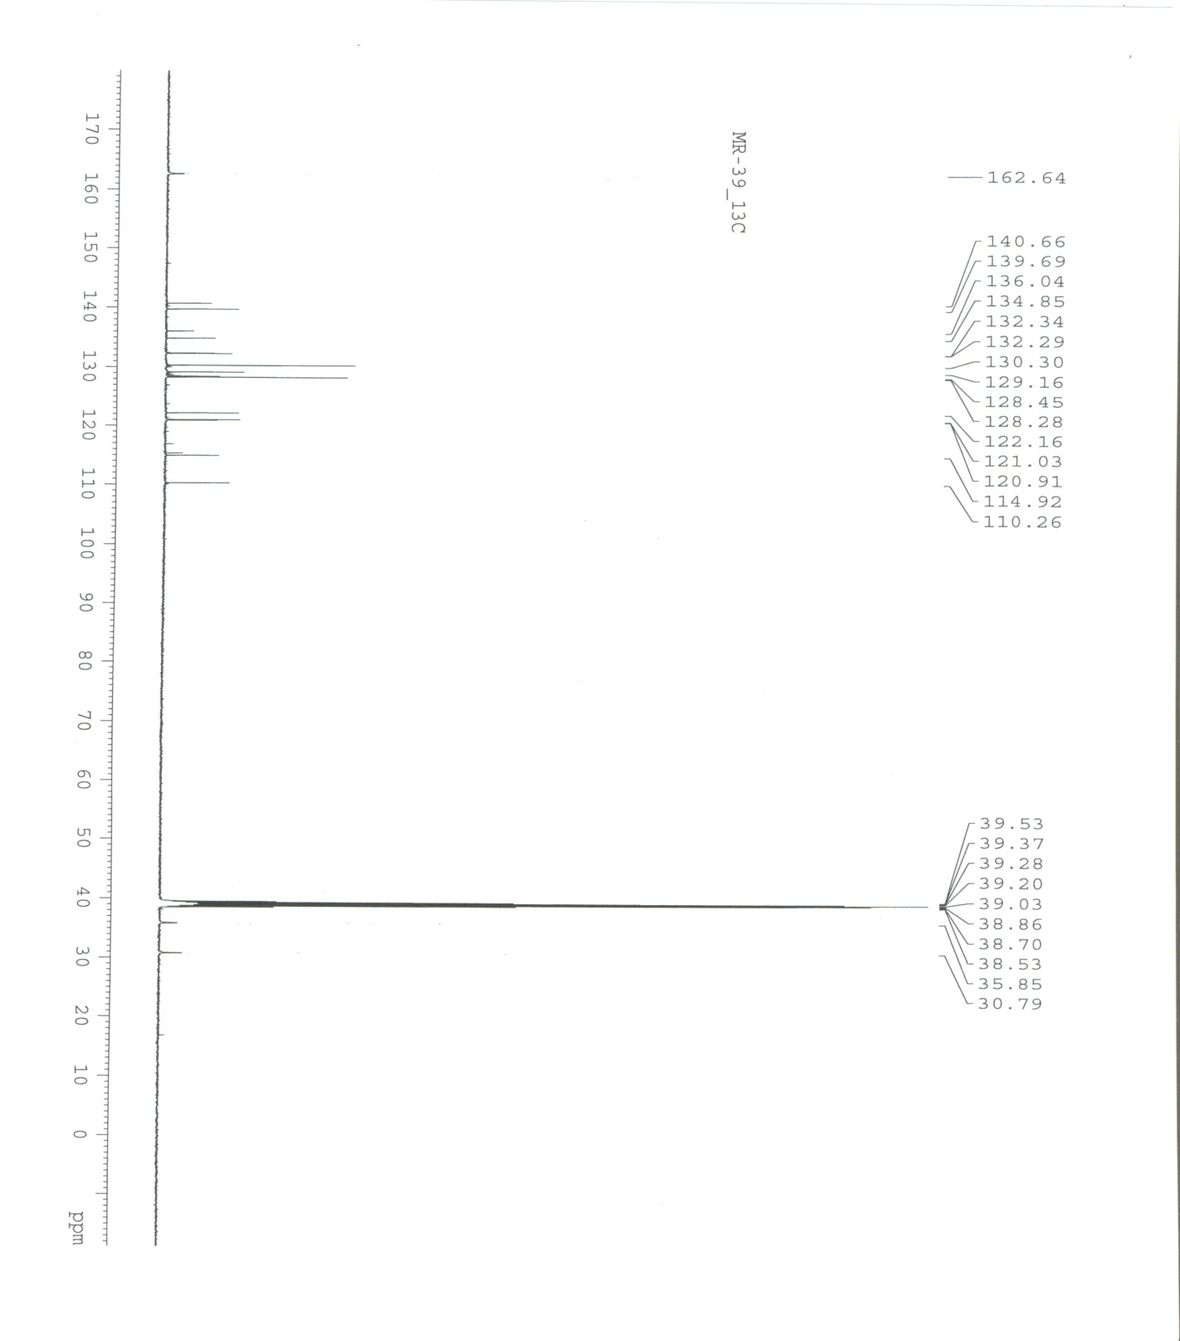

GC-MS of **2a**:





GC-MS of **2b**:





IR Spectrum of **2a**:



IR Spectrum of **2b**:

