**Supplementary material**

**Exploring socio-hydrological determinants of crop yield in under-performing irrigation schemes: Pathways for sustainable intensification**

**Muhammad Khalifa *et al.***

*(e-mail: mkhalifa@smail.uni-koeln.de, msakhalifa@hotmail.com)*

**S1 Gezira Irrigation Scheme**

The scheme was established after the construction of Sennar Dam in 1925 on the Blue Nile. This was during the era of the British rule in Sudan with a purpose to mainly cultivate cotton for the British textile industry. It has played a major role in the Sudan’s economy, and in fact was considered the central engine for the economy of the country for several decades during the 20th century (Ishag *et al.* 2007, Woldegebriel *et al.* 2012, Ertsen 2016). During the oil era of the 1990s and 2000s in Sudan, the contribution of agriculture to the Sudan gross domestic product (GDP) decreased due to the large revenues of oil (Mahgoub 2014). Neglecting the agriculture sector during this period resulted in severe deterioration of the irrigation systems, which originated from a range of problems, including sedimentation of irrigation canals, improper removal of sediments (Ertsen 2016), and dramatic and non-sustainable changes of policies (Al Zayed and Elagib 2017, Elshaikh *et al.* 2018). It is clear from the cultivated area of crops at the scheme-wide level for the years 2001–2016 that, sorghum was the dominant crop (Fig. S1). The water is diverted to the different administrative groups using a large irrigation canals, which currently suffer from different problems (Fig. S2). While sorghum is the main cultivated crop in the summer season in addition to lesser areas of cotton and groundnuts, wheat and chickpea are cultivated in the winter season (Fig. S3).

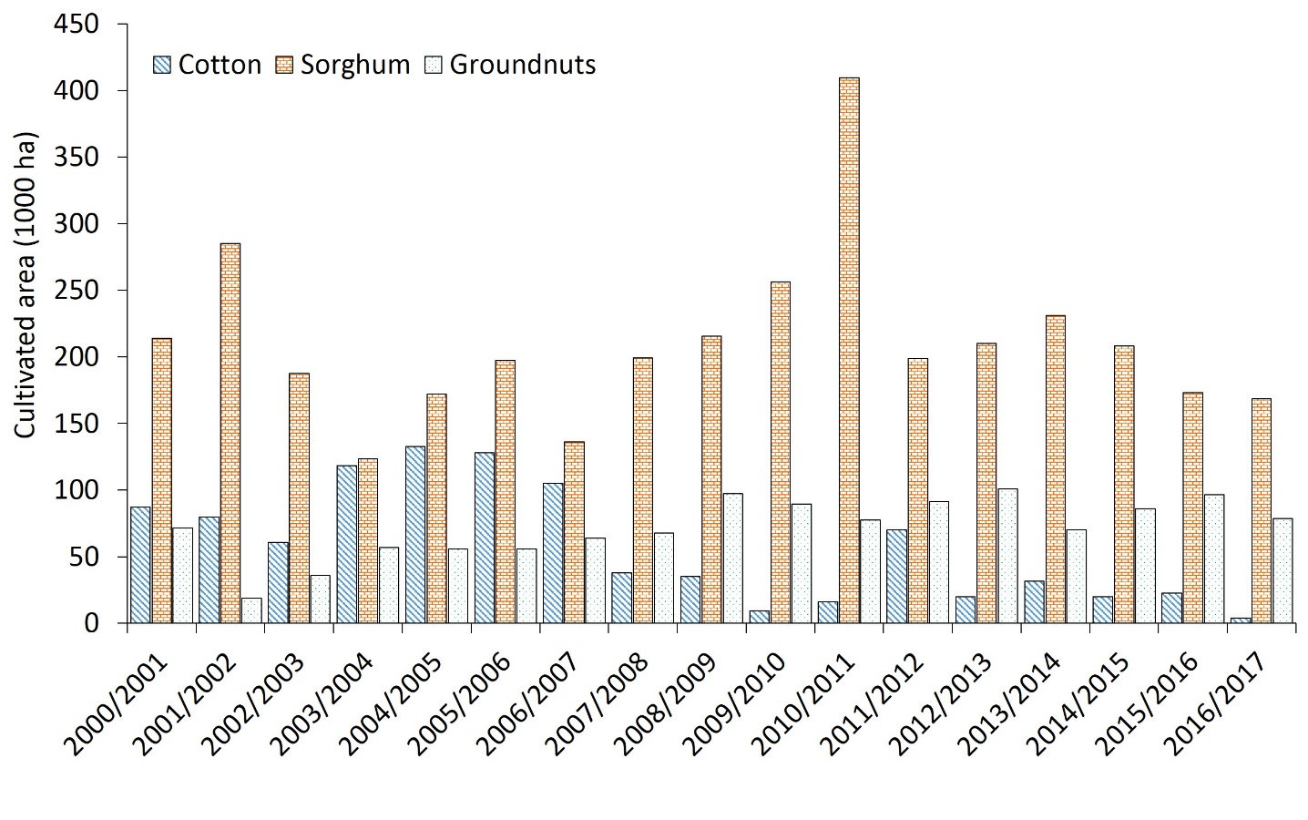

**Figure S1.** Cultivated area of the main summer crops in the Gezira Scheme for the seasons 2000/01–2016/17.

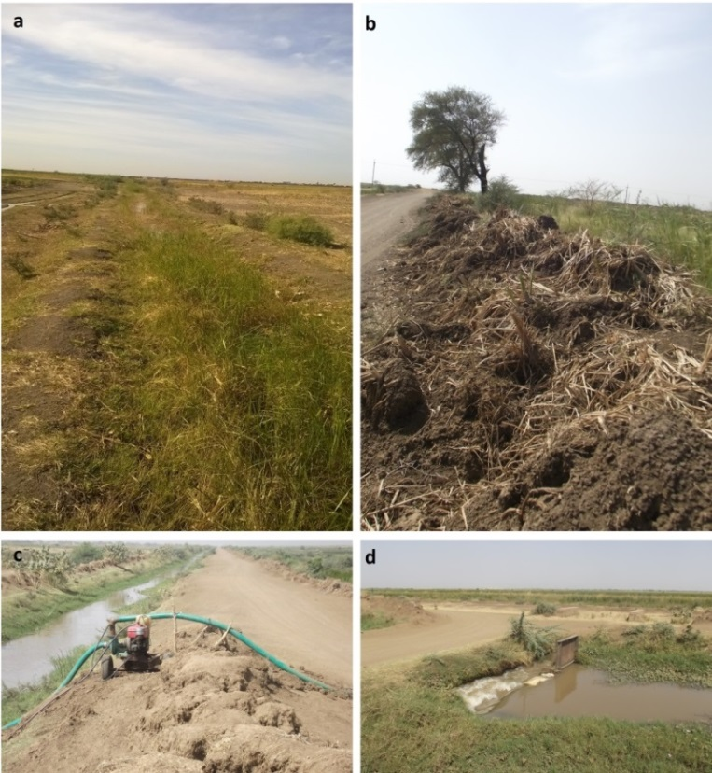

**Figure S2.** Problems in the irrigation canals in the Gezira Scheme: (a) weeds, (b) siltation, (c) improper maintenance resulted in different levels in the canals and (d) broken water gates.

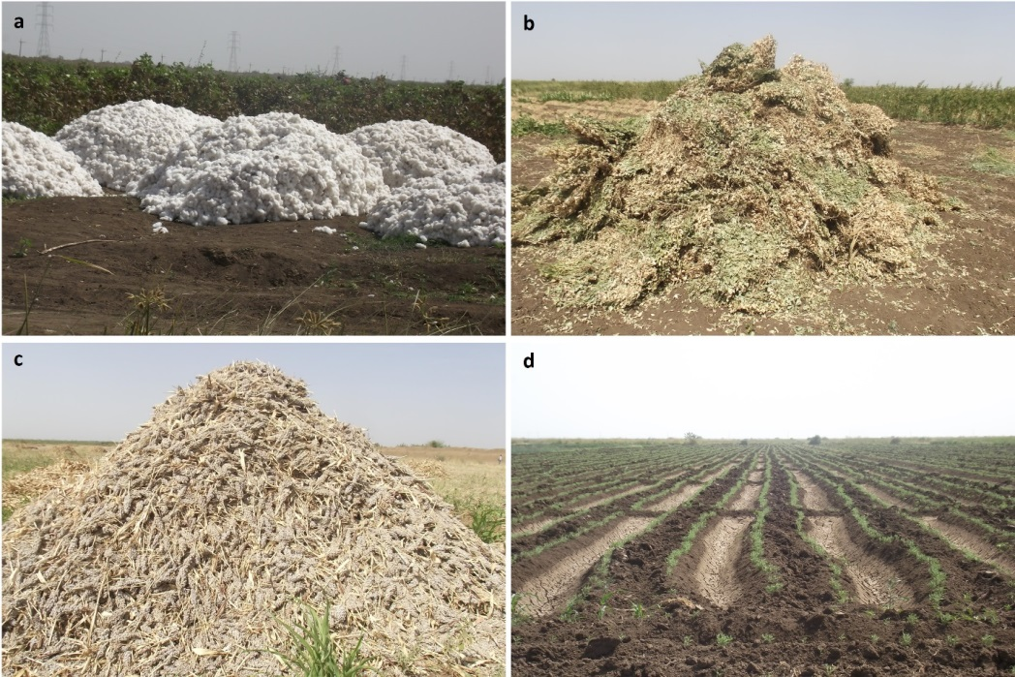

**Figure S3.** Main crops in the Gezira Scheme: (a) cotton, (b) groundnuts (c) sorghum and (d) chickpea during the 2017/18 season.

**S2 Field survey**

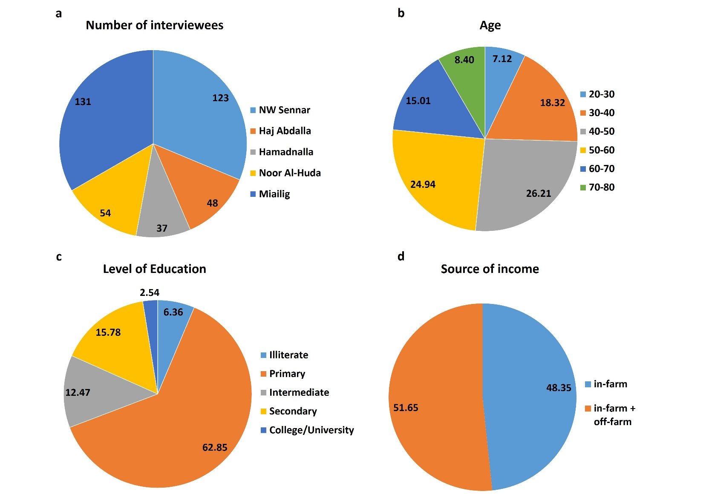

**Figure S4.** Summary of socio-economic characteristics of the respondent farmers: (a) number of interviewees in each block, (b) age, (c) level of education and (c) source of income. Values in (b), (c) and (d) are percentages (%).

**S3 Consistency of iNDVI and iFAPAR datasets**

The data on iNDVI and iFAPAR indicators exhibited significant positive correlation between the two indices (p < 0.01) at the pixel level. While the Spearman’s Rho (ρ) value of correlating multi-year average (2001–2016) of iNDVI and iFAPAR was 0.72, correlating the maximum value composites of iNDVI and iFAPAR revealed expectedly lower ρ of 0.4 (Fig. S5). Using all pixel values for the years 2001–2016, the relative frequency distribution shows similar patterns but differences in the actual relative frequency values between the two indicators (Fig. S6). CV values of the time series of the two indicators was found to be 32% and 30% for iNDVI and iFAPAR, respectively. However, the difference between the two population variances using *T*-test was found to be significant. On the other hand, CVs for all pixel values of maximum iNDVI and maximum iFAPAR were around 14% and 18% for the two datasets, respectively (Fig. S7). The result of *F*-test showed a significant difference between the two population variances. The maximum iNDVI and iFAPAR share some similarities in their spatial distribution (Fig. S8). The differences in the spatial distribution could be attributed mainly to the difference in their spatial resolution. These results indicate that the two indicators are independent. Therefore, one should take the magnitude of productivity gap derived by using them with caution.

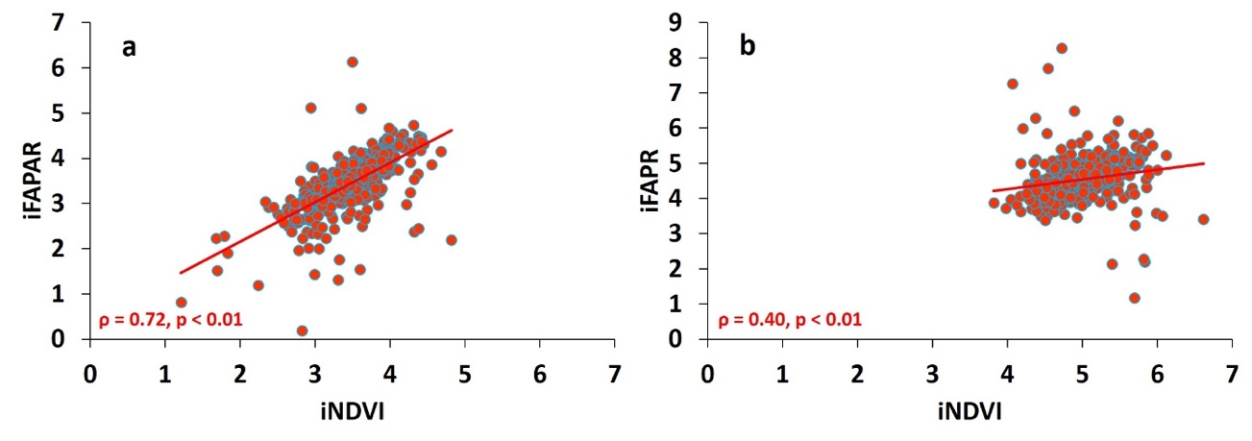

**Figure S5.** Correlation between iNDVI and iFAPAR: (a) multi-year average (2001–2016), and (b) maximum value composite.

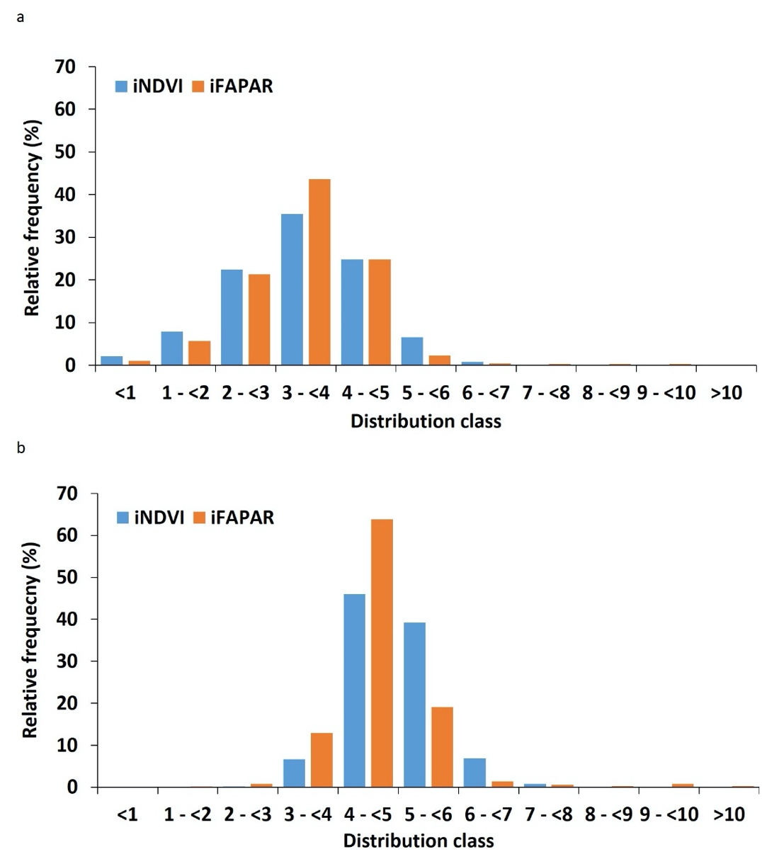  
**Figure S6.** Relative frequency distribution of all pixel values of (a) multi-year average and (b) maxima of iNDVI and iFAPAR over the whole Gezira Scheme for the period 2001–2016.

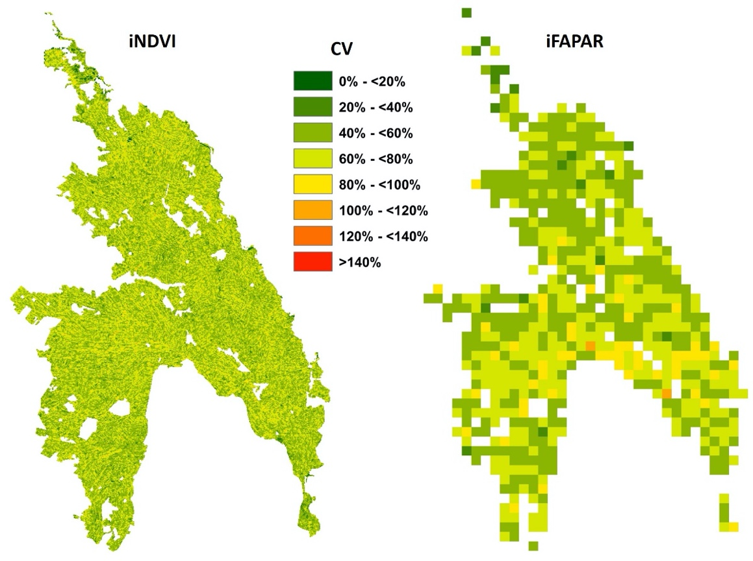

**Figure S7.** Spatial distribution of coefficient of variation (CV) of iNDVI and iFAPAR for the period 2001–2016 over the Gezira Scheme.

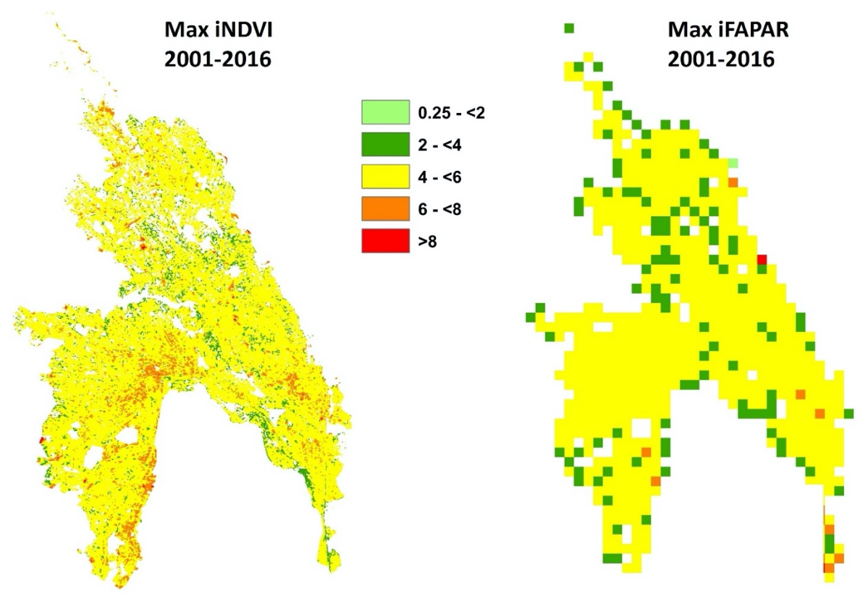

**Figure S8.** Maximum productivity levels created from the iNDVI and iFAPAR datasets for the years 2001–2016 using the maximum value composite (MVC) method.

**S4 Cultivated area and sorghum yield in Gezira Scheme during 2015 and 2016**

Taking the years 2015 and 2016 as examples of low and high productivity levels, respectively, it could be noted that while there are no large differences in the cultivated areas of sorghum, large differences in the average yield were detected for the two years (Fig. S9).

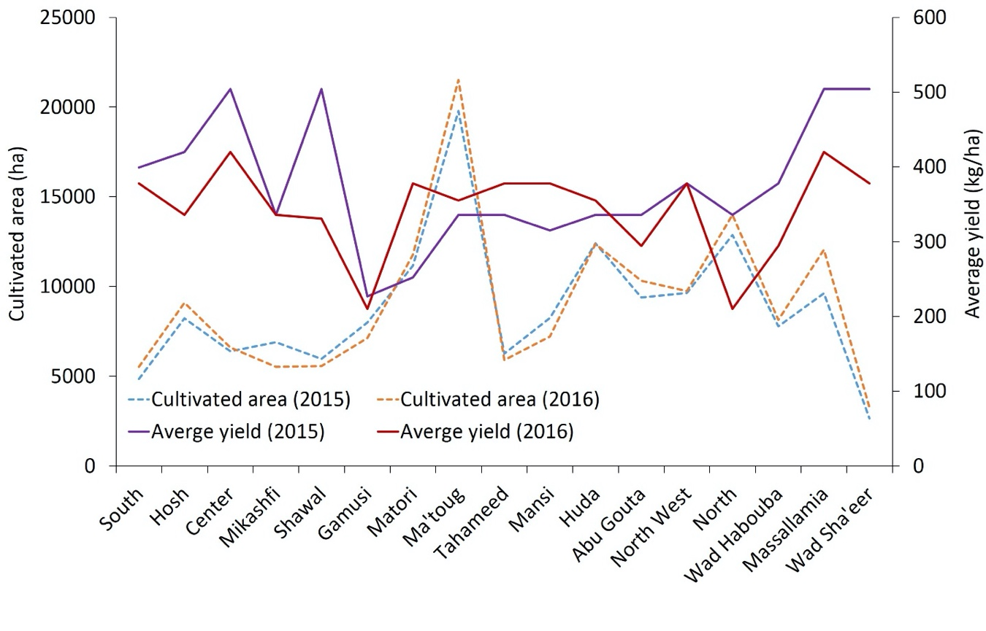**Figure S9.** Comparison between the cultivated area and average yield of sorghum for years 2015 and 2016 at the level of administrative groups.

**S5 Inter-correlation between the field survey data**



**Figure S10.** Matrix of spearman’s Rho (ρ) values shows the degree of correlation between the main average sorghum yield, socio-economic factors and field practices of farmers.

**References**

Elshaikh, A., et al., 2018. Impacts of legal and institutional changes on irrigation management performance: A case of the Gezira Irrigation Scheme, Sudan. Water, 10 (11), 1579.

Ertsen, M., 2016. A Matter of relationships-actor-networks of colonial rule in the Gezira Irrigation System, Sudan. Water Alternatives, 9 (2), 203–221.

Ishag, K., et al., 2007. Farm location and farmers’ performance on the Hamza minor canal. International Journal of Water Resources Development, 7 (1), 2–15.

Mahgoub, F., 2014. Current status of agriculture and future challenges in Sudan. Upsala.

Woldegebriel, E., Smit, H., and Alex, B., 2012. Water distribution changes in Tuweir minor canal, Gezira Scheme. Nile Basin Water Science & Engineering Journal, 5 (2), 11–22.

Al Zayed, I.S. and Elagib, N.A., 2017. Implications of non-sustainable agricultural water policies for the water-food nexus in large-scale irrigation systems: A remote sensing approach. Advances in Water Resources, 110, 408–422.