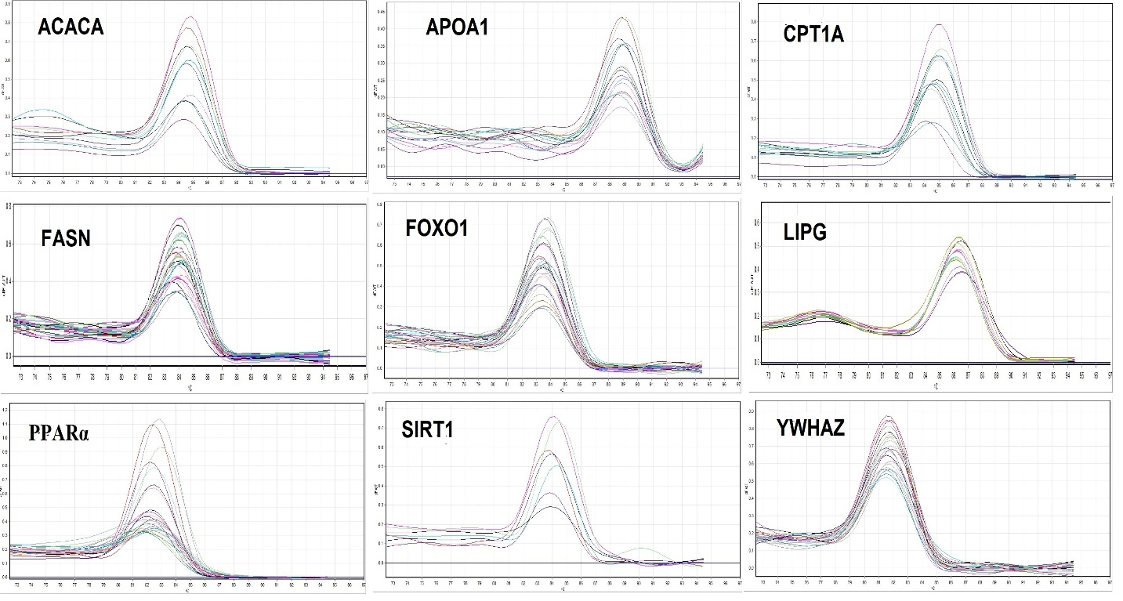

Supplementary Figure 1. Specificity of real time PCR amplification. Melting curves (dissociation curves) of the 8 target genes and 1 reference gene (YWHAZ) amplicons after the real time PCR reactions, all showing one peak. X-axis (horisonatal): temperature (℃); Y-axis (vertical): negative derivative of fluorescence over temperature (-dF/dT).

