Supplementary
fMRI acquisition and preprocessing
MR images were acquired on a 7T MR scanner (Siemens Healthcare, Erlangen, Germany) using a 32-channel head array coil. Participants were instructed to keep still with their eyes closed and not fall asleep. EPIs were distortion corrected using an improved point-spread function (PSF) mapping method (Chung et al., 2011; In & Speck, 2012). However, this PSF method requires a long acquisition time and is therefore vulnerable to the potential motion of participants during scanning. Thus, 7 subjects with sufficient BDNF values were excluded based on obvious artifacts in the EPI scan rated by two independent rater’s opinions.

RS-fMRI data was preprocessed following the pipeline developed in the 1000 Functional Connectomes Project with a few modifications. In short, the preprocessing included brain extraction, slice timing, realignment, nuisance regression, normalization, temporal filtering with a bandpass filter (0.01 - 0.1 Hz), spatial smoothing (6 mm FWHM). Increased motion was detected via a framewise displacement (FD) threshold of 0.2 (92). Based on the FD values, an individual confound matrix was created to remove large motion using a multiple linear regression for each subject. The motion parameters (3 translations, 3 rotations), mean signals of white matter and cerebrospinal fluid (CSF) were added to this regression. No global signal regression was performed.
Supplementary tables

Suppl. Table 1 Demography of study groups. There were no statistical differences between the groups. Age and BMI is represented as mean ± standard deviation

 | Ketamine  (N = 40) | Placebo  (N = 40) | Mann- Whitney U-test or Pearson Chi² interaction test
Age | 25.95 ± 5.65 | 25.83 ± 4.98 | U=794.0, p=0.95
Gender | 16 females | 17 females | Chi²=0.05, p=0.82
Body mass index (BMI) | 23.81± 3.07 | 23.76± 2.94 | U=793.5, p=0.95

Suppl. Table 2: Sample sizes with available BDNF levels for each time point
Age is represented as mean ± standard deviation; BDNF genotype is divided in Wt= wild type (Val66Val) and polymorphism (Val66Met), no subjects with Met66Met.

 | Sample size | Sex  female/male | Age  mean ± SD | BDNF genotype Wt/polymorph | Treatment  Ketamine/Placebo
BDNF baseline | 69 | 27/42 | 25.09±4.46 | 51/18 | 37/32
BDNF 2h | 69 | 26/43 | 25.42±4.69 | 51/18 | 36/33
BDNF 24h | 69 | 25/44 | 25.41±4.66 | 51/18 | 35/34
BDNF 2h-baseline | 65 | 25/40 | 25.20±4.57 | 49/16 | 35/30
BDNF 24h-baseline | 65 | 24/41 | 25.18±4.53 | 49/16 | 34/31
RSFC-BDNF Regression | 53 | 21/32 | 24.42±2.94 | 39/14 | 26/27

Suppl. Table 3 Link between RSFC and plasma BDNF changes at an acute and 24h time point
Association of extracted mean resting-state functional connectivity (RSFC) values derived from Figure 4A/Table1 (p<0.05 FWE) and plasma BDNF change after 24h divided by subjects receiving ketamine or placebo infusion. Abbreviations: PFC, prefrontal cortex; pgACC, perigenual anterior cingulate cortex.

 | Infusion | Cluster | Statistics
24h | Ketamine | Medial PFC | r= -0.62, n=26, p<0.001
 |  | Posterior cingulate cortex | r= -0.67, n=26, p<0.001
 |  | Inferior temporal gyrus, left | r= -0.48, n=26, p=0.014
 |  | Cerebellum, left | r= -0.53, n=26, p=0.005
 |  | Superior temporal gyrus, right | r= -0.47, n=26, p=0.015
 | Placebo | Medial PFC | r= 0.05, n=27, p=0.81
 |  | Posterior cingulate cortex | r= 0.21, n=27, p=0.30
 |  | Inferior temporal gyrus, left | r= 0.46, n=27, p=0.017
 |  | Cerebellum, left | r= 0.16, n=27, p=0.43
 |  | Superior temporal gyrus, right | r= 0.31, n=27, p=0.11
100min | Ketamine | Medial PFC/pgACC | r= -0.60, n=26, p=0.001
 |  | Posterior cingulate cortex | r= -0.70, n=26, p<0.001
 |  | Lateral PFC | r= -0.55, n=26, p=0.003
 | Placebo | Medial PFC/pgACC | r= 0.05, n=27, p=0.79
 |  | Posterior cingulate cortex | r= 0.22, n=27, p=0.28
 |  | Lateral PFC | r= 0.14, n=27, p=0.50

Suppl. Table 4 Statistics for within-subgroups RSFC changes at 24h dependent on plasma BDNF changes
Within-subgroup t-tests for resting-state functional connectivity (RSFC) changes at 24h divided by plasma BDNF increase (↑)/ decrease (↓) at 24h. Numbers marked in bold depict p-values that survive Bonferroni correction for a p<0.05, corrected for 20 comparisons (5 regions x 4 subgroups) which results in an effective p-value threshold of p<0.0025. Abbreviations: PFC, prefrontal cortex; S.E.M., standard error of mean.

Subgroup | Cluster | Delta RSFC mean±SEM |  | Statistics
Ketamine-BDNF increase (↑) | Medial PFC |  | -0.088 ± 0.018 | t=-4.83, df=15, p<0.001
 | Posterior cingulate cortex |  | -0.092 ± 0.021 | t=-4.43, df=15, p<0.001
 | Inferior temporal gyrus, left |  | -0.028 ± 0.006 | t=-5.03, df=15, p<0.001
 | Cerebellum, left |  | -0.049 ± 0.015 | t=-3.30, df=15, p=0.005
 | Superior temporal gyrus, right |  | -0.070 ± 0.011 | t=-6.15, df=15, p<0.001
Ketamine-BDNF decrease (↓) | Medial PFC |  | 0.009 ± 0.011 | t=0.77, df=9, p=0.46
 | Posterior cingulate cortex |  | 0.025 ± 0.023 | t=1.08, df=9, p=0.31
 | Inferior temporal gyrus, left |  | -0.002 ± 0.008 | t=-0.22, df=9, p=0.83
 | Cerebellum, left |  | 0.006 ± 0.016 | t=0.34, df=9, p=0.74
 | Superior temporal gyrus, right |  | 0.005 ± 0.031 | t=0.17, df=9, p=0.87
Placebo- BDNF increase (↑) | Medial PFC |  | -0.006 ± 0.030 | t=-0.21, df=9, p=0.84
 | Posterior cingulate cortex |  | 0.018 ± 0.026 | t=0.69, df=9, p=0.51
 | Inferior temporal gyrus, left |  | 0.014 ± 0.008 | t=1.83, df=9, p=0.10
 | Cerebellum, left |  | 0.020 ± 0.025 | t=0.81, df=9, p=0.44
 | Superior temporal gyrus, right |  | 0.016 ± 0.029 | t=0.54, df=9, p=0.60
Placebo-BDNF decrease (↓) | Medial PFC |  | -0.026 ± 0.017 | t=-1.56, df=16, p=0.14
 | Posterior cingulate cortex |  | -0.028 ± 0.026 | t=-1.10, df=16, p=0.29
 | Inferior temporal gyrus, left |  | -0.014 ± 0.007 | t=-2.07, df=16, p=0.06
 | Cerebellum, left |  | -0.005 ± 0.013 | t=-0.38, df=16, p=0.71
 | Superior temporal gyrus, right |  | -0.023 ± 0.023 | t=-0.97, df=16, p=0.35

Suppl Table 5 Statistics for between-subgroups RSFC changes at 24h dependent on plasma BDNF changes
Interaction analyses for resting-state functional connectivity (RSFC) changes at 24h compared to baseline between ketamine subgroup with BDNF increase (Ketamine-BDNF increase ↑) vs. other three subgroups (Ketamine-BDNF decrease ↓; Placebo-BDNF increase ↑; Placebo-BDNF decrease ↓; 2x2 ANOVA). Numbers marked in bold depict p-values that survive Bonferroni correction for a p<0.05, corrected for 15 comparisons (5 regions x 3 between-subgroup combinations) which results in an effective p-value threshold of p<0.0033. Abbreviations: PFC, prefrontal cortex.

1st group | 2nd group | Cluster | Statistics
Ketamine-BDNF increase (↑) | Ketamine-BDNF decrease (↓) | Medial PFC | t= 3.89, df=24, p=0.001
 |  | Posterior cingulate cortex | t= 3.64, df=24, p=0.001
 |  | Inferior temporal gyrus, left | t= 2.77, df=24, p=0.011
 |  | Cerebellum, left | t= 2.39, df=24, p=0.025
 |  | Superior temporal gyrus, right | t= 2.68, df=24, p=0.013
 | Placebo- BDNF increase (↑) | Medial PFC | t= 2.48, df=24, p=0.021
 |  | Posterior cingulate cortex | t= 3.31, df=24, p=0.003
 |  | Inferior temporal gyrus, left | t= 4.52, df=24, p<0.001
 |  | Cerebellum, left | t= 2.54, df=24, p=0.018
 |  | Superior temporal gyrus, right | t= 3.19, df=24, p=0.004
 | Placebo-BDNF decrease (↓) | Medial PFC | t= 2.49, df=31, p=0.018
 |  | Posterior cingulate cortex | t= 1.90, df=31, p=0.07
 |  | Inferior temporal gyrus, left | t= 1.69, df=31, p=0.10
 |  | Cerebellum, left | t= 2.24, df=31, p=0.03
 |  | Superior temporal gyrus, right | t= 1.78, df=31, p=0.08

Supplementary figures
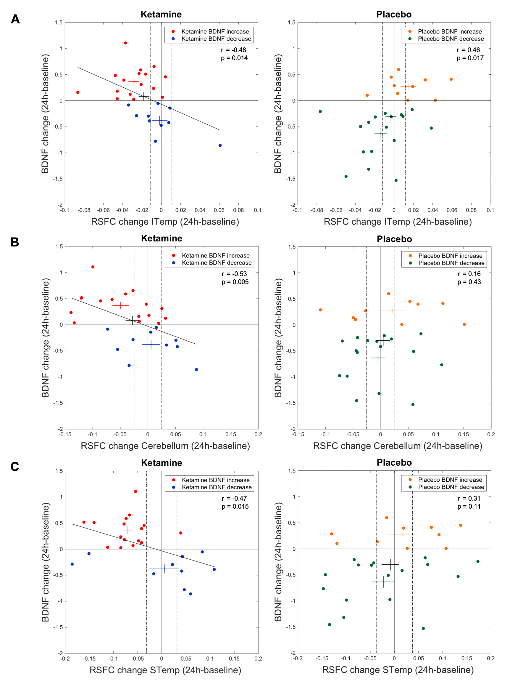Supplementary Figure 1: Correlations between plasma BDNF and RSFC changes after 24h divided by subgroups
Depictured are the correlations between relative dorsomedial prefrontal cortex (dmPFC) seeded RSFC changes to (A) left inferior temporal gyrus (ITemp), (B) cerebellum and (C) right superior temporal gyrus (STemp) and the relative BDNF changes 24h after ketamine (left side) and placebo (right side) infusion. Red and orange markers represent subjects that showed an increase in BDNF levels after ketamine and placebo infusion, respectively. Blue and green markers represent subjects that showed a decrease in BDNF levels after ketamine and placebo infusion, respectively. Crosses represent the mean and the standard error of mean (SEM) of the subgroups (in color) and whole group (in black, n=53). Dotted vertical lines represent the borders when RSFC changes become significance for the whole group.

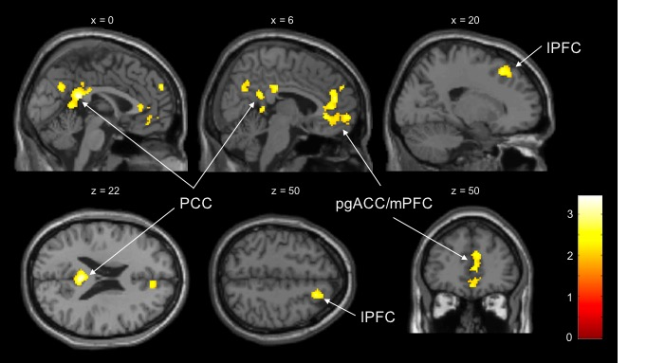
Suppl Figure 2: Whole-brain interaction regression analysis for link between delayed BDNF change at 24h and acute RSFC changes
Participants receiving ketamine or placebo showed a significantly distinct association between plasma BDNF change after 24h and dorsomedial prefrontal cortex (dmPFC) seeded Resting-State Functional Connectivity (RSFC) changes to posterior cingulate cortex (PCC), medial prefrontal cortex/ perigenual anterior cingulate cortex (mPFC/pgACC) and lateral prefrontal cortex (IPFC) at 100min (whole-brain level, p<0.05 FWE, n=53, controlled for sex, BDNF genotype and time of the day; x and z represent MNI coordinates).

Supplementary references

Chung J-Y, In M-H, Oh S-H, Zaitsev M, Speck O, Cho Z-H (2011). An improved PSF mapping method for EPI distortion correction in human brain at ultra high field (7T). Magn Reson Mater Phys Biol Med 24: 179–190.
In, M. H., & Speck, O. (2012). Highly accelerated PSF-mapping for EPI distortion correction with improved fidelity. MAGMA, 25(3), 183-192.
Power, J. D., Barnes, K. A., Snyder, A. Z., Schlaggar, B. L., & Petersen, S. E. (2012). Spurious but systematic correlations in functional connectivity MRI networks arise from subject motion. Neuroimage, 59(3), 2142-2154.

