Supporting information for

Matteuinterins A-C, three new glucosides from the rhizomes of Matteuccia intermedia
Xue Liª, Li-Ting Niuª, Wei-Tong Mengª, Ling-Juan Zhuª, Xue Zhang^{a,} * and Xin-Sheng Yao^{a, b,} *

ªSchool of Traditional Chinese Materia Medica, Key Laboratory of Structure-Based Drug Design & Discovery, Ministry of Education, Shenyang Pharmaceutical University, Shenyang 110016, China; ^{b}Institute of Traditional Chinese Medicine & Natural Products, College of Pharmacy, Jinan University, Guangzhou 510632, China

Contents
Figure S1. ¹H NMR spectrum of matteuinterin A (1) in CD₃OD
Figure S2. ¹³C NMR spectrum of matteuinterin A (1) in CD₃OD
Figure S3. HSQC spectrum of matteuinterin A (1) in CD₃OD
Figure S4. HMBC spectrum of matteuinterin A (1) in CD₃OD
Figure S5. COSY spectrum of matteuinterin A (1) in CD₃OD
Figure S6. NOESY spectrum of matteuinterin A (1) in CD₃OD
Figure S7. DEPT spectrum of matteuinterin A (1) in CD₃OD
Figure S8. HRESIMS spectrum of matteuinterin A (1)
Figure S9. UV spectrum of matteuinterin A (1)
Figure S10. IR spectrum of matteuinterin A (1)
Figure S11. ¹H NMR spectrum of 1a in CD₃OD
Figure S12. ¹³C NMR spectrum of 1a in CD₃OD
Figure S13. HSQC spectrum of 1a in CD₃OD
Figure S14. HMBC spectrum of 1a in CD₃OD
Figure S15. HRESIMS spectrum of 1a
Figure S16. UV spectrum of 1a
Figure S17. ¹H NMR spectrum of matteuinterin B (2) in CD₃OD
Figure S18. ¹³C NMR spectrum of matteuinterin B (2) in CD₃OD
Figure S19. HSQC spectrum of matteuinterin B (2) in CD₃OD
Figure S20. HMBC spectrum of matteuinterin B (2) in CD₃OD
Figure S21. COSY spectrum of matteuinterin B (2) in CD₃OD
Figure S22. DEPT spectrum of matteuinterin B (2) in CD₃OD
Figure S23. HRESIMS spectrum of matteuinterin B (2)
Figure S24. UV spectrum of matteuinterin B (2)
Figure S25. IR spectrum of matteuinterin B (2)
Figure S26. ¹H NMR spectrum of matteuinterin C (3) in CD₃OD
Figure S27. ¹³C NMR spectrum of matteuinterin C (3) in CD₃OD
Figure S28. HSQC spectrum of matteuinterin C (3) in CD₃OD
Figure S29. HMBC spectrum of matteuinterin C (3) in CD₃OD
Figure S30. COSY spectrum of matteuinterin C (3) in CD₃OD
Figure S31. DEPT spectrum of matteuinterin C (3) in CD₃OD
Figure S32. HRESIMS spectrum of matteuinterin C (3) in CD₃OD
Figure S33. UV spectrum of matteuinterin C (3)
Figure S34. IR spectrum of matteuinterin C (3)
Scheme S1 Determination of the absolute configuration of HMG group in matteuinterins C (2).
Figure S35. ¹H NMR spectra of compound 2C in CD₃Cl.

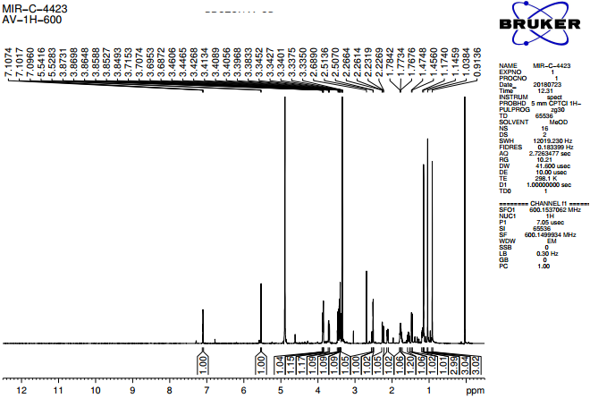
Figure S1. ¹H NMR spectrum of matteuinterin A (1) in CD₃OD
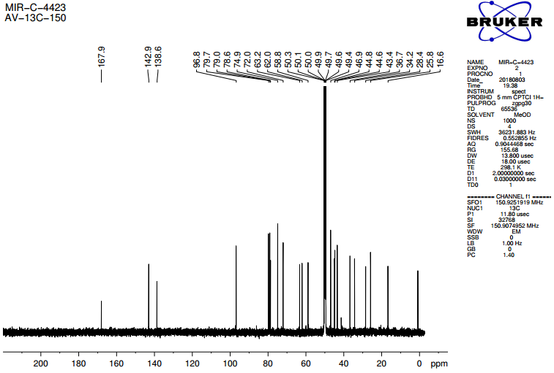
Figure S2. ¹³C NMR spectrum of matteuinterin A (1) in CD₃OD
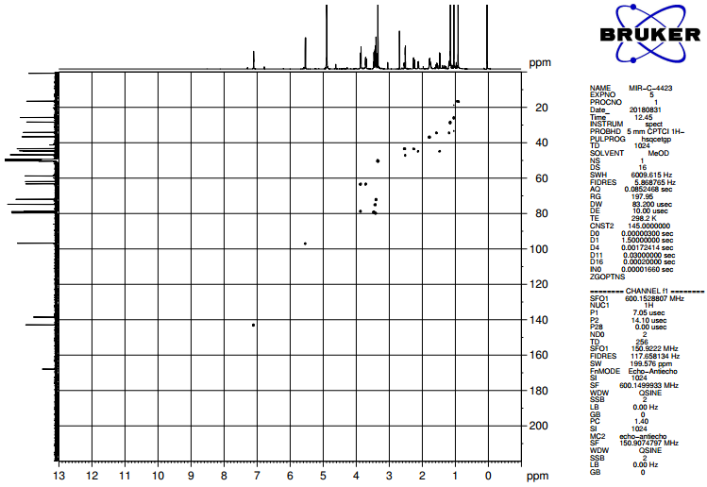
Figure S3. HSQC spectrum of matteuinterin A (1) in CD₃OD
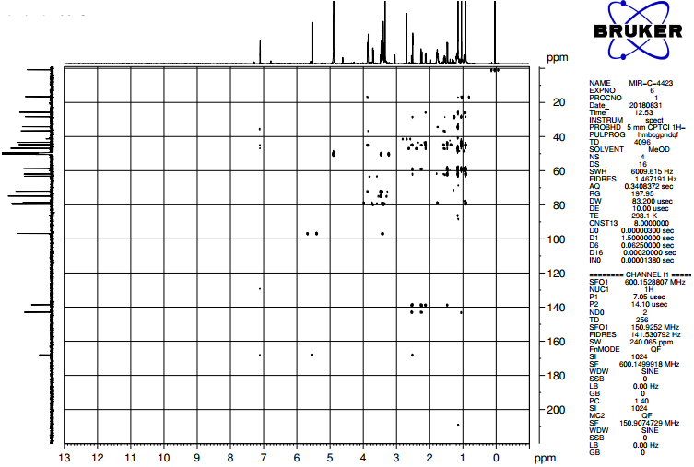
Figure S4. HMBC spectrum of matteuinterin A (1) in CD₃OD
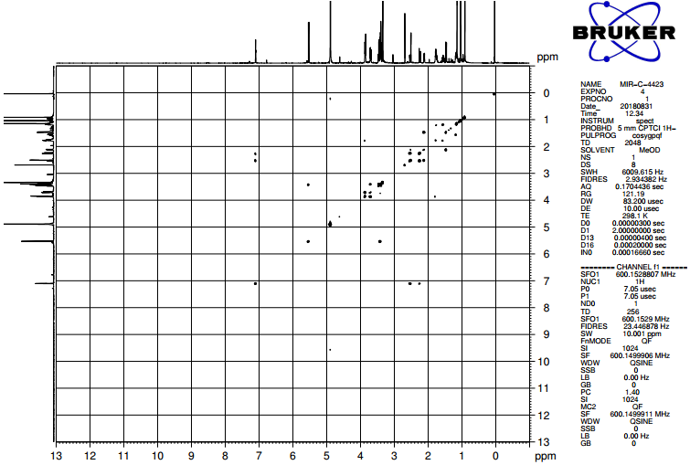
Figure S5. COSY spectrum of matteuinterin A (1) in CD₃OD
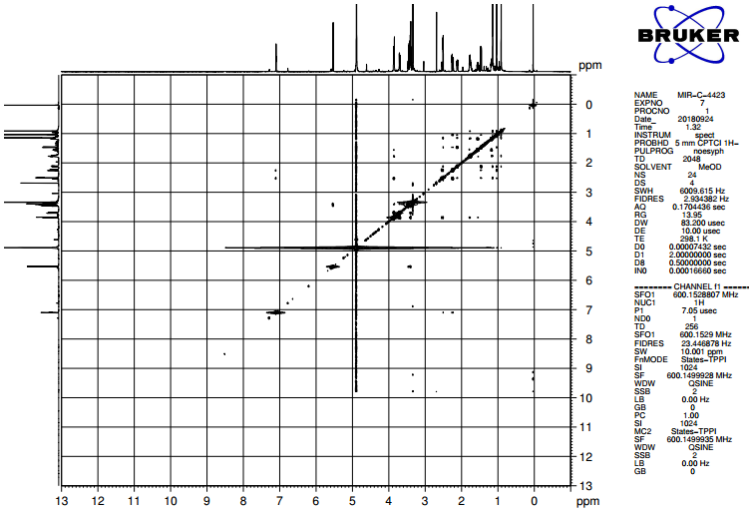
Figure S6. NOESY spectrum of matteuinterin A (1) in CD₃OD
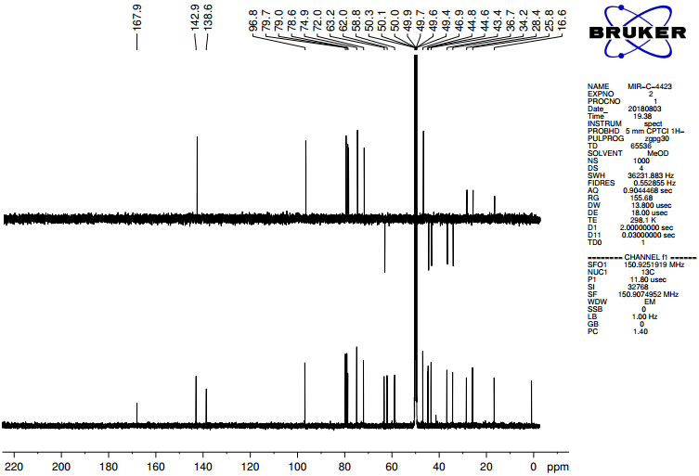
Figure S7. DEPT spectrum of matteuinterin A (1) in CD₃OD
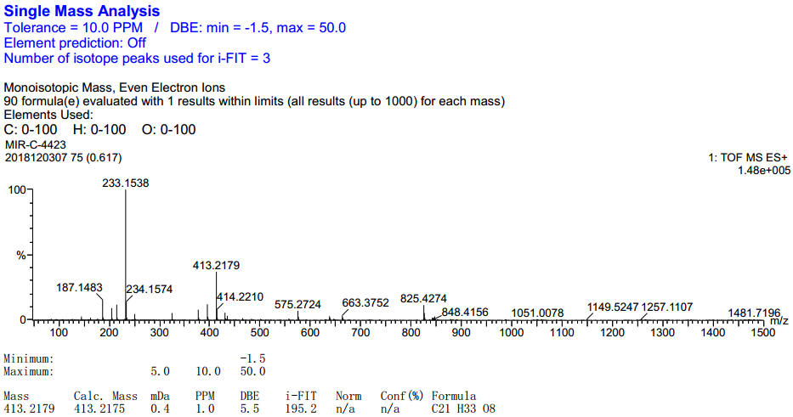
Figure S8. HRESIMS spectrum of matteuinterin A (1)

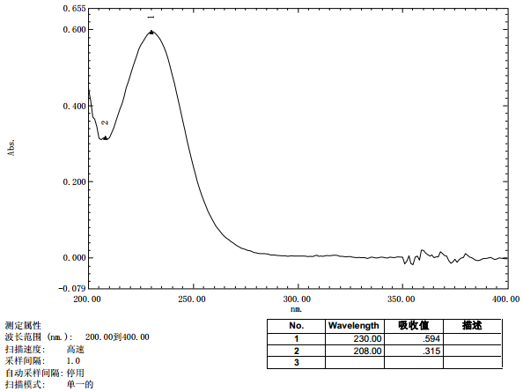
Figure S9. UV spectrum of matteuinterin A (1)
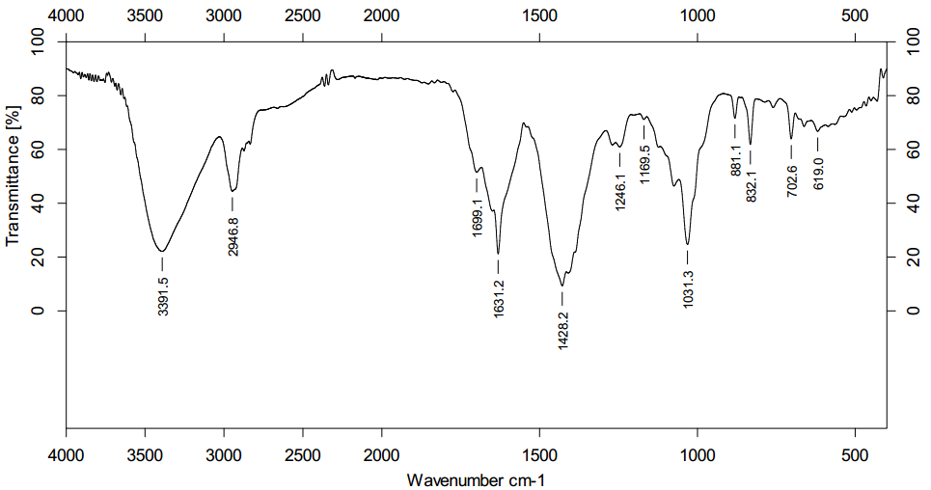
Figure S10. IR spectrum of matteuinterin A (1)
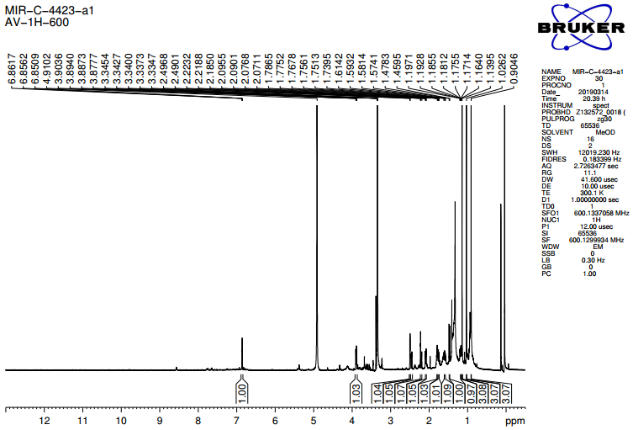
Figure S11. ¹H NMR spectrum of 1a in CD₃OD
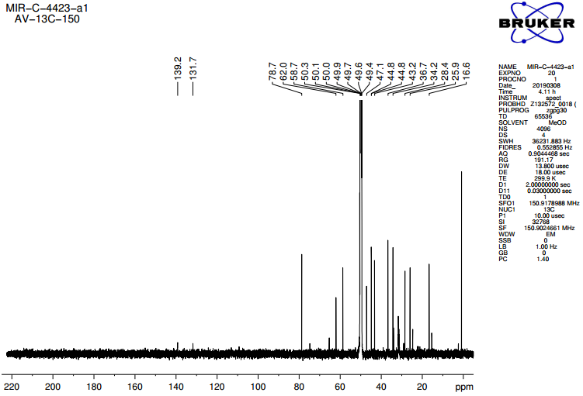
Figure S12. ¹³C NMR spectrum of 1a in CD₃OD
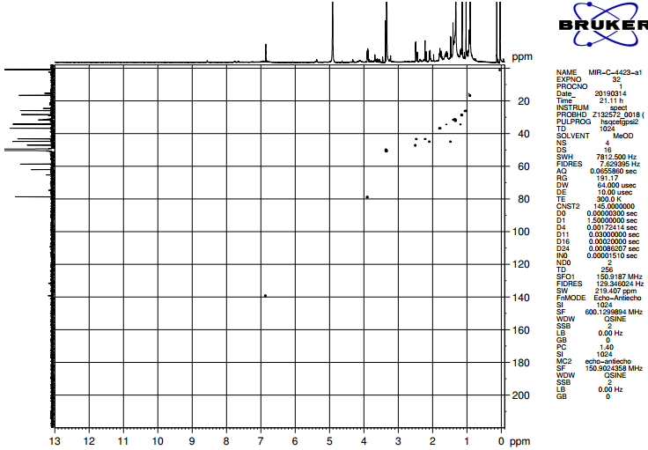
Figure S13. HSQC spectrum of 1a in CD₃OD
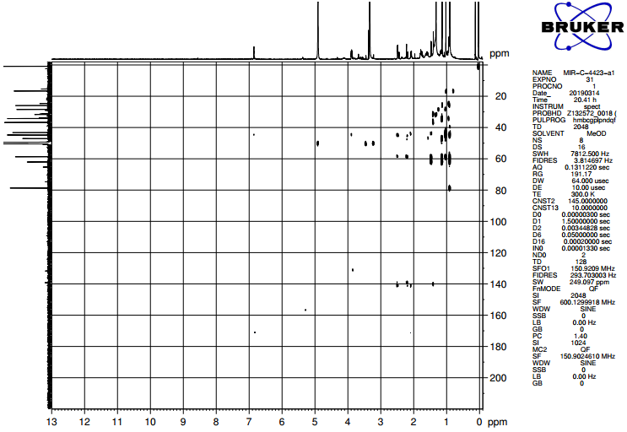
Figure S14. HMBC spectrum of 1a in CD₃OD
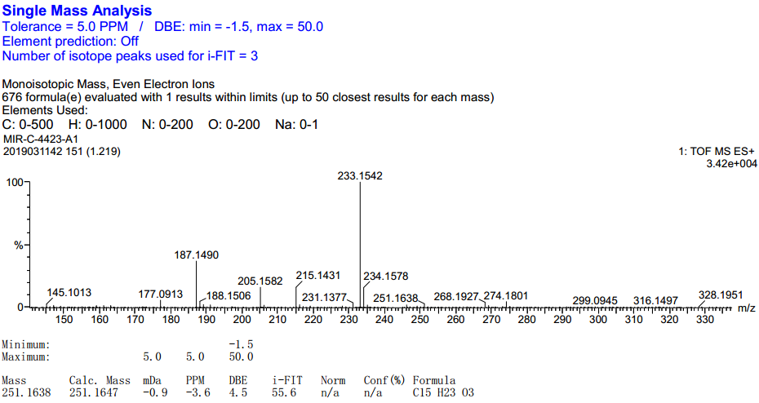
Figure S15. HRESIMS spectrum of 1a
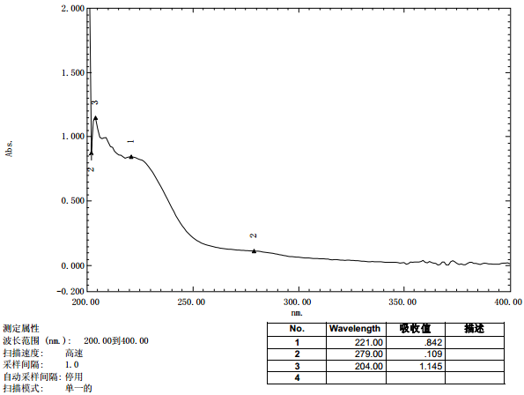
Figure S16. UV spectrum of 1a

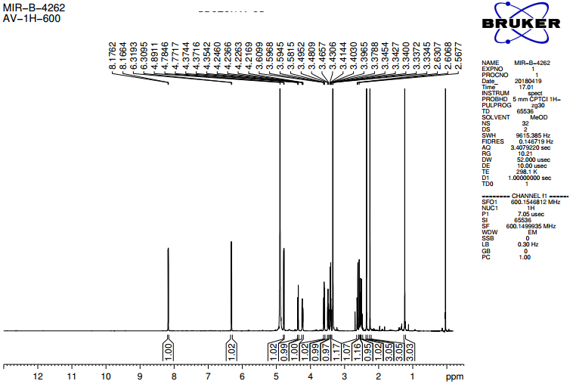
Figure S17. ¹H NMR spectrum of matteuinterin B (2) in CD₃OD
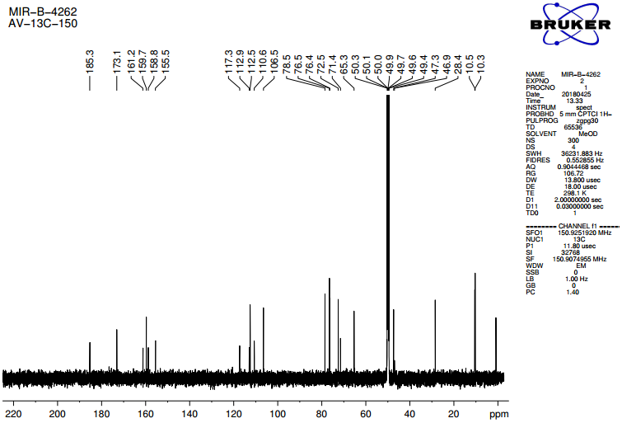
Figure S18. ¹³C NMR spectrum of matteuinterin B (2) in CD₃OD

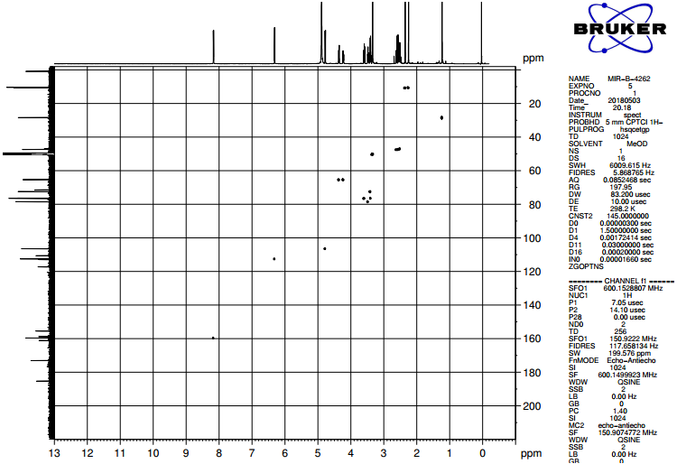Figure S19. HSQC spectrum of matteuinterin B (2) in CD₃OD
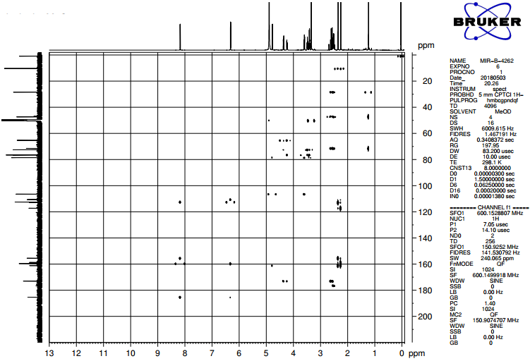Figure S20. HMBC spectrum of matteuinterin B (2) in CD₃OD

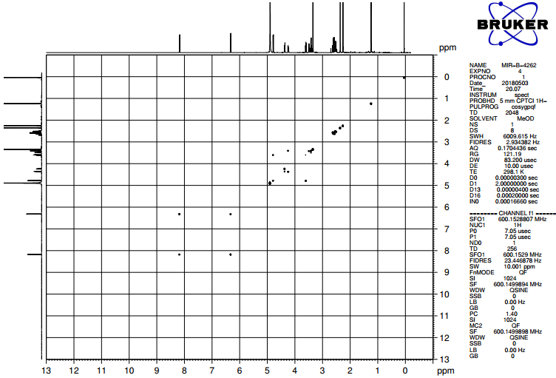Figure S21. COSY spectrum of matteuinterin B (2) in CD₃OD
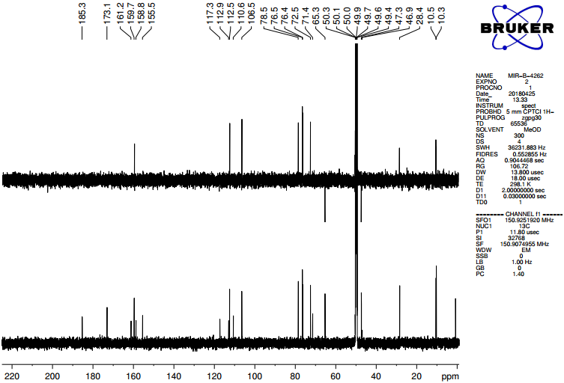Figure S22. DEPT spectrum of matteuinterin B (2) in CD₃OD
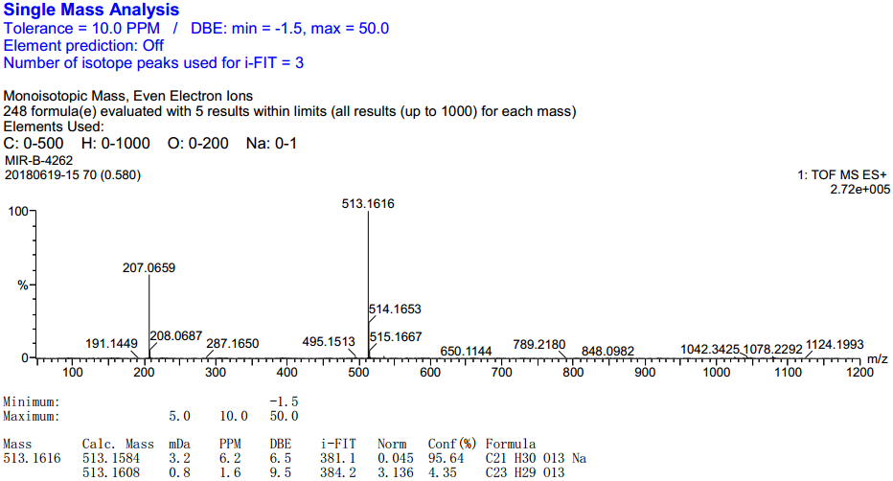Figure S23. HRESIMS spectrum of matteuinterin B (2)
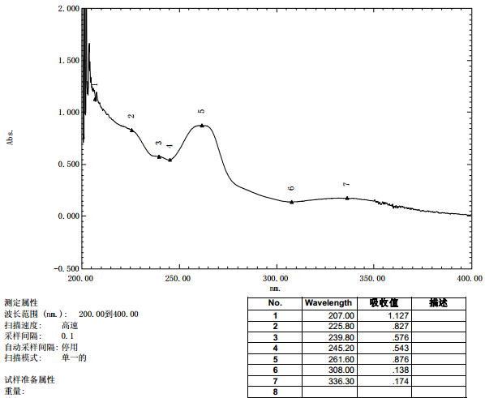Figure S24. UV spectrum of matteuinterin B (2)

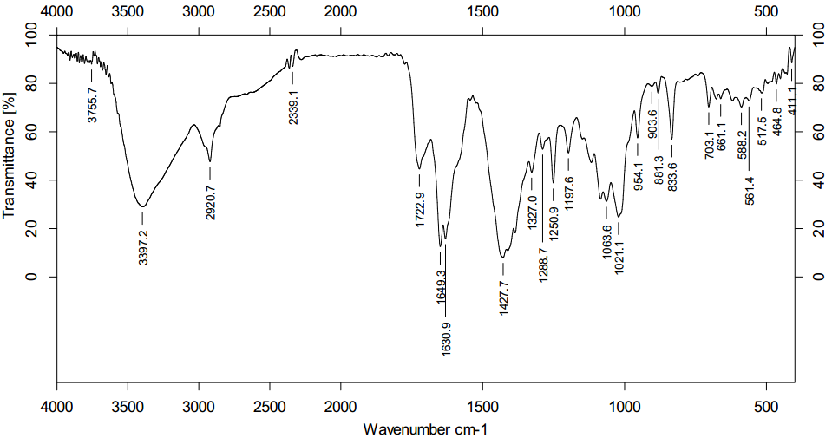Figure S25. IR spectrum of matteuinterin B (2)
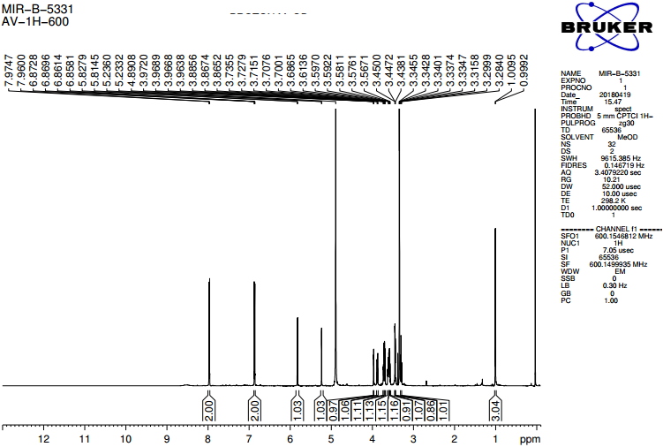Figure S26. ¹H NMR spectrum of matteuinterin C (3) in CD₃OD

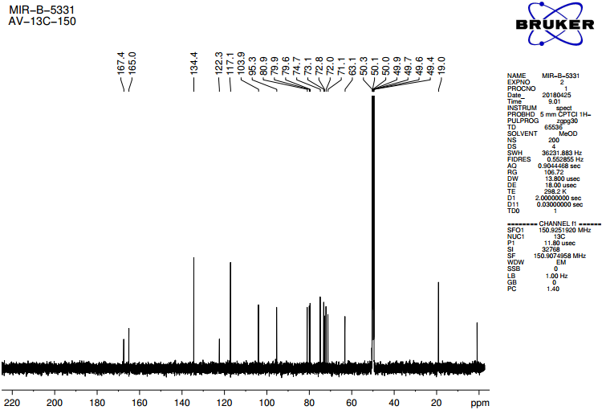Figure S27. ¹³C NMR spectrum of matteuinterin C (3) in CD₃OD
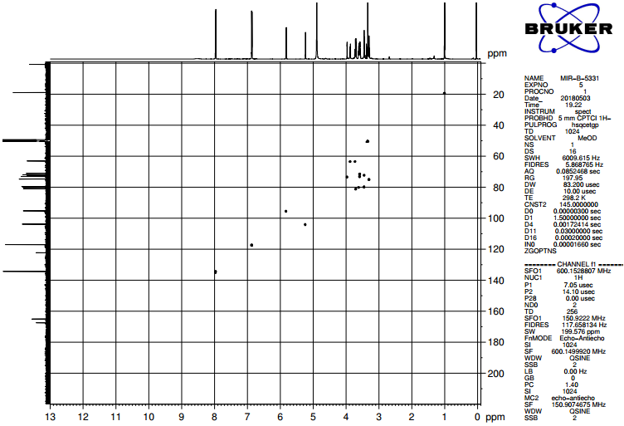Figure S28. HSQC spectrum of matteuinterin C (3) in CD₃OD
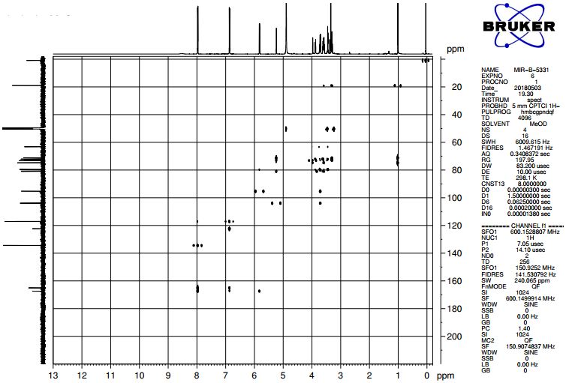Figure S29. HMBC spectrum of matteuinterin C (3) in CD₃OD
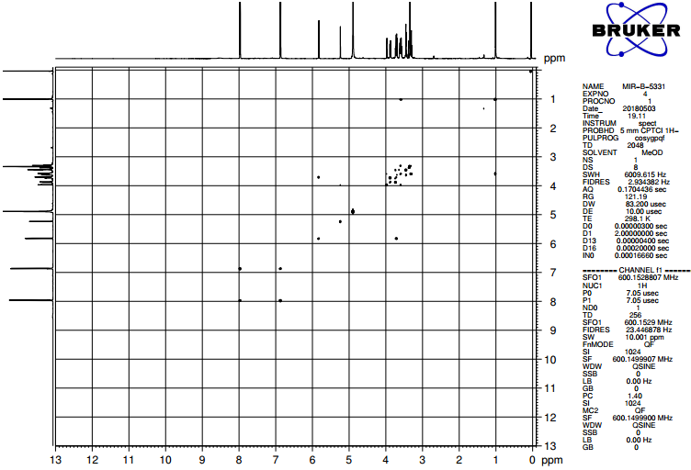Figure S30. COSY spectrum of matteuinterin C (3) in CD₃OD

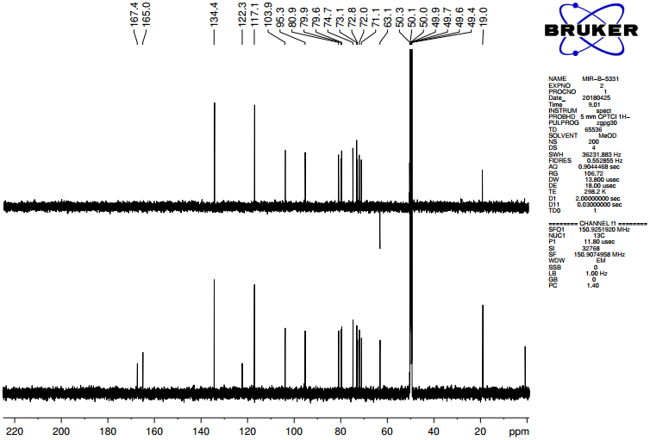Figure S31. DEPT spectrum of matteuinterin C (3) in CD₃OD
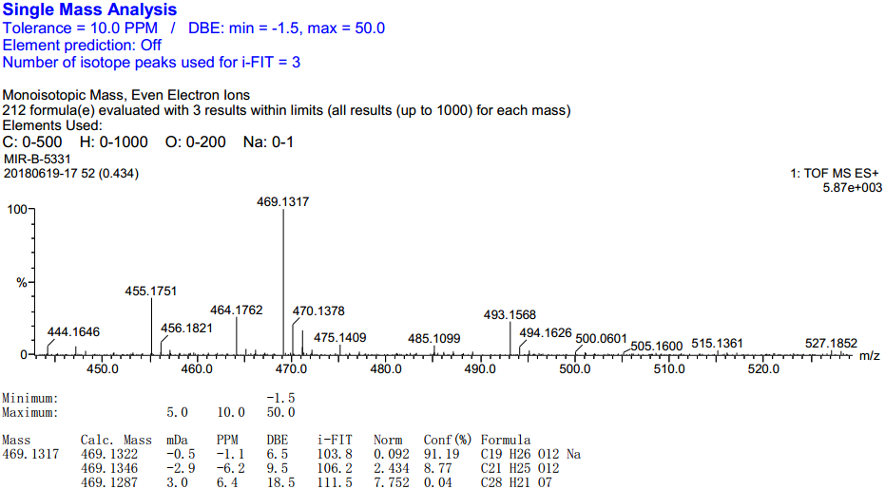
Figure S32. HRESIMS spectrum of matteuinterin C (3)
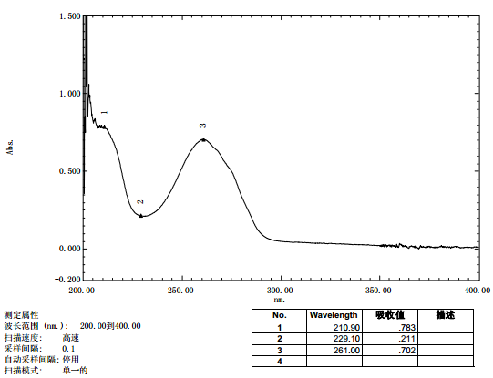
Figure S33. UV spectrum of matteuinterin C (3)
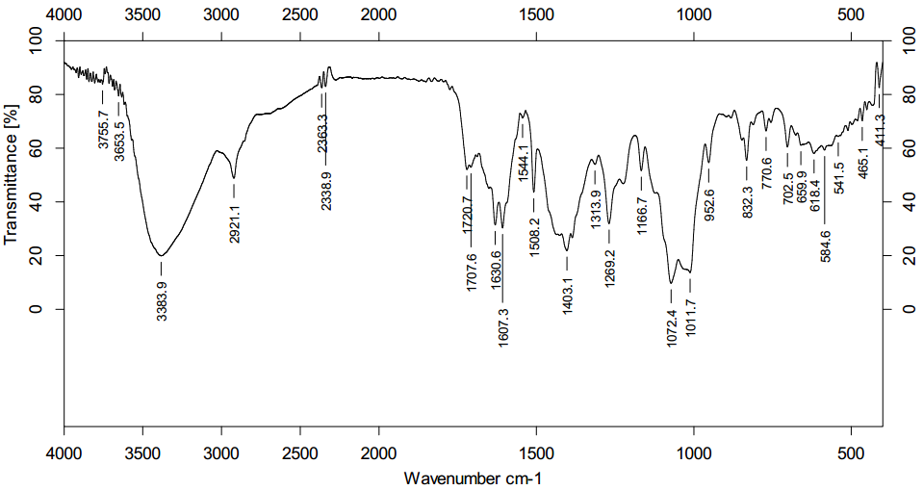
Figure S34. IR spectrum of matteuinterin C (3)
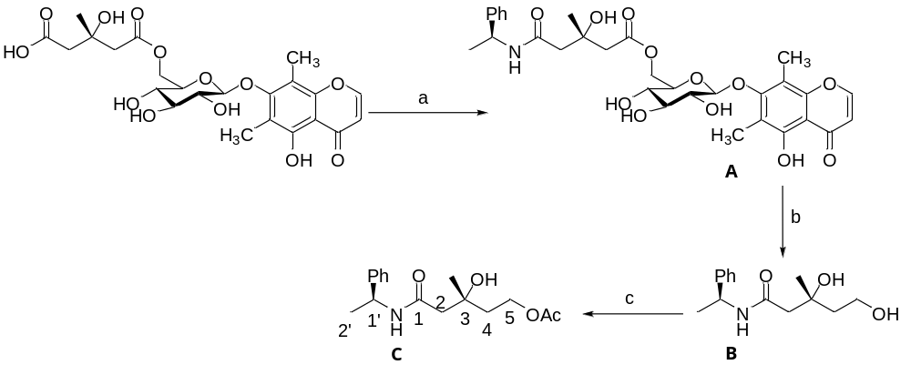Scheme S1 Determination of the absolute configuration of HMG group in matteuinterins C (2). Reagents and conditions: (a) (S)-1-phenylethylamine, PyBOP, HOBt, Et₃N, DMF; (b) LiBH₄, THF; (c) Ac₂O, pyridine.
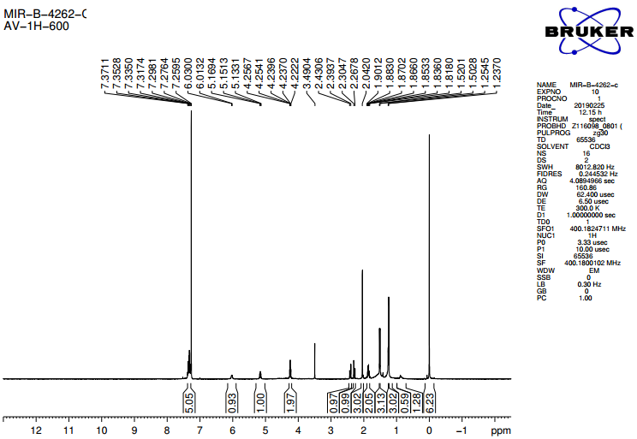
Figure S35. ¹H NMR spectra of compound 2C in CD₃Cl.

