Supporting Information

A novel hydroxy-bisphosphonic acid prodrug as a candidate for the delivery of ibuprofen to bone

Sameh Aoun *,
Haythem Bennour.

Université Libre de Tunis, Organic Chemistry Department, 30 Bis avenue Kheireddine Pacha, 1002 Tunis, Tunisia.
E-mail : sameh.aoun@gmail.com

Table of Contents

Synthesis of compounds 2-5 p 2 - 3
References p 3
¹H and ¹³C NMR spectra of compound 2 p 4
¹H and ¹³C NMR spectra of compound 3 p 5
¹H and ¹³C NMR spectra of compound 4 p 6
¹H and ¹³C NMR spectra of compound 5 p 7
¹H and ¹³C NMR spectra of compound 5’ p 8
¹H, ¹³C and ³¹P NMR spectra of compound 1 p 9 - 10

3-Hydroxybenzyl alcohol (2) ¹
To a solution of 3-hydroxybenzaldehyde (2 g, 16.38 mmol, 1 eq) in EtOH (10 mL), NaBH₄ (310 mg, 8,19 mmol, 0.5 eq) was carefully introduced at 0°C under argon. The mixture was stirred at 0°C for 1 h. Then, A 2 N solution of HCl was added gradually until pH= 3. After stirring for 10 min, a saturated aqueous solution of NaHCO₃ was added until pH= 7. The mixture was dried over anhydrous Na₂SO₄ and subjected to vacuum filtration. Concentration under reduced pressure afforded compound 2 (2.03 g, 100%) as a viscous brown oil which crystallized gradually to give brown crystals.
R_{f} = 0.27 (DCM/MeOH 95:5).
¹H NMR (MeOD, 300 MHz): δ (ppm) 7.17-7.11 (t, J = 7.8 Hz, 1H), 6.82-6.80 (m, 2H), 6.72-6.68 (dd, J = 7.3, 1.9 Hz, 1H), 4.53 (s, 2H).
¹³C NMR (MeOD, 75 MHz,): δ (ppm) 158.3, 144.1, 130.3, 119.1, 115.1, 114.7, 65.1.
MS (CI): m/z = 142 [M+NH₄]⁺.

tert-Butyl 2-(3-(hydroxymethyl)phenoxy)acetate (3) ²
To a solution of 2 (1 g, 8.13 mmol, 1 eq) in DMF (17 mL), K₂CO₃ (1.35 g, 9.76 mmol, 1.2 eq) was added at room temperature. Then, the mixture was stirred for 45 min before introducing tert-Butyl bromoacetate (1.44 mL, 9.76 mmol, 1.2 eq) and stirring in the same conditions for 36 h. After dilution with ethyl acetate, the organic phase was washed several times with brine, dried over anhydrous Na₂SO₄, filtered and concentrated under reduced pressure. Column chromatography on silica gel (DCM to DCM/MeOH 95:5) gave 3 (1.76 g, 91%) as a white powder.
R_{f} = 0.61 (DCM/MeOH 95:5).
¹H NMR (CDCl₃, 300 MHz): δ (ppm) 7.27-7.22 (t, J = 7.9 Hz, 1H), 6.95-6.89 (m, 2H), 6.82-6.78 (dd, J = 8.2, 2.4 Hz, 1H), 4.61 (s, 2H), 4.49 (s, 2H), 2.32 (s, 1H, OH), 1.48 (s, 9H).
¹³C NMR (CDCl₃, 75 MHz): δ (ppm) 168.2, 158.2, 142.9, 129.6, 120.0, 113.8, 113.0, 82.5, 65.7, 65.0, 28.1 (3C).
IR (cm⁻¹): 3511, 2997, 2981, 1731, 1603, 1246, 1146, 1069.
MS (CI): m/z = 256 [M+NH₄]⁺.
HRMS (MALDI, DHB, PEG 400): m/z [M+Na]⁺ calcd for C₁₃H₁₈O₄: 261.1097, found: 261.1086.

3-(2-tert-Butoxy-2-oxoethoxy)benzyl 2-(4-isobutylphenyl)propanoate (4)
To a solution of DCC (600 mg, 2.91 mmol, 1.2 eq) in dry DCM (20 mL) at room temperature, was added the commercial ibuprofen (500 mg, 2.42 mmol, 1 eq). The mixture became milkwhite. After stirring during 15 min, alcohol 3 (693 mg, 2.91 mmol, 1.2 eq) and DMAP (0.6 mL of a freshly prepared 0.2 M solution of DMAP in dry DCM, 0.12 mmol, 0.05 eq) were successively added. After completion of the reaction (TLC monitoring), the reaction mixture was diluted with DCM. The organic layer was washed with water (3x), dried over anhydrous MgSO₄, filtered and concentrated under reduced pressure. Column chromatography on silica gel (DCM) afforded ester 4 (857 mg, 83%) as a yellowish oil.
R_{f} = 0.59 (DCM).
¹H NMR (CDCl_{3,} 300 MHz): δ (ppm) 7.22-7.17 (m, 3H), 7.10-7.07 (m, 2H), 6.84-6.78 (m, 3H), 5.11-5.01 (AB system, J_{AB} = 15.0 Hz, Δν_{AB} = 16.5 Hz, 2H), 4.45 (s, 2H), 3.78-3.71 (q, J = 7.2 Hz, 1H), 2.45-2.43 (d, J = 7.2 Hz, 2H), 1.93-1.77 (nonpt, J = 6.8 Hz, 1H), 1.51-1.48 (d, J = 7.2 Hz, 3H), 1.48 (s, 9H), 0.90-0.88 (d, J = 6.6 Hz, 6H).
¹³C NMR (CDCl_{3,} 75 MHz): δ (ppm) 174.4, 167.9, 158.0, 140.6, 137.7, 137.6, 129.6, 129.4 (2C), 127.3 (2C), 120.8, 114.3, 113.8, 82.3, 66.0, 65.6, 45.2, 45.1, 30.2, 28.1 (3C), 22.4 (2C), 18.5.
IR (cm⁻¹): 2955, 2868, 1755, 1736, 1454, 1368, 1224, 1153.
MS (CI): m/z = 444 [M+NH₄]⁺.
HRMS (MALDI, DHB, PEG 400): m/z [M+Na]⁺ calcd for C₂₆H₃₄O₅: 449.2298, found: 449.2301.

2-(3-((2-(4-Isobutylphenyl)propanoyloxy)methyl)phenoxy)acetic acid (5)
To a solution of tert-butyl ester 4 (400 mg, 0.94 mmol, 1 eq) in DCM (4 mL), was added TFA
(2.16 mL, 28.2 mmol, 30 eq) at room temperature under argon atmosphere. The reaction mixture was stirred for 4 h before being concentrated under reduced pressure. Several evaporations with DCM were necessary to get rid of residual TFA. Column chromatography on silica gel (DCM to DCM/MeOH 90:10) gave 5 (344 mg, 99%) as a colourless gel.
R_{f} = 0.31 (DCM/MeOH 90:10)
¹H NMR (CDCl₃, 400 MHz): δ (ppm) 9.75 (bs, 1H, CO₂H), 7.18-7.11 (m, 3H), 7.07-7.05 (m, 2H), 6.81-6.75 (m, 3H), 5.05-4.96 (AB system, J_{AB} = 15.0 Hz, Δν_{AB} = 22.0 Hz, 2H), 4.47 (s, 2H), 3.74-3.68 (q, J = 7.1 Hz, 1H), 2.43-2.41 (d, J = 7.2 Hz, 2H), 1.87-1.77 (nonpt, J = 6.8 Hz, 1H), 1.47-1.46 (d, J = 7.2 Hz, 3H), 0.88-0.87 (d, J = 6.6 Hz, 6H).
¹³C NMR (CDCl_{3,} 100 MHz): δ (ppm) 174.7 (2C), 157.7, 140.7, 138.0, 137.6, 129.8, 129.5 (2C), 127.3 (2C), 121.3, 114.5, 114.4, 66.0, 65.7, 45.2, 45.1, 30.3, 22.5 (2C), 18.5.
IR (cm⁻¹): 3188, 2953, 2931, 2867, 1736, 1589, 1453, 1237, 1161.
MS (CI): m/z = 388 [M+NH₄]⁺.
HRMS (MALDI, DHB, PEG 400): m/z [M+Na]⁺ calcd for C₂₂H₂₆O₅: 393.1672, found: 393.1654.

References
(1) Chaikin, S. W.; Brown, W. G. J. Am. Chem. Soc. 1949, 71, 122.
(2) Klaikherd, A.; Sandanaraj, B. S.; Vutukuri, D. R.; Thayumanavan, S. J. Am. Chem. Soc. 2006, 128, 9231.

Compound 2:

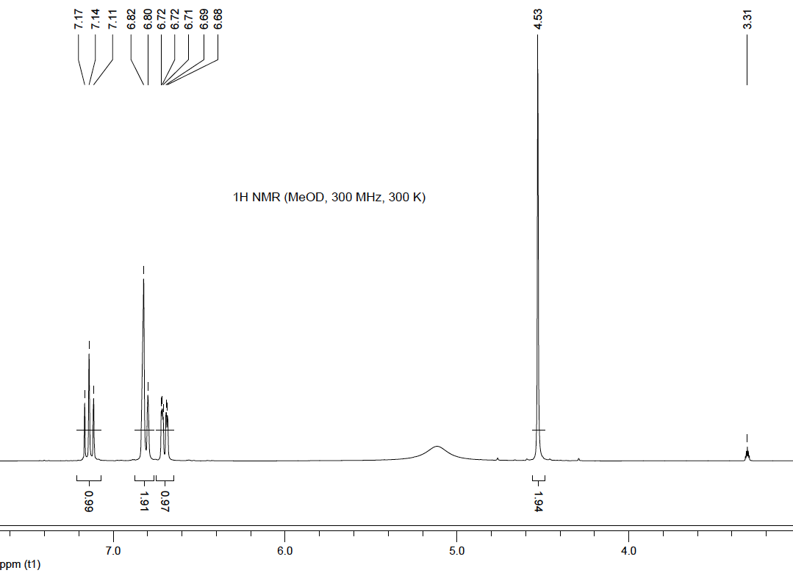
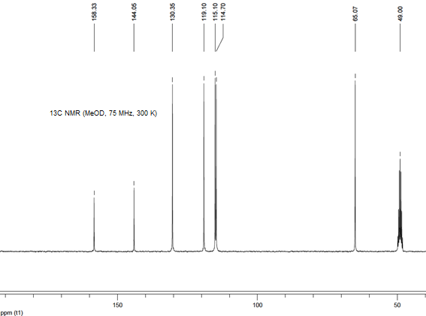
Compound 3:

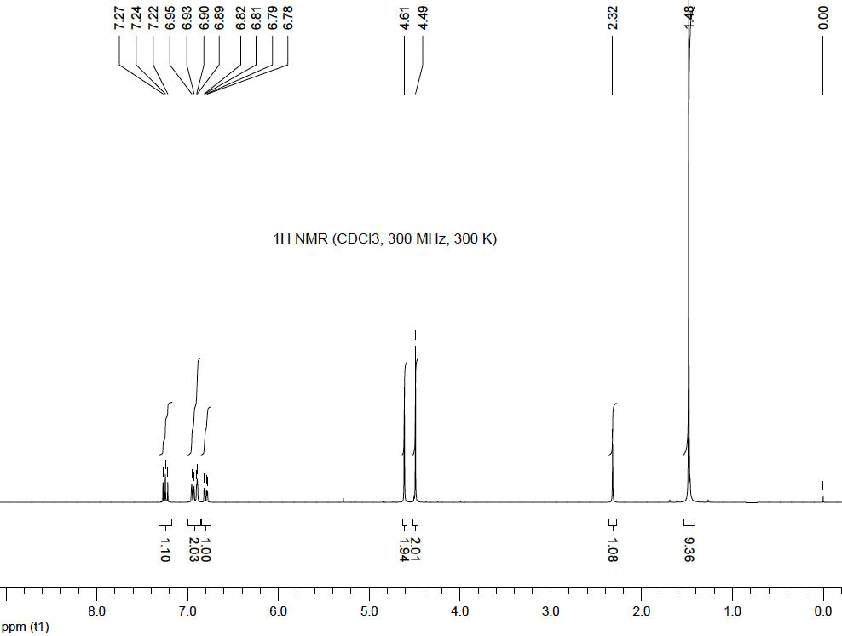

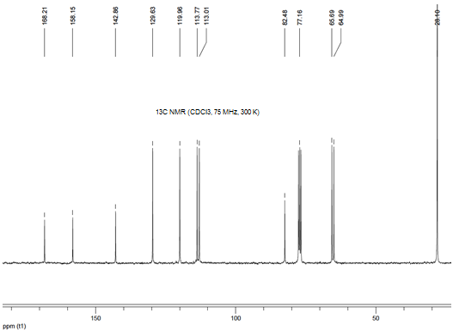
Compound 4:

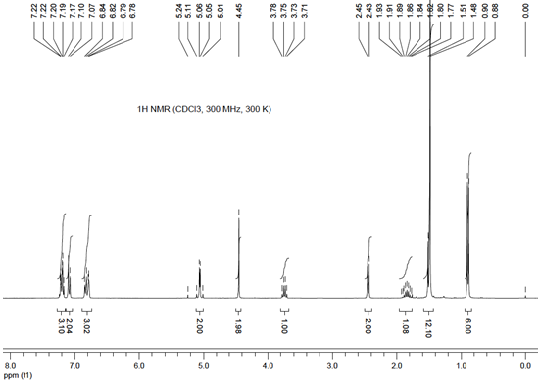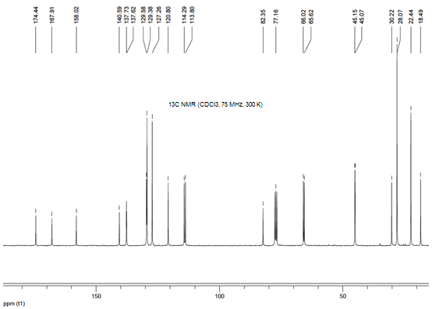
Compound 5:

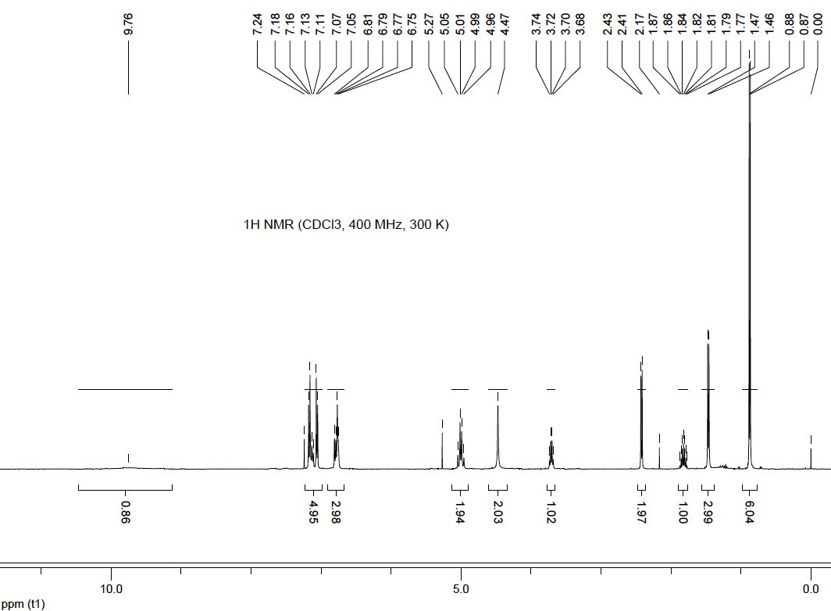
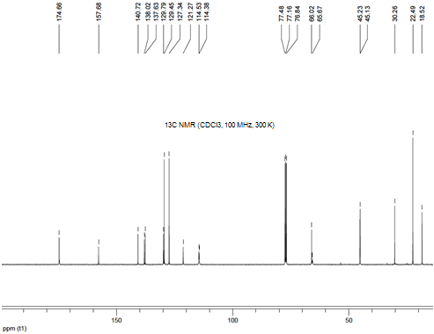
Compound 5’:

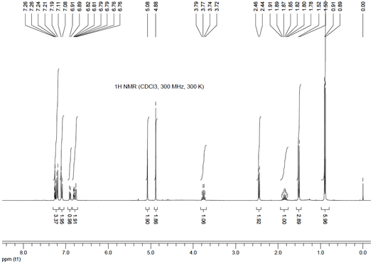
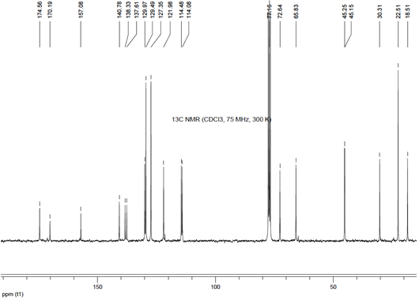
Compound 1:

