Supplementary file

The effect of atmospheric particulates on the rainwater chemistry in the Yangtze River Delta, China
Yan Han^{a,b}, Hong Xu^{a,b}, Xiaohui Bi^{a,b*}, Fengmei Lin^{c}, Li Jiao^{c}, Yufen Zhang^{a,b}, Yinchang Feng^{a,b}
a. College of Environmental Science and Engineering, Nankai University, No.38 Tongyan Road, Jinnan District, Tianjin, 300350. China.
b. The State Environment Protection Key Laboratory of Urban Particulate Air Pollution and Prevention, No.38 Tongyan Road, Jinnan District, Tianjin, 300350. China.
c. The Environmental Monitoring Center of Hangzhou, Hangzhou, Zhejiang 310007, China

As to make it clear for the readers, the percentage change in the concentrations of PM and chemical components (Fig.S1) and sources of air masses (Fig.S2) are given in the following:
Generally, the percentage change in the concentration of PM₁₀ and TSP from the day of ‘before rain event’ to the day of ‘during rain event’ were negative on average, that of most ions in TSP and in PM₁₀ also were negative, indicating the possible scavenging effect of rain on PM and the components, while F⁻ and Cl⁻ in PM₁₀ was positive on average.

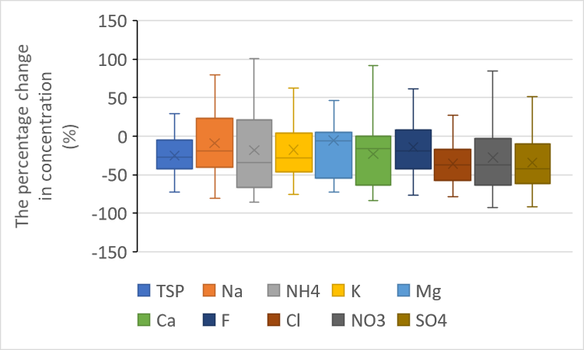
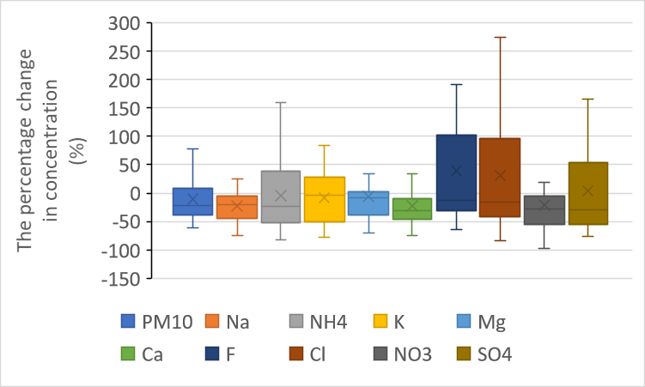

Fig.S1 The percentage change in the concentrations of PM and chemical components from the day of ‘before rain event’ to the day of ‘during rain event’

The backward trajectory analysis for each season by using the HYSPLIT4 model from National Oceanic Atmospheric Administration (NOAA) and the meteorological data from Global Data Assimilation System(GDAS) at 500m above ground level was conducted in Hangzhou. The results are shown in the following figure, the big picture of air mass directions in each season is generally stable and most of the trajectories passed the marine area in summer, winter and spring, but in autumn it varied a lot.
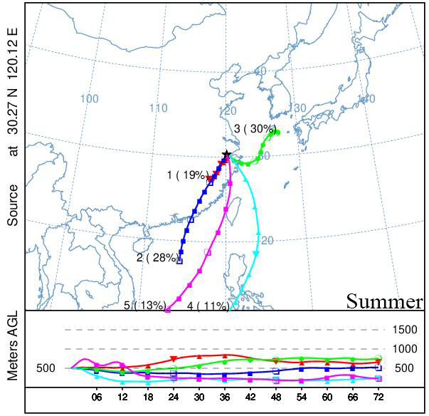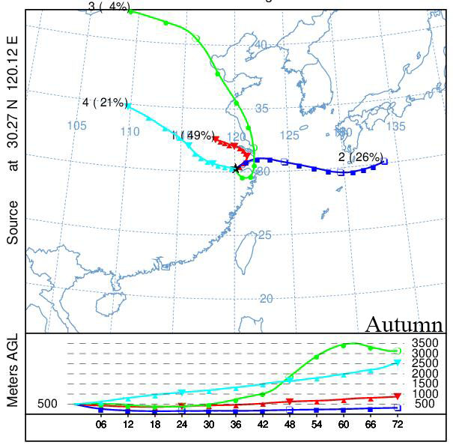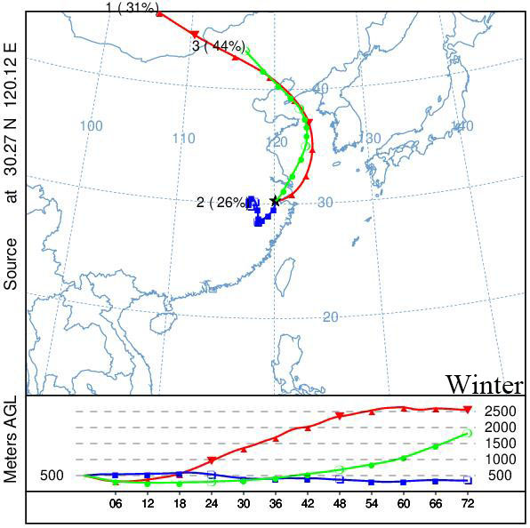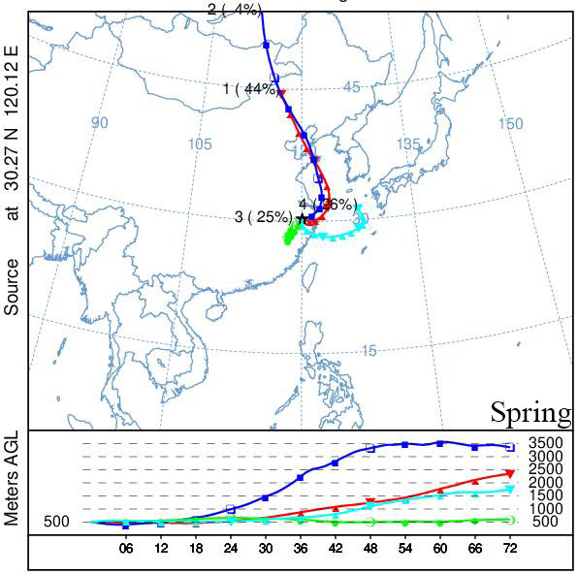

Fig.S2 Back trajectory analysis of air masses during the study period in Hangzhou

