Electronic Supplementary Information

Bent-Core Liquid Crystal-Functionalised Flexible Polymer Substrates for Liquid Crystal Alignment
B. Sivaranjini,ª V. Ganesh^{b} and S. Umadevi*ª
ªDepartment of Industrial Chemistry, Alagappa University, Karaikudi – 630002, India
^{b}Electrodics and Electrocatalysis Division (EEC), CSIR – Central Electrochemical Research Institute (CSIR−CECRI), Karaikudi – 630003,India
∗umadevilc@gmail.com

Experimental
Synthesis of BC 1
Bent-core compound 1 was synthesised following the procedure already reported [1-3]. The schemes followed are depicted below. The BC compound 1 was chemically characterised using IR, NMR technique (Figure.S1 and S2) and mesophase behavior was studied using POM and DSC techniques (Figure. S3). The transition temperatures obtained for compound 1 matched with the reported values. [2]

Scheme S1Synthetic route followed to prepare the C11-acid compound containing a terminal
vinyl moiety, A.

Scheme S2 Synthetic route followed to prepare the C12-acid compound B.

Scheme S3Synthetic route followed to obtain BC compound 1.

Figure S1 FTIR spectra recorded for (1) BCLC alkene compound, (2) BCLC silane compound
respectively.

Figure S2 ¹H-NMR spectrum of compound 1

Figure S3 DSC thermogram of compound 1 showing phase transition temperatures at a heating
and cooling rate of 10°C min⁻¹.

Figure S4 ¹H-NMR spectrum of compound 2.

Synthesis of 4-chloro-1,3-phenylene bis(4-((4-(dodecyloxy)benzoyl)oxy)benzoate)[ClPbis-12BB]

The symmetric BC compound containing a chloro- substitution in the central phenyl ring is synthesised following a procedure reported earlier.[4] A schematic representation of the synthetic pathway is shown in Scheme S4. In a typical procedure, 4-(4-dodecyloxybenzoyloxy)benzoic acid (0.5g, 1.17mmol), 4-chlororesorcinol (0.0677g, 0.469mmol) and DMAP (0.006g) were dissolved in 20 ml dry dichloromethane and the resulting solution was stirred for 15 minutes. Following this, DIC (0.0651g, 0.515 mmol) was added and stirring continued for an overnight at r.t. Thereafter, solvent from the reaction mixture was evaporated and the crude product obtained was purified through column chromatography on silica gel (60-120 mesh size) by using dichloromethane as an eluent. Removal of the solvent from the eluent provided a white product which was further purified by crystallisation. Yield: 40%. Analysis: (¹H NMR) (500 MHz, CDCl₃) δ (ppm): 8.35-8.25(dd, 4H, Ar-H), 8.2-8.1(d, 4H, Ar-H), 7.6-7.5(1H,d, Ar-H), 7.4-7.35(d, 4H, Ar-H), 7.3(s, 1H, Ar-H), 7.3-7.25(d,1H, Ar-H), 7.0-6.9(d, 4H, Ar-H), 4.1-4.0(t, 4H, Ar-O-CH₂-), 1.9-1.8(t, 4H, Ar-O-CH₂-CH₂-), 1.6-1.2(m, 36H, -(CH₂-)₁₈ ), 0.9-0.8(t, 6H, -CH₃).

Scheme S4 Synthetic route followed to prepare the bent-core compound, ClPbis-12BB.

Figure S5 ¹H NMR spectrum of bent-core compound,ClPbis-12BB.

Figure S6 DSC thermogram of BC compound ClPbis-12BB showing phase transition
temperatures. Both heating and cooling cycles were carried out at a rate of 10°C min⁻¹.

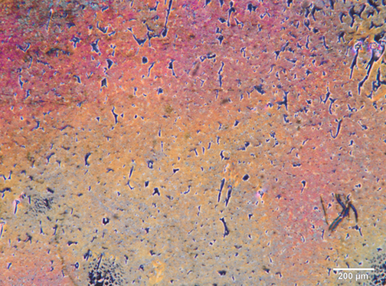
Figure S7 A representative POM image of nematic phase of BC compound ClPbis-12BB held
in between a normal glass slide and a cover slip at 82°C.
Figure S8 XPS overall elemental survey scan of (a) unmodified substrate and (b) BCLC
modified substrate. Inset shows the expanded graph of the region 0-200eV.

Reference:

[1] Marx VM, Girgis H, Heiney PA, Hegmann T. Bent-core liquid crystal decorated gold
nanoclusters: synthesis, self-assembly and effects in mixture with bent-core LC hosts J.
Mater. Chem. 2008;18:2983-2994.
[2] Umadevi S, Feng X, Hegmann T. Bent-core and nematic liquid crystal functionalized gold
nanorods. Ferroelectrics. 2012;431:164-175.
[3] Achten R, Koudils A, Giesbers M, Marcelis ATM, Sudholter EJR. Non-symmetric bent-
core mesogens with one terminal vinyl group. Liq. Cryst. 2005;32:277-285.
[4] Pelzl G, Eremin A, Diele S, Kresse H, Weissflog W. Spontaneous chiral ordering in the
nematic phase of an achiral banana-shaped compound. J. Mater. Chem. 2002;12:2591-2593.

