Supplementary Information
Synthesis and characterization of redox and ultrasonic dual-responsive organic-inorganic amphiphilic hybrid copolymers for drug delivery
Materials
MPEG with average number molecular weight 550, 2000, and 5000 Da, α-chloro-cyclohexanone, 3-mercapto propionic acid (MPA), halfnium (iv) chloride tetrahydrofuran comples (HfCl₄.2THF), pyrene, indomethacin (IMC), and Nile red (NR), ε-CL and sodium dodecyl sulfate (SDS) were purchased from Aldrich Chemical Co. (Milwaukee, WI). In addition, aminopropylisobutyl POSS was purchased from Hybrid Plastics (Hattiesburg MS), m-chloroperoxybenzoic acid was purchased from Fluka Chemical Co. (Buchs SG1, Switzerland), and stannous octoate (SnOct₂) was purchased from Strem Chemical Inc. (Newburyport, MA). α-ClCL, MPEG-SH, and 2-(2-pyridyldithio) ethanol were prepared according to reported procedures.^{[1,2]} Alkynyl-functionalized POSS was prepared according to the modified previously reported.^{[3]} Doxorubicin hydrochloride (99%) (Aldrich, Saint Louis, MO) was deprotonated to obtain hydrophobic DOX, as previously described.^{[4]} N,N-Dimethyl formamide (DMF), and toluene were dried and distilled under calcium hydride. Other high-pressure liquid chromatography (HPLC) grade solvents, such as tetrahydrofuran (THF), dimethylsulfoxide (DMSO), methanol, chloroform (CHCl₃), and n-hexane, were purchased from Merck (Darmstadte, Germany). A Milli-Q Plus system (Waters, Milford, MA) was used to obtain ultrapure water. Dulbecco’s modified Eagle’s medium (DMEM), trypsin/EDTA, 100 × antibiotic- antimycotic, and Hoechst 33342 nuclei dye were purchased from Gibco, Invitrogen Corp. (Carlsbad, CA). Fetal bovine serum (FBS) was obtained from Biological Industry (Kibbutz Beit Haemek, Israel). A CellTiter 96® AQueuous One Solution kit was obtained from Promega (Fitchburg, WI).
Characterization
¹H NMR spectra were recorded from CDCl₃ solution on a Bruker AM 400 spectrometer. IR spectra were measured using a Bruker TENSOR 27 Fourier transform infrared (FT-IR) spectrophotometer (Bruker, Germany). Samples were placed on sodium chloride plates or pressed into potassium bromide pellets, and the number- and weight-average molecular weights (M_{n} and M_{w}, respectively) of the polymers were determined through gel permeation chromatography (GPC). GPC was conducted using an HPLC system equipped with a model PU-2031 refractive-index detector (Jasco, Tokyo, Japan) and Jordi Gel poly(divinyl benzene) columns with pore sizes of 100, 500, and 1000 Å. THF was used as an eluent at a flow rate of 0.5 mL min⁻¹. Poly(ethylene glycol) standards of low dispersity (Polymer Sciences) were used to generate a calibration curve. Data were recorded and manipulated using a Windows-based software package (Scientific Information Service). The glass transition temperatures (T_{g}) and melting temperatures (T_{m}) of the polymer were performed on a DuPont 9900 system that consisted of DSC (Newcastle, DE) under a continuous nitrogen purge (50 mL/min). The heating rate was 10 ℃ min⁻¹. T_{g} was read at the middle of the change in the heat capacity. The thermal stability of the synthesized polymer was analyzed by thermogravimetry (TGA) using a TA instruments TGA/DSC1 (Mettler Toledo, Schwerzenbach, Switzerland) under a continuous nitrogen purge of 50 mL/min. The sample was heated from room temperature to 700 ℃ with a uniform heating rate of 20 ℃/min. Dynamic light scattering (DLS) experiments were carried out on the Zetasizer Nano ZS (Malvern, UK) spectrometer with an argon laser operating at 632.8 nm and a fixed scattering angle of 90º at 20 ℃.
Self-assembly behavior of polymers
Polymeric micelles of MPEG-S-S-P(αN₃CL-g-ibu₇POSS)_{x}-r-PCL_{y} polymers were prepared through dialysis. In brief, a solution of the MPEG₄₅-S-S-P(αN₃CL-g-ibu₇POSS)₄-r-PCL₁₀ polymer (30 mg) in DMF (5 mL) was placed in a dialysis bag with a molecular weight cutoff (MWCO) of 3.5 kDa and subsequently dialyzed against deionized water at an ambient temperature for 24 h. The water was replaced at 2 h intervals. The obtained aqueous solutions were subsequently used for analyzing critical micelle concentration (CMC), and dynamic light scattering (DLS), and performing transmission electron microscopy (TEM).
The CMCs of the copolymers were determined through fluorescence spectroscopy with pyrene as the probe. Briefly, the polymer samples were equilibrated for 10 min before measurements were taken. Aliquots of pyrene in acetone solution (6.1 × 10⁻⁵ M, 10 μL) were added to glass vials and air-dried to remove the acetone. Polymer solutions of varying concentrations were added to the pyrene at 1 mL each, and left to stand for 24 h. The final pyrene concentration in each vial was 6.1 × 10⁻⁷ M. The fluorescence spectra were recorded using a Hitachi F-4500 fluorescence spectrometer equipped with a 20 kW xenon discharge lamp. The slit width was 10 nm, and square cells (1.0 × 1.0 cm) were used. The excitation spectra were scanned at wavelengths from 300 to 360 nm, with an emission wavelength of 395 nm at 25 ℃.
The average particle size, size distribution (PD), and zeta potential of the micelles in the aqueous solution were measured using DLS. Measurements were recorded after an aqueous micellar solution (C = 0.3 g L⁻¹) was filtered by using a microfilter with an average pore size of 0.2 μm (Advantec MFS, Inc., Dublin, CA, USA).
The morphologies of the self-assembled micelles were observed through TEM (JEM 1200-EXII, Tokyo, Japan). Drops of the micelle solution (0.3 g L⁻¹, not containing a staining agent) were placed on a carbon film coated copper grid (400 mesh) and dried at room temperature. The micelles were observed at an accelerating voltage of 100 kV.
Kinetic stability analysis of MPEG₄₅-S-S-P(αN₃CL-g-ibu₇POSS)₄-r-PCL₁₀ micelles and IMC-loaded micelles
Kinetic stability of the blank and IMC-loaded micelles was studied by DLS measurement in the absence or presence of SDS, which acts as a destabilizing agent, at various temperatures (25 ℃, 37 ℃, and 50 ℃). The micelle solutions (3.0 mg/mL) were mixed with an SDS aqueous solution (1 mg/mL, and 10 mg/mL) at a 2:1 (v/v) ratio, and the resulting mixed solutions were placed at 37 ℃. After 1 and 24 h, DLS measurements on the collapsing micelles were performed at 37 ℃.
HIFU irradiation of polymer micelles
HIFU was generated using a commercially available ultrasound apparatus (Q125, Qsonica, Newtown, CT, USA) comprising three main components: an arbitrary waveform generator, a radio frequency power amplifier (A150, Electronics & Innovation), and an acoustic lens transducer (H-101, Sonic Concept). The ultrasound amplitude could be adjusted in the range of 20% − 100%, and the ultrasound frequency was 20 kHz. In all ultrasound irradiation experiments, the focal spot of the beams was the center of the micellar solution (10 mL) in a tube reactor immersed in a water tank. Following ultrasound irradiation, the tube reactor was removed from the water tank, and the polymer solution was used for characterization.
Drug loading and entrapment efficiency
To determine the drug loading and encapsulation efficiency, the anti-inflammatory drug indomethacine (IMC) served as a model drug. IMC-loaded micelles were prepared according to the following method: MPEG-S-S-P(αN₃CL-g-ibu₇POSS)_{x}-r-PCL_{y} (50-fold CMC) and IMC (1:1 weight ratio to polymer) were dissolved in 6 mL of methylene chloride. The solution was subsequently added dropwise to 100 mL of distilled water. The emulsion was stirred at an ambient temperature overnight to evaporate the methylene chloride. The unloaded IMC residue was removed through filtration using a Teflon filter (Whatman) with an average pore size of 0.45 μm, and the micelles were obtained through vacuum drying. A weighed amount of micelles was subsequently disrupted by adding a 10-fold excess volume of DMF. The IMC concentration was measured by UV-Vis spectroscopy at 320 nm. The experiments were conducted in triplicate. The results were presented as the average ± standard deviation. The following equations were used to calculate the drug-loading content and drug-entrapment efficiency:
Drug-loading content (%)
= (weight of the drug in the micelles/weight of micelles) × 100 (1)
Drug-entrapment efficiency (%)
= (weight of the drug in the micelles/weight of the drug initially provided) × 100 (2)
Cell culture
HeLa cells were maintained in DMEM/F12 1:1 medium containing 10% FBS and 1% antibiotic- antimycotic at 37 ℃ in a humidified atmosphere with 5% carbon dioxide (CO₂).
References
[1] Lenior, S.; Riva, R.; Lou, X.; Detrembleur, Ch.; Jérôme, R.; Lecomte, Ph. Macromolecules 2004, 37, 4055-4061.
[2] Fang, J. Y.; Lin, Y. K.; Wang, S. W.; Yu, Y. C.; Lee, R. S. RSC Adv. 2016, 6, 107669-107682 .
[3] Zhang, W.; Liu, L.; Zhuang, X.; Li, X.; Bai, J.; Chen, Y. J. Polym. Sci. Part A: Polym. Chem. 2008, 46, 7049-7061.
[4] Huang, H.; Wu, S.; Xie, Z.; Meng, F.; Jing, X.; Huang, Y. Biomacromolecules 2012, 13, 3004-3012.

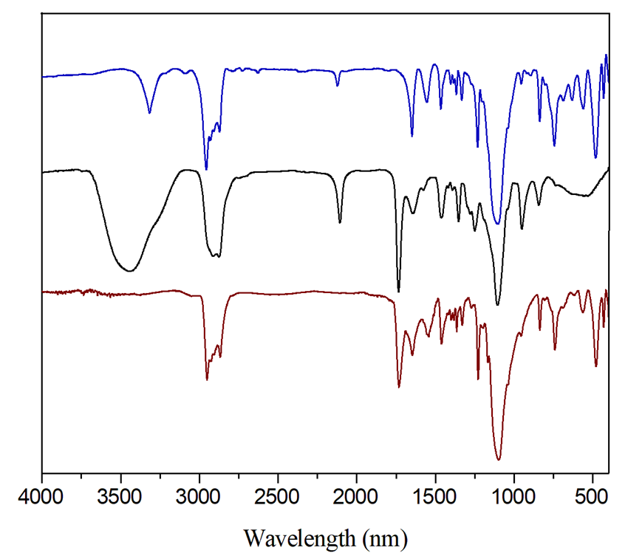
Figure S1 FT-IR spectra of (A) ibu₇POSS(CH₂)₃NHCO(CH₂)₂C≡CH , (B) MPEG₄₅-S-S-P(αN₃CL)₄-r-PCL₁₀, and
(C)
(B)
(A)
C≡C
Si-O-Si
Si-C
N₃
(C) MPEG₄₅-S-S-P(αN₃CL-g-ibu₇POSS)₄-r-PCL₁₀

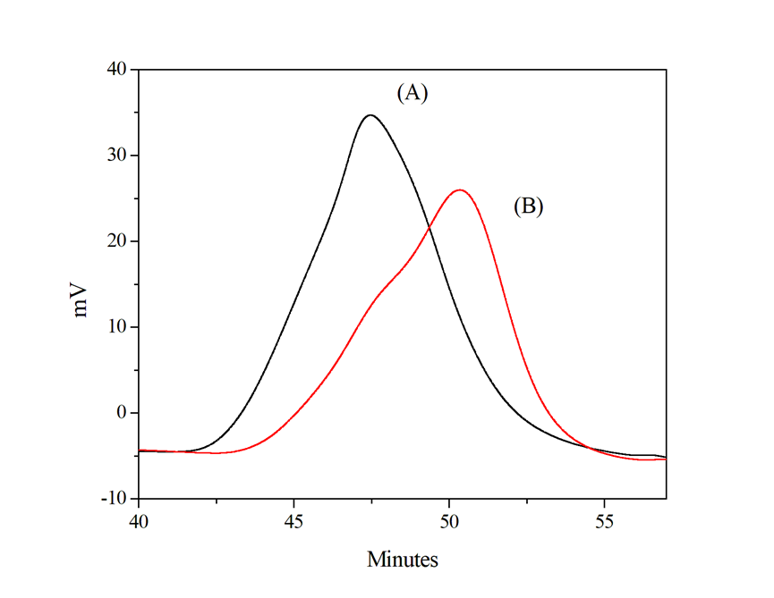
Figure S2 GPC curves of (A) MPEG₄₅-S-S-P(αN₃CL-g-ibu₇POSS)₄-r-PCL₁₀, and (B) MPEG₄₅-S-S-P(αN₃CL)₄-r-PCL₁₀.

(B)
(A)

Figure S3 (A) TGA and (B) DSC curves of MPEG₄₅-S-S-P(αN₃CL-g-ibu₇POSS)₄-r-PCL₁₀ (curve a), MPEG₄₅-S-S-P(αN₃CL)₄-r-PCL₁₀ (curve b). A heating rate of 10 ℃/min was applied to sample in a nitrogen environment.

(A)
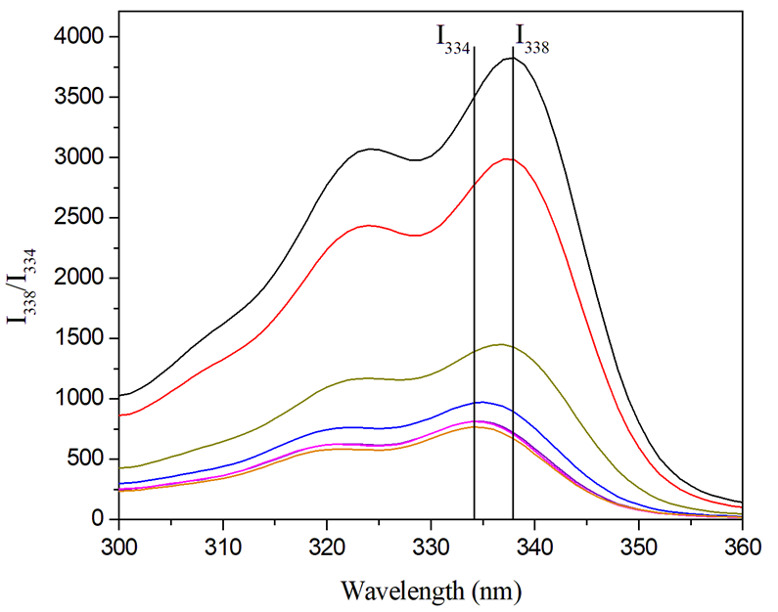
(B)
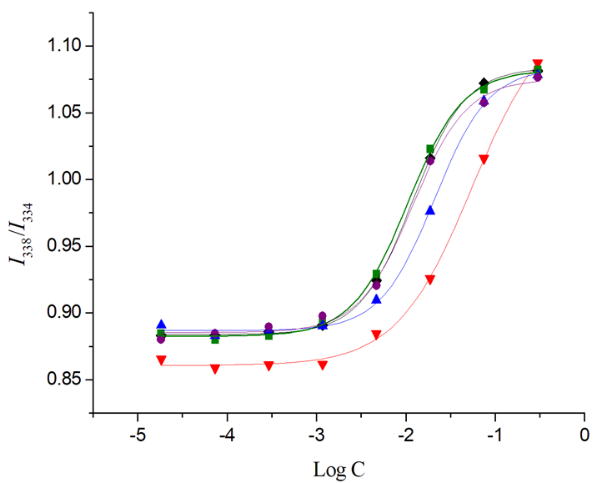
Figure S4 (A) Excitation spectra of pyrene loaded MPEG₄₅-S-S-P(αN₃CL-g-ibu₇POSS)₄-r-PCL₁₀
micelles monitored at λ_{em} = 390 nm with different concentrations, (B) plot of the I₃₃₈/I₃₃₄
intensity ratio (from pyrene concentration = 6.1 x 10⁻⁷ M) versus the logarithm of the
concentration (Log C, mg L⁻¹) of MPEG₄₅-S-S-P(αN₃CL-g-ibu₇POSS)₄-r-PCL₁₀ (●);
MPEG₁₂-S-S-P(αN₃CL-g-ibu₇POSS)₉-r-PCL₂₇(■); MPEG₄₅-S-S-P(αN₃CL-g-ibu₇POSS)₉-r-PCL₁₂
(◆); MPEG₁₁₃-S-S-P(αN₃CL-g-ibu₇POSS)₄-r-PCL₁₀ (▲); MPEG₄₅-S-S-P(αN₃CL-g-ibu₇POSS)₈(▼).

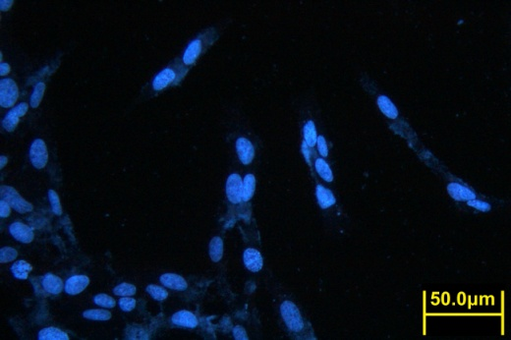  (B)  (A) | 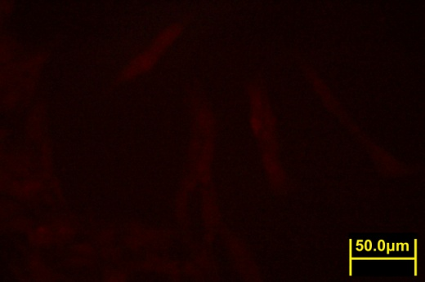 | 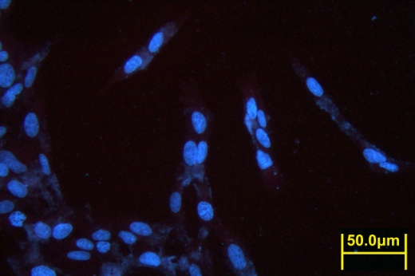
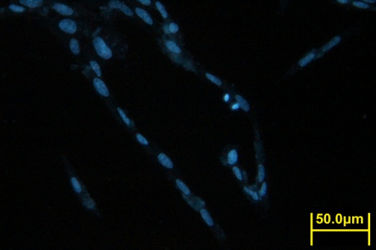  (C) | 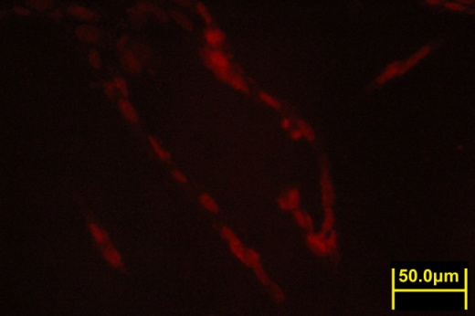 | 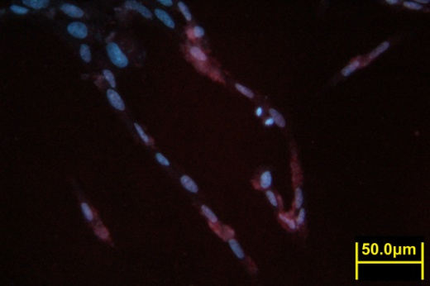
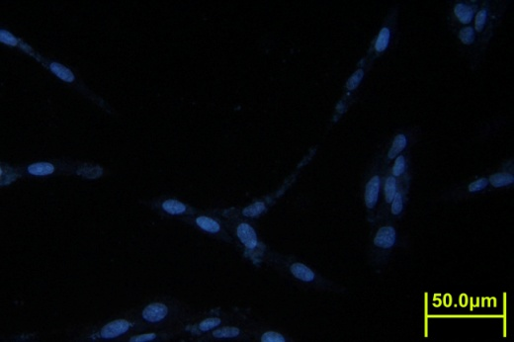  (D) | 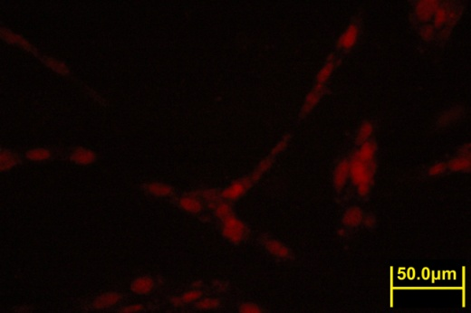 | 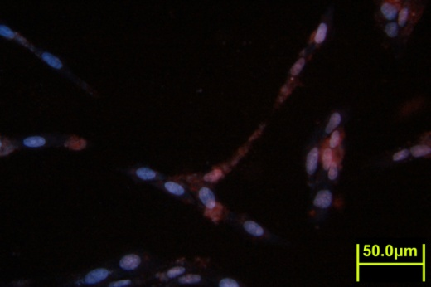
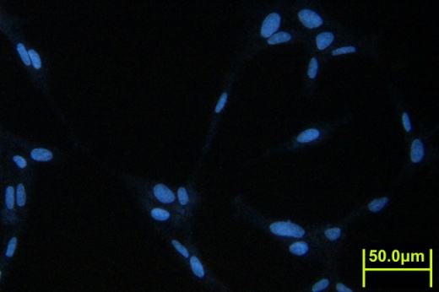  (E) | 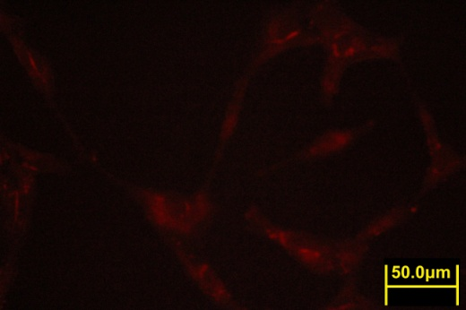 | 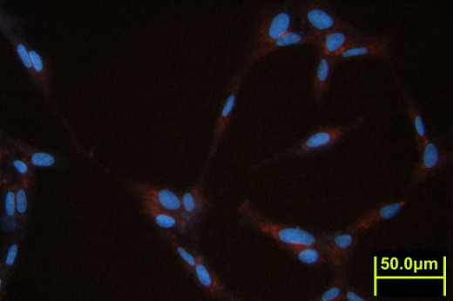
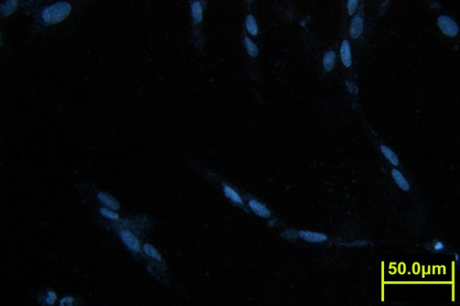  (F) | 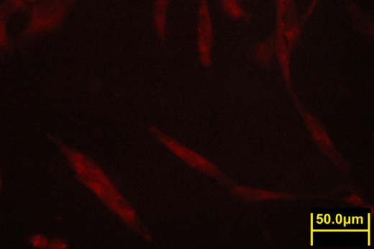 | 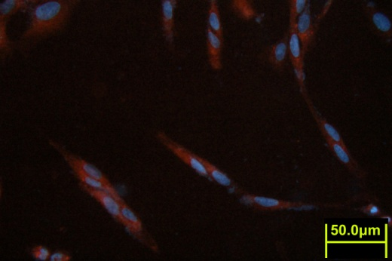
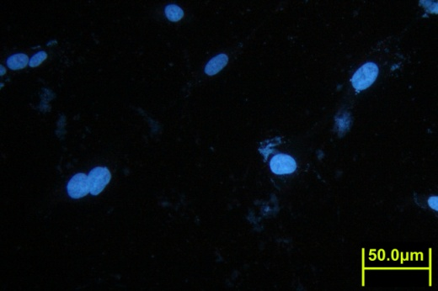 | 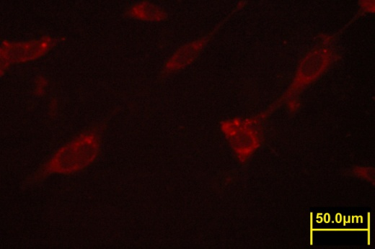 | 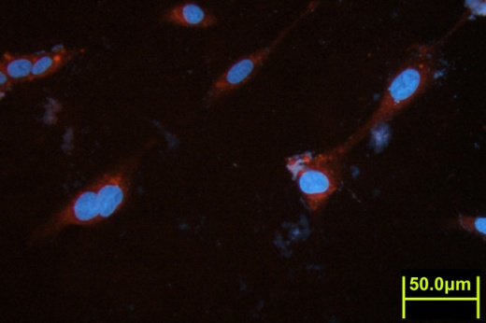
Figure S5 Fluorescence microscopic images of HeLa cells incubated with free DOX (254.7 ng mL⁻¹) or DOX-loaded MPEG₄₅-S-S-P(αN₃CL-g-ibu₇POSS)₄-r-PCL₁₀ micelles for different time intervals: (A) free DOX, 5min; (B) free DOX, 30 min; (C) free DOX, 60 min; (D) DOX-loaded micelle, 5 min; (E) DOX-loaded micelle, 30 min; (F) DOX-loaded micelle, 60 min.

Table S1 Results of the click coupling of MPEG_{n}-S-S-P(αN₃CL)_{x}-r-PCLy with i-bu₇POSS alkyne

Polymerª | Isolated  yield  (%) | M_{n, th}^{b} | M_{n, NMR}^{c} | M_{n, GPC}^{d} | M_{w}/M_{n}^{d}  (PDI)
MPEG₄₅-S-S-P(αN₃CL-g-ibu₇POSS)₈ | 68 | 9981 | 9065 | 5080 | 1.15
MPEG₄₅-S-S-P(αN₃CL-g-ibu₇POSS)₉-r-PCL₁₂ | 74 | 12545 | 12468 | 9740 | 1.26
MPEG₄₅-S-S-P(αN₃CL-g-ibu₇POSS)₄-r-PCL₁₀ | 82 | 7236 | 6275 | 6080 | 1.15
MPEG₁₁₃-S-S-P(αN₃CL-g-ibu₇POSS)₄-r-PCL₁₀ | 68 | 10381 | 9381 | 8760 | 1.17
MPEG₁₂-S-S-P(αN₃CL-g-ibu₇POSS)₉-r-PCL₂₇ | 58 | 12749 | 11747 | 7580 | 1.22
ªAbbreviations: MPEG = methyl poly(ethylene glycol) with M_{n} = 500, 2000, 5000 Da; S-S = disulfide bond; PαN₃CL = poly(α-azo caprolactone); ibu₇POSS = iso-butyl polyhedral oligomeric silsesquioxanes; PCL = poly(ε-caprolactone).
^{b}M_{n,th} = M_{n,MPEG-S-S-P(αN3CL)9-r-PCL12} +( M_{n,ibu7POSS} × grafted molar ratio).
^{c}M_{n,NMR} = Determine by ¹H NMR spectroscopy of MPEG-S-S-P(αN₃CL-g-ibu₇POSS)_{x}-r-PCL_{y}.
^{d}Determine by GPC.

