One-Pot, Three-Component Synthesis of Pyrido[2,3-d]pyrimidinones Using Aluminate Sulfonic Acid Nanocatalyst Under Grinding Technique

Fathy M. Abdelrazek^{1,4*}, Sobhi M. Gomha^{1,2}, Mohamed S. Farghaly^{1,3}, Peter Metz⁴

- Chemistry Department, Faculty of Science, Cairo University, Giza 12613, Egypt
- Department of Chemistry, Faculty of Science, Islamic University in Almadinah Almonawara, Almadinah Almonawara, 42351, Saudi Arabia
- Science & Technology Center of Excellence, Ministry of Military Production, Cairo, Egypt
- Fakultat Chemie und Lebensmittelchemie, TU-Dresden, 01069 Dresden, Germany
E mails: prof.fmrazek@gmail.com, s.m.gomha@gmail.com

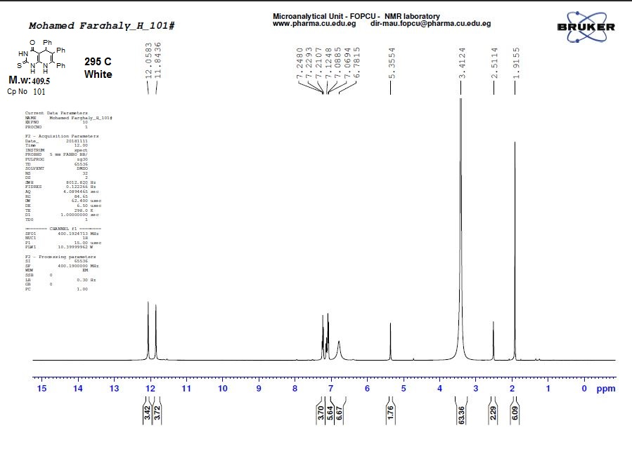
¹HNMR of compound 4a
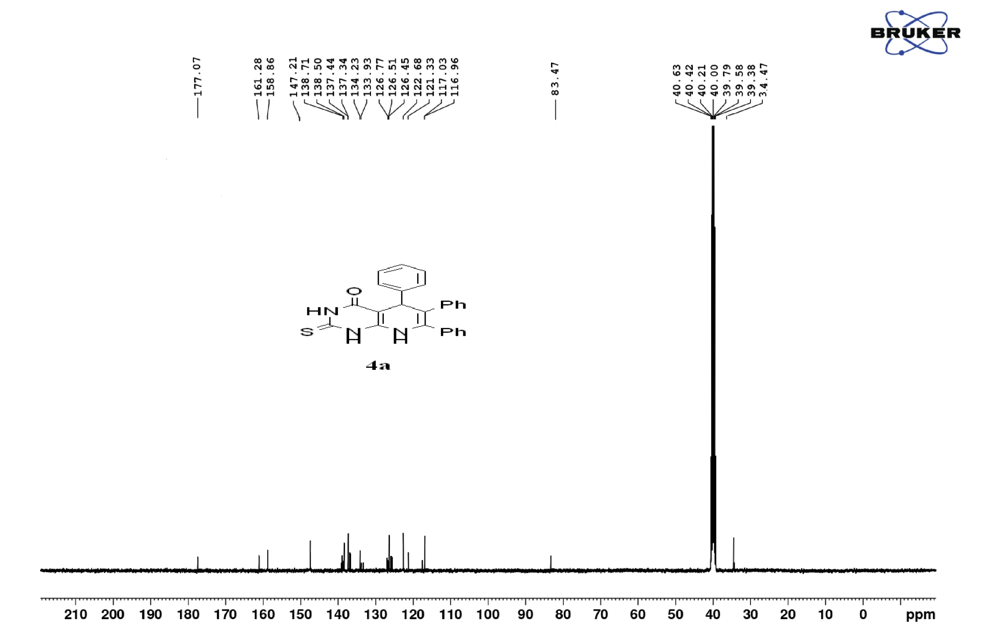
¹³CNMR of compound 4a

IR of compound 4a

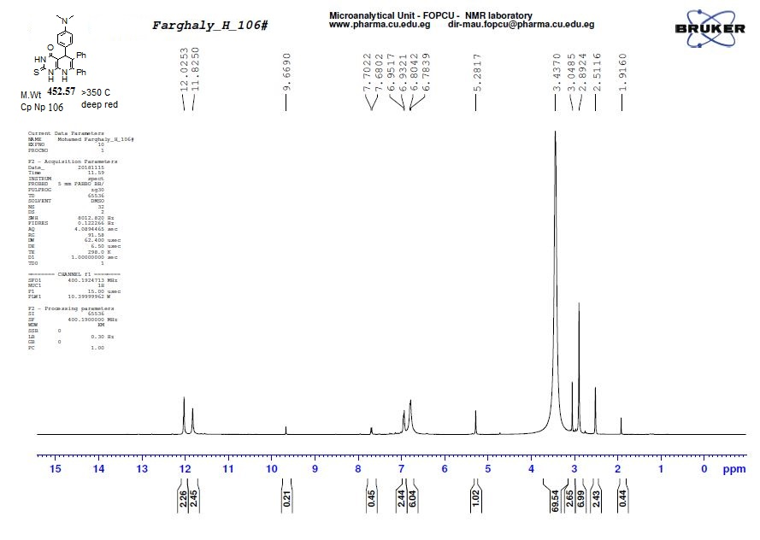

¹HNMR of compound 4c
IR of compound 4c

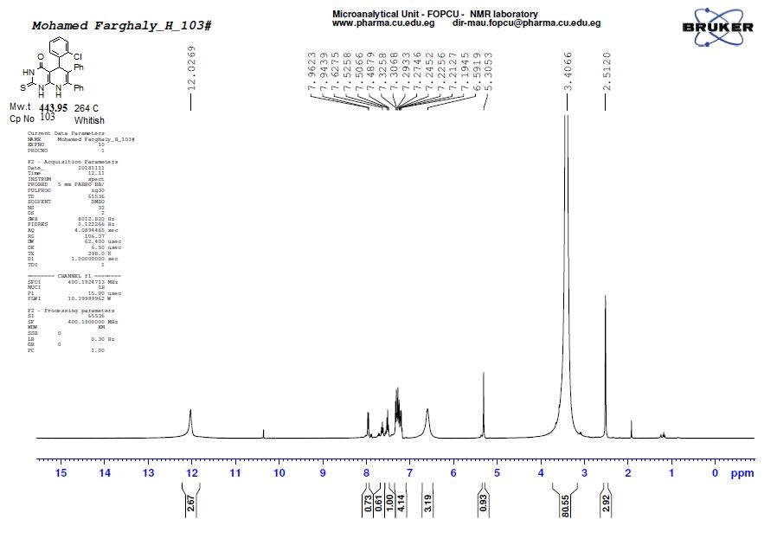
¹HNMR of compound 4d
IR of compound 4d

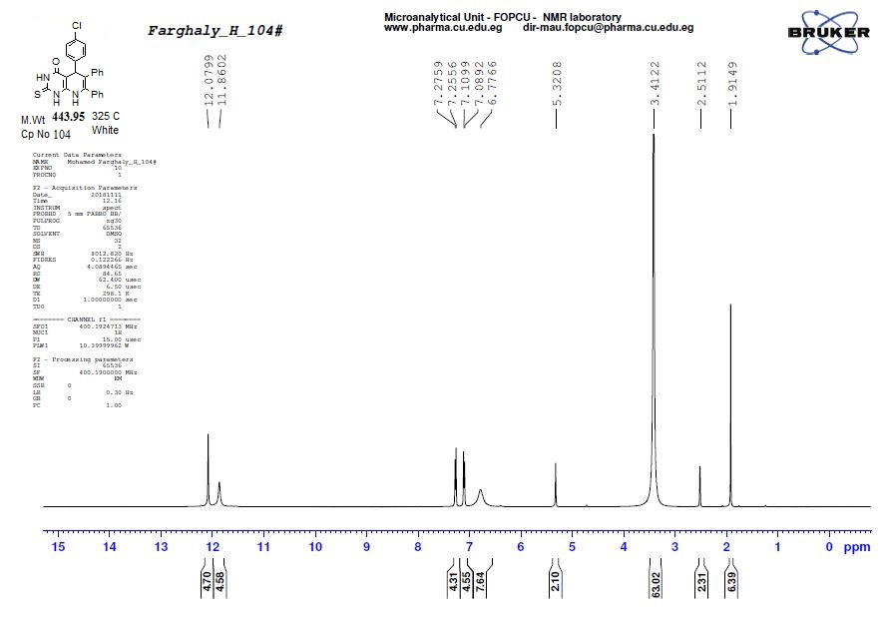
¹HNMR of compound 4e

IR of compound 4e

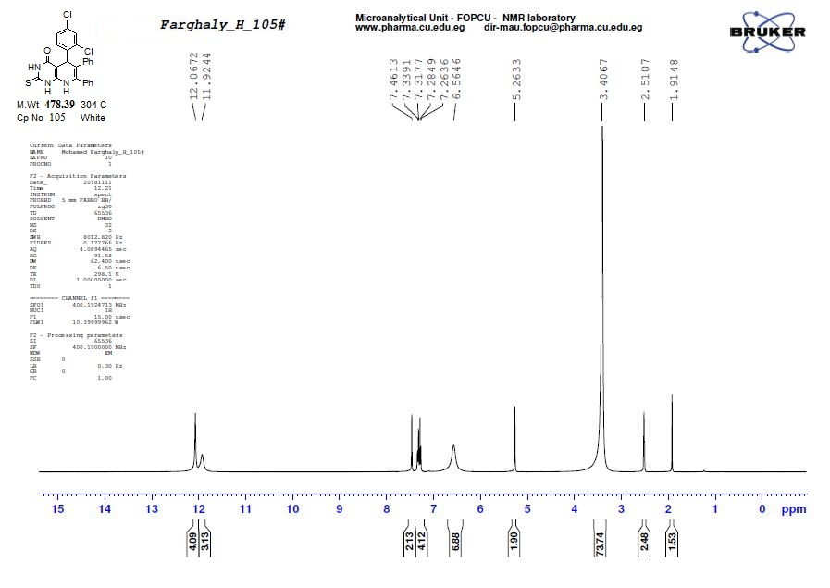
¹HNMR of compound 4f

IR of compound 4f

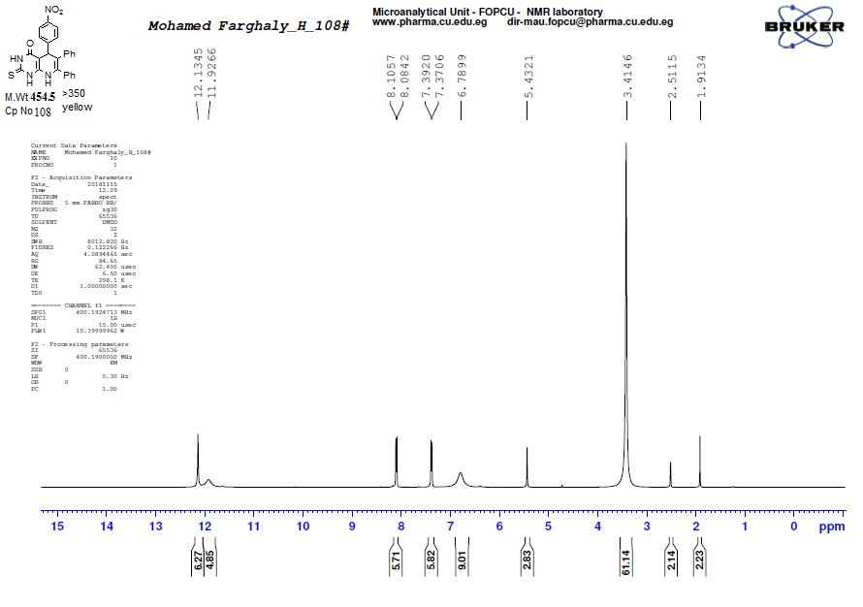

¹HNMR of compound 4g

IR of compound 4g

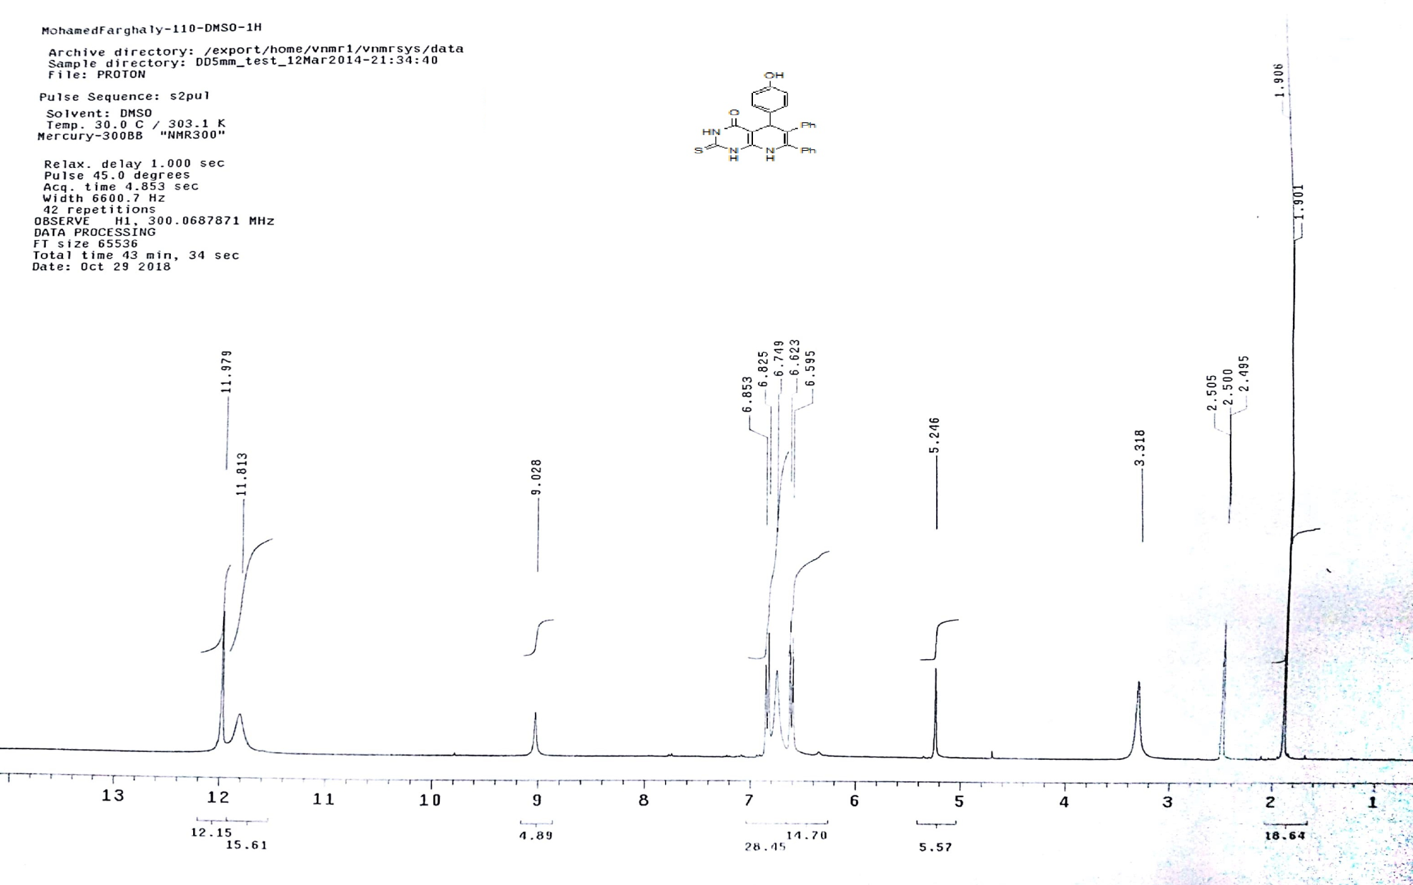
¹HNMR of compound 4i

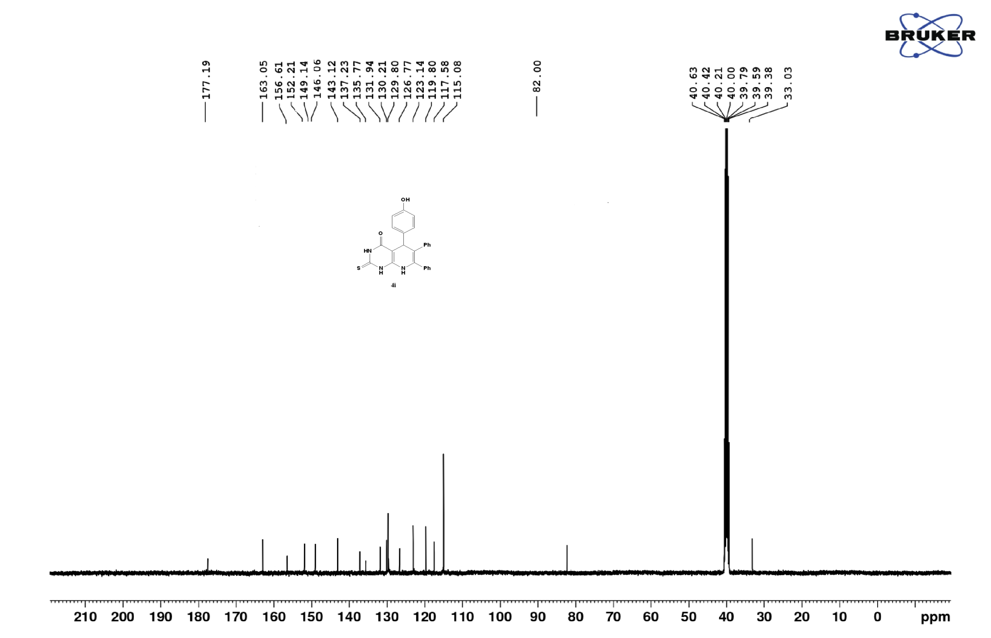
¹³CNMR of compound 4i
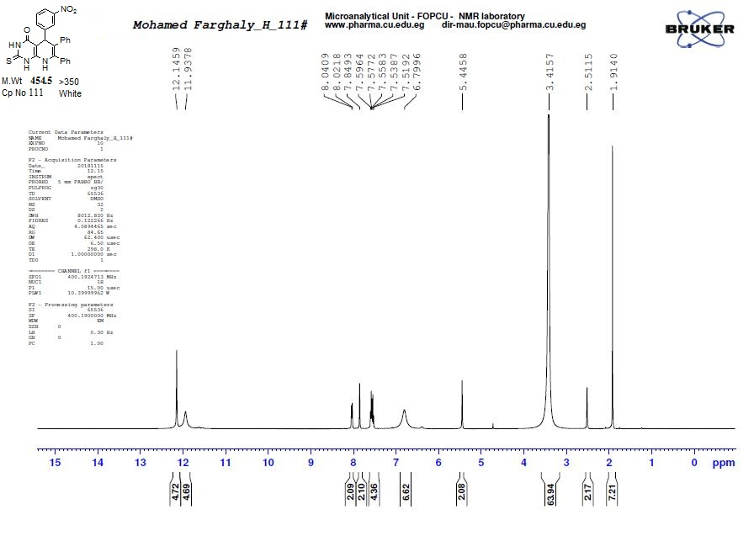
¹HNMR of compound 4h
IR of compound 4h

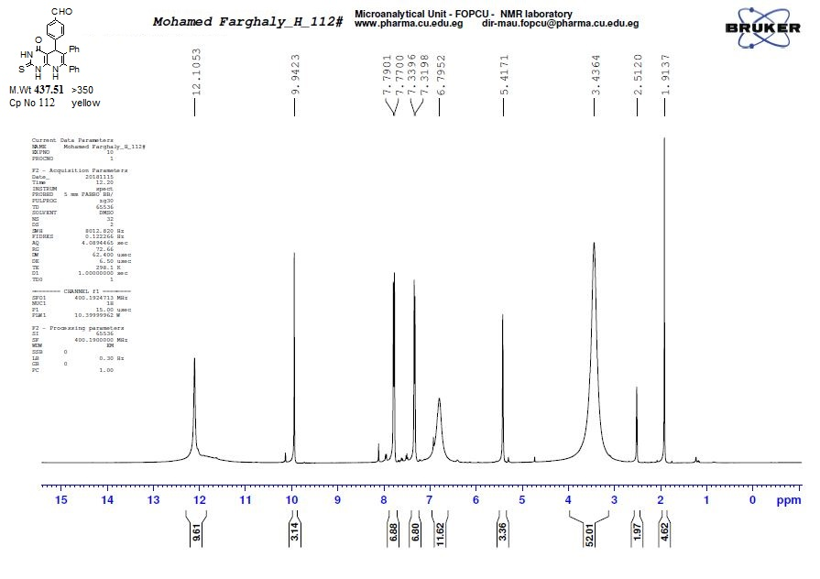
¹HNMR of compound 4j

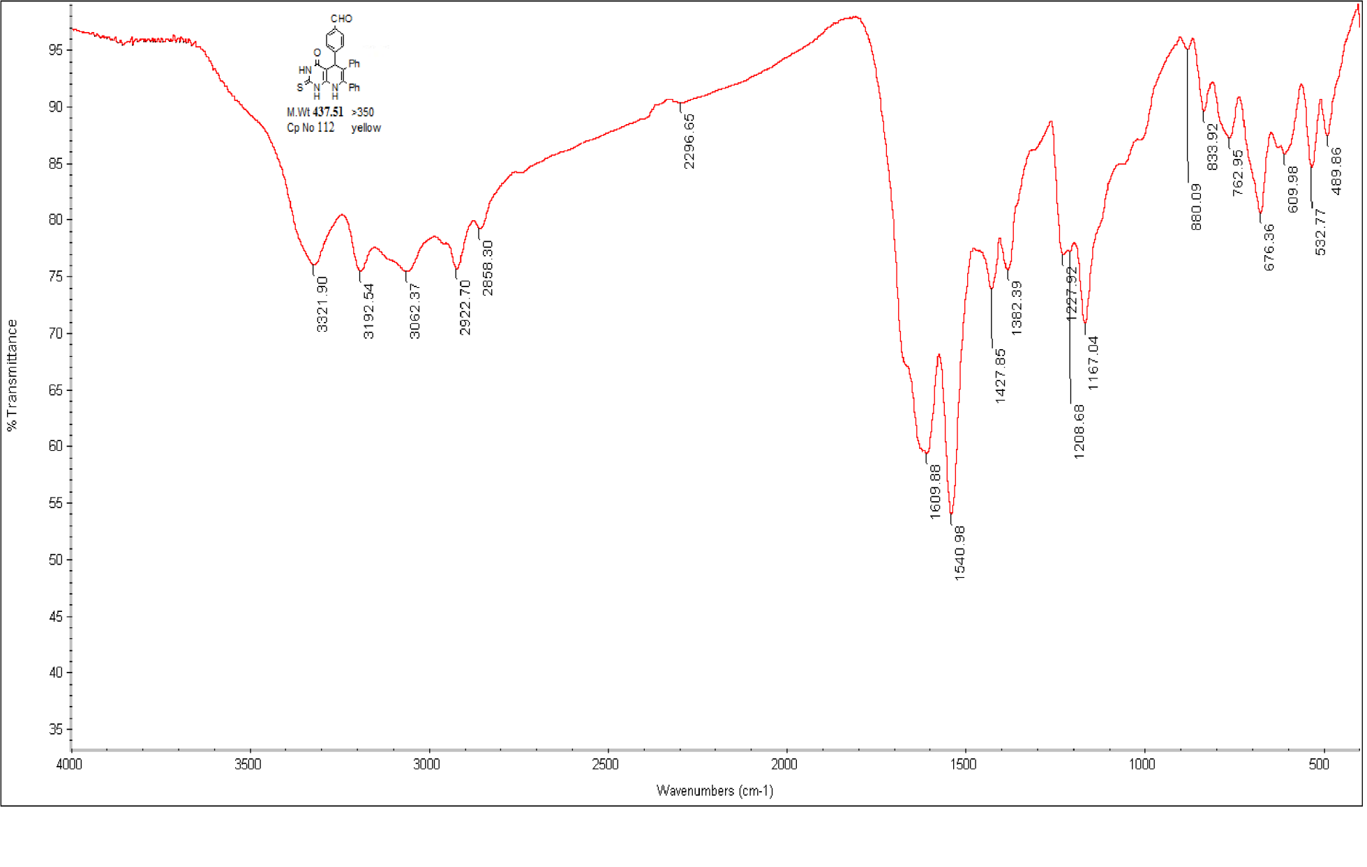
IR of compound 4j

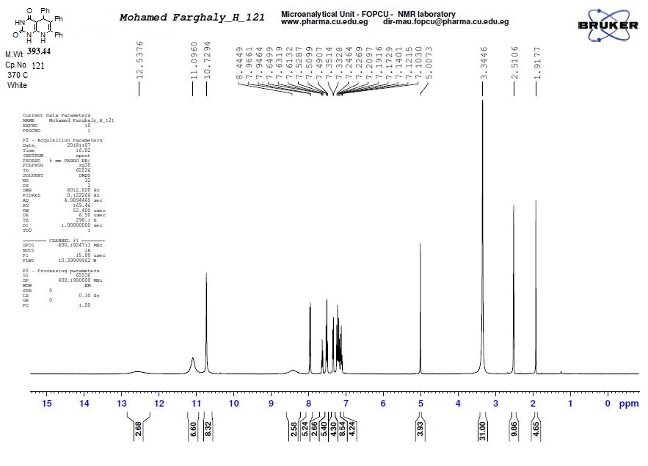
¹HNMR of compound 4k
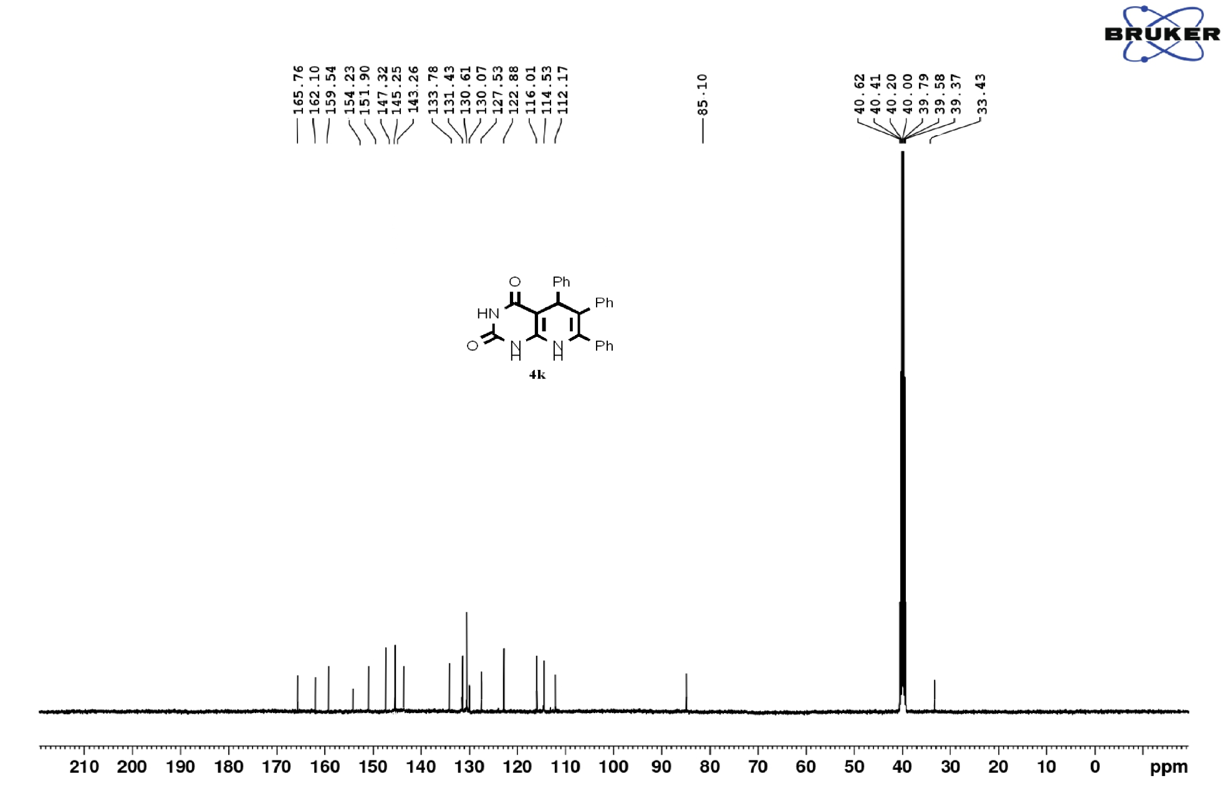
¹³CNMR of compound 4k

IR of compound 4k

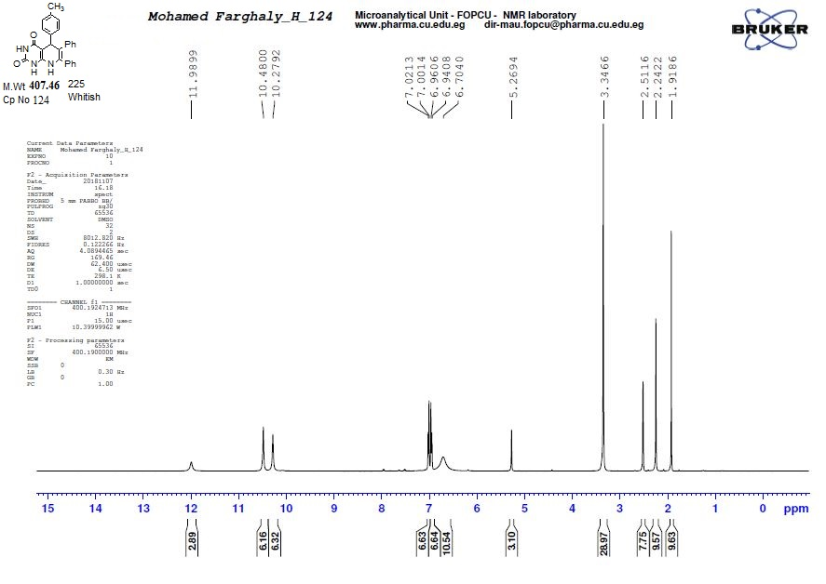
¹HNMR of compound 4l

IR of compound 4l

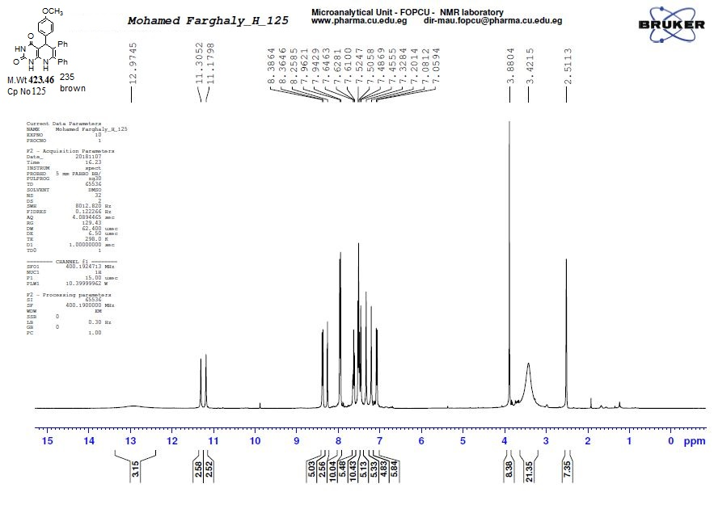
¹HNMR of compound 4m
IR of compound 4m

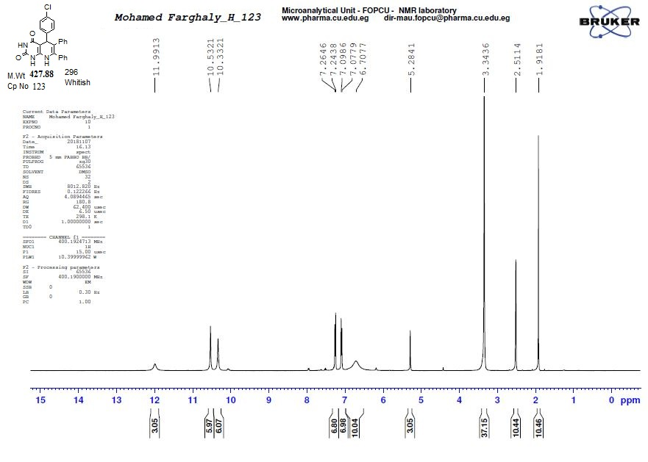
¹HNMR of compound 4n

IR of compound 4n

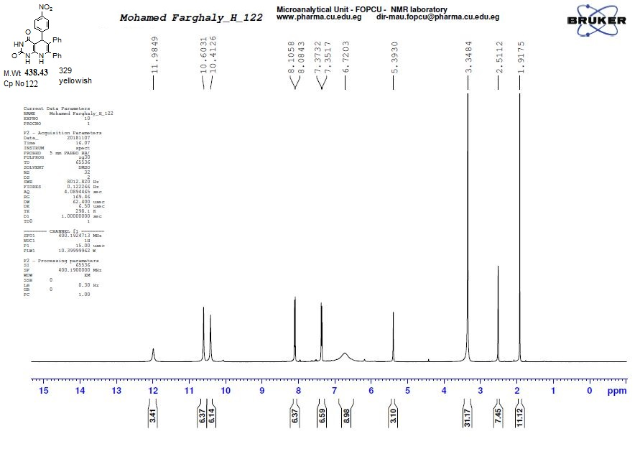
¹HNMR of compound 4o

IR of compound 4o

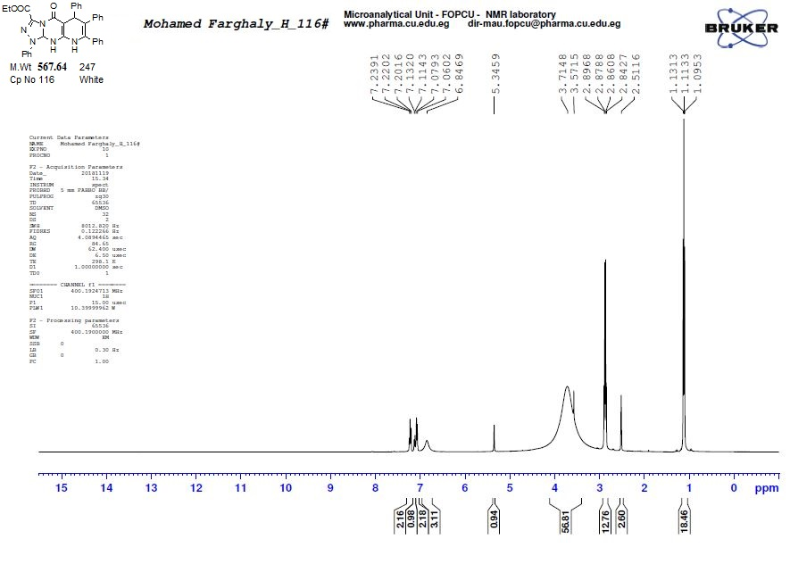
¹HNMR of compound 6a

IR of compound 6a

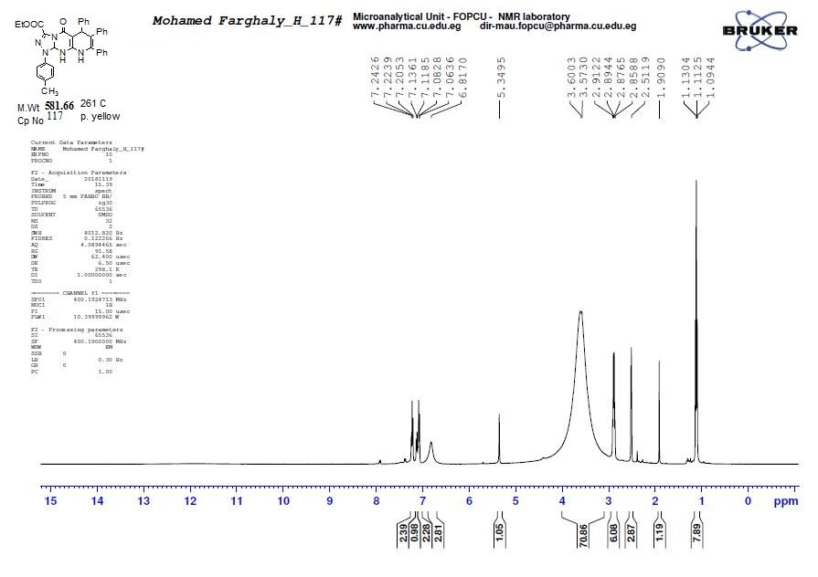
¹HNMR of compound 6b

IR of compound 6b

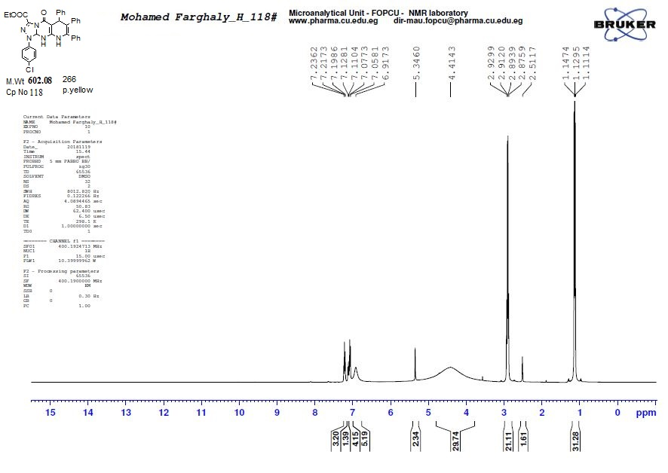
¹HNMR of compound 6c

IR of compound 6c

