Supplemental Figure 1
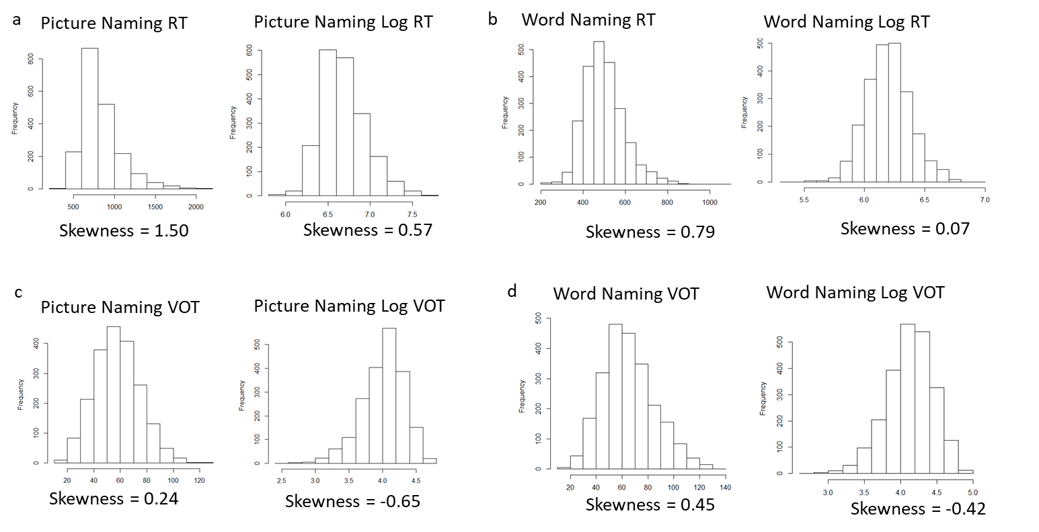
Distribution of original and log-transformed RT and VOT in Experiment 1 (Picture Naming) and Experiment 2 (Word Naming).
Supplemental Table 1

Estimate coefficients (Est.), standard error (SE), t values, and the Pr value of chi-square test for the PND and MP condition effects in all models. Note that z values were reported for accuracy models. T values greater than 2 are in bold. All stimuli, data, and analysis scripts are available through the Open Science Framework: https://osf.io/2cdjz/?view_only=219ae7e45d314b6da7c70b3384cb22db.

A. Picture Naming
Model | Factor 1 |  |  |  | Factor 2
 | Est. | SE | t | Pr (>Chisq) | Est. | SE | t | Pr (>Chisq)
Picture Naming RT
Basic Model
Basic Model + 1. PND | .01 | .02 | .23 | .82 | -- | -- | -- | --
Basic Model + 1. PND + 2. MP Condition | -.01 | .03 | -.28 | -- | .05 | .04 | 1.20 | .23
Basic Model + 1. MP Condition | .05 | .04 | 1.24 | .22 | -- | -- | -- | --
Basic Model + 1. MP Condition + 2. PND | .05 | .04 | 1.20 | -- | -.01 | .03 | -.28 | .78
Picture Naming ACC
Basic Model
Basic Model + 1. PND | -.06 | .18 | -.30 | .62 | -- | -- | -- | --
Basic Model + 1. PND + 2. MP Condition | -.17 | .21 | -.84 | -- | .44 | .35 | 1.27 | .20
Basic Model + 1. MP Condition | .32 | .31 | 1.05 | .29 | -- | -- | -- | --
Basic Model + 1. MP Condition + 2. PND | .44 | .35 | 1.27 | -- | -.17 | .21 | -.84 | .38
Picture Naming VOT
Basic Model
Basic Model + 1. PND | 3.12 | 1.18 | 2.64 | .01 | -- | -- | -- | --
Basic Model + 1. PND + 2. MP Condition | 3.10 | 1.30 | 2.38 | -- | .08 | 2.15 | .04 | .97
Basic Model + 1. MP Condition | 2.24 | 2.06 | 1.09 | .28 | -- | -- | -- | --
Basic Model + 1. MP Condition + 2. PND | .08 | 2.15 | .04 | -- | 3.10 | 1.30 | 2.38 | .02

B. Word Naming
Model | Factor 1 |  |  |  | Factor 2
 | Est. | SE | t | Pr (>Chisq) | Est. | SE | t | Pr (>Chisq)
Word Naming RT
Basic Model
Basic Model + 1. PND | -.005 | .01 | -.81 | .42 | -- | -- | -- | --
Basic Model + 1. PND + 2. MP Condition | -.01 | .01 | -1.10 | -- | .01 | .01 | .87 | .39
Basic Model + 1. MP Condition | .005 | .01 | .48 | .64 | -- | -- | -- | --
Basic Model + 1. MP Condition + 2. PND | .01 | .01 | .87 | -- | -.01 | .01 | -1.10 | .28
Word Naming VOT
Basic Model
Basic Model + 1. PND | 4.87 | 1.20 | 4.06 | <.001 | -- | -- | -- | --
Basic Model + 1. PND + 2. MP Condition | 4.47 | 1.28 | 3.51 | -- | 1.89 | 2.17 | .87 | .39
Basic Model + 1. MP Condition | 4.65 | 2.25 | 2.07 | .04 | -- | -- | -- | --
Basic Model + 1. MP Condition + 2. PND | 1.89 | 2.17 | .87 | -- | 4.47 | 1.28 | 3.51 | <.001

C. Two Paradigms
Model | Factor 1 |  |  |  | Factor 2 |  |  |  | Factor 3 |  |  |  | Factor 4
 | Est. | SE | t | Pr (>Chisq) | Est. | SE | t | Pr (>Chisq) | Est. | SE | t | Pr (>Chisq) | Est. | SE | t | Pr (>Chisq)
Comparing Two Paradigms RT
Basic Model
Basic Model + 1. PND | -.01 | .01 | -.79 | .43 | -- | -- | -- | -- | -- | -- | -- | -- | -- | -- | -- | --
Basic Model + 1. PND + 2. PND : Paradigm | .01 | .01 | .64 | -- | .02 | .02 | 1.49 | .14
Basic Model + 1. PND + 2. PND : Paradigm + 3. MP Condition | .004 | .01 | .38 | -- | .02 | .02 | 1.50 | -- | .01 | .01 | .90 | .38 | -- | -- | -- | --
Basic Model + 1. PND + 2. PND : Paradigm + 3. MP Condition + 4. MP Condition : Paradigm | -.01 | .01 | -.44 | -- | .006 | .02 | .31 | -- | .04 | .02 | 1.74 | -- | .06 | .04 | 1.49 | .14
Basic Model + 1. MP Condition | .005 | .01 | .50 | .62 | -- | -- | -- | -- | -- | -- | -- | -- | -- | -- | -- | --
Basic Model + 1. MP Condition + 2. MP Condition : Paradigm | .04 | .02 | 2.01 | -- | .06 | .03 | 2.06 | .04 | -- | -- | -- | -- | -- | -- | -- | --
Basic Model + 1. MP Condition + 2. MP Condition : Paradigm + 3. PND | .05 | .02 | 2.25 | -- | .07 | .03 | 2.11 | -- | -.01 | .01 | -1.17 | .25
Basic Model + 1. MP Condition + 2. MP Condition : Paradigm + 3. PND + 4. PND : Paradigm | .04 | .02 | 1.74 | -- | .06 | .04 | 1.49 | -- | -.005 | .01 | -.44 | -- | -.006 | .02 | .31 | .76
Comparing Two Paradigms VOT
Basic Model
Basic Model + 1. PND | 4.14 | 1.16 | 3.58 | .001 | -- | -- | -- | -- | -- | -- | -- | -- | -- | -- | -- | --
Basic Model + 1. PND + 2. PND : Paradigm | 4.12 | 1.16 | 3.56 | -- | -.93 | .50 | -1.85 | .07 | -- | -- | -- | -- | -- | -- | -- | --
Basic Model + 1. PND + 2. PND : Paradigm + 3. MP Condition | 3.92 | 1.27 | 3.09 | -- | -.93 | .50 | -1.85 | -- | .85 | 2.12 | .40 | .70 | -- | -- | -- | --
Basic Model + 1. PND + 2. PND : Paradigm + 3. MP Condition + 4. MP Condition : Paradigm | 3.95 | 1.27 | 3.11 | -- | -.70 | .52 | -1.34 | -- | .77 | 2.12 | -.36 | -- | -1.73 | 1.17 | -1.47 | .15
Basic Model + 1. MP Condition | 3.24 | 2.10 | 1.54 | .14 | -- | -- | -- | -- | -- | -- | -- | -- | -- | -- | -- | --
Basic Model + 1. MP Condition + 2. MP Condition : Paradigm | 3.39 | 2.10 | 1.61 | -- | -2.25 | 1.13 | -1.99 | .051 | -- | -- | -- | -- | -- | -- | -- | --
Basic Model + 1. MP Condition + 2. MP Condition : Paradigm + 3. PND | .73 | 2.12 | .35 | -- | -2.18 | 1.12 | -1.96 | -- | 3.97 | 1.27 | 3.13 | .003 | -- | -- | -- | --
Basic Model + 1. MP Condition + 2. MP Condition : Paradigm + 3. PND + 4. PND : Paradigm | .77 | 2.12 | .36 | -- | -1.73 | 1.17 | -1.47 | -- | 3.95 | 1.27 | 3.11 | -- | -.70 | .52 | -1.34 | .24

Supplemental Materials VOT effects without including RT as a covariate
To investigate the effect of including RT in the VOT models, we ran all the VOT models again without RT, in Picture Naming, Word Naming, and comparing both paradigms.
Picture Naming
A generalized linear basic mixed-effect model on VOTs included fixed slopes of control variables (i.e., H-index, word frequency, number of syllables, average biphone probability, and first vowel height), random intercepts by participant and by word, and random slopes of phonological neighborhood density and minimal pair condition (MP vs. Non-MP). Adding phonological neighborhood density to the basic model significantly improved the model fit (χ² = 6.99, df = 1, p = .008). Adding minimal pair condition in addition to PND did not significantly improve the model fit (χ² = 0.006, df = 1, p = .94). On the other hand, adding minimal pair condition to the basic model did not significantly improve the model fit (χ² = 1.34, df = 1, p = .25), but adding phonological neighborhood density in addition to MP condition consistently improved the model fit (χ² = 5.65, df = 1, p = .02). In summary, the model fits of VOTs with and without including RT as a covariate were comparable.
Word Naming
A generalized linear basic mixed-effect model on VOTs included fixed slopes of control variables (i.e., word frequency, number of syllables, average biphone probability, and first vowel height), random intercepts by participant and by word, and random slopes of phonological neighborhood density and minimal pair condition (MP vs. Non-MP). Results showed that adding phonological neighborhood density to the basic model significantly improved the model fit (χ² = 20.96, df = 1, p < .001), then adding minimal pair condition in addition to PND did not improve the model fit further (χ² = .85, df = 1, p = .36). On the other hand, adding minimal pair condition to the basic model first significantly improved the model fit (χ² = 11.39, df = 1, p < .001), then adding phonological neighborhood density in addition to MP condition further improved the model fit (χ² = 10.42, df = 1, p = .001). These results are consistent with the model while including RT as a covariate in VOT models.
Comparing Two Paradigms
The basic model of VOT included fixed effects of H-index and its interaction with paradigm, word frequency, number of syllables, average biphone probability, and first vowel height, random intercepts of word and subject, and random slopes of phonological neighborhood density and minimal pair condition. First, factors including PND (χ² = 10.86, df = 1, p < .001), the interaction between PND and paradigm (χ² = 2.62, df = 1, p = .10), MP condition (χ² = .21, df = 1, p = .65), and the interaction between MP condition and paradigm (χ² = 1.58, df = 1, p = .21) were added to the model in that order. These results were consistent with the models while including the RT as a covariate. Additionally, these variables were added to the basic model stepwise in a different order (MP condition: χ² = 2.51, df = 1, p = .11; interaction between MP condition and paradigm: χ² = 2.92, df = 1, p = .09; PND: χ² = 8.43, df = 1, p = .004; interaction between PND and paradigm: χ² = 1.41, df = 1, p = .23). In addition to the significant effect of PND on VOTs, the interaction effect between MP condition and paradigm on VOTs was marginally significant. These results were by and large consistent with the VOT models while including RT as a covariate. It is noteworthy, however, that the marginally significant interaction between PND and paradigm (p = .07) became not significant after taking RTs out of the model (p = .10). Additionally, the nearly significant interaction between MP condition and paradigm (p = .051) became less significant (p = .09) without RT in the model.

