Supplementary Figures
Figure S1
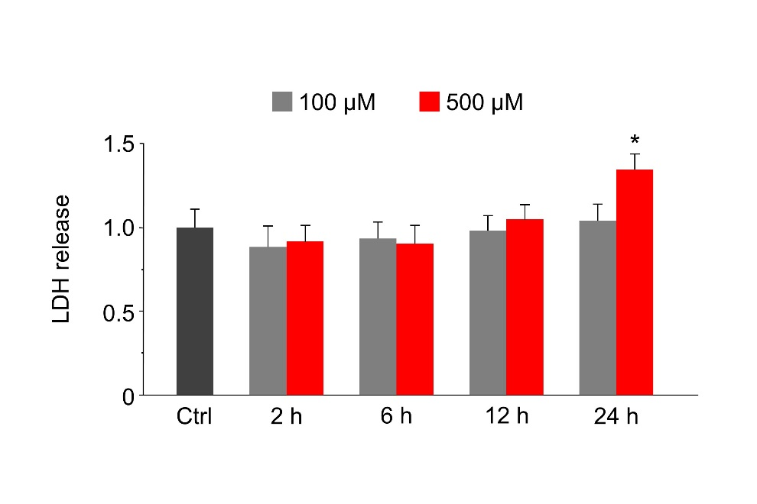
Figure S1. Effects of Mn on cell viability assessed by LDH release in primary astrocytes. Primary astrocytes were exposed to 100 μM or 500 μM Mn for the times indicated. Values are normalized to control. n=3. Values reflect means ± SD. *p<0.05.

Figure S2
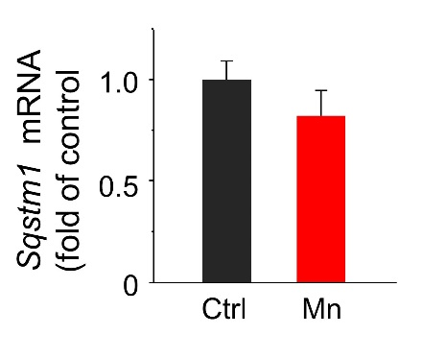
Figure S2. Mn exposure does not significantly alter Sqstm1 mRNA expression. Primary astrocytes were exposed to 100 μM Mn for 24 h. The Sqstm1 mRNA expression levels were determined by real-time qPCR. No significant difference is observed between control and Mn-treated astrocytes. n=4. Values reflect means ± SD.

Figure S3
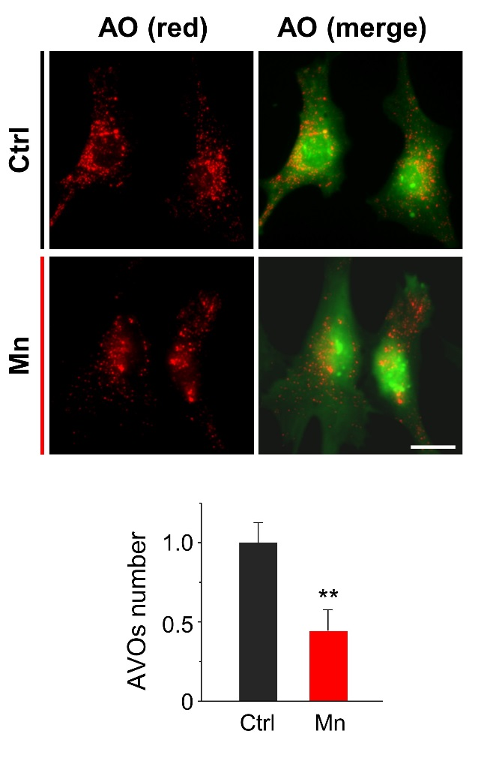
Figure S3. Mn reduces the number of acidic vesicular organelles (AVOs) in primary astrocytes. Primary astrocyte cultures were treated with 100 μM Mn for 24 h and stained with acridine orange (AO). Red staining is associated with acidic vesicles. Scale bar: 15 μm. Summary data show average number of red puncta per cell and are normalized to control group. n ≥ 60 astrocytes from 4 independent experiments. Values reflect means ± SD. **p<0.01.

Figure S4
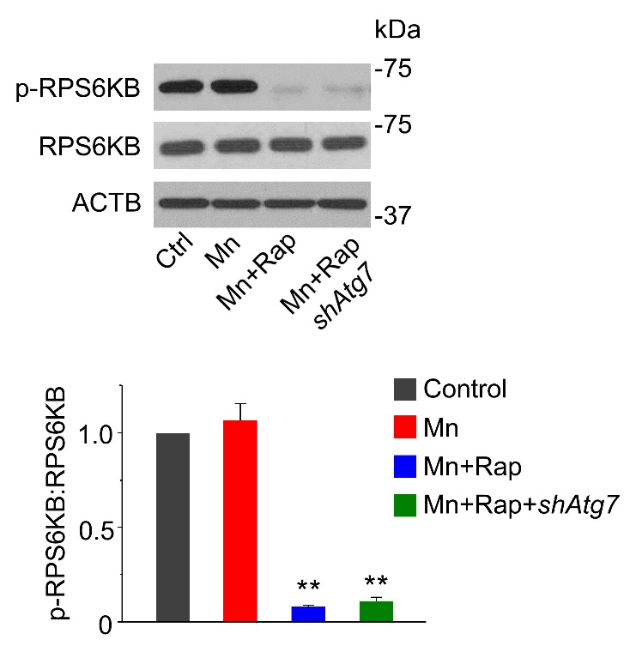
Figure S4. Rapamycin inhibits MTOR-RPS6KB signaling pathway in the presence of Mn. Primary astrocytes were transfected with lentivirus carrying non-target shRNA or Atg7 shRNA. Rapamycin (100 nM) was added 2 h prior to Mn exposure (100 μM, 24 h). Western blots of p-RPS6KB and total RPS6KB. ACTB is used as a loading control. Summary data are normalized to control (n=3). Values reflect means ± SD. **p<0.01.

Figure S5
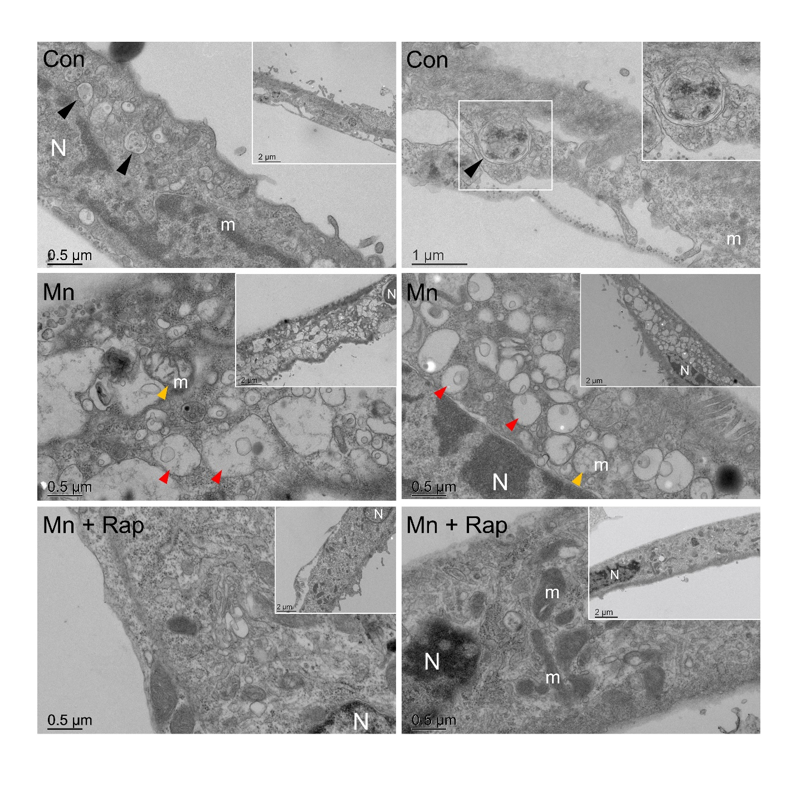
Figure S5. Electron micrographs showing rapamycin ameliorates ultrastructural changes in Mn-treated astrocytes. Con: control astrocytes with no Mn exposure; Mn: astrocyte treated with 100 μM Mn for 24 h; Mn+Rap: rapamycin (100 nM) was added 2 h prior to Mn exposure. N: nucleus; m: mitochondria; yellow arrow : damaged mitochondria; black arrow : autophagic structures; red arrow : unknown vesicles. Scale bar values are indicated in the images.

Figure S6
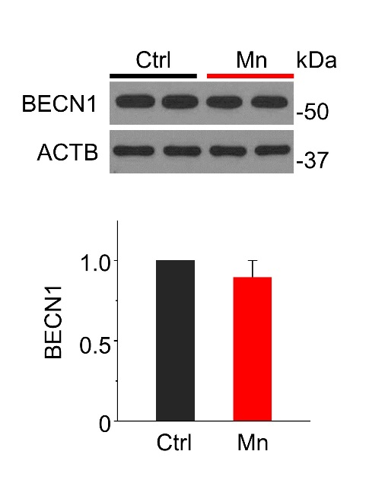
Figure S6. Western blots of BECN1 expression in primary astrocytes. Primary astrocytes were exposed to 100 μM Mn for 24 h. ACTB is used as a loading control. Summary data (n=3) are normalized to control. Values reflect means ± SD.

Figure S7
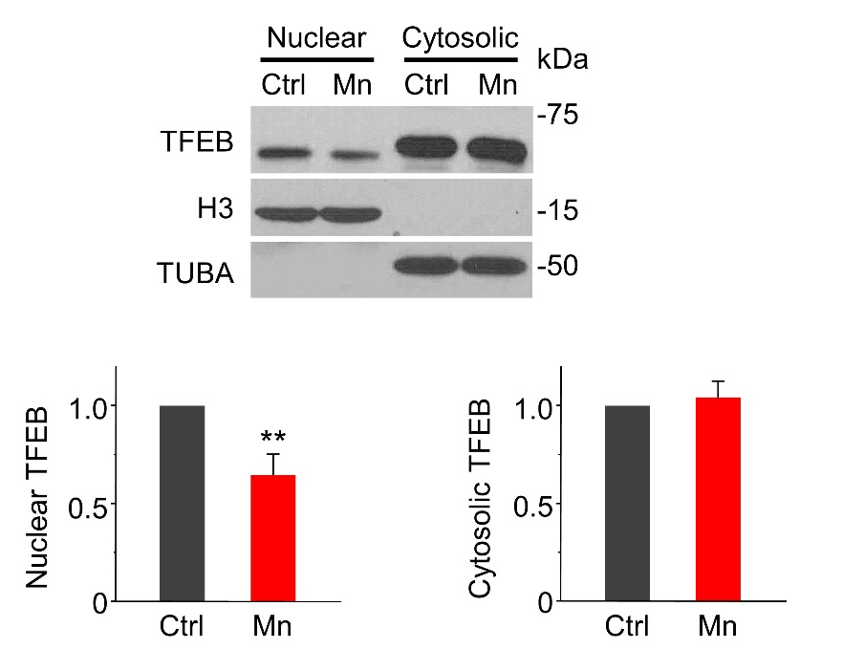
Figure S7. Mn decreases TFEB nuclear localization in mouse striatum. Western blots of TFEB in nuclear and cytoplasmic fraction in mice subjected to vehicle or MnCl₂∙4H₂O (50 mg/kg, s.c., day 0, 3 and 6) injection. Bar graphs show summary data (n=4). Nuclear and cytoplasmic fractions are normalized to histone H3 and TUBA, respectively. Summary data are normalized to control. Values reflect means ± SD. **p<0.01.
Figure S8
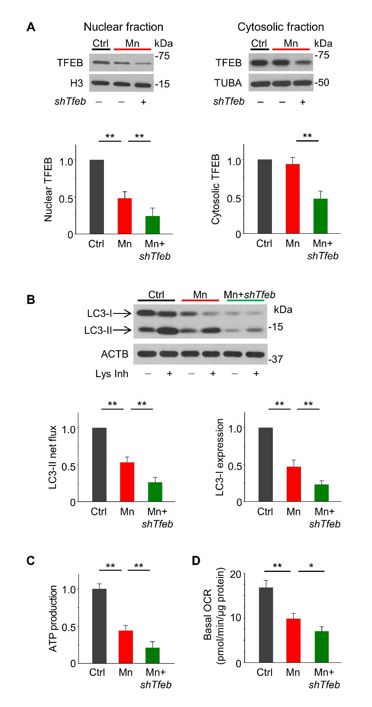
Figure S8. TFEB knockdown exacerbates Mn-induced autophagy failure and mitochondrial dysfunction. Primary astrocytes were transfected with lentivirus carrying non-target shRNA or Tfeb shRNA and then exposed to 100 μM Mn for 24 h. (A) Western blots of TFEB in nuclear and cytoplasmic fractions. Bar graphs show summary data (n=3). Nuclear and cytoplasmic fractions are normalized to histone H3 and TUBA, respectively. (B) Western blots of LC3 in the presence and absence of lysosomal inhibitors (Lys Inh, 20 mM NH₄Cl and 100 μM leupeptin) for the last 2 h. ACTB is used as a loading control. Bar graphs show LC3-II flux and LC3-I protein levels (n=3). (C) Total intracellular ATP (n=3). (D) Basal OCR (n=3). Values are normalized to protein content. Values are normalized to control group in (A, B and C). Values reflect means ± SD. *p<0.05, **p<0.01.

Figure S9
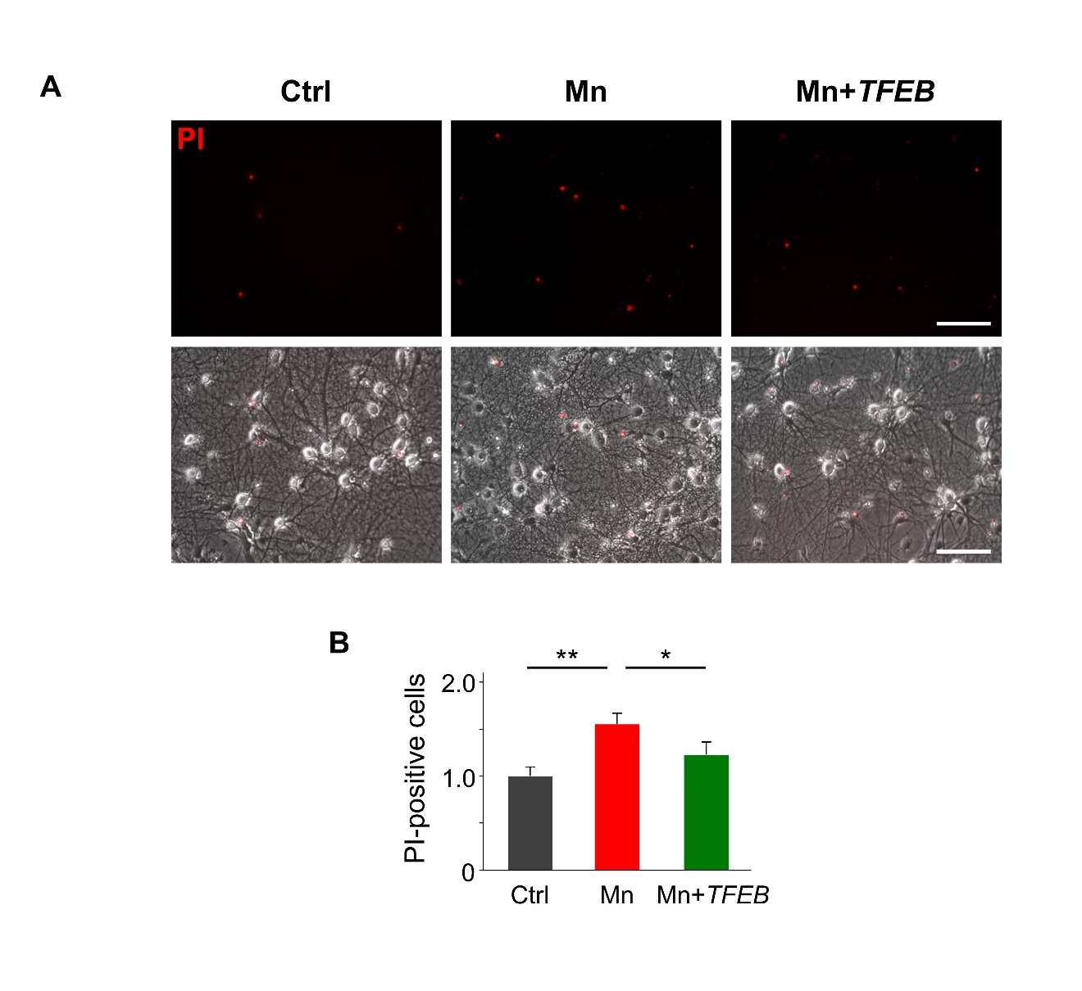
Figure S9. TFEB overexpressing astrocytes attenuate Mn-induced neurotoxicity in a neuron-astrocyte co-culture system. Primary astrocytes were plated on transwell inserts and transfected with lentivirus carrying TFEB or empty vector. Primary midbrain dopaminergic neurons were plated on 24-well plates and exposed to Mn on day 14. The neuron-astrocyte co-cultures were exposed to 100 μM Mn for 24 h. (A) Representative fluorescent and bright-field images showing uptake of PI (red) by primary neurons, an indicator of cell death. Scale bar: 50 μm. (B) Summary data of PI-stained neurons. n=5-7 coverslips per treatment group/3 independent experiments. Values are normalized to control and reflect means ± SD. *p<0.05, **p<0.01.
Figure S10
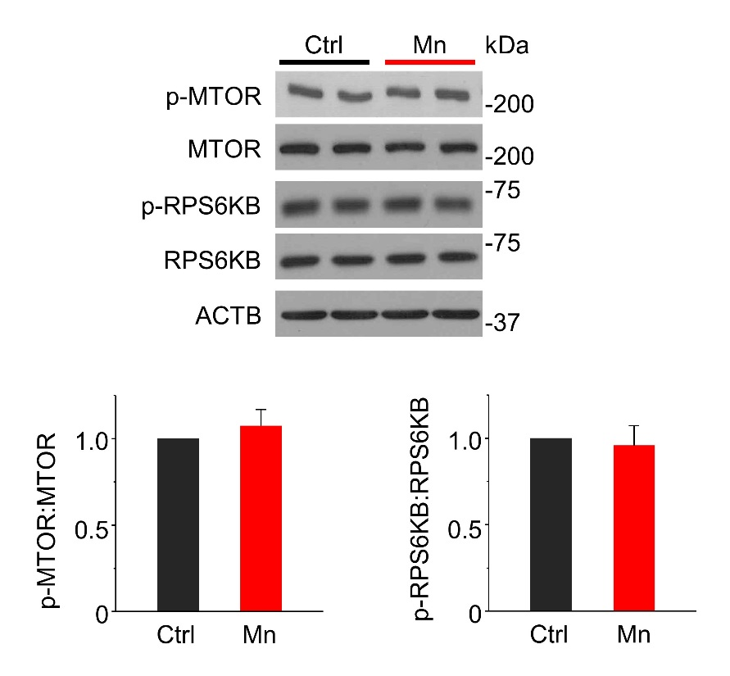
Figure S10. Mn exposure does not alter MTOR signaling in primary astrocytes. Primary astrocytes were exposed to 100 μM Mn for 24 h. Western blots of p-MTOR, total MTOR, p-RPS6KB and total RPS6KB. ACTB is used as a loading control. Summary data (n=3) are normalized to control. Values reflect means ± SD.

Figure S11
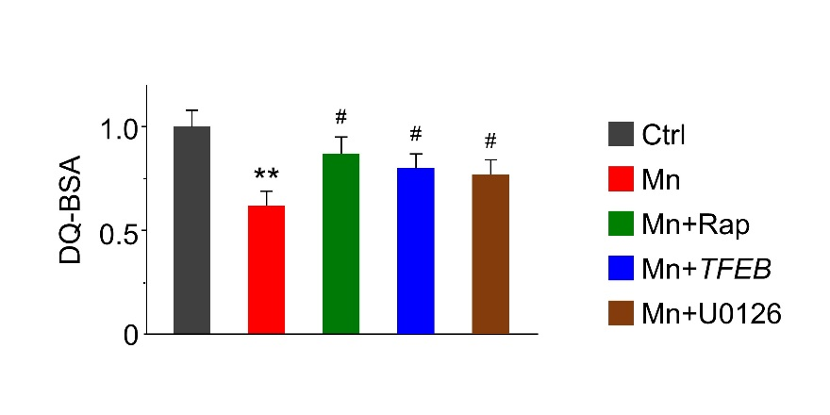
Figure S11. Lysosomal proteolytic activity is partially restored by treatment with rapamycin, TFEB overexpression, or U0126 in Mn-exposed astrocytes. Lysosomal proteolytic activity is measured by DQ-BSA fluorescence intensities. Summary data (n=3) are normalized to control. Values reflect means ± SD. **p<0.01 vs. control, #p<0.05 vs. Mn.

Figure S12
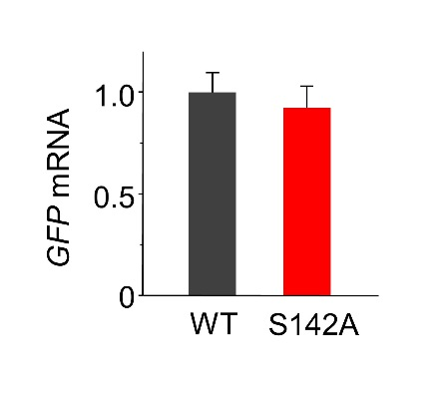
Figure S12. Quantitative PCR shows equal levels of GFP mRNA (reporter) are expressed in astrocytes transfected with lentivirus expressing wild type (WT) TFEB-GFP or site-mutant TFEB^{S142A}-GFP (n=4). Values reflect means ± SD.
Figure S13
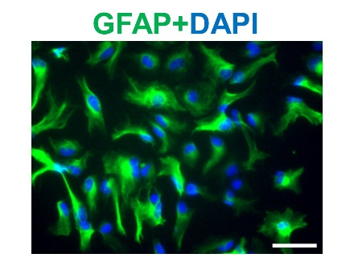
Figure S13. Primary astrocyte cultures are >95% positive for the astrocyte marker GFAP. Primary astrocytes were immunostained for GFAP (green) and counterstained with DAPI (blue). Scale bar: 50 μm.

