Mycotoxins accumulation showed significant positive correlation to disease severity during Fusarium Head Blight infection in wheat using in vitro spike culture technique
CHEN HUANG, MANU P. GANGOLA AND RAVINDRA N. CHIBBAR

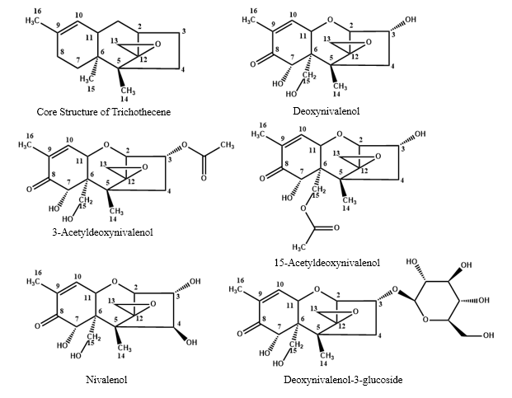
Fig. S1 Chemical structures of analyzed mycotoxins produced during Fusarium head blight in wheat

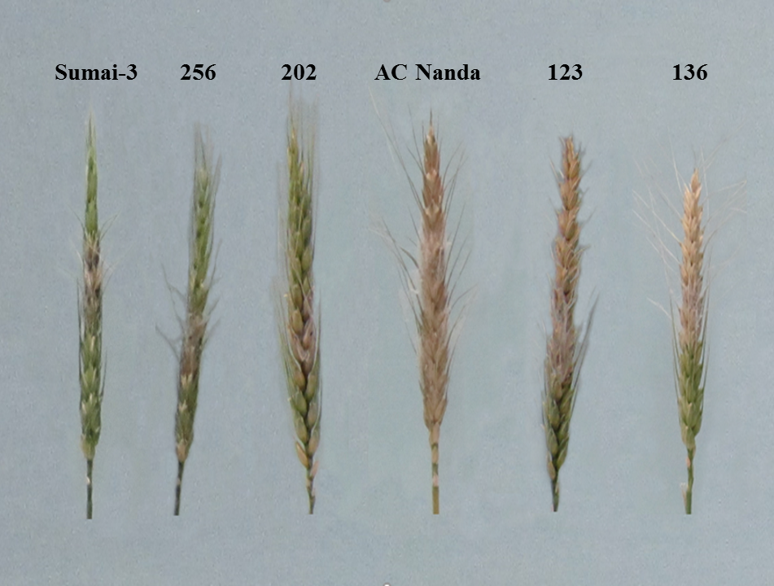

Fig. S2 In vitro spike culture showing difference between FHB resistant (Sumai-3 256 and 202) and FHB susceptible (AC Nanda, 123 and 136) genotypes

