SUPPLEMENTAL MATERIAL

Time to treatment failure following initiation of fingolimod versus teriflunomide for multiple sclerosis: A retrospective U.S. claims study

Table S1. Codes used to identify MS treatments in medical and pharmacy claims

Treatment | GPI codes | HCPCS codes
Disease-modifying therapies
Alemtuzumab | 62 40 50 10 00 xx xx | J0202, J9010, Q9979
Daclizumab | 62 40 50 25 00 xx xx | J7513
Dimethyl fumarate | 62 40 55 25 00 xx xx  96 48 58 37 40 xx xx
Fingolimod | 62 40 70 25 10 xx xx
Glatiramer acetate | 62 40 00 30 10 xx xx | J1595
Interferon beta-1a | 62 40 30 60 45 xx xx | J1825, J1826, Q3025, Q3026, Q3027, Q3028
Interferon beta-1b | 62 40 30 60 50 xx xx | J1830
Mitoxantrone | 21 20 00 55 00 xx xx | J9293
Natalizumab | 62 40 50 50 00 xx xx | J2323, Q4079
Peginterferon beta-1a | 62 40 30 75 30 xx xx
Rituximab | 21 35 30 60 00 xx xx | J9310
Teriflunomide | 62 40 40 70 00 xx xx
Acute treatments for MS
Corticosteroids | 22 10 00 15 10 xx xx  22 10 00 20 00 xx xx  22 10 00 20 10 xx xx  22 10 00 20 20 xx xx  22 10 00 30 00 xx xx  22 10 00 30 10 xx xx  22 10 00 30 20 xx xx  22 10 00 45 00 xx xx  22 10 99 02 60 xx xx | J1020, J1030, J1040, J1094, J1100, J2920, J2930, J7506, J7509, J7512, J8540
Corticotropin | 30 30 00 10 00 xx xx  30 30 00 20 10 xx xx | J0800
GPI Generic Product Identifier, HCPCS Healthcare Common Procedure Coding System, MS multiple sclerosis

Table S2. Codes used to identify MS symptoms in medical claims

Condition | ICD-9-CM diagnosis codes
Demyelinating disease of CNS, unspecified | 341.9x
Disorders of optic nerve and visual pathways | 377.xx
General symptoms: dizziness and giddiness | 780.4x
General symptoms: fatigue/malaise | 780.7x
Neurogenic bladder NOS | 596.54
Other causes of myelitis | 323.82
Other disorders of soft tissues: neuralgia, neuritis, and radiculitis, unspecified | 729.2x
CNS Central nervous system, ICD-9-CM International Classification of Diseases, 9th Revision, Clinical Modification, MS multiple sclerosis, NOS Not otherwise specified

Table S3. Kaplan-Meier analysis of time to treatment failure by age group

Age group / cohort | N | Median  (months) | IQR (months) | Proportion of patients with event (%) |  |  | Log-rank  p-value
 |  |  |  | 12-month | 18-month | 24-month
18 to <35 years
Teriflunomide | 142 | 8.0 | (2.8, 16.3) | 63.7% | 77.0% | 84.8% | -
Fingolimod | 620 | 18.0 | (5.9, NR) | 38.7% | 50.3% | 56.5% | <0.001 | *
35 to <45 years
Teriflunomide | 393 | 9.3 | (2.8, 28.8) | 54.5% | 65.0% | 70.7% | -
Fingolimod | 822 | 24.6 | (7.7, NR) | 34.3% | 43.6% | 49.4% | <0.001 | *
45 to <55 years
Teriflunomide | 701 | 10.4 | (3.0, 35.5) | 53.7% | 62.0% | 69.5% | -
Fingolimod | 842 | 18.3 | (5.9, 40.5) | 40.9% | 49.3% | 59.0% | <0.001 | *
55 to <65 years
Teriflunomide | 623 | 10.1 | (2.8, 34.1) | 54.5% | 63.4% | 69.6% | -
Fingolimod | 420 | 18.8 | (6.0, 41.3) | 39.9% | 49.4% | 55.8% | <0.001 | *

IQR interquartile range, NR not reached

Table S4. Multivariable Cox proportional hazards model of time to first relapse
 | HR | 95% CI | P-value
Estimated effect of fingolimod (vs. teriflunomide), unadjusted | 0.772 | (0.694, 0.860) |  | <0.001 | *
Estimated effect of fingolimod (vs. teriflunomide), adjusted | 0.757 | (0.674, 0.849) |  | <0.001 | *
Age (years) | 0.997 | (0.992, 1.003) |  | 0.352
Female | 1.111 | (0.972, 1.271) |  | 0.124
US geographic region (vs. South)
Northeast | 1.023 | (0.882, 1.186) |  | 0.767
North central | 1.137 | (0.991, 1.305) |  | 0.068
Other (i.e., West or unknown) | 0.984 | (0.838, 1.155) | 0.843
Insurance type (vs. preferred provider organization)
Health maintenance organization (HMO) | 1.145 | (0.971, 1.352) | 0.108
Other | 1.022 | (0.900, 1.161) | 0.734
Index year (vs. 2012)
2013 | 0.972 | (0.805, 1.174) | 0.768
2014 | 0.990 | (0.811, 1.209) | 0.925
2015 | 1.066 | (0.861, 1.319) | 0.557
Symptoms during the 1-year baseline period
Demyelinating disease of CNS, unspecified | 0.853 | (0.701, 1.039) | 0.114
Disorders of optic nerve and visual pathways | 1.034 | (0.899, 1.188) | 0.640
General symptoms: dizziness and giddiness | 1.057 | (0.886, 1.261) | 0.539
General symptoms: fatigue/malaise | 1.318 | (1.174, 1.479) | <0.001 |  | *
Neurogenic bladder NOS | 1.354 | (1.119, 1.639) | 0.002 |  | *
Other causes of myelitis | 1.445 | (0.878, 2.379) | 0.147
Other disorders of soft tissues: neuralgia, neuritis, and radiculitis, unspecified | 0.989 | (0.734, 1.333) | 0.944
CCI¹ during the 1-year baseline period | 1.079 | (1.029, 1.131) | 0.002 |  | *
Number of relapses during the 1-year baseline period | 1.544 | (1.459, 1.633) | <0.001 |  | *
Use of ≥1 DMT during the 1-year baseline period | 1.014 | (0.904, 1.137) | 0.817
* p-value < 0.05; HR: Hazard ratio; CI: Confidence interval; US: United States; CNS: Central nervous system; NOS: Not otherwise specified; CCI: Charlson comorbidity index; DMT: Disease modifying therapy

Table S5. Multivariable Cox proportional hazards model of time to treatment discontinuation
 | HR | 95% CI | P-value
Estimated effect of fingolimod (vs. teriflunomide), unadjusted | 0.568 | (0.515, 0.625) | <0.001 | *
Estimated effect of fingolimod (vs. teriflunomide), adjusted | 0.550 | (0.495, 0.610) | <0.001 | *
Age (years) | 0.994 | (0.989, 0.999) | 0.025 | *
Female | 1.151 | (1.019, 1.300) | 0.023 | *
US geographic region (vs. South)
Northeast | 1.053 | (0.922, 1.202) | 0.446
North central | 1.034 | (0.910, 1.175) | 0.610
Other (i.e., West or unknown) | 1.030 | (0.894, 1.186) | 0.687
Insurance type (vs. preferred provider organization)
Health maintenance organization (HMO) | 1.070 | (0.916, 1.250) | 0.393
Other | 1.137 | (1.016, 1.272) | 0.025 | *
Index year (vs. 2012)
2013 | 1.020 | (0.860, 1.211) | 0.820
2014 | 0.939 | (0.784, 1.125) | 0.493
2015 | 0.948 | (0.783, 1.148) | 0.585
Symptoms during the 1-year baseline period
Demyelinating disease of CNS, unspecified | 0.839 | (0.699, 1.006) | 0.058
Disorders of optic nerve and visual pathways | 1.004 | (0.882, 1.143) | 0.948
General symptoms: dizziness and giddiness | 1.026 | (0.869, 1.212) | 0.762
General symptoms: fatigue/malaise | 1.117 | (1.004, 1.244) | 0.043 | *
Neurogenic bladder NOS | 1.258 | (1.047, 1.512) | 0.015 | *
Other causes of myelitis | 1.029 | (0.636, 1.666) | 0.907
Other disorders of soft tissues: neuralgia, neuritis, and radiculitis, unspecified | 0.833 | (0.616, 1.126) | 0.235
CCI¹ during the 1-year baseline period | 1.025 | (0.976, 1.077) | 0.320
Number of relapses during the 1-year baseline period | 1.116 | (1.048, 1.188) | <0.001 | *
Use of ≥1 DMT during the 1-year baseline period | 0.795 | (0.719, 0.880) | <0.001 | *
* p-value < 0.05; HR: Hazard ratio; CI: Confidence interval; US: United States; CNS: Central nervous system; NOS: Not otherwise specified; CCI: Charlson comorbidity index; DMT: Disease modifying therapy

Table S6. Univariate and multivariable negative binomial regressions of ARR

 | IRR | 95% CI | P-value
Estimated effect of fingolimod (vs. teriflunomide) on ARR, unadjusted | 0.77 | (0.67, 0.88) | <0.001 | *
Estimated effect of fingolimod (vs. teriflunomide) on ARR, adjusted | 0.78 | (0.68, 0.89) | <0.001 | *
Age (years) | 1.00 | (0.99, 1.01) | 0.705
Female | 1.20 | (1.02, 1.42) | 0.026 | *
Census region (vs. South)
Northeast | 1.04 | (0.87, 1.24) | 0.669
North central | 1.17 | (1.00, 1.39) | 0.057
Other (i.e., West or unknown) | 1.06 | (0.88, 1.28) | 0.547
Insurance type (vs. preferred provider organization)
Health maintenance organization (HMO) | 1.19 | (0.98, 1.45) | 0.087
Other | 0.94 | (0.81, 1.10) | 0.457
Index year (vs. 2012)
2013 | 0.97 | (0.76, 1.24) | 0.816
2014 | 0.94 | (0.74, 1.21) | 0.646
2015 | 1.12 | (0.87, 1.44) | 0.370
Symptoms during 1-year baseline period
Demyelinating disease of CNS, unspecified | 0.87 | (0.69, 1.10) | 0.232
Disorders of optic nerve and visual pathways | 1.00 | (0.85, 1.18) | 0.978
General symptoms: dizziness and giddiness | 1.10 | (0.90, 1.35) | 0.359
General symptoms: fatigue/malaise | 1.29 | (1.13, 1.48) | <0.001 | *
Neurogenic bladder NOS | 1.41 | (1.13, 1.75) | 0.002 | *
Other causes of myelitis | 1.45 | (0.81, 2.58) | 0.207
Other disorders of soft tissues: neuralgia, neuritis, and radiculitis, unspecified | 1.19 | (0.85, 1.65) | 0.309
CCI during 1-year baseline period | 1.12 | (1.06, 1.19) | <0.001 | *
Number of relapses during 1-year baseline period | 1.66 | (1.55, 1.78) | <0.001 | *
Use of ≥1 DMT during 1-year baseline period | 1.02 | (0.89, 1.17) | 0.739

*p-value < 0.05; ARR Annualized relapse rate, CCI Charlson comorbidity index, CI Confidence interval, CNS Central nervous system, DMT Disease modifying therapy, IRR Incidence rate ratio, NOS Not otherwise specified

Notes: ARR was calculated as the number of relapses divided by total time at risk (in years). Time at risk started at the index date and ended at one year after the index date or end of eligibility, whichever occurred first. The multivariable analysis of ARR was conducted using a negative binomial regression model with number of relapses (numerator of ARR) as the dependent variable and the natural logarithm of years at risk (denominator of ARR) as the offset variable. Baseline characteristics were included as control variables.

Table S7. Univariate and multivariable logistic regressions of adherence measured by MPR ≥80%

 | Odds Ratio | 95% CI | P-value
Estimated effect of fingolimod (vs. teriflunomide) on MPR ≥80%, unadjusted | 1.75 | (1.45, 2.12) | <0.001 | *
Estimated effect of fingolimod (vs. teriflunomide) on MPR ≥80%, adjusted | 1.94 | (1.58, 2.39) | <0.001 | *
Age (years) | 1.02 | (1.01, 1.03) | <0.001 | *
Female | 0.92 | (0.73, 1.17) | 0.506
Census region (vs. South)
Northeast | 1.11 | (0.85, 1.44) | 0.456
North central | 1.21 | (0.93, 1.57) | 0.156
Other (i.e., West or unknown) | 1.12 | (0.85, 1.46) | 0.430
Insurance type (vs. preferred provider organization)
Health maintenance organization (HMO) | 0.78 | (0.59, 1.04) | 0.087
Other | 1.08 | (0.85, 1.37) | 0.539
Index year (vs. 2012)
2013 | 0.95 | (0.68, 1.33) | 0.787
2014 | 1.19 | (0.84, 1.69) | 0.317
2015 | 1.28 | (0.89, 1.84) | 0.188
Symptoms during 1-year baseline period
Demyelinating disease of CNS, unspecified | 1.19 | (0.83, 1.70) | 0.334
Disorders of optic nerve and visual pathways | 1.01 | (0.78, 1.31) | 0.928
General symptoms: dizziness and giddiness | 0.94 | (0.68, 1.30) | 0.702
General symptoms: fatigue/malaise | 0.92 | (0.74, 1.14) | 0.433
Neurogenic bladder NOS | 1.40 | (0.91, 2.17) | 0.130
Other causes of myelitis | 0.84 | (0.32, 2.17) | 0.716
Other disorders of soft tissues: neuralgia, neuritis, and radiculitis, unspecified | 1.25 | (0.68, 2.29) | 0.480
CCI during 1-year baseline period | 0.91 | (0.83, 1.00) | 0.044 | *
Number of relapses during 1-year baseline period | 1.03 | (0.90, 1.17) | 0.693
Use of ≥1 DMT during 1-year baseline period | 1.11 | (0.91, 1.36) | 0.322
*p-value < 0.05; CCI Charlson comorbidity index, CI Confidence interval, CNS Central nervous system, DMT Disease modifying therapy, MPR Medication possession ratio, NOS Not otherwise specified

Notes: MPR was calculated as the fraction of days with an available index drug supply out of the total number of days during the measurement period (from index date until the earliest of index drug discontinuation date, end of continuous eligibility, or one year after the index date).

Table S8. Multivariable logistic regression of adherence measured by PDC ≥80%

 | Odds Ratio | 95% CI | P-value
Estimated effect of fingolimod (vs. teriflunomide) on PDC ≥80%, unadjusted | 2.25 | (1.93, 2.61) | <0.001 | *
Estimated effect of fingolimod (vs. teriflunomide) on PDC ≥80%, adjusted | 2.33 | (1.98, 2.74) | <0.001 | *
Age (years) | 1.01 | (1.00, 1.02) | 0.005 | *
Female | 0.82 | (0.68, 0.98) | 0.032 | *
Census region (vs. South)
Northeast | 0.90 | (0.73, 1.11) | 0.347
North central | 0.97 | (0.80, 1.18) | 0.777
Other (i.e., West or unknown) | 0.86 | (0.68, 1.08) | 0.187
Insurance type (vs. preferred provider organization)
Health maintenance organization (HMO) | 0.90 | (0.71, 1.15) | 0.417
Other | 0.94 | (0.78, 1.12) | 0.471
Index year (vs. 2012)
2013 | 0.87 | (0.66, 1.14) | 0.301
2014 | 0.99 | (0.75, 1.31) | 0.934
2015 | 0.91 | (0.67, 1.23) | 0.532
Symptoms during 1-year baseline period
Demyelinating disease of CNS, unspecified | 1.14 | (0.87, 1.50) | 0.353
Disorders of optic nerve and visual pathways | 1.13 | (0.92, 1.39) | 0.244
General symptoms: dizziness and giddiness | 0.94 | (0.73, 1.23) | 0.669
General symptoms: fatigue/malaise | 0.89 | (0.75, 1.06) | 0.196
Neurogenic bladder NOS | 0.90 | (0.66, 1.22) | 0.494
Other causes of myelitis | 1.99 | (0.77, 5.10) | 0.153
Other disorders of soft tissues: neuralgia, neuritis, and radiculitis, unspecified | 0.94 | (0.60, 1.46) | 0.773
CCI during 1-year baseline period | 0.97 | (0.90, 1.05) | 0.455
Number of relapses during 1-year baseline period | 0.84 | (0.76, 0.93) | 0.001 | *
Use of ≥1 DMT during 1-year baseline period | 1.31 | (1.11, 1.53) | 0.001 | *

*p-value < 0.05; CCI Charlson comorbidity index, CI Confidence interval, CNS Central nervous system, DMT Disease modifying therapy, NOS Not otherwise specified, PDC Proportion of days covered

Notes: Patients were included in the estimation of PDC only if they had one year of continuous health plan enrollment following the index date. PDC was calculated as the fraction of days with an available index drug supply out of a fixed interval of 365 days.

Figure S1. Time to first relapse

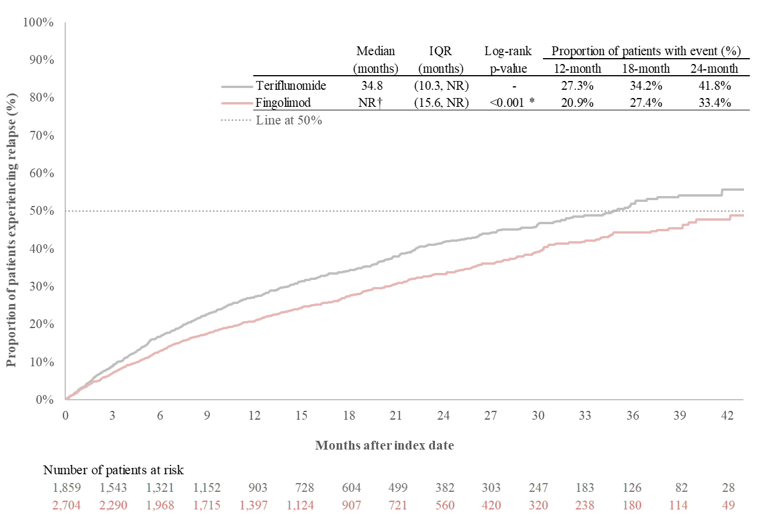

*p-value < 0.05; IQR Interquartile range; NR Not reached
†Median time to first relapse was not reached in the fingolimod cohort, as the cumulative proportion of patients experiencing relapse was below 50% at the end of the available post-index follow-up.

Figure S2. Time to treatment discontinuation

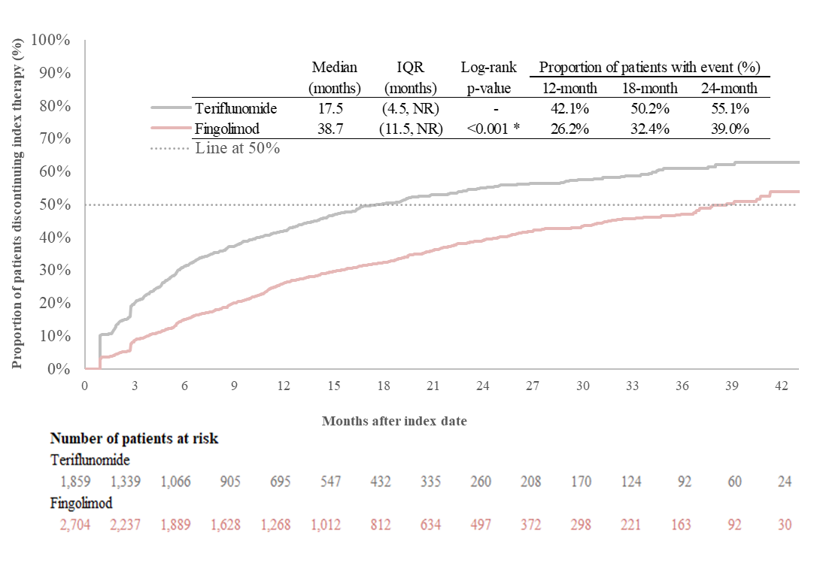
*p-value < 0.05; IQR Interquartile range; NR Not reached

