Supplementary materials
Determination of an organophosphate pesticide using antibody immobilized hybrid nanocomposites
Navpreet Kaur ª, Archana Bhatnagar ª, Aman Bhalla ^{b} and Nirmal Prabhakar ^{a *}
ª Department of Biochemistry, Panjab University Chandigarh 160014, India
^{b} Department of Chemistry, Panjab University Chandigarh 160014, India
e-mail address: nirmalprabhakar@gmail.com, nirmalprabhakar@pu.ac.in

SI-1: Conjugate characterization
Hapten - BSA conjugate was characterized by SDS-PAGE electrophoresis using 15% separating and 5% stacking gel. The conjugate solution was prepared in SDS-PAGE sample buffer (50 mM Tris-Cl, 2% SDS, 10% glycerol, 0.1% bromophenol blue, 100 mM DTT, pH 6.8) and heated to 90ºC for 5 min. The solution was loaded along with the marker and run under denaturing conditions for 2 h at 100 V. The gel was stained according to Coomassie blue staining using a standard developing protocol supplied by the manufacturer followed by destaining and washing in milli Q water.
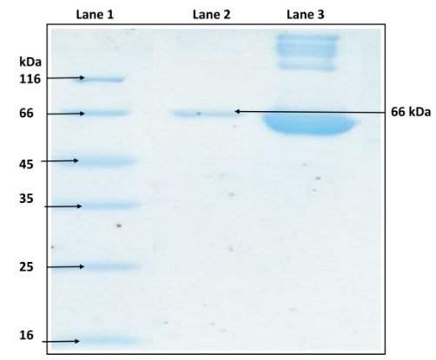
Figure S1. SDS-PAGE containing bands of marker, BSA and hapten - BSA conjugate in lane 1, 2 and 3.

SI-2: Abs characterization by dot blot
The obtained Abs raised against immunogen were characterized by dot blot. For the analysis, 3 μL of BSA, hapten and hapten - BSA was spotted on nitrocellulose membrane. The membrane was air dried and kept in 0.8% skimmed milk for overnight blocking followed by washing with 1X PBS (pH 7.5) thrice for 10 min. Each spot on the membrane was incubated for 2 h with 10 μL of the serum as primary antibody. Again the membrane was washed thrice with 1X PBS (pH 7.5) and 0.01% Tween - 20. Further, the membrane was incubated with secondary antibody diluted in 1X PBS (pH 7.5) (1:2000) for 2 h and washed thrice. The spots appeared on membrane were analyzed after adding the chemiluminescent reagent (Luminol).

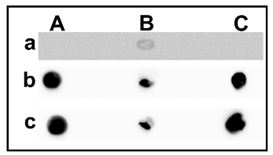
Figure S2. Dot blots for the antigens BSA (A), hapten (B) and hapten - BSA (C) for - control (a), after immunization (b) and after purification (c).

SI-3: Purification of raised Abs
The polyclonal Abs were purified by affinity chromatography in which Abs were allowed to pass through Protein A sepharose column and bound antibody was eluted with 0.1 M citric acid elution buffer (pH 2.75). The detailed procedure for purification of the developed Abs was followed as guided by Biovision Company.

SI-4: Electroactive surface area estimation
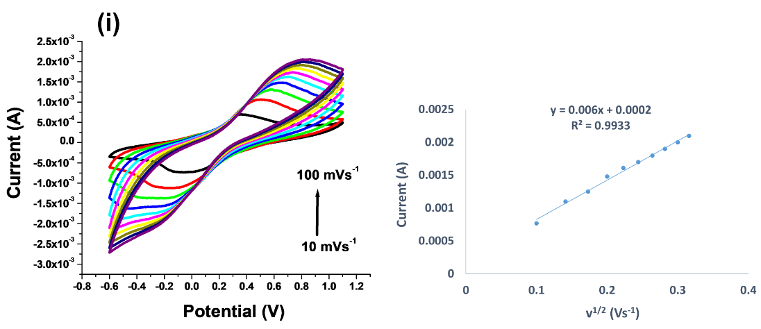

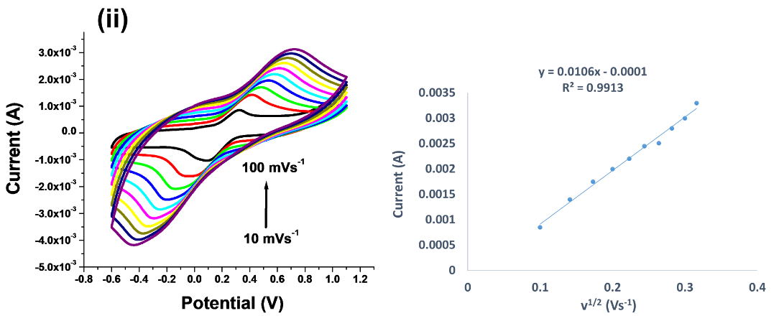

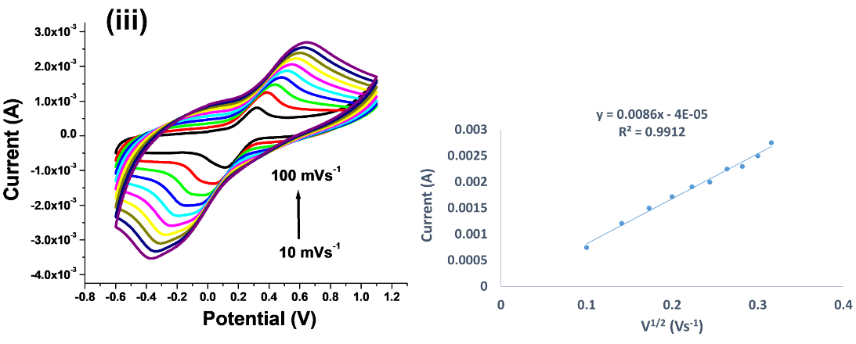
Figure S3. CVs of the PEDOT/FTO (i), PEDOT-c-MWCNTs/FTO (ii) and Ab/PEDOT-c-MWCNTs/FTO (iii) bioelectrode at scan rates ranging from 10 – 100 mVs⁻¹ in 0.1 M PBS (pH 7.5) containing 5 mM [Fe(CN)₆]^{3-/4-} and 0.1 M KCl.

SI-5: Parameters optimization
(a) Ab concentration
The Ab concentration had a great effect on the performance of an immunosensor. Different amounts of Ab within the linear range 1 - 150 µgmL⁻¹ were immobilized on the nanocomposites surface (Fig. S4a). The peak current increased with increase in concentration upto 50 µgmL⁻¹ whereas, further increase in concentration led to fall of the DPV peaks. It was found that maximum response occurred at 50 µgmL⁻¹ due to the perfect Ag - Ab interactions. Therefore, 50 µgmL⁻¹ concentration was selected for further experiments.
(b) Incubation time
The incubation time is an important influencing factor in the development of immunosensor. The prepared immunosensor was incubated with 1 nM malathion solution for 2 - 10 min. As shown in Fig. S4b, the peak current decreased with increase in time and after 8 min, the current response showed no obvious decrease, which suggested the interaction of Ab with malathion reached an equilibration state. Thus, 8 min was employed as the optimized incubation time.

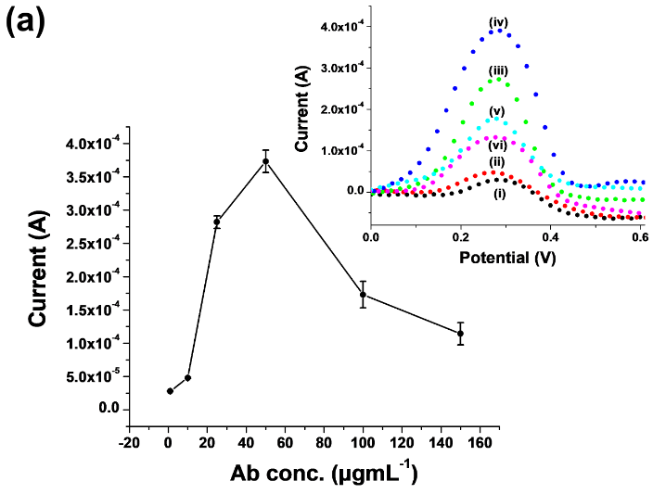

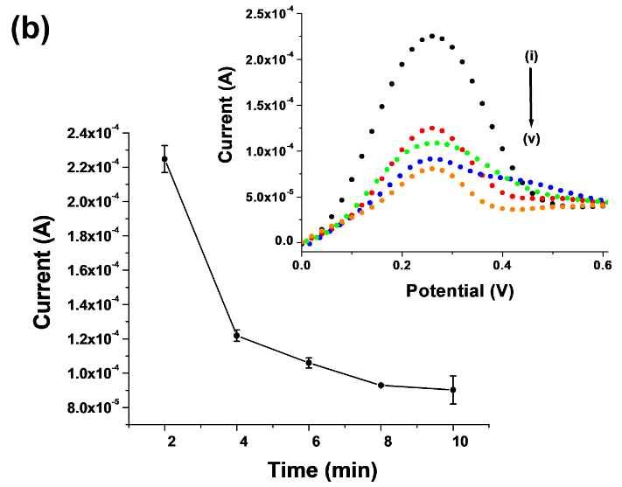
Figure S4. (a) Optimization of Ab concentrations 1 (i), 10 (ii), 25 (iii), 50 (iv), 100 (v) and 150 µgmL⁻¹ (vi). (b) Incubation time of malathion with anti-malathion Abs for 2 (i), 4 (ii), 6 (iii), 8 (iv) and 10 min (v). Error bars represents the standard deviation of three measurements and inset demonstrates the DPV peaks obtained.

SI-6: Regeneration, reusability and storage stability studies

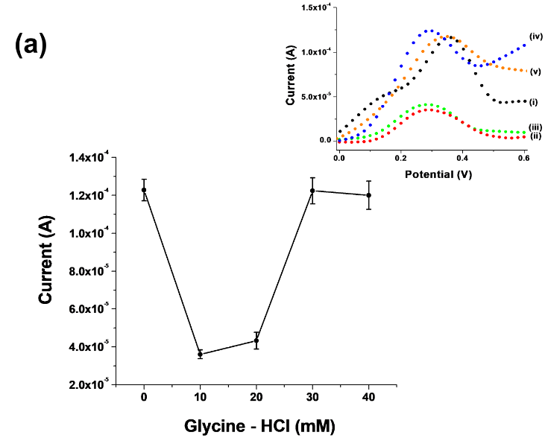

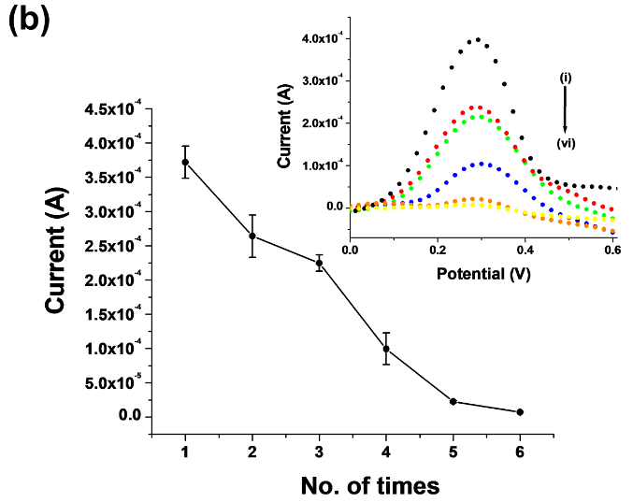

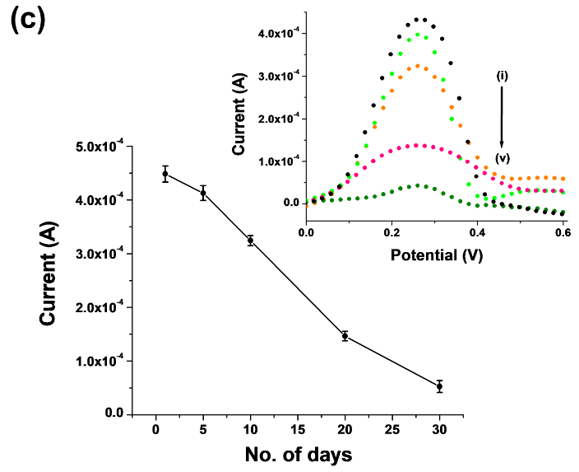
Figure S5. (a) Regeneration of an immunosensor with glycine - HCl (pH 2.3) of concentrations 0 (i), 10 (ii), 20 (iii), 30 (iv) and 40 mM (v). (b) Reusability studies upto six cycles. (c) Storage stability on days: 1 (i), 5 (ii), 10 (iii), 20 (iv) and 30 (v).

SI-7: Spiked sample analysis

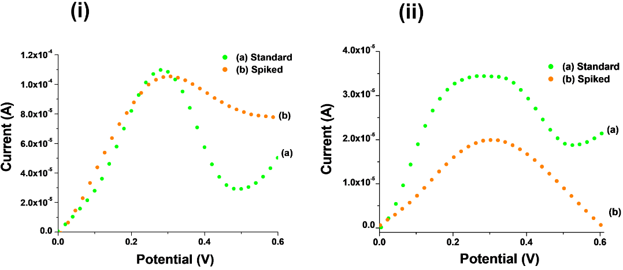

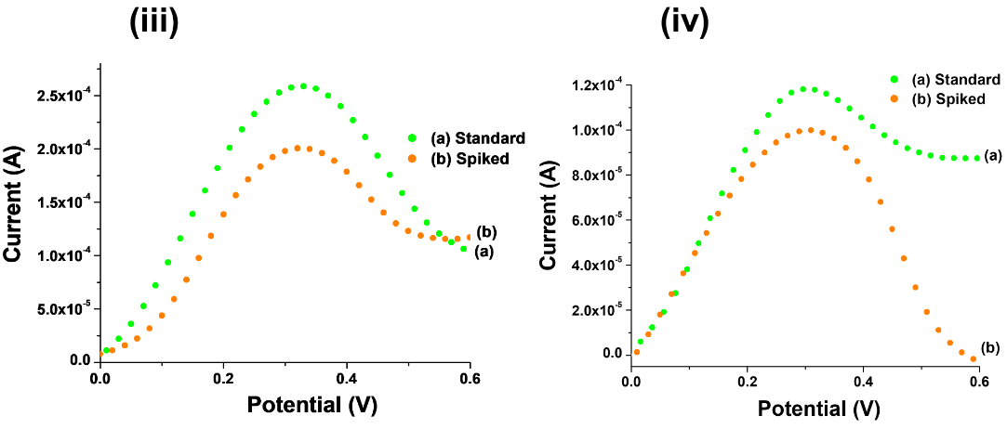

Figure S6. DPV peaks of malathion standards (a) as well as spiked lettuce (b) of concentrations 0.1 pM (i), 0.01 nM (ii), 1 nM (iii) and 0.1 µM (iv).
SI-8: RP-HPLC analysis

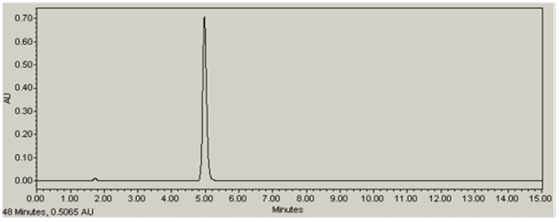
Figure S7. Chromatogram peak of malathion standard with RT at 5 min.

For this, C18 column (Spherisorb® 4.6×250 mm, 5 µm ODS2) and water : acetonitrile (30:70) was used as a mobile phase. The compound was monitored at 230 nm using PDA detector. Retention time (RT) of malathion standard and spiked sample was found 5 min.

