Supplementary information
Figure S1. TGA analysis of Sm-PL₃ Complex

Figure S2. UV-Vis. Spectrum of Sm-PL₃ Complex

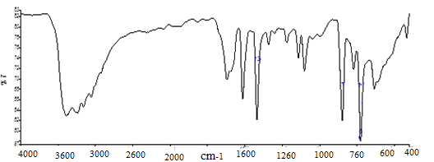
Figure S3. IR Spectrum of Sm-PL₃ Complex

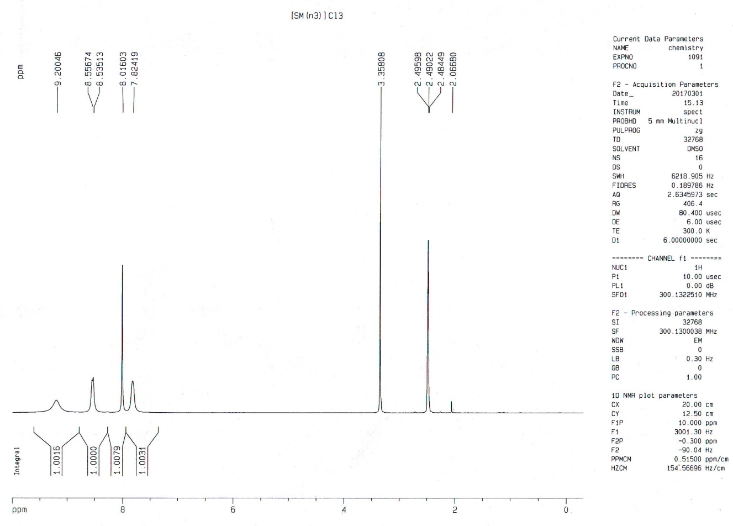

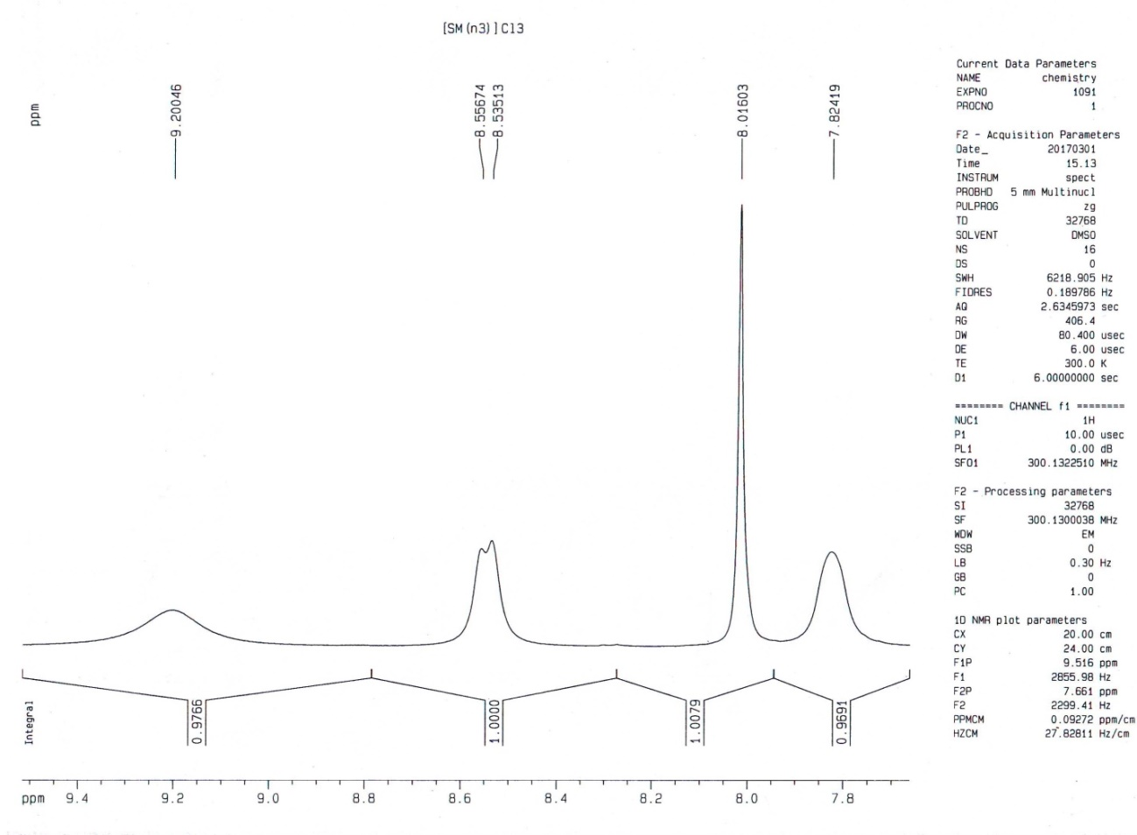
Figure S4. 1HNMR Spectrum of Sm-PL₃ Complex

