TECHNICAL ANNEX
Community-based Monitoring of Oil Extraction: Lesson Learned in the Ecuadorian Amazon
This section covers the main technical aspects of the paper “Community Monitoring of Environmental Liabilities in the Northern Ecuadorian Amazon: Origins and Lesson Learned” and it is intended to inform the community of practitioners on the main features of the Community Based Monitoring (CBM) system and main technological tools used.
Figure 1 shows the essential components and flow of information within the CBM system:
(a) organizational structure refers to the way the organizations define their objectives and the strategic use of the information produced, how they select their monitors, and how they sustain the activities. In our case, in addition to the clear objective of the CBM - to collect all information about oil liabilities and make them public -- each organization had their own secondary objectives of the use of information on the ground;
(b) Logistics refers to the optimization of resources, in terms of time and routes. In our case, areas designated for monitoring are close to monitors’ homes and external funding was used mostly to cover transportation across designated areas;
(c) technological tools used included a combination of Survey123 software (https://survey123.arcgis.com/) for data collection and ArcGIS Online (http://www.arcgis.com) to generate a web mapping portal to disseminate information (Figure 2). The software used allow the transmission and dissemination of information in real time. In terms of hardware, each monitoring team use a smart phone, capable of taking good quality pictures and locating coordinates and a DJI Phantom III drone to take pictures and videos of places with difficult accessibility.
Planning of fieldwork

Registering liabilities on site

Review / Quality Control

Information becomes public

Information transmitted to the government
Lesson learned and further training
(a) Organizational structure

(b) Logistics

(c) Technological tools

Figure 1: Components of the CBM system and flux of information

In terms of information generation and management, the system starts with a monthly planning between monitors, coordinators and support staff. Information is produced in the field by monitors and then transmitted in real time to coordinators. Coordinators are social organization staff who oversee the work of monitors and provide the first quality control check of the data. If needed, a second quality control check is carried out by support staff in the universities or external organizations involved. Only then would information collected becomes public and communicated to the authorities.
An important component of the system is training, where monitors and coordinators get to know new techniques or methods but also share their experiences. Although training should be carried out at least once a month, funding restrictions limited meetings to once every two or three months. Examples of training include drone flying, photography, law and regulations, ecology, geographic information systems, etc.

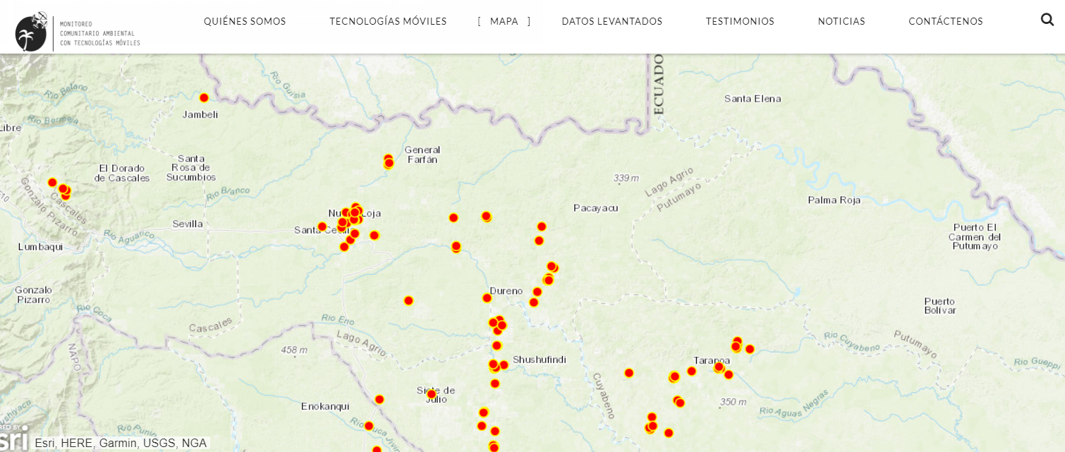
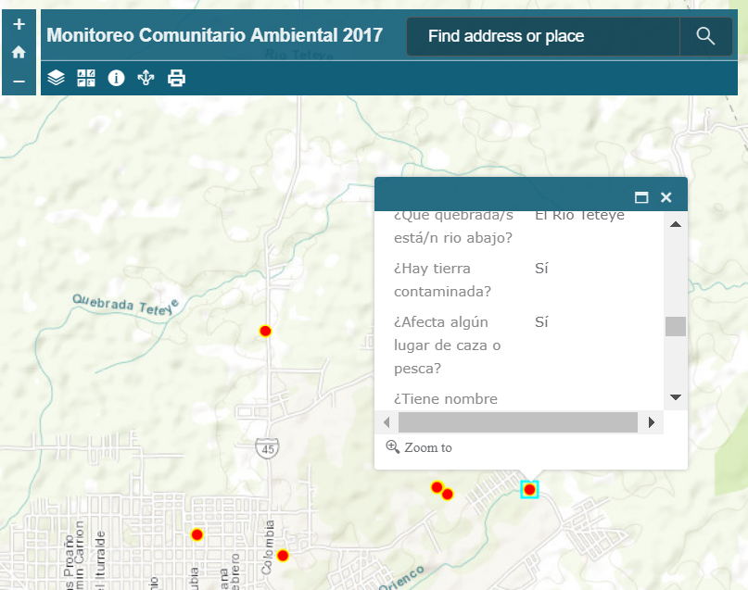

Figure 2: Web-mapping portal to disseminate information collected

