Supplementary Data
Cyclooxygenase-2 modulates ER-mitochondria crosstalk to mediate superparamagnetic iron oxide nanoparticles induced hepatotoxicity: an in vitro and in vivo study

Lin Che ª*, Huan Yao ª*, Chuan-Li Yang ª, Ni-Jun Guo ª, Jing Huang ª, Zi-Li Wu ª, Li-Yin Zhang ª, Yuan-Yuan Chen ª, Gang Liu ª, Zhong-Ning Lin ª, Yu-Chun Lin ª

ª State Key Laboratory of Molecular Vaccinology and Molecular Diagnostics, School of Public Health, Xiamen University, Xiamen, 361102, China

* These authors contributed equally to this work.
Corresponding author: Z-N Lin and Y-C Lin, State Key Laboratory of Molecular Vaccinology and Molecular Diagnostics, School of Public Health, Xiamen University, Xiang’an south Road, Xiamen, 361102, China.
Tel: +86 592 2880615;
Fax: +86 592 2881578;
- mail: linzhn@xmu.edu.cn and linych@xmu.edu.cn

Supplementary Figures

Figure S1:

Figure S1. SPIO-NPs suspension characteristics in cell culture medium (RPMI-1640). (A) Representative TEM image of SPIO-NPs when suspended in RPMI-1640 medium. (B-C) The hydrodynamic size and zeta potential of SPIO-NPs were measured in RPMI-1640 medium with a Zetasizer instrument.

Figure S2:
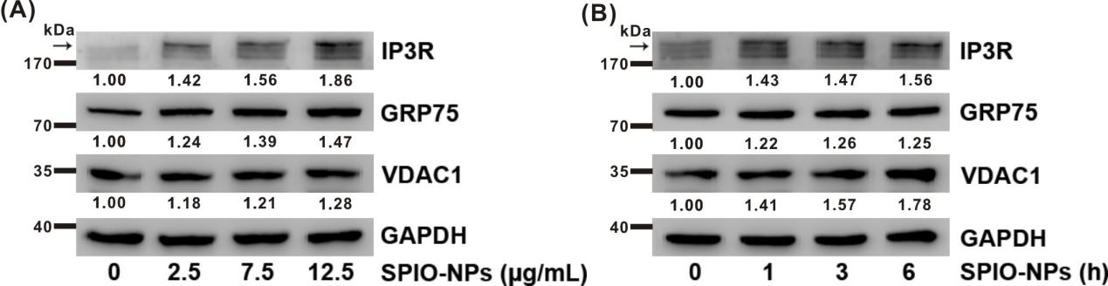

Figure S2. Effects of SPIO-NPs on MAM-related proteins in L02 cells. (A) L02 cells were treated with different concentrations of SPIO-NPs for 6 h. (B) L02 cells were treated with SPIO-NPs (12.5 μg/mL) for different duration. The levels of MAM-related proteins were detected by Western blot. Arrow indicates the specific band.

Figure S3:
Figure S3. Knockdown of GRP75 (siHSPA9) on the SPIO-NPs-induced apoptosis in L02 cells. L02 Cells were treated with or without 12.5 μg/mL SPIO-NPs for 6 h after transfected with siHSPA9 or siNC (50 nmol/L) for 8 h. siNC, siRNA negative control. Apoptosis was determined by Annexin V-FITC staining. The representative fluorescence images (A) and quantification of apoptotic cells (B) with Annexin V positive (green) were shown. Scale bars are 10 μm. Data were expressed as means ± SD. * P<0.05, vs corresponding control; # P<0.05, vs cells with siNC transfection and SPIO-NPs treatment group.

Figure S4:
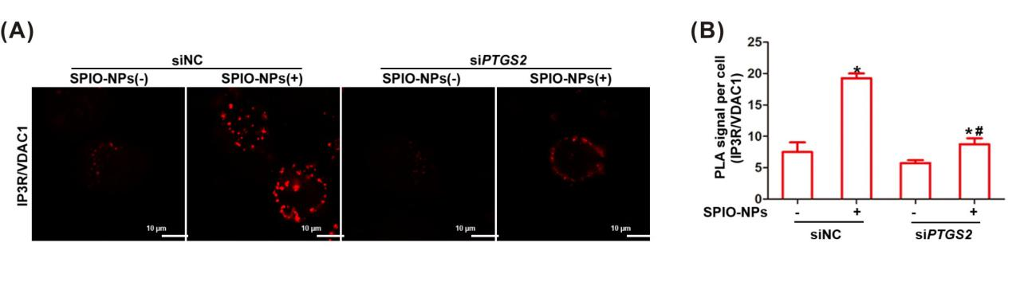

Figure S4. Inhibition of COX-2 (siPTGS2) reduced the physical interaction of MAMs in SPIO-NPs-treated L02 cells. L02 cells were treated with or without 12.5 μg/mL SPIO-NPs for 6 h after transfected with siPTGS2 or siNC (50 nmol/L) for 8 h. siNC, siRNA negative control. (A) PLA showed the interaction between IP3R and VDAC1. Interaction events were shown as red fluorescent PLA foci. (B) Quantification of IP3R/VDAC1 PLA foci was shown in the bar graph. Data were expressed as means ± SD. * P<0.05, vs corresponding control; # P<0.05, vs cells with siNC transfection and SPIO-NPs treatment group.

Figure S5:

Figure S5. Effect of inhibition or overexpression of COX-2 on the SPIO-NPs-induced apoptosis in L02 cells. L02 cells were treated with or without 12.5 μg/mL SPIO-NPs after COX-2-intervention. Apoptosis was determined by Annexin V-FITC staining, while cells were immunostained with anti-Annexin V antibody (green) and DAPI. (A-B) L02 cells were treated with or without 12.5 μg/mL SPIO-NPs for 6 h after transfected with siPTGS2 or siNC (50 nmol/L) for 8 h to knockdown COX-2. siNC, siRNA negative control. (C-F) L02 cells were pretreated with or without 100 μM COX-2 inhibitors, aspirin (C-D) and celecoxib (E-F) for 6 h and exposed to SPIO-NPs for another 24 h. (G-H) L02-pB-PTGS2 cell was constructed for the overexpression of COX-2. L02-pBabe cell was as control cell. Cells were treated with SPIO-NPs (12.5 μg/mL) for 6 h. The representative confocal microscope images (A, C, E, G) and corresponding quantification of apoptotic cells (B, D, F, H) with Annexin V positive (green) were shown. Scale bars are 10 μm. Data were expressed as means ± SD. * P<0.05, vs corresponding control; # P<0.05, vs cells with SPIO-NPs treatment group.

Figure S6:

Figure S6. Inhibition of COX-2 (siPTGS2) reduced the interactions of COX-2 with IP3R in SPIO-NPs-treated L02 cells. L02 cells were transfected with siPTGS2 or siNC for 8 h and then treated with 12.5 μg/mL SPIO-NPs for another 6 h. (A) PLA images showed the interactions of COX-2 with IP3R. (B) Quantification of COX-2/IP3R PLA foci was shown in the bar graph. Data were expressed as means ± SD. * P<0.05, vs corresponding control; # P<0.05, vs cells with siNC transfection and SPIO-NPs treatment group.

