Supplementary material

The mirage water concept and an index-based approach to quantify causes of hydrological changes in semi-arid regions
Ali Torabi Haghighi et al.

Figure S1. Measures of spatio-temporal hydrological (SDI) and metrological (SPI) droughts in the Mond River Basin for the period 1974–2014: (a) Bande-Bahman, (b) Hakkan, (c) Barak, (d) Tange-Karzin, (e) Hanifaghan, (f) Tangab, (g) Dehroud and (h) Qantareh gauges. The years are defined based on the Iranian hydrological year, which runs from October to September.
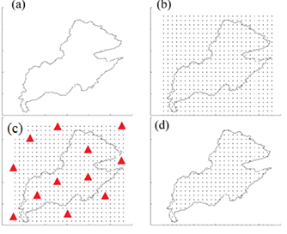

Figure S2. Calculating rainfall over the area of sub-basin. Triangles show the location of rainfall stations in this example.

Table S1. Names and coordinates of the meteorological stations.
Station | Longitude | Latitude
Bahman | 52.57 | 29.28
Karzin | 53.11 | 28.45
Fasa | 53.63 | 28.92
Hanifaghan | 52.55 | 29.10
Tangab | 52.55 | 28.92
Babaarab | 53.77 | 28.58
Dezhgah | 52.40 | 28.21
Jahrom | 53.56 | 28.50
Shonbe | 51.77 | 28.39
Jahanabad | 53.86 | 29.71
Doboneh | 52.78 | 29.42
Qalat | 52.35 | 29.84
Karian | 53.53 | 28.13
Lar | 54.28 | 27.68
Shiraz | 52.28 | 29.70
Govazoon | 54.45 | 28.70
Borghan | 52.02 | 30.22
Farashband | 52.09 | 28.86
Jereh | 51.98 | 29.25
Chiti | 51.30 | 29.58
Dashte-arzhan | 52.00 | 29.66
Bushehr | 50.85 | 28.91
Lamerd | 53.18 | 27.34
Zarindasht | 54.43 | 28.35
Neyriz | 54.30 | 29.18
Rooniz | 53.77 | 29.19

Table S2. Names and coordinates of the gauge stations at the outlets of the sub-basins in the study area.
Number | Station | River | Comment
1 | Bande-Bahman | Qareaqaj | Headwater and near Kavar Dam
2 | Hakkan | Shoor Jahrom | Headwater
3 | Barak | Simakon | Headwater
4 | Karzin | Mond | Below Salman Farsi Dam
5 | Hanifaghan | Shoor Firouzabad | Headwater
6 | Tangab | Shoor Firouzabad | Below Tangab Dam
7 | Dehroud | Shoor Firouzabad | Haiqer Dam place
8 | Qantareh | Mond | Outlet of the basin

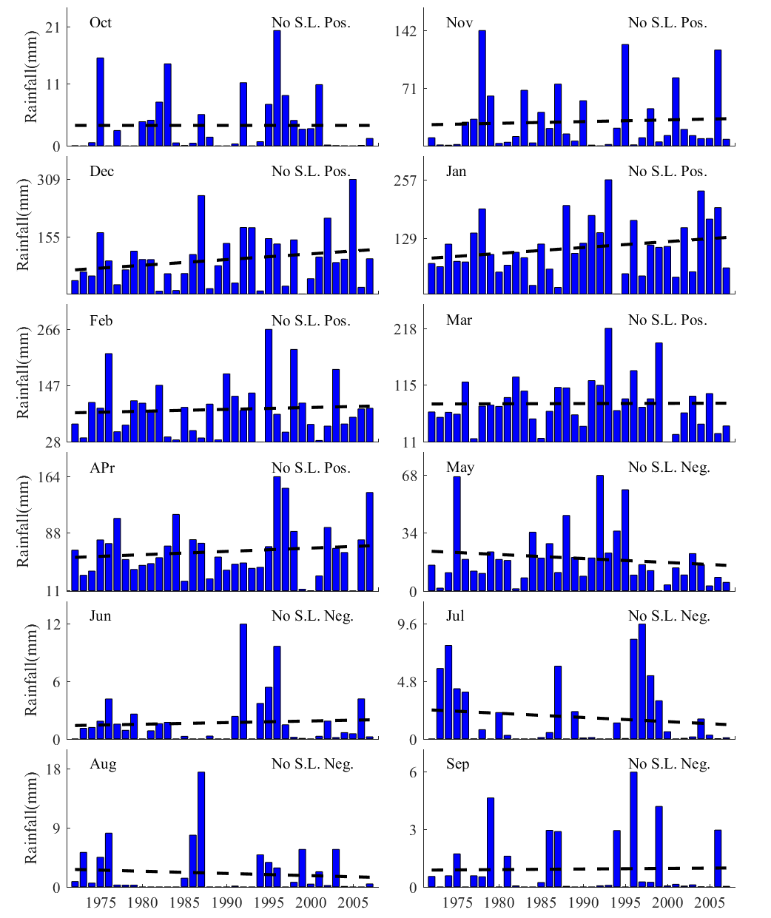
Figure S3. Trend of monthly rainfall in Mond River Basin upstream of Bande-Bahman gauge station near Kavar Dam (no. 1 in Table S2).

Figure S4. Trend of monthly rainfall in the sub-basin upstream of Hakkan gauge station (no. 2 in Table S2).
Figure S5. Trend of monthly rainfall in the sub-basin upstream of Barak gauge station (no. 3 in Table S2).
Figure S6. Trend of monthly rainfall in the sub-basin upstream of Karzin gauge station (no. 4 in Table S2).
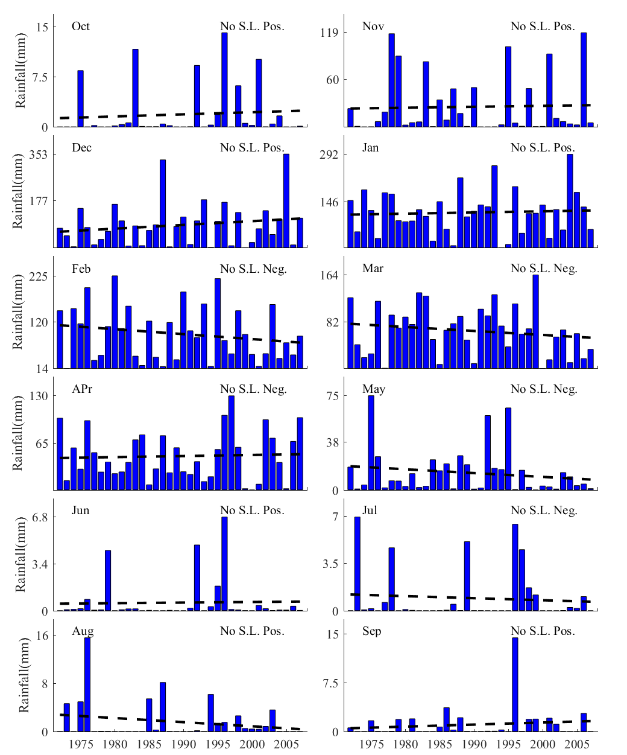
Figure S7. Trend of monthly rainfall in the sub-basin upstream of Hanifaghan gauge station (no. 5 in Table S2).
Figure S8. Trend of monthly rainfall in the sub-basin upstream of Tangab gauge station (no. 6 in Table S2).
Figure S9. Trend of monthly rainfall in the sub-basin upstream of Dehroud gauge station near Haiqer Dam (no. 7 in Table S2).

Figure S10. Trend of monthly rainfall in Mond River Basin.

Figure S11. Trend of monthly flow at Qantareh gauge station (no. 7 in Table S2).
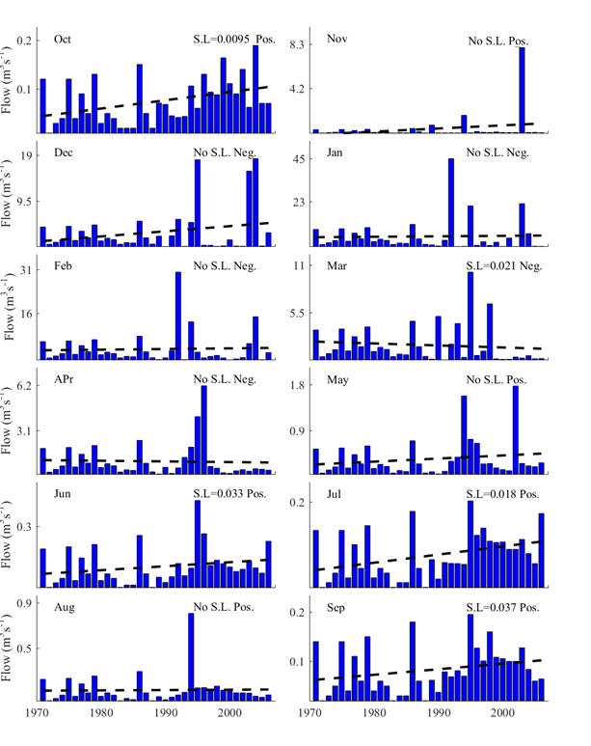
Figure S12. Trend of monthly flow at Hakkan gauge station (no. 2 in Table S2).

Figure S13. Trend of monthly flow at Bande-Bahman gauge station (no. 1 in Table S2).
Figure S14. Trend of monthly flow at Barak gauge station (no. 3 in Table S2).
Figure S15. Trend of monthly flow at Karzin gauge station (no. 4 in Table S2).
Figure S16. Trend of monthly flow at Hanifaghan gauge station (no. 5 in Table S2).
Figure S17. Trend of monthly flow at Tangab gauge station (no. 6 in Table S2).
Figure S18. Trend of monthly flow at Tangab gauge station (no. 6 in Table S2).

