Supplementary Figures- 3D pictures of docked files

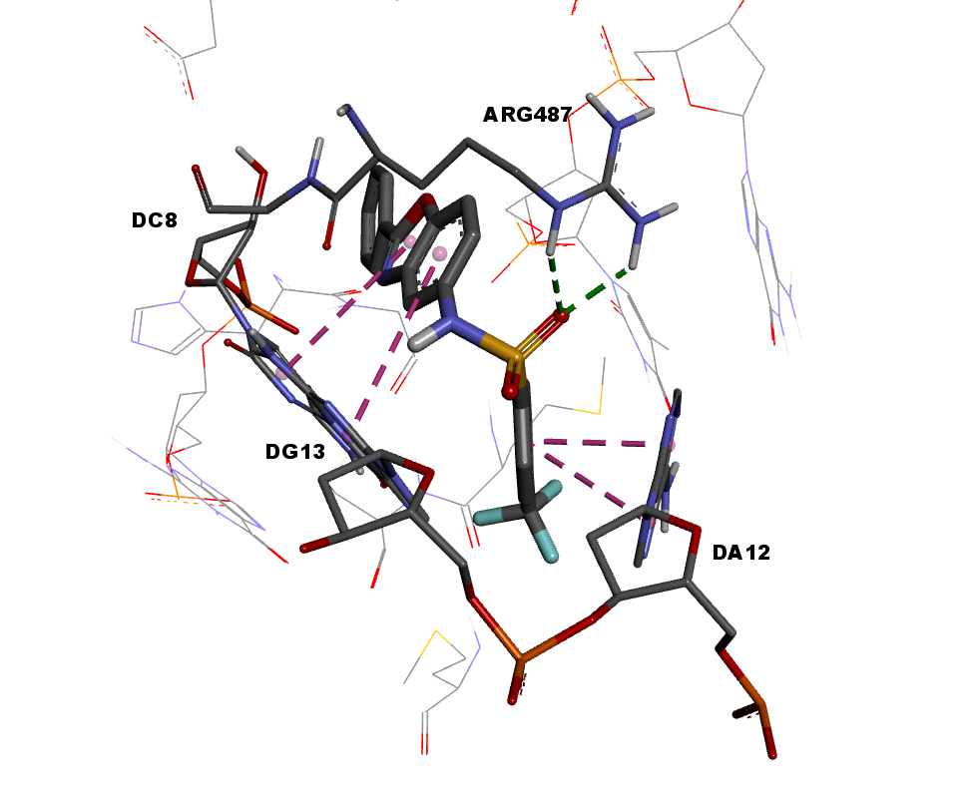
Figure 1 Docked position of PTPS: compound revealed H-bond with Arg487; pi-pi stacking with deoxycytidine DC8, deoxyadenosine DA12 and deoxyguanosin DG13.

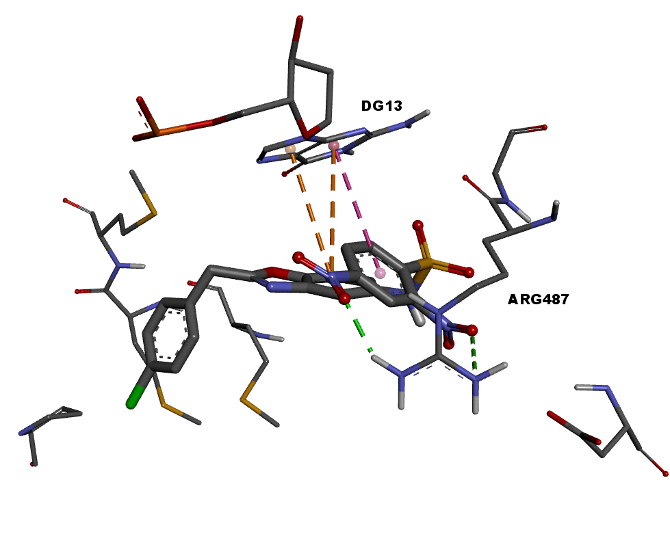
Figure 2 Docked position of CNSB: compound revealed H-bond and salt bridge with Arg487; pi-pi stacking and pi-cation interactions with deoxyguanosin DG13.

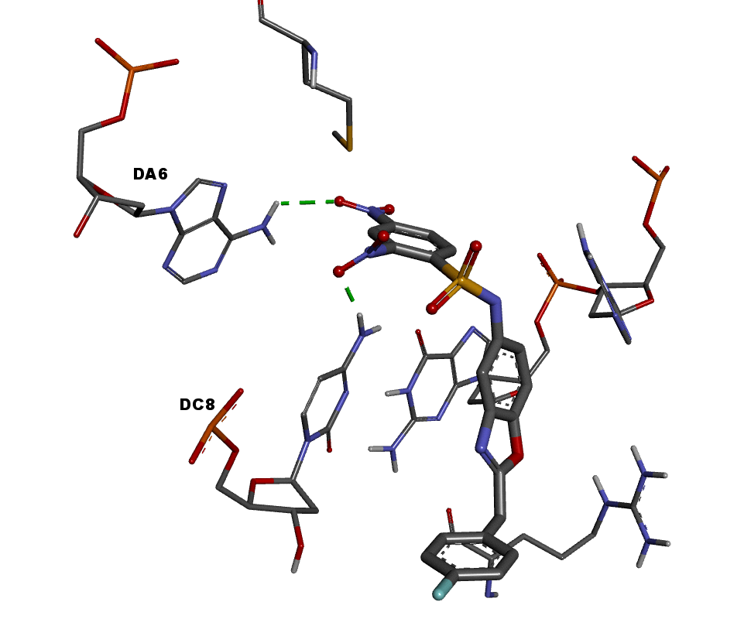
Figure 3 a) Docked position of FBPS: compound revealed H-bonds with deoxyadenosine DA6 and deoxycytidine DC8.

