Supplementary Figure 1.

Supplementary Figure 2.
Supplementary Figure 3.

Supplementary Figure 4.

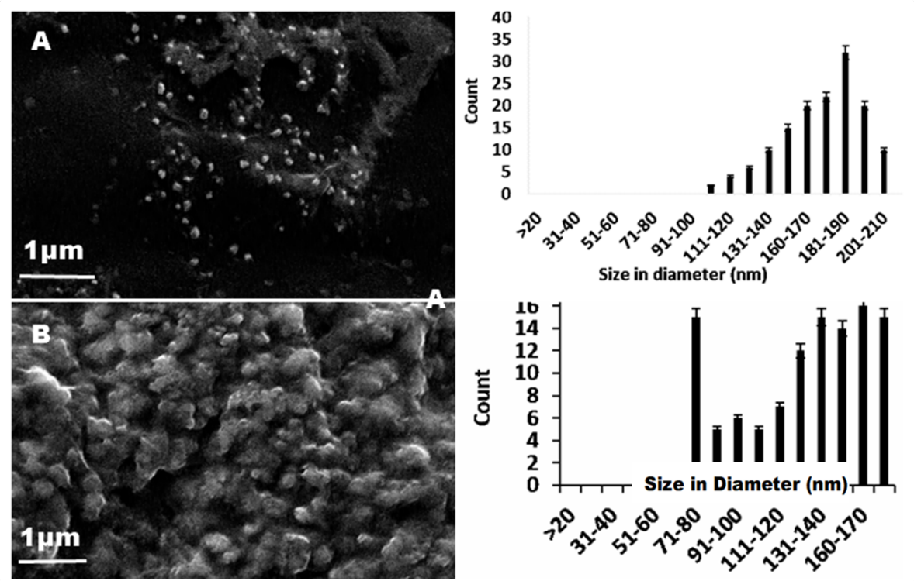

Table 1 Report Summarizes the adjusted and predicted values; Cook’s distance; residual values for the model designed.
Report of AuNp synthesis experimental design
Run Order |  | Actual Value | Predicted Value⁽¹⁾ |  | Residual | Leverage | Internally Studentized Residuals |  | Externally Studentized Residuals |  | Cook's Distance | Influence on Fitted Value DFFITS |  | Standard Order
1 |  | 533.00 | 534.50 |  | -1.50 | 0.706 | -0.549 |  | -0.527 |  | 0.066 | -0.816 |  | 4
2 |  | 553.00 | 550.71 |  | 2.29 | 0.706 | 0.838 |  | 0.823 |  | 0.153 | 1.274 |  | 2
3 |  | 549.00 | 551.12 |  | -2.12 | 0.706 | -0.777 |  | -0.759 |  | 0.132 | -1.175 |  | 7
4 |  | 550.00 | 539.42 |  | 10.58 | 0.194 | 2.345 |  | 3.543 |  | 0.121 | 1.741 |  | 10
5 |  | 541.00 | 539.42 |  | 1.58 | 0.194 | 0.351 |  | 0.333 |  | 0.003 | 0.164 |  | 11
6 |  | 545.00 | 545.15 |  | -0.1495 | 0.706 | -0.055 |  | -0.052 |  | 0.001 | -0.080 |  | 6
7 |  | 548.00 | 548.43 |  | -0.4342 | 0.706 | -0.159 |  | -0.150 |  | 0.006 | -0.233 |  | 8
8 |  | 534.00 | 532.34 |  | 1.66 | 0.706 | 0.610 |  | 0.588 |  | 0.081 | 0.910 |  | 5
9 |  | 550.00 | 549.40 |  | 0.6005 | 0.706 | 0.220 |  | 0.208 |  | 0.011 | 0.322 |  | 1
10 |  | 534.00 | 539.42 |  | -5.42 | 0.194 | -1.200 |  | -1.234 |  | 0.032 | -0.606 |  | 9
11 |  | 549.00 | 548.68 |  | 0.3158 | 0.706 | 0.116 |  | 0.109 |  | 0.003 | 0.169 |  | 3
12 |  | 532.00 | 539.42 |  | -7.42 | 0.194 | -1.643 |  | -1.851 |  | 0.059 | -0.910 |  | 12
13 |  | 534.00 | 534.93 |  | -0.9330 | 0.679 | -0.328 |  | -0.311 |  | 0.021 | -0.452 |  | 17
14 |  | 533.00 | 532.30 |  | 0.6978 | 0.679 | 0.245 |  | 0.232 |  | 0.012 | 0.337 |  | 18
15 |  | 546.00 | 546.19 |  | -0.1942 | 0.679 | -0.068 |  | -0.064 |  | 0.001 | -0.094 |  | 13
16 |  | 537.00 | 536.65 |  | 0.3528 | 0.250 | 0.081 |  | 0.076 |  | 0.000 | 0.044 |  | 19
17 |  | 543.00 | 545.54 |  | -2.54 | 0.679 | -0.891 |  | -0.880 |  | 0.153 | -1.280 |  | 15
18 |  | 537.00 | 536.65 |  | 0.3528 | 0.250 | 0.081 |  | 0.076 |  | 0.000 | 0.044 |  | 20
19 |  | 545.00 | 545.04 |  | -0.0411 | 0.679 | -0.014 |  | -0.014 |  | 0.000 | -0.020 |  | 14
20 |  | 550.00 | 547.70 |  | 2.30 | 0.679 | 0.808 |  | 0.791 |  | 0.126 | 1.152 |  | 16
Report of SeNp synthesis experimental design
Run Order | Actual Value |  | Predicted Value | Residual |  | Leverage |  | Internally Studentized Residuals | Externally Studentized Residuals | Cook's Distance |  |  | Influence on Fitted Value DFFITS |  | Standard Order
1 | 284.00 |  | 283.54 | 0.4638 |  | 0.166 |  | 0.082 | 0.077 | 0.000 |  |  | 0.035 |  | 16
2 | 296.00 |  | 298.54 | -2.54 |  | 0.670 |  | -0.710 | -0.691 | 0.102 |  |  | -0.985 |  | 8
3 | 276.00 |  | 272.91 | 3.09 |  | 0.607 |  | 0.792 | 0.776 | 0.097 |  |  | 0.965 |  | 13
4 | 284.00 |  | 285.83 | -1.83 |  | 0.607 |  | -0.468 | -0.449 | 0.034 |  |  | -0.558 |  | 14
5 | 280.00 |  | 283.54 | -3.54 |  | 0.166 |  | -0.622 | -0.602 | 0.008 |  |  | -0.269 |  | 17
6 | 284.00 |  | 283.54 | 0.4638 |  | 0.166 |  | 0.082 | 0.077 | 0.000 |  |  | 0.035 |  | 20
7 | 268.00 |  | 268.03 | -0.0340 |  | 0.670 |  | -0.009 | -0.009 | 0.000 |  |  | -0.013 |  | 5
8 | 276.00 |  | 283.54 | -7.54 |  | 0.166 |  | -1.325 | -1.384 | 0.035 |  |  | -0.618 |  | 19
9 | 242.00 |  | 244.59 | -2.59 |  | 0.607 |  | -0.664 | -0.645 | 0.068 |  |  | -0.802 |  | 9
10 | 279.00 |  | 283.54 | -4.54 |  | 0.166 |  | -0.798 | -0.782 | 0.013 |  |  | -0.349 |  | 18
11 | 280.00 |  | 284.81 | -4.81 |  | 0.670 |  | -1.345 | -1.410 | 0.367 |  |  | -2.008 |  | 2
12 | 272.00 |  | 268.08 | 3.92 |  | 0.670 |  | 1.095 | 1.108 | 0.243 |  |  | 1.577 |  | 7
13 | 301.00 |  | 300.00 | 1.00 |  | 0.670 |  | 0.280 | 0.267 | 0.016 |  |  | 0.380 |  | 6
14 | 298.00 |  | 294.14 | 3.86 |  | 0.607 |  | 0.988 | 0.987 | 0.151 |  |  | 1.227 |  | 10
15 | 266.00 |  | 267.90 | -1.90 |  | 0.670 |  | -0.530 | -0.510 | 0.057 |  |  | -0.727 |  | 3
16 | 294.00 |  | 294.86 | -0.8601 |  | 0.670 |  | -0.240 | -0.229 | 0.012 |  |  | -0.326 |  | 4
17 | 298.00 |  | 283.54 | 14.46 |  | 0.166 |  | 2.543 | 4.059 | 0.129 |  |  | 1.813 |  | 15
18 | 258.00 |  | 256.35 | 1.65 |  | 0.670 |  | 0.460 | 0.441 | 0.043 |  |  | 0.629 |  | 1
19 | 296.00 |  | 295.61 | 0.3893 |  | 0.607 |  | 0.100 | 0.095 | 0.002 |  |  | 0.118 |  | 12
20 | 288.00 |  | 287.12 | 0.8751 |  | 0.607 |  | 0.224 | 0.213 | 0.008 |  |  | 0.265 |  | 11

Table 2 Cryopreservation of nanoparticles and their Stability
Method | Absorbance (nm) |  |  |  |  |  | Ease of handling
 | Control | Glycine | Tween 20 |  | Dextrose | PEG_{4K}  PEG_{6K}
Temperature | a/b/c | a/b/c | a/b | c | a/b/c | a/b/c | - Requires minimum processing  - Easy freeze thaw cycles
Suspension  AuNp  SeNp | ̴ 540  ̴290 | ̴ 530  ̴290 | ̴530  ̴290 | ̴550  ̴320 | ̴ 550  ̴300 | aggregate
Centrifuged  AuNp  SeNp | ̴550  ̴320 | ̴550  ̴320 | ̴550  ̴320 |  | ̴ 550  ̴300 | aggregate | - Extra step of centrifugation needed
Drying  AuNp  SeNp | ̴550  ̴320 | ̴550  ̴320 | ̴550  ̴320 |  | ̴ 550  ̴300 | aggregate | - Drying is required, followed by -20 ºC storage

* a = 4 ºC, b = -20 ºC, c = -80 ºC

