Supplementary 2: A- Strict consensus of 14 most parsimonious trees obtained by EW analysis and branch support values (Bremer). Consistency Index (CI): 0.51; Retention Index (RI): 0.75. B- Support values (Jacknife) for the EWA. C- Majority consensus tree (85%) from the EW analysis

A- B-

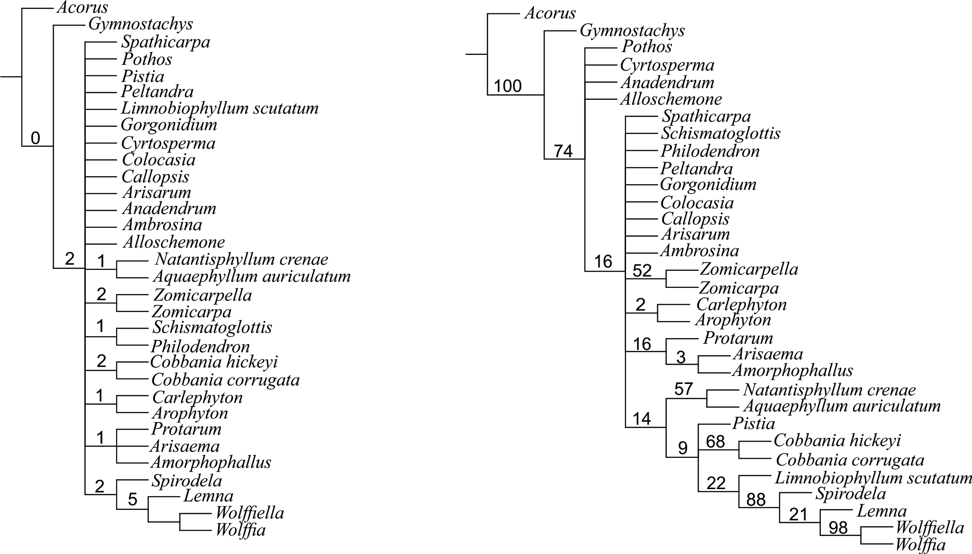

C-



