The xanthophyll cycle as an early pathogenic target to deregulate guard cells during Sclerotinia sclerotiorum infection

SUPPORTING INFORMATION

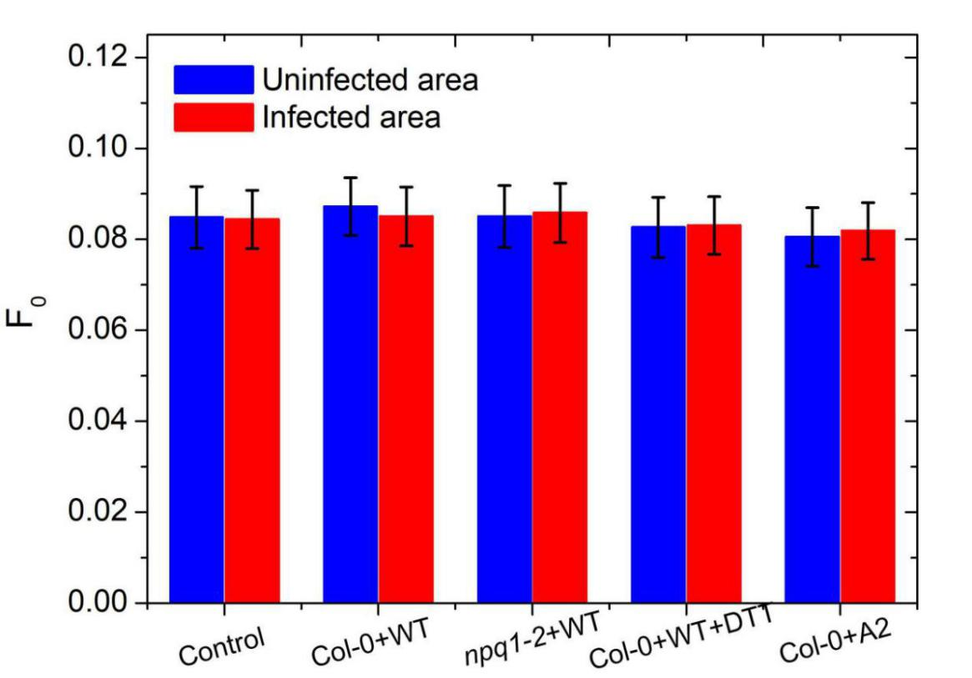
FIGURE S1
FIGURE S1 LEGEND: Changes in F_{o} of Col-0 and npq1-2 after treatment by WT, DTT with WT and A2. With respect to the control group, Col-0 was only treated with water. This experiment was repeated in triplicate with similar results. The data indicated that the minimum fluorescence (F_{o}) had no significant change in the infected and uninfected areas.
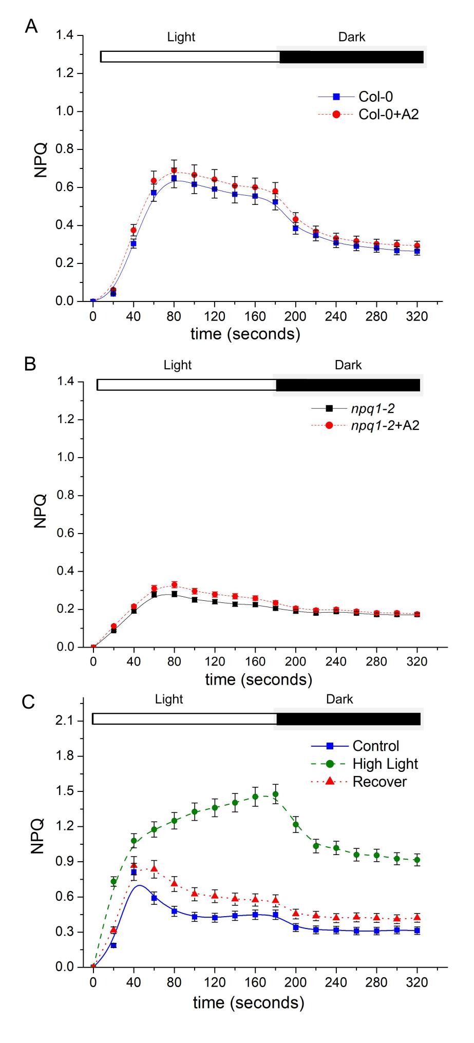
FIGURE S2
FIGURE S2 LEGEND: During early stages of infection with A2, the NPQ kinetics curves of Col-0 (A) and npq1-2 (B) with the actinic light on and off, respectively. The NPQ kinetics curve (C) of the Col-0 after 3 min moderate high-light treatment and 3 min dark photosynthetic recovery. The control group was under normal light with an intensity of 120 μmol photons m⁻² s⁻¹. The intensity of moderate high-light was 725 μmol photons m⁻² s⁻¹. The intensity of actinic light was 133 μmol photons m⁻² s⁻¹. The experimental data came from three independent experiments. The data indicated that, with respect to infection with A2, when the actinic light was on or off, the NPQ kinetic curves of Col-0 (A) and npq1-2 (B) did not show significant changes. Col-0 received high-light treatment for 3 min (C), the NPQ kinetic curve increased faster than that of the control group when the actinic light was on. The NPQ fell more slowly than the control group when the actinic light was off. After dark photosynthetic recovery for 3 min, the NPQ kinetic curve was restored to the level before the moderate high-light treatment. These data indicated that plants treated with moderate high-light could have the activity of VDE and ZEP restored after dark adaption.
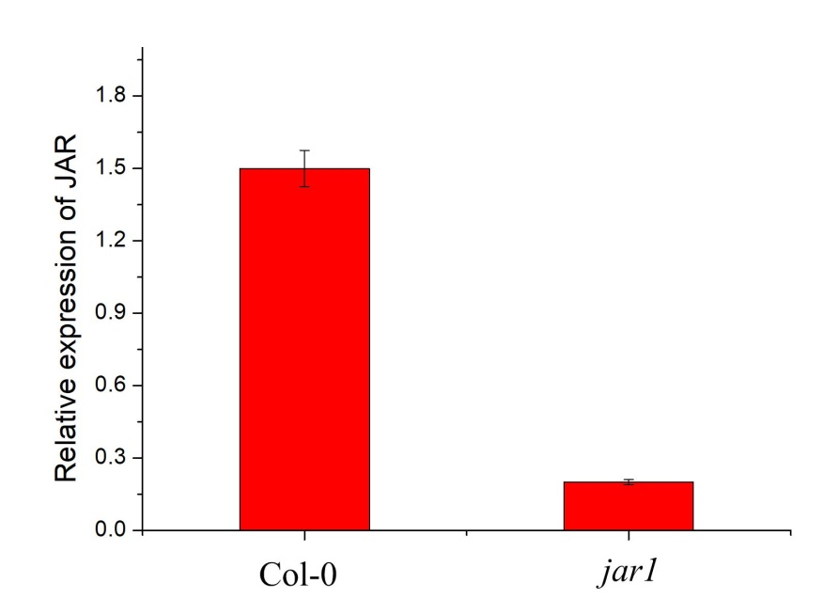
FIGURE S3
FIGURE S3 LEGEND: Relative expression of JAR in Col-0 and jar1-11. In order to verify whether the JAR1 is missing in the jar1-11, we use qRT-PCR to referee the mutant. It was found that the relative expression of JAR1 was very few in jar1-11 compared to Col-0.

