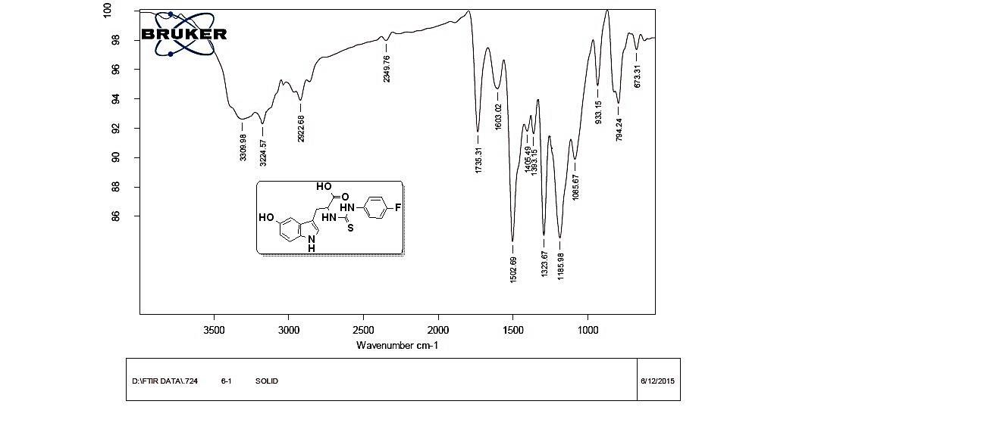
IR spectrum of compound 3a
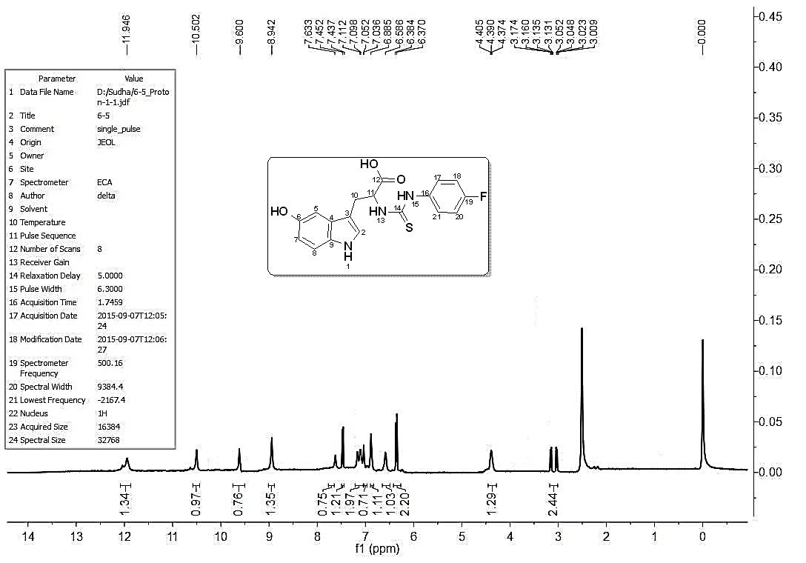
¹H NMR Spectrum of compound 3a
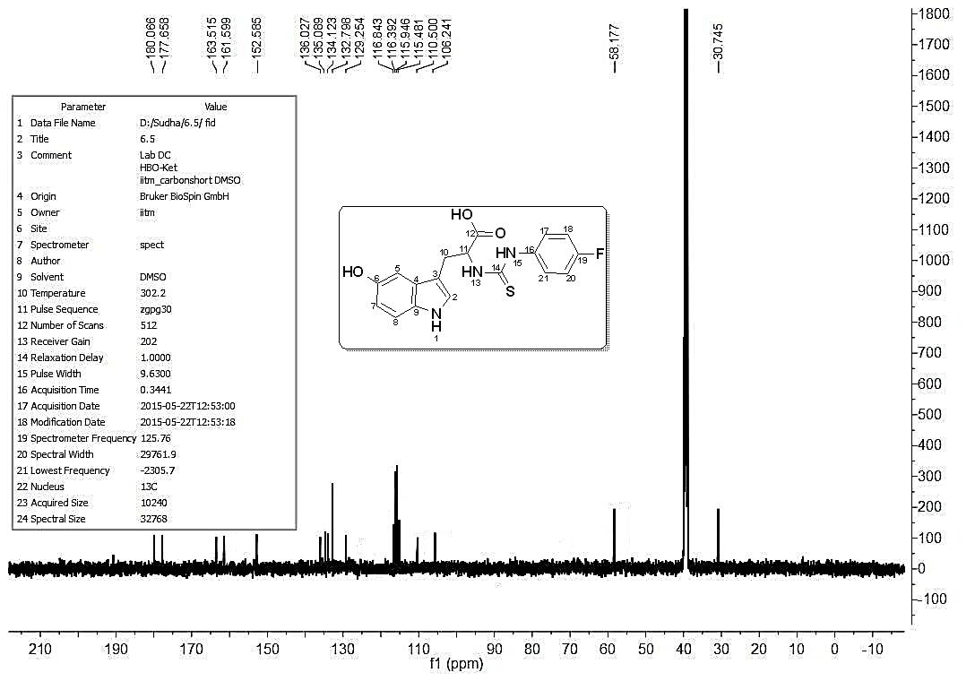
¹³C NMR Spectrum of compound 3a
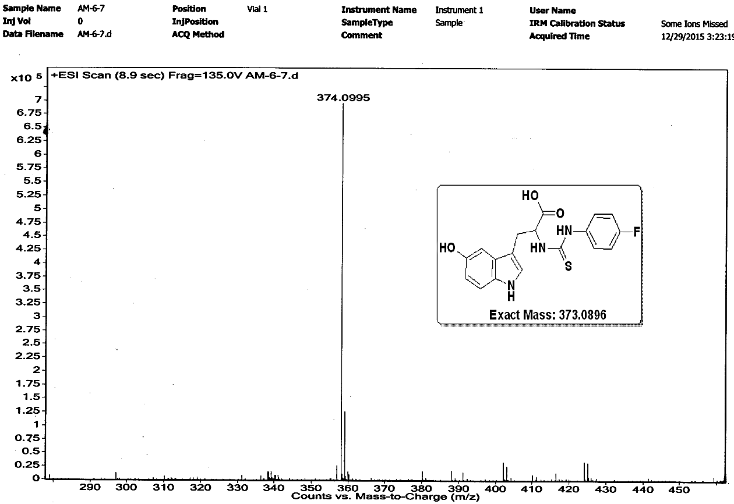
HRMS spectrum of compound 3a

