Electronic Supplementary Material

A simple chemosensor for ultrasensitive fluorescent “turn-on” detection of Fe³⁺ and alternant detection of CN⁻
Qin-Peng Zhangª, Tai-Bao Wei^{a*}, Jun-Nian Anª, Yan-Yan Chenª, Guan-Fei Gongª, Qi Zhouª, Hai-Long Yangª, Hong Yaoª, You-Ming Zhang^{a,b} and Qi Lin^{a*}

ª Key Laboratory of Eco-Environment-Related Polymer Materials, Ministry of Education of China; Research Center of Gansu Military and Civilian Integration Advanced Structural Materials; College of Chemistry and Chemical Engineering, Northwest Normal University, Lanzhou, Gansu, 730070, China.
^{b} College of Chemistry and Chemical Engineering, Lanzhou City University, Lanzhou, Gansu, 730070, P. R. China.

Contens
Figure S1. The ¹H NMR spectra of chemosensor T in CDCl_{3.} 3
Figure S2. The ¹³C NMR spectra of chemosensor T in CDCl₃ (150 MHz, 298K). 3
Figure S3. ESI-MS spectra of chemosensor T. 4
Figure S4. (a) Fluorescent spectra and (b) Fluorescent histogram of the T (2 × 10⁻⁴ M, λ_{ex} = 390 nm, λ_{em} = 528 nm) in DMSO/H₂O binary solution with different volumetric fractions of water (vol%). 4
Figure S5. The photograph of the UV-vis absorption spectra linear range: chemosensor T for Fe³⁺. 4
Figure S6. The photograph of the fluorescent spectra linear range: chemosensor T for Fe³⁺. 5
Figure S7. UV-vis absorption spectra of chemosensor T-Fe³⁺ (2 × 10⁻⁴ M) in DMSO/H₂O (8 : 2, v/v) binary solution in the presence of CN⁻ and other anions ( 5.0 equiv.). 5
Figure S8. UV-vis absorption histogram of T-Fe³⁺ with addition of 5.0 equiv. CN⁻ in the presence of various anions in DMSO/H₂O (8 : 2, v/v) binary solution (λ_{ex} = 285 nm). 6
Figure S9. The photograph of (a) UV-vis titration spectra of chemosensor T-Fe³⁺ with increasing concentrations of CN⁻; (b) the UV-vis absorption spectra linear range: the complex T-Fe³⁺ for CN⁻. 6
Figure S10. The photograph of (a) fluorescent titration spectra of chemosensor T-Fe³⁺ with increasing concentrations of CN⁻ (λ_{ex} = 390 nm); (b) fluorescent spectra linear range: the complex T-Fe³⁺ for CN⁻. 6
Figure S11. FT-IR spectra of powder T, T-Fe³⁺ and T-Fe³⁺-CN⁻. 7
Figure S12. The Job’s plot of chemosensor T with Fe³⁺, indicating the 2 : 1 stoichiometry between T and Fe³⁺ (λ_{ex} = 390 nm, λ_{em} = 528 nm). 7
Figure S13. The Mass spectroscopy of T-Fe³⁺. 8
Figure S14. The SEM images of powder (a) T, (b) T-Fe³⁺ and (c) T-Fe³⁺-CN⁻. 8
Figure S15. Energy-minimized structure of chemosensor T and T-Fe³⁺. 8
Figure S16. Fluorescent ‘‘on-off-on’’ cycles of T-Fe³⁺, controlled by alternating the addition of Fe³⁺ and CN⁻ (λ_{ex} = 390 nm, λ_{em} = 528 nm). 9
Figure S17. Fluorescence emission spectra of T (2 × 10⁻⁴ M) in the presence of Fe³⁺ (0.24 equiv.) and CN⁻ (9.8 equiv.) in DMSO/H₂O (8 : 2, v/v) binary solution (λ_{ex} = 390 nm). Inset: photograph from left to right shows the change in the fluorescence of only T, T-Fe³⁺ and T-Fe³⁺-CN⁻ in DMSO/H₂O (8 : 2, v/v) binary solution under irradiation at UV lamp (365 nm). 9

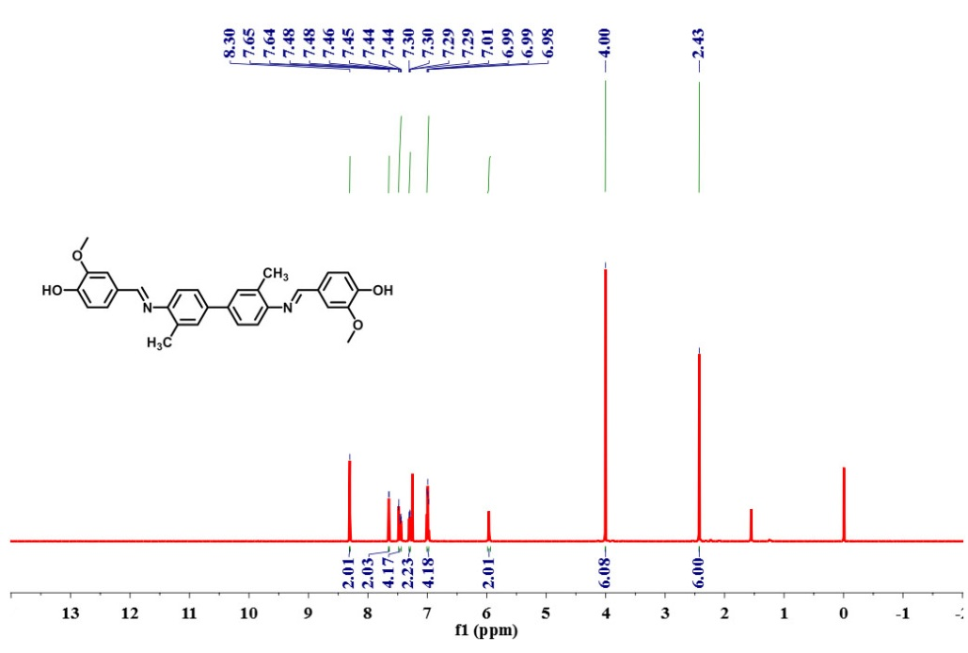

Figure S1. The ¹H NMR spectra of chemosensor T in CDCl_{3.}

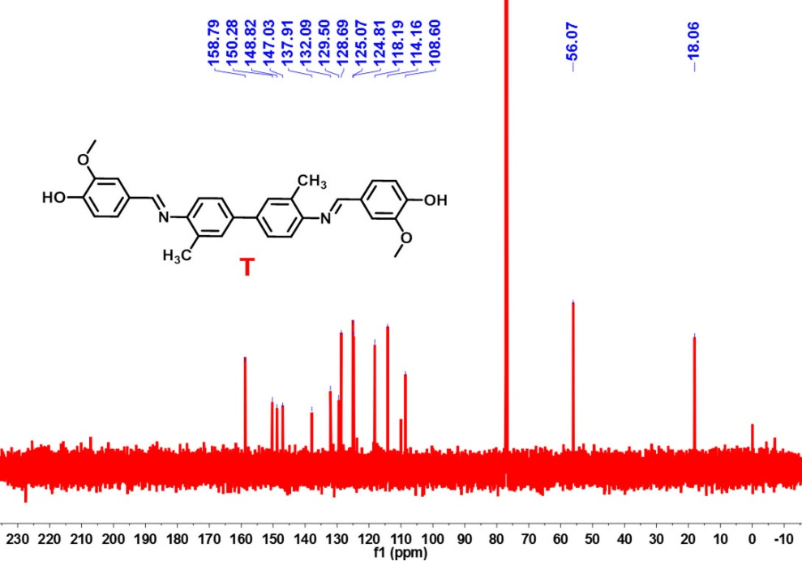

Figure S2. The ¹³C NMR spectra of chemosensor T in CDCl₃ (150 MHz, 298K).

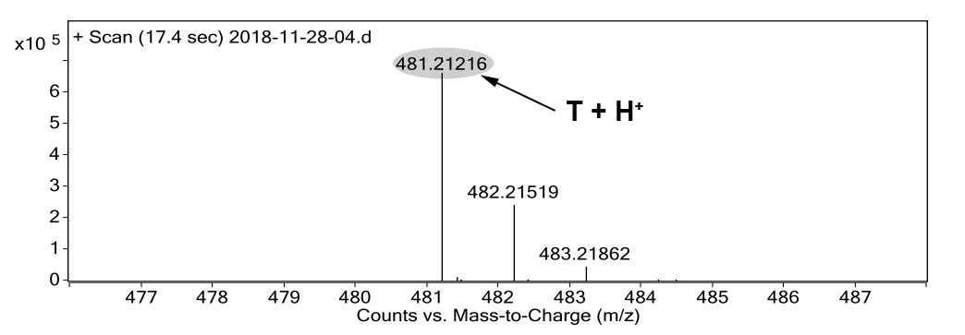

Figure S3. ESI-MS spectra of chemosensor T.

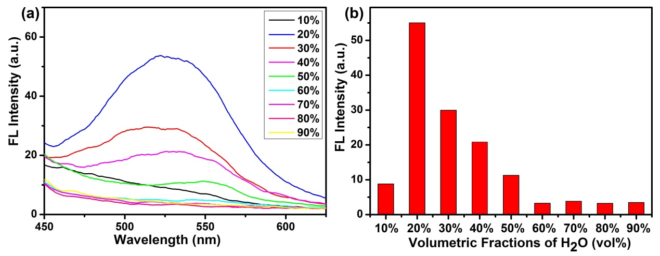

Figure S4. (a) Fluorescent spectra and (b) Fluorescent histogram of the T (2 × 10⁻⁴ M, λ_{ex} = 390 nm, λ_{em} = 528 nm) in DMSO/H₂O binary solution with different volumetric fractions of water (vol%).
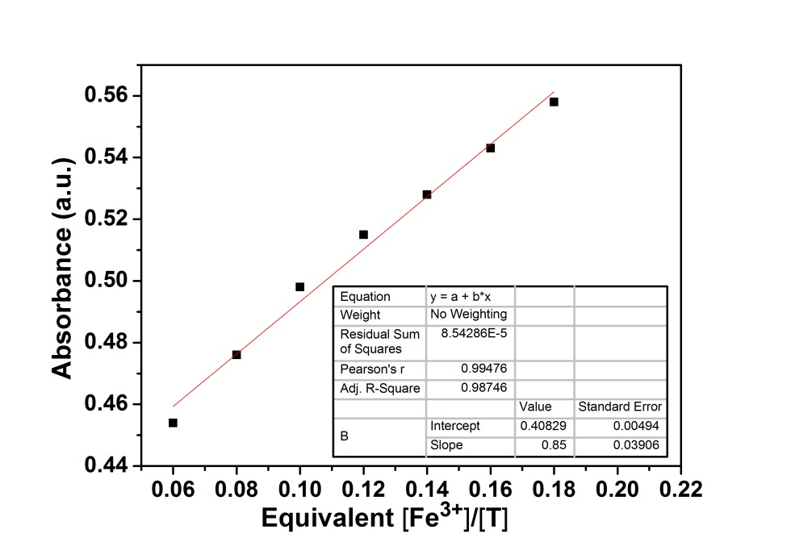

Figure S5. The photograph of the UV-vis absorption spectra linear range: chemosensor T for Fe³⁺.

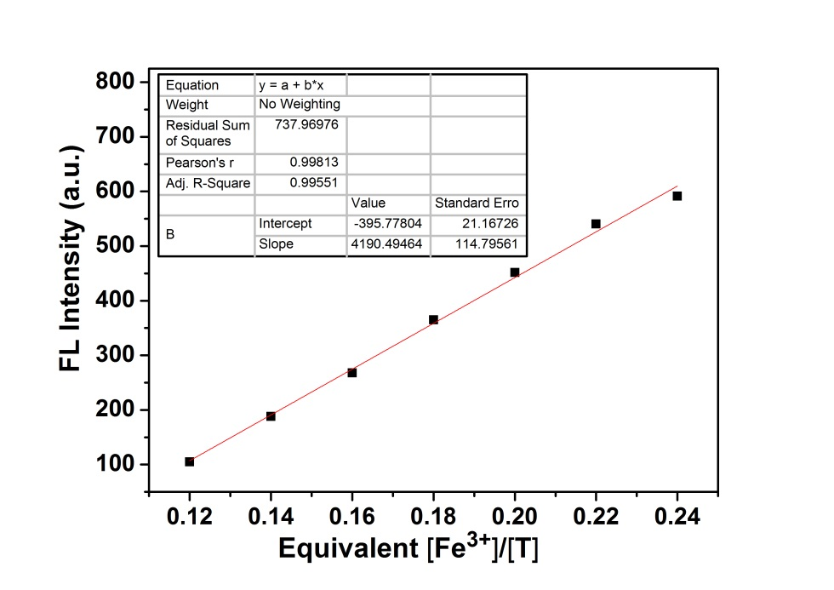

Figure S6. The photograph of the fluorescent spectra linear range: chemosensor T for Fe³⁺.

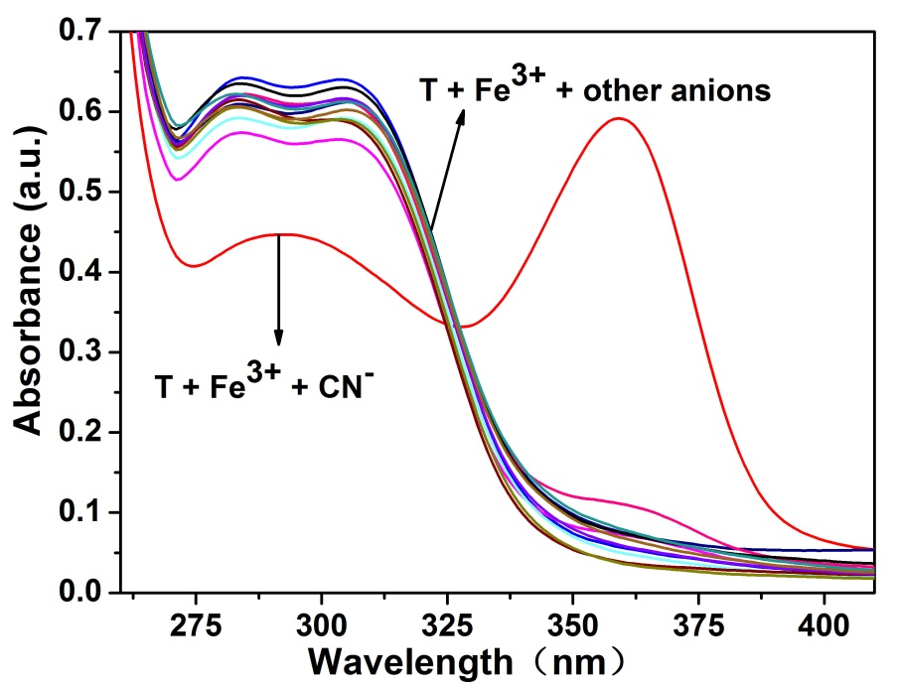

Figure S7. UV-vis absorption spectra of chemosensor T-Fe³⁺ (2 × 10⁻⁴ M) in DMSO/H₂O (8 : 2, v/v) binary solution in the presence of CN⁻ and other anions ( 5.0 equiv.).

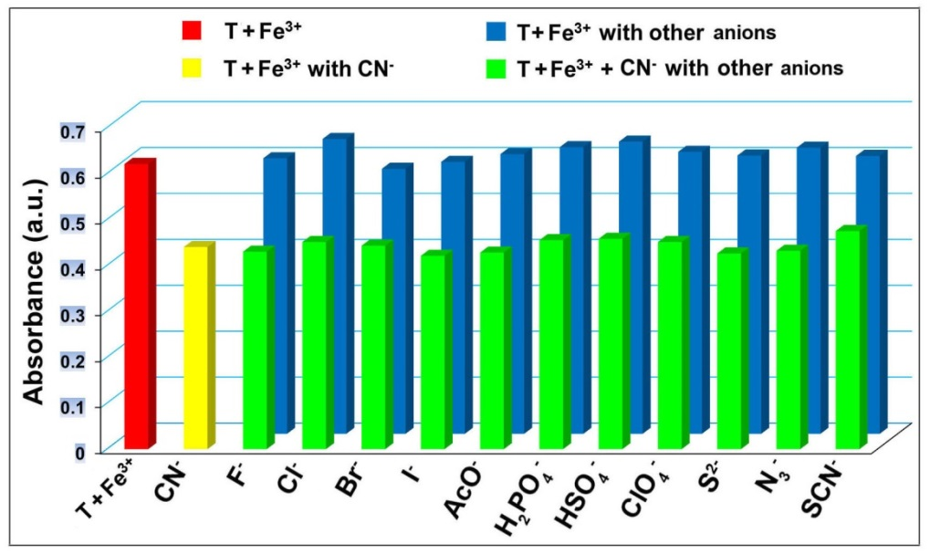

Figure S8. UV-vis absorption histogram of T-Fe³⁺ with addition of 5.0 equiv. CN⁻ in the presence of various anions in DMSO/H₂O (8 : 2, v/v) binary solution (λ_{ex} = 285 nm).

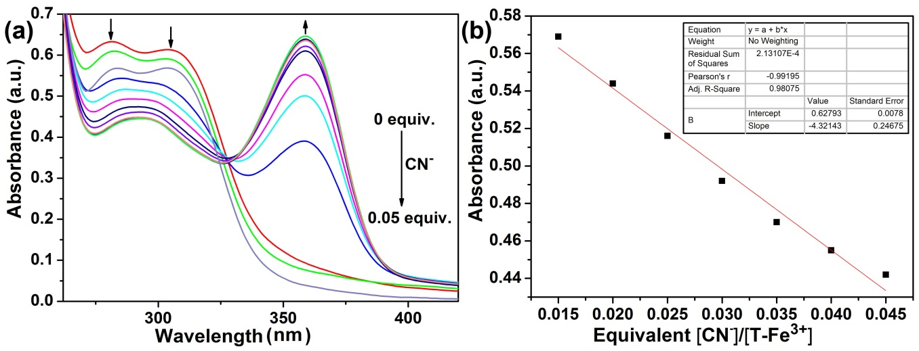

Figure S9. The photograph of (a) UV-vis titration spectra of chemosensor T-Fe³⁺ with increasing concentrations of CN⁻; (b) the UV-vis absorption spectra linear range: the complex T-Fe³⁺ for CN⁻.
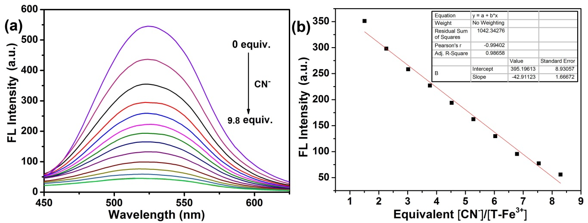

Figure S10. The photograph of (a) fluorescent titration spectra of chemosensor T-Fe³⁺ with increasing concentrations of CN⁻ (λ_{ex} = 390 nm); (b) fluorescent spectra linear range: the complex T-Fe³⁺ for CN⁻.

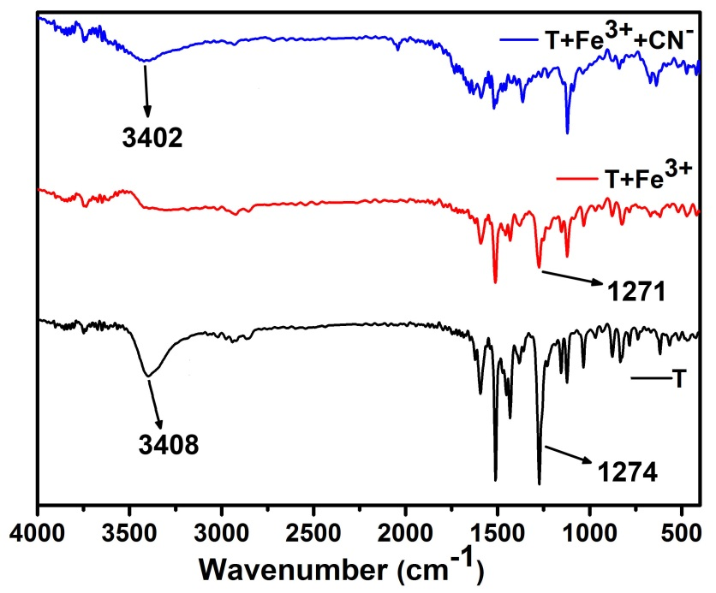

Figure S11. FT-IR spectra of powder T, T-Fe³⁺ and T-Fe³⁺-CN⁻.

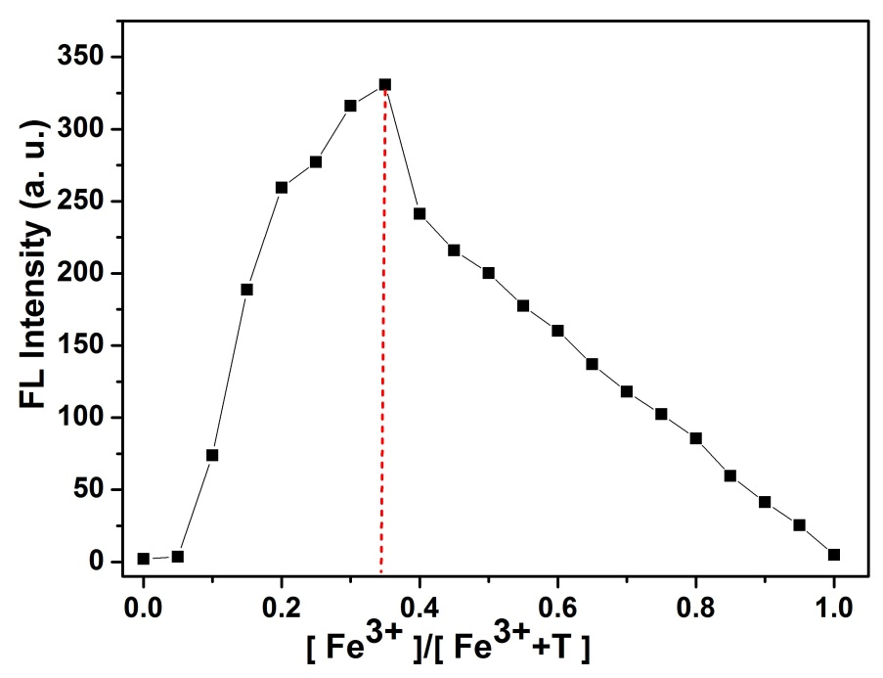

Figure S12. The Job’s plot of chemosensor T with Fe³⁺, indicating the 2 : 1 stoichiometry between T and Fe³⁺ (λ_{ex} = 390 nm, λ_{em} = 528 nm).

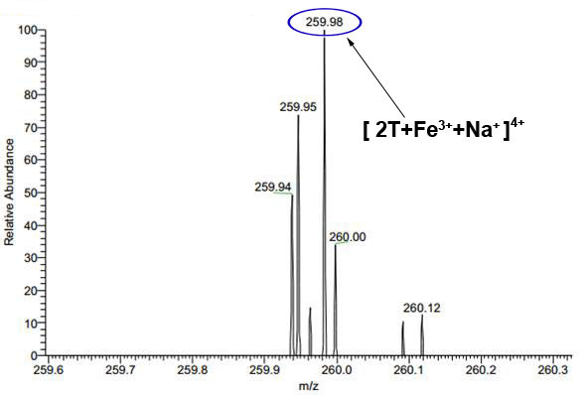

Figure S13. The Mass spectroscopy of T-Fe³⁺.

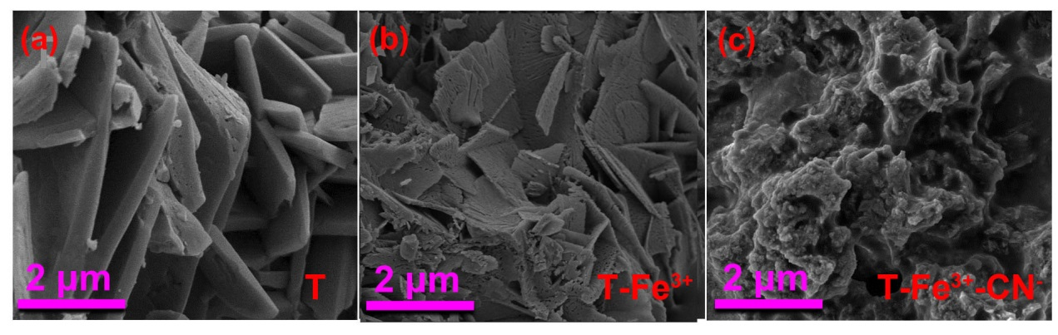

Figure S14. The SEM images of powder (a) T, (b) T-Fe³⁺ and (c) T-Fe³⁺-CN⁻.

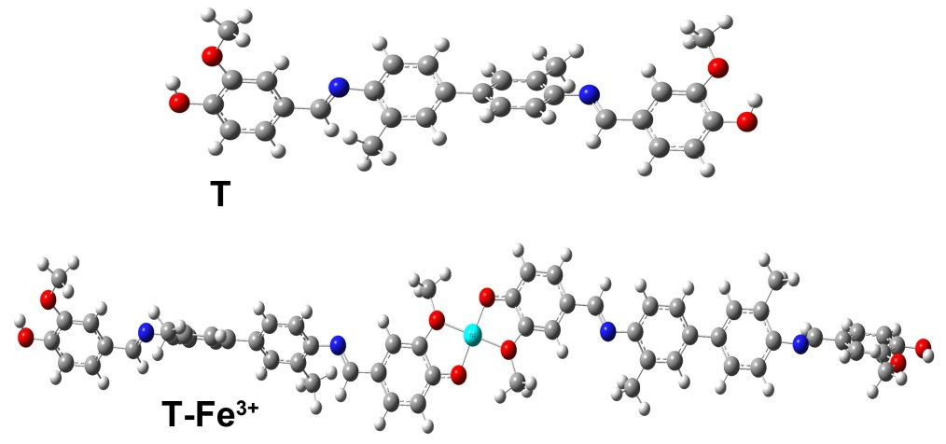

Figure S15. Energy-minimized structure of chemosensor T and T-Fe³⁺.
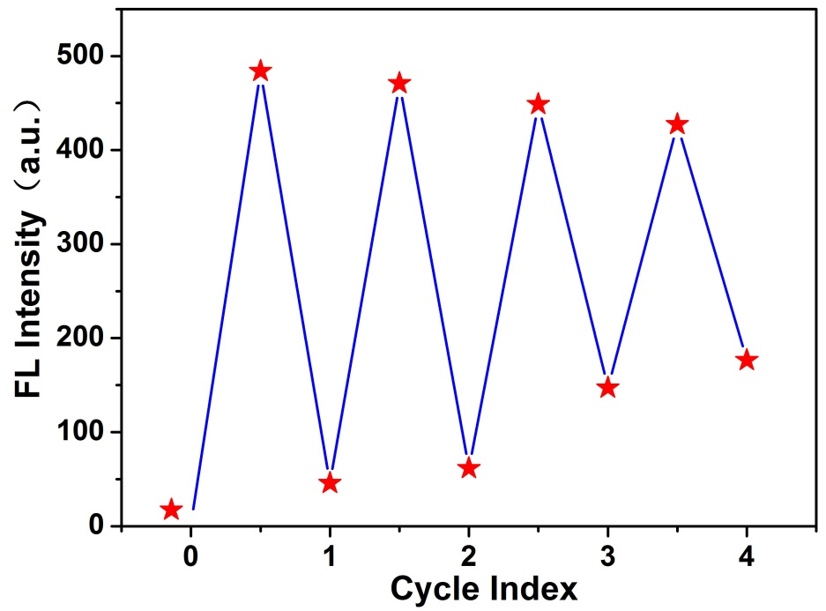

Figure S16. Fluorescent ‘‘on-off-on’’ cycles of T-Fe³⁺, controlled by alternating the addition of Fe³⁺ and CN⁻ (λ_{ex} = 390 nm, λ_{em} = 528 nm).

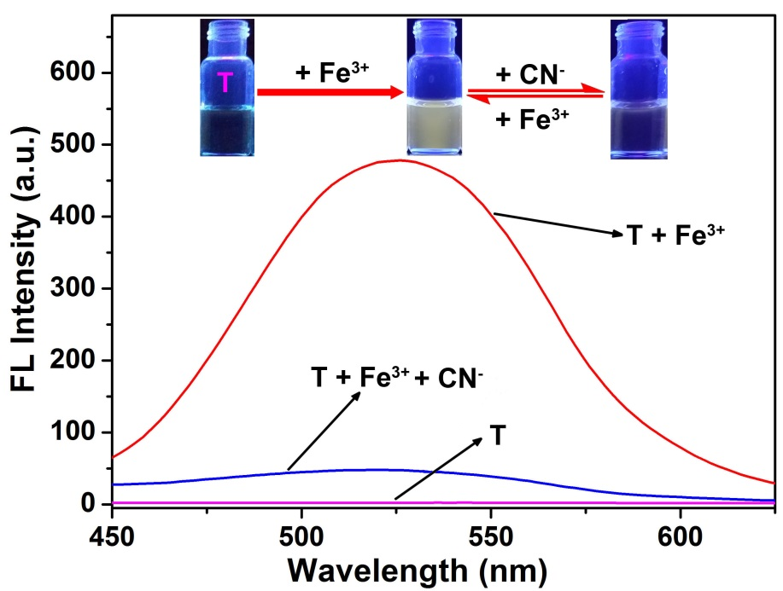

Figure S17. Fluorescence emission spectra of T (2 × 10⁻⁴ M) in the presence of Fe³⁺ (0.24 equiv.) and CN⁻ (9.8 equiv.) in DMSO/H₂O (8 : 2, v/v) binary solution (λ_{ex} = 390 nm). Inset: photograph from left to right shows the change in the fluorescence of only T, T-Fe³⁺ and T-Fe³⁺-CN⁻ in DMSO/H₂O (8 : 2, v/v) binary solution under irradiation at UV lamp (365 nm).

