Supplemental material

Eprinomectin nanoemulgel for transdermal delivery against endo- and ectoparasites: preparation, in vitro and in vivo evaluation
Yujuan Mao^{1#}, Xiaolan Chen^{1#}, Bohui Xu², Yan Shen³, Zixuan Ye³, Birendra Chaurasiya², Li Liu¹, Yi Li⁴, Xiaoling Xing^{1*}, Daquan Chen^{4*}
¹ Jiangsu Animal Husbandry and Veterinary College, Taizhou, China
²School of Pharmacy, Nantong University, No.19 Qixiu Road, Nantong 226001, PR China
³Department of Pharmaceutics, School of Pharmacy, China Pharmaceutical University, Nanjing, China
⁴School of Pharmacy, Yantai University, Yantai, China
#These authors contributed equally to this work.
*Corresponding author: Xiaoling Xing. Tel: +86 0 523 86156928. E-mail: jstzxln@sina.com; Daquan Chen. Tel: 0535-6706021. Email: cdq1981@126.com

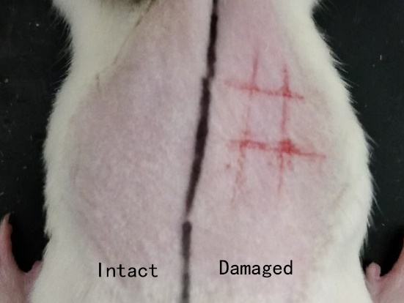
Figure S1. Intact skin and damaged skin of rats.
Table S1. The score of erythema according to symptoms
Symptoms | Score
No erythema | 0
Mild erythema (barely seen) | 1
Visible | 2
Severe erythema | 3
Dark red erythema with scab | 4

Table S2. The score of edema according to symptoms
Symptoms | Score
No edema | 0
Mild edema (barely seen) | 1
Bump with clear boundary | 2
Bump up about 1cm | 3
Bump up>1 cm, range increase | 4

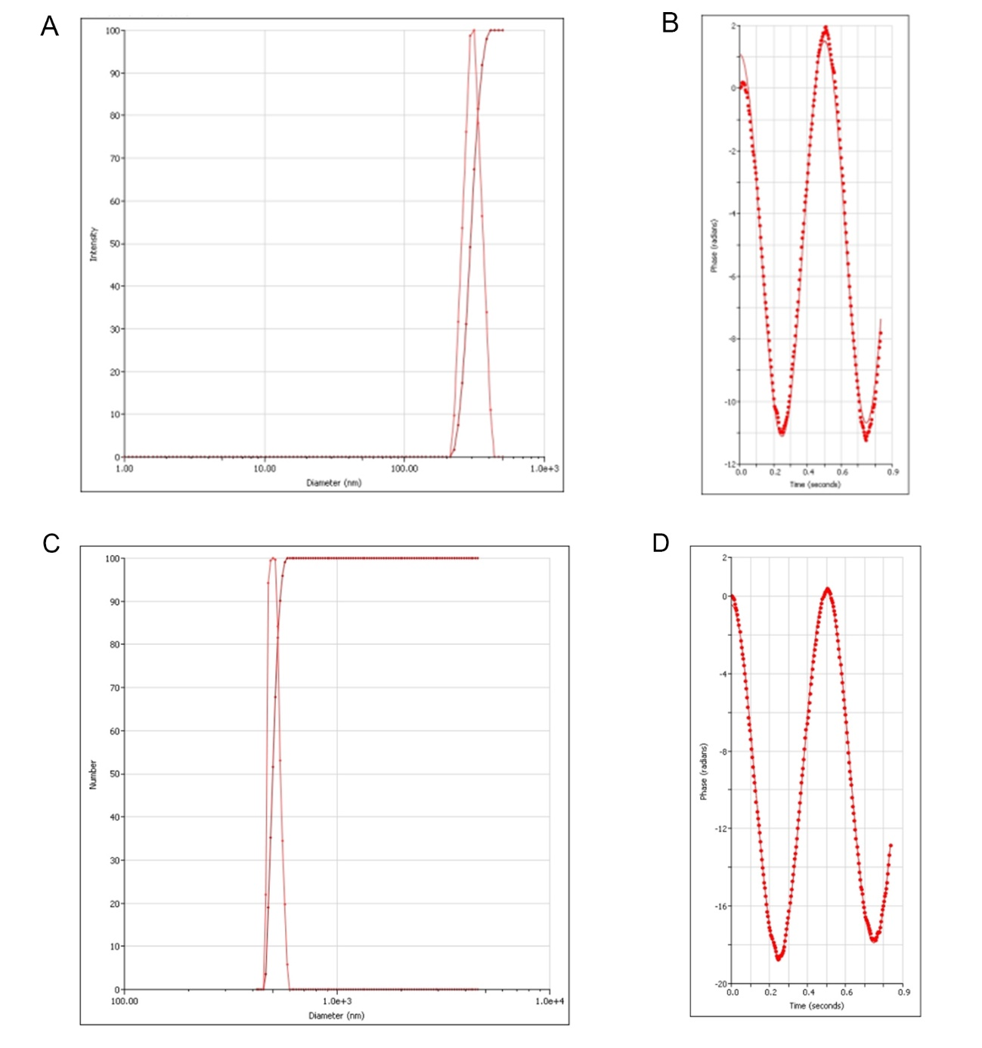
Figure S2. Zeta size and zeta potential of optimized EPR nanoemulsion (A & B) and EPR emulsion (C & D).
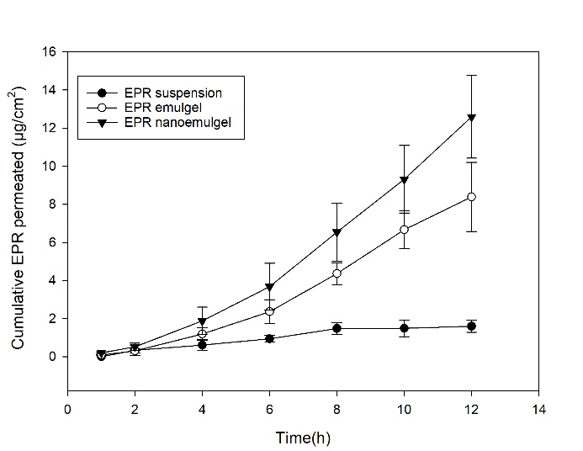
Figure S3. The cumulative transdermal permeation profile of different EPR formulations (n=3, mean±SD)

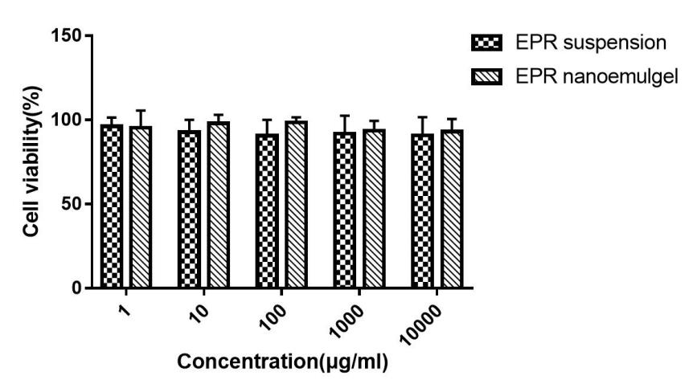
Figure S4. Cell viability (%) exposed to EPR suspension and EPR nanoemulgel at different concentration.

Table S3. Average skin stimulation scores of different group (n=3)
Group | Intact/damaged skin | Scores
 |  | 1(h) | 24(h) | 48(h) | 72(h)
Normal saline | Intact | 0 | 0 | 0 | 0
 | Damaged | 0 | 0 | 0 | 0
EPR nanoemulgel | Intact | 0 | 0 | 0 | 0
 | Damaged | 0 | 0 | 0 | 0
Blank nanoemulgel | Intact | 0 | 0 | 0 | 0
 | Damaged | 0 | 0 | 0 | 0
EPR nanoemulsion | Intact | 0 | 0 | 0 | 0
 | Damaged | 0 | 0 | 0 | 0
Blank nanoemulsion | Intact | 0 | 0 | 0 | 0
 | Damaged | 0 | 0 | 0 | 0

