*SUPPLEMENTAL INFORMATION*

**Mouse Trmt2B protein is a dual specific mitochondrial metyltransferase responsible for the m5U formation in both tRNA and rRNA**

Ivan Laptev1,2† Ekaterina Shvetsova3†, Sergey Levitskii4, Marina Serebryakova1,5, Maria Rubtsova1,2, Alexey Bogdanov2,5, Piotr Kamenski4*, Petr Sergiev1,2,5,6* and Olga Dontsova1,2,5,7

1Center of Life Sciences, Skolkovo Institute of Science and Technology, Skolkovo, Moscow Region, 143028, Russia

2Department of Chemistry, Lomonosov Moscow State University, Moscow, 119992, Russia

3Faculty of Bioengineering and Bioinformatics, Lomonosov Moscow State University, Moscow, 119992, Russia

4Faculty of Biology, Lomonosov Moscow State University, Moscow, 119992, Russia

5Belozersky Institute of Physico-Chemical Biology, Lomonosov Moscow State University, Moscow, 119992, Russia

6Institute of Functional Genomics, Lomonosov Moscow State University, 119992 Moscow, Russia

7Shemyakin-Ovchinnikov Institute of Bioorganic Chemistry, 117997 Moscow, Russia

†These authors contributed equally to the paper

*Correspondence: [petya@genebee.msu.ru](mailto:petya@genebee.msu.ru) (PS), [peter@protein.bio.msu.ru](mailto:peter@protein.bio.msu.ru) (PK)

**Supplementary figures**



**Figure S1. Relative quantity of *Trmt2B* mRNA in different murine cell lines** (n=1, error bars are SD between three technical replicates), normalization to *Gapdh*.

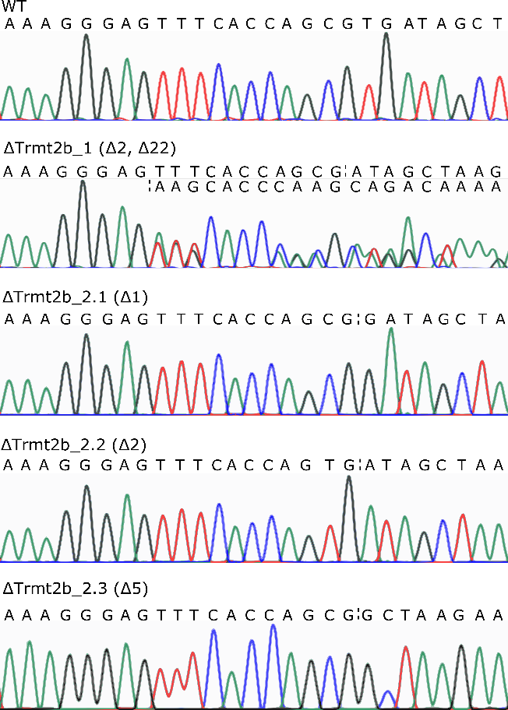

**Figure S2. Sequences of Trmt2B KO alleles in the knockout cell lines.** Dashed line indicates position where deletion occurred.

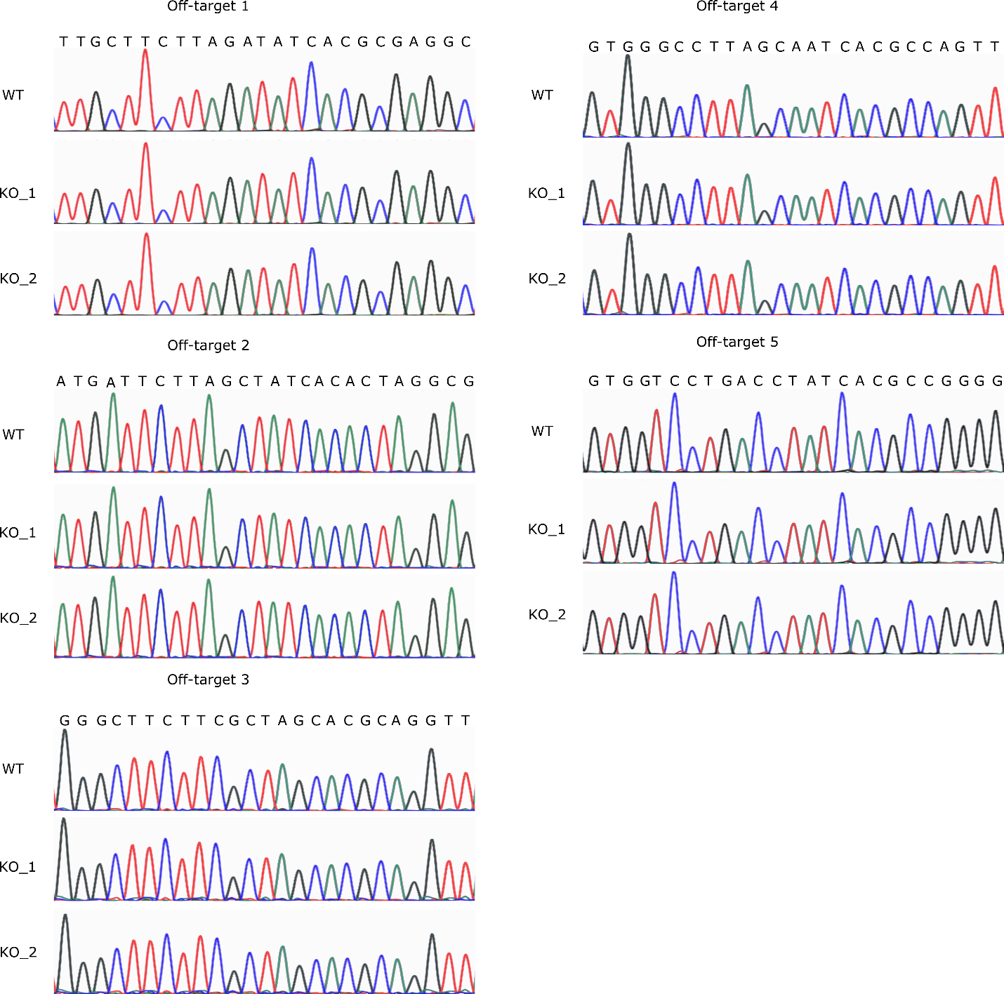

**Figure S3. Sequences of 5 off-targets** with highest score (numeration as in Supplementary table 1) in WT and two KO cell lines.

**A**

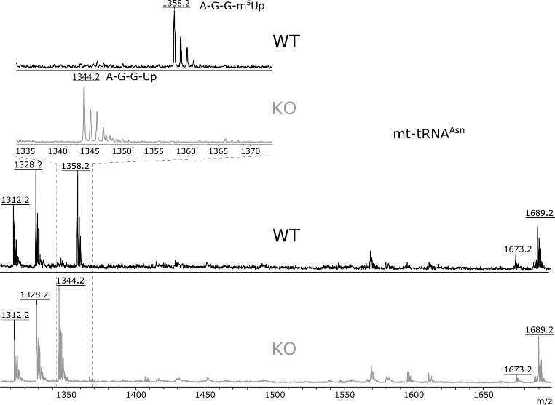

**B**

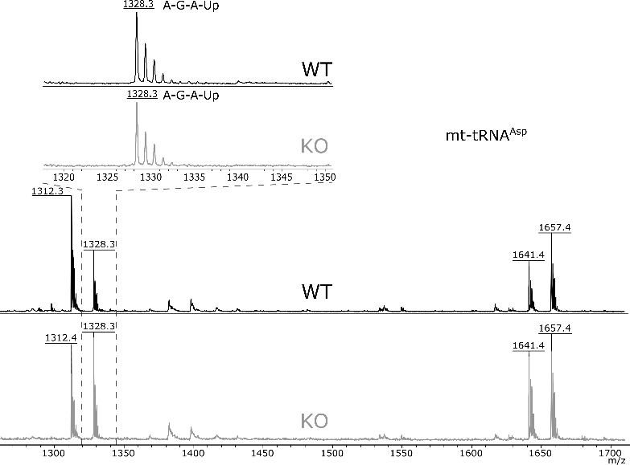

**C**

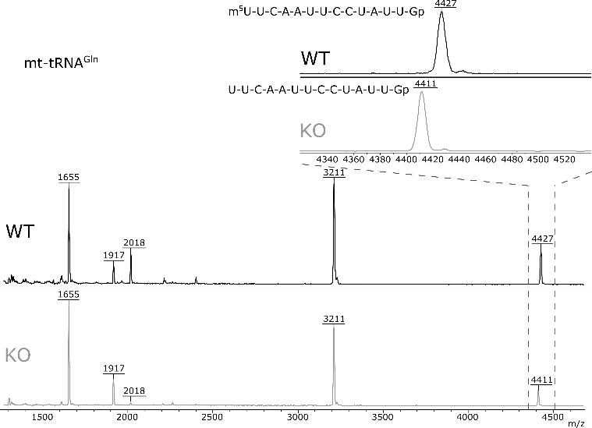

**D**

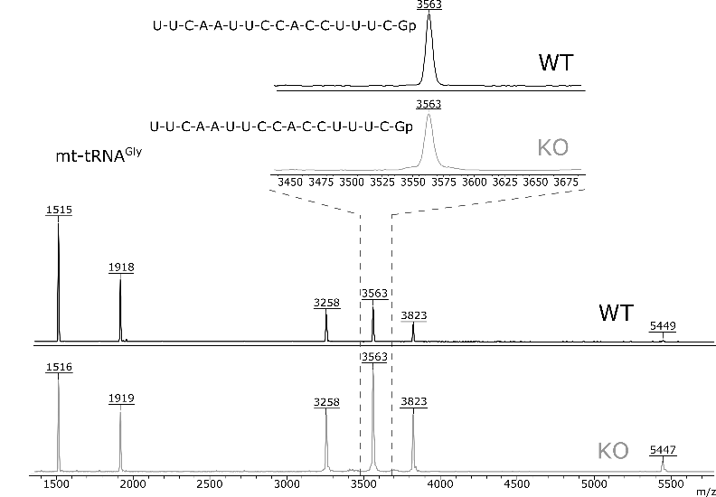

**E**

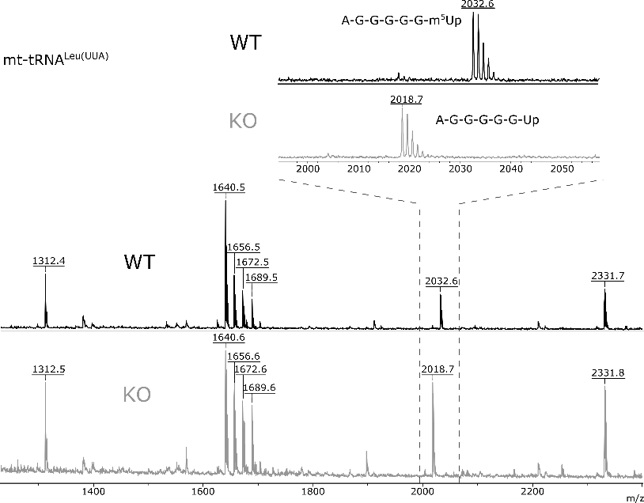

**F**

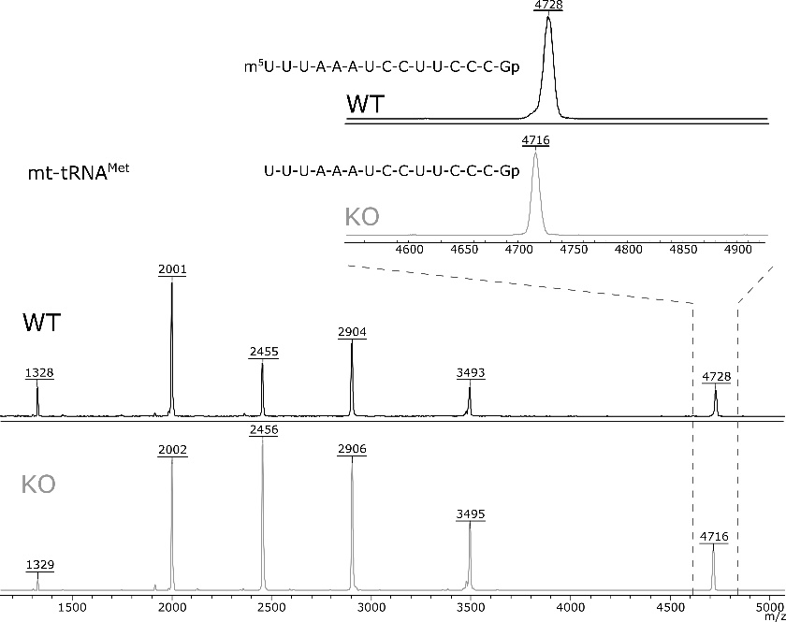

**G**

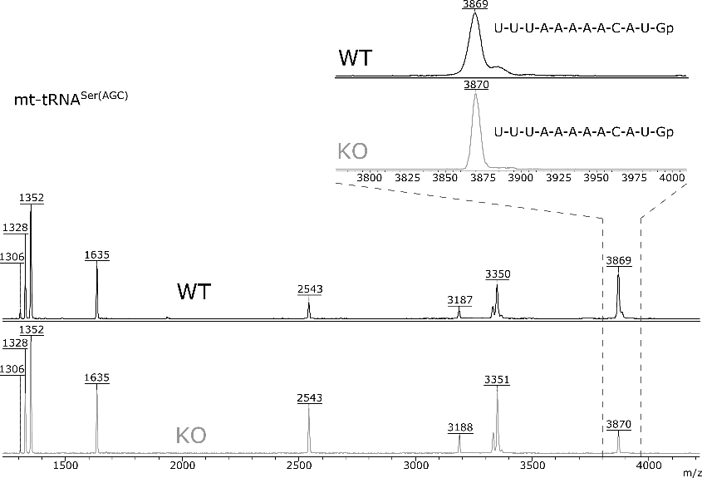

**H**

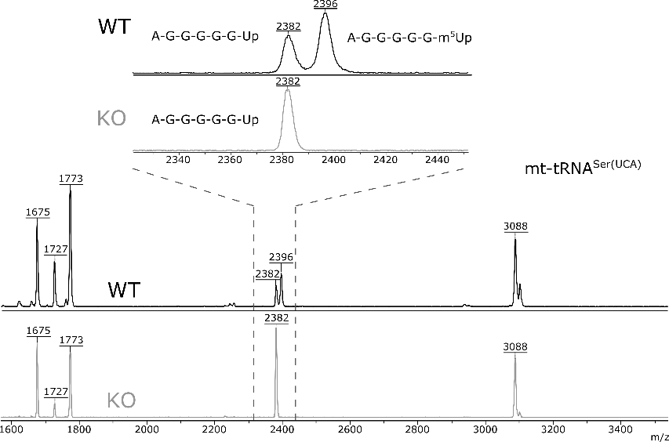

**I**

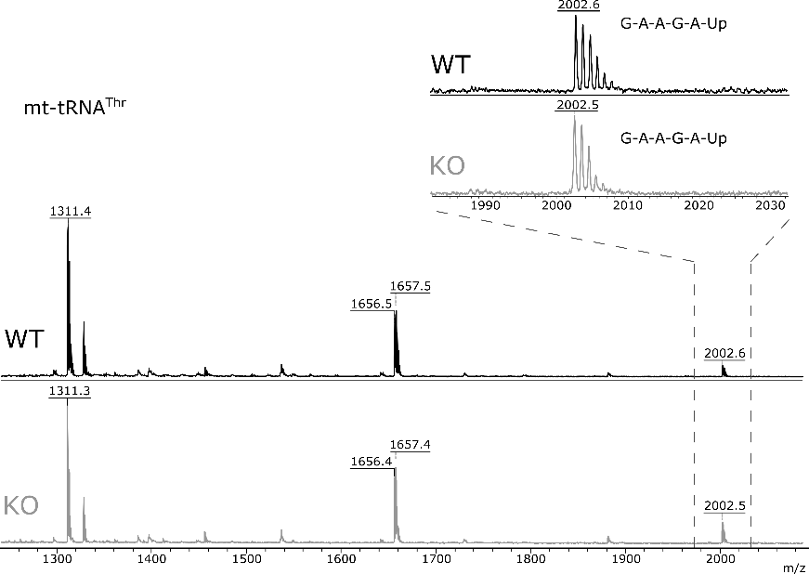

**J**

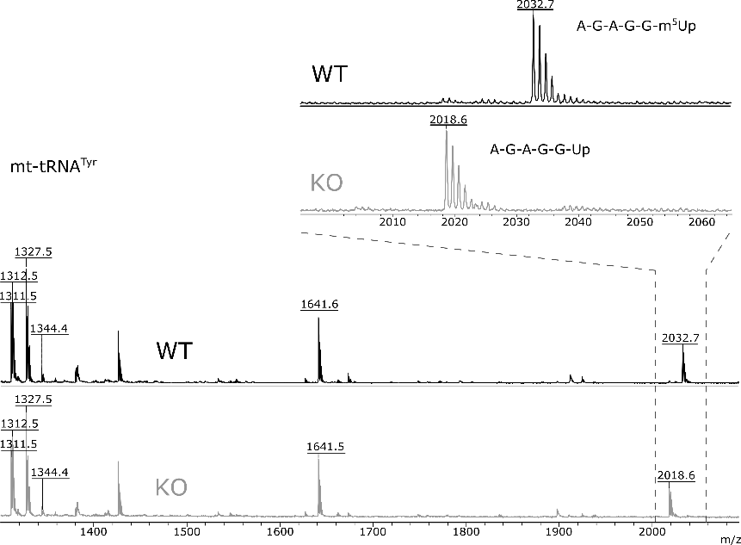

**K**

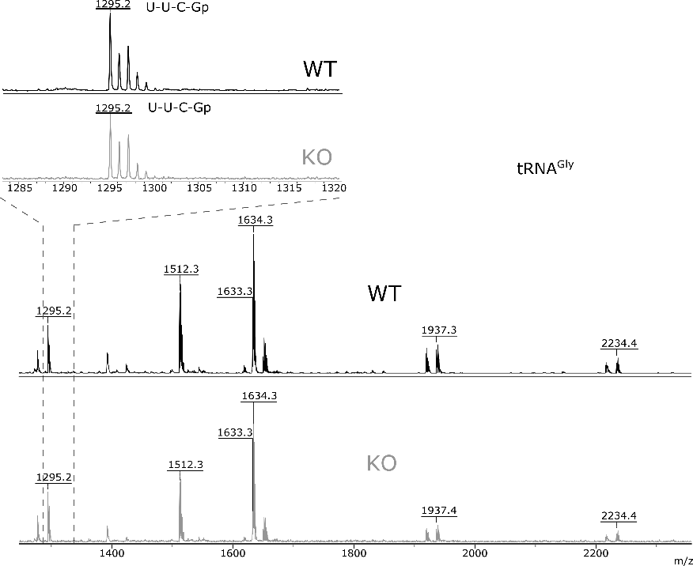

**Figure S4. TRMT2B forms methylated m5U54 residue of mouse mitochondrial tRNAs.** Shown are mass-spectral analyses of several mitochondrial and cytoplasmic tRNA species as indicated. WT and KO corresponds to mass spectra of tRNA fragments form the wild type and *Trmt2B* knockout cell lines correspondingly. Insets show closeups on the fragments with expected mass shift due to the lack of methylation. Panels correspond to the analysis of (A) mitochondrial tRNAAsn, (B) mitochondrial tRNAAsp, (C) mitochondrial tRNAGln, (D) mitochondrial tRNAGly, (E) mitochondrial tRNALeu(UAA), (F) mitochondrial tRNAMet, (G) mitochondrial tRNASer(AGC), (H) mitochondrial tRNASer(UCA), (I) mitochondrial tRNAThr, (J) mitochondrial tRNATyr, (K) cytoplasmic tRNAGly.

**A**



**B**



**C**

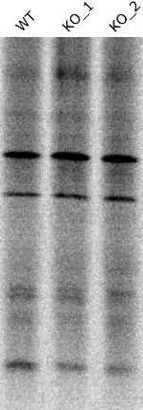

**Figure S5. TRMT2B knockout does not alter the number of mitochondria, quantity of mitochondrial 12S rRNA and yield of mitochondrial protein synthesis. (**A) Comparison of mtDNA copy number in WT and KO cell lines determined by qPCR. A single copy nuclear DNA locus was used as a control. (B) Comparison of the 12S rRNAs levels in WT and KO cell lines determined by qRT-PCR. Mitochondrial large subunit 16S rRNA and cytoplasmic small subunit 18S rRNA were used for comparison. Values were normalized to *Gapdh* mRNA. (C) Mitochondrial protein synthesis in the WT and KO cell lines as revealed by [35S]methionine inclusion into proteins upon the cytoplasmic protein synthesis inhibition by cycloheximide.



**Figure S6. Alignment of m5U RNA methyltransferases from a set of model species.** Enzyme names and species designations are shown on the left side relative to the sequences. Numbers corresponds to the number of aminoacid residue of particular protein starting a row. Secondary structure elements are marked for the proteins with known tertiary structure with the help of UCSF Chimera (1). Green boxes correspond to the -sheets, while yellow boxes to -helices.

**Supplementary tables**

**Table S1.** Off-targets and primers for their sequences.

|  |  |  |  |  |  |
| --- | --- | --- | --- | --- | --- |
| **№** | **Off-target sequence** | **Score** | **Gene** | **Coordinates** | **Primers** |
| 1 | TTGCTTCTTAGATATCACGC | 4.6 | – | chr1:-157762344 | 5’-GGCCTCTGATACATCCGTCT-3’ 5’-GCTGCCATCTGCCTACAGAAT-3’ |
| 2 | ATGATTCTTAGCTATCACAC | 1.4 | – | chr4:+6759800 | 5’-AACCTGGGACAGATTCCAGCA-3  5’-AAGCTACACTCGTGGGCAAAG-3 |
| 3 | GGGCTTCTTCGCTAGCACGC | 0.9 | – | chr1:+63106396 | 5’-CCTGGGTGTTGATTTTCTTCTGAG-3  5’-GCTCGGGCAGGGATTCAG-3 |
| 4 | GTGGGCCTTAGCAATCACGC | 0.4 | – | chr5:+144524999 | 5’-AACTATCTCTGTGGCAGCACC-3  5’-TCTGGGAACAAATTCCTGTGGG-3 |
| 5 | GTGGTCCTGACCTATCACGC | 0.3 | Dolpp1 | chr2:-30392368 | 5’-TGCGAGTGCTCCATTCTCTT-3  5’-CTCCAAGGCTCGCTGTTTGA-3 |

**Table S2.** Sequences of 5’-biotynilated oligodeoxyribonucleotides for isolation of 12SrRNA of different tRNAs.

|  |  |
| --- | --- |
| RNA | Oligodeoxyribonucleotide sequence |
| 12S rRNA | 5’-ATTTAGGTTTATGGCTAAGCATAGTGGGGTATCTAATC-3’ |
| mt-tRNAIle | 5’-GCTTGAACCTCTATAATTTACTCTATCAAAG-3’ |
| mt-tRNAGln | 5’-ATTGAACCTACACTTAAGAATTCAAAATTCTCCG-3’ |
| mt-tRNALeu(UUA) | 5’-ATTAGGGAGAGGATTTGAACCTCTGGGAACAAGGTTTTAAG-3’ |
| mt-tRNASer(UCA) | 5’-GTTTCAAGCCAATCTCATATCCTATATGTCT-3’ |
| mt-tRNATyr | 5’-CCTCTGTGTTTAGATTTACAGTCTAATGCTTA-3’ |
| mt-tRNAAsn | 5’-CAGGAATTAAACCTACGAAAATTTAGTTAACAGCT-3’ |
| mt-tRNAMet | 5’-TATGGGCCCGATAGCTTAATTAGCTGACCT-3’ |
| mt-tRNASer(AGC) | 5’-AAACATGGAAGCATGAATTAGCAGTTCTTGC-3’ |
| mt-tRNAThr | 5’-GAAGATCTTCATTTCAGGTTTACAAGACCAG-3’ |
| mt-tRNAAsp | 5’-GATCTATAATTTAACTTTGACAAAGTTATGTAATTGATTTTAC-3’ |
| mt-tRNAGly | 5’-GGGTTTATTCAGAATCTACTAATTGGAAGTC-3’ |
| tRNASec | 5’-CGCCCGAAAGGTGGAATTGAACCACTCTGTCGCTA-3’ |
| tRNAGly(GGA) | 5’-AGCTATGCTCACCACTATACCACCAACGC-3’ |

**Supplementary references**

1. Pettersen EF, et al. (2004) UCSF Chimera--a visualization system for exploratory research and analysis. *J Comput Chem* 25(13):1605–1612.