Electronic Supplementary Information

# Distinguishing Amines with an Amino Acid Appended Resorcinarene-Based Cavitand

## Tayyebeh Panahi, Holly L. Anderson, Karla I. Castro, John D. Lamb, Roger G. Harrison*

Department of Chemistry and Biochemistry, Brigham Young University, Provo, UT, 84602



Fig. S1 Conformations of vase and kites. The vase confirmation would have a 1H NMR signal at ca. 5 ppm for Ha and two signals for Hb and Hc. The kite confirmation can possibly convert to another kite confirmation. Depending on the rate of interconversion, 2 to 4 1H NMR signals are possible for Hb and Hc hydrogens.

## NMR of GME, GMA, GUE and GUA



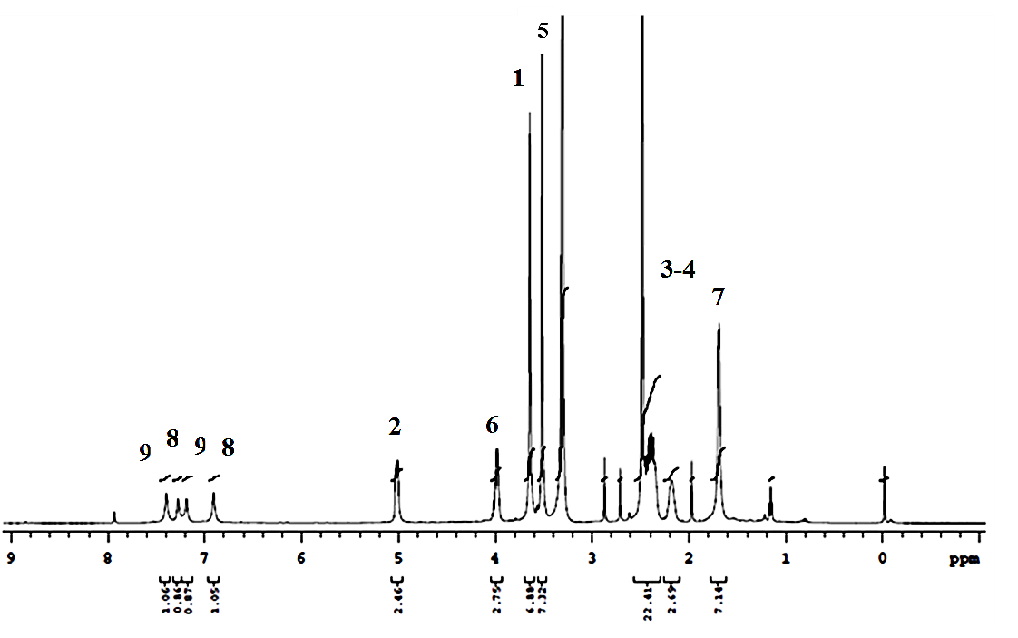

Fig S2 1H NMR of GME in d6-DMSO.

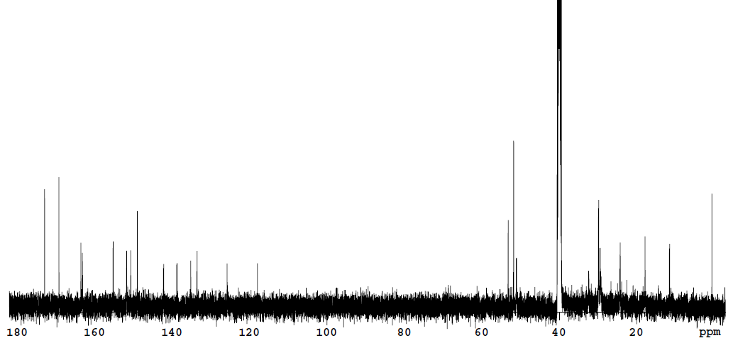

Fig S2b 13C NMR of GME in d6-DMSO.



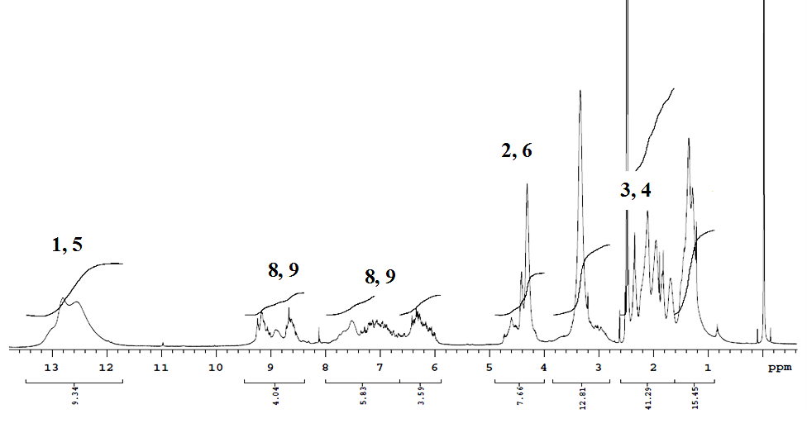

Fig S2c1H NMR of **GMA** in d6-DMSO.



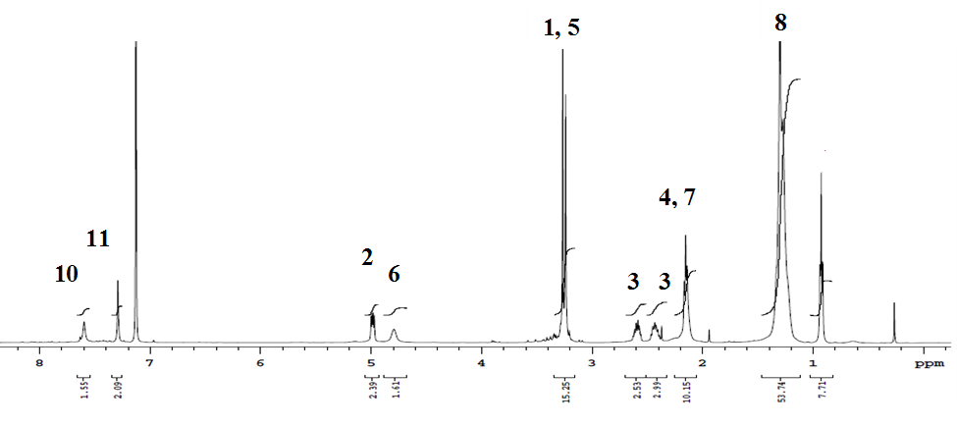

Fig S3 1H NMR of GUE in d6-C6H6.

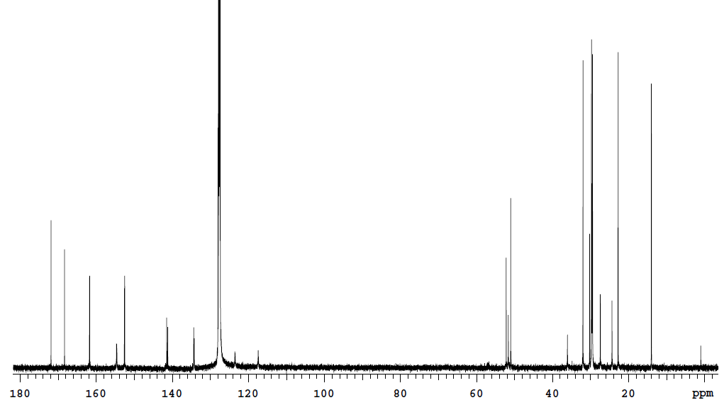

Fig S3a 13C NMR of GUE in d6-C6H6.



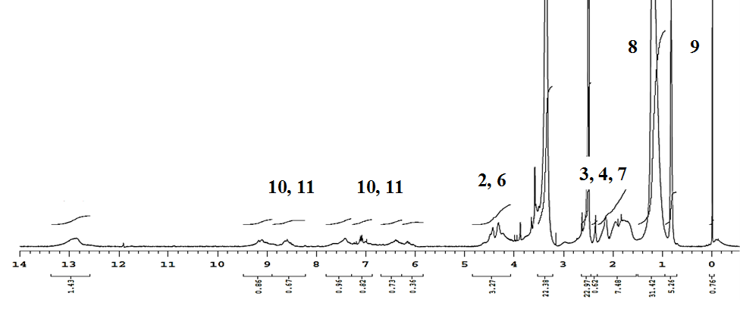

Fig S3b 1H NMR of **GUA** in DMSO.

Fig. S4 UV-vis absorbance of GMA and benzylamines (**1**).

Fig. S5 UV-vis absorbance of GMA and 4-methylbenzylamine (**2**).

Fig. S6 UV-vis absorbance of GMA and (S)-(-)-a-methylbenzylamine (**3**).

Fig. S7 UV-vis absorbance of GMA and (R)-(-)-a-methylbenzylamine (**4**).

Fig. S8 UV-vis absorbance of GMA and (S)-(-)-N, a-dimethylbenzylamine (**5**).

Fig. S9 UV-vis absorbance of GMA and (R)-(+)-N, a-dimethylbenzylamine (**6**).

Fig. S10 UV-vis absorbance of GMA and (S)-(-)-N, N-dimethyl-1-phenethylamine (**7**).

Fig. S11 UV-vis absorbance of GMA and (R)-(+)-N, N-dimethyl-1-phenethylamine (**8**).

Fig. S12 UV-vis absorbance of GMA and (S) & (R)-(1-naphtyl)ethylamine (**9, 10**).

Fig. S13 UV-vis absorbance of GMA and (S)-(+)-1-cyclohexylethylamine (**11**).

Fig. S14 UV-vis absorbance of GMA and (R)-(-)-1-cyclohexylethylamine (**12**).

Fig. S15 UV-vis absorbance of GMA and (S)-(+)-2-methylpiperazine (**13**).

Fig. S16 UV-vis absorbance of GMA and (R)-(-)-2-methylpiperazine (**14**).

Fig. S17 UV-vis absorbance of GMA and benzonitrile (**17**).

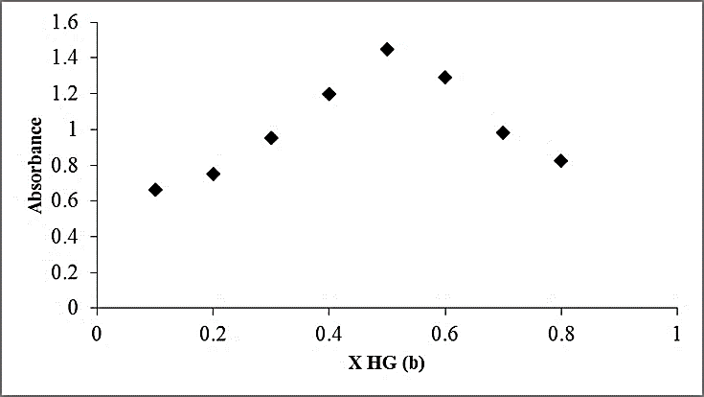

Fig. S18 Job plots of guest 3 with GMA. Conditions: 0.018 mM solutions of GMA and 0.006 mM of 3.

Fig. S19 UV-vis absorbance of **GMA** and guanidine (**18**).

Fig. S20 UV-vis absorbance of **GMA** and methylguanidine (**19**).

Fig. S21 UV-vis absorbance of **GMA** and dimethylbiguanidine (**20**).

Fig. S22 UV-vis absorbance of **GMA** and agmatine (**21**).

Fig. S23 UV-vis absorbance of **GMA** and cimetidine (**22**).