Supplementary materials
Methods
GC/MS/MS analysis
Water samples were filtered through glass wool, acidified with concentrated H₂SO₄ (pH 2) and extracted by liquid–liquid partitioning using CH₂Cl₂. After phase separation, CH₂Cl₂ extracts were dried with acidified Na₂SO₄, reduced on a Roto-evaporator, and then added to 40 mL hexane. The final volume was reduced to 10 mL for analysis. An Agilent 7000C Pesticide Analyzer Triple Quad GC/MS/MS operating in MRM mode was used to analyze the extracts (2-µL injections). The column was HP-5MS-UI, PN 19091S-433UI 30 m ’ 0.25 mm ’ 0.25 mm with the temperature at 70°C for 2 min, ramp of 25°C min⁻¹ to 150°C, followed by ramp of 3°C min⁻¹ to 200°C and ramp of 8°C min⁻¹ to 280°C (total run time of 38.9 min). One target ion and at least two qualifier ions were monitored to identify compounds at expected retention times. The lower limit of quantification was 25 ng L⁻¹ for most compounds and detections below this limit were considered no detects. The water samples of nAz and Az stock solutions prepared for sub-lethal experiments were analyzed through the same method.

Dynamic light scattering
Dynamic light scattering (DLS; Zetasizer Nano Series, Malvern Instruments Ltd.) was used to characterize hydrodynamic diameter and polydispersity index (PDI) and zeta-potential of nAz at nominal concentrations of 20 and 100μg L⁻¹ test suspensions at 28.5 °C at 0, 2, 4, 8, 12, 24, 48, 72 and 96 h in 173° backscatter mode (Zetasizer software, v. 7.01). The cell (ZEN 1002) was inserted into cuvette and remaining air bubbles were removed by gently flicking the cuvette to avoid interference with the measurements of zeta potential. Samples were covered by parafilm and kept static between measurements.

Zebrafish larvae images
Larvae at 120 hpf after sub-lethal exposure were transferred into 200 μL micropipette tips and then placed under dissecting microscope (Olympus SZ61) linked to microscope digital camera (ScopeTek MDC-320, 3.2 Megapixels) that was connected to a computer. The tips containing larvae were rotated and two photos were taken, one was the side view and the other one was the ventral view of zebrafish larvae, the images were processed by ScopeTek Scope Photo version 3.0, and the lengths of three axes of yolk sac were measured (Figure S1).

Oxygen consumption and heart rate
Two embryos/larvae (pooled together as N=1) were placed into a single 250 µl well on a 24-well microplate filled with fresh RO water. The microplate was sealed by a silicone pad in the chamber and placed on a sensor reading dish on a mixing table and incubated at 27 °C. Continuous O₂ measurements were conducted over a period of 20 min, with all recordings being made above 70% air O₂ saturation limits. Final MO₂ measurements were recorded as mg O₂⁻¹g⁻¹hr⁻¹. Embryos were disposed of after the measurement. Heart rate of zebrafish larvae was measured at 120 hpf. Briefly, the heart rate of each larva was counted for 20s under dissecting microscope at 3 times magnification and heartbeats per minute were deduced. This process was repeated three times on each larva and the average was used as the final value.

Enzyme activity assays
Frozen 120 hpf zebrafish (20 larvae per sample) were first left to thaw on ice for 5 min and subsequently sonicated on ice (pulse sonication 1s on/1s off for 8 times, two rounds) by Virtis Virsonic 100 ultrasonic cell disrupter (115 v, 1 amp, 60 Hz) in the appropriate buffer for the assay. For catalase activity assays, sonicated samples were centrifuged at 10,000 x g for 15 min at 4°C. For superoxide dismutase (sod) assays, samples were centrifuge at 1,500 x g for 5 min at 4°C. The supernatant was transferred to an Eppendorf tube on ice. Catalase activity was measured using Cayman Catalase Assay Kit (Cayman Chemical; Item No. 707002) following the manufacturer’s manual. Sod activity was determined by Cayman Superoxide Dismutase Assay Kit (Cayman Chemical; Item No. 706002) according to the manufacturer’s specifications. All samples were normalized to total protein content which was pre-determined by the Pierce BCA Protein Assay Kit (Thermo Scientific; 23225) based on manufacturer’s recommendations.

RNA isolation and cDNA synthesis
Total RNA was isolated from ten 120 hpf larvae of each treatment and control group mentioned in the sub-lethal experiment using the NucleoSpin RNA Plus (Macherey-Nagel; 740984) following manufacturer’s instructions. RNA quality, including 260/280 and 260/230 ratios and RNA concentration were determined right after RNA isolation using a NanoDrop spectrophotometer (ND-1000, v.3.8.1). Samples with both ratios between 1.8 and 2.2 and RNA concentration higher than 100 ng mL⁻¹ were then subsampled to perform cDNA synthesis. The first-strand cDNA synthesis was accomplished by using SuperScriptTM IV First-Strand Synthesis System (Thermo Fisher Scientific; 18091050) according to manufacturer’s instructions.

Western blotting and image processing
Briefly, 10 larvae at 120 hpf (pooled together as N=1) were sonicated in 1% NP-40 cell lysis buffer (Thermo Fisher Scientific; FNN0021) on ice (pulse sonication 1s on/1s off for 8 times, two rounds) by Virtis Virsonic 100 ultrasonic cell disrupter. Samples were placed on rotator at 4°C for 20 min to get complete lysis and then centrifuged at 14,000 x g at 4°C for 10 min. The supernatant was transferred to a new tube on ice. Ten μL supernatant was diluted to 40 μL and then used to determine protein concentration by the Pierce BCA Protein Assay Kit. All the original samples were sub-sampled and diluted to the same concentration based on the BCA assay results. Subsamples were diluted in equal volume (1:1) by reducing buffer (10 mL 2x Laemmli sample buffer (Bio-Rad; 1610737) plus 500μL 2-Mercaptoethanol (Sigma-Aldrich; M6250) and then boiled at 95 °C for 10 min. A 20 μg sample was added to each well of 8% gel and then followed Western blotting protocol with anti-4-HNE antibody (67 kDa; StressMarq Biosciences, SMC-511) as the primary antibody (1:1000) and Goat Anti-Mouse IgG (H+L) HRP (ThermoFisher, G-21040) as the secondary antibody (1:1000). 4-HNE was normalized to beta-actin using anti-beta-actin antibody (42 kDa; ThermoFisher, MA5-15739) as the primary antibody (1:1000) and Goat Anti-Rabbit IgG (H+L) HRP (ThermoFisher, G-21234) as the secondary antibody (1:2000). The membranes were exposed and imagines were captured by ChemiDoc™ Touch Gel Imaging System (Bio-Rad; 1708370). The images were processed and analyzed by Image LabTM Software (v.6.0.1, Bio-Rad).

Modified thiobarbituric acid reactive substances assay
Briefly, 53.6 mg 2-DR powder (Sigma; 31170) was added into RO water to make a 400 mM 2-deoxy-D-ribose (2-DR) stock solution. The 2-DR stock solution was sonicated in a water bath for 5 min and then 50 μL of 2-DR stock solution was added into each well of polystyrene 12-well plates containing 4.95 mL of either nAz at a nominal concentration of 1 or 10 mg L⁻¹, Az at a nominal concentration of 1 or 10 mg L⁻¹, input polymer at a nominal concentration of 10 mg L⁻¹ or Allosperse at nominal concentration of 10 mg L⁻¹, RO water or 0.01% methanol. One 12-well plate was incubated 5 cm below UV lamp UVA: 3.0 ± 0.14 W m⁻², UVB: 1.5 ± 0.11 W m⁻²) for 30 min while the other one was incubated under laboratory light. The spectral irradiance from UV lamp with UVA (UVX-36; calibrated at 365 nm) or UVB (UVX-31; calibrated at 310 nm) sensor (Ultra-Violet Products Ltd., CA, USA) was measured by UVX digital radiometer. After incubation, the amount of •OH produced in the presence or absence of UV light was determined by thiobarbituric acid reactive substances (TBARS) assay.

Figures and Tables:
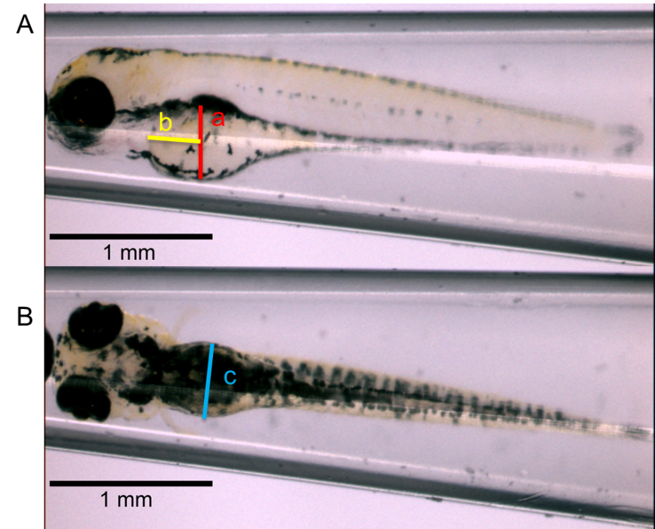
Figure S1. The side view (A) and the ventral view (B) of zebrafish larvae in at 120 hpf in control under laboratory light.

Figure S2. Measured concentrations of nano-enabled (A) and conventional (B) azoxystrobin at nominal concentrations of 20 and 100μg L⁻¹ under either laboratory light or UV light. Means sharing the same letter are not significantly different from each other (p>0.05). Values are mean ± SEM. N=3.

Figure S3. Average hydrodynamic diameter (A), zeta-potential (B) and polydispersity index (C) of nano-enabled azoxystrobin measured by DLS at 0, 2, 4, 8, 24, 48, 72 and 96 hours at nominal concentration of 20 and 100 μg L⁻¹. * indicates measurement at 20 μg L⁻¹ is significantly different than 100 μg L⁻¹. Means sharing the same small letter are not significantly different from each other at 20 μg L⁻¹ (p>0.05). Means sharing the same capital letter are not significantly different from each other at 100 μg L⁻¹ (p>0.05). Values are mean ± SEM. N=3.

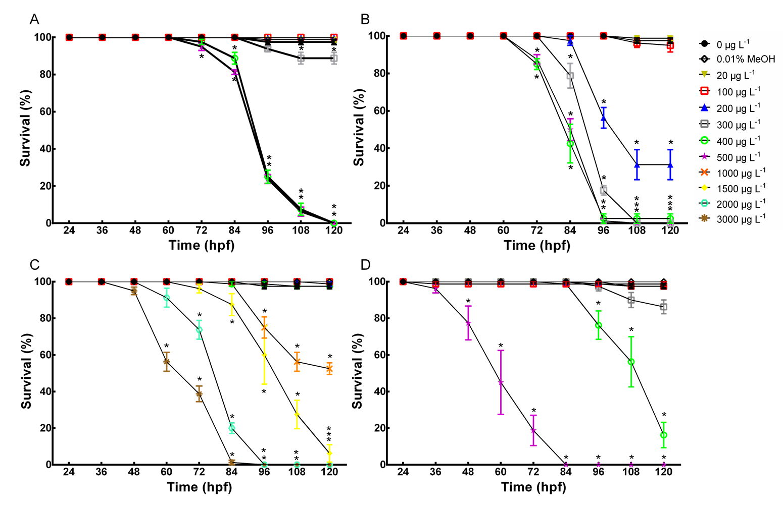
Figure S4. Survival rate of zebrafish embryos exposed to nano-enabled (A&B), conventional (C&D) azoxystrobin at various nominal concentrations, control and methanol control (0.01% MeOH) under fluorescent light (A&C) or UV light (B&D) from 24 hpf to 120 hpf. Asterisk (*) indicates significant difference between treatments and control. Values are mean ± SEM. N=4.

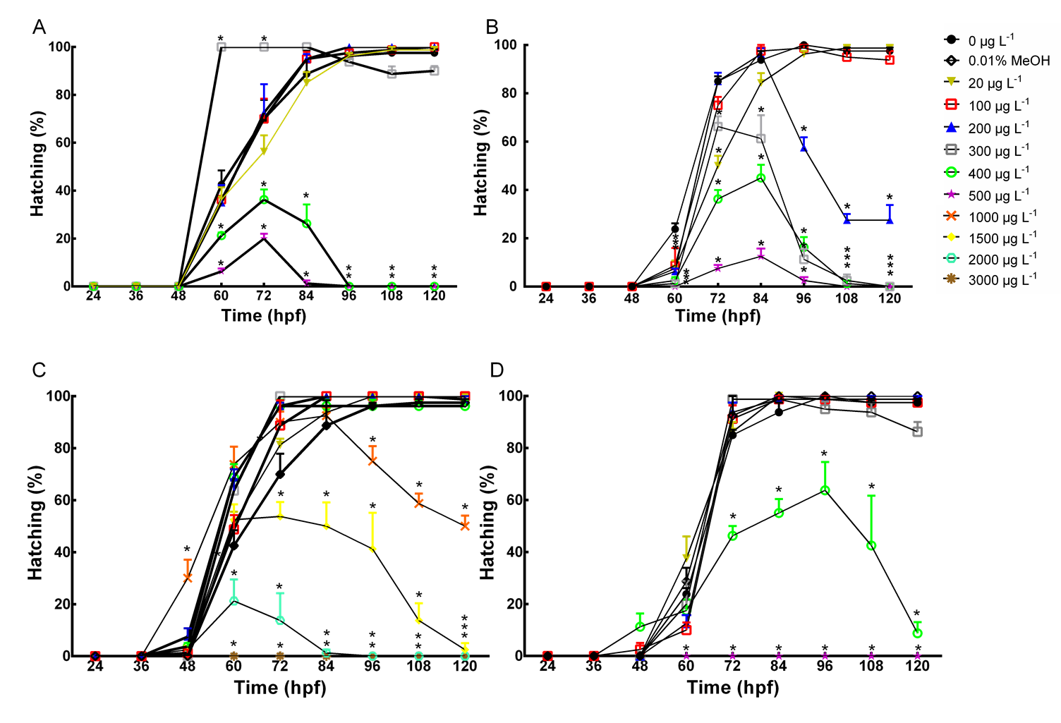
Figure S5. Hatching success of zebrafish embryos exposed to nano-enabled (A&B), conventional (C&D) azoxystrobin at various nominal concentrations, control and methanol control under fluorescent light (A&C) or UV light (B&D) from 24 hpf to 120 hpf. Asterisk (*) indicates significant difference between treatments and control. Values are mean ± SEM. N=4.

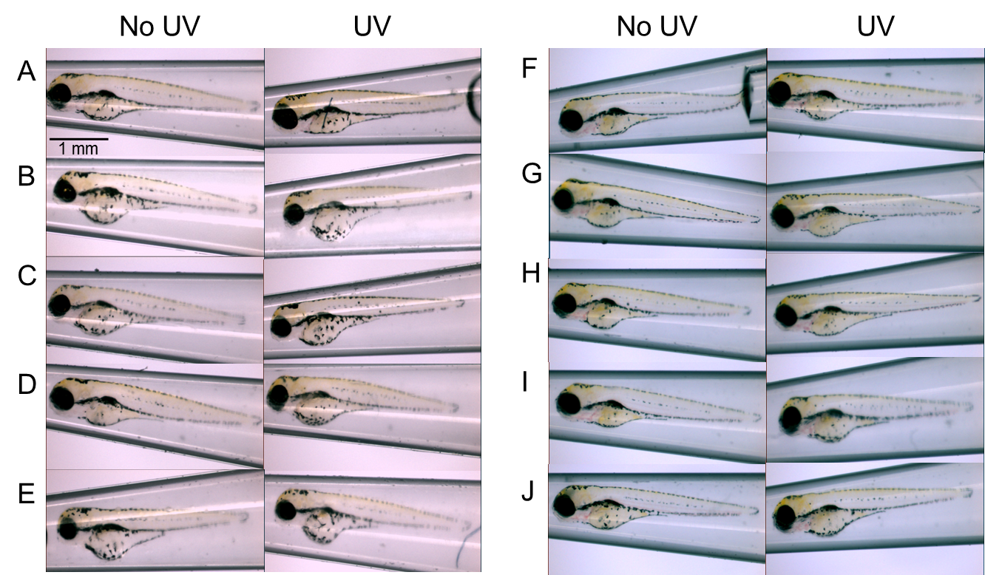
Figure S6. Side view of zebrafish larvae at 120 hpf in control (A), nAz at 20 μg L⁻¹ (B) and 100 μg L⁻¹ (C), Az at 20 μg L⁻¹ (D) and 100 μg L⁻¹ (E), vehicle control (F), input polymer at 20 μg L⁻¹ (G) and 100 μg L⁻¹ (H), and Allosperse at 20 μg L⁻¹ (I) and 100 μg L⁻¹ (J) under laboratory light and UV light. Arrows in A (control) and E (nAz at 100μg L⁻¹) illustrate variation in yolk sac volume as reported in Fig 2. The scale is 1 mm in length.

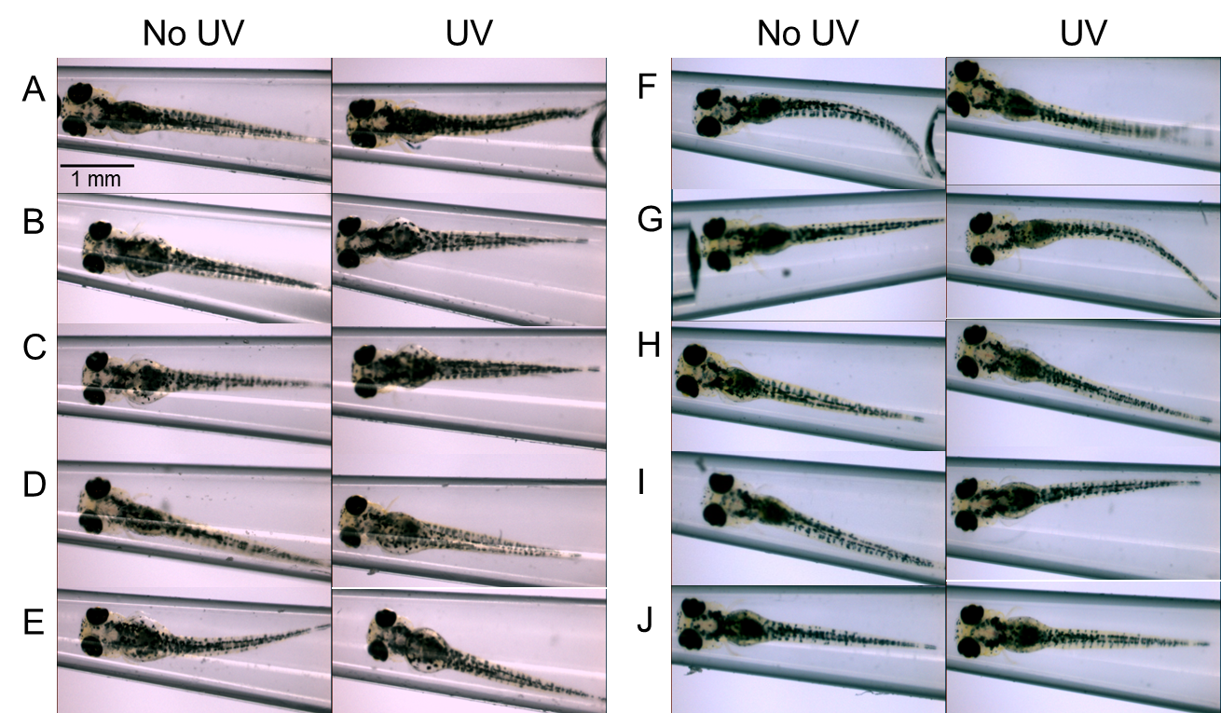
Figure S7. Ventral view of zebrafish larvae at 120 hpf in control (A), nAz at 20 μg L⁻¹ (B) and 100 μg L⁻¹ (C), Az at 20 μg L⁻¹ (D) and 100 μg L⁻¹ (E), vehicle control (F), input polymer at 20 μg L⁻¹ (G) and 100 μg L⁻¹ (H), and Allosperse at 20 μg L⁻¹ (I) and 100 μg L⁻¹ (J), and Allosperse at 20 μg L⁻¹ (I) and 100 μg L⁻¹ (J) under laboratory light and UV light. The scale is 1 mm in length.

Figure S8. Relative fold change in gene expression of ef1α in zebrafish larvae at 120 hpf after 96-hour exposure from 24 hpf under either laboratory light or UV light. Values are mean ± SEM. N=4.

Figure S8. Western blot images of beta-actin expression n zebrafish larvae at 120 hpf in control (A), vehicle control (B), nano-enabled azoxystrobin at 20 μg L⁻¹ (C) and 100 μg L⁻¹ (D), conventional azoxystrobin at 20 μg L⁻¹ (E) and 100 μg L⁻¹ (F), input polymer at 20 μg L⁻¹ (G) and 100 μg L⁻¹ (H), and Allosperse at 20 μg L⁻¹ (I) and 100 μg L⁻¹ (J) under laboratory light (lane 1, 2 and 3) and UV light (lane 4, 5 and 6).

Table S1. Gene-specific primers for zebrafish. Abbreviation of gene names, NCBI reference sequence, forward and reverse primer sequences (5’-3’), amplicon size in base pairs and amplification efficiency measured by quantitative polymerase chain reaction.
Gene | Accession no. | Forward primer 5’–3’ | Reverse primer 5’–3’ | Amplicon size (bp) | Eff.
ef1α | NM_131263.1 | TTCTCAGGCTGACTGTGCTG | GGGTCTGTCCGTTCTTGGAG | 83 | 2.02
cat | NM_130912.2 | GAGAGAGTCGTGCATGCTAAA | GATCGGTGTCGTCTTTCCAATA | 117 | 2.00
sod1 | NM_131294 | TCGGAGACCTGGGTAATGT | CACCATGGTCCTCCCAATAAT | 113 | 2.02
sod2 | NM_199976.1 | GAGCCTCACATCTGTGCTGA | CTTGGCCAGAGCCTCTTGAT | 111 | 1.98
gpx1a | NM_001007281.2 | TTTACGACCTGTCCGCGAAA | CTGTTGTGCCTCAAAGCGAC | 108 | 1.98
gpx1b | NM_001004634 | GAGTCCCGTATGCAGAAATGA | TCAGGAATCTCCGGCTGTA | 98 | 1.99

Table S2. The linear relationship between measured concentrations (y) and nominal concentration (x) for two types of azoxystrobin under laboratory light and UV light.
Azoxystrobin | No UV | UV
Nano-enabled | y = 0.7113x + 23.798 | y = 0.6184x + 22.341
 | R² = 0.852 | R² = 0.957
Conventional | y = 0.3768x + 99.825 | y = 0.3493x + 101.2
 | R² = 0.957 | R² = 0.940

Table S3. Probit analysis of LC50 values of nano-enabled and bulk form azoxystrobin under laboratory light and UV light at nominal concentration and measured concentration. Values are mean. Ranges are 95% confidence interval (95% CI).
Azoxystrobin | Concentration | No UV (95%CI) | UV (95%CI)
Nano-enabled | Nominal | 341 μg L⁻¹ (328-356) | 162 μg L⁻¹ (147-181)
 | Measured | 267 μg L⁻¹ (257-278) | 131 μg L⁻¹ (123-139)
Conventional form | Nominal | 937 μg L⁻¹ (820-1072) | 404 μg L⁻¹ (353-462)
 | Measured | 463 μg L⁻¹ (422-509) | 248 μg L⁻¹ (228-271)

Table S4. The QA/QC measures for Azoxystrobin. All samples were run against a 10 point standard curve to ensure that the GC/MS/MS analysis is reporting standards and samples with the same internal condition. Characteristic accuracy for azoxystrobin R² was ~0.999.
 | Level of Quantitation  (μg L⁻¹) |  | Recovery % |  | Spiking Amounts  (μg L⁻¹)
 |  |  | High | Low | High | Low
Azoxystrobin |  | 0.113 | 111.5 | 103.5 | 116.21 | 23.24

