Some mutations in the Xeroderma Pigmentosum D gene may lead to moderate but significant radiosensitivity associated with a delayed radiation-induced ATM nuclear localization

SUPPLEMENTARY DATA

Table S1 : Major radiobiological features of the fibroblast cell lines tested here

Cell lines | α dp (Gy⁻¹) | β dp(Gy⁻²) | SF2 dp (%) | α ip (Gy⁻¹) | β ip (Gy⁻²) | SF2 ip (%)
1BR3 | 0.13 ± 0.03 | 0.04 ± 0.02 | 65 ± 2 | 0.36 ± 0.01 | 0.001 ± 0.001 | 48 ± 2
149BR | 0.24 ± 0.01 | 0.008 ± 0.001 | 59 ± 3 | 0.34 ± 0.01 | 0.001 ± 0.001 | 50 ± 2
XP1BR | 0.39 ± 0.02 | 0.01 ± 0.003 | 45 ± 2 | 0.44 ± 0.03 | 0.01 ± 0.002 | 40 ± 3
XP2NE | 0.36 ± 0.02 | 0.001 ± 0.003 | 48 ± 2 | 0.42 ± 0.02 | 0.01 ± 0.01 | 41 ± 1
XP34BE | 0.35 ± 0.03 | 0.001 ± 0.003 | 49 ± 1 | 0.44 ± 0.02 | 0.01 ± 0.01 | 40 ± 1
XP35BE | 0.30 ± 0.03 | 0.01 ± 0.01 | 55 ± 4 | 0.39 ± 0.01 | 0.01 ± 0.01 | 45 ± 3
XP16BR | 0.80 ± 0.05 | 0.02 ± 0.01 | 18 ± 1 | 1.1 ± 0.1 | 0.01 ± 0.01 | 10 ± 1
XP17PV | 0.73 ± 0.04 | 0.02 ± 0.01 | 23 ± 2 | 1.2 ± 0.02 | 0.01 ± 0.005 | 8 ± 1
XP26VI | 0.75 ± 0.03 | 0.02 ± 0.01 | 22 ± 2 | 1.05 ± 0.02 | 0.01 ± 0.01 | 12 ± 1
XP16BR/XPD | 0.34 ± 0.03 | 0.001 ± 0.003 | 50 ± 2 | 0.42 ± 0.04 | 0.02 ± 0.01 | 41± 3
XP17PV/XPD | 0.29 ± 0.03 | 0.01 ± 0.01 | 56 ± 4 | 0.52 ± 0.02 | 0.01 ± 0.01 | 34 ± 3
XP26VI/XPD | 0.14 ± 0.03 | 0.04 ± 0.02 | 64 ± 3 | 0.41 ± 0.01 | 0.01 ± 0.01 | 43 ± 3
AT4BI | 2.0 ± 0.07 | 0.001± 0.001 | 2 ± 0.5 | 1.9 ± 0.04 | 0.001± 0.001 | 2.0 ± 0.5
AT5BI | 2.12 ± 0.07 | 0.001± 0.001 | 1.3 ± 0.2 | 2.10 ± 0.01 | 0.001± 0.001 | 1.0 ± 0.2

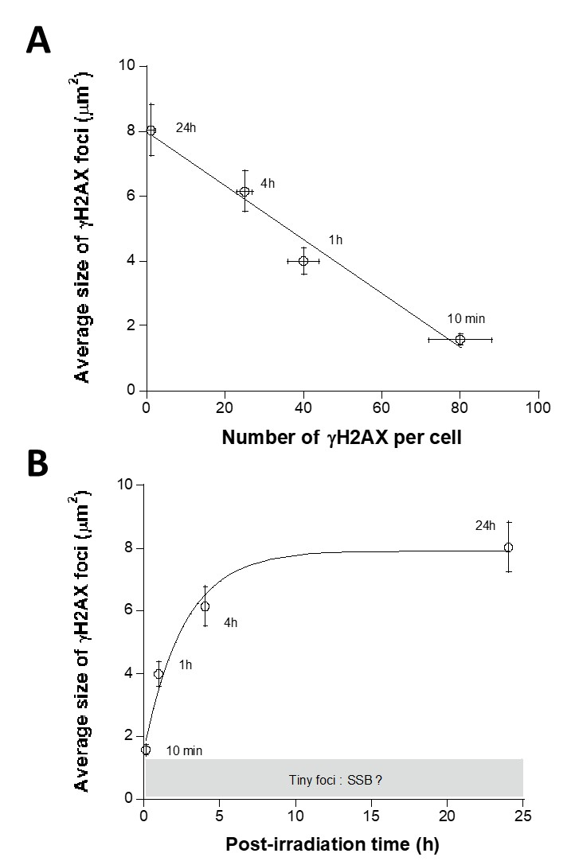

Fig. S1 : Average size of γH2AX foci as a function of the number of foci per cell (A) and of the post-irradiation time (B). A sum of 300 foci obtained from 3 independent replicates were analysed by the Cell F software of Olympus and the size of each foci was deduced and averaged. The foci data were plotted against the number of foci and of the post-irradiation-time as indicated. These experiments were performed on the radioresistant 1BR3 cell lines.

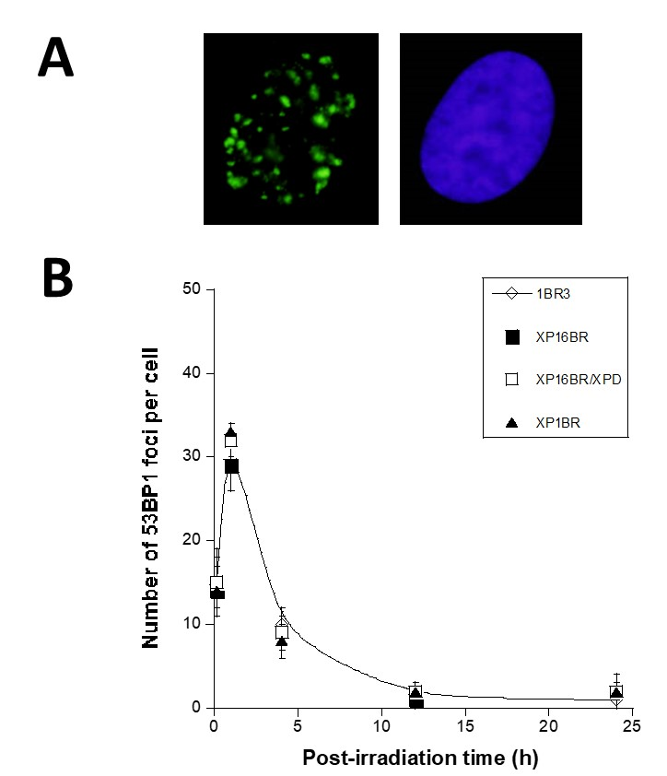

Fig S2: 53BP1 foci in XPD-mutated fibroblasts in response to IR. (A) Representative examples of 53BP1 foci after 2 Gy followed by 24 h for repair in XP16BR fibroblasts. (B). Kinetics of IR-induced 53BP1 foci in XPD-mutated cells assessed by immunofluorescence. Data were expressed as a number of 53BP1 foci per cell. Data plots represent the mean of triplicate experiments ± standard error. Data were fitted to the Bodgi’s formula (Bodgi, et al. 2013). The dotted and the dashed lines represent the fits to the controls and hyper-radiosensitive ATM-mutated fibroblasts, respectively. 1BR3 () is a radioresistant control cell line; XP1BR () and XP16BR (); XP17PV are XPD-mutated fibroblasts and their XPD-transduced counterparts XP16BR/XPD ().
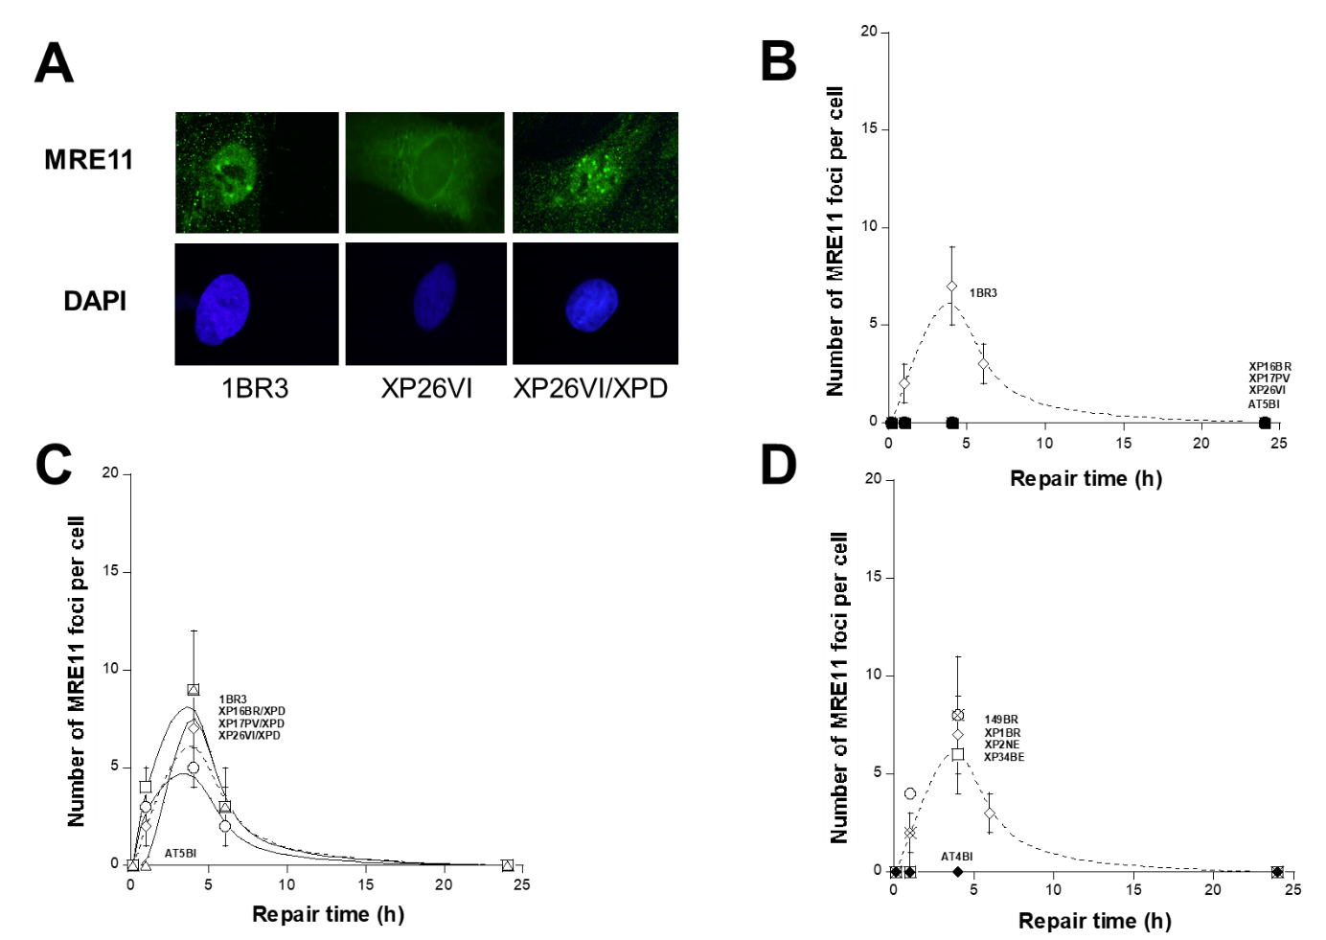

Fig S3: MRE11 foci in XPD-mutated fibroblasts in response to IR. (A). Representative examples of MRE11 foci after 2 Gy followed by 1 h for repair in 1BR3, XP26VI, XP26VI/XPD fibroblasts. (B). IR-induced MRE11 foci kinetics of XPD-mutated cells assessed by immunofluorescence. Data were expressed as a number of MRE11 foci per cell. Data plots represent the mean of triplicate experiments ± standard error. Data were fitted to the Bodgi’s formula (Bodgi et al., 2013). The dotted and the dashed lines represent the fits to the controls and hyper-radiosensitive ATM-mutated fibroblasts, respectively. Panels B and C: 1BR3 () is a radioresistant control cell line; AT5BI () is a hyper-radiosensitive ATM-mutated cell line; XP16BR (); XP17PV () and XP26V () are XPD-mutated fibroblasts and XP16BR/XPD (), XP17PV/XPD () and XP26VI/XPD () are their XPD-transduced counterparts; Panel D : 149BR () is a radioresistant control cell line; AT4BI () is a hyper-radiosensitive ATM-mutated cell line; XP1BR (), XP2NE (), XP34BE () are XPD-mutated fibroblasts.

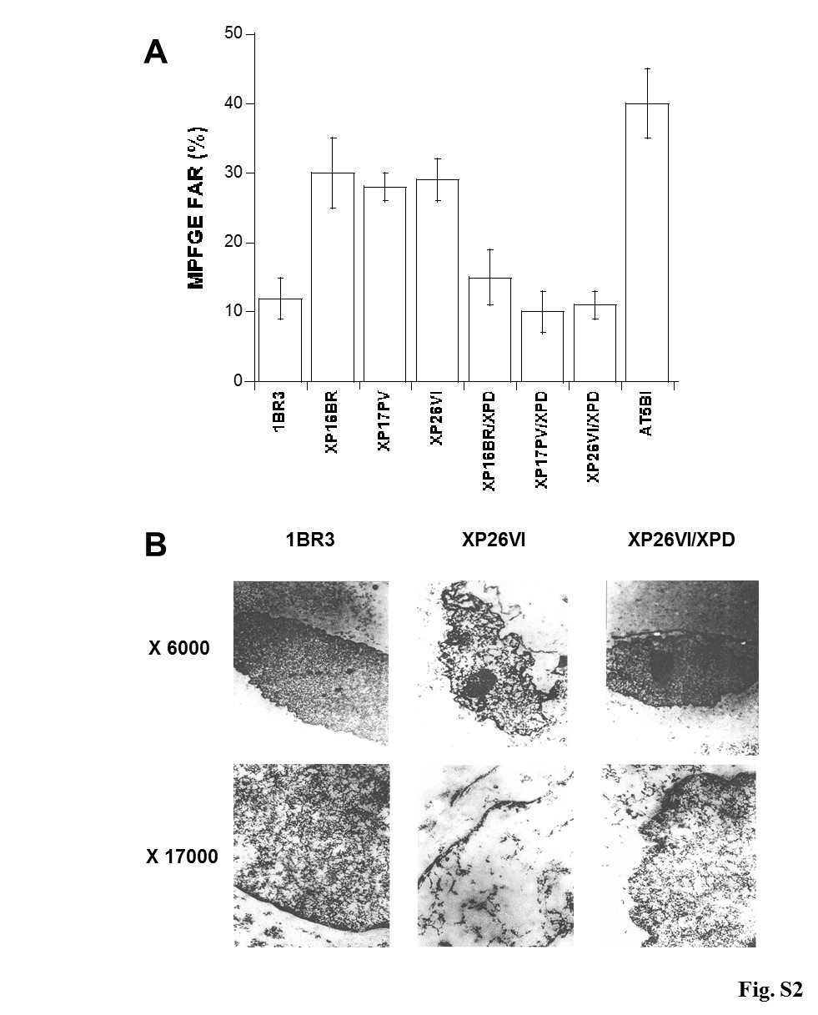
Figure S4: Chromatin impairments in XPD-mutated fibroblasts (A). Chromatin decondensation assessed by the MFPGE technique. Data were expressed in MFGE FAR obtained after irradiating plugs containing DNA loops fragments at 4°C (100 Gy). Data plots represent the mean of triplicate experiments ± standard error. (B). Representative example of the microscopic chromatin structure of an XPD-mutated fibroblast and its XPD-transduced counterpart. The 1BR3 cell line served as a radioresistant control. As indicated, two magnifications were used.

