Supporting Information

Cybotactic Nematic phases with wide ranges in photoresponsive polycatenars

Mohamed Alaasar,*^{a,b} Silvio Poppe,^{b}

^{[a]} Department of Chemistry, Faculty of Science, Cairo University, Giza, Egypt; malaasar@sci.cu.edu.eg

^{[b]} Institute of Chemistry, Martin Luther University Halle-Wittenberg, Kurt Mothes Str. 2, D-06120 Halle (Saale), Germany

Contents
- NMR Spectra of compounds A-E ………………………………………. S1
- Additional DSC curves …………………………………………………...S6

1. NMR Spectra of compounds A-E
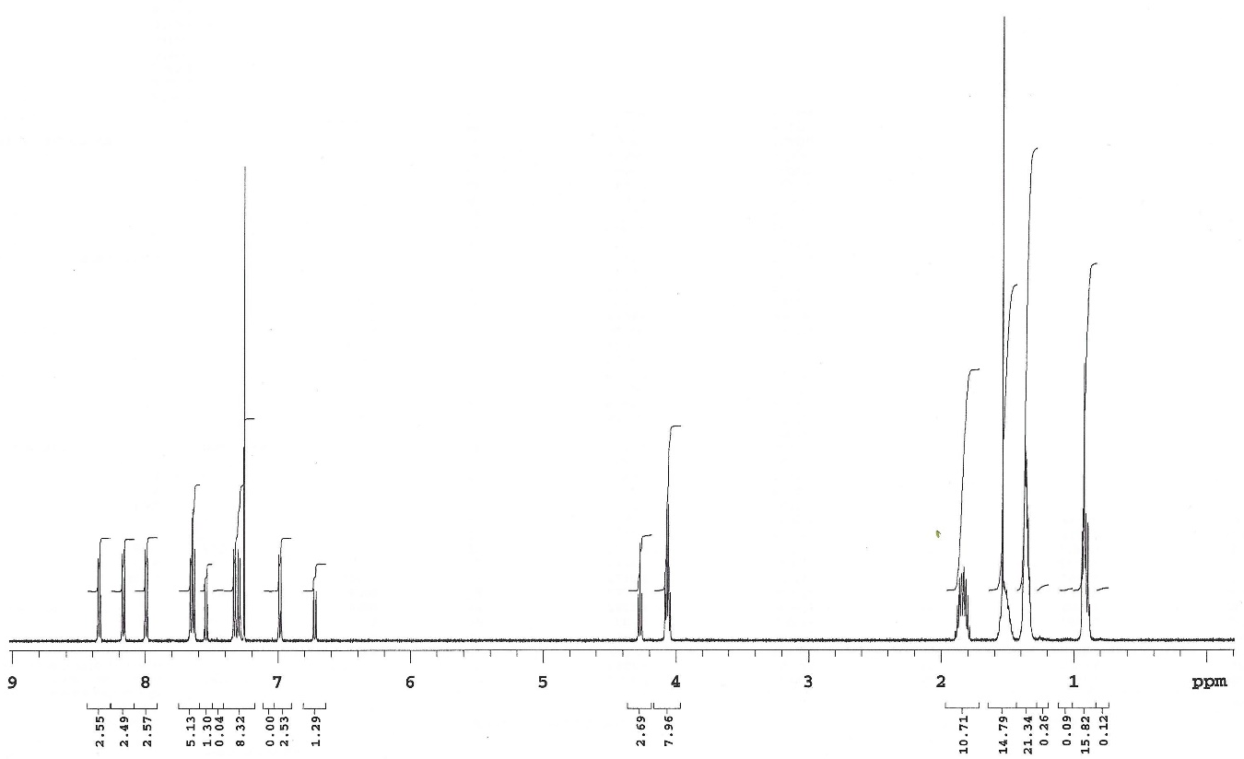
Figure S1. ¹H-NMR Spectrum of A in CDCl₃.

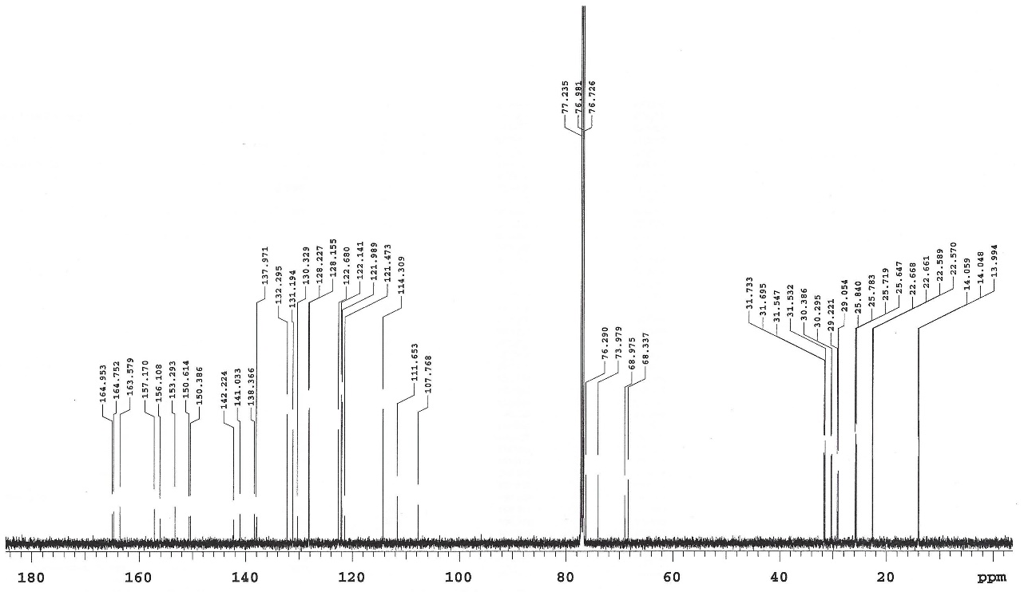

Figure S2. ¹³C-NMR Spectrum of A in CDCl₃.

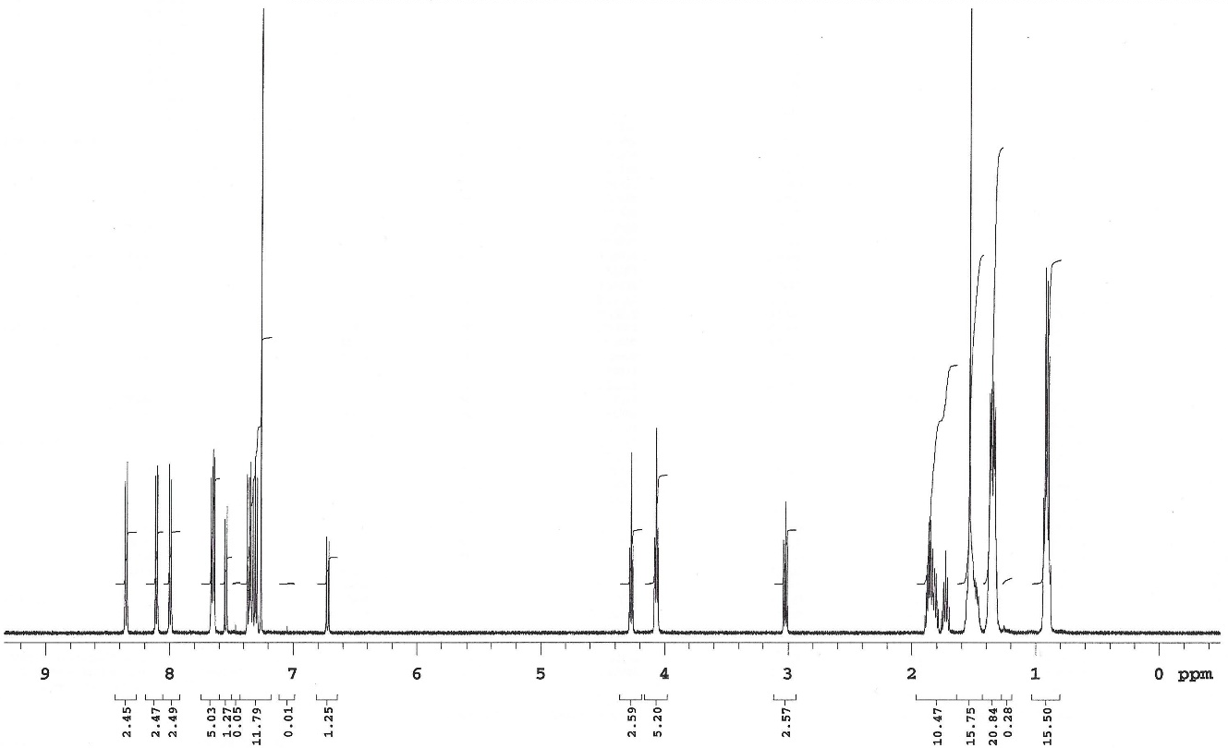
Figure S3. ¹H-NMR Spectrum of B in CDCl₃.

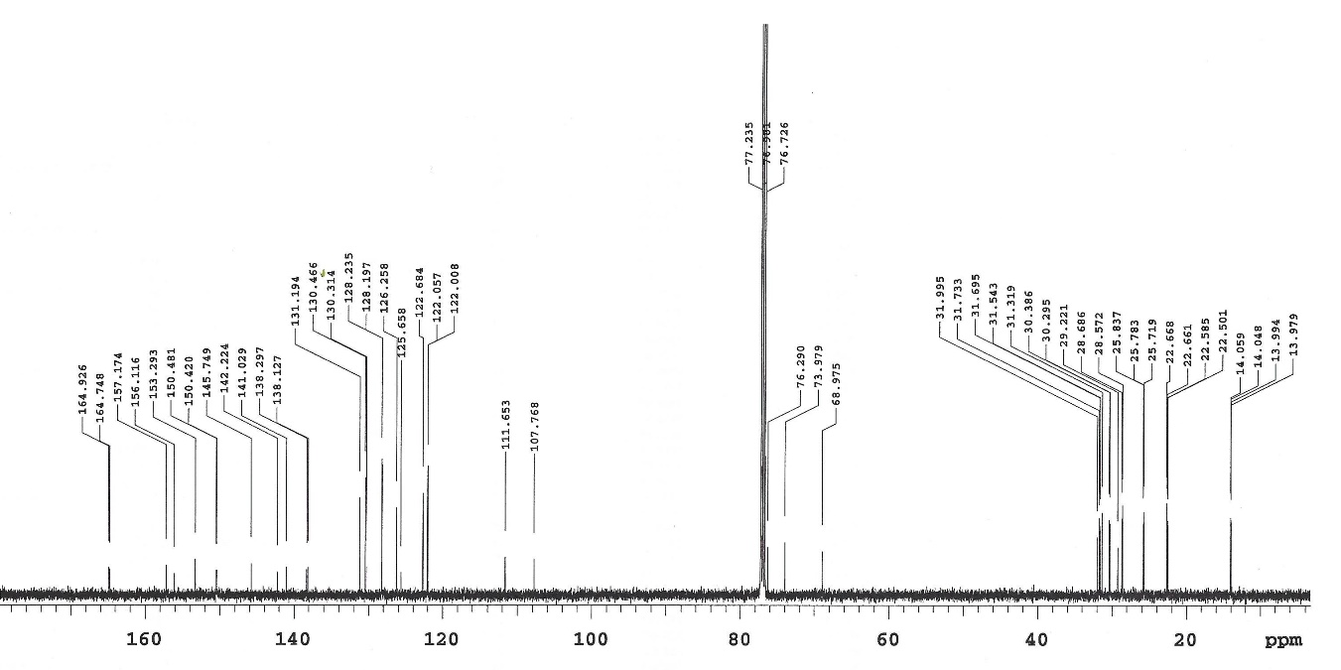
Figure S4. ¹³C-NMR Spectrum of B in CDCl₃.

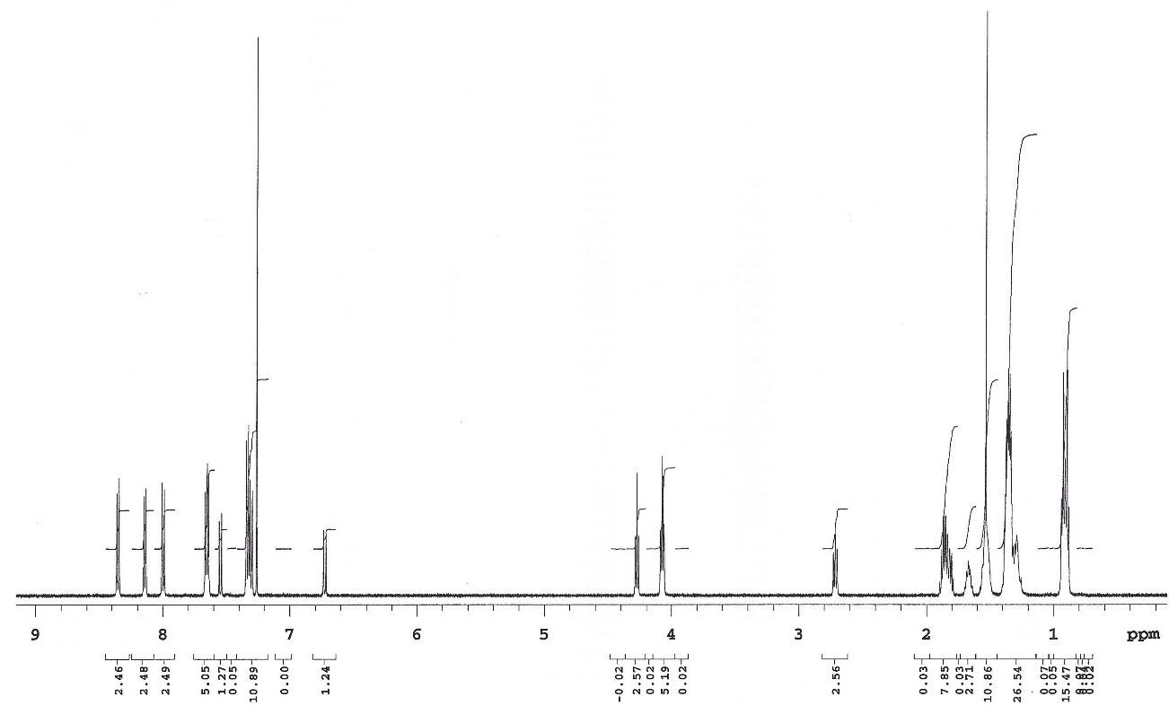

Figure S5. ¹H-NMR Spectrum of C in CDCl₃.

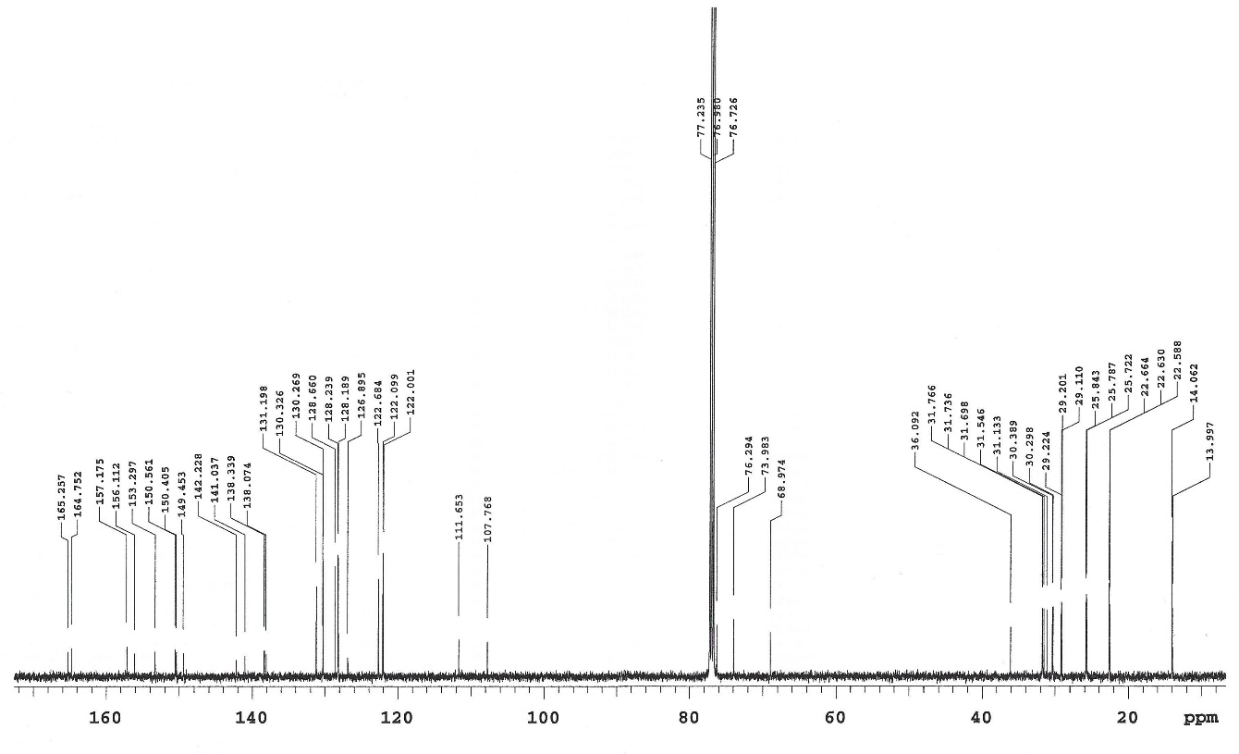

Figure S6. ¹³C-NMR Spectrum of C in CDCl₃.

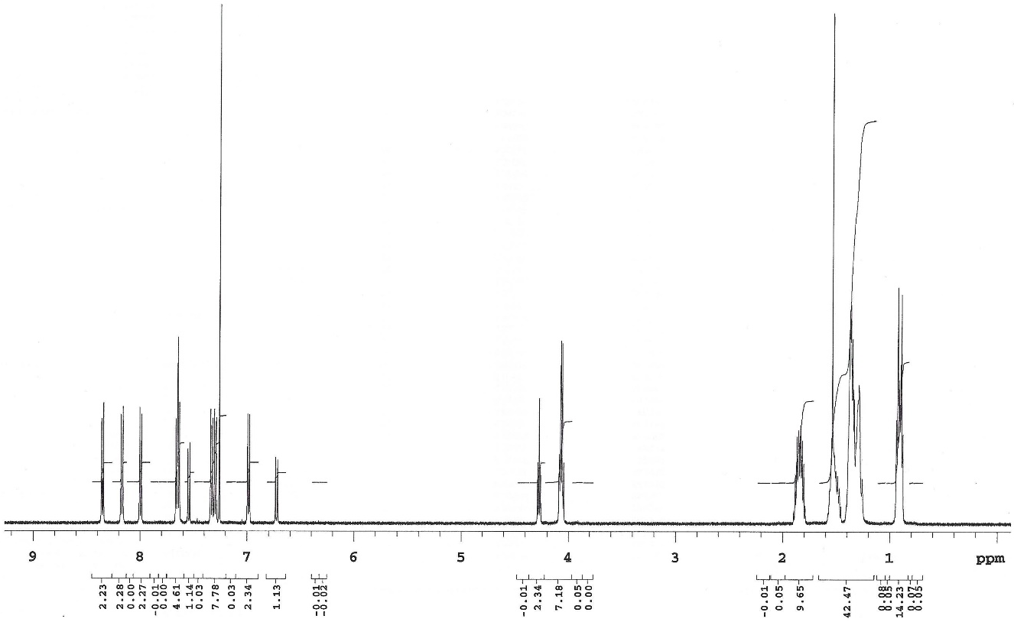

Figure S7. ¹H-NMR Spectrum of D in CDCl₃.

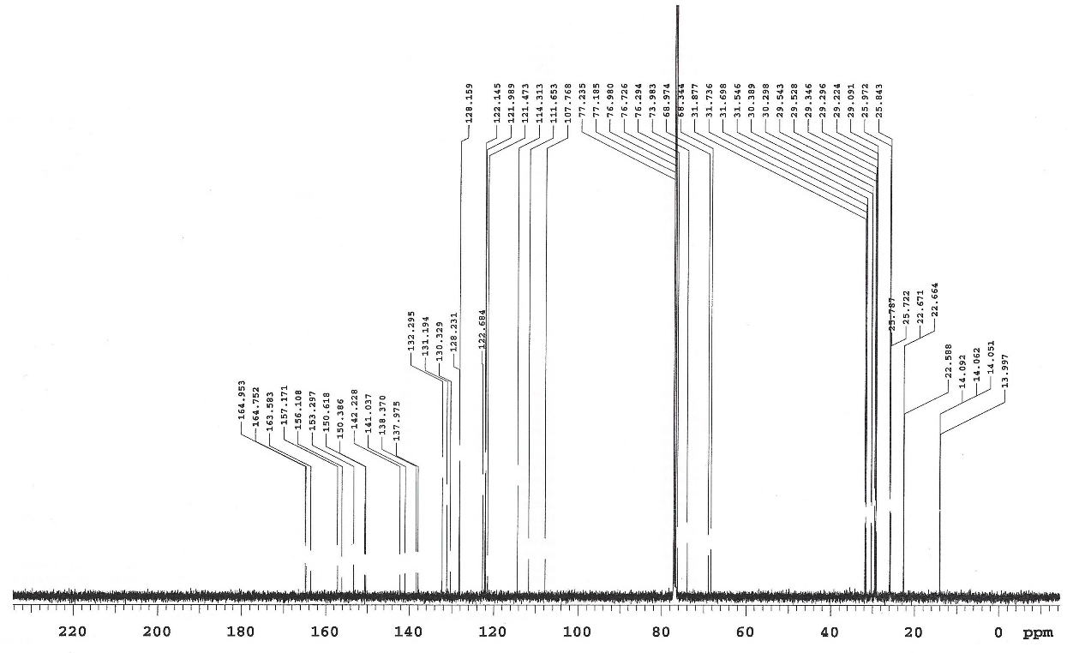

Figure S8. ¹³C-NMR Spectrum of D in CDCl₃.

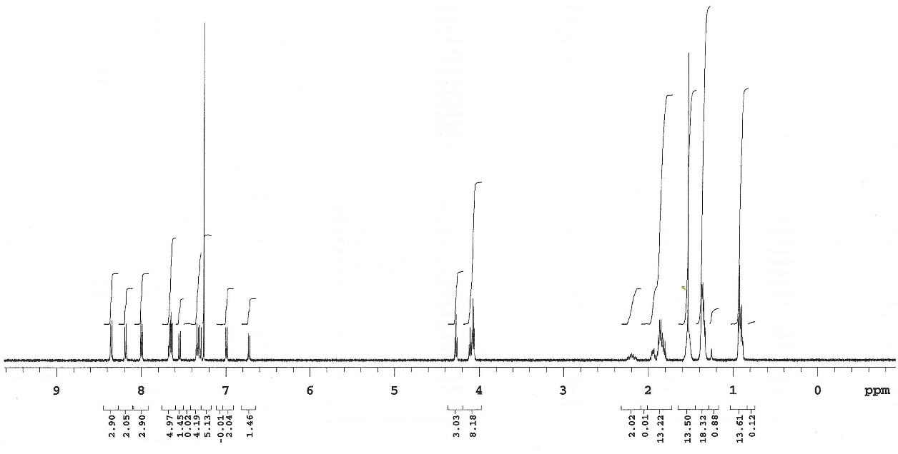

Figure S9. ¹H-NMR Spectrum of E in CDCl₃.

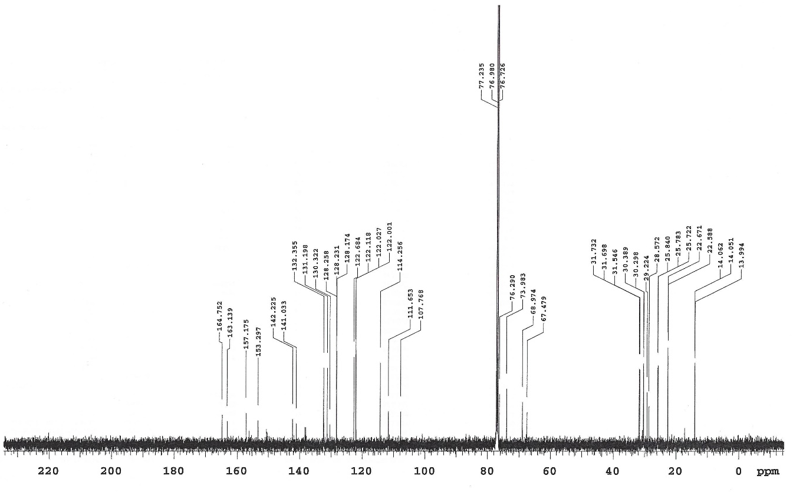

Figure S10. ¹³C-NMR Spectrum of E in CDCl₃.

2. Additional DSC curves

Figure S11. DSC Heating and cooling curves of compound B (10 K min.⁻¹ heating and cooling rates).

Figure S12. DSC Heating and cooling curves of compound C (10 K min.⁻¹ heating and cooling rates).

Figure S13. DSC Heating and cooling curves of compound E (10 K min.⁻¹ heating and cooling rates).

