Assessment of crustal element and trace metal concentrations in atmospheric particulate matter over a coastal city in the Eastern Arabian Sea
ªCynthia V. Gaonkar, ^{b}Ashwini Kumar, ªVishnu MurtyMatta*, ^{b}Siby Kurian
ªThe School of Earth, Ocean and Atmospheric Sciences (SEOAS) , Goa University, Goa- 403206;^{b}CSIR-National institute of Oceanography, Dona Paula, Goa-403004
Submitted to Journal of the Air & Waste Management Association
September-2019

Supplementary material 1:
Meteorological parameters ambient temperature, relative humidity, wind speed and wind directions at the three sampling sites were obtained from AWS datasets from of Space Applications Centre, Ahmedabad.
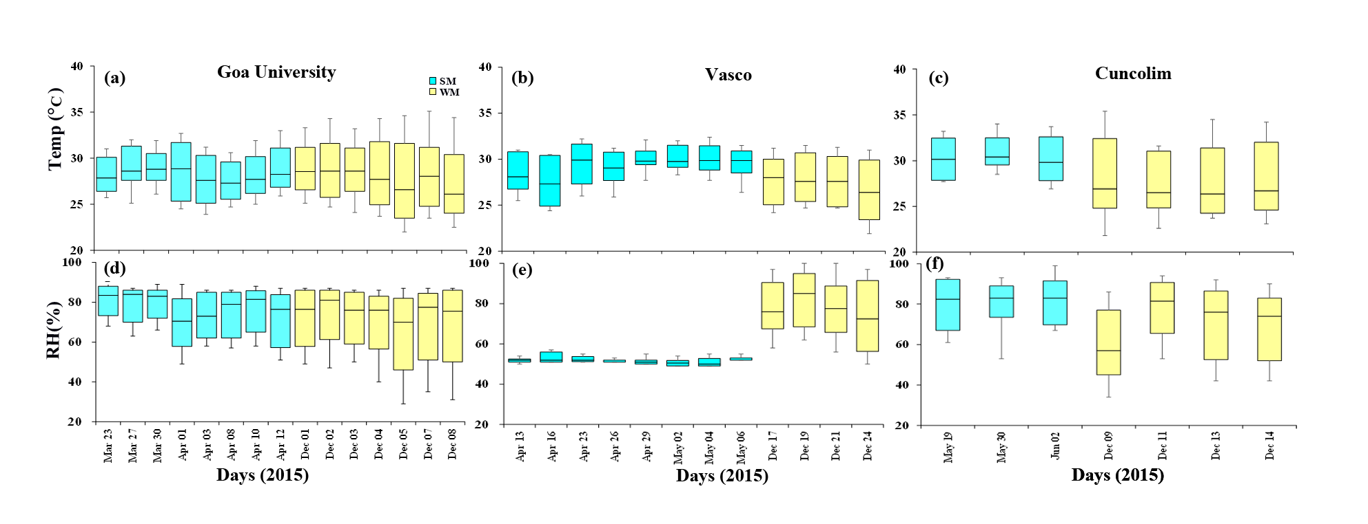
Fig. S1: Meteorological parameter (temperature, relative humidity, wind speed and wind direction) for sampling days are shown in below

Supplementary Material 2:

PM10 mass concentration (in μg ⁻³) as well as concentration (in ng m⁻³)of crustal elements (Al, Ca, Mg, K and Fe) and trace metals (Mn, Cr, Cu, Pb, Zn and Ni) in aerosols collected at three sites along with collection date are given below:

Goa University | PM₁₀ (μg m⁻³) | Al | Ca | Mg | K | Fe | Mn | Cr | Cu | Pb | Zn | Ni
Sampling Day | ng m⁻³
Summer
23-03-2015 | 22.3 | 220 | 124 | 509 | 1055 | 308 | 7.0 | 1.8 | 12.4 | 2.9 | 419 | 5.3
27-03-2015 | 50.1 | 120 | 171 | 297 | 1963 | 287 | 3.9 | 0.1 | 2.8 | 6.3 | 346 | 6.8
30-03-2015 | 38.9 | 340 | 67 | 402 | 1432 | 420 | 6.2 | 1.5 | 4.8 | 1.1 | 239 | 6.7
01-04-2015 | 68.3 | 740 | 193 | 260 | 2102 | 646 | 12.5 | 2.8 | 49.1 | 3.5 | 160 | 6.3
03-04-2015 | 22.7 | 200 | 82 | 401 | 2488 | 166 | 2.4 | 0.4 | 4.4 | 1.3 | 148 | 7.5
08-04-2015 | 71.4 | 2340 | 328 | 528 | 611 | 852 | 38.7 | 5.5 | 1.3 | 1.3 | 35 | 2.8
10-04-2015 | 75.0 | 1630 | 357 | 271 | 1113 | 432 | 54.9 | 7.7 | 6.6 | 28.2 | 30 | 0.8
12-04-2015 | 41.3 | 1300 | 212 | 287 | 2758 | 237 | 23.0 | 2.5 | 2.4 | 1.9 | 88 | 5.3
Winter
01-12-2015 | 72.5 | 4412 | 112 | 841 | 1546 | 550 | 30.2 | 0.8 | 17.9 | 21.3 | 510 | 80.8
02-12-2015 | 145.2 | 5766 | 21 | 858 | 1567 | 562 | 14.2 | 1.1 | 5.7 | 33.1 | 552 | 29.0
03-12-2015 | 113.4 | 10730 | 228 | 923 | 831 | 1814 | 52.5 | 6.2 | 56.8 | 65.0 | 475 | 37.9
04-12-2015 | 106.5 | 10608 | 64 | 1220 | 1087 | 875 | 19.8 | 3.2 | 6.7 | 23.1 | 637 | 72.0
05-12-2015 | 123.3 | 6323 | 175 | 609 | 956 | 682 | 44.0 | 3.3 | 37.1 | 50.5 | 445 | 31.6
07-12-2015 | 36.0 | 7421 | 37 | 890 | 491 | 895 | 36.5 | 2.3 | 8.2 | 6.7 | 725 | 66.9
08-12-2015 | 93.9 | 489 | 101 | 610 | 710 | 721 | 32.7 | 1.3 | 10.4 | 24.8 | 669 | 65.7

Vasco | PM₁₀ (μg m⁻³) | Al | Ca | Mg | K | Fe | Mn | Cr | Cu | Pb | Zn | Ni
Sampling Day | ng m⁻³
Summer
13-04-2015 | 53.3 | 1810 | 19 | 273 | 2292 | 659 | 11.2 | 4.8 | 4.8 | 3.5 | 212 | 7.0
16-04-2015 | 109.0 | 100 | 115 | 278 | 453 | 570 | 10.2 | 1.1 | 3.7 | 9.7 | 811 | 6.3
19-04-2015 | 81.8 | 500 | 43 | 488 | 455 | 301 | 1.8 | 0.9 | 4.8 | 15.5 | 820 | 7.0
21-04-2015 | 21.3 | 1790 | 95 | 397 | 2488 | 294 | 1.5 | 0.4 | 4.6 | 2.5 | 854 | 6.2
23-04-2015 | 36.9 | 800 | 95 | 322 | 2182 | 91 | 1.6 | 3.0 | 4.8 | 13.8 | 466 | 7.0
26-04-2015 | 85.1 | 1260 | 92 | 159 | 3588 | 220 | 0.3 | 6.4 | 5.9 | 3.0 | 23 | 8.5
29-04-2015 | 43.1 | 5980 | 40 | 1121 | 975 | 209 | 2.3 | 3.5 | 6.2 | 5.8 | 124 | 8.6
02-04-2015 | 61.3 | 1610 | 27 | 190 | 773 | 267 | 0.4 | 0.1 | 6.3 | 5.3 | 506 | 7.0
04-05-2015 | 69.6 | 1420 | 10 | 231 | 4151 | 362 | 3.4 | 0.5 | 5.1 | 2.9 | 427 | 7.0
06-05-2015 | 62.1 | 2730 | 16 | 434 | 2392 | 151 | 1.6 | 3.0 | 5.7 | 2.8 | 144 | 6.8
Winter
17-12-2015 | 134.0 | 4270 | 18.52 | 731 | 419 | 1118 | 23.2 | 2.3 | 23.5 | 32.0 | 883 | 34.1
19-12-2015 | 162.0 | 3064 | 82.53 | 528 | 1206 | 1046 | 32.3 | 0.9 | 19.8 | 25.3 | 712 | 111.1
21-12-2015 | 133.0 | 3126 | 74.47 | 814 | 1593 | 1395 | 30.3 | 1.4 | 21.1 | 35.5 | 591 | 42.9
24-12-2015 | 108.0 | 7184 | 20.03 | 1124 | 312 | 723 | 44.3 | 1.6 | 28.4 | 51.3 | 390 | 21.5

Cuncolim | PM₁₀ (μg m⁻³) | Al | Ca | Mg | K | Fe | Mn | Cr | Cu | Pb | Zn | Ni
Sampling Day | ng m⁻³
Summer
19-05-2015 | 47.0 | 1540 | 47 | 252 | 1479 | 112 | 39.4 | 1.4 | 5.1 | 15.4 | 218 | 9.4
20-05-2015 | 52.6 | 2641 | 205 | 581 | 3884 | 359 | 56.1 | 1.5 | 3.2 | 98.0 | 481 | 9.0
21-05-2015 | 42.2 | 4558 | 136 | 900 | 544 | 70 | 22.0 | 1.5 | 7.6 | 12.9 | 405 | 7.2
23-05-2015 | 56.0 | 8077 | 119 | 1034 | 536 | 265 | 24.8 | 1.6 | 5.1 | 46.6 | 290 | 9.5
24-05-2015 | 60.5 | 5022 | 82 | 818 | 302 | 275 | 19.8 | 1.8 | 4.2 | 16.2 | 296 | 9.6
25-05-2015 | 68.7 | 6862 | 100 | 880 | 885 | 423 | 185.0 | 0.5 | 3.3 | 80.2 | 78 | 9.2
26-05-2015 | 74.6 | 3031 | 130 | 379 | 1547 | 390 | 47.5 | 1.1 | 2.7 | 137.0 | 248 | 9.1
28-05-2015 | 84.0 | 4304 | 169 | 726 | 3084 | 921 | 32.1 | 3.4 | 12.1 | 28.0 | 83 | 4.9
30-05-2015 | 88.6 | 1840 | 60 | 524 | 186 | 574 | 14.3 | 0.4 | 1.0 | 8.6 | 208 | 5.2
02-06-2015 | 124.2 | 4846 | 208 | 755 | 1026 | 1272 | 28.9 | 1.5 | 12.9 | 32.7 | 294 | 5.2
Winter
09-12-2015 | 155.0 | 4330 | 46 | 658 | 470 | 723 | 83.7 | 1.8 | 11.1 | 57.1 | 1410 | 64.4
11-12-2015 | 144.0 | 6760 | 30 | 698 | 1522 | 479 | 123.0 | 2.9 | 6.2 | 77.8 | 1200 | 48.0
13-12-2015 | 143.0 | 3553 | 33 | 709 | 1566 | 808 | 165.0 | 1.6 | 11.2 | 33.2 | 1280 | 59.4
14-12-2015 | 201.0 | 4391 | 36 | 925 | 1583 | 674 | 154.0 | 5.2 | 12.0 | 62.9 | 1820 | 60.6

Supplementary Material 3:
Computation of PCA was done by the following steps:
- Data acquisition
Seasonal data for crustal and trace metals were organised for three different sampling sites for the PCA analysis.
- Normalisation of data
However, because of the different scale among individual metal concentrations, all the data were normalized by subtracting their mean and then dividing by their standard deviation.
- Calculation of covariance matrix
The covariance matrix is used to measure how much the dimensions vary from the mean with respect to each other. The covariance of two random variables is their tendency to vary together as:
cov (X,Y) = E [ E[ X ] –X ] . E [E [Y ] – Y] where E [ X ] & [ Y ] denotes the expected value of X & Y respectively.
In the covariance matrix, the exact value is not as important as its sign (i.e. positive or negative). If the value is positive, it indicates that both dimensions i.e .X & Y increase. If the value is negative, then as one dimension increases, the other decreases. In the case, where the covariance is zero, the two dimensions are independent of each other.
- Calculation of the eigenvectors and Eigen values of the covariance Matrix
From the covariance matrix, the eigenvectors and eigen values are calculated thereafter the eigenvalues are sorted in descending order which gives us the components in order of significance. The eigenvector associated with the largest eigen values has the same direction as the first principal components. The eigenvector associated with the 2nd largest eigen values determines the direction of the 2nd principal components. The eigenvector with the highest eigenvalue is the most dominant principle component of the dataset (PC1).Further for the interpreting of the data the method of Kaiser Criterion (Kaiser,1960) is followed which will retain only those factors having a eigen value >1 has been used for further interpretation. Factor loadings>0.71 are typically regard as strong and<0.32 weak loadings (Nowak, 1998).

