Au₂Si₂₀：a honeycomb-shaped structure with short Au−Au single bond at the center coordinated by twelve Si₅ pentagons and reinforced by strong Au−Si interactions and aromaticity

Sheng-Jie Lu^{1, 2*}, Li-Shun Wu¹, Bao-Hua Yin¹, Feng Lin¹, and Ming-Yong Chao¹
¹Department of Chemistry and Chemical Engineering, Heze University, Heze, Shandong Province, 274015, China
²Beijing National Laboratory for Molecular Sciences, Beijing, 100190, China

* Corresponding authors. E-mail: lushengjie@iccas.ac.cn

Table S1. Theoretical ADEs and VDEs of the low-lying isomers of Au₂Si₂₀ˉ are calculated at the different levels of theory.

Isomer | VDE (eV) |  |  |  | ADE (eV)
Isomer | B3LYP | TPSSH | HSE06 | PBE | B3LYP | TPSSH | HSE06 | PBE | B3LYP
20A | 2.89 | 3.00 | 2.99 | 2.94 | 2.78 | 2.70 | 2.79 | 2.79 | 2.73
20B | 3.06 | 2.99 | 2.96 | 2.89 | 2.96 | 2.90 | 2.91 | 2.88 | 2.95
20C | 2.97 | 2.89 | 2.95 | 2.90 | 2.79 | 2.71 | 2.70 | 2.69 | 2.66
20D | 3.06 | 2.98 | 3.01 | 2.97 | 2.70 | 2.66 | 2.61 | 2.71 | 2.64

TPSSH, HSE06, and PBE functionals were also tested for comparisons, which provide results agreeing well with those of the B3LYP functional.

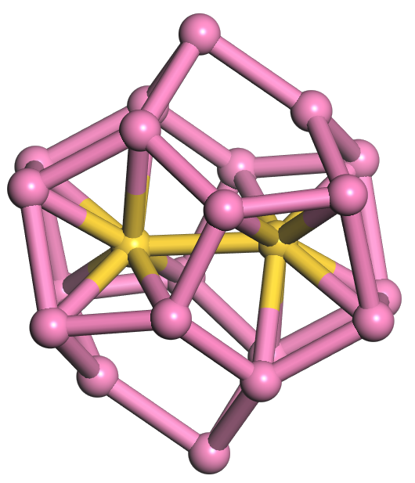  20A C_{2h} ²A_{g}  +0.00 eV | 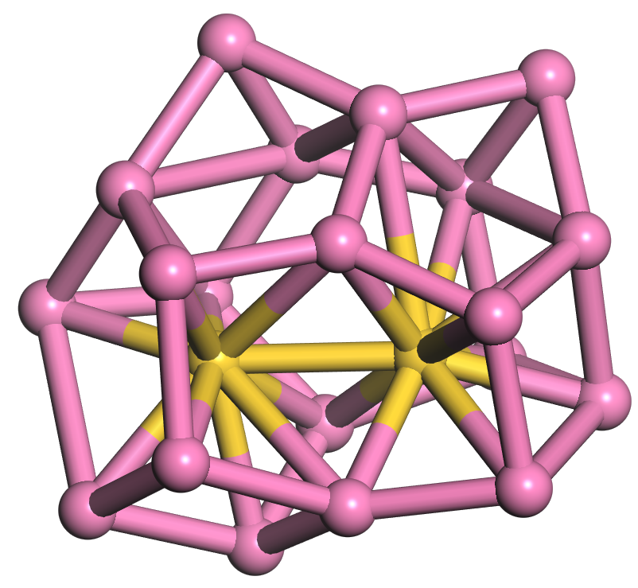  20B C₁ ²A  +0.13 eV | 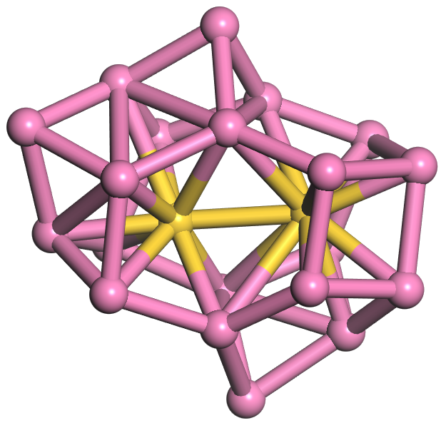  20C C₁ ²A  +0.39 eV | 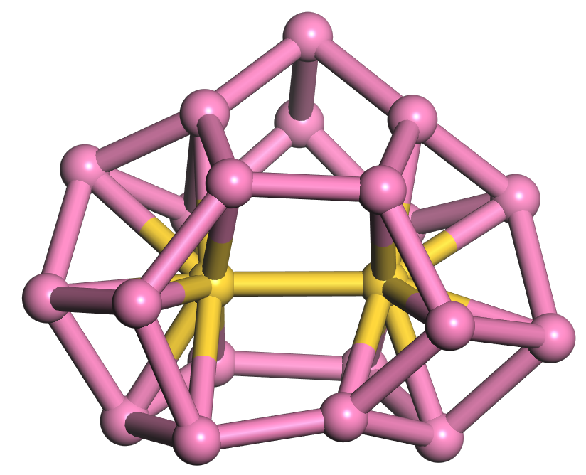  20D C_{s} ²A′  +0.60 eV
(a) Optimized geometries of the typical low-lying isomers of anionic Au₂Si₂₀.
20A′ C_{2h} ¹A_{g}  +0.00 eV | 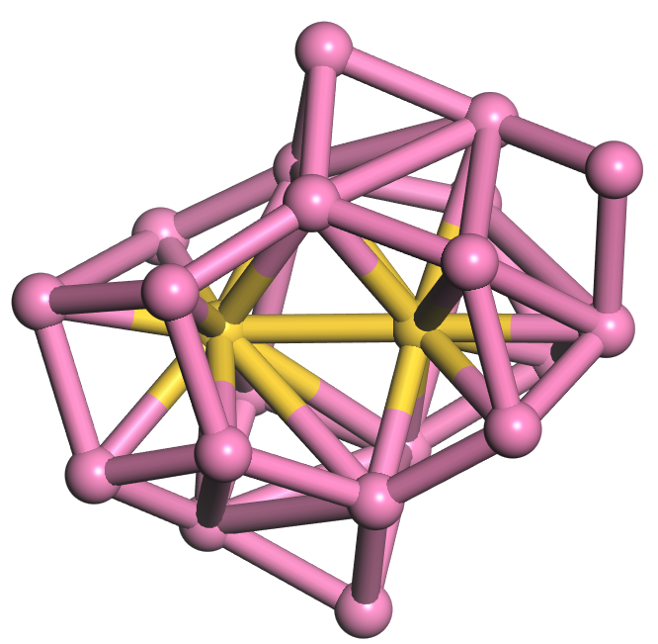  20B′ C₁ ¹A  +0.33 eV | 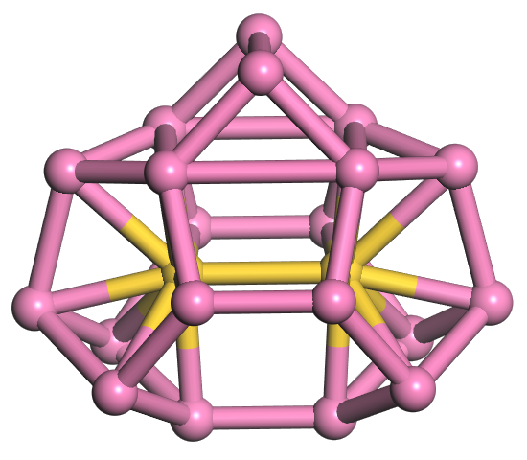  20C′ C_{2v} ¹A₁  +0.59 eV | 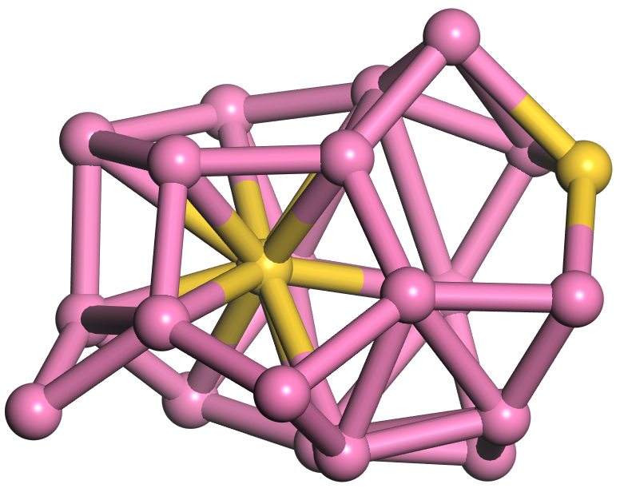  20D′ C₁ ¹A  +0.92 eV
(b) Optimized geometries of the typical low-lying isomers of neutral Au₂Si₂₀.
20A′′ C₁ ²A_{g}  +0.00 eV | 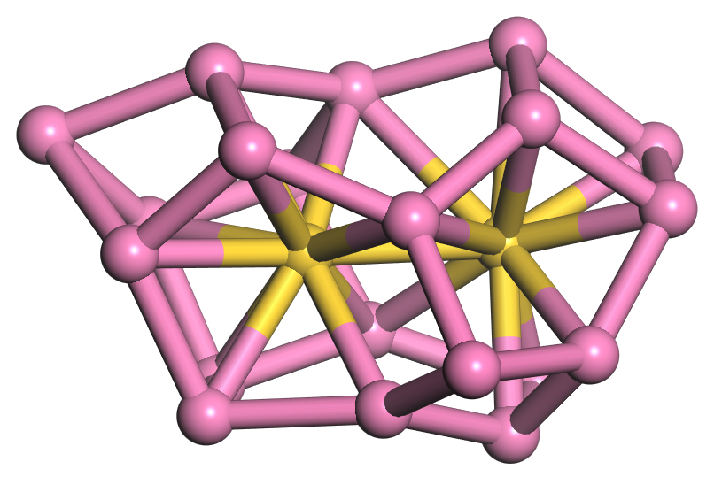  20B′′ C₁ ²A  +0.28 eV | 20C′′ C_{2v} ²A₁  +0.33 eV | 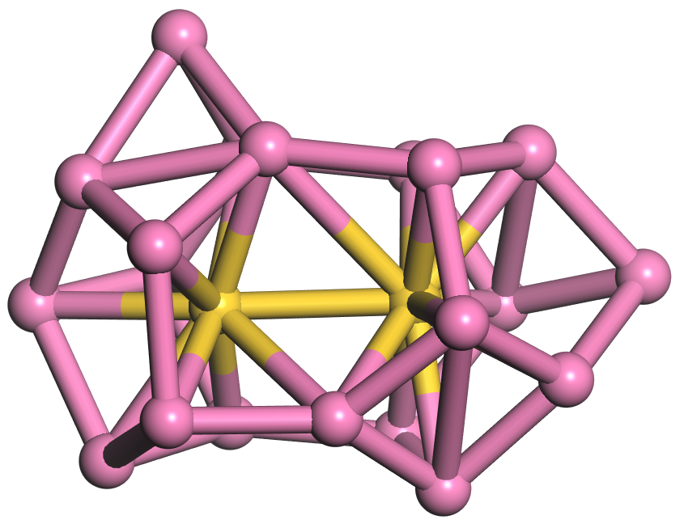  20D′′ C₁ ²A  +0.39 eV
(c) Optimized geometries of the typical low-lying isomers of cationic Au₂Si₂₀.

Figure S1. Optimized geometries of the typical low-lying isomers of anionic, neutral, and cationic Au₂Si₂₀ clusters at the TPSSH/Si/6-311+G(d, p)/Au/SDD level. Yellow and pink balls stand for the Au atoms and Si atoms, respectively.

20A C_{2h} ²A_{g}  +0.00 eV | 20B C₁ ²A  +0.19 eV | 20C C₁ ²A  +0.30 eV | 20D C_{s} ²A′  +0.51 eV
(a) Optimized geometries of the typical low-lying isomers of anionic Au₂Si₂₀.
20A′ C_{2h} ¹A_{g}  +0.00 eV | 20B′ C₁ ¹A  +0.30 eV | 20C′ C_{2v} ¹A₁  +0.48 eV | 20D′ C₁ ¹A  +0.77 eV
(b) Optimized geometries of the typical low-lying isomers of neutral Au₂Si₂₀.
20A′′ C₁ ²A_{g}  +0.00 eV | 20B′′ C₁ ²A  +0.26 eV | 20C′′ C_{2v} ²A₁  +0.39 eV | 20D′′ C₁ ²A  +0.51 eV
(c) Optimized geometries of the typical low-lying isomers of cationic Au₂Si₂₀.

Figure S2. Optimized geometries of the typical low-lying isomers of anionic, neutral, and cationic Au₂Si₂₀ clusters at the HSE06/Si/6-311+G(d, p)/Au/SDD level. Yellow and pink balls stand for the Au atoms and Si atoms, respectively.

20A C_{2h} ²A_{g}  +0.00 eV | 20B C₁ ²A  +0.23 eV | 20C C₁ ²A  +0.41 eV | 20D C_{s} ²A′  +0.61 eV
(a) Optimized geometries of the typical low-lying isomers of anionic Au₂Si₂₀.
20A′ C_{2h} ¹A_{g}  +0.00 eV | 20B′ C₁ ¹A  +0.19 eV | 20C′ C_{2v} ¹A₁  +0.30 eV | 20D′ C₁ ¹A  +0.67 eV
(b) Optimized geometries of the typical low-lying isomers of neutral Au₂Si₂₀.
20A′′ C₁ ²A_{g}  +0.00 eV | 20B′′ C₁ ²A  +0.20 eV | 20C′′ C_{2v} ²A₁  +0.42 eV | 20D′′ C₁ ²A  +0.70 eV
(c) Optimized geometries of the typical low-lying isomers of cationic Au₂Si₂₀.

Figure S3. Optimized geometries of the typical low-lying isomers of anionic, neutral, and cationic Au₂Si₂₀ clusters at the PBE/Si/6-311+G(d, p)/Au/SDD level. Yellow and pink balls stand for the Au atoms and Si atoms, respectively.

