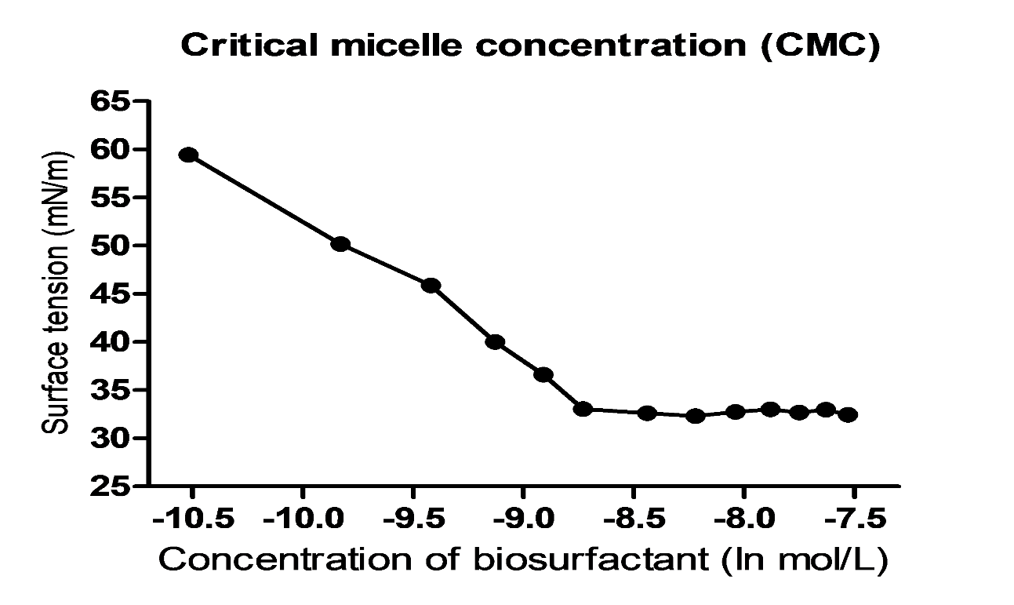
Figure S1: Critical micelle concentration (CMC) of kurstakin molecules produced by Bacillus thuringiensis strain 7SA
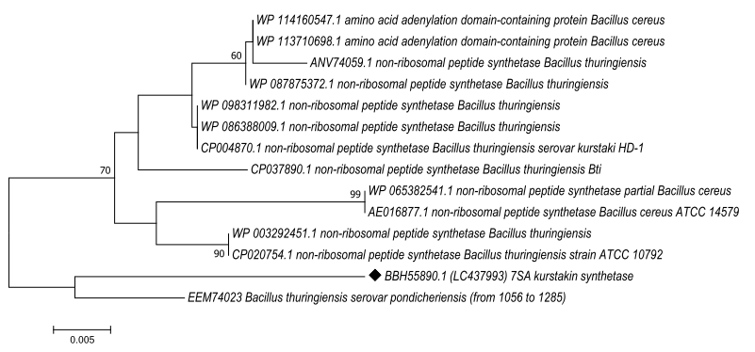
Figure S2: Maximum Likelihood phylogenetic trees based on the alignment of amino acid sequences of the kurstakin synthetase gene from strain 7SA. The reference sequences were retrieved from NCBI database.

Figure S3: CLUSTAL O (1.2.4) multiple sequence alignment and comparison of amino acid sequences of the kurstakin synthetase gene from strain 7SA and reference sequences retrieved from NCBI database.
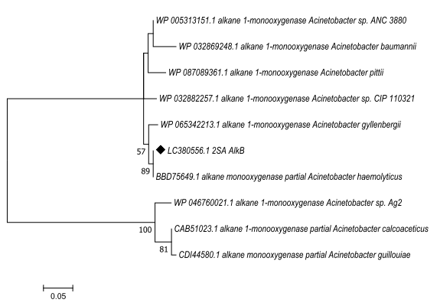
Figure S4: Maximum Likelihood phylogenetic trees based on the alignment of amino acid sequences of the alkB gene from strain 2SA. The reference sequences were retrieved from NCBI database.

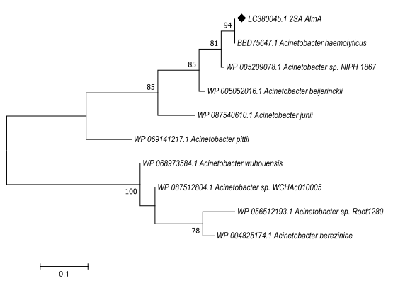
Figure S5: Maximum Likelihood phylogenetic trees based on the alignment of amino acid sequences of the almA gene from strain 2SA. The reference sequences were retrieved from NCBI database.

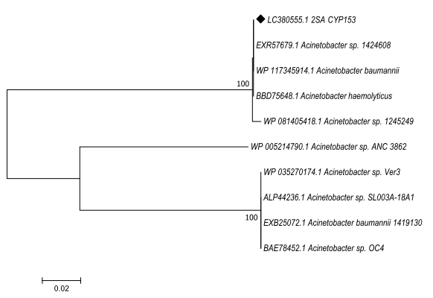
Figure S6: Maximum Likelihood phylogenetic trees based on the alignment of amino acid sequences of the cyp153 gene from strain 2SA. The reference sequences were retrieved from NCBI database.

