Supplementary Materials

Fig. S₁ Mechanism of adsorption of Pb (II) and As (III) ions on GCIO

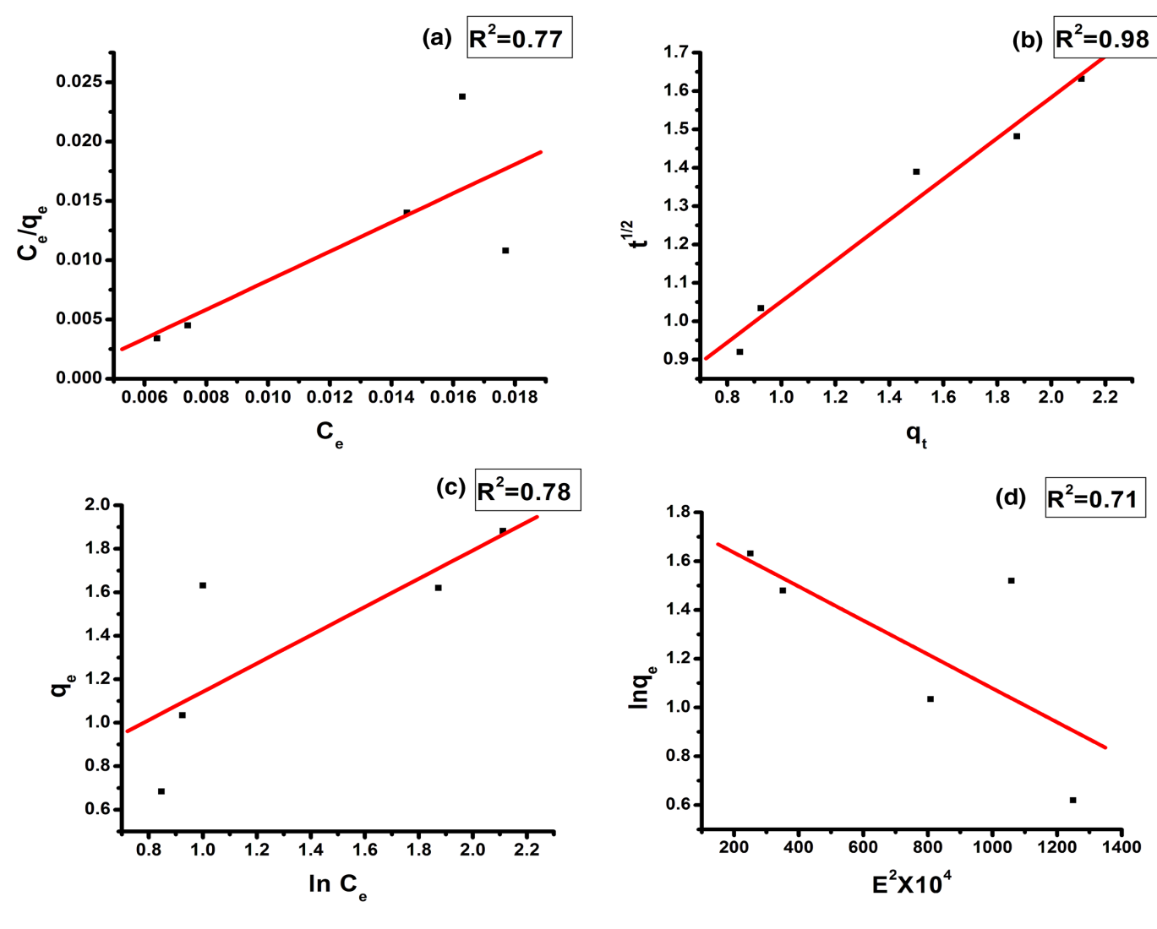
Fig. S₂ (a) Plots drawn for lead adsorption on GCIO in accordance with Langmuir isotherm, S₂(b) Freundlich isotherm, S₂(c) Temkin isotherm, and S₂(d) D-R isotherm models
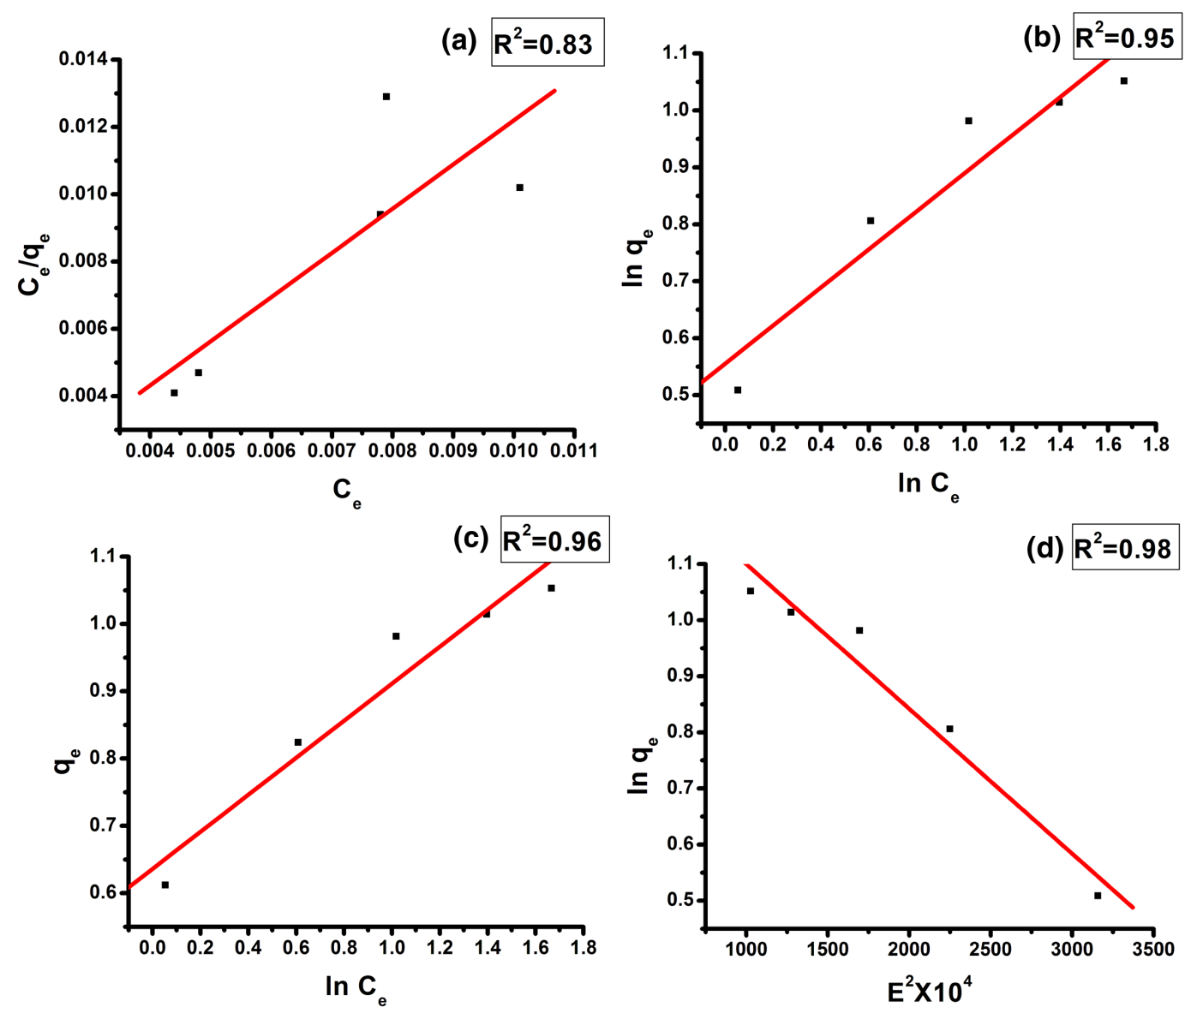
Fig. S₃ (a) Plots drawn for arsenic adsorption on GCIO in accordance with Langmuir isotherm, S₃(b) Freundlich isotherm, S₃(c) Temkin isotherm, and S₃(d) D-R isotherm models
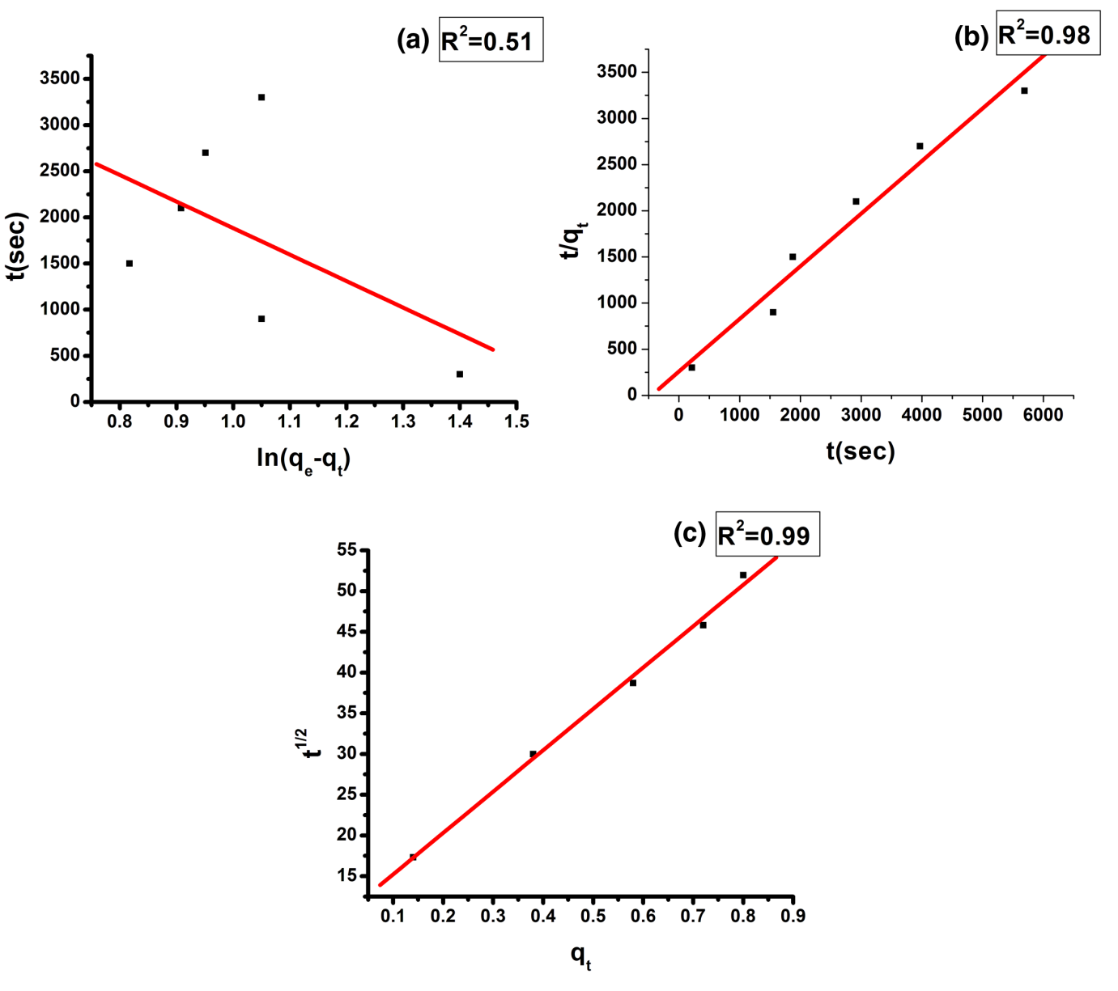
Fig. S₄ (a) Pseudo first order kinetic model for lead removal, S₄(b) Pseudo second order kinetic model for lead removal and S₄(c) Intraparticle diffusion model for lead removal
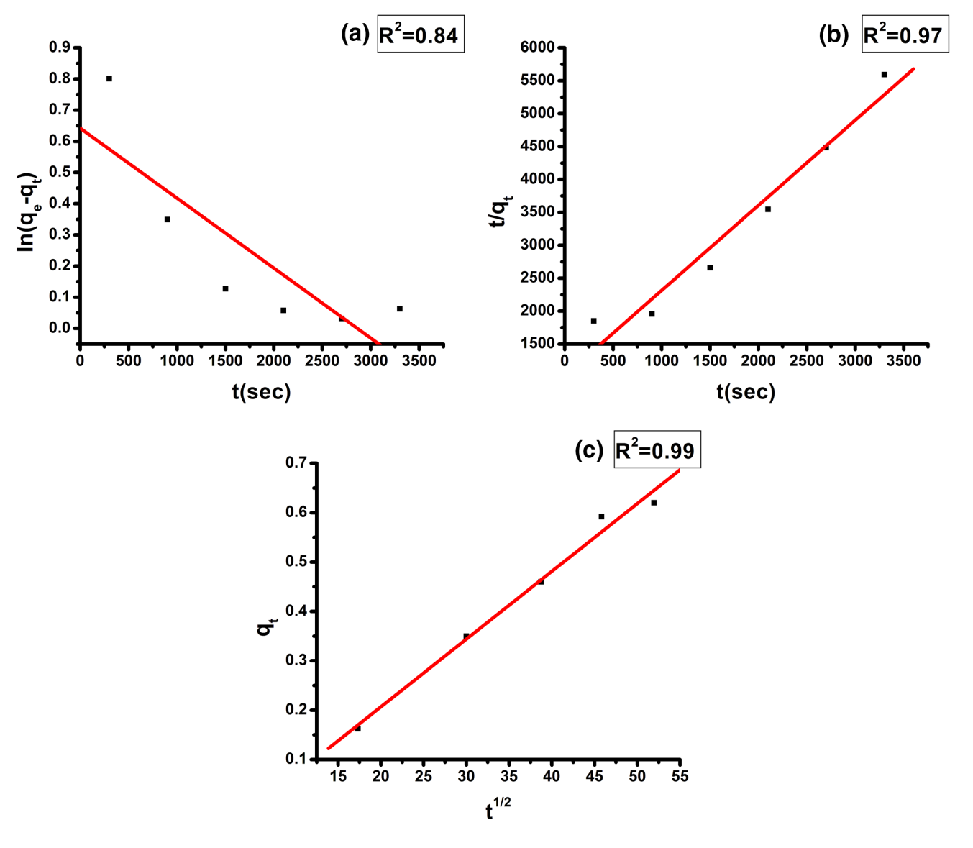
Fig. S₅ (a) Pseudo first order kinetic model for arsenic removal, S₅(b) Pseudo second order kinetic model for arsenic removal and S₅(c) Intraparticle diffusion model for arsenic removal

