Supporting Information
Synthesis and evaluation of Zn(II) dithiocarbamate complexes as potential antibacterial, antibiofilm and antitumor agents

VINAY KUMAR MAURYA, ASHISH KUMAR SINGH, RAVI PRATAP SINGH, SHIVANGI YADAV, KRISHNA KUMAR, PRADYOT PRAKASH and LAL BAHADUR PRASAD*

Table S1. Analytical data of the complexes.
Complexes | Melting point (ºC) | Yield  (%) | Calculated (found) %
 |  |  | C | H | N | S
C₃₆H₄₀N₂S₄Zn (A1) | 185-189 | 83 | 63.00(62.87) | 6.40(6.32) | 3.87(3.72) | 17.70(17.65)
C₂₀H₂₄N₂S₄Zn (A2) | 188-192 | 84 | 49.22(49.13) | 5.37(5.18) | 5.74(5.53) | 26.28(26.15)
C₃₈H₄₆O₂N₂S₄Zn (A3) | 187-191 | 82 | 60.34(60.20) | 6.13(6.05) | 3.70(3.63) | 16.96(16.88)
C₃₂H₃₂N₂S₄Zn (A4) | 189-197 | 82 | 60.03(58.90) | 5.35(5.08) | 4.38(4.22) | 20.03(19.92)

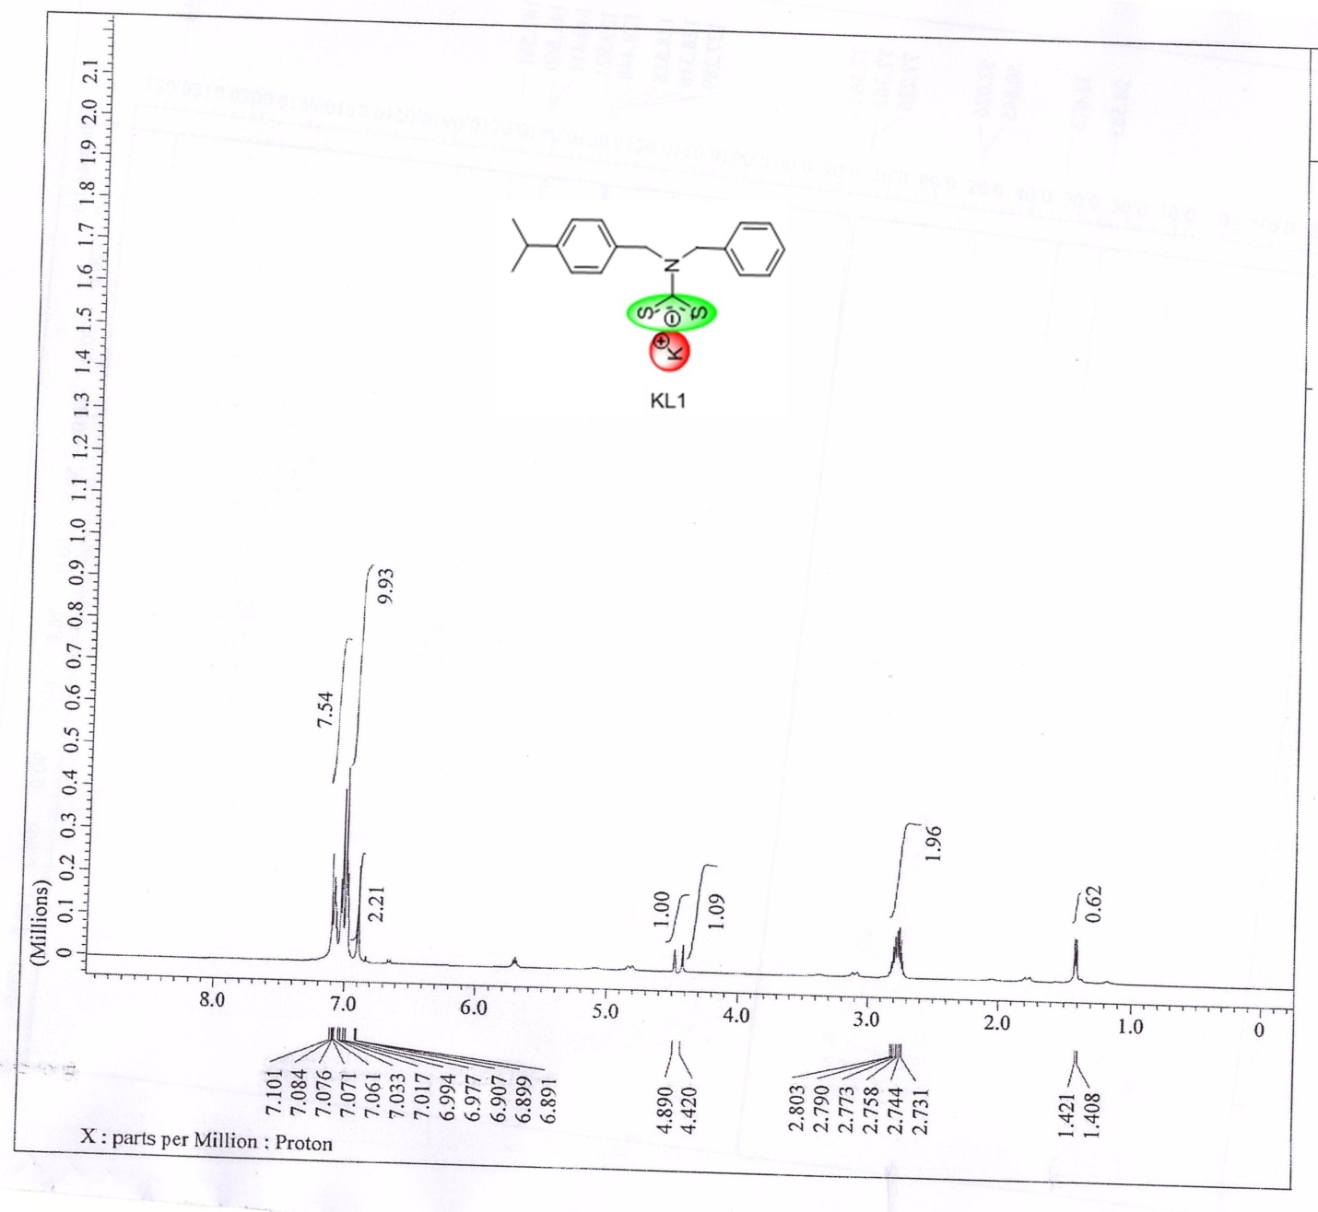
Figure S1. ¹H NMR spectrum of KL1 ligand.
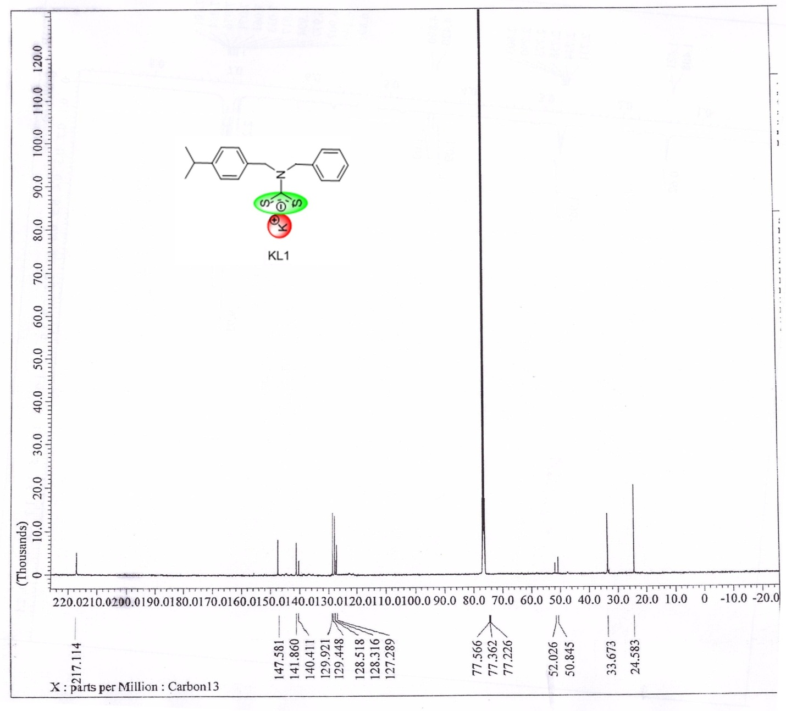
Figure S2. ¹³C NMR spectrum of KL1 ligand.
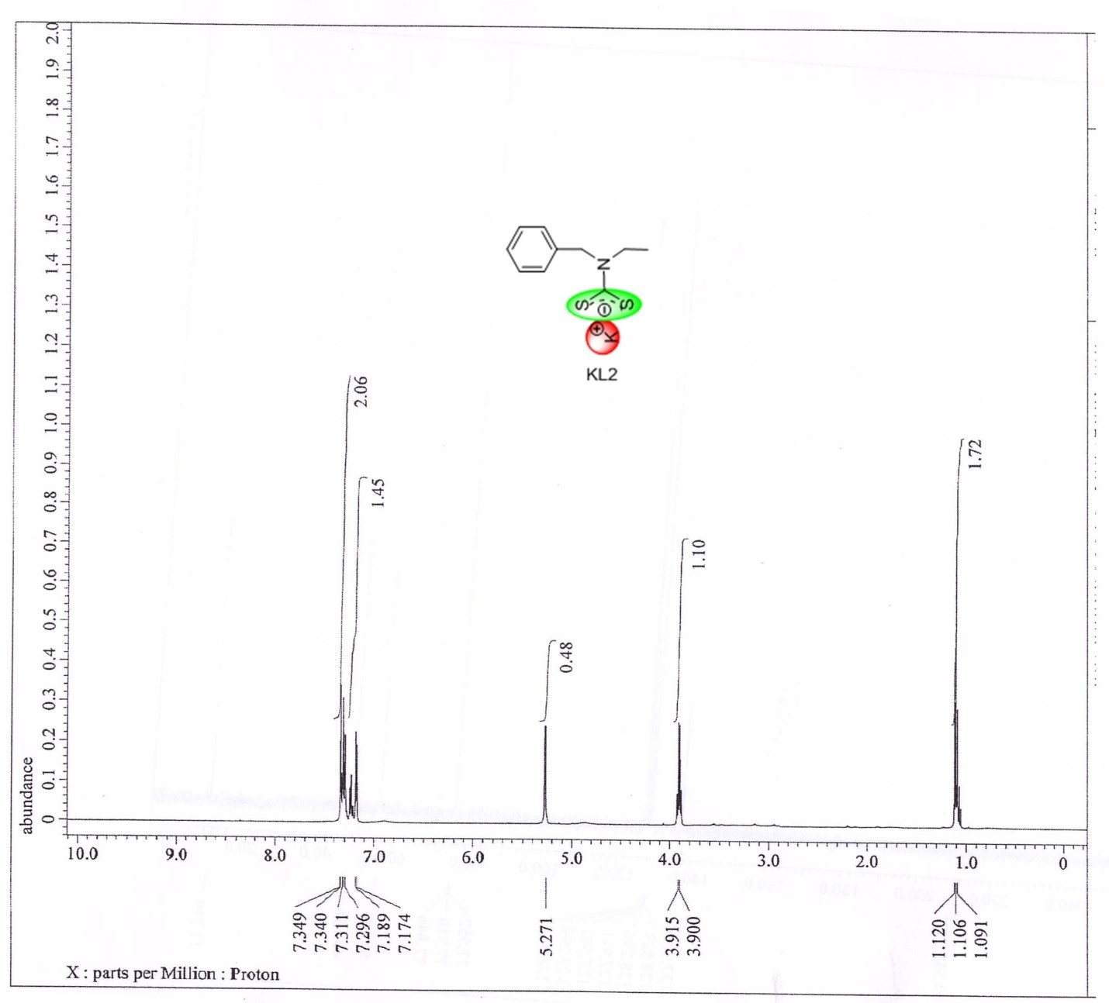
Figure S3. ¹H NMR spectrum of KL2 ligand.

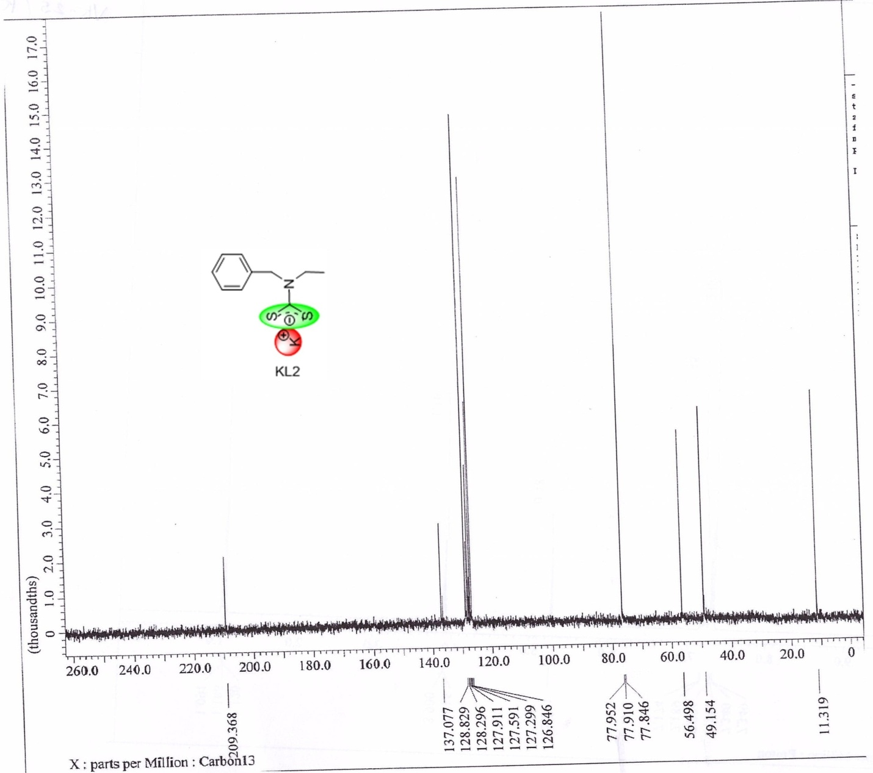
Figure S4. ¹³C NMR spectrum of KL2 ligand.
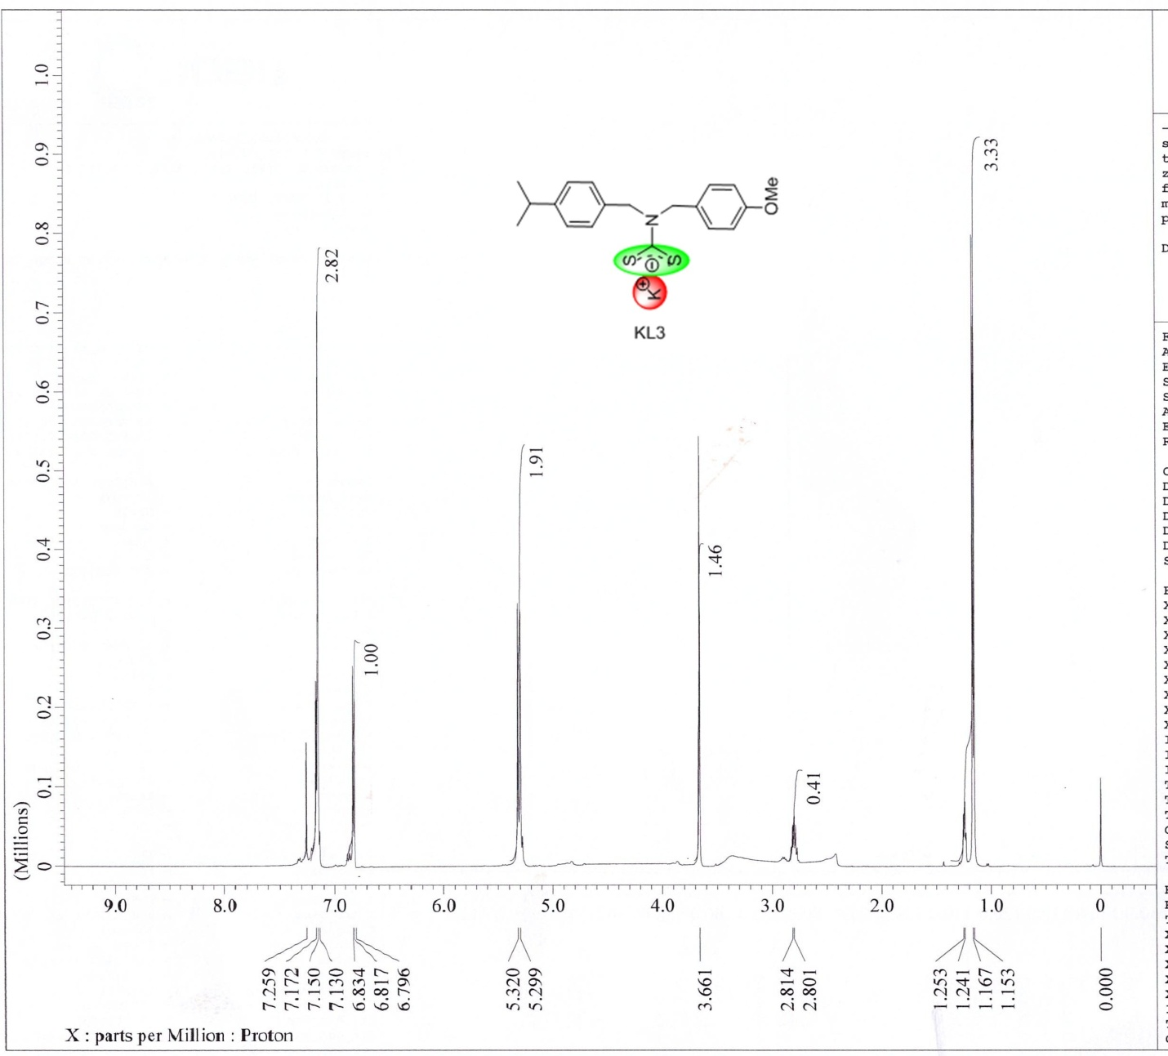
Figure S5. ¹H NMR spectrum of KL3 ligand.
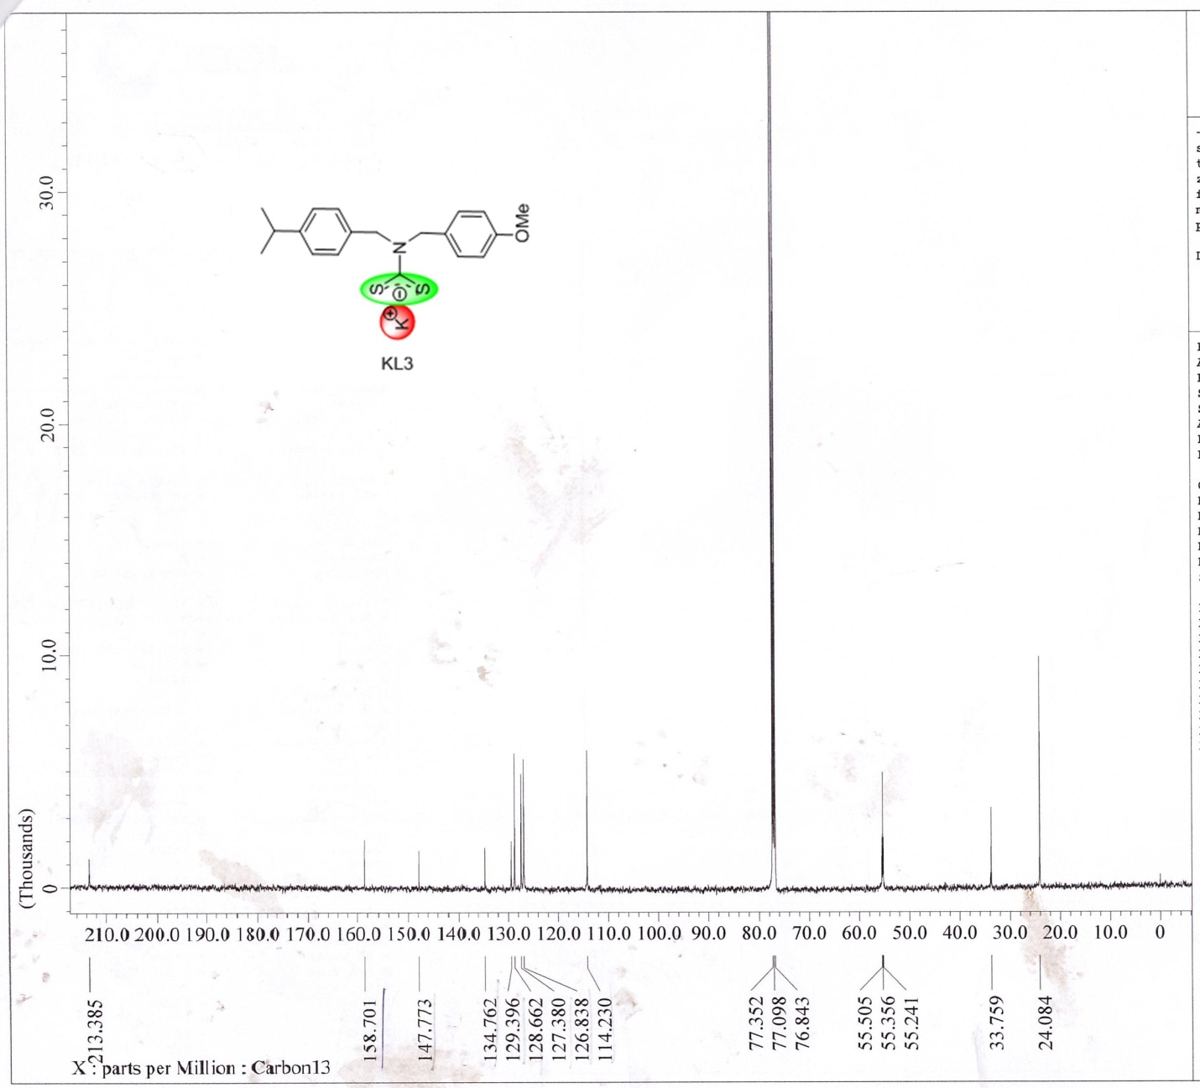
Figure S6. ¹³C NMR spectrum of KL3 ligand.
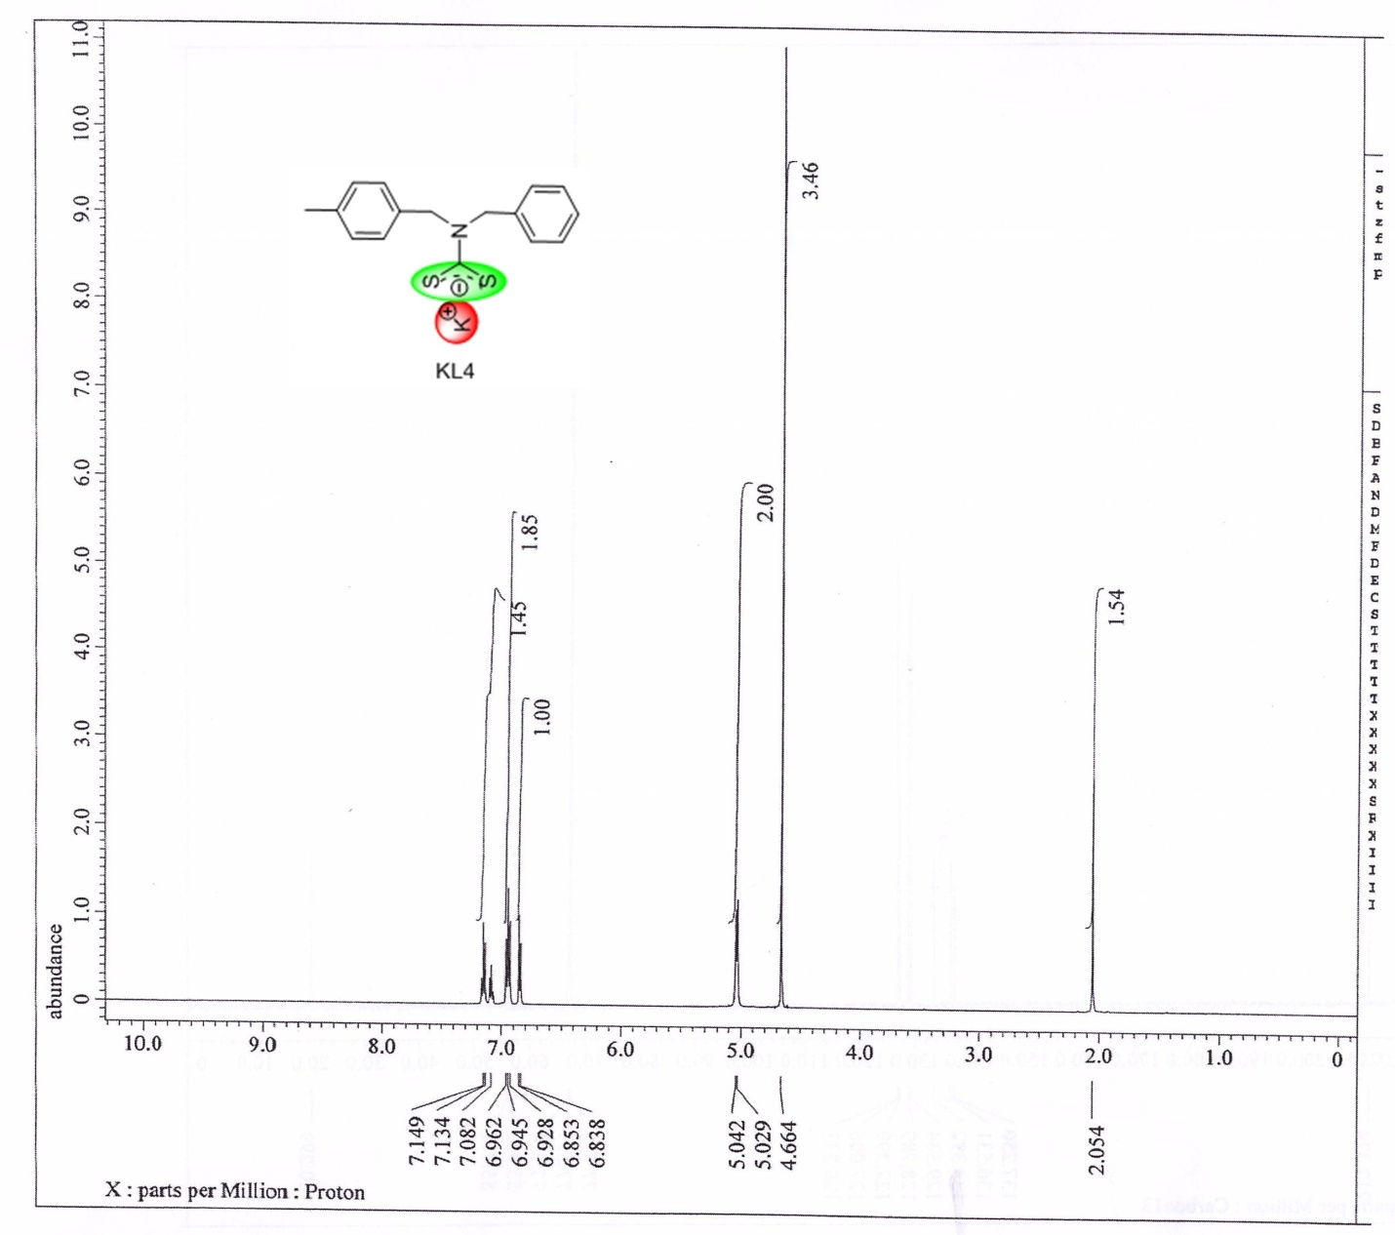
Figure S7. ¹H NMR spectrum of KL4 ligand.
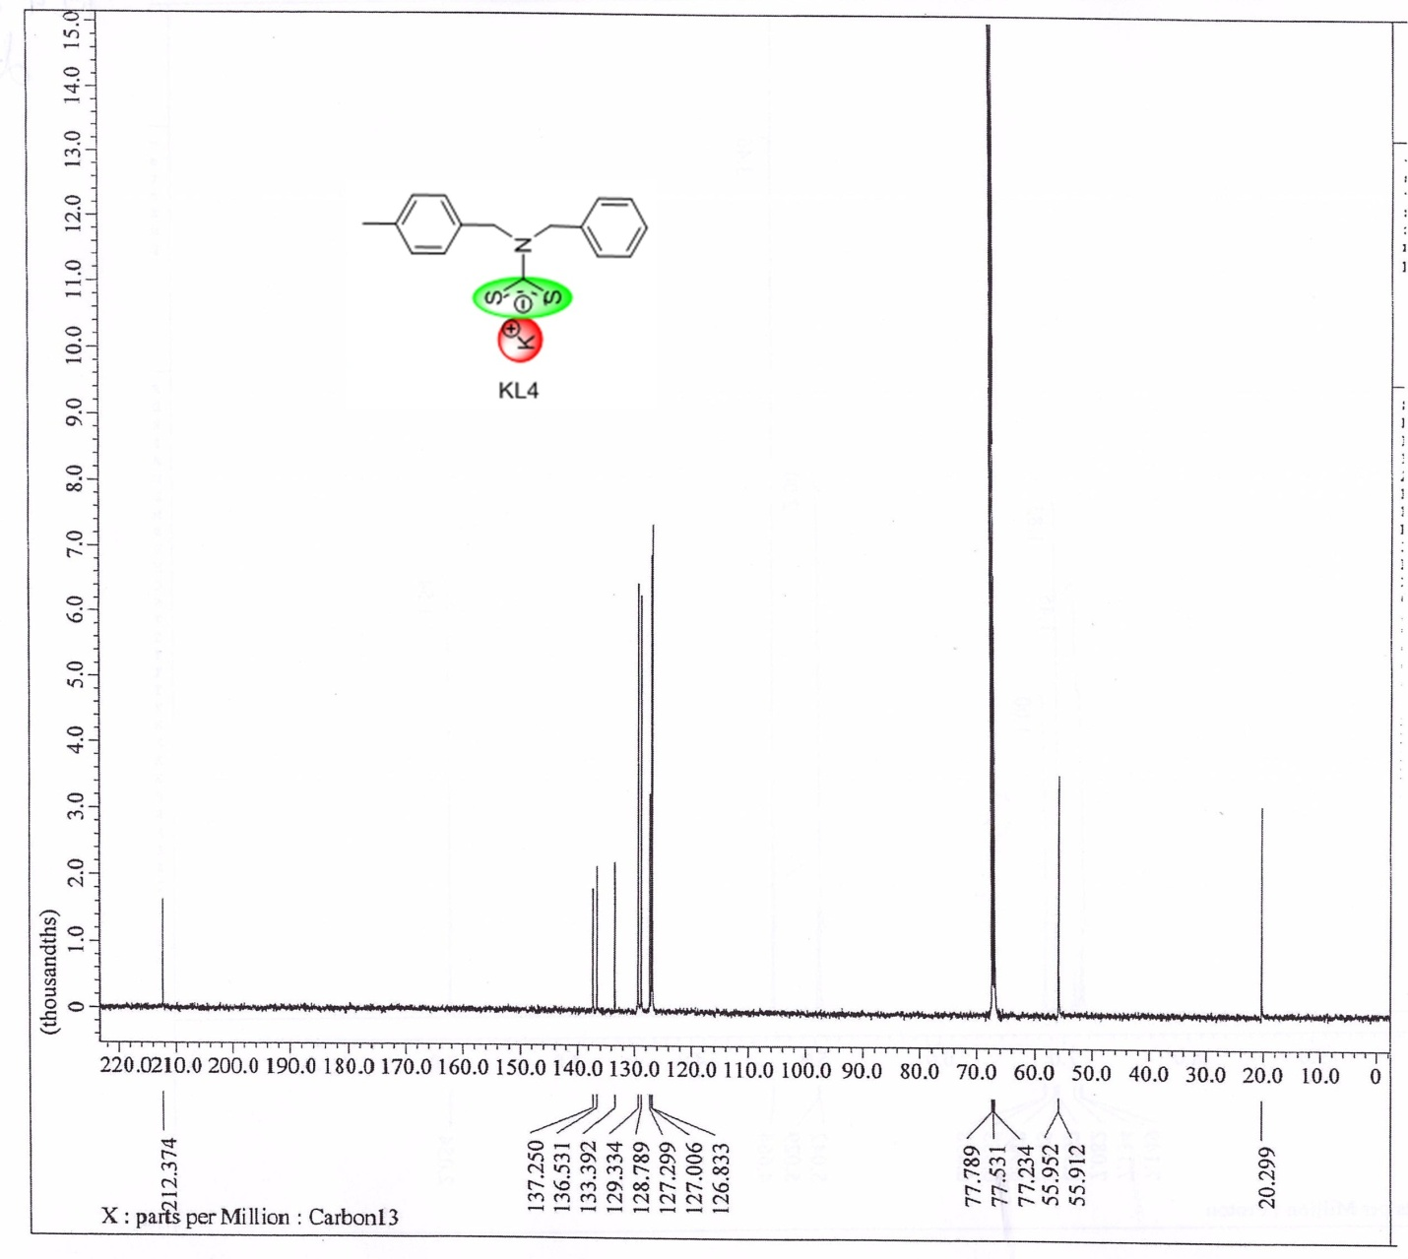
Figure S8. ¹³C NMR spectrum of KL4 ligand.
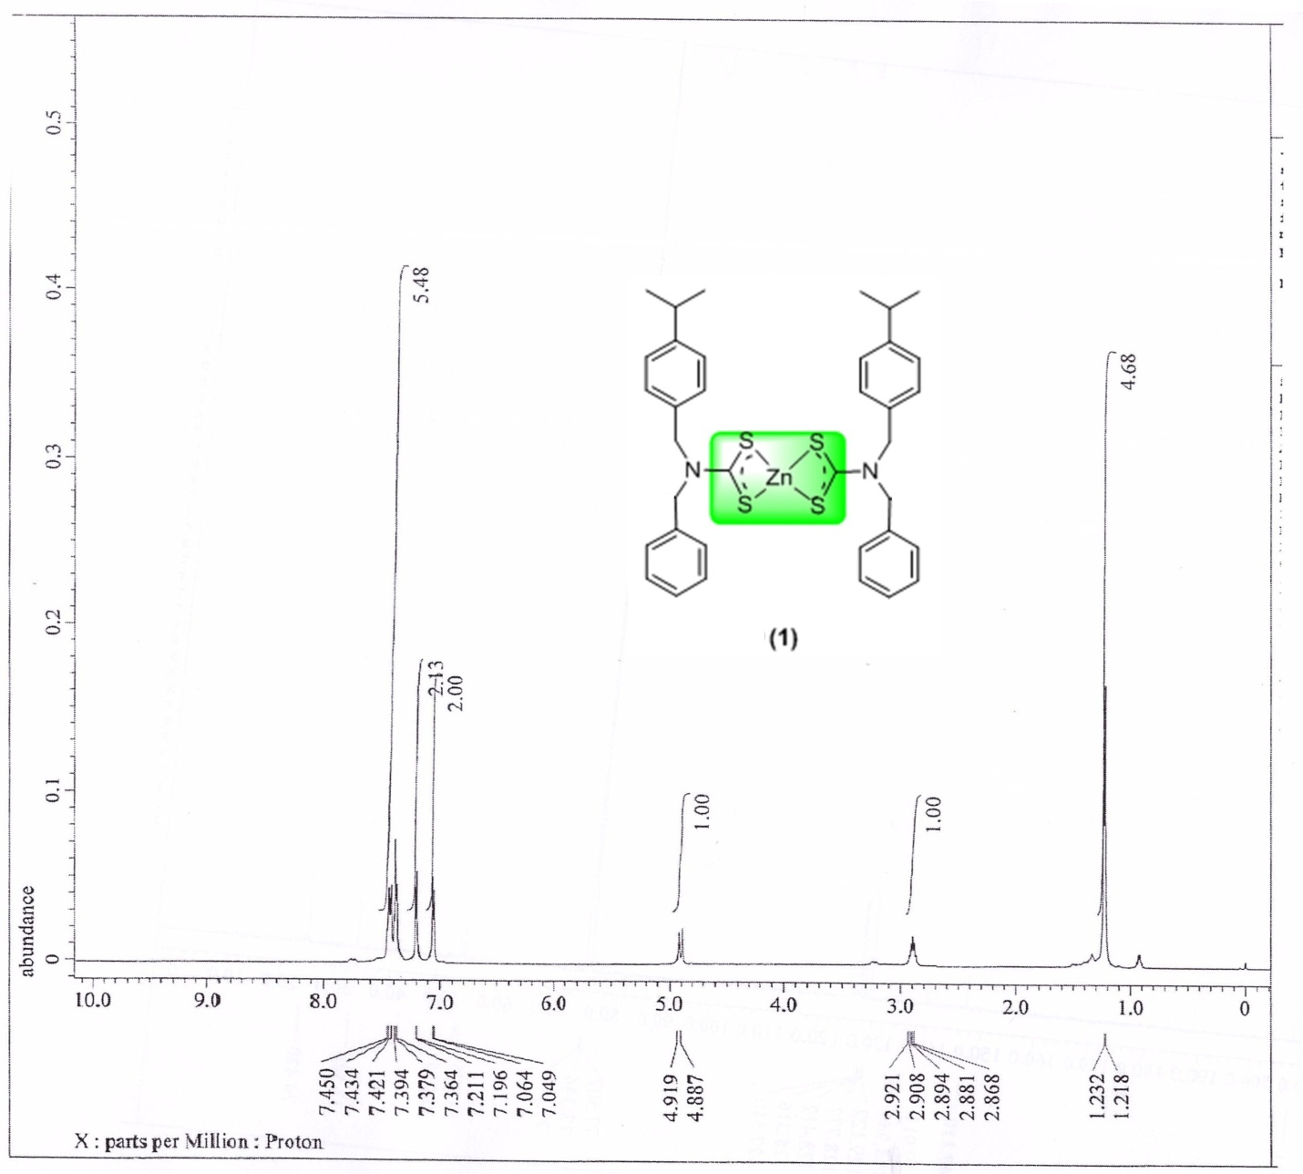
Figure S9. ¹H NMR spectrum of complex A1.
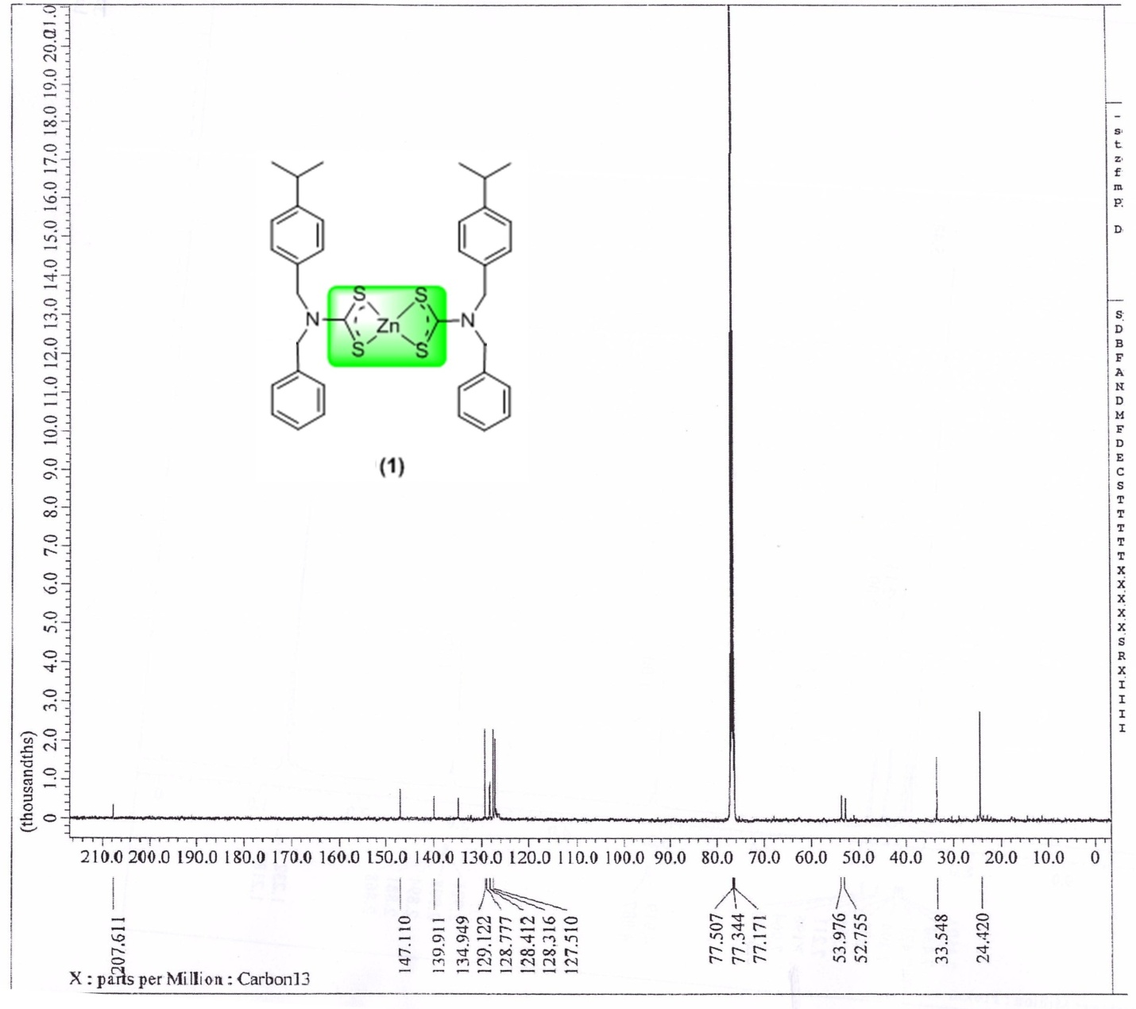
Figure S10. ¹³C NMR spectrum of complex A1.
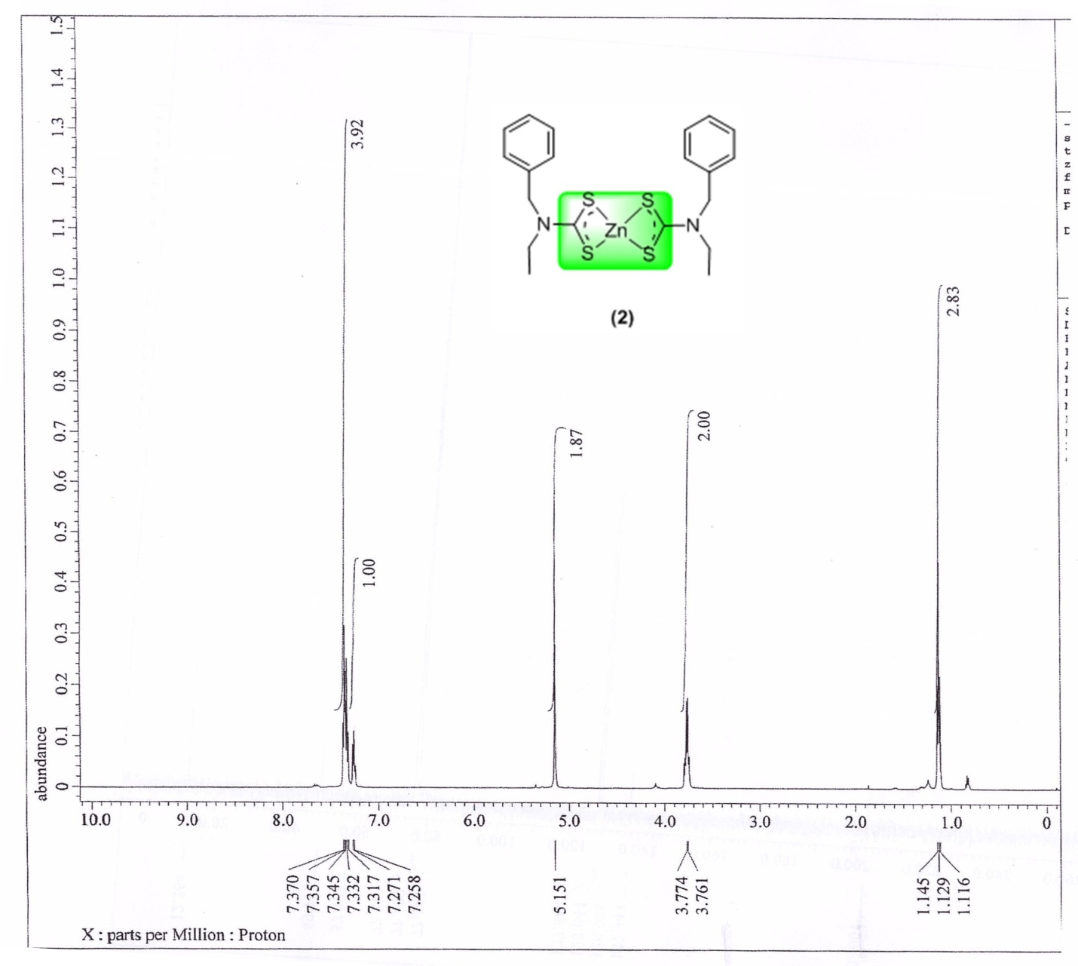
Figure S11. ¹H NMR spectrum of complex A2.
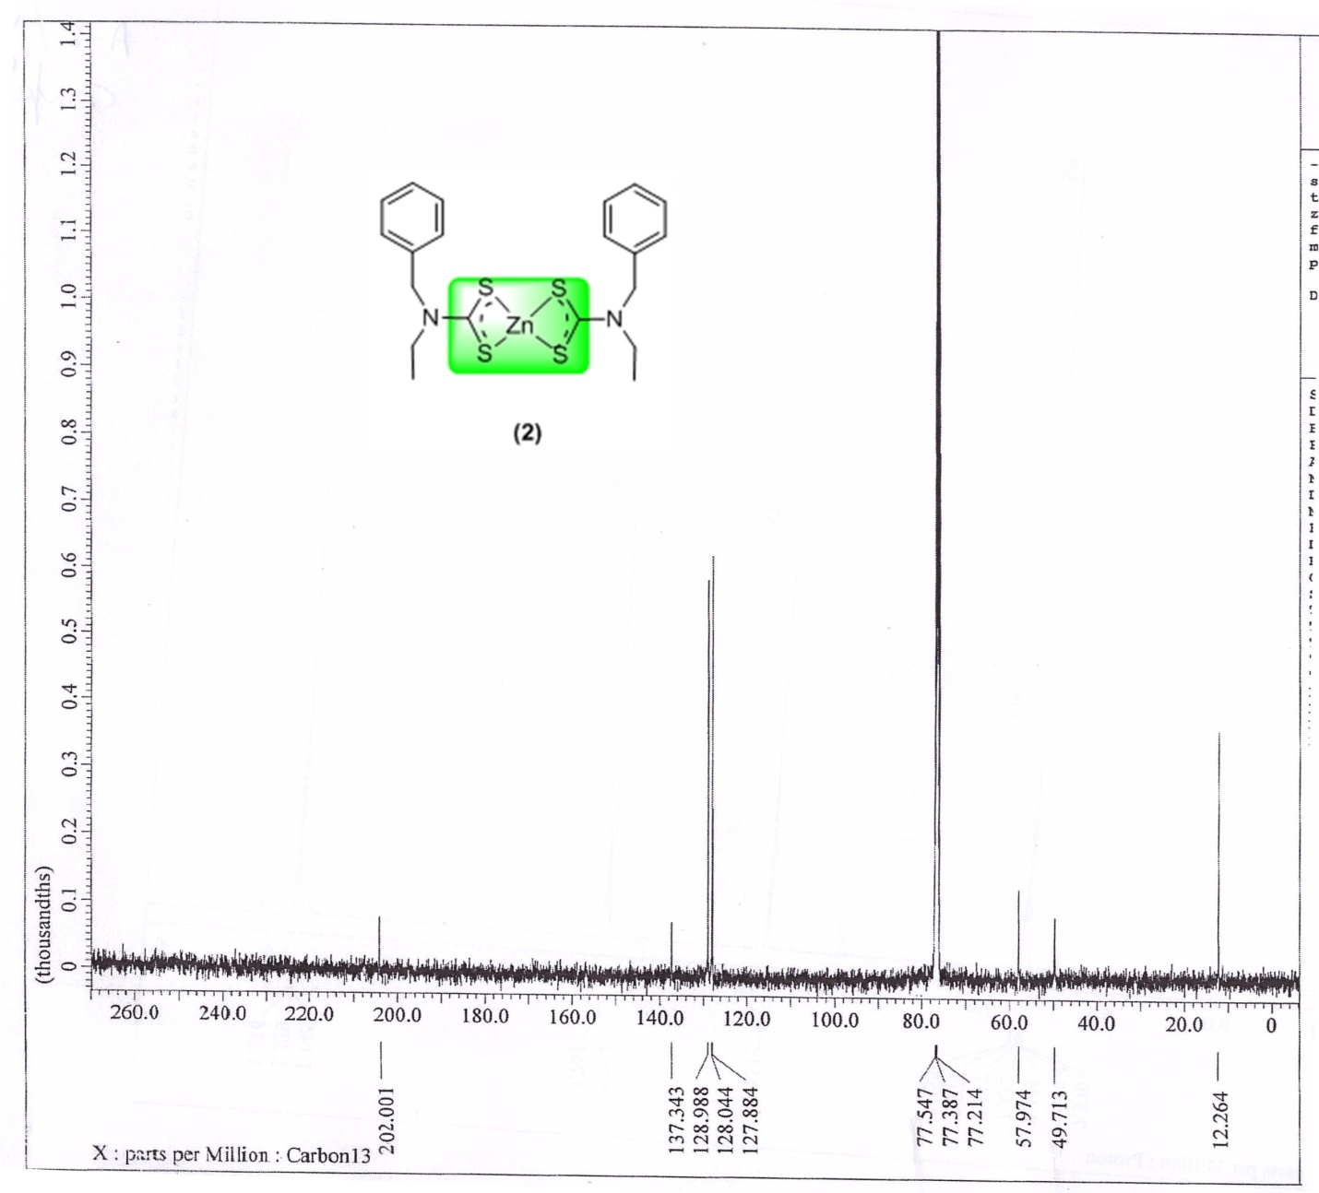
Figure S12. ¹³C NMR spectrum of complex A2.
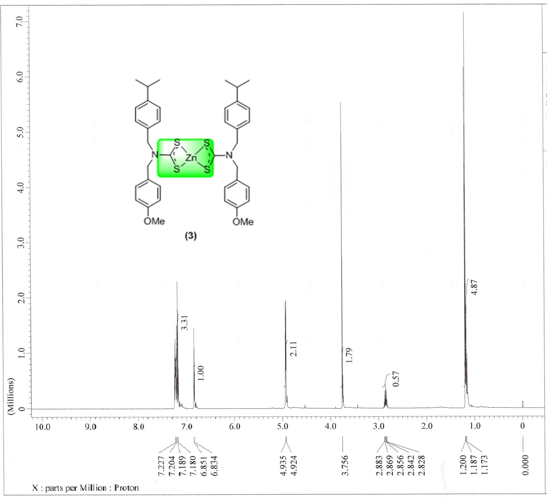
Figure S13. ¹H NMR spectrum of complex A3.

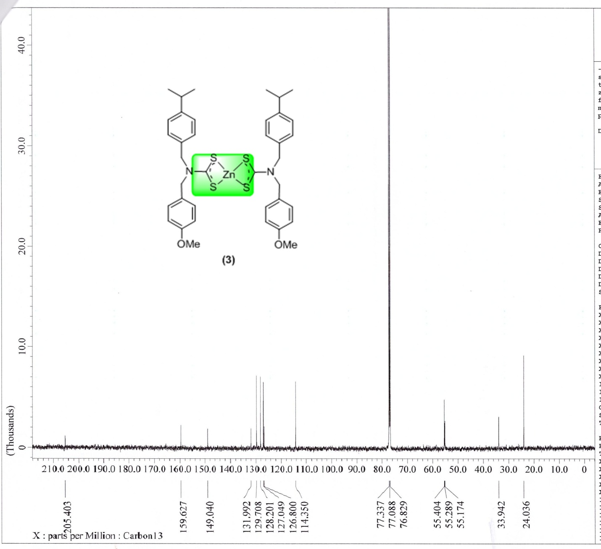
Figure S14. ¹³C NMR spectrum of complex A3.
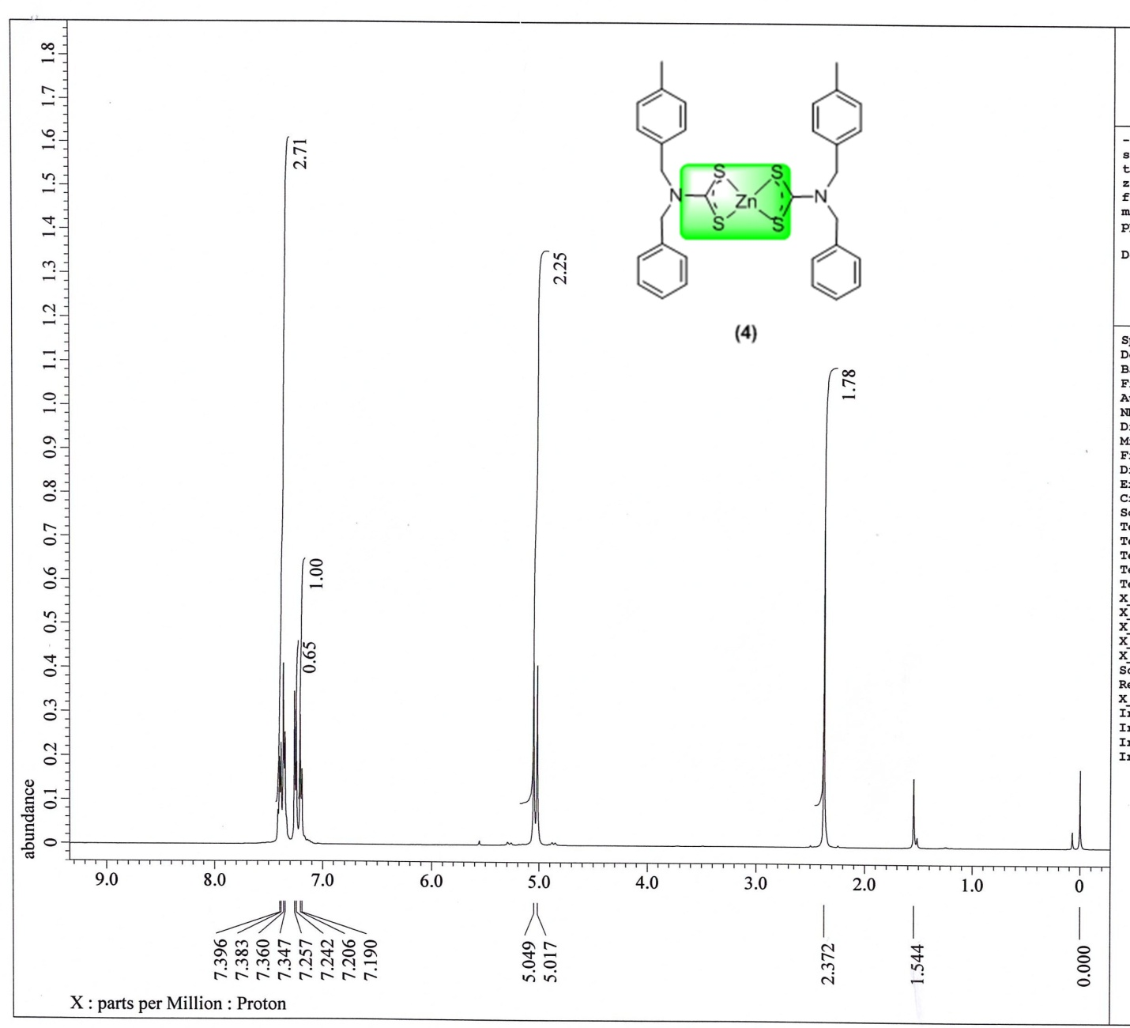
Figure S15. ¹H NMR spectrum of complex A4.
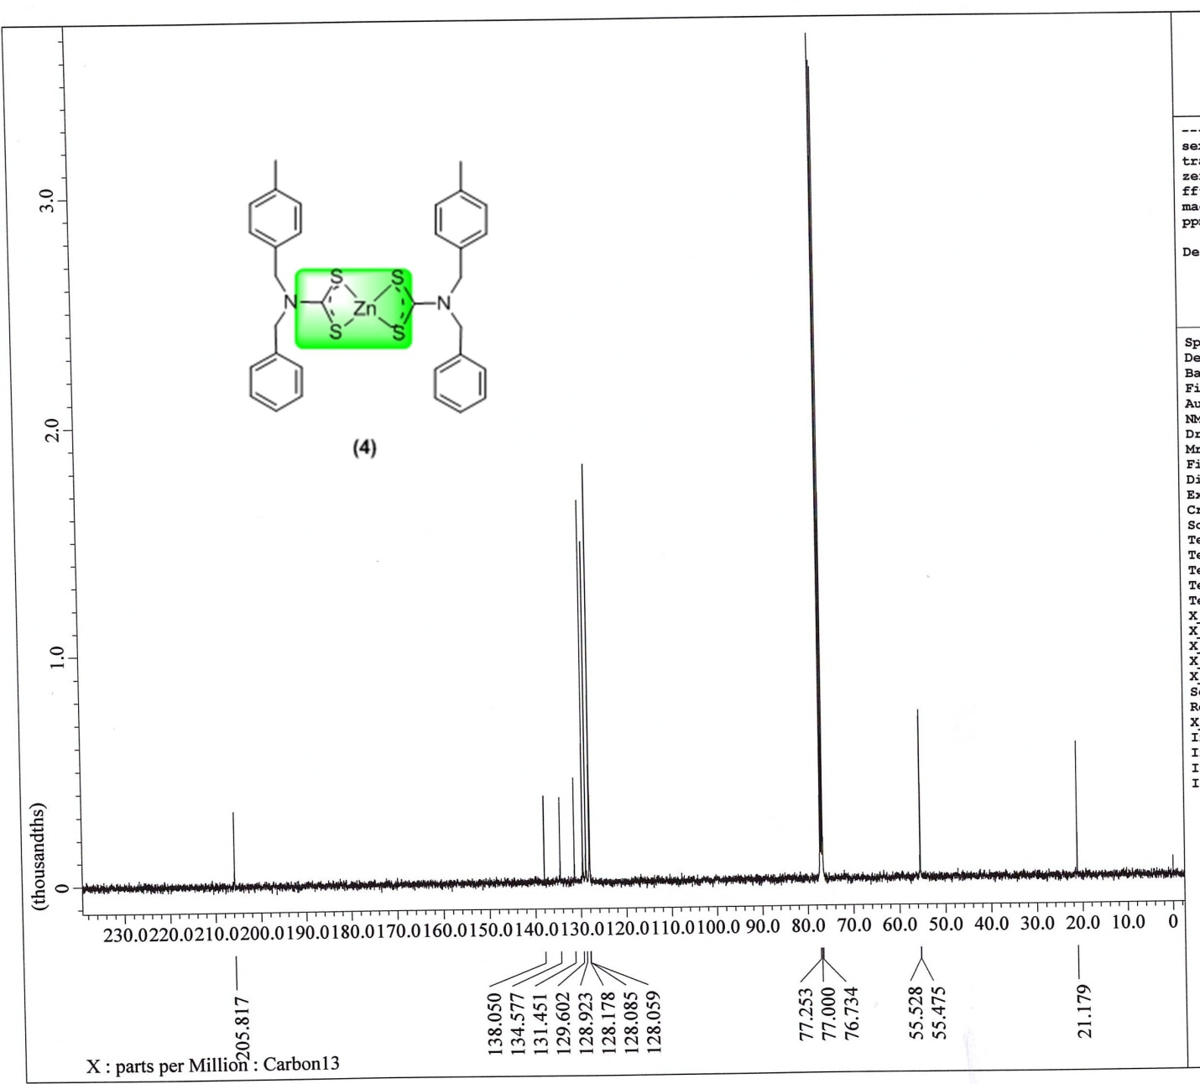
Figure S16. ¹³C NMR spectrum of complex A4.

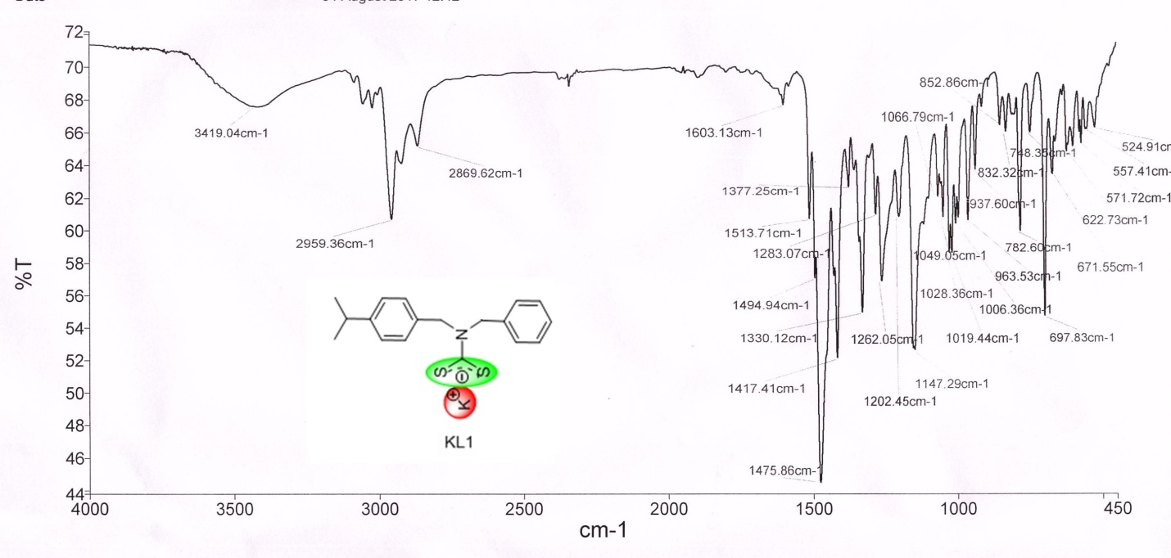
Figure S17. FTIR spectra of KL1 ligand.

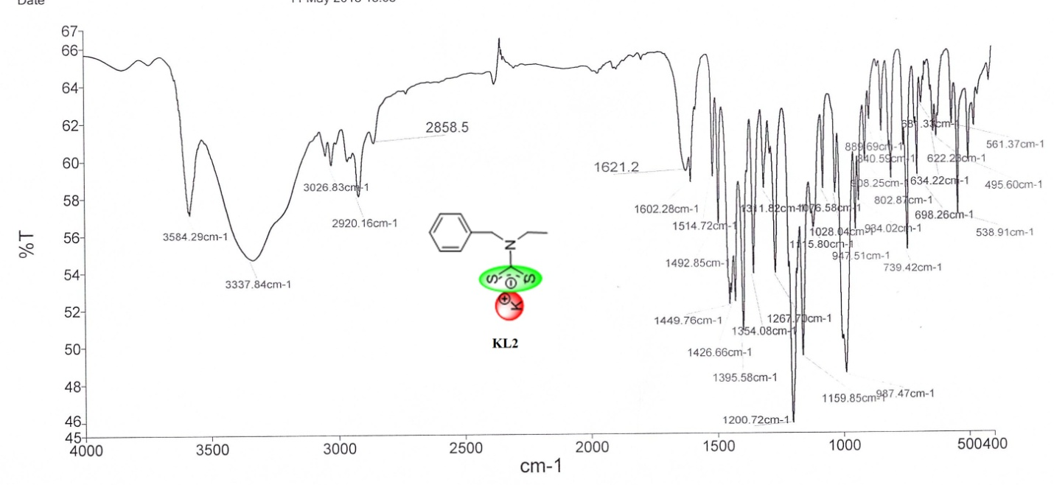
Figure S18. FTIR spectra of KL2 ligand.
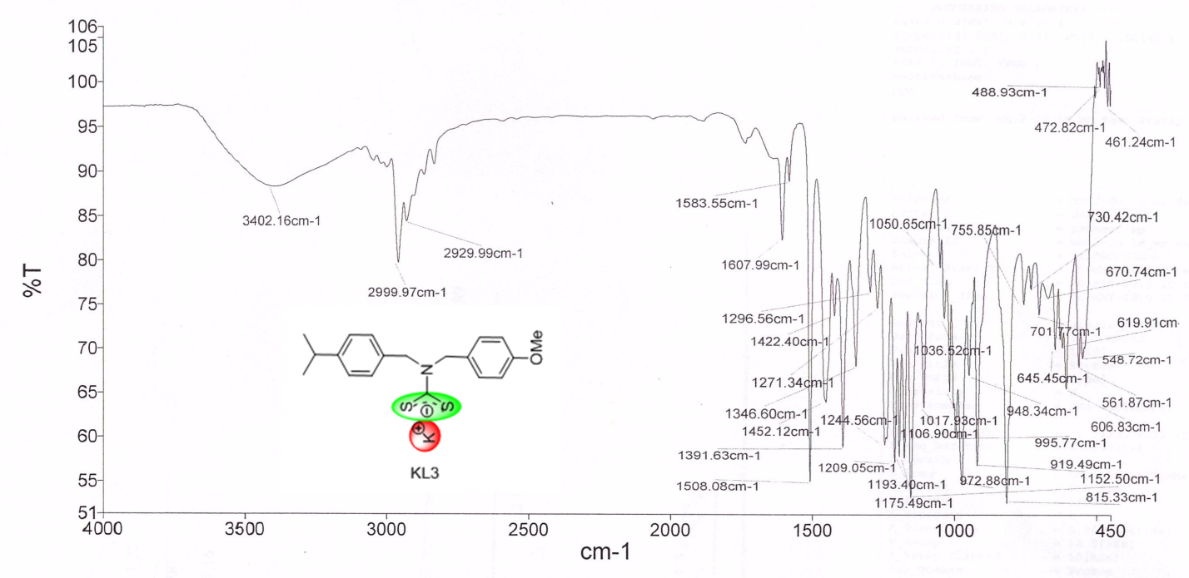
Figure S19. FTIR spectra of KL3 ligand.

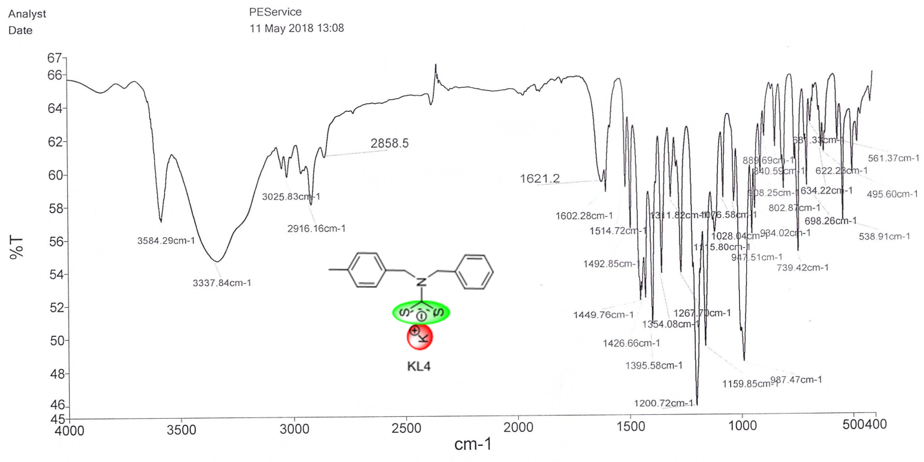
Figure S20. FTIR spectra of KL4 ligand.
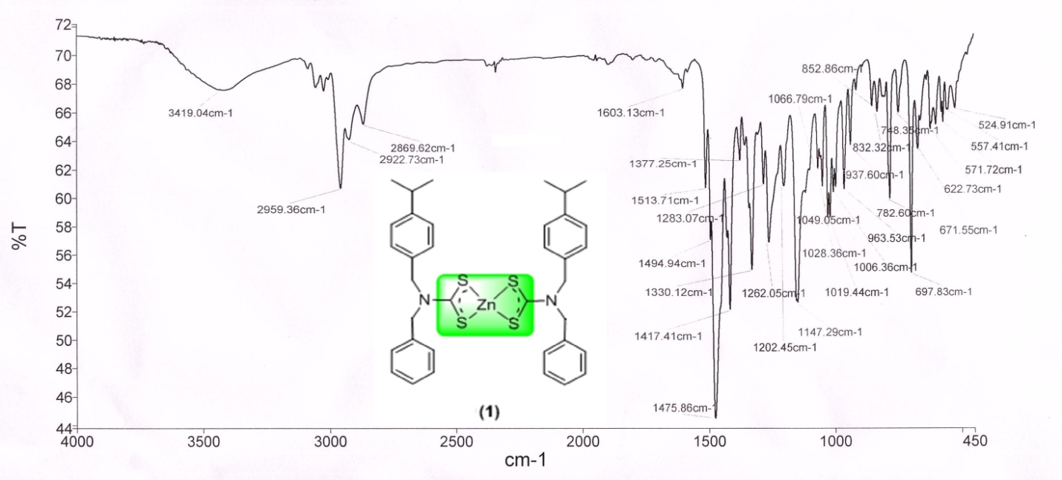
Figure S21. FTIR spectra of complex A1.

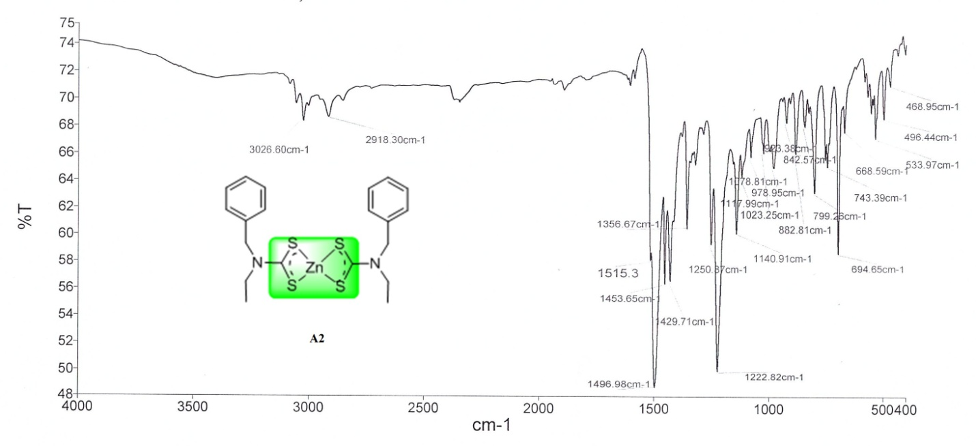
Figure S22. FTIR spectra of complex A2.
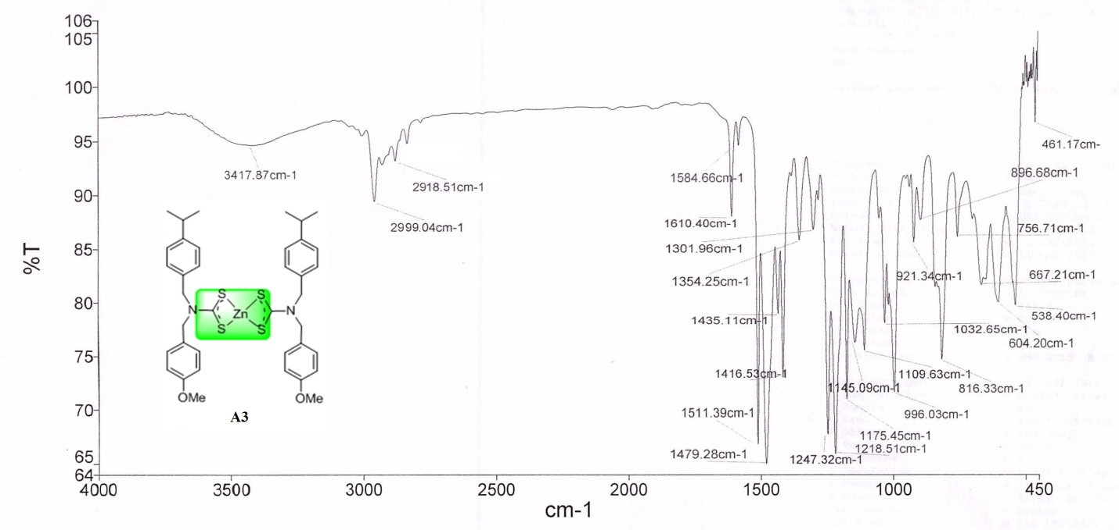
Figure S23. FTIR spectra of complex A3.

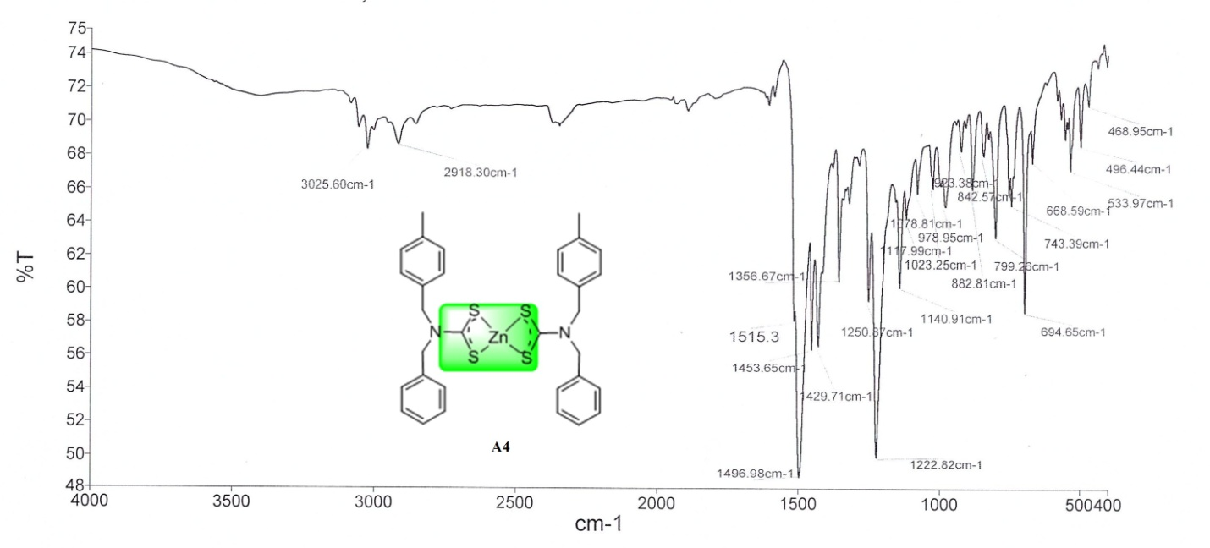
Figure S24. FTIR spectra of complex A4.

Figure S25. Evaluation of antibiofilm activities of complexes.

Figure S26. Preliminary screening of compound A2 against S. aureus and E. coli. The complex concentration increases by 10 units as we move from A1-A2-A3-A4. SA is the symbolic of S. aureus while EC is the symbolic of E. coli.

Figure S27. Dose dependent antitumor assay of Zn(II) dithiocarbamate complexes against HCT116 cells. Control is the untreated panel that is actually the negative control. (1) Treated HCT116 cells with 16 µg/ml A3 (1’) Treated HCT116 cells with 16 µg/ml A2 (2) Treated HCT116 cells with 64 µg/ml A3 (2’) Treated HCT116 cells with 64 µg/ml A2 (3) Treated HCT116 cells with 128 µg/ml A3 (3’) Treated HCT116 cells with 128 µg/ml A2 (4) Treated HCT116 cells with 256 µg/ml A3 (4’) Treated HCT116 cells with 256 µg/ml A2.

