Aryl ethers decorated gallic acid-naphthalimide conjugate: Aggregation and sensing toward amines and F⁻
Chiranjit Pati, Kumaresh Ghosh*

Department of Chemistry, University of Kalyani, Kalyani-741235, India. Email:ghosh_k2003@yahoo.co.in, kumareshchem18@klyuniv.ac.in Fax: +913325828282; Tel: +913325828750 Extn: 305.
.

Table 1S. Results of gelation test for compound 1.

Solvents | Results
THF | S
1,2-dichlorobenzene- dioxane (5:1, v/v) | G (6 )
1,2- dichloroethane | PG
DMSO | G (20)
Toluene- dioxane (5:1, v/v) | G (6)
CH₃CN- dioxane (5:1, v/v) | G (8)
dioxane | S
CHCl₃ | PS
CCl₄ | PS
MeOH | I
S = Solution; G = Gel (minimum gelation concentration; mg/ ml); PG = partial gel; I = Insoluble; PS = partial soluble

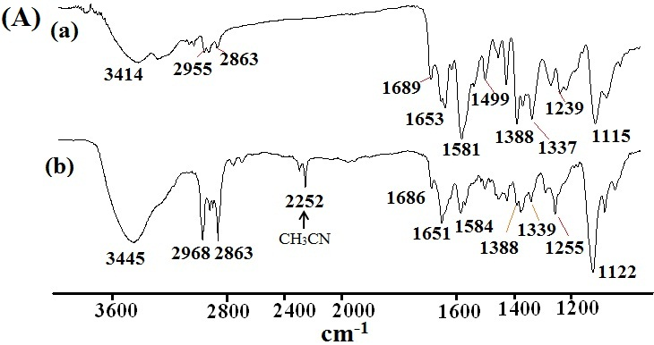

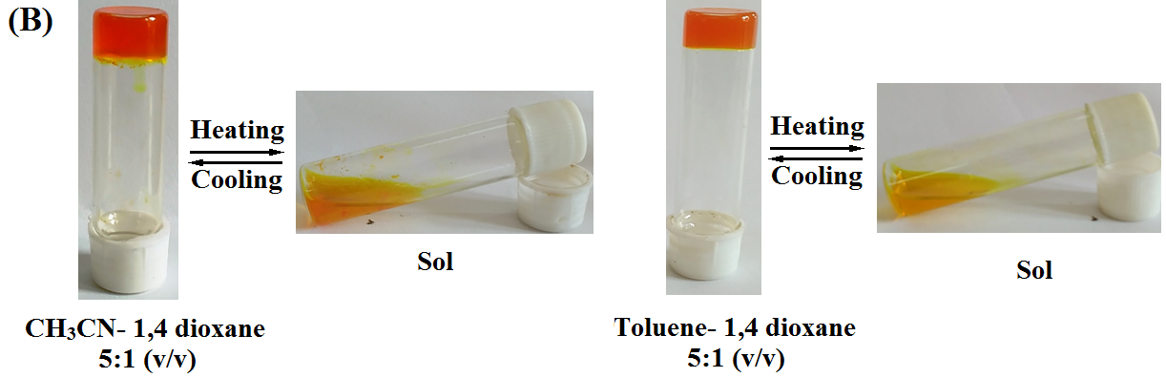

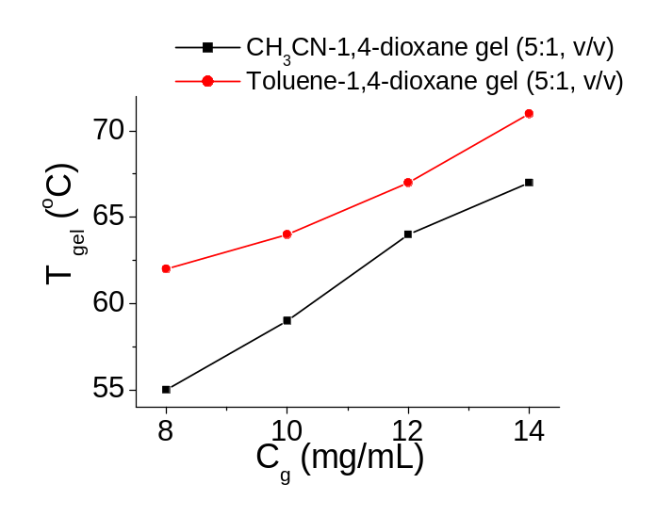
(C)

Fig. 1S. (A) Partial FTIR spectra of 1 in (a) amorphous state, (b) gel state obtained from CH₃CN-1,4-dioxane (5:1, v/v); (B) Pictorial presentation of thermo-reversibilly of the gel states obtained from CH₃CN-1,4-dioxane (5:1, v/v) and Toluene-1,4-dioxane (5:1, v/v); (C) Plot of T_{gel} with varying concentration of gelator 1 in different solvents.

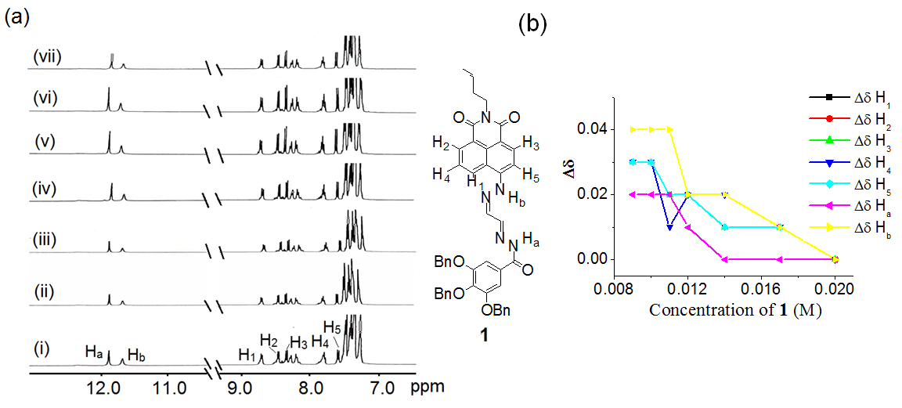

Fig. 2S. (a) Partial ¹H NMR (400 MHz, d₆- DMSO) of 1 at different concentrations at 25ºC (i) 0.02 M, (ii) 0.017 M, (iii) 0.014 M, (iv) 0.012 M, (v) 0.011 M, (vi) 0.01 M, (vii) 0.009 M; (b) Change in chemical shift (Δδ in ppm) of the indicated protons with concentration of 1.
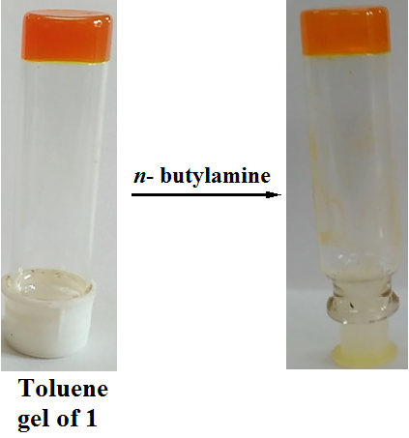
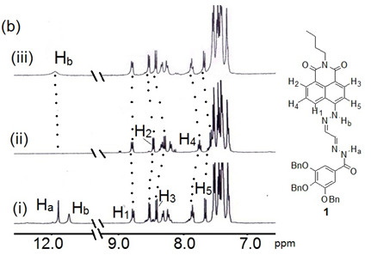
(a)

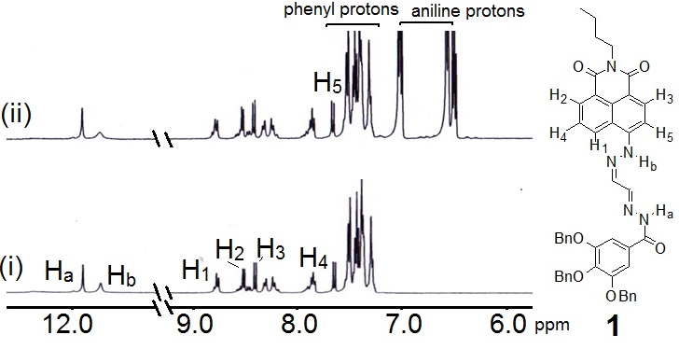
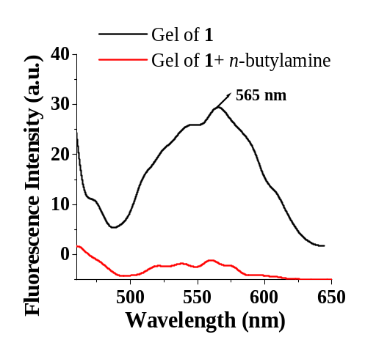
Fig. 3S. (a) Pictorial representation of the sensitivity of the gel of 1 in toluene-1,4-dioxane (5:1, v/v) in presence of 1 equiv. amount of n-butylamine (c = 0.1 M); (b) Partial ¹H NMR (d₆- DMSO, 400 MHz) of (i) 1 (c = 5.53 x 10⁻³ M) and (ii) 1 in the presence of 1 equiv. amount of n-butylamine followed treatment with (iii) acetic acid.

(a) (b) (b)

Fig. 4S. (a) Comparison of emission spectra of CH₃CN-1,4-dioxane (5:1, v/v) gel of 1 in the absence and presence of n-butylamine (λ_{ex} = 445 nm); (b) Partial ¹H NMR spectra (400 MHz, d₆- DMSO) of (i) 1 (c = 5.87 x 10⁻³ M) and (ii) 1 in the presence of 5 equiv. amounts of aniline.
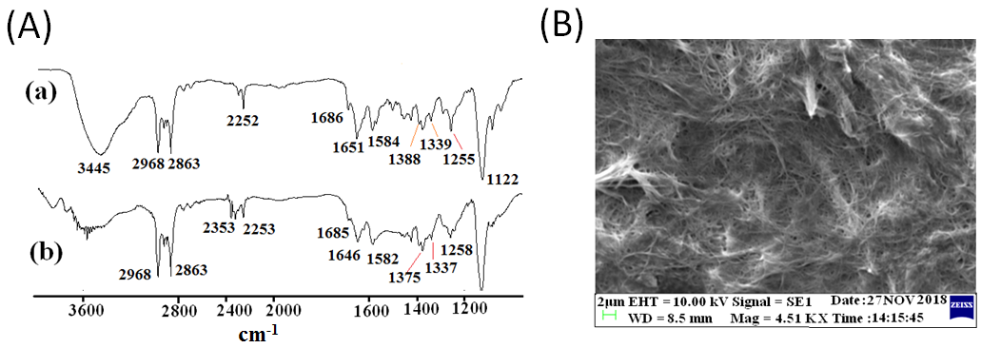

Fig. 5S. (A) Partial FTIR spectra of gel of 1 (prepared from CH₃CN-1,4-dioxane (5:1, v/v)) (a) in absence and (b) presence of n-butylamine; (B) SEM image of the n-butylamine treated xerogel.
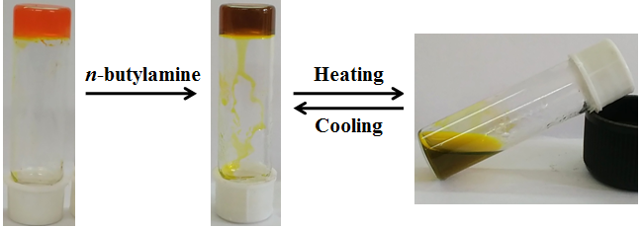

Fig. 6S. Pictorial representation of thermo-reversibility of 1 equivalent amount of n-butylamine (c = 0.1 M) treated gel of 1 in CH₃CN-1,4-dioxane (5:1, v/v).
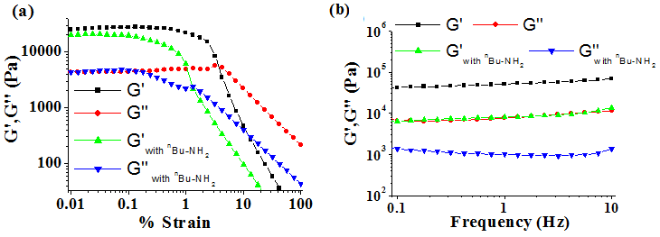

Fig. 7S. (a) Amplitude and (b) Frequency sweep experiments of CH₃CN-1,4-dioxane (5:1, v/v) gel of 1 without and with 1 equiv. amount of n-butylamine (c = 0.1 M). Amplitude sweep experiment was carried out at constant frequency of 1Hz and frequency sweep experiment was conducted at constant 0.1 % strain. Gelator concentration was 8 mg/mL.

Table 2S. Summary of the rheological properties of the gels of 1 in CH₃CN-1,4-dioxane (5:1,
v/v)
Gels | Crossover (% strain) | G′_{av} (Pa)* | G′′_{av} (Pa)*
1 | 3.5 | 52400 | 8150
1 with  n-butylamine | 1.3 | 8530 | 1081

* G′_{av} and G′′_{av} values were calculated from frequency sweep data.

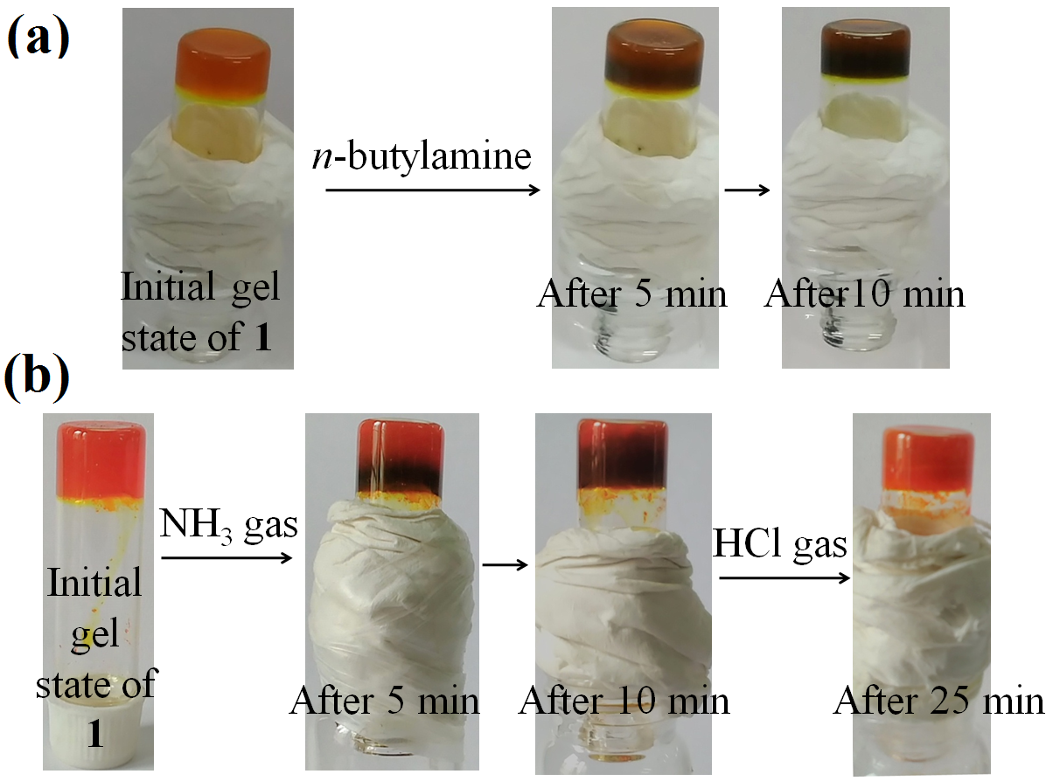

Fig. 8S. Vapor phase detection through color change: (a) in presence of 1 equiv. amount of n-butylamine (c = 0.1 M) and (b) NH₃ using CH₃CN-1,4-dioxane (5:1, v/v) gel of 1.

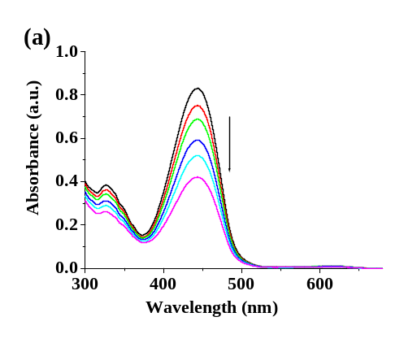
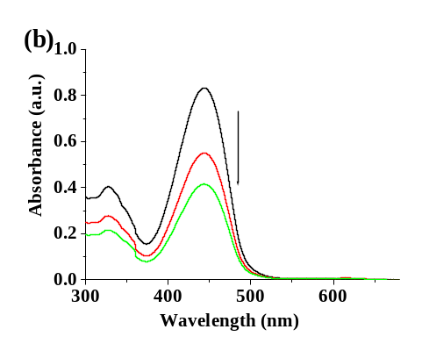
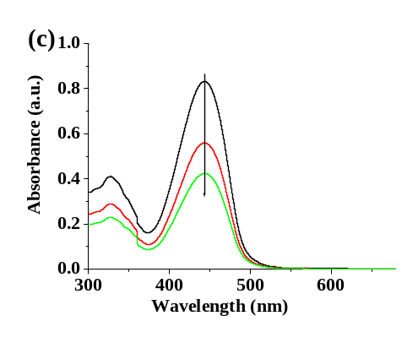

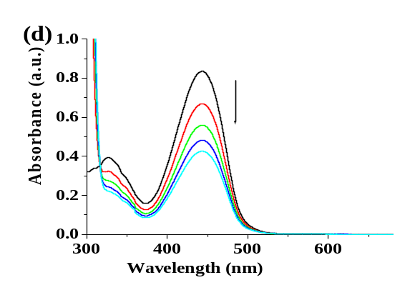
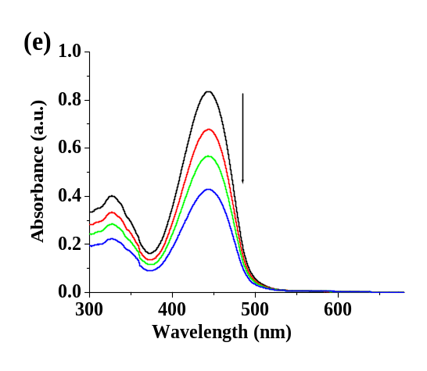
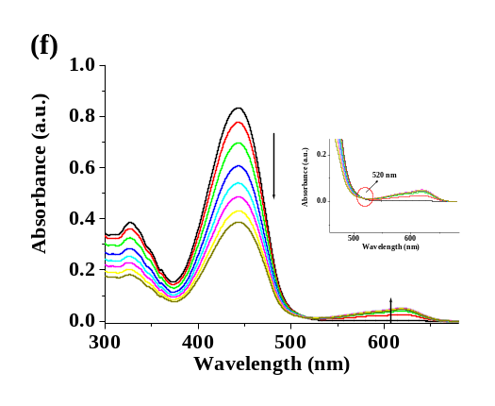

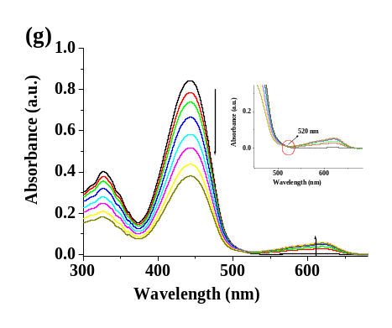

Fig. 9S. UV-vis titration spectra of 1 (c = 2.50 x 10⁻⁵ M) upon addition of (a) ethanolamine, (b) N₂H₄, (c) NH₂OH, (d) aniline, (e) pyridine, (f) dimethylamine (DMA), (g) Et₃N (c = 1.0 x 10⁻² M) in CH₃CN containing 1% THF.

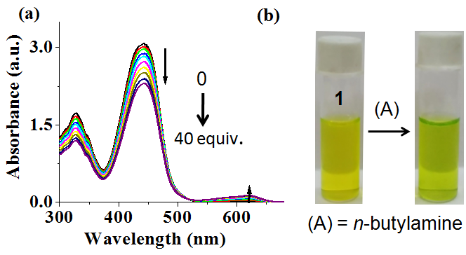

Fig. 10S. Change in absorbance of 1 (c = 1 x 10⁻⁴ M) upon addition of 40 equiv. amounts of n-butylamine (c = 1.0 x 10⁻² M) in CH₃CN containing 1% THF; (b) Color change of 1 (c = 1 x 10⁻⁴ M) upon addition of 40 equiv. amounts of n-butylamine (c = 1.0 x 10⁻² M) in CH₃CN containing 1% THF.

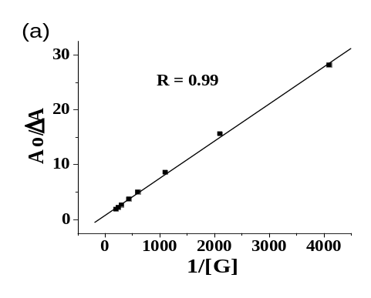
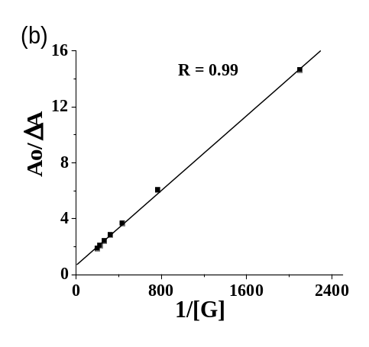
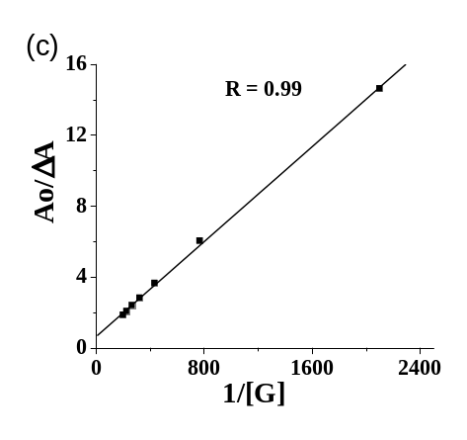

Fig. 11S. (a) Benesi–Hilderband plots for 1 (c = 2.5 x 10⁻⁵ M) with (a) n-butylamine, (b) dimethylamine (DMA), (c) triethylamine (Et₃N) (c = 1.0 x 10⁻³ M) at 442 nm from UV-vis study in CH₃CN containing 1% THF.
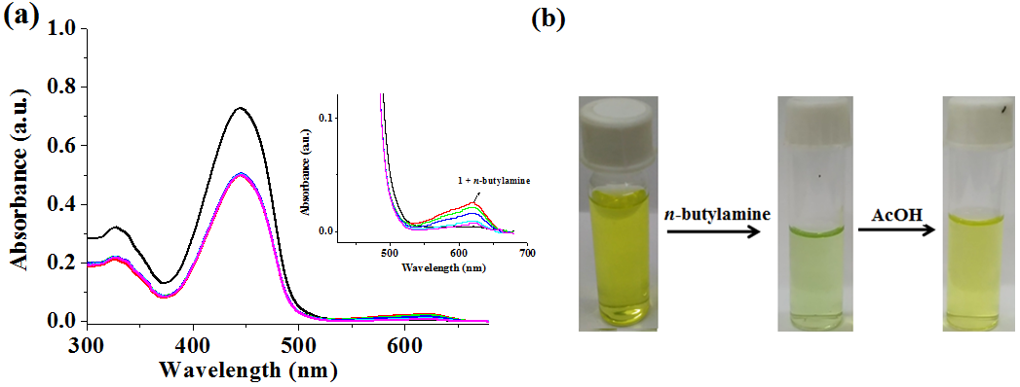

Fig. 12S. (a) Change in absorbance of 1 (c = 2.50 x 10⁻⁵ M) with n-butylamine followed by addition of acetic acid (c = 1.0 x 10⁻² M) in CH₃CN containing 1% THF; (b) Color change upon addition of n-butylamine followed by acetic acid.

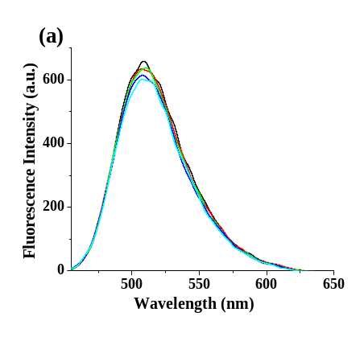
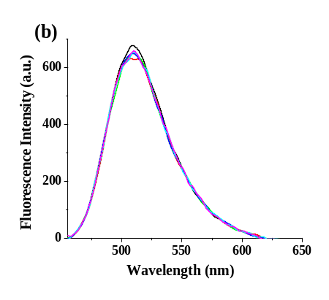
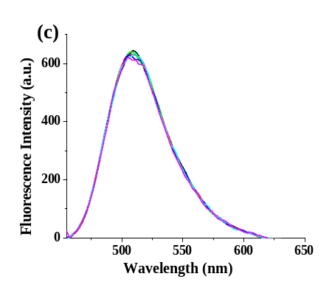

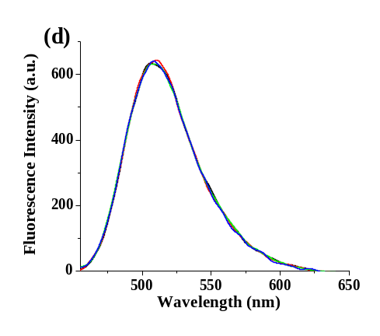
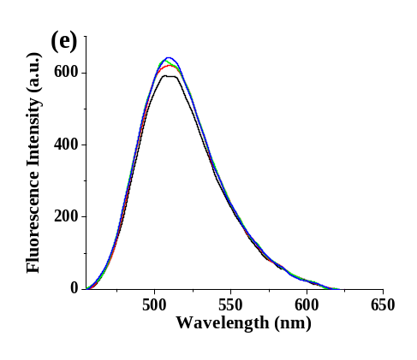
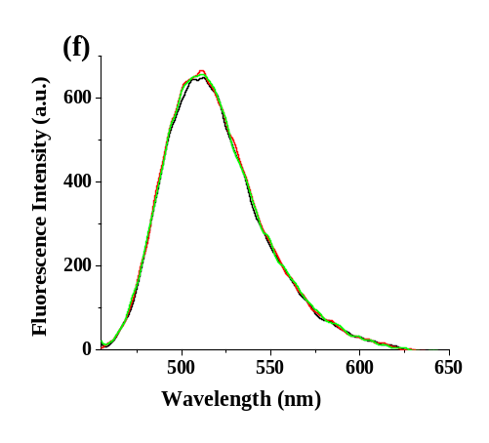
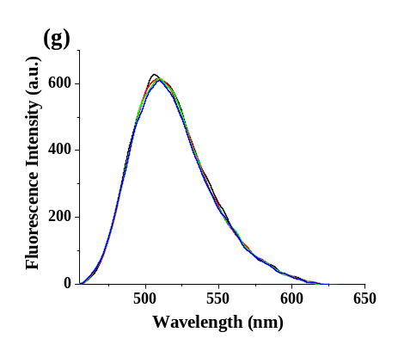
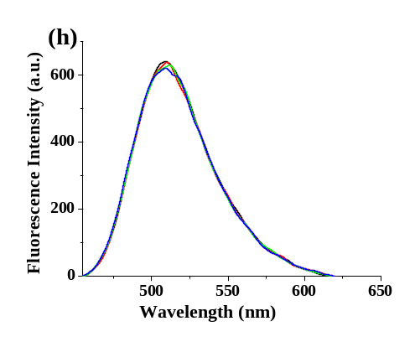

Fig. 13S. Change in emission of 1 (c = 2.50 x 10⁻⁵ M) upon addition of (a) n-butylamine, (b) dimethylamine, (c) Et₃N, (d) ethanolamine, (e) N₂H₄, (f) NH₂OH, (g) aniline, (h) pyridine (c = 1.0 x 10⁻² M) containing 1% THF in CH₃CN ( λ_{ex} = 445 nm).
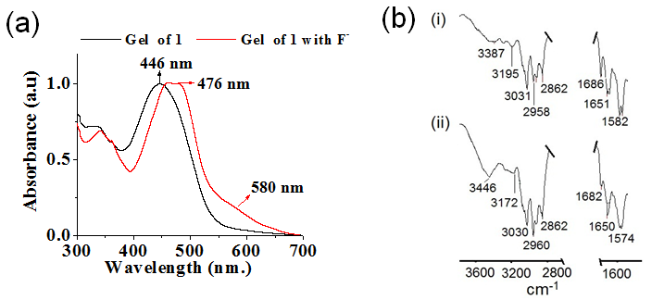

Fig. 14S. Comparison of normalized UV-vis spectra of toluene-1,4-dioxane (5:1, v/v) gel of 1 before and after treatment with F⁻ ions; (b) Partial FTIR spectra of gel of (i) 1 [prepared from toluene-1,4-dioxane (5:1, v/v)] and (ii) gel of 1 with F- ions.

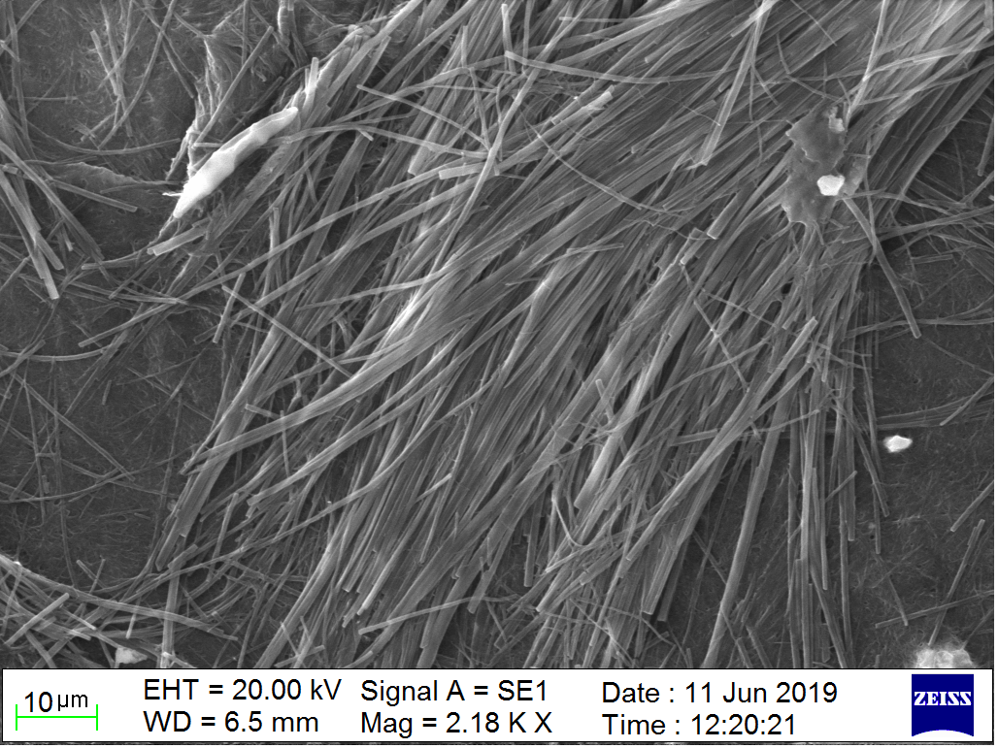

Fig. 15S. SEM image of the xerogel of 1 prepared from toluene-1,4-dioxane (5:1, v/v) after treatment with F⁻ ions.

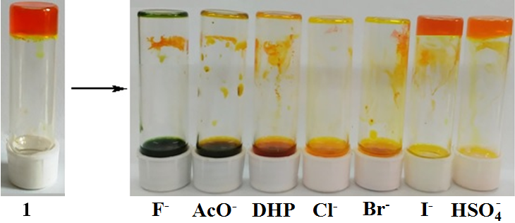

Fig. 16S. Photograph showing the changes in gel state of 1 in CH₃CN-1,4-dioxane (5:1 v/v) (c = 6 mg/mL) upon addition of 1 equiv. amount of different anions (c = 0.08 M) after 25 min.
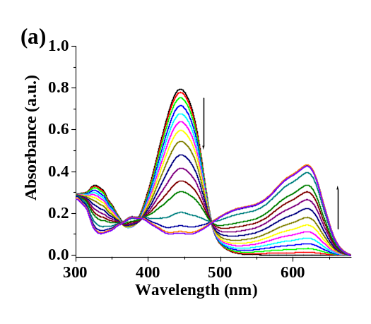
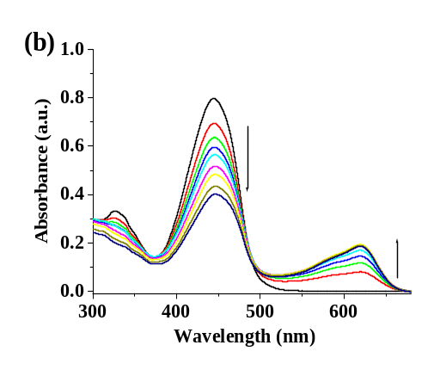
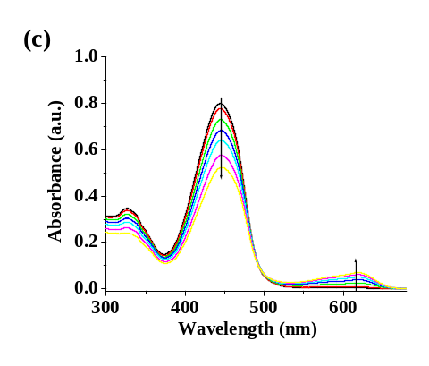

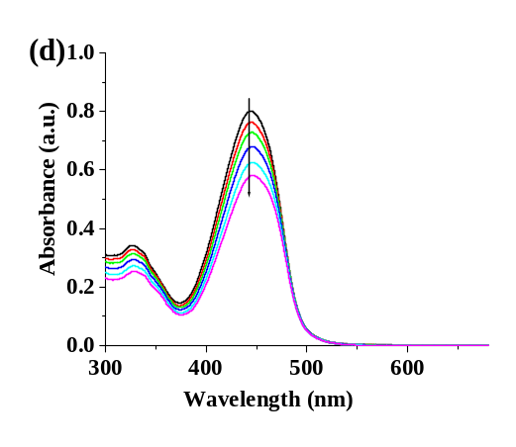
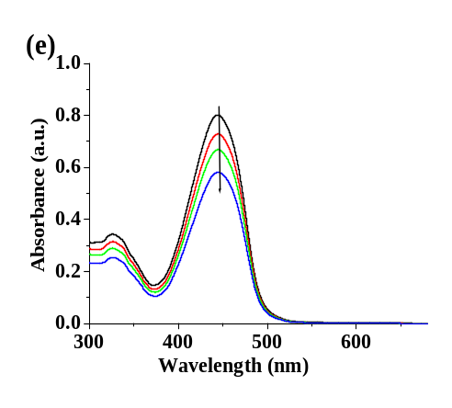
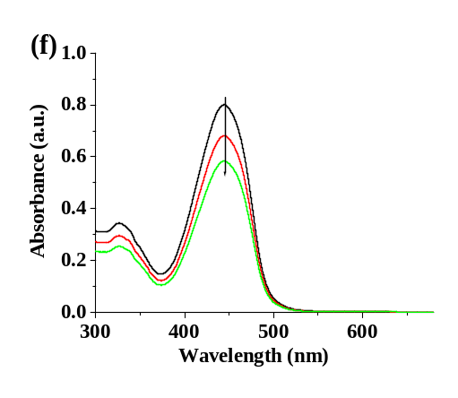

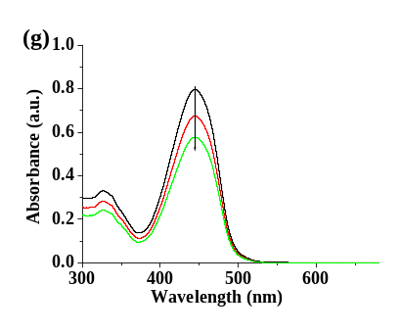

Fig. 17S. Change in absorbance of 1 (c = 2.5 x 10⁻⁵ M) from 0 up to 15 equiv. amounts of tetrabutylammonium salts of (a) F⁻, (b) AcO⁻, (c) DHP, (d) Cl⁻, (e) Br⁻, (f) I⁻, (g) HSO₄⁻ (c =1 x 10⁻³ M) in 1% THF in CH₃CN.
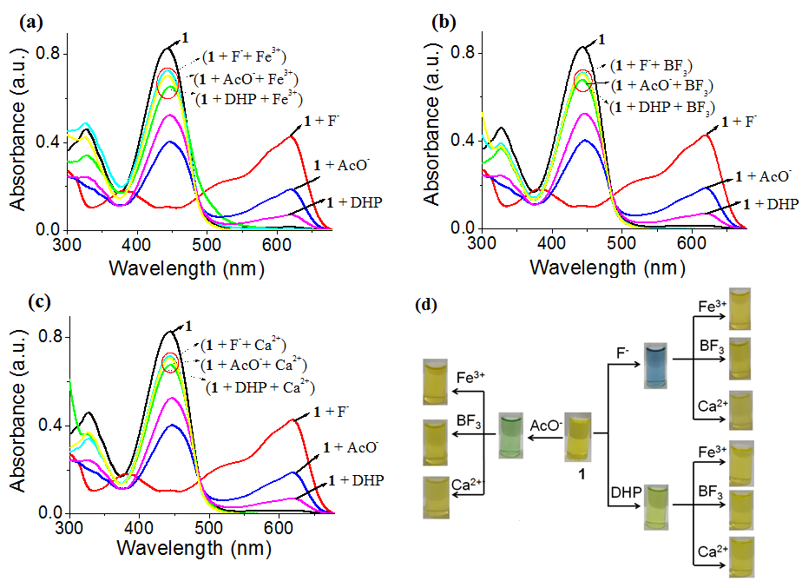

Fig. 18S. Change in absorbance of 1 (c =2.5 x 10⁻⁵ M) upon addition of 15 equiv. amounts of F⁻, AcO⁻ and H₂PO₄⁻ (DHP) (c =1 x 10⁻³ M) ions as their tetrabutylammonium salts followed by addition of 4 equiv. amounts of (a) Fe(ClO₄)₃, (b) BF₃ and Ca(ClO₄)₂ (c =1 x 10⁻³ M) in CH₃CN containing 1% THF; (d) Change in color of the solution of 1 (c =2.5 x 10⁻⁵ M) in CH₃CN containing 1% THF during the experiments mentioned in (a), (b) and (c).
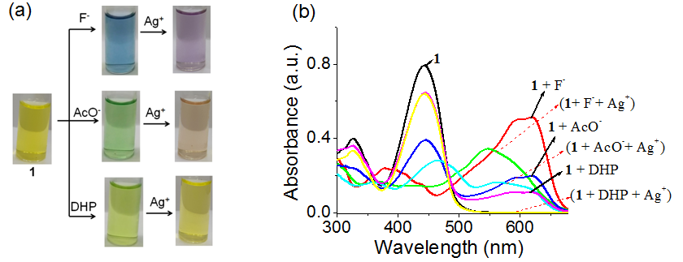

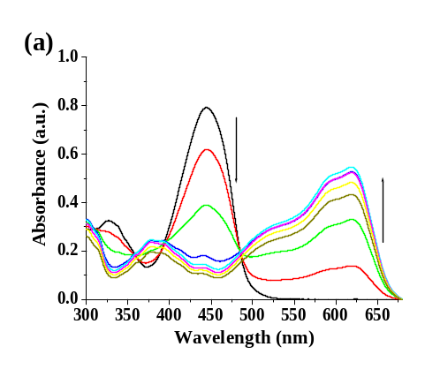
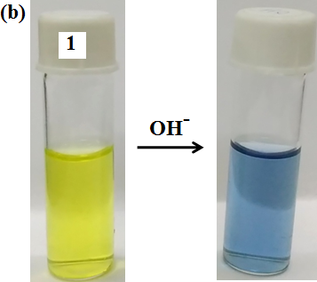
Fig. 19S. Change in (a) color and (b) absorbance of 1 (c =2.5 x 10⁻⁵ M) upon addition of 15 equiv. amounts of each anions (c =1 x 10⁻³ M) followed by addition of 6 equiv. amounts of AgClO₄ (c =1 x 10⁻³ M) in CH₃CN containing 1% THF.

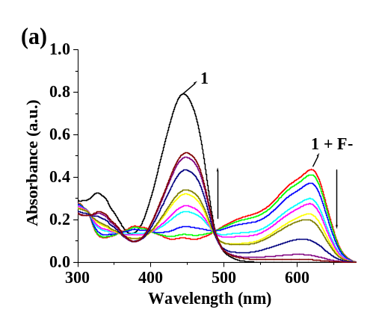
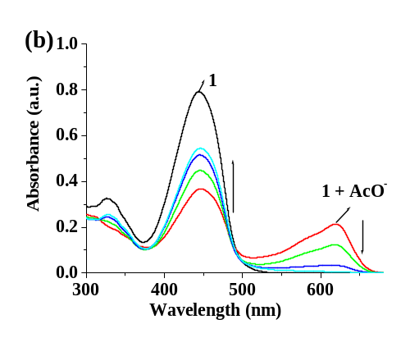
Fig. 20S. Change in (a) absorbance and (b) color of 1 (c = 2.5 x 10⁻⁵ M) in CH₃CN containing 1% THF upon addition of 15 equiv. amounts of tetrabutylammonium hydroxide (c =1 x 10⁻³ M).

Fig. 21S. Change in absorbance of 1 (c = 2.5 x 10⁻⁵ M) in presence of 15 equiv. amounts of (a) F⁻, (b) AcO⁻ and then upon gradual addition of H₂O.
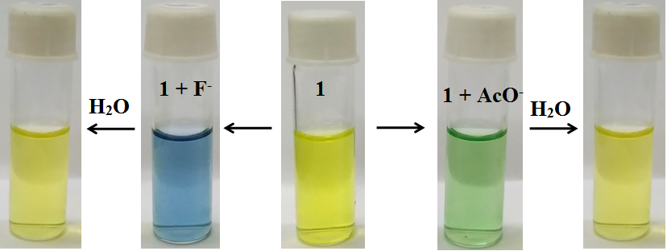

Fig. 22S. Change in colour of 1 (c = 2.5 x 10⁻⁵ M) in presence of 15 equiv. amounts of F⁻ and AcO⁻ followed by addition of H₂O.
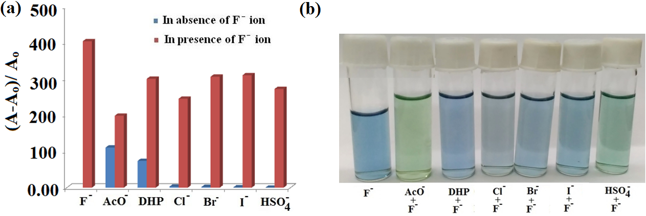

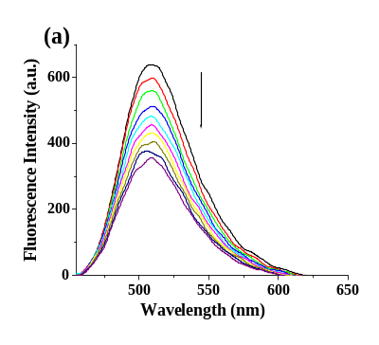
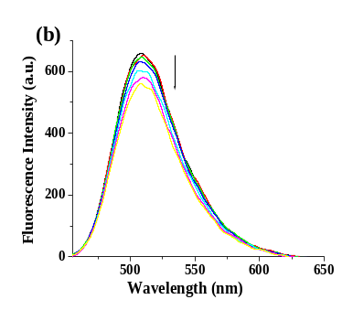
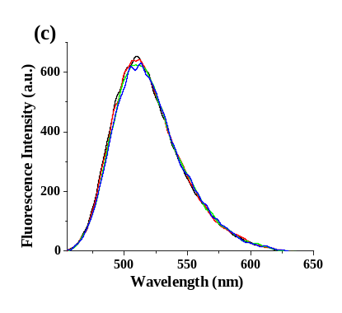
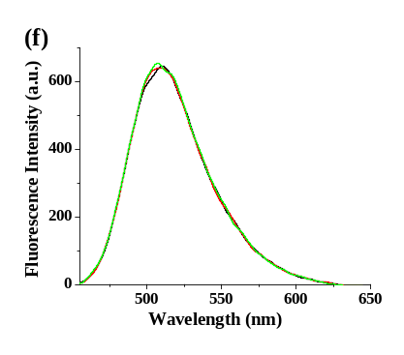
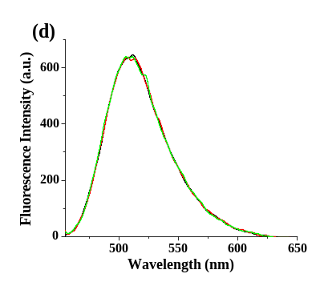
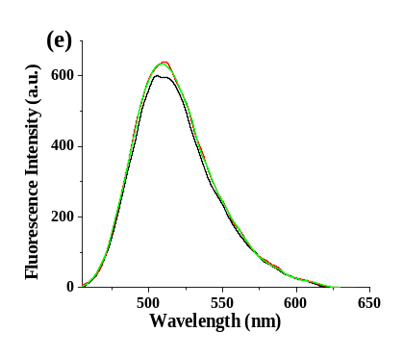
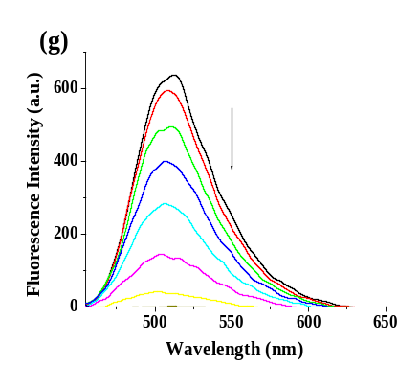
Fig. 23S. (a) Absorbance ratio of 1 (c = 2.5 x 10⁻⁵ M) at 620 nm upon addition of 15 equiv. amounts of F⁻ ions to the solution containing 15 equiv. amounts other anions in CH₃CN containing 1% THF and (b) the associated color changes.

Fig. 24S. Change in emission (λ_{ex} = 445 nm) of 1 (c = 2.5 x 10⁻⁵ M) upon addition of 8 equiv. amounts of tetrabutylammonium salts of (a) AcO⁻, (b) DHP, (c) Cl⁻, (d) Br⁻, (e) I⁻, (f) HSO₄⁻, (g) OH⁻ (c = 1 x 10⁻³ M) in CH₃CN containing 1% THF.
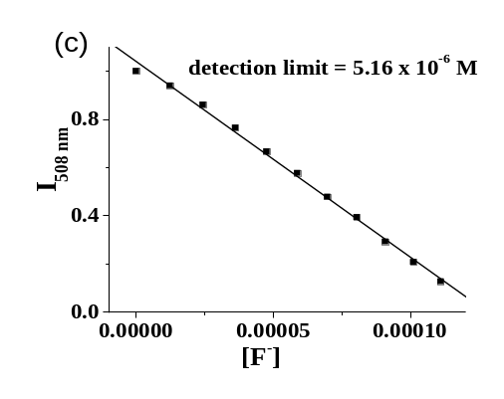
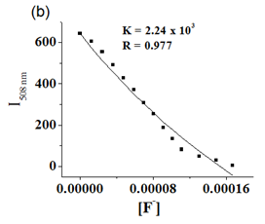
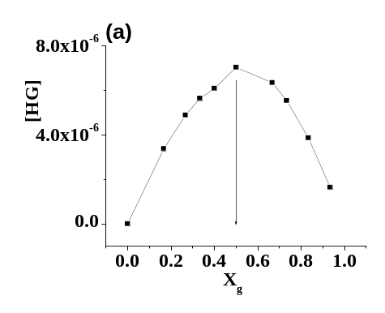

Fig. 25S. (a) UV-vis Job plot of 1 with F⁻ at 445 nm in CH₃CN containing 1% THF where [H] = [G] = 2.5 x 10⁻⁵ M; (b) Non linear fitting of the titration data for 1 (c = 2.5 x 10⁻⁵ M) with F⁻ (c = 1.0 x 10⁻³ M) at 508 nm in CH₃CN containing 1% THF and (c) Detection limit of 1 (c = 2.5 x 10⁻⁵ M) for F⁻ (c = 1.0 x 10⁻³ M) in CH₃CN containing 1% THF.

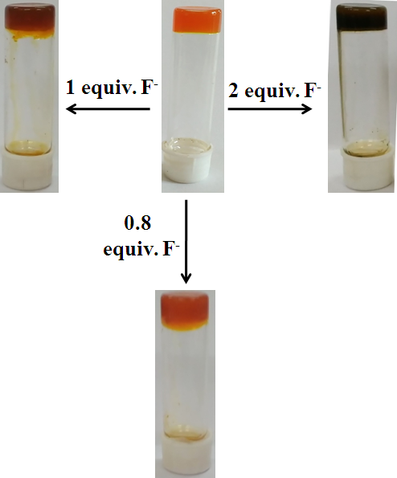

Fig. 26S. The color change of gel phase of 1 in toluene-1,4-dioxane (5:1 v/v) (c = 6 mg/mL) upon addition of different equiv. amounts of TBAF (c = 0.08 M).

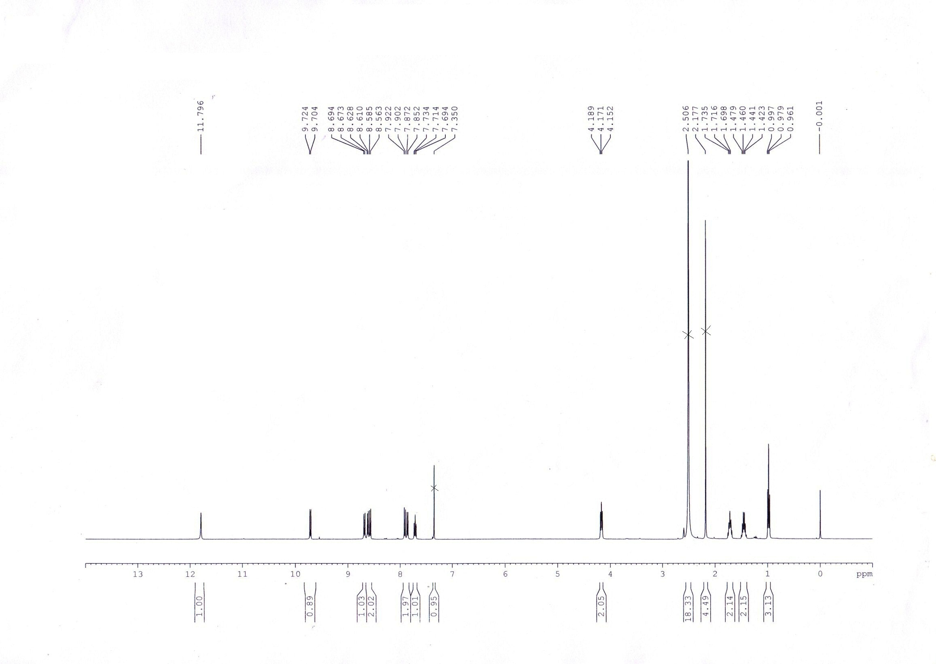
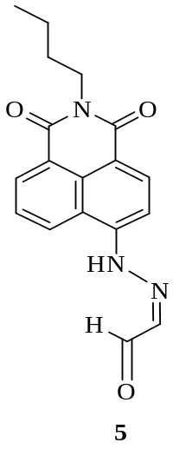

Fig. 27S. ¹H NMR (400 MHz) of compound 5 in CDCl₃ containing few drops of d₆-DMSO.

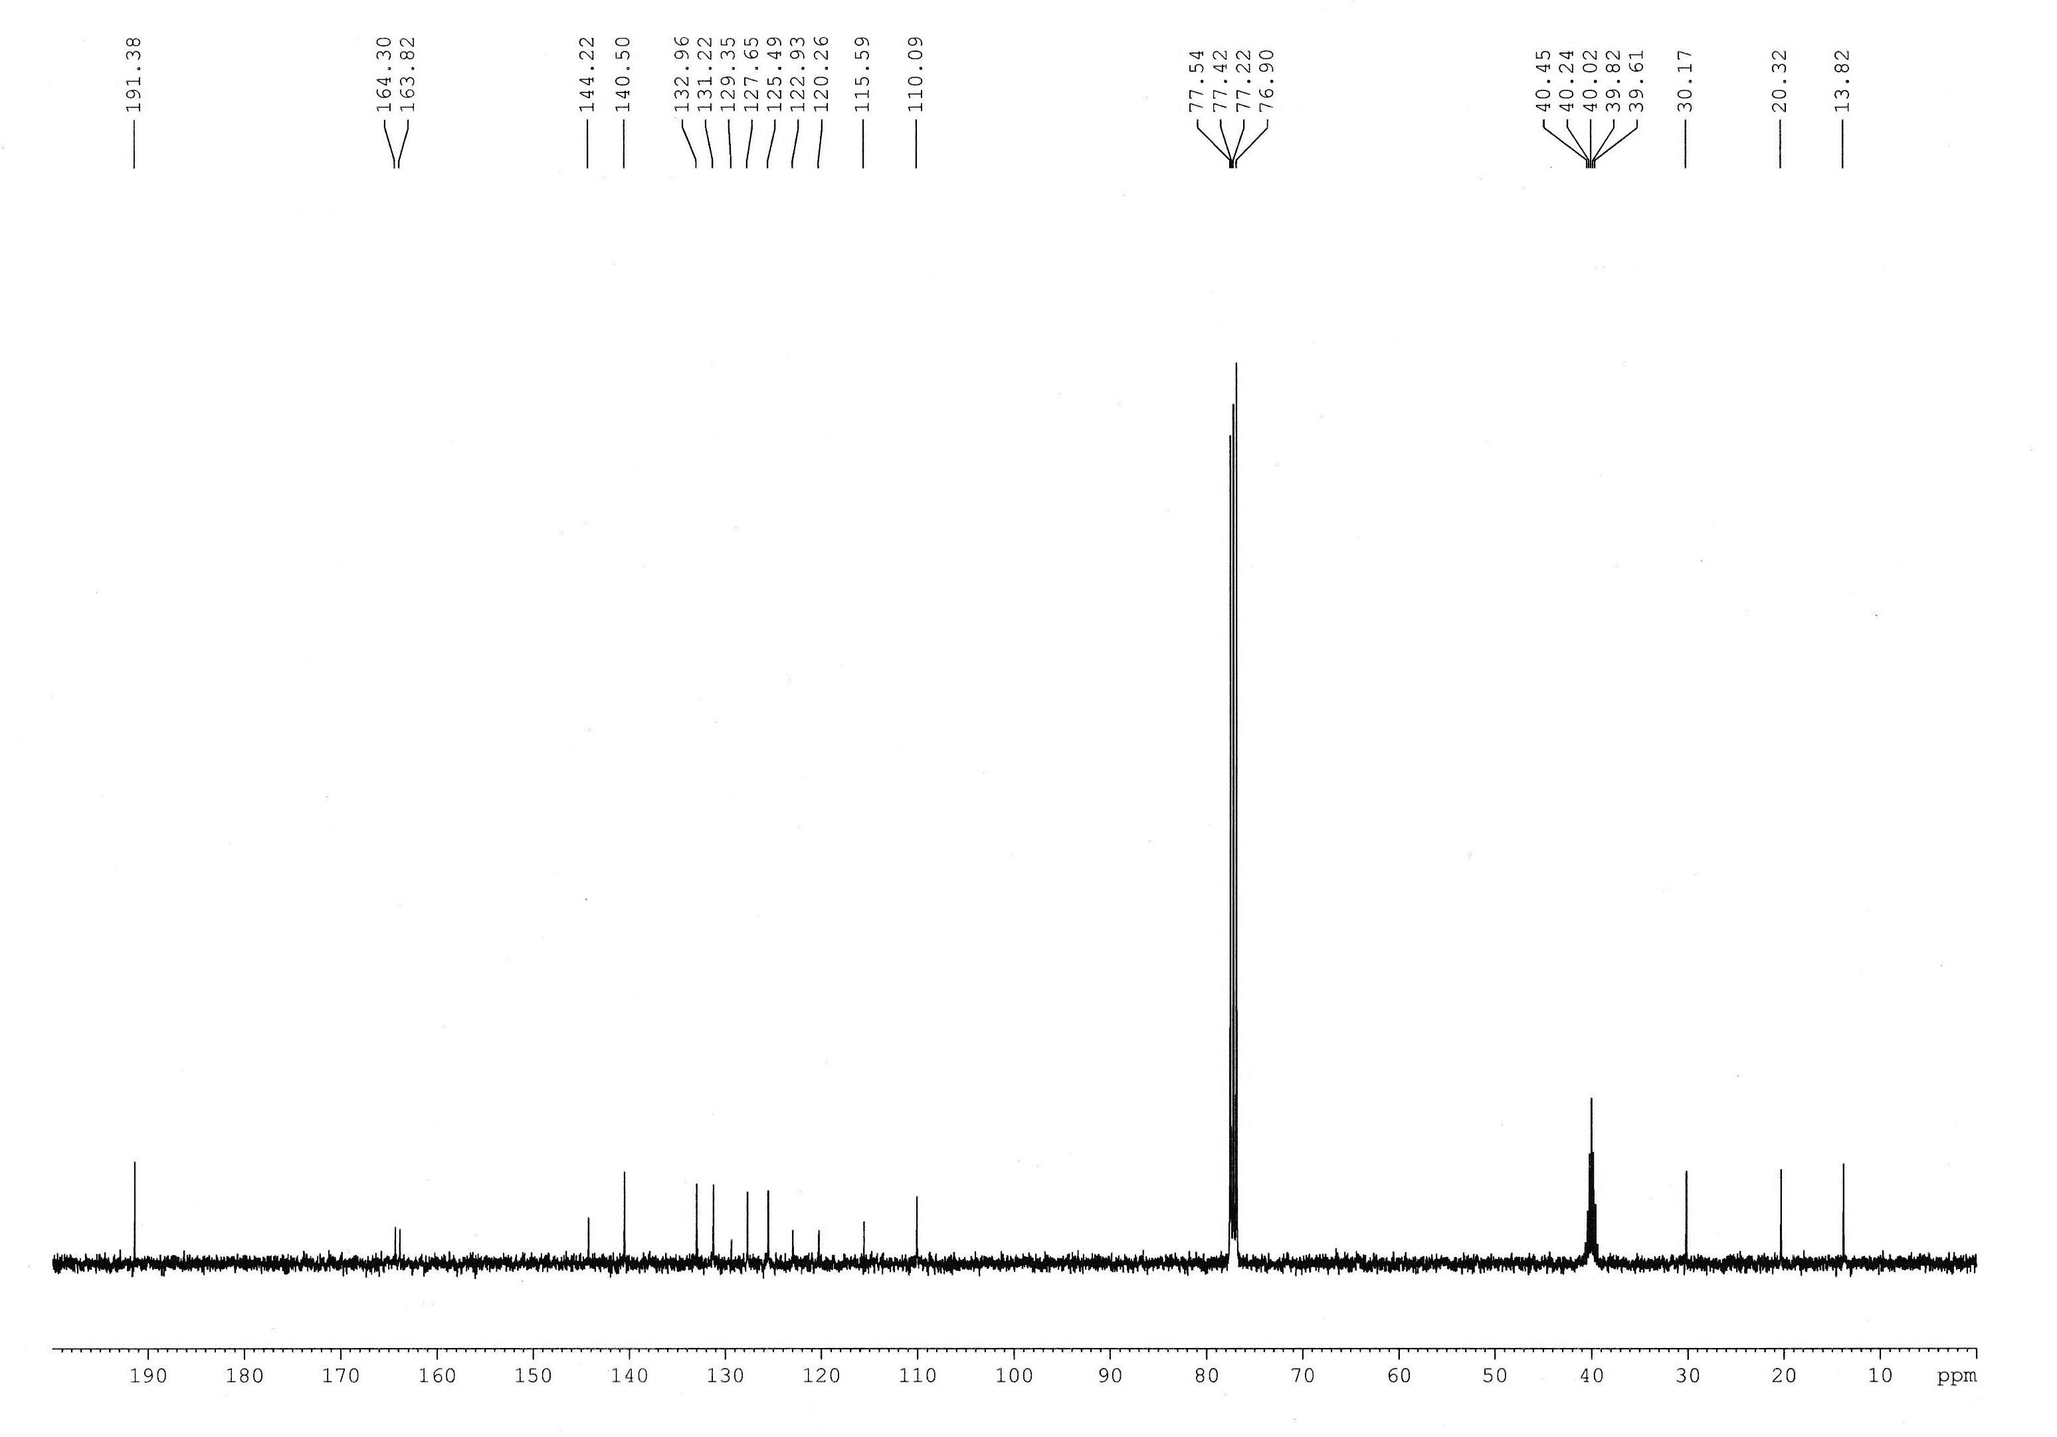

Fig. 28S. ¹³C NMR of 5 in CDCl₃ containing two drops of d₆-DMSO (100 MHz).

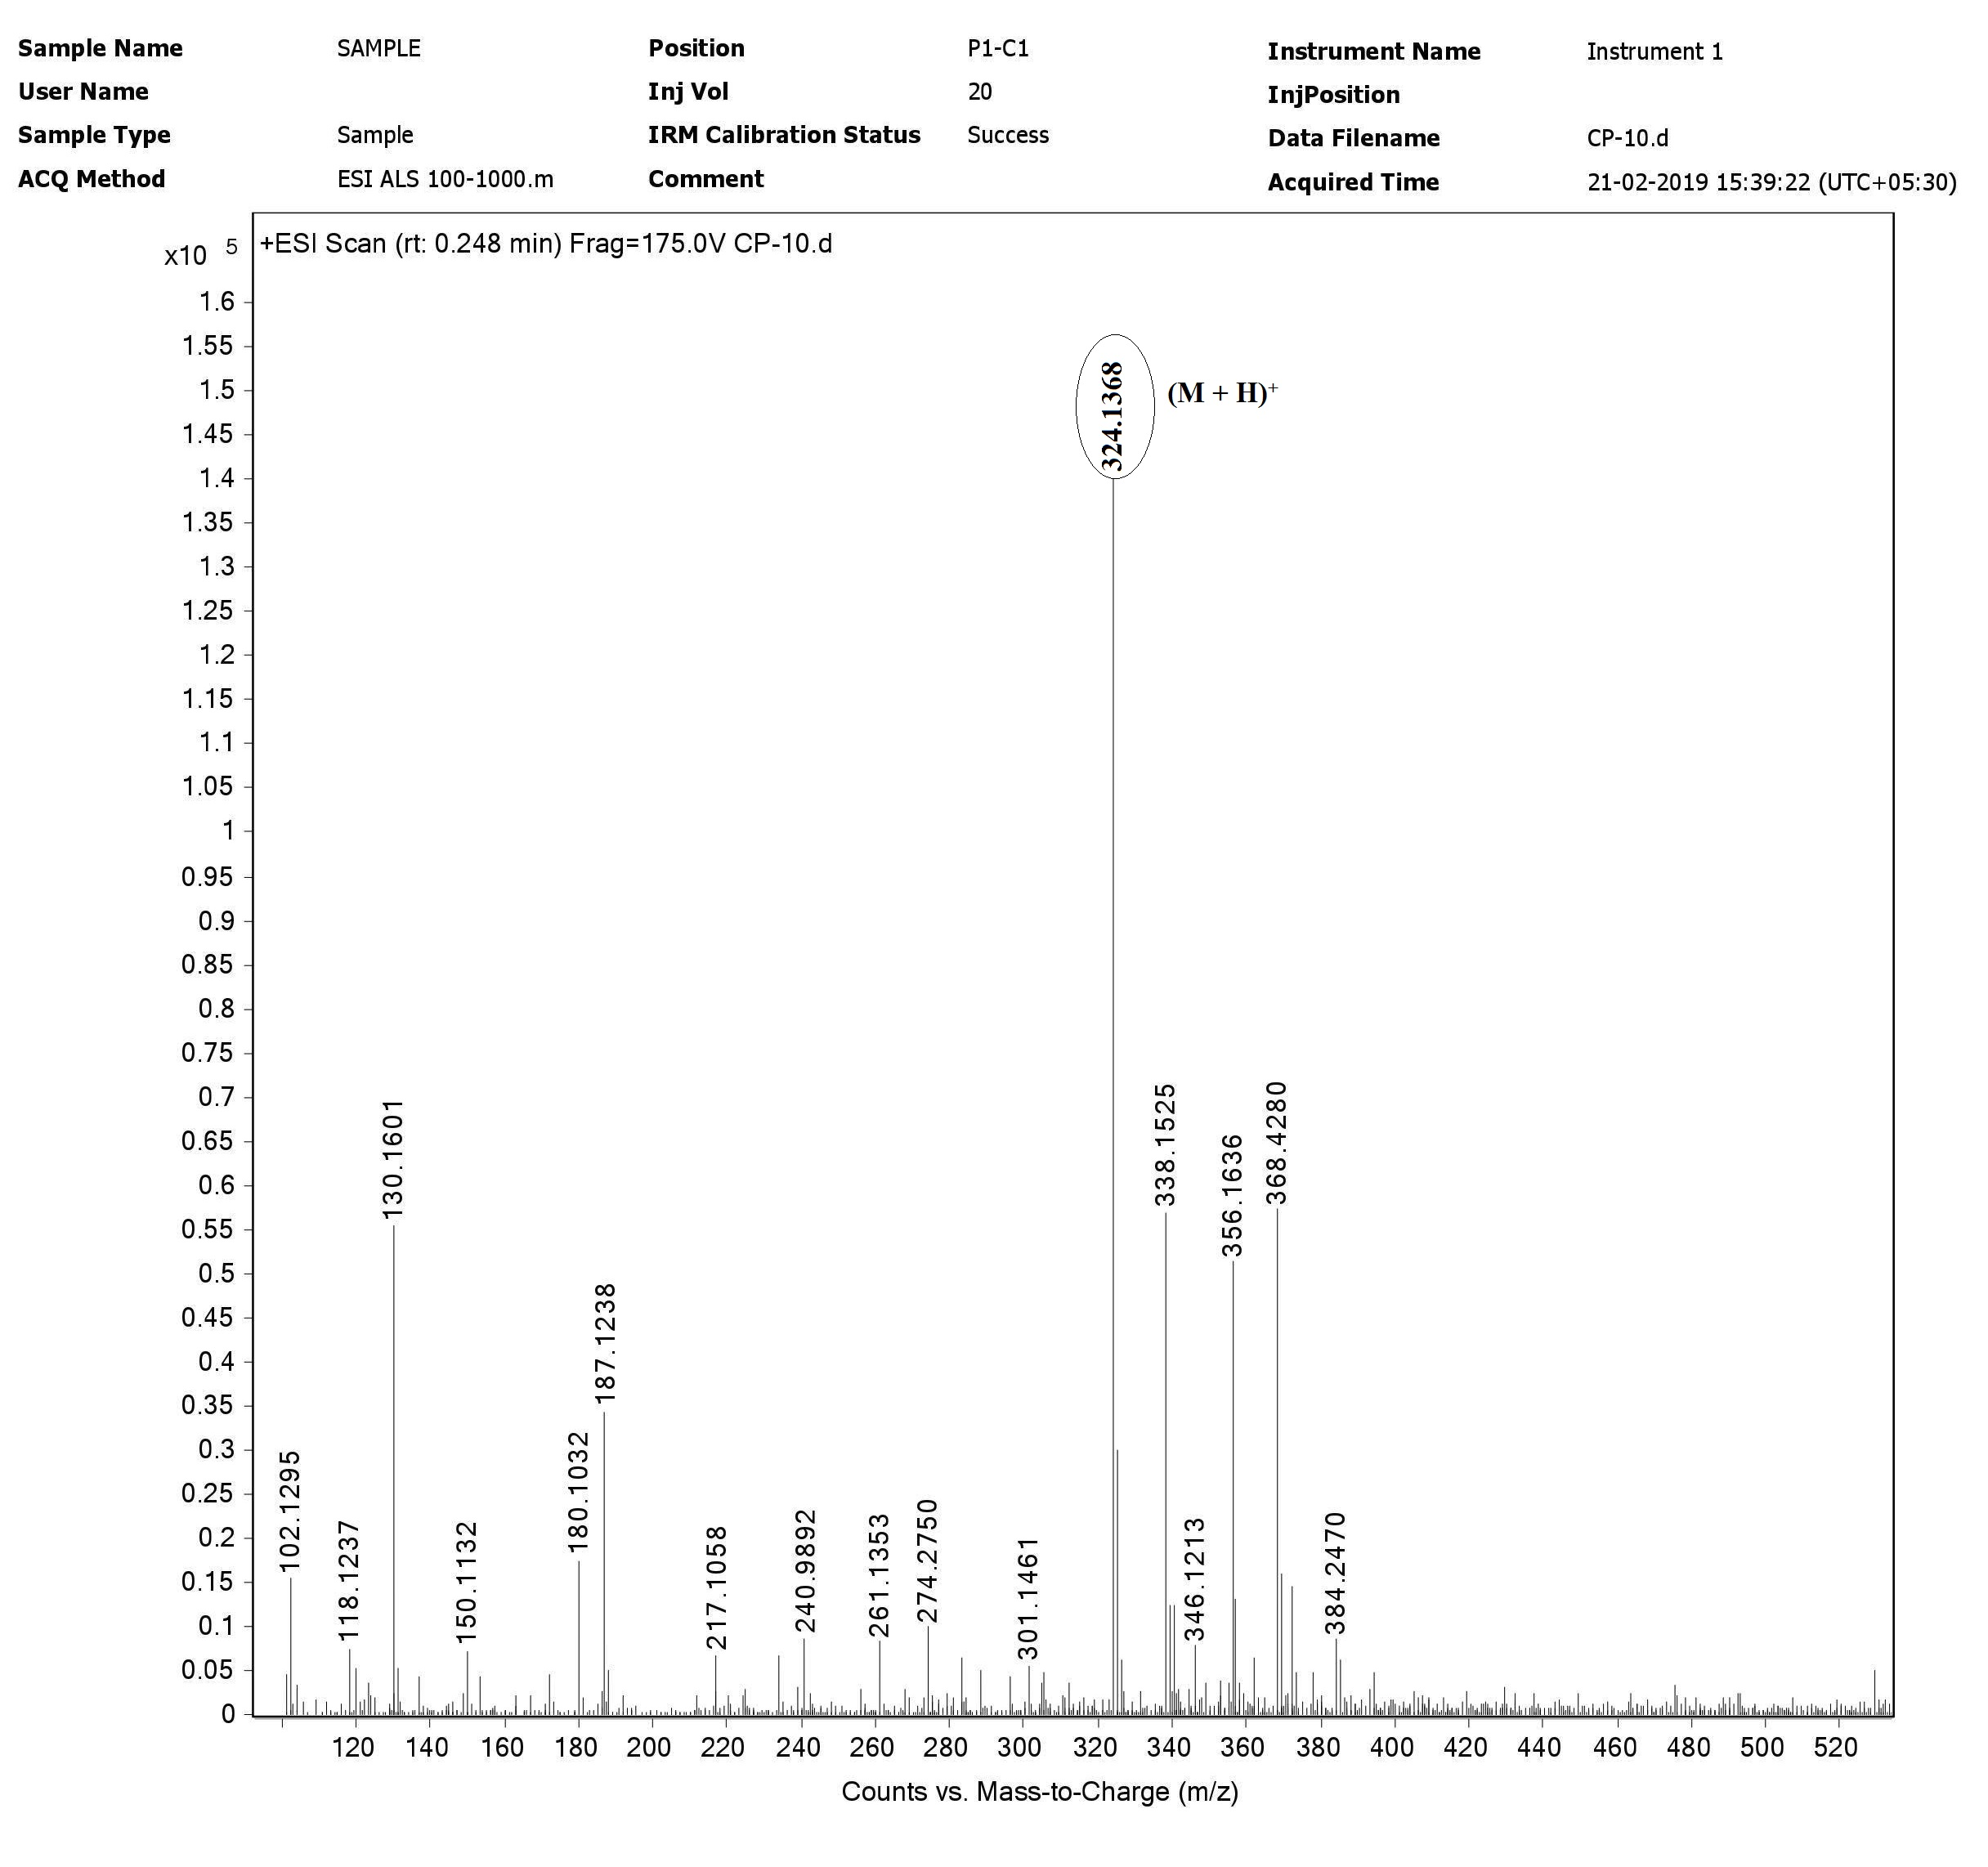
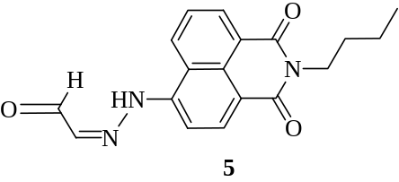

Fig. 29S. HRMS spectrum of 5.

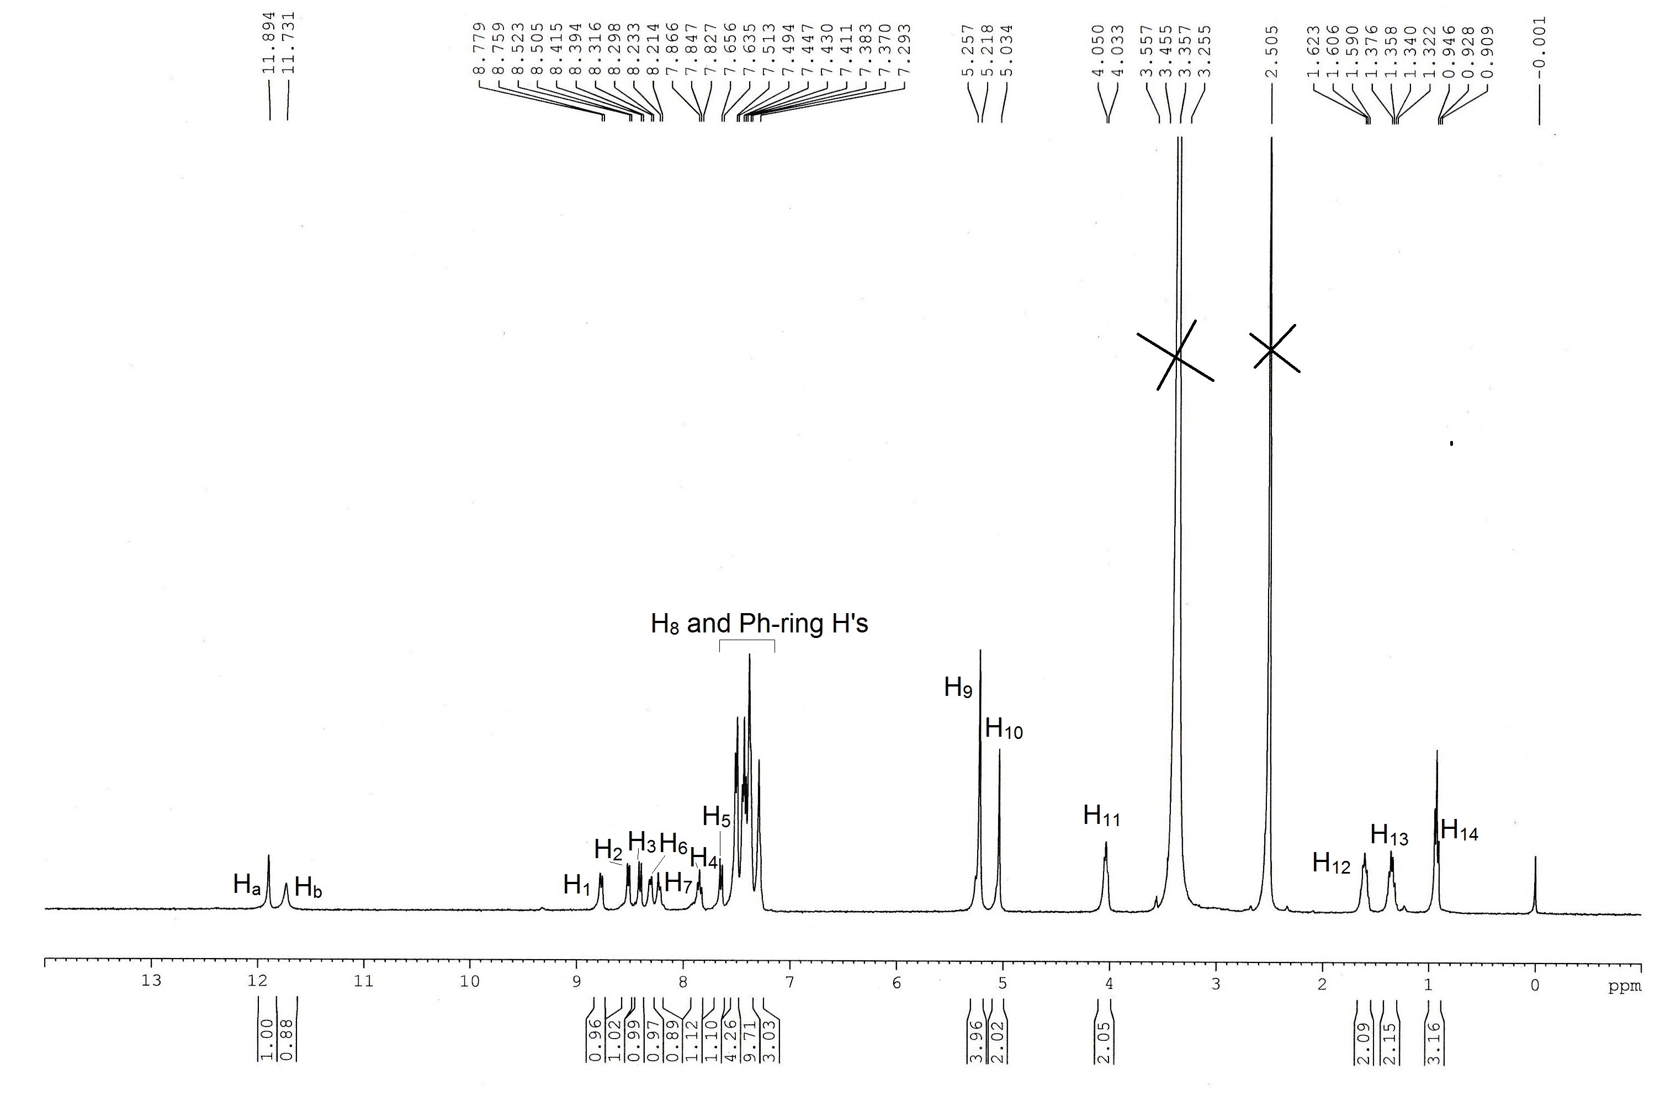
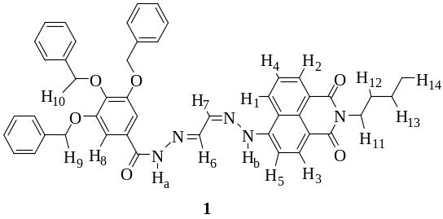

Fig. 30S. ¹H NMR (400 MHz) of compound 1 in d₆-DMSO.

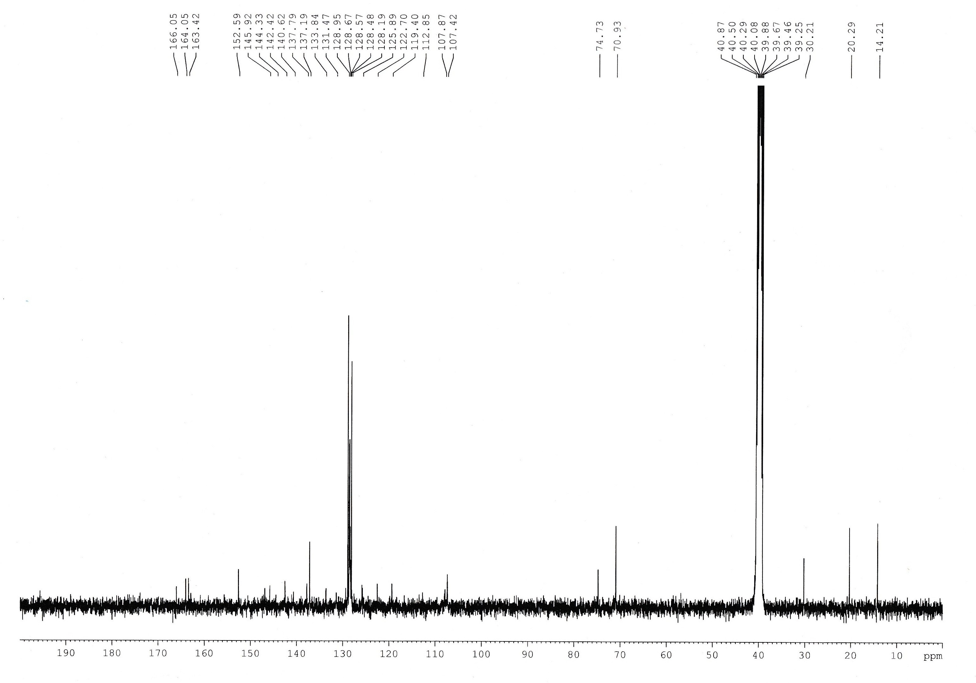
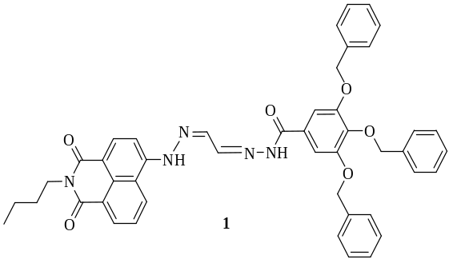

Fig. 31S. ¹³C NMR (100 MHz) of 1 in d₆-DMSO.

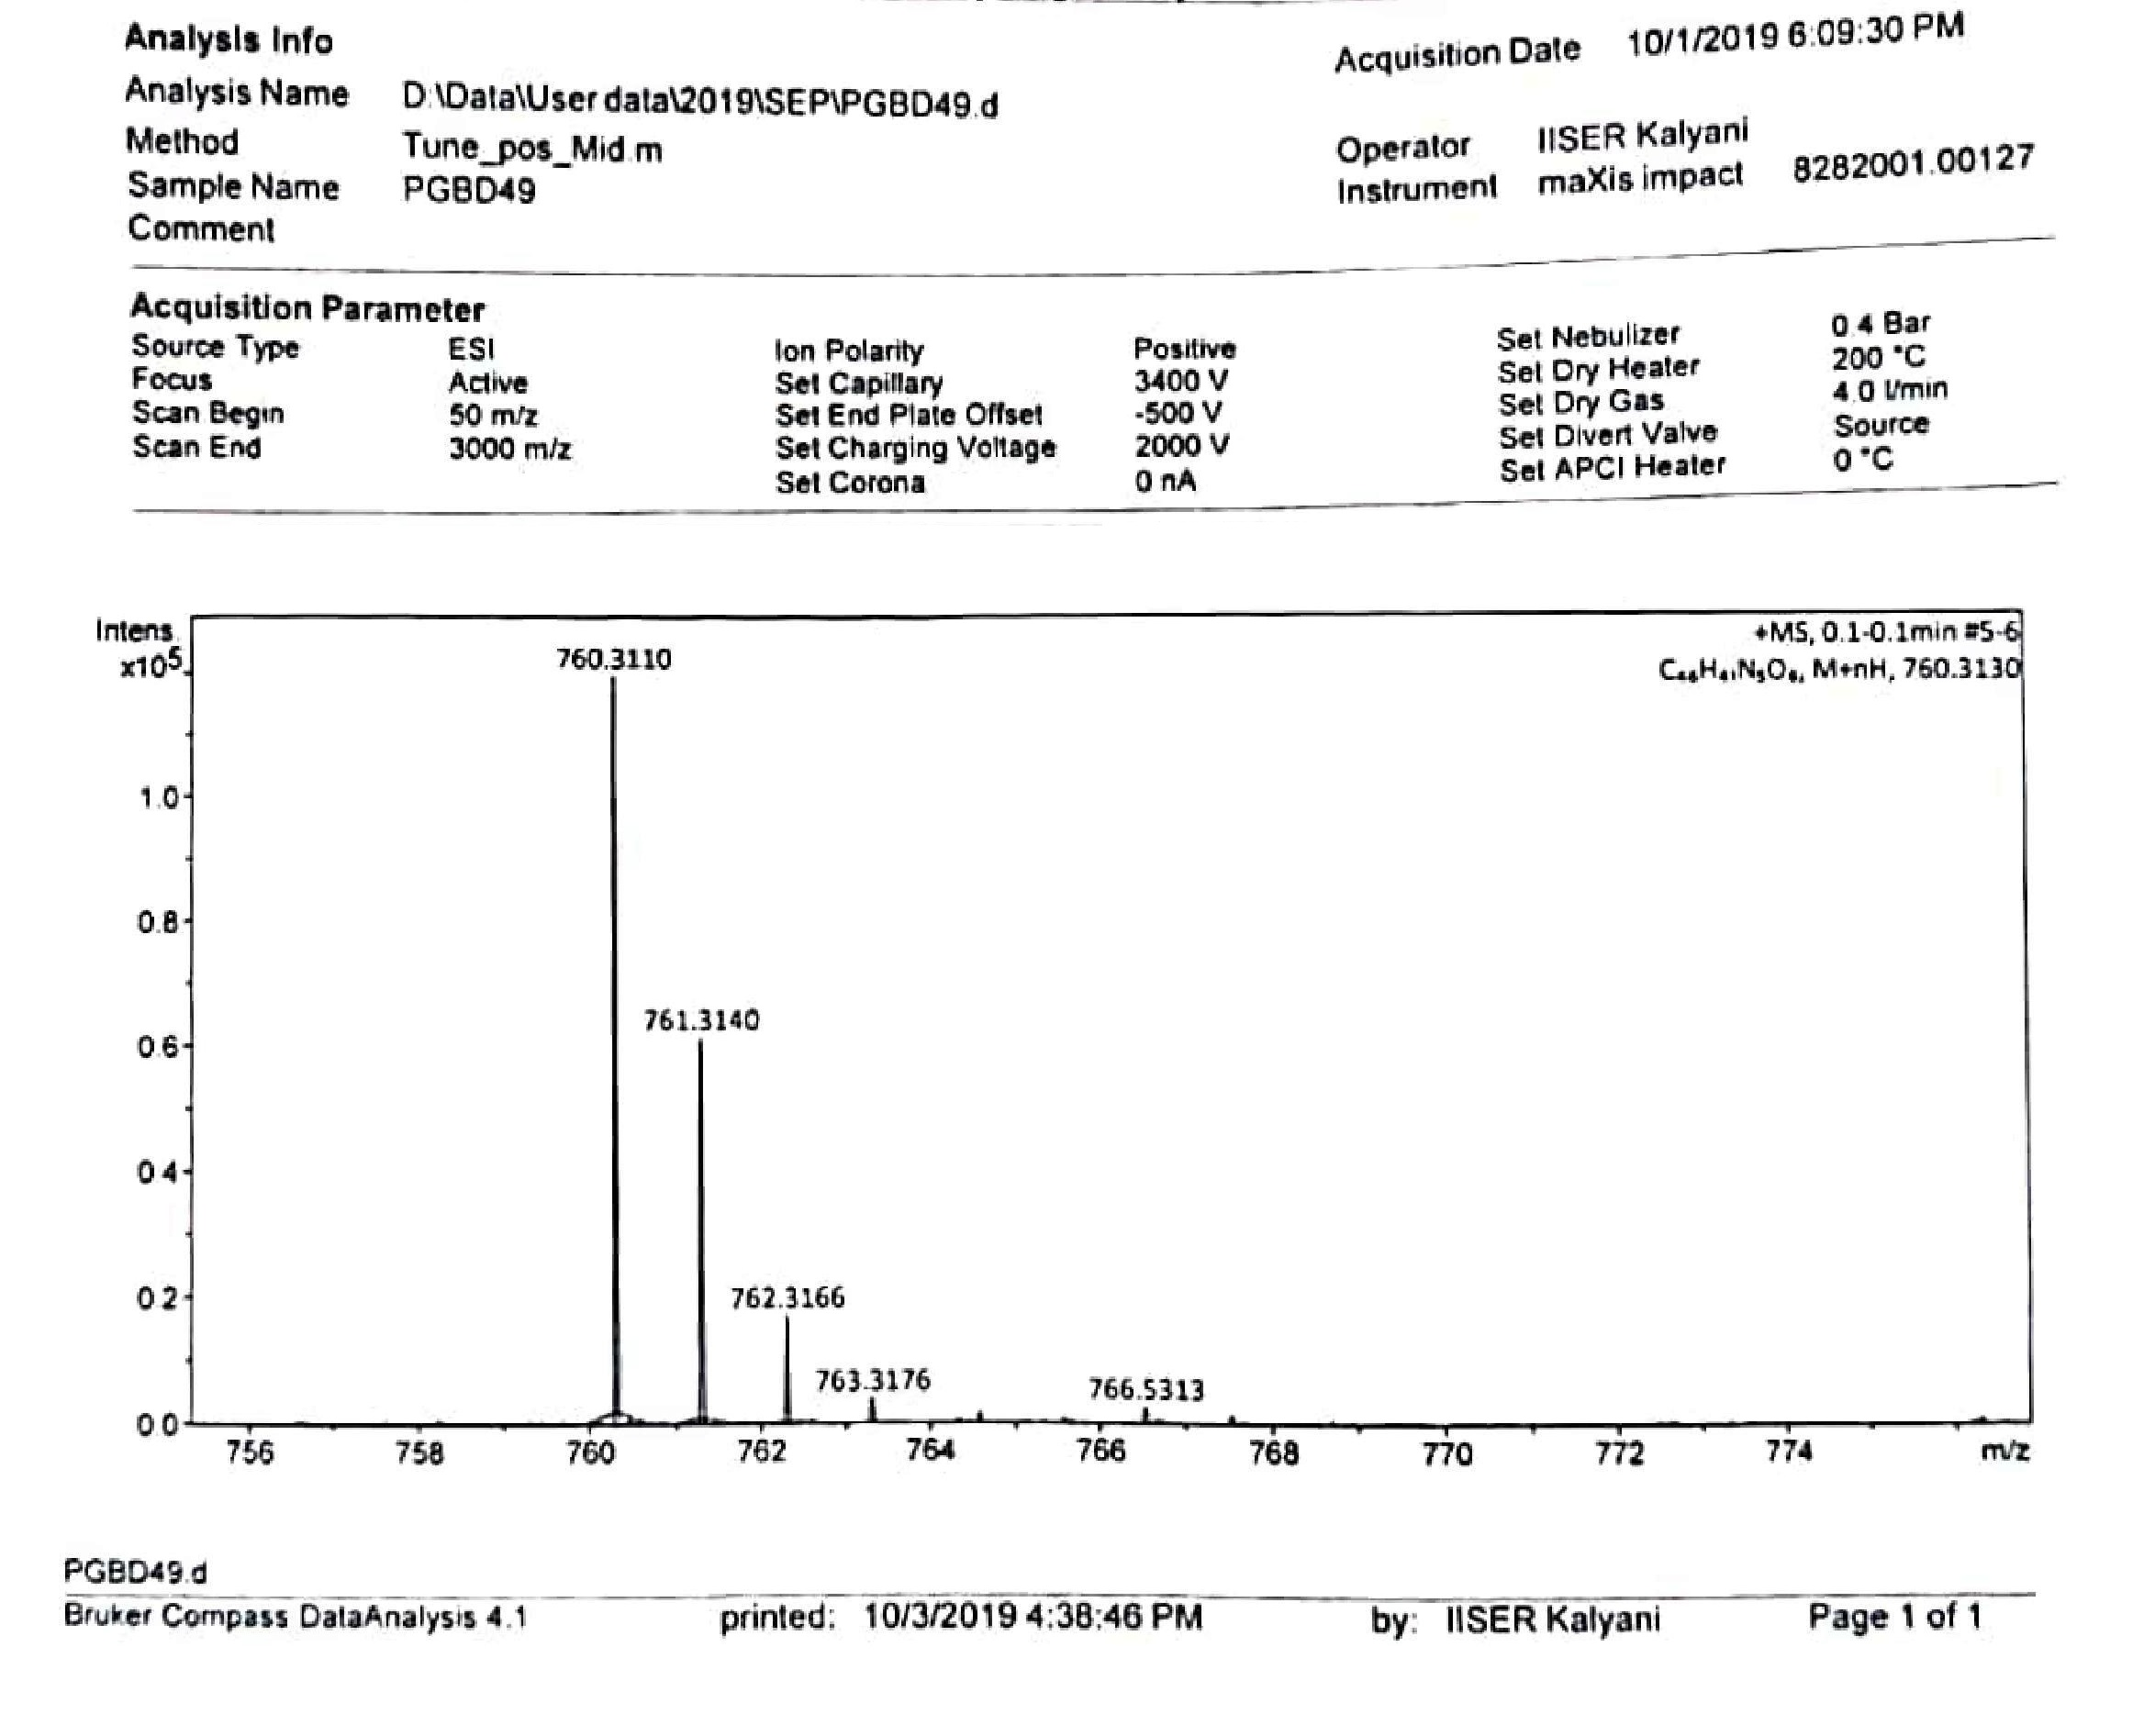
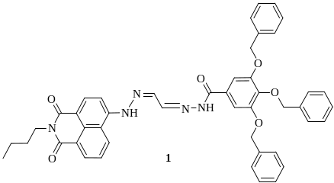
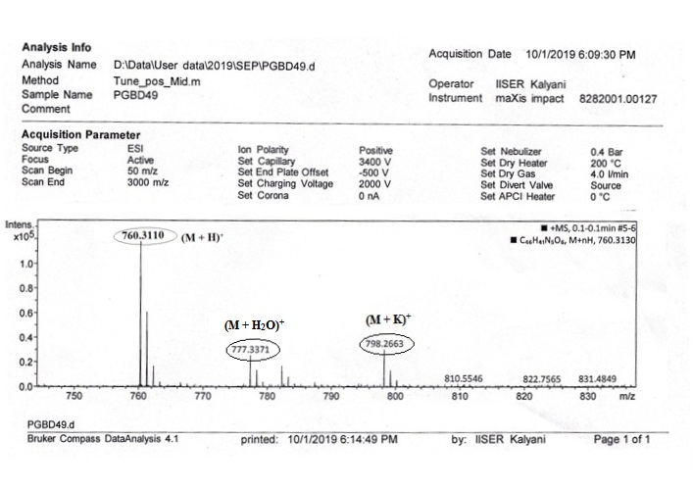

Fig. 32S. HRMS spectrum and isotopic mass distribution of compound 1.

