Platelet activation and neutrophil extracellular trap (NET) formation in immune thrombocytopenia: is there an association?
Maria L Lozano, et al

Supplementary material
Supplementary Table 1. Patients and controls clinical characteristics, and patient therapies.
Supplementary Table 2. Association between clinical parameters in patients and plasma nucleic acid levels.
Supplementary Table 3. Patients characteristics and percentage of P-selectin positive platelets according to cfDNA concentration (by ≤ or > percentile 75%)
Supplementary Figure 1. Flow cytometric representative histograms of platelet size (FSC), CD62, CD63 binding, and neutrophil CD11b expression of two ITP patients and one parallel control.
Supplementary Figure 2. Correlations between platelet count, size, activation, and neutrophil degranulation in ITP patients.

Supplementary Table 1. Patients and controls clinical characteristics, and patient therapies.

 | Patients (n=63) | Controls (n=30) | p
Age (median; range) | 49; 16-89 | 46; 20-78 | p=0.585
Women, n (%) | 37 (58.7%) | 12 (40%) | p=0.121
Chronic ITP, n (%) | 50 (79.4%) | Ø
Persistent ITP,n (%) | 6 (9.5%) | Ø
Newly diagnosed ITP, n (%) | 7 (11.1%) | Ø
Cardiovascular riskfactors
Smokers | 4 (6.3%) | 1 (3.3%) | 1.000
Hypertension | 20 (31.7%) | 3 (10.0%) | 0.045
Hypercholesterolemia | 20 (31.7%) | 5 (16.7%) | 0.219
Diabetes | 8 (12.7%) | Ø | 0.056
Previous arterial ischemic events
Myocardial infarction | 6 (9.5%) | Ø
Central retinal artery occlusion | 1 (1.6%) | Ø
Previoustherapies
Glucocorticoids, n (%) | 62 (98.4%) | Ø
IVIG, n (%) | 12 (19.0%) | Ø
Splenectomy, n (%) | 16 (25.4%) | Ø
Romiplostin, n (%) | 28 (44.4%) | Ø
Eltrombopag, n (%) | 17 (27.0%) | Ø
Immunosupresion, n (%)  Rituximab, n (%) | 6 (9.5%)  6 (9.5%) | Ø  Ø
Active treatments
Glucocorticoids, n (%) | 11 (17.5%) | Ø
TPO-RAs, n (%) | 27 (42.9%)  - 14 Romiplostin  - 13 Eltrombopag | Ø
Immunosupresion, n (%) | 1 (MMF) (1.6%) | Ø
No therapies, n (%) | 24 (38.1%) | Ø
Results are given as median; range, or as percentages. Abbreviations: IVIG, intravenous immunoglobulins; MMF, mycophenolatemofetil; TPO-RAs, thrombopoietin receptor agonist

Supplementary Table 2.Association between clinical parameters in patients and plasma nucleic acid levels.

 | cfDNA (g/ml) | CitH3-DNA (OD)
Age  - ≤45 years  - >45 years  - p | 0.146; 0.067-0.679  0.168; 0.041-0.588  0.041 | 0.163; 0.062-0.391  0.150; 0.092-0.444  0.696
Sex  - Female  - Male  - p | 0.146; 0.041-0.238  0.174; 0.072-0.679  0.029 | 0.160; 0.062-0.391  0.153; 0.103-0.444  0.973
Hypertension  - Yes  - No  - p | 0.168; 0.041-0.588  0.155; 0.080-0.679  0.116 | 0.145; 0.092-0.354  0.162; 0.062-0.444  0.307
Smoking  - Yes  - No  - p | 0.170; 0.072-0.588  0.155; 0.041-0.679  0.067 | 0.145; 0.092-0.366  0.166; 0.062-0.444  0.026
Hypercholesterolemia  - Yes  - No  - p | 0.170; 0.072-0.588  0.155; 0.041-0.679  0.106 | 0.145; 0.092-0.366  0.166; 0.062-0.444  0.380
Diabetes  - Yes  - No  - p | 0.194; 0.072-0.588  0.155; 0.041-0.679  0.133 | 0.132; 0.103-0.354  0.161; 0.062-0.444  0.224
Splenectomy  - Yes  - No  - p | 0.167; 0.107-0.216  0.155; 0.041-0.679  0.695 | 0.151; 0.083-0.225  0.158; 0.062-0.444  0.712
CurrentTPO-RA therapy  - Yes  - No  - p | 0.155; 0.041-0.588  0.157; 0.067-0.679  0.833 | 0.154; 0.062-0.444  0.161; 0.083-0.391  0.678
Currenttherapy  - Yes  - No  - p | 0.155; 0.041-0.588  0.163; 0.067-0.679  0.881 | 0.158; 0.062-0.444  0.150; 0.083-0.366  0.761
Phase of disease  - Chronic  - Non chronic  - p | 0.159; 0.041-0.679  0.147; 0.080-0.255  0.624 | 0.156; 0.062-0.444  0.160; 0.092-0.230  0.817
Results are given as median; range. Abbreviations: cfDNA, cell free DNA; OD, optical density; TPO-RA, thrombopoietin receptor agonists

Supplementary Table 3. Patients characteristics and percentage of P-selectin positive platelets according to cfDNA concentration (by ≤ or > 75th percentile)

 | > 75th Percentile (n=14) | ≤ 75th Percentile (n=49) | p
Age > 50 years, n (%) | 10 (71.4%) | 20 (40.8%) | 0.043
Hypertension, n (%) | 7 (50.0%) | 13 (26.5%) | 0.096
Hypercholesterolemia, n (%) | 8 (57.1%) | 12 (24.5%) | 0.031
Diabetes, n (%) | 4 (28.6%) | 4 (8.2%) | 0.043
Previous ischemic event, n (%) | 4 (28.6%) | 3 (6.1%) | 0.020
CD62+ (% platelets), median; range | 22.4; 6.6-54.7 | 15.1; 5.2-57.9 | 0.086
Results are given as median; range, or as percentages

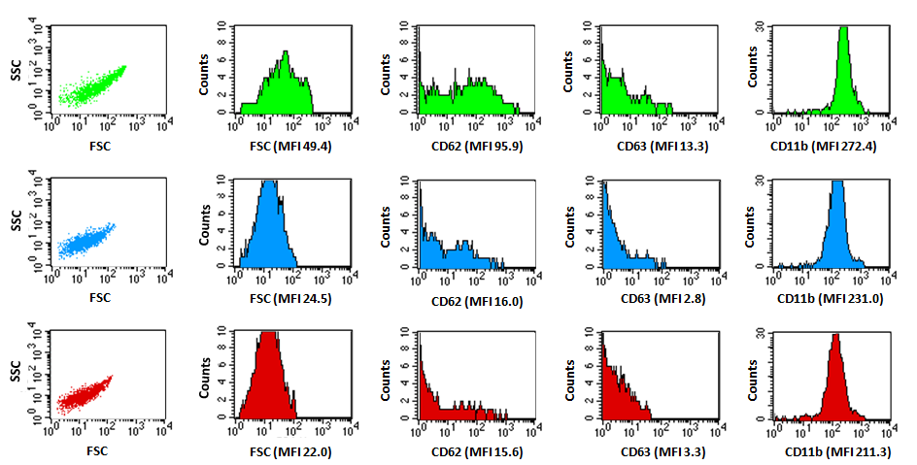
Supplementary Figure 1. Flow cytometric representative histograms of platelet size (FSC), CD62, CD63 binding, and neutrophil CD11b expression of two ITP patients and one parallel control. Below each dot plot mean fluorescence intensity (MFI) values are presented. The green panels illustrate the flow cytometry plots from a 34 yr old female patient under Romiplostim with thrombocytopenia (platelet count 31x10⁹/l; cfDNA 0.133 μg/ml, H3Cit-DNA OD 0.062). The blue panels show the flow cytometry plots from a 57 yr old male patient under Romiplostim without thrombocytopenia (platelet count 298x10⁹/l; cfDNA 0.168 μg/ml, H3Cit-DNA OD 0.290). The red panels illustrate the flow cytometry plots from a 35 yr old female healthy control (platelet count 217x10⁹/l; cfDNA 0.067μg/ml, H3Cit-DNA OD 0.113).
FSC-H

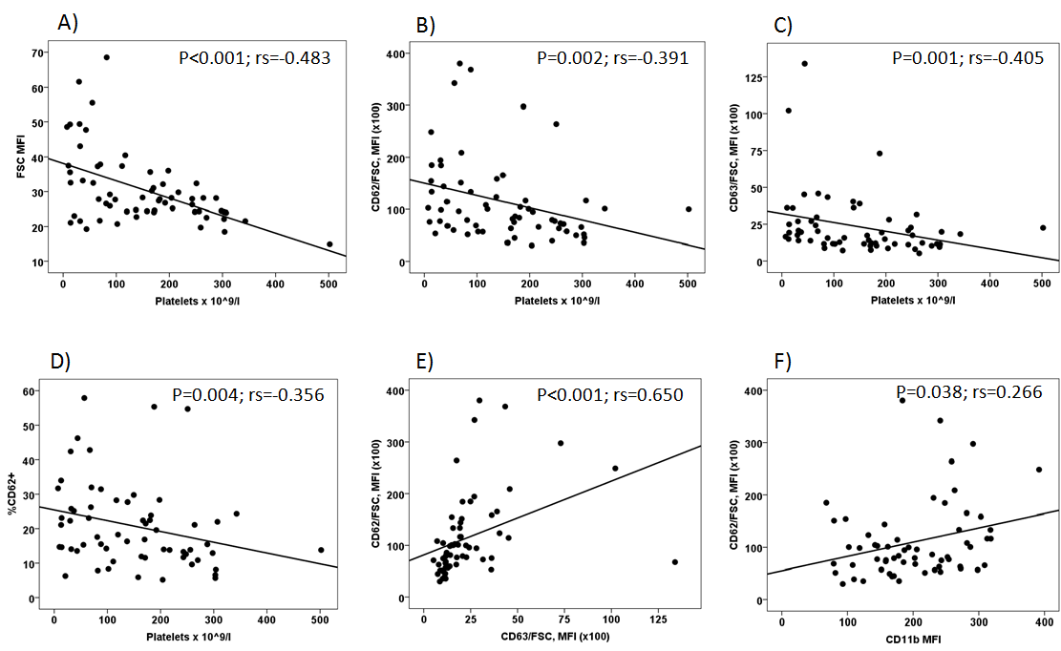
Supplementary Figure 2. Correlations between platelet count, size, activation, and neutrophil degranulation in ITP patients. (A) Correlation between platelet counts and size; (B) correlation between platelet count and CD62 antigen density; (C) correlation between platelet count and CD63 expression; (D) correlation between platelet count and percentage of platelets expressing P-selectin; (E) correlation between platelet alpha granule (CD62) and dense/lysosomal granule (CD63) release; (F) correlation between platelet (CD62) and neutrophil (CD11b) activation. rs values represent Spearman's rank correlation coefficients.

