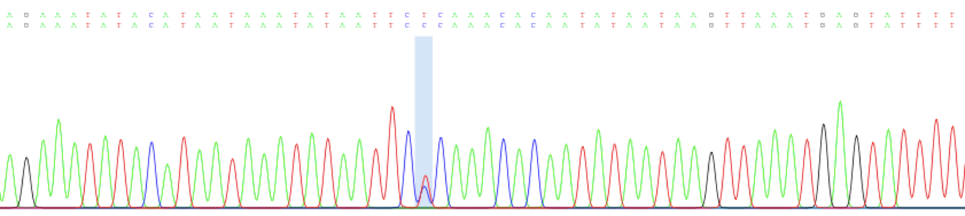
Supplemental materials
Supplementary Figure 1: Chromatogram of partial mtCR sequence of MPk29 presenting a clear double peak at position 331 of the reference mtCR. The blue band highlighted on this double peak indicated the intra-sample variant called by the Poly Peak Parser [1] with the signal ratio cutoff at 0.33.

Supplementary Table 1: Summary statistics of the assembled partial 5kb mitogenome
Sample | Number of paired-end readsª |  |  |  | Average sequencing depth
 | After quality control | Mapped to the reference^{b} | Retained after Deduplication^{b} | Retained after Filtering^{b}
MPk15 | 1,732,080 | 1,110,795 | 719,316 | 697,775 | 9,405.19
EPk15 | 1,689,562 | 1,309,156 | 845,532 | 834,491 | 11,635.10
MPk28 | 1,986,746 | 1,420,300 | 908,931 | 870,940 | 11,719.37
EPk28 | 1,451,262 | 644,755 | 448,185 | 440,951 | 6,120.60
MPk29 | 2,121,238 | 1,645,209 | 554,664 | 513,890 | 7,382.55
EPk29_1 | 7,971,184 | 3,042,463 | 1,143,980 | 970,089 | 14,293.89
EPk29_2 | 8,181,462 | 3,795,905 | 1,418,271 | 1,242,741 | 18,501.28

a: Number of reads taken both ends into account
b: Number of mapped reads calculated by flagstat in samtools [2]

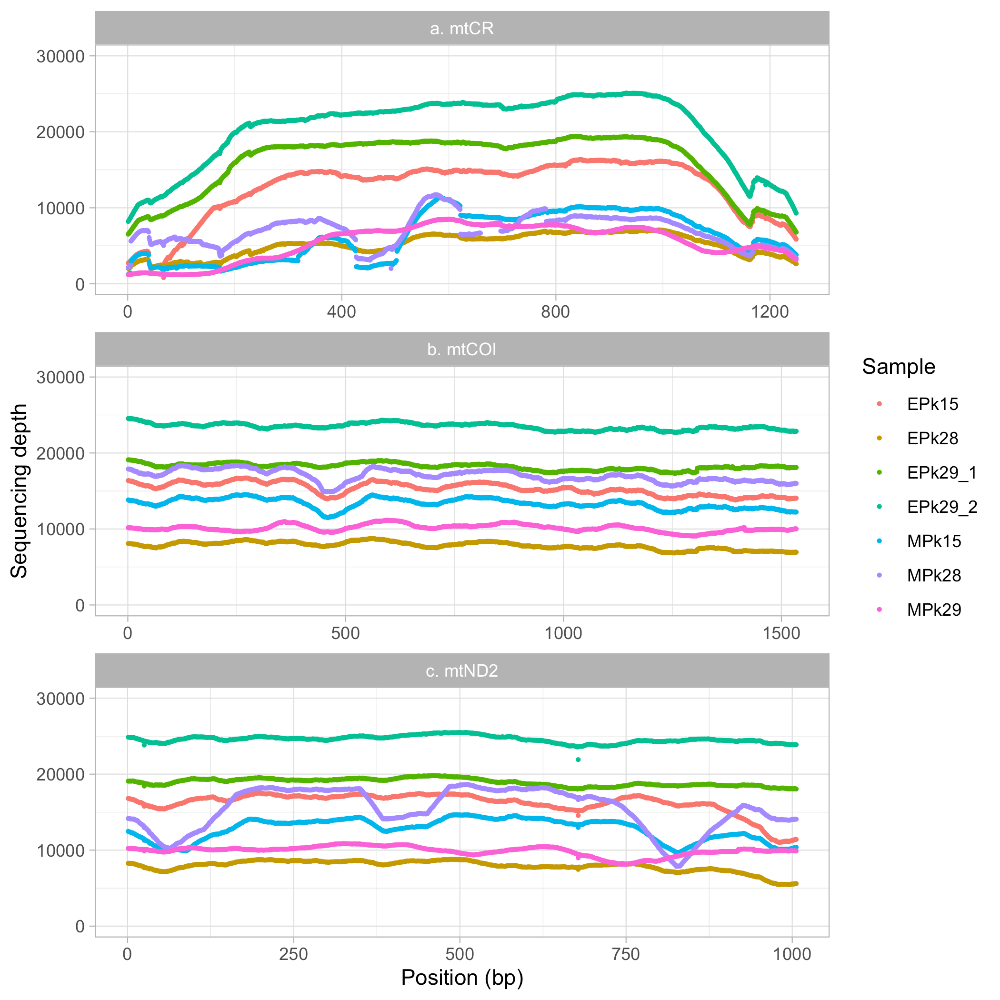
Supplementary Figure 2: Distribution of sequencing depth supporting mtCR (a), mtCOI (b) and mtND2 (c) of seven P. pelagicus samples: EPk15, EPk28, EPk29_1, EPk29_2, MPk15, MPk28 and MPk29.

Supplementary Table 2: The statistical results carried out on the differences in the heteroplasmy levels between offspring and their corresponding mothers (O-M). The O-M values were separated into sub-datasets based on the type of mutation, mtDNA region and maternal relationship.
Sample | N | Median(Mean) | H₀: Mean(O-M) = 0 |  | Kolmogorov-Smirnov testª | Multiple comparison^{b}
 |  |  | Student’s  t test | Wilcoxon test |  | ANOVA | Kruskal-Wallis test
Segregating heteroplasmic variants
All | 48 | -0.116  (0.029) | 0.579 | 0.883 | < 0.001*** | NA | NA
Type of mutation
Noncoding | 7 | 0.666  (0.488) | 0.017* | 0.078 | 0.709 | < 0.001*** | < 0.001***
Silence | 38 | -0.128  (-0.059) | 0.219 | 0.153 | < 0.001***
Replacement | 3 | -0.093  (0.066) | 0.726 | 1.000 | 0.653
mtDNA region
mtCR | 7 | 0.666  (0.488) | 0.017* | 0.078 | 0.709 | < 0.001*** | 0.001**
mtCOI | 22 | -0.128  (-0.037) | 0.549 | 0.353 | 0.002**
mtND2 | 19 | -0.117  (-0.064) | 0.359 | 0.332 | 0.026*
Maternal relationship
EPk15 | NA | NA | NA | NA | NA | NA | NA
EPk28 | 25 | 0.393  (0.163) | 0.088 | 0.016* | 0.115 | 0.021* | 0.485
EPk29_1 | 4 | -0.132  (-0.112) | 0.015* | 0.125 | 0.450
EPk29_2 | 19 | -0.117  (-0.118) | < 0.001*** | < 0.001*** | 0.748
Non-segregating heteroplasmic variants
All | 85 | -0.067  (0.015) | 0.705 | < 0.001*** | < 0.001*** | NA | NA
Type of mutation
Noncoding | 26 | -0.011  (0.350) | 0.001** | 0.075 | 0.012* | < 0.001*** | < 0.001***
Silence | 55 | -0.127  (-0.134) | < 0.001*** | < 0.001*** | 0.291
Replacement | 4 | -0.084  (-0.114) | 0.120 | 0.125 | 0.924
mtDNA region
mtCR | 26 | -0.011  (0.350) | 0.001** | 0.075 | 0.012* | < 0.001*** | < 0.001***
mtCOI | 26 | -0.146  (-0.163) | < 0.001*** | < 0.001*** | 0.191
mtND2 | 33 | -0.082  (-0.109) | < 0.001*** | < 0.001*** | 0.123
Maternal relationship
EPk15 | 32 | -0.206  (-0.025) | 0.743 | 0.032* | 0.001** | 0.001** | < 0.001***
EPk28 | 18 | -0.015  (0.290) | 0.010* | 0.417 | 0.009**
EPk29_1 | 25 | -0.120  (-0.103) | < 0.001*** | < 0.001*** | 0.341
EPk29_2 | 10 | -0.062  (-0.059) | < 0.001*** | 0.002** | 0.999
All inherited heteroplasmic variants
All | 133 | -0.095  (0.020) | 0.523 | 0.003** | < 0.001*** | NA | NA
Type of mutation
Noncoding | 33 | 0.472 (0.379) | < 0.001*** | 0.009** | 0.009** | < 0.001*** | < 0.001***
Silence | 93 | -0.128  (-0.103) | < 0.001*** | < 0.001*** | < 0.001***
Replacement | 7 | -0.093  (-0.037) | 0.650 | 0.297 | 0.340
mtDNA region
mtCR | 33 | 0.472 (0.379) | < 0.001*** | 0.009** | 0.009** | < 0.001*** | < 0.001***
mtCOI | 48 | -0.130  (-0.105) | 0.001** | < 0.001*** | 0.001**
mtND2 | 52 | -0.100 (-0.093) | 0.001** | < 0.001*** | 0.001**
Maternal relationship
EPk15 | 32 | -0.206  (-0.025) | 0.743 | 0.032* | 0.001** | < 0.001*** | < 0.001***
EPk28 | 43 | -0.015  (0.216) | 0.003** | 0.010* | 0.038*
EPk29_1 | 29 | -0.124  (-0.104) | < 0.001*** | < 0.001*** | 0.161
EPk29_2 | 29 | -0.107  (-0.097) | < 0.001*** | < 0.001*** | 0.389

a: Kolmogorov-Smirnov test was applied to test whether the distribution of O-M was normal.
b: ANOVA and Kruskal-Wallis test were applied to compare mean of normally distributed datasets and median of non-normally distributed datasets, respectively.
*: p-value is less than 0.05. **: p-value is less than 0.01. ***: p-value is less than 0.001.
NA: Not applicable

Supplementary Table 3: The multiple pairwise comparison p-values of O-M calculated from segregating and non-segregating variants categorized by type of mutation. The p-values computed by Wilcoxon rank sum test (the Kruskal-Wallis post-hoc test) of segregating and non-segregating variants were shown above and below the diagonal line, respectively.
 | Noncoding | Silence | Replacement
Noncoding |  | 0.001** | 0.205
Silence | < 0.001*** |  | 0.311
Replacement | 0.048* | 1.000

*: p-value is less than 0.05. **: p-value is less than 0.01. ***: p-value is less than 0.001.

Supplementary Table 4: The multiple pairwise comparison p-values of O-M calculated from combined segregating and non-segregating variants categorized by type of mutation. The p-values computed by the Turkey (the ANOVA post-hoc test) and Wilcoxon rank sum test (the Kruskal-Wallis post-hoc test) were shown above and below the diagonal line, respectively.
 | Noncoding | Silence | Replacement
Noncoding |  | < 0.001*** | 0.002**
Silence | < 0.001*** |  | 0.829
Replacement | 0.013* | 0.361

*: p-value is less than 0.05. **: p-value is less than 0.01. ***: p-value is less than 0.001.

Supplementary Table 5: The multiple pairwise comparison p-values of O-M calculated from segregating and non-segregating variants categorized by mtDNA region. The p-values computed by the Wilcoxon rank sum test (the Kruskal-Wallis post-hoc test) for segregating and non-segregating variants were shown above and below the diagonal line, respectively.
 | mtCR | mtCOI | mtND2
mtCR |  | 0.002** | 0.004**
mtCOI | < 0.001*** |  | 1.000
mtND2 | < 0.001*** | 0.076

*: p-value is less than 0.05. **: p-value is less than 0.01. ***: p-value is less than 0.001.

Supplementary Table 6: The multiple pairwise comparison p-values of O-M calculated from combined segregating and non-segregating variants categorized by mtDNA region. The p-values computed by the Turkey (the ANOVA post-hoc test) and Wilcoxon rank sum test (the Kruskal-Wallis post-hoc test) were shown above and below the diagonal line, respectively.
 | mtCR | mtCOI | mtND2
mtCR |  | < 0.001*** | < 0.001***
mtCOI | < 0.001*** |  | 0.976
mtND2 | < 0.001*** | 0.240

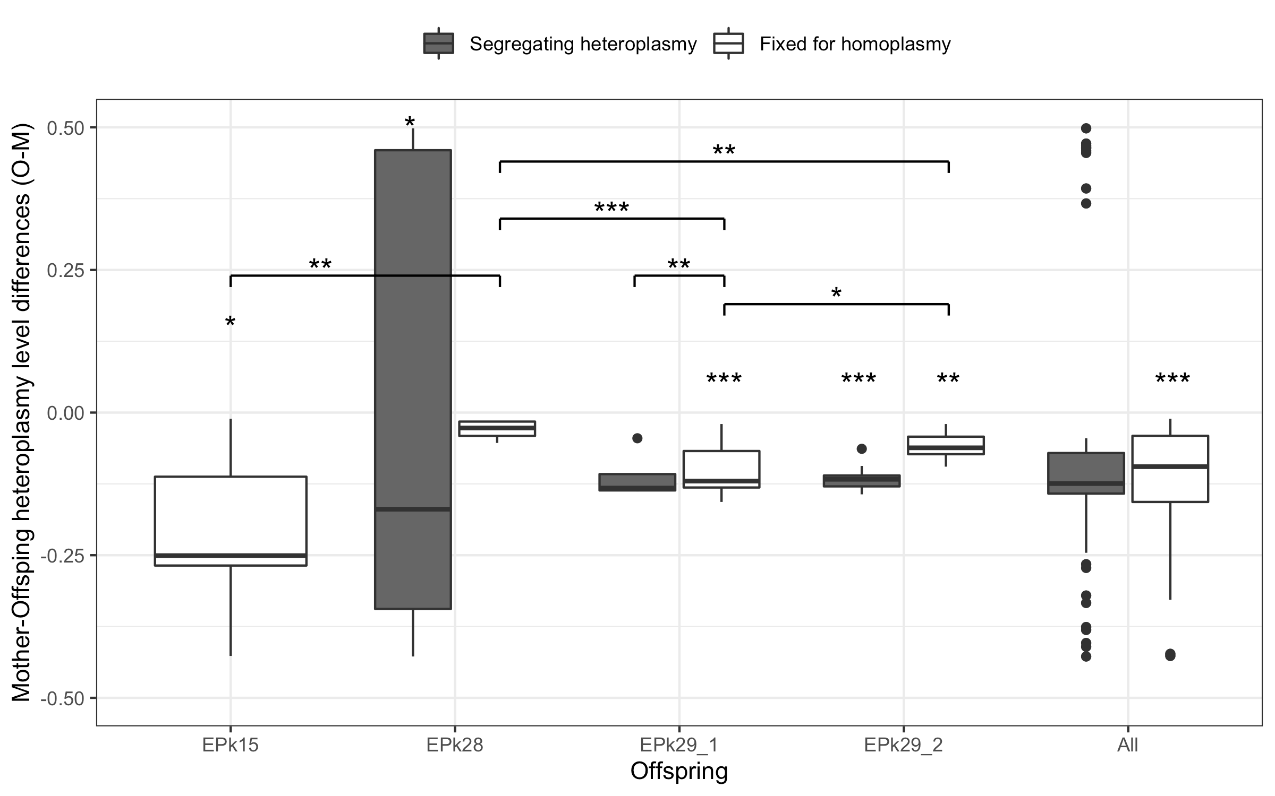
Supplementary Figure 3: The distribution of the differences in heteroplasmy levels between offspring and their corresponding mothers (O-M) of segregating and non-segregating variants. The O-M values were further separated into groups based on the familial relationship. The height of each box represents the inter-quartile range (IQR). The upper and lower whiskers extend 1.5 IQR from the 75th and 25th percentiles, respectively. The line at the middle of the box represents the median value. The stars presented above the box represent that the median of O-M values was significantly different from zero, which *, ** and *** represent p-values of the Wilcoxon test that are less than 0.05, 0.01, and 0.001, respectively. The significant difference of the median O-M between datasets that were computed by the Wilcoxon rank sum test was also shown using the same symbol.

Supplementary Table 7: The multiple pairwise comparison p-values of O-M calculated from segregating and non-segregating variants categorized by maternal relationship. The p-values computed by the Wilcoxon rank sum test (the Kruskal-Wallis post-hoc test) for segregating and non-segregating variants were shown above and below the diagonal line, respectively.
 | EPk15 | EPk28 | EPk29_1 | EPk29_2
EPk15 |  | NA | NA | NA
EPk28 | 0.005** |  | 1.000 | 0.830
EPk29_1 | 0.636 | < 0.001*** |  | 1.000
EPk29_2 | 0.571 | 0.003** | 0.039*

*: p-value is less than 0.05. **: p-value is less than 0.01. ***: p-value is less than 0.001.

Supplementary Table 8: The multiple pairwise comparison p-values of O-M calculated from combined segregating and non-segregating variants categorized by maternal relationship. The p-values computed by the Turkey (the ANOVA post-hoc test) and Wilcoxon rank sum test (the Kruskal-Wallis post-hoc test) were shown above and below the diagonal line, respectively.
 | EPk15 | EPk28 | EPk29_1 | EPk29_2
EPk15 |  | 0.012* | 0.790 | 0.831
EPk28 | 0.153 |  | < 0.001*** | < 0.001***
EPk29_1 | 0.625 | 0.003** |  | 0.999
EPk29_2 | 0.461 | 0.003** | 1.000

*: p-value is less than 0.05. **: p-value is less than 0.01. ***: p-value is less than 0.001.

References

1. Hill JT, Demarest BL, Bisgrove BW, Su YC, Smith M, Yost HJ. Poly peak parser: Method and software for identification of unknown indels using sanger sequencing of polymerase chain reaction products. Developmental Dynamics. 2014;243:1632-6.
2. Li H, Handsaker B, Wysoker A, Fennell T, Ruan J, Homer N, Marth G, Abecasis G, Durbin R. The sequence alignment/map format and SAMtools. Bioinformatics. 2009;25:2078-9.

