Supplementary Information
for
Microbial stabilisation and kinetic enhancement of marine methane hydrates

Mohammad Reza Ghaani,¹ Christopher C.R. Allen^{2,a),} Jonathan M. Young,² Prithwish K. Nandi,¹⁺ Shamsudeen U. Dandare,² Timofey Skvortsov³, and Niall J. English^{1,b)}
¹¹ School of Chemical and Bioprocess Engineering, University College Dublin, Belfield, Dublin 4, Ireland.
²School of Biological Sciences, Queen's University Belfast, University Road, Belfast BT7 1NN, Northern Ireland.
³School of Pharmacy, Queen’s University Belfast, University Road, Belfast BT7 1NN, Northern Ireland.

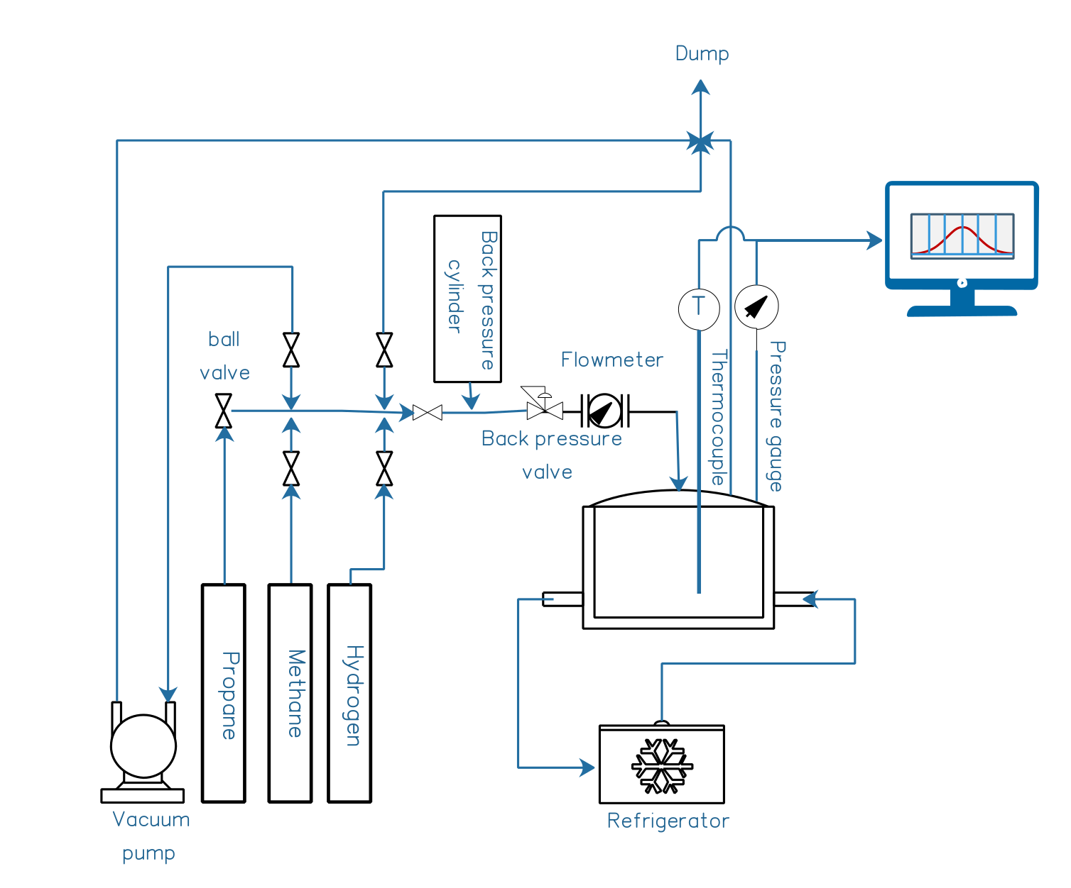 | 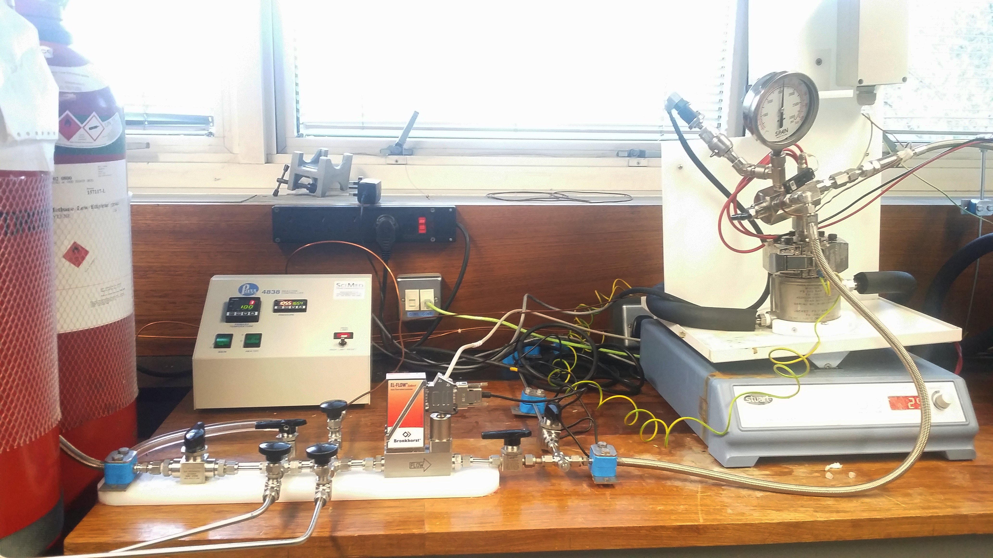
Figure S1: Schematic of gas-hydrate rig. The four main sections are: gas supplier, distribution terminal, reactor and refrigerator. High-purity (N5-level) gases (methane, propane, CO₂ and hydrogen) are supplied to the 0.34 litre, 200 bar-rated stainless-steel and rocker-mounted pressure vessel through the distribution terminal, with line-cleaning before purging the desired gas, by way of mass-flow controller and accurate measurement of gas loading into the (liquid-/sediment- loaded) reactor. The system operates under either isobaric or constant-volume modes, with a back-pressure cylinder for isobaric operation. For the constant-volume case, the reactor’s inlet valve is closed upon reaching the desired pressure, and pressure logged digitally every second for the experiment’s duration (as in the current study). On the right is a photograph of the current system, showing pressure vessel mounted on the rocker, gas tanks, and the temperature-control system¹.

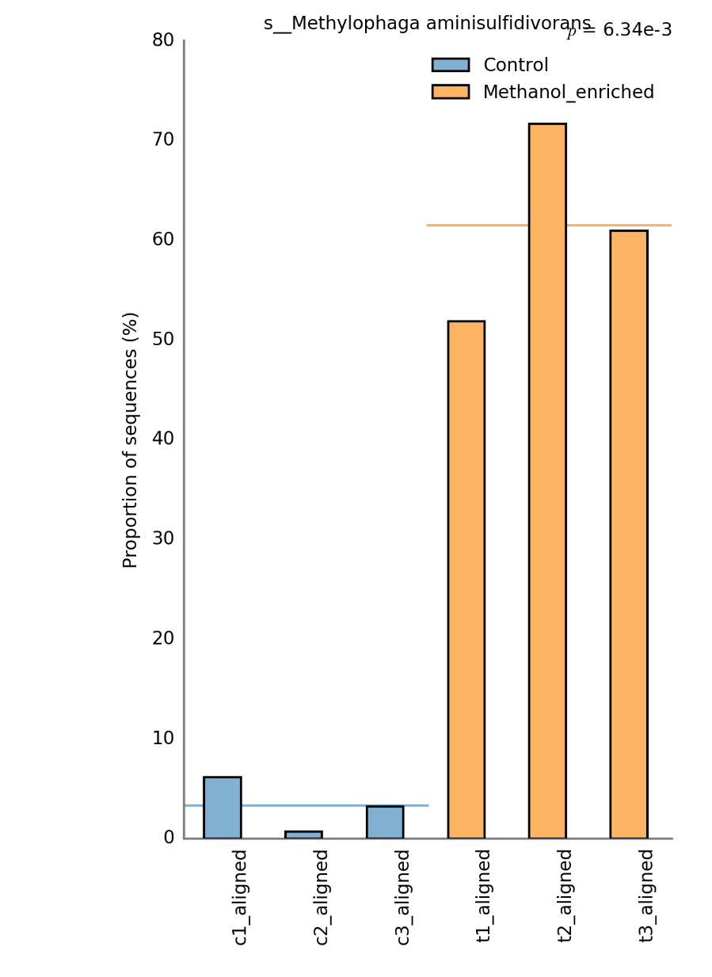
Figure S2: Metagenomic analysis of methanol-enriched seawater cultures reveals significant enrichment of Methylophaga aminisulfidivorans from analysis of assembled partial genomes. The figure shows the assembled genome data that aligned to M. aminisulfidivorans, in the test cultures (T1-3) relative to the control (methanol-free) cultures (C1-3).

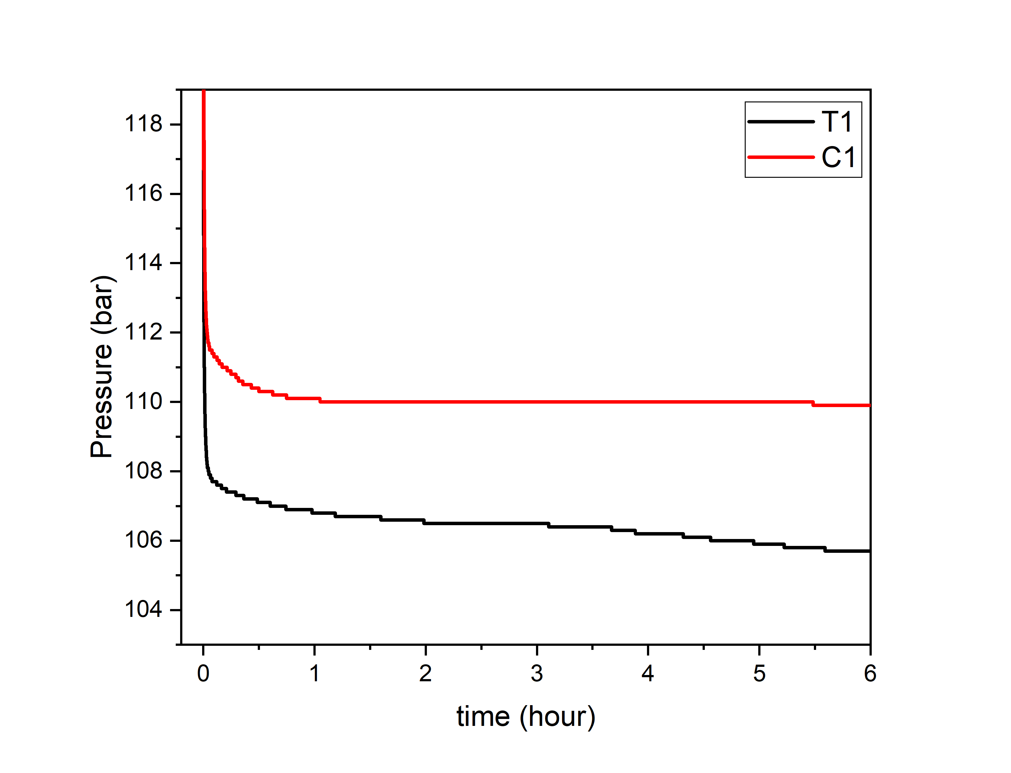
Figure S3: A typical comparison of hydrate formation for cell-free supernatants (10ml), T1 and C1, over a 6-hour timeframe. These well-representative data show that – in a seawater milieu – there is an evident increase in hydrate formation due to the effect of a component in the T1 solution. The T1 and C1 solution differ only in the fact that methanol was added to promote the growth of methanol-degrading bacteria in the seawater medium. Whole cells were removed by centrifugation prior to testing, and the supernatant was tested within one week of preparation (stored at 4ºC).

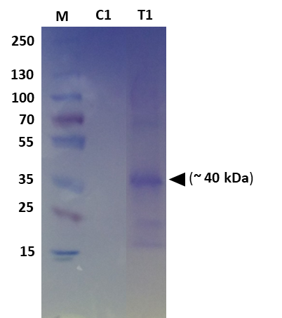

Figure S4: 10% SDS-PAGE resolving gel of total protein recovered from seawater-enrichment samples. M: Pre-stained molecular-weight protein markers. A relatively intense band was found around 40 kDa in the T1 acetone-concentrated supernatant (protein concentration post-acetone precipitation/resuspension = 0.4mg.ml⁻¹); the estimated protein concentration in the T1 supernatant before concentration (below the assay threshold) was 40μg.ml⁻¹.

Rank | Protein | Taxonomy | % Sequence Coverage
1 | hypothetical protein | Methylophaga aminisulfidivorans | 62
2 | hypothetical protein | Halobacteriovorax marinus | 17
3 | Methanol dehygrogenase | Methylophaga aminisulfidivorans | 38
4 | outer membrane cobalamin receptor protein | Methylophaga aminisulfidivorans | 28
5 | hypothetical protein AXW15_03255 | Neptuniibacter sp. Phe_28 | 36
6 | elongation factor Tu | Methylophaga aminisulfidivorans | 45
7 | membrane protein | Methylophaga aminisulfidivorans | 35
8 | Full=Murein-lipoprotein | Serratia marcescens | 42
9 | quinonprotein alcohol dehydrogenase, partial | Neptuniibacter sp. Phe_28 | 30
10 | lipoprotein, putative | Methylophaga aminisulfidivorans | 32

Table S5: Protein-family summary of the ranked top hits from mass-spectrometry analysis of the total supernatant T1, in order of highest MASCOT probability score.

Sample | DNA total yield (0.1g cell pellet) | Total Paired end sequencing reads (2X 150bp)
Control 1 | 0.24 µg | 39251604
Control 2 | 0.11 µg | 45832482
Control 3 | 0.13 µg | 46021144
Treatment 1 | 8.0 µg | 50841080
Treatment 2 | 6.6 µg | 87092122
Treatment 3 | 8.6 µg | 71920872

Table S6. Total DNA yield per cell pellet from each culture flask and total paired-end sequencing reads returned from each sequencing library.

Assembly Statistics
No. of contigs (>= 0 bp) | 42027
No. of contigs (>= 1000 bp) | 11721
No. of contigs (>= 5000 bp) | 2642
No. of contigs (>= 10000 bp) | 1234
No. of contigs (>= 25000 bp) | 362
No. of contigs (>= 50000 bp) | 167
Total length (>= 0 bp) | 84536872
Total length (>= 1000 bp) | 70140144
Total length (>= 5000 bp) | 51385626
Total length (>= 10000 bp) | 41507544
Total length (>= 25000 bp) | 28440042
Total length (>= 50000 bp) | 21926609
No. of contigs | 22678
Largest contig | 833376
Total length | 77673648
GC (%) | 40.18
N50 | 11839
N75 | 2854
L50 | 989
L75 | 4473

Table S7 Assembly statistics for the de-novo co-assembled metagenomes. Sequence reads were assembled using spades with the –meta flag and assembly quality was assessed using QUAST.²⁹ N50 is the contig size in base pairs over which 50% of the total assembly length is contained in contigs of this size. L50 is the number of contigs of length N50 or greater. N75 is the contig size in base pairs over which 75% of the total assembly length is contained in contigs of this size. L75 is the number of contigs of length N75 or greater.

Gene | Signal peptide? |  | Subcellular localization? |  | Coverage in T1 sample | % AA identity to LC-MSMS top hit | BLAST top hit (NCBI nr protein database)
 | SignalP | Phobius | Psort | Phobius
64197 | Yes | Yes | Non-Cytoplasmic | Outer membrane | 210.01 | 95.95 | porin [Methylophaga aminisulfidivorans]  acc: WP_007147016.1
63181 | Yes | Yes | Non-Cytoplasmic | Outer membrane | 109.45 | 94.73 | porin [Methylophaga aminisulfidivorans]  acc: WP_007147016.1
59061 | Yes | Yes | Non-Cytoplasmic | Outer membrane | 40.97 | 88.67 | porin [Methylophaga aminisulfidivorans]  acc: WP_007147016.1
61486 | Yes | Yes | Non-Cytoplasmic | Outer membrane | 70.38 | 86.88 | porin [Methylophaga aminisulfidivorans]  acc: WP_007147016.1
12180 | Yes | Yes | Non-Cytoplasmic | Outer membrane | 2.30 | 86.76 | porin [Methylophaga aminisulfidivorans]  acc: WP_007147016.1
63824 | Yes | Yes | Non-Cytoplasmic | Outer membrane | 70.38 | 83.13 | porin [Methylophaga aminisulfidivorans]  acc: WP_007147016.1
56963 | Yes | Yes | Non-Cytoplasmic | Outer membrane | 91.51 | 85.79 | porin [Methylophaga aminisulfidivorans]  acc: WP_007147016.1
10558 | Yes | Yes | Non-Cytoplasmic | Outer membrane | 0.36 | 74.14 | porin [Methylophaga sulfidovorans]  acc: WP_091715223.1
45932 | Yes | Yes | Non-Cytoplasmic | Outer membrane | 2.63 | 74.63 | porin [Methylophaga nitratireducenticrescens]  acc: WP_014707656.1
55948 | Yes | Yes | Non-Cytoplasmic | Outer membrane | 18.71 | 67.87 | porin [Methylophaga lonarensis] WP_009727329.1

Table S8 Analysis of the 11 ORFs which showed highest similarity to the major protein identified in the supernatant of the T1 flask by LC-MSMS. Signal peptide detection and subcellular-localization prediction were performed as described in the ‘Methodology’ section. The coverage was calculated as the number total number of bases which mapped to the contig, from which the ORF was derived divided by the contig length and is proportional to the relative abundance of that gene sequence in the original data sample. The top hits retrieved from a BLASTp search of the amino-acid translations ORF sequences, along with NCBI accession codes, are also shown.

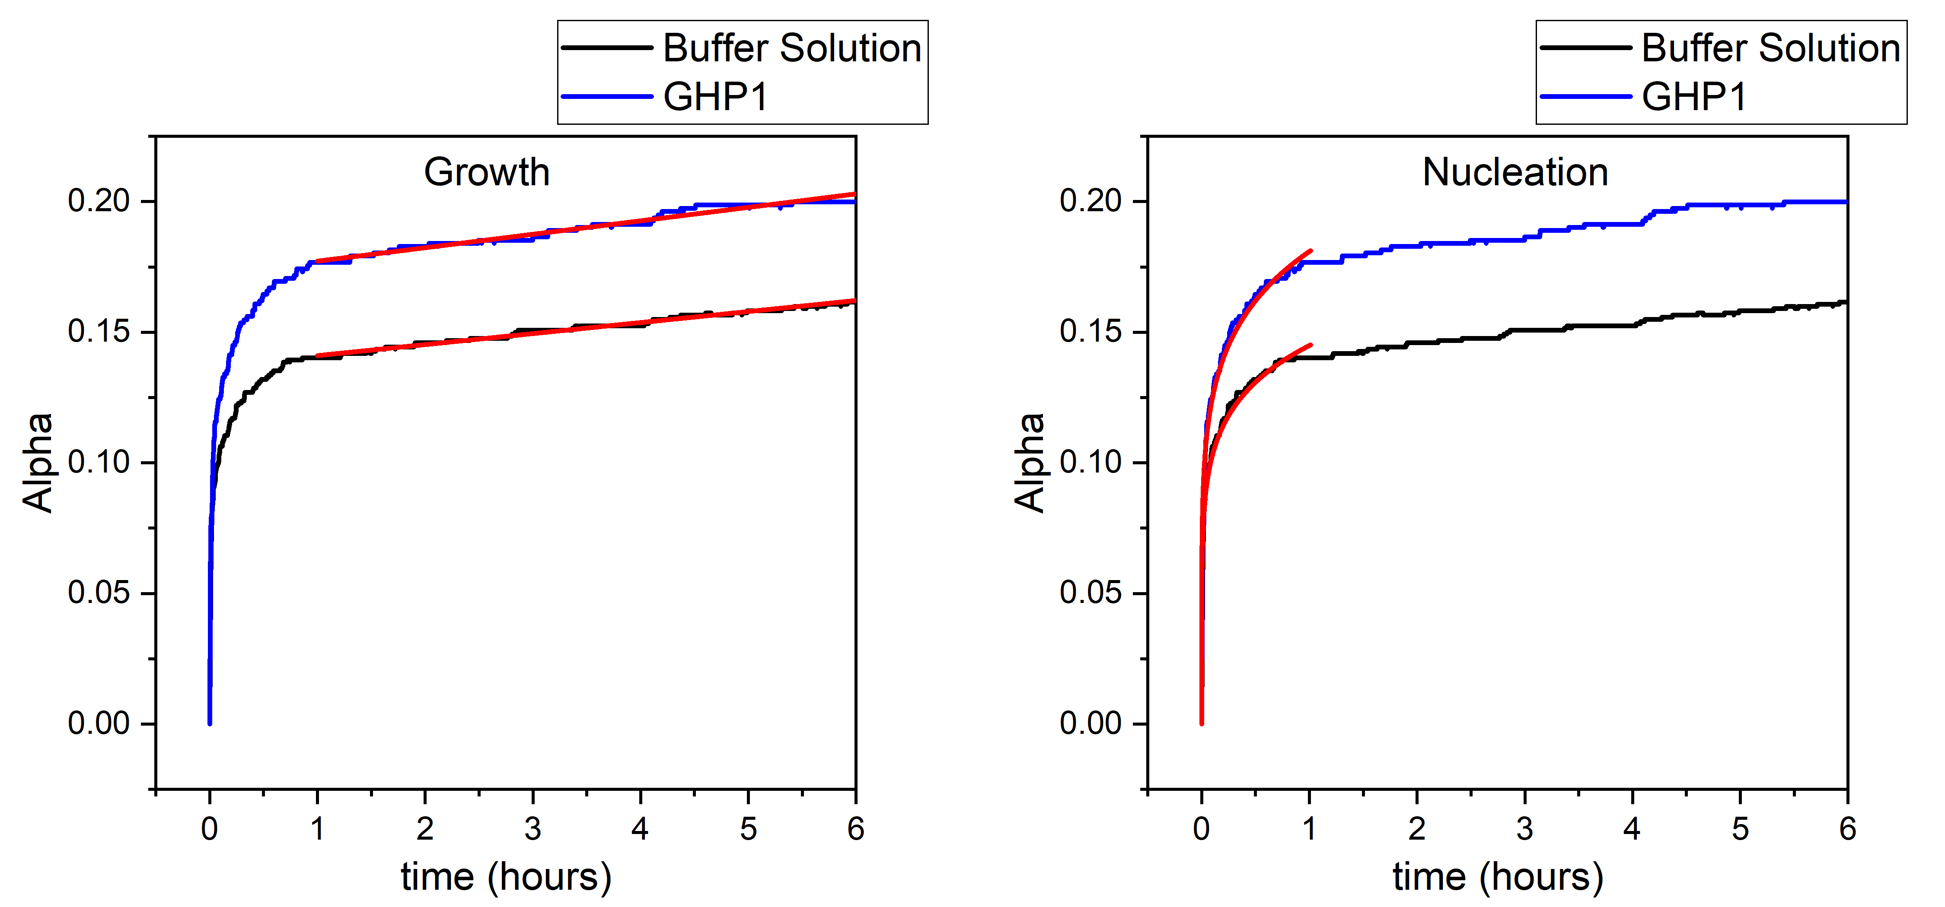

Figure S9: Two-régime kinetic analysis of averaged GHP1 versus buffer-solution hydrate formation evident in Figure 2 (framed as induction/nucleation - on the right, and growth - on the left). ‘Alpha’, α, denotes the fractional conversion to hydrate (see ‘Methodology’ section in the paper). Up to about 1 hour, it can be seen that early-stage, incipient formation is dominated by a rapid drop in pressure (Fig. 2) and increase in conversion, characteristic of formation towards critically-sized nuclei. Modelling this stage by the Avrami equation, α = 1-exp(-(kt)^{n}), the reaction rate k for the GHP1 case (obtained by least-squares regression fitting) is one order of magnitude higher (vide infra, see table below). During growth, after the steep pressure drop of early-onset induction in the first hour, the formation rate is almost linear (evidenced by straight-line regression fits) and slopes are small; still, that of GHP1 is still ~20% higher, although later, at ~4.5-6 hours, this difference between any GHP1 and buffer-solution rate becomes essentially negligible [1].

Stage | Model | Avrami
Induction stage | Equation | 1-exp(-(k*t)^n)
 | Plot | GHP1 | Buffer Solution
 | k | 2.711E-8 ± 1.02E-9 | 2.309E-9 ± 1.34E-10
 | n | 0.1745 ± 6.5524E-4 | 0.1585 ± 7.398E-4
 | Reduced Chi-Sqr | 1.88E-05 | 1.67E-05
 | R-Square (COD) | 0.9649 | 0.9457
 | Adj. R-Square | 0.9639 | 0.9457
Growth stage | Model | Linear fit
 | Equation | y = a + b*x
 | Plot | GHP1 | Buffer Solution
 | Intercept | 0.1721 ± 2.609E-5 | 0.1369 ± 1.389E-5
 | Slope | 1.430E-6 ± 1.915E-9 | 1.172E-6 ± 1.019E-9
 | Residual Sum of Squares | 0.0321 | 0.0091
 | Pearson's r | 0.9842 | 0.99330
 | R-Square (COD) | 0.9687 | 0.9865
 | Adj. R-Square | 0.9687 | 0.9865
Additional References for Supplementary Section

- MR Ghaani, et al., “A method of altering gas hydrate formation”, Submitted to British Patent Office, Oct. 2018, Ref. no. 1820946.0

