**Metastatic colorectal carcinomas with high SATB2 expression are associated with better prognosis and response to chemotherapy: A population-based Scandinavian study**

*Supplementary figures and tables*

S1. Flow chart over patient cohort and patient treatments. Paraffin blocks with sufficient amount of invasive, non-necrotic tumor for tissue microarray (TMA) construction and DNA extraction were available in 467 cases from the cohort of 798 patients.



S2. Representative images of tissue cores (1 mm in diameter) stained for SATB2, showing increasing intensity and fraction of stained tumor cells: A-negative, B-weak, C-moderate and partial, D-strong and diffuse. First row original magnification 200x, second row= insets of the boxed areas. E: Distribution of immunohistochemistry scores for SATB2 nuclear fraction (NF) and nuclear intensity (NI) in the TMA cohort.

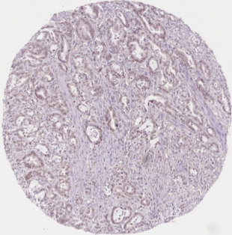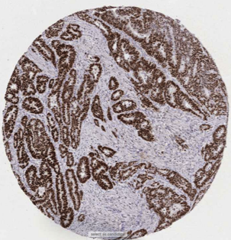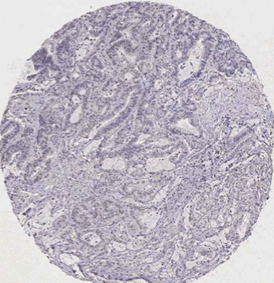

**A**

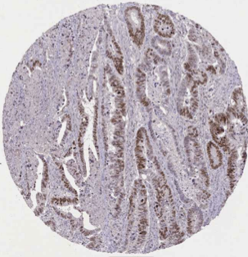

**B**

**D**

**C**

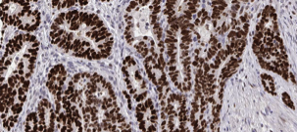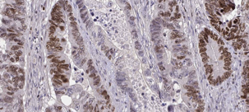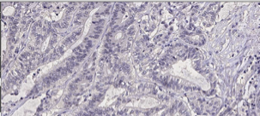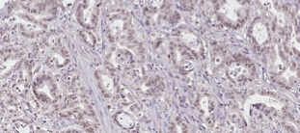

E

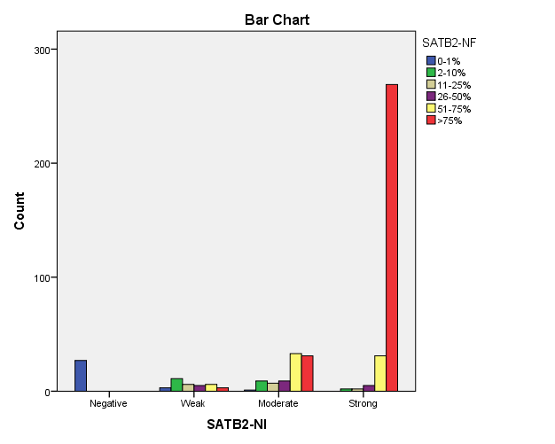

S3. Baseline clinical data of the whole cohort and its subgroups: patients receiving chemotherapy or best supportive care (BSC). Data are presented as absolute values and, in parentheses, as % of the total for the respective group. The statistical significances of the differences between the subgroups are indicated by the p-value (chi-square test, or * Mann-Whitney U Test).

|  |  |  |  |  |
| --- | --- | --- | --- | --- |
|  | All patients  n (%) | Treated patients | BSC only | Difference between subgroups |
| Number | 450 | 282 | 168 | p-value |
| Age, mean (range) | 69 (24-96) | 64 (24-85) | 78 (49-96) | <0.001* |
| Gender   * male * female | 222 (49)  228 (51) | 139 (49)  143 (51) | 83 (49)  85 (51) | 0.981 |
| Clinical TNM1 stage at diagnosis   * I-II * III * IV | 72 (16)  115 (26)  263 (58) | 37 (13)  70 (25)  175 (62) | 35 (21)  45 (27)  88 (52) | 0.056 |
| Location   * Right colon * Left colon2 * Rectum | 175 (40)  160 (36)  108 (24) | 100 (36)  108 (39)  71 (25) | 75 (46)  52 (32)  37 (23) | 0.116 |
| WHO Performance status   * 0-1 * ≥2 | 300 (67)  150 (33) | 236 (84)  46 (16) | 64 (38)  104 (62) | <0.001 |
| Synchronous metastases3 | 243 (54) | 160 (57) | 83 (49) | 0.131 |
| Number of metastatic sites   * 1 * ≥2 | 189 (42)  261 (58) | 127 (45)  155 (55) | 62 (37)  106 (63) | 0.091 |

1 TNM stages according to AJCC 7th ed.: Stage I-II = T1-4N0M0, Stage III = T1-4N1-2M0, Stage IV = T1-4N1-2M1.

2 Left colon includes colon from splenic flexure to sigmoid.

3 Synchronous metastases defined as within 6 months from diagnosis date, irrespective of location.

S4. Association between SATB2 expression in the primary tumor and localization of distant metastases. Data are presented as number of patients and, in parentheses, as the percentages of respective location group. Chi-square test was used for evaluation of statistical significance.

|  |  |  |  |
| --- | --- | --- | --- |
|  | **SATB2** | | |
| n, (percent) | | *p value* |
| Low | High |
| Liver | 103 (54) | 182 (70) | 0.001 |
| Lung | 36 (19) | 76 (29) | 0.015 |
| Peritoneum | 46 (24) | 41 (16) | 0.022 |
| Bone | 23 (12) | 49 (19) | 0.066 |
| Skin | 6 (3) | 3 (1) | 0.130 |
| Brain | 14 (7) | 15 (6) | 0.470 |

S5. Association between expression of SATB2 and presence of selected markers. Data are presented as number of patients and, in parentheses, as percentages of respective marker group. Chi-square test was used for evaluation of statistical significance.

|  |  |  |  |
| --- | --- | --- | --- |
|  | **SATB2** | |  |
| n, (percent) | | *p value* |
| Low | High |
| CK20 |  |  |  |
| * positive | 146 (77) | 245 (94) | <0.001 |
| * negative | 43 (23) | 16 (6) |  |
| CDX2 expression |  |  |  |
| * positive | 144 (76) | 253 (97) | <0.001 |
| * negativelow | 44 (23) | 7 (3) |  |
| * missing | 1 (1) | 1 (0) |  |

S6. Clinicopathological characterization of patients with both mutated *BRAF* and low SATB2. Chi-square test with contingency coefficient or Mann-Whitney U Test (*) was used for evaluation of statistical significance.

|  |  |  |  |
| --- | --- | --- | --- |
|  |  | | |
| n, (percent) | | *p value* |
| *BRAF*mut and  SATB2 low  (69) | Others  (379) |
| Age, mean (range) | 69  (24-96) | 70  (47-86) | 0.112* |
| Gender |  |  |  |
| * Male | 25 (36) | 196 (52) | 0.018 |
| * Female | 44 (64) | 183 (48) |  |
| Location   * right-sided * left-sided1 * multiple | 50 (73)  19 (28)  0 (0) | 124 (33)  248 (65)  7 (2) | <0.001 |
| Number of metastatic sites   * 1 * ≥2 | 33 (48)  36 (52) | 155 (41)  224 (59) | 0.283 |
| Metastasis type |  |  |  |
| * Synchronous | 29 (42) | 177 (47) | 0.474 |
| * Metachronous | 40 (58) | 202 (53) |  |
| WHO Performance status |  |  |  |
| * 0-1 | 40 (58) | 258 (68) | 0.102 |
| * ≥2 | 29 (42) | 121 (32) |  |
| Alkaline phosphatase |  |  |  |
| * High2 | 29 (42) | 190 (50) | 0.229 |
| * Normal | 31 (45) | 145 (38) |  |
| * Missing | 9 (13) | 44 (12) |  |
| Tumor differentiation |  |  |  |
| * Well-medium diff | 38 (55) | 301 (79) | <0.001 |
| * Low and undifferentiated | 28 (41) | 68 (18) |  |
| * Missing | 3 (4) | 10 (3) |  |
| Chemotherapy for mCRC   * Given * Not given | 42 (61)  27 (39) | 239 (63)  140 (37) | 0.729 |

1 Left-sided includes colon from splenic flexure, sigmoid and rectum.

2 Alkaline phosphatase high was defined according to clinical routine practice at the laboratories in Bergen, Odense and Uppsala.

S7. Progression-free survival (PFS) of patients receiving first-line chemotherapy (any combination). High SATB2 expression is indicated by red line and low expression by blue line. A. No statistically significant difference in PFS between those having high SATB2 expression and those having low expression. B. PFS of patients receiving different combinations of first-line chemotherapy indicating a statistically significant difference for patients treated with irinotecan in any combination (upper right) or with 5-FU and irinotecan (lower right). Log rank test was used for statistical analysis.



S8. Baseline clinical data of the SATB2 study cohort and its subgroups: patients receiving irinotecan (in any combination) or oxaliplatin (except with irinotecan). Data are presented as absolute values and, in parentheses, as % of the total for the respective group. The statistical significances of the differences between the subgroups are indicated by the p-value (chi-square test, or * Mann-Whitney U Test)

|  |  |  |  |
| --- | --- | --- | --- |
|  | n, (percent) | | *p value* |
| Oxaliplatin | Irinotecan |
| Age, mean (range) | 61  (26-81) | 61  (24-78) | 0.568* |
| Location |  |  |  |
| * Right colon | 57 (35) | 18 (30) |  |
| * Left colona | 67 (41) | 24 (40) | 0.616 |
| * Rectum | 39 (24) | 18 (30) |  |
| WHO Performance status |  |  |  |
| * 0-1 | 149 (90) | 52 (86) | 0.435 |
| * ≥2 | 16 (10) | 8 (13) |  |
| Alkaline phosphatase |  |  |  |
| * Highb | 83 (52) | 37 (69) | 0.037 |
| * Normal | 76 (48) | 17 (32) |  |
| Tumor differentiation |  |  |  |
| * Well-medium diff | 134 (82) | 48 (83) | 0.925 |
| * Low and undifferentiated | 29 (18) | 10 (17) |  |
| *BRAF*   * w.t. * mutated | 98 (61)  63 (39) | 33 (55)  27 (45) | 0.430 |

Notes:

a Left colon includes colon from splenic flexure and sigmoid.

b Alkaline phosphatase high was defined according to clinical routine practice at the laboratories in Bergen, Odense and Uppsala.

## S9. Response rate

Distribution of SATB2 in different categories of response after chemotherapy. CR: complete response, PR: partial response, SD: stable disease. Data are presented as absolute values and, in parentheses, as % of the total for the respective group. The statistical significances of the differences between the subgroups are indicated by the p-value (chi-square test).

|  |  |  |  |
| --- | --- | --- | --- |
|  | **SATB2** | | |
| n, (percent) | | *p value* |
| Low  102 (37) | High  174 (63) |
| response |  |  |  |
| * CR or PR | 30 (29) | 75 (43) | 0.024 |
| * rest | 72 (71) | 99 (57) |  |
| response |  |  |  |
| * CR or PR or SD | 70 (67) | 145 (83) | 0.004 |
| * rest | 32 (31) | 29 (17) |  |