Supplementary File

Pharmacokinetics and Brain targeting of Trans-Resveratrol loaded mixed micelles in rats following intravenous administration
Roshan Katekar^{a#}, Ganeshkumar Thombre^{b#}, Mohammed Riyazuddinª, Athar Husainª, Hiral Raniª, Kusuma Sushma Praveena^{b}, Jiaur R. Gayen^{a,c,}*
ªPharmaceutics & Pharmacokinetics Division, CSIR-Central Drug Research Institute, Lucknow-226031, India
^{b}Department of Pharmaceutics, National Institute of Pharmaceutical Education and Research, Raibarelly-229010, India.
^{c}Academy of Scientific and Innovative Research (AcSIR), New Delhi, India.

#Equal contribution

*Correspondence to: Jiaur R. Gayen, Senior Scientist, Pharmaceutics & Pharmacokinetics Division, CSIR-Central Drug Research Institute, Sector-10, Jankipuram Extension, Sitapur Road, Lucknow, India‐226031. E-mail: jr.gayen@cdri.res.in

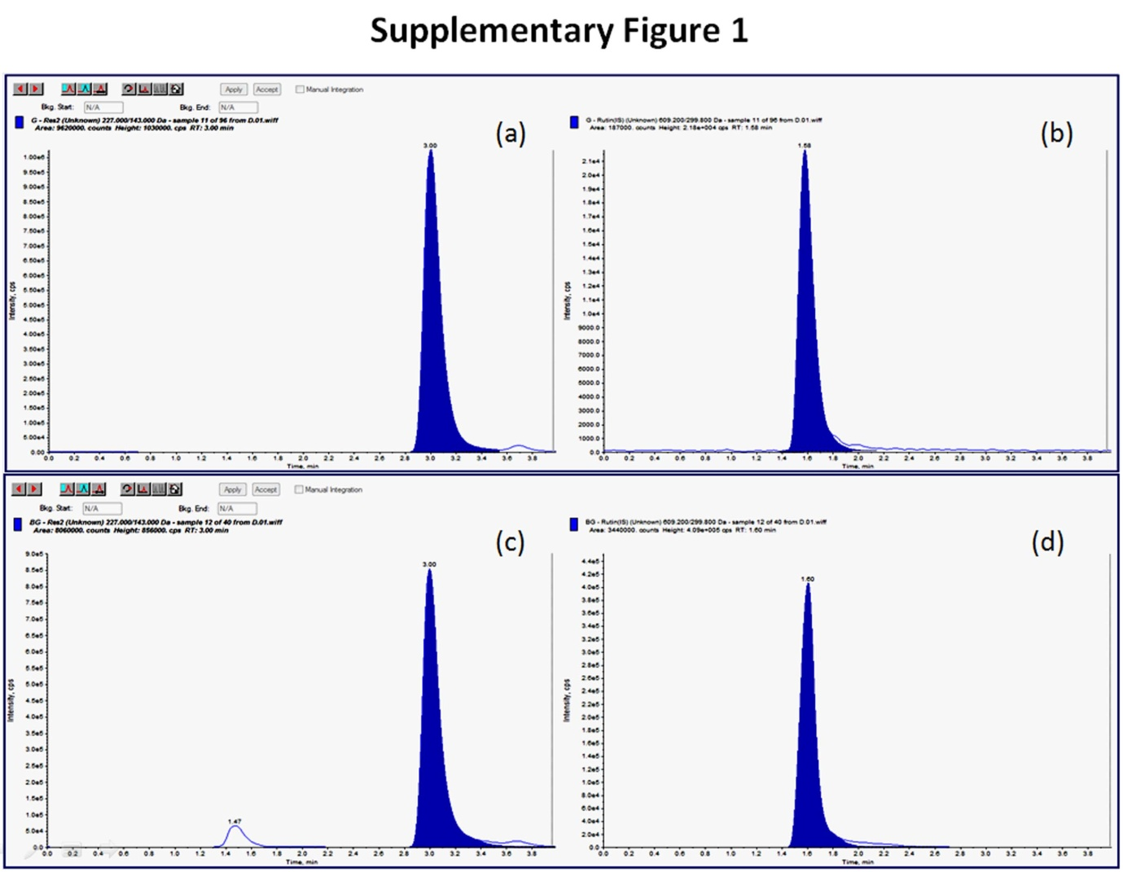

Supplementary Figure 1: HPLC-MS chromatograms for estimation of T-RES from (a) blood and (c) brain; And (b) & (d) are profile of internal standard (rutin) in blood & brain samples, respectively.

