Supplementary Material
Synthesis and spectral characterization of metal complexes of Schiff base derived from indole-3-carboxaldehyde and L-histidine as potent biocides

R. RESHMA, R. SELWIN JOSEYPHUS*, ARISH DASAN and LIJI JOHN

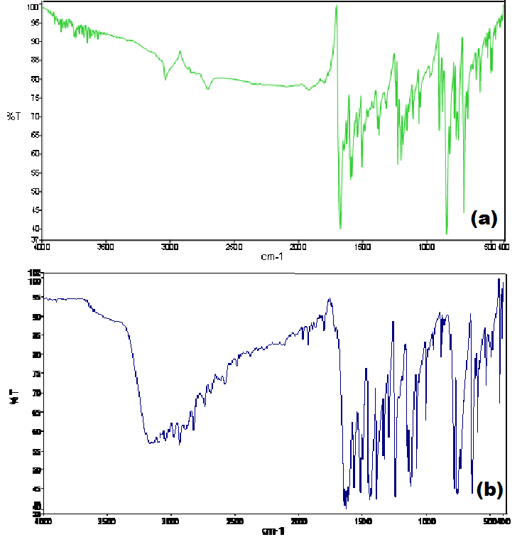
Figure S1. IR spectra of (a) [Mn(II)-(indal-L-his)₂(H₂O)₂] and (b) [Fe(II)-(indal-L-his)₂(H₂O)₂].

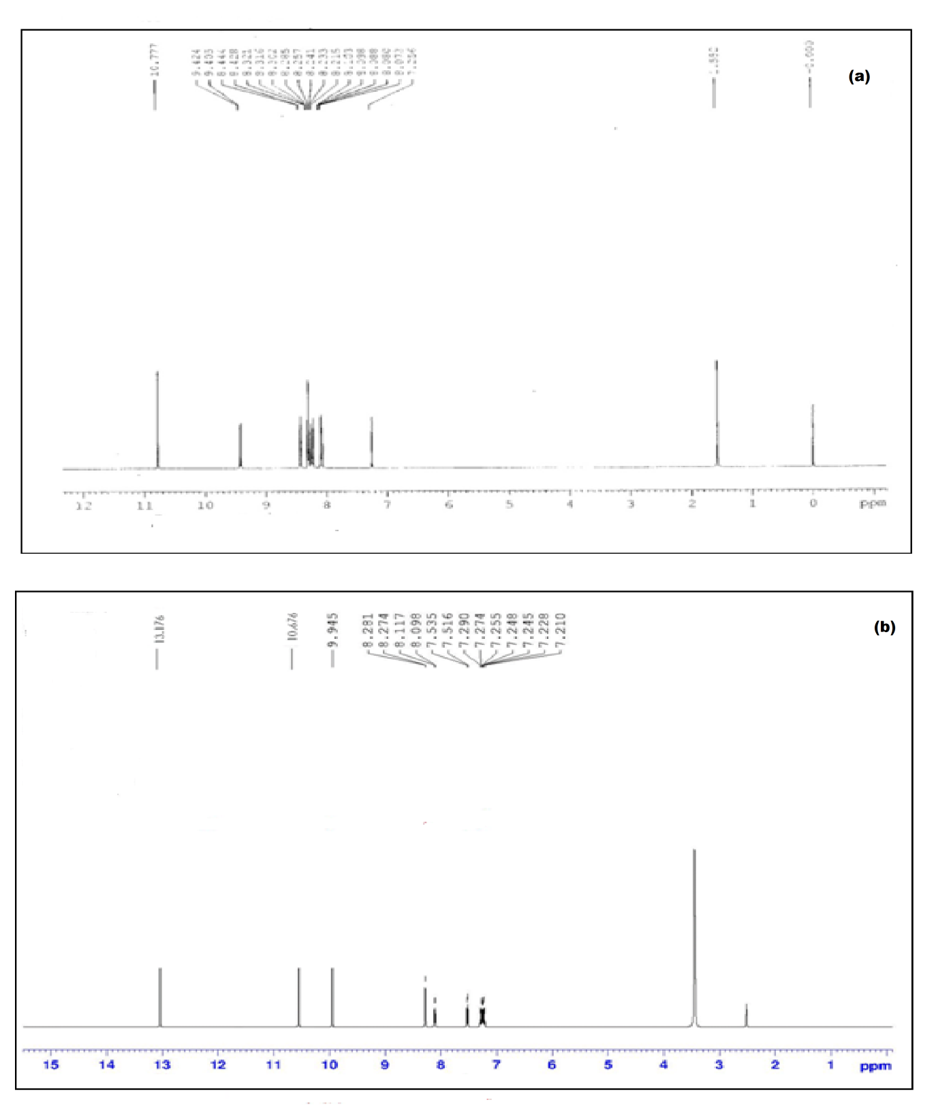
Figure S2. ¹H NMR spectra of (a) indal-L-his and (b) [Zn(II)-(indal-L-his)₂].

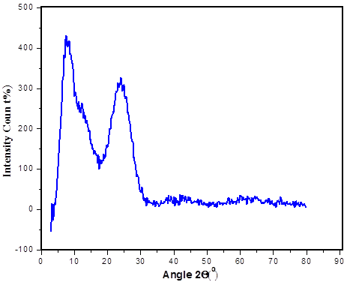
Figure S3. Powder XRD pattern of [Cu(II)-(indal-L-his)₂].

Figure S4. Photocatalytic degradation of indal-L-his (L) and its metal(II) complexes.

Figure S5. Antimicrobial activity of indal-L-his (L) and its metal(II) complexes.

Table S1. Molar conductance and magnetic data of metal(II) complexes.
Metal(II) complexes | Molar conductance  (Ohm⁻¹cm²mol⁻¹) | μ_{eff} (BM)
[Mn(II)-(indal-L-his)₂(H₂O)₂] | 10 | 5.89
[Fe(II)-(indal-L-his)₂(H₂O)₂ ] | 18 | 4.51
[Co(II)-(indal-L-his)₂] | 22 | 3.82
[Cu(II)-(indal-L-his)₂] | 14 | 1.99
[Ni(II)-(indal-L-his)₂] | 8 | Dia
[Zn(II)-(indal-L-his)₂] | 12 | Dia

