**2-Aminoethanesulfonic acid: An Efficient Organocatalyst for Green Synthesis of Spirooxindole dihydroquinazolinones and Novel 1,2-(Dihydroquinazolin-3(4*H*)isonicotinamides in Water**

Asha V. Chate,a* Priyanka Rudrawar,a Giribala M. Bondle,a Jaiprakash Sangeshettib

*aDepartment of Chemistry, Dr. Babasaheb Ambedkar Marathwada University,*

*Aurangabad-431 004, M.S., India. Fax: +01 240 2400491, Phone No. +91 240 2403311.*

*bDepartment of Quality Assurance, Y. B. Chavan College of Pharmacy, Rafiq Zakaria Campus,*

*Aurangabad 431 001, India*

*\*Corresponding* [*author-chateav@gmail.com*](mailto:author-chateav@gmail.com)

**Table of Contents**

General Method…………………………………………………………………………………...2

Experimental procedures for the synthesized compound…………………………………….....2-3

Spectral and analytical data of compounds **4a, 4b, 4c, 4h, 4i, 4j, 4n, 4o, 4p, 4q, 4r, 7a, 7b, 7c and 7g**…………………………………………………………………………………………...3-7

IR,1H NMR, Mass and 13C NMR spectral data of compounds **4a, 4b, 4c, 4h, 4i, 4j, 4n, 4o, 4p, 4q, 4r, 7a, 7b, 7c, and 7g**………...............................................................................................8-28

**Experimental**

*Materials and methods*

All the chemicals used were of laboratory grade. Melting points of all the synthesized compounds were determined in open capillary tube and are uncorrected. Progress of the reaction was monitored by thin layer chromatography on Merck’s silica plates and visualization was accomplished by iodine/ultraviolet light. IR spectra were obtained on a Bruker ALPHA (Eco-ATR) spectrometer. 1H NMR spectra of were recorded with an NMR predict proton DMSO (BRUKER/TOPSPIN) spectrometer operating at 700 MHz using DMSO solvent and trimethylsilane (TMS) as the internal standard and chemical shift in δ ppm and 13C NMR at 176 MHz, DMSO, Mass spectra were recorded on a Waters (BRUKER/TOPSPIN) (ESI-MS and APCI-MS) Instrument and elemental analysis were recorded on CHNS autoanalyser Thermofischer (FLASH EA1112 SERIES).

***General procedure for synthesis of 1'H-spiro[indoline-3,2'-quinazoline]-2,4'(3'H)-diones 4a-r:*** A equimolar mixture ofisatoic anhydride (1.0 mole), aniline (1.0 mole), and isatins (1.0 mole) was taken in 10 mL water in 100 mL round bottom flask and 15 mol% of taurine catalyst was added to this reaction mixture. The reaction content was heated for the appropriate time given in **(Table 4)**. After the completion of reaction, which was monitored by TLC, the reaction mixture was allowed to cool and 10 mL of water was added and stirred for 3 minutes. During this time, the product was precipitated and subsequently separated by filtration. The separated product was washed with water for several times. After drying, the pure product was obtained; there was no need for further purification by column chromatography or addition of any organic solvent. Furthermore, water was evaporated from the filtrate to recycle and recovered the taurine catalyst. The recovered taurine reused for same transformation 2-3 consecutive runs without any significant loss in yield and activity. The products were characterized by M. P., FT-IR, 1H NMR, 13C NMR, Mass spectra and elemental analysis and are good agreement with the reported compounds [39].

***General procedure for synthesis of N-(4-oxo-2-phenyl-1,2-dihydroquinazolin-3(4H)-yl)sonicotinamide 7a-j:*** A equimolar mixture ofisatoic anhydride (1.0 mole), isoniazid (1.0 mole), aldehyde (1.0 mole) was taken in 10 mL water in 100 mL round bottom flask and 15 mol% of taurine catalyst was added to this reaction mixture. The reaction content was heated for the appropriate time given in **(Table 5)** After the completion of reaction, which was monitored by TLC, the reaction mixture was allowed to cool and 10 mL of water was added and stirred for 3 minutes. During this time, the product was precipitated and subsequently separated by filtration. The separated product was washed with water for several times. After drying, the pure product was obtained; there was no need for further purification by column chromatography or addition of any organic solvent. Furthermore, water was evaporated from the filtrate to recycle and recovered the taurine catalyst. The recovered taurine reused for same transformation 2-3 consecutive runs without any significant loss in yield and activity. The obtained new products were characterized by M. P., FT-IR, 1H NMR, 13C NMR, Mass spectra and elemental analysis.

**Spectral Analysis of Representative Compounds as Follows**:

**3'-phenyl-1'H-spiro[indoline-3,2'-quinazoline]-2,4'(3'H)-dione (4a):** M. P. 250-253 οC; IR (ATR) νmax cm-1: 3243 (NH), 3059 (NH), 1735 (C=O), 1706 (C=O), 1454, 1326 (Ar-H).1H NMR 700 MHz, DMSO): δ: 10.29 (s, CONH); 1H NMR (400 MHz, DMSO) δ 10.77 (s, 1H), 7.77 (dd, J=7.7, 1.5 Hz, 1H), 7.67 (s, 1H), 7.53 (d, J =7.2 Hz, 1H), 7.31 (ddd, J =8.1, 7.4, 1.6 Hz, 1H), 7.27 (t, J= 7.4 Hz, 2H), 7.17 (ddd, J = 9.0, 4.9,1.2 Hz, 2H), 7.15-6.99 (m, 2H, Ar-H), 6.95 (t, J =7.6, 0.9 Hz, 1H), 6.91-6.87 (m, 1H), 6.76 (d, J = 8.1 Hz, 1H), 6.63 (d, J = 7.7 Hz, 1H);13C NMR (100 MHz, DMSO-*d6*): δ: 175.66, 164.56, 146.10, 131.79, 128.60, 127.69, 127.40, 127.29, 126.47, 117.75, 115.57, 114.08, 110.57, 75.33. Elemental Analysis Calcd. For C21H15N3O2: C, 73.89; H, 4.43; N, 12.31; Found: C, 73.85; H, 4.46; N, 12.35; LC-MS (ESI, m/z): 342.18 (M+1).

***3'-(4-chlorophenyl)-1'H-spiro[indoline-3,2'-quinazoline]-2,4'(3'H)-dione (4b):*** M. P. 262-264 οC; IR (ATR) νmax cm-1: 3241 (NH), 3009 (NH), 1735 (C=O), 1719 (C=O), 1477, 1349 (Ar-H); 1H NMR (700 MHz, DMSO): δ 10.50 (s, 1H, NH), 7.78 (s, 1H, NH), 7.62-7.70 (d, 2H, J = 7.0, Ar-H), 7.40 (d, 1H, J = 7.3, Ar-H), 7.31 (t, 1H, J = 7.0, Ar-H), 7.23 (t, 1H, J = 7.2, Ar-H), 7.21 (d, 2H, J = 8.2, Ar-H), 7.02 (d, 1H, J = 7.5, Ar-H), 6.97 (d, 2H, J = 8.2, Ar-H), 6.60–6.69 (m, 2H, Ar-H); 13C NMR (176 MHz, DMSO): δ 173.05, 164.55, 150.07, 148.73, 142.15, 140.53, 136.87, 135.23, 133.27, 131.63, 129.28, 126.06, 124.71, 123.08, 113.53, 113.23, 112.26, 110.91, 76.68.Elemental Analysis Calcd. For C21H14ClN3O2: C, 67.12; H, 3.75; N, 11.18; Found: C, 67.10; H, 3.79; N, 11.15; LC-MS (ESI, m/z): 376.01 (M+1).

***3'-(4-bromophenyl)-1'H-spiro[indoline-3,2'-quinazoline]-2,4'(3'H)-dione (4c):*** M. P. 210-212 οC; IR (ATR) νmax cm-1: 3269 (NH), 2815 (NH), 1734 (C=O), 1609 (C=O), 1480, 1358 (Ar-H); 1H NMR (700 MHz, DMSO): δ 10.49 (s, 1H, NH), 7.60-7.69 (d, 2H, J = 7.0, Ar-H), 7.58 (s, 1H, NH), 7.44-7.46 (d, 2H, J = 7.3, Ar-H), 7.22 (t, 1H, J = 7.0, Ar-H), 7.20 (t, 1H, J = 7.2, Ar-H), 7.02 (d, 1H, J = 7.5, Ar-H), 6.96-6.98 (m, 2H, J = 8.2, Ar-H), 6.73 (d, 1H, J = 8.2, Ar-H), 6.69 (d, 1H, Ar-H); 13C NMR (176 MHz, DMSO): δ 175.71, 164.07, 146.41, 142.00, 138.02, 137.93, 134.36, 132.46, 130.95, 127.93, 127.19, 126.73, 122.39, 121.02, 118.25, 114.52, 110.48, 76.69. Elemental Analysis Calcd. For C21H14BrN3O2: C, 60.02; H, 3.36; N, 10.00; Found: C, 60.00; H, 3.40; N, 9.97; LC-MS (ESI, m/z): 420.12 (M+1).

**3’p-tolyl-1’'H-spiro-[indoline-3,2'-quinazoline]-2,4'(3'H)-dione (4h):** M. P. 272-274 οC; IR (ATR) νmax cm-1: 3262 (NH), 3020 (NH),1714 (C=O), 1610 (C=O), 1508, 1471, 1353 (Ar-H). 1H-NMR (400 MHz, DMSO, ppm): δ 10.37 (s, 1H, NH), 7.67 (d, 1H, J = 7.0, Ar-H), 7.65 (s, 1H, NH), 7.53 (d, 1H, J = 7.3, Ar-H), 7.27 (t, 1H, J = 7.0, Ar-H), 7.16 (t, 1H, J = 7.2, Ar-H), 7.14 (d, 2H, J = 8.2, Ar-H), 6.95 (d, 1H, J = 7.5, Ar-H), 6.87 (d, 2H, J = 8.2, Ar-H), 6.63–6.69 (m, 3H, Ar-H), 2.18 (s, 3H, CH3); 13C NMR (176 MHz, DMSO): δ 175.81, 168.25, 164.12, 148.13, 142.15, 138.54, 137.38, 134.24, 132.85, 132.48, 131.34, 129.80, 129.13, 128.64, 127.89, 127.21, 127.11, 126.82, 122.60, 116.87, 115.63, 115.16, 113.23, 103.98, 76.86; Elemental Analysis Calcd. For C22H17N3O2: C, 74.35; H, 4.82; N, 11.82; Found: C, 63.39; H, 3.88; N, 11.78; LC-MS (ESI, m/z): 356 (M+1).

***3'-(m-tolyl)-1'H-spiro[indoline-3,2'-quinazoline]-2,4'(3'H)-dione (4i):*** M. P. 265-268 οC; IR (ATR) νmax cm-1: 3267 (NH), 2897 (NH), 1729 (C=O), 1650 (C=O), 1483, 1293 (Ar-H); 1H NMR (700 MHz, DMSO): δ 10.01 (s, 1H, NH), 7.72 (d, 1H, J = 7.0, Ar-H), 7.62 (s, 1H, NH), 7.58-7.50 (d, 2H, J = 8.2, Ar-H), 7.49 (d, 2H, J = 7.0, Ar-H), 7.36 (d, 2H, J = 7.3, Ar-H), 7.28 (m, 3H, Ar-H), 7.20 (d, 1H, J = 7.0, Ar-H), 6.63 (d, 1H, J = 7.5, Ar-H), 2.29 (s, 3H, CH3). 13C NMR (176 MHz, DMSO): δ 168.26, 163.98, 147.27, 146.64, 139.92, 134.87, 131.71, 125.89, 124.87, 122.22, 121.57, 118.06, 116.24, 115.60, 114.46, 111.42, 91.52, 21.51. Elemental Analysis Calcd. For C22H17N3O2: C, 74.35; H, 4.82; N, 11.82; Found: C, 74.31; H, 4.86; N, 11.80; LC-MS (ESI, m/z): 356.14 (M+1).

***5-nitro-3’-p-tolyl-1'H-spiro[indoline-3,2'-quinazoline]-2,4'(3'H)-dione (4n):*** M. P. 160-163 οC; IR (ATR) νmax cm-1): 3248 (NH), 1733.4 (C=O), 1602 (C=O), 1321, 1397, 1505 (Ar-H)**:** 1H NMR (700 MHz, DMSO): δ 10.26 (s, 1H, -CONH), 10.26 (s, 1H, -NH), 8.39 – 8.14 (m, 3H), 7.97 – 7.80 (m, 2H), 7.64 – 7.57 (m, 2H), 7.54 (d, *J* = 8.9 Hz, 1H), 7.54 (d, *J* = 8.9 Hz, 1H), 7.42 – 7.16 (m, 1H), 6.94 – 6.87 (m, 1H), 2.67 (s, 3H, -CH3). LC-MS (ESI, m/z): 400.12(M+). Elemental Analysis Calcd. For C22H16N4O4: C, 66.00; H, 4.03; N, 13.99; Found: C, 65.98; H, 4.07; N, 13.94; LC-MS (ESI, m/z): 401.12 (M+1).

***3'-(4-methoxyphenyl)-4-nitro-1'H-spiro[indoline-3,2'-quinazoline]-2,4'(3'H)-dione (4o):*** M. P. 180-183 οC; IR (ATR) νmax cm-1: 3310 (NH), 3089 (NH), 1741 (C=O), 1608 (C=O), 1461, 1337 (Ar-H); 1H NMR (700 MHz, DMSO): δ 9.85 (s, 1H, NH), 7.85 (s, 1H, NH), 7.71-7.75 (d, 2H, J = 7.0, Ar-H), 7.55 (d, 1H, J = 7.3, Ar-H), 7.50 (t, 2H, J = 7.0, Ar-H), 7.46 (t, 2H, J = 7.2, Ar-H), 7.21 (d, 2H, J = 8.2, Ar-H), 7.16 (d, 1H, J = 7.5, Ar-H), 6.95 (d, 1H, J = 8.2, Ar-H), 3.63 (s, 3H, OCH3); 13C NMR (176 MHz, DMSO): δ 167.96, 158.90, 148.08, 134.50, 132.66, 132.25, 131.92, 130.96, 130.33, 129.85, 129.18, 128.92, 128.19, 128.07, 126.48, 126.38, 126.19, 122.50, 121.63, 121.36, 120.43, 118.74, 117.95, 116.65, 115.78, 115.14, 114.23, 114.10, 112.35, 55.63. Elemental Analysis Calcd. For C22H16N4O5: C, 63.46; H, 3.87; N, 13.46; Found: C, 63.42; H, 3.90; N, 13.42; LC-MS (ESI, m/z): 417.11(M+1).

***4-bromo-3'-phenyl-1'H-spiro[indoline-3,2'-quinazoline]-2,4'(3'H)-dione (4p):*** M. P. 275-278 οC; IR (ATR) νmax cm-1: 3243 (NH), 3059 (NH), 1735 (C=O), 1706 (C=O), 1454, 1326 (Ar-H); 1H NMR (700 MHz, DMSO): δ 10.54 (s, 1H, NH), 7.80 (dd, J=7.7, 1.5 Hz, 1H), 7.80-7.78 (d, J =7.2 Hz, 2H), 7.69 (s, 1H), 7.44-7.68 (t, J= 7.4 Hz, 2H), 7.36 (m, J = 9.0, 4.9,1.2 Hz, 1H), 7.33 (t, J =7.6, 0.9 Hz, 1H), 7.21-6.89 (m, 2H), 6.77 (t, J =7.6, 0.9 Hz, 1H), 6.62 (d, J = 8.1 Hz, 1H), 6.51 (d, J = 7.7 Hz, 1H); 13C NMR (176 MHz, DMSO): δ 177.38, 166.48, 145.75, 140.83, 136.88, 134.28, 128.36, 127.99, 127.40, 125.69, 123.08, 117.18, 116.81, 115.85, 111.89, 76.09, 41.18, 39.24. Elemental Analysis Calcd. For C21H14BrN3O2: C, 60.02; H, 3.36; N, 10.00; Found: C, 60.00; H, 3.40; N, 9.98; LC-MS (ESI, m/z): 420.12 (M+1).

***4-bromo-3'-(p-tolyl)-1'H-spiro[indoline-3,2'-quinazoline]-2,4'(3'H)-dione (4q):*** M. P. 280-282 οC; IR (ATR) νmax cm-1: 3237 (NH), 3002 (NH), 1791 (C=O), 1645 (C=O), 1448, 1293 (Ar-H); 1H NMR (700 MHz, DMSO): δ 2.51 (s, 3H, CH3), 6.55 (d, 1H, J = 7.5, Ar-H), 6.84 (d, 1H, J = 8.2, Ar-H), 6.89 (d, 2H, J = 7.5, Ar-H), 6.93 (d, 1H, J = 8.2, Ar-H), 7.17 (t, 1H, J = 7.2, Ar-H), 7.21 (t, 2H, J = 7.0, Ar-H), 7.33 (d, 1H, J = 7.3, Ar-H), 7.53 (s, 1H, NH), 7.61-7.69 (d, 2H, J = 7.0, Ar-H), 11.08 (s, 1H, NH); 13C NMR (176 MHz, DMSO): δ 174.77, 169.76, 167.15, 165.83, 163.87, 160.89, 156.64, 154.69, 149.70, 146.80, 142.47, 137.25, 135.91, 130.69, 128.66, 118.16, 116.49, 113.53, 113.24, 39.96. Elemental Analysis Calcd. For C22H16BrN3O2: C, 60.80; H, 3.76; N, 9.60; Found: C, 60.76; H, 3.80; N, 9.57; LC-MS (ESI, m/z): 434.12 (M+1).

***4-bromo-3'-(4-methoxyphenyl)-1'H-spiro[indoline-3,2'-quinazoline]-2,4'(3'H)-dione (4r):*** M. P. 240-242 οC; IR (ATR) νmax cm-1: 3173 (NH), 3020 (NH), 1793 (C=O), 1601 (C=O), 1383, 1329 (Ar-H); 1H NMR (700 MHz, DMSO): δ 1H NMR (700 MHz, DMSO) δ 10.57 (s, 1H, NH), 7.79 (t, 1H, J = 7.2, Ar-H), 7.68 (t, 2H, J = 7.0, Ar-H), 7.66 (s, 1H, NH), 7.60 (t, 1H, J = 7.2, Ar-H), 7.47 (t, 1H, J = 8.2, Ar-H), 7.36 (d, 1H, Ar-H), 7.31 (d, 1H, J = 7.3, Ar-H), 7.22 (d, 1H, J = 7.3, Ar-H), 7.14 (d, 1H, Ar-H), 7.08 (d, 1H, J = 8.2, Ar-H), 6.88 (d, 1H, J = 7.3, Ar-H), 3.36 (s, 3H, OCH3) . 13C NMR (176 MHz, DMSO) δ 13C NMR (176 MHz, DMSO): δ 175.65, 163.71, 146.59, 143.10, 141.53, 136.76, 134.32, 134.07, 130.81, 130.22, 129.39, 127.90, 127.54, 123.87, 122.54, 120.01, 118.28, 117.53, 115.14, 114.71, 114.10, 113.13, 112.40, 77.36, 55.33. Elemental Analysis Calcd. For C22H16BrN3O3: C, 58.60; H, 3.62; N, 9.28; Found: C, 58.57; H, 3.66; N, 9.25; LC-MS (ESI, m/z): 450.19 (M+1).

***N-(4-oxo-2-phenyl-1,2-dihydroquinazolin-3(4H)-yl)isonicotinamide (7a):*** M. P. 130-132 οC; IR (ATR) νmax cm-1: 3303, 3189, 3038, 1793, 1651, 1600, 1492, 1402, 1287, 1052; 1H NMR (400 MHz, CDCl3): δ 8.65-8.80 (dd, J = 9.2 Hz, 2H, Ar-H), 8.38-8.48 (dd, 2H, Ar-H), (8.16 (s, 1H, -NH), 7.94-7.57 (m, 4H, Ar-H), 7.54-7.11 (m, J = 2.8, 5.2, 3.6 Hz, 5H, Ar-H), 6.35 (s, 1H, -CH), 5.35 (s, 1H, -NH); 13C NMR (125 MHz, DMSO): δ 164.42, 158.92, 150.02, 149.64, 149.13, 145.02, 143.11, 132.12, 129.71, 126.53, 124.12, 121.13, 118.19, 112.92, 85.21; Elemental Analysis Calcd. For C20H16N4O2: C, 69.76; H, 4.68; N, 16.27; Found: C, 69.72; H, 4.72; N, 16.23; LC-MS (ESI, m/z): 344.3 (M+1).

***N-(4-oxo-2-(p-tolyl)-1,2-dihydroquinazolin-3(4H)-yl)isonicotinamide (7b):*** M. P. 165-168 οC; IR (ATR) νmax cm-1: 3303, 3155, 3030, 1651, 1592, 1410, 1300, 1242, 1018; 1H NMR (400 MHz, CDCl3): δ 8.35-8.21 (dd, J = 7.6, 8 Hz, 2H, Ar-H), 7.46-7.31 (dd, 2H, Ar-H), 7.21 (s, 1H, -NH), 7.17-6.99 (m, J = 8, 4.5, 8 Hz, 4H, Ar-H), 6.89-6.68 (dd, J = 8 Hz, 2H, Ar-H), 6.65-6.63 (m, 2H, Ar-H), 6.60 (s, 1H, -CH), 5.86 (s, 1H, -NH), 2.48 (s, 3H, -CH3); 13C NMR (125 MHz, DMSO): δ 164.12, 159.12, 149.24, 148.63, 145.72, 144.11, 137.02, 132.12, 133.07, 129.71, 125.90, 121.13, 118.19, 113.92, 85.21, 23.26; Elemental Analysis Calcd. For C21H18N4O2: C, 70.38; H, 5.06; N, 15.63;; Found: C, 70.40; H, 5.03; N, 15.60;; LC-MS (ESI, m/z): 344.3 (M+1).

***N-(2-(4-bromophenyl)-4-oxo-1,2-dihydroquinazolin-3(4H)-yl)isonicotinamide (7c):*** M. P. 160-163 οC; IR (ATR) νmax cm-1: 3314, 3194, 2996, 1657, 1558, 1407, 1286, 1057, 746; 1H NMR (400 MHz, DMSO): δ 8.80 (dd, J = 2, 1.6 Hz, 2H, Ar-H), 7.70-7.67 (dd, J = 4, 1.6 Hz, 2H, Ar-H), 7.51 (s, 1H, -NH), 7.50-7.40 (m, 2H, Ar-H), 7.38-7.14 (m, 3H, Ar-H), 7.12 (s, 1H, -NH), 7.10-6.97 (dd, 2H, Ar-H), 5.81 (s, 1H, -NH); 13C NMR (125 MHz, DMSO): δ 163.12, 158.12, 149.24, 147.23, 145.12, 143.01, 133.37, 130.15, 129.01, 121.13, 117.19, 114.12, 86.21; Elemental Analysis Calcd. For C20H15BrN4O2: C, 56.75; H, 3.57; N, 13.24; Found: C, 56.71; H, 3.60; N, 13.20; LC-MS (ESI, m/z): 421 (M+).

***N-(4-oxo-2-(3,4,5-trimethoxyphenyl)-1,2-dihydroquinazolin-3(4H)-yl)isonicotinamide (7g):*** M. P. 182-185 οC; IR (ATR) νmax cm-1: 3356, 3170, 2954, 2828, 1669, 1562, 1454, 1412, 1286, 1060, 1383, 1329; 1H NMR (400 MHz, DMSO): δ 10-0-8.78 (dd, 2H, Ar-H), 8.76-8.36 (dd, 2H, Ar-H), 7.81-7.80 (m, 3H, Ar-H), 7.80-7.58 (m, 2H, Ar-H), 7.36 (s, 1H, -NH), 7.32 (s, 1H, Ar-H), 6.85 (s, 1H, -CH), 5.85 (s, -1H, NH), 3.45 (s, 6H, 2 X -OCH3), 3.41 (s, 3H, -OCH3); 13C NMR (125 MHz, DMSO): δ 164.12, 158.12, 153,14, 150.24, 145.12, 137.12, 133.87, 129.45, 127.01, 122.13, 118.12, 105.34, 85.12, 56.21, 60.12; Elemental Analysis Calcd. For C23H22N4O5: C, 63.59; H, 5.10; N, 12.90; Found: C, 63.56; H, 5.07; N, 12.88; LC-MS (ESI, m/z): 435 (M+2).

**IR of Compd. (4a)**





**Mass of Comp. (4a)**

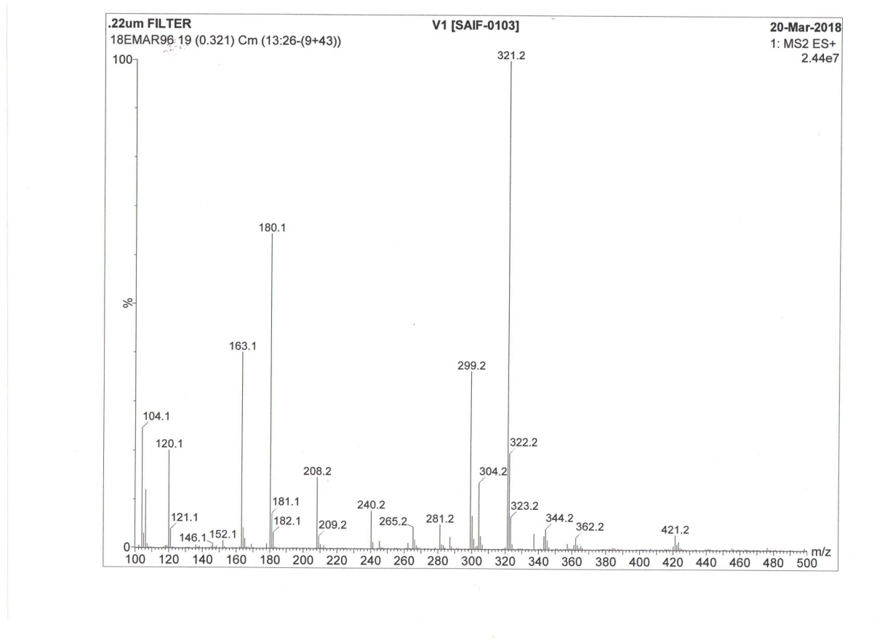



**1H NMR of Compd. (4a)**

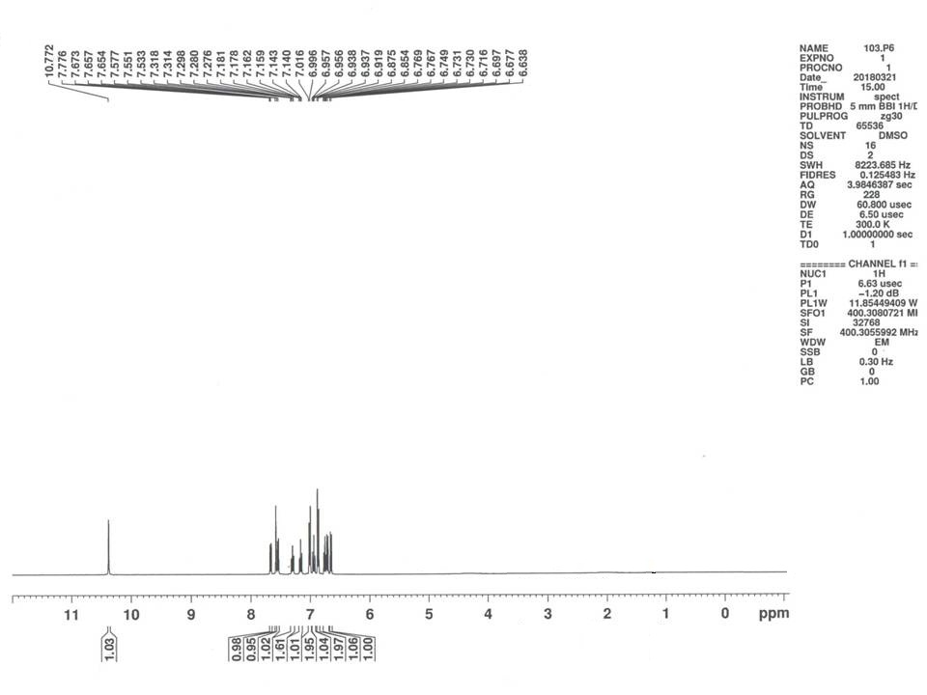



**13C NMR of Comp. (4a)**

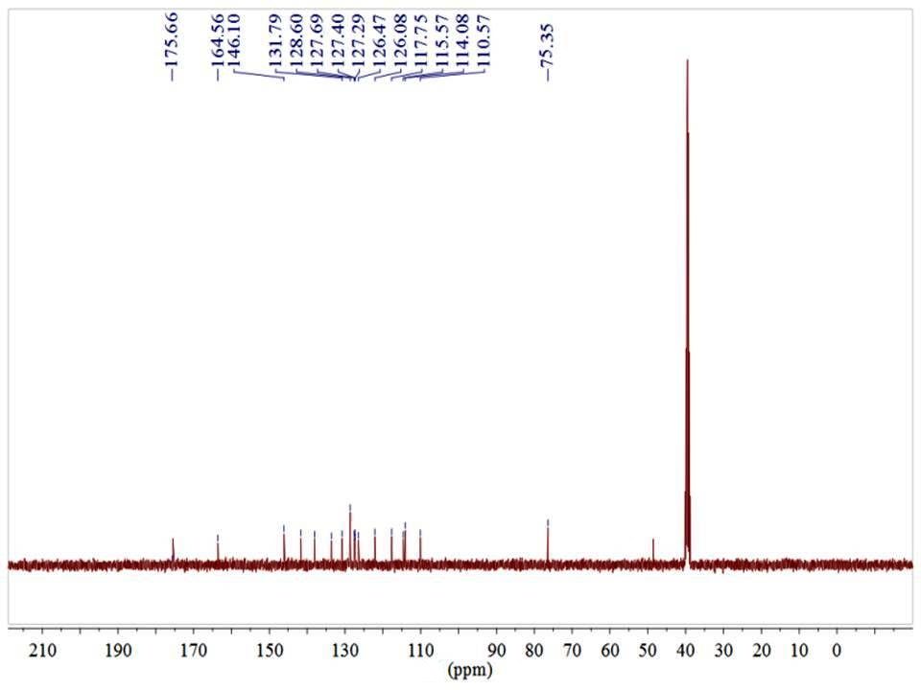



**IR of Comp. (4b)**





**1H NMR of (4b)**

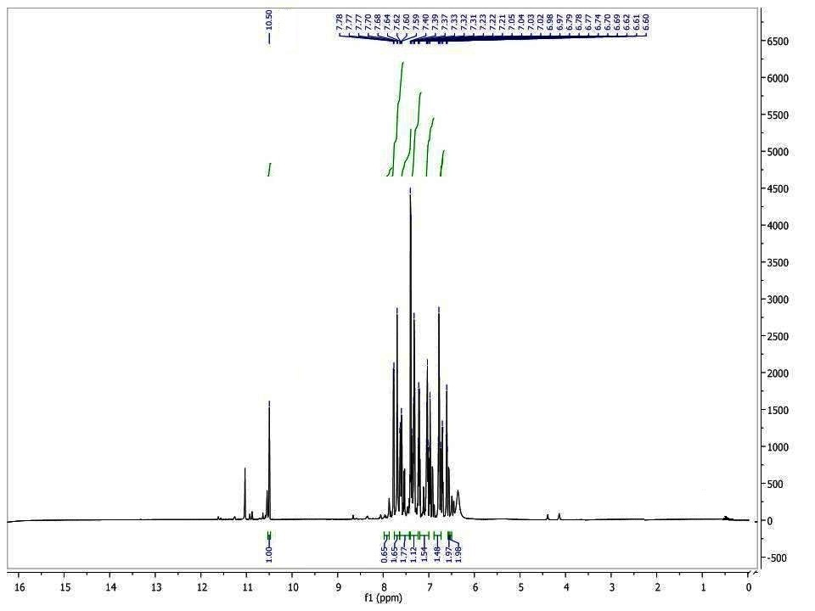



**13C NMR of (4b)**





**IR of Compd. (4c)**





**1H NMR of Compd. (4c)**





**13C NMR of Compd. (4c)**





**IR of Compd. (4h)**





**Mass of Compd. (4h)**

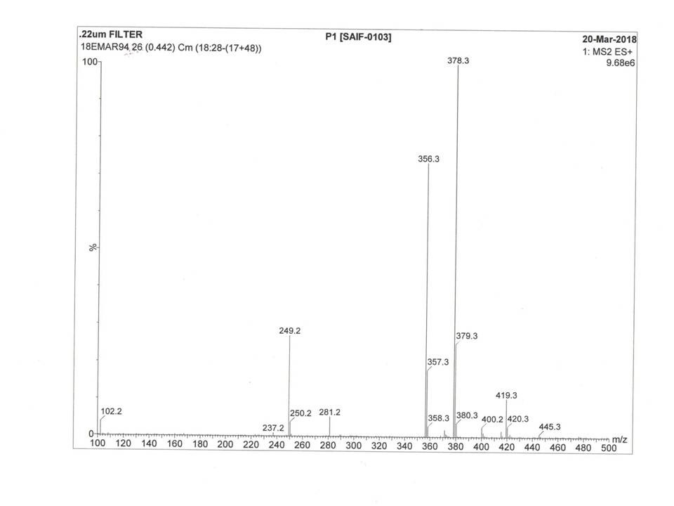



**1H NMR of Comp. (4h)**

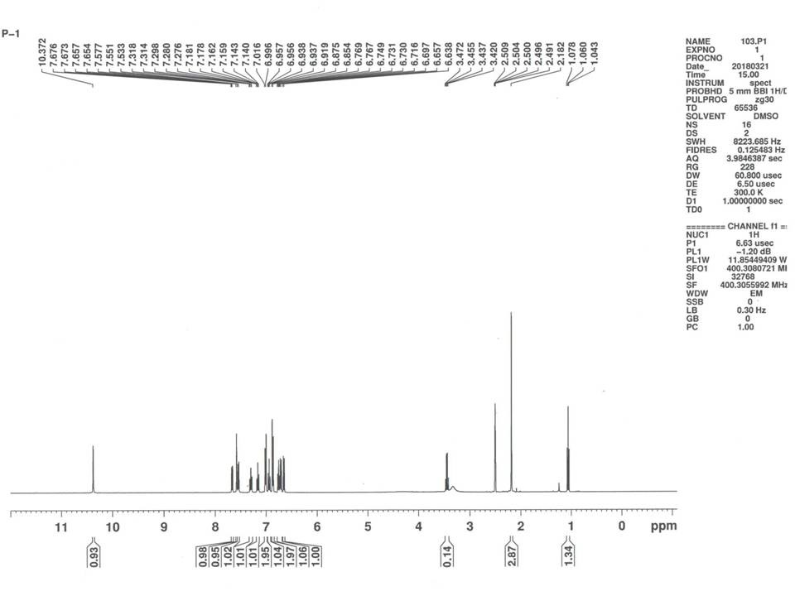



**13C NMR of Comp. (4h)**

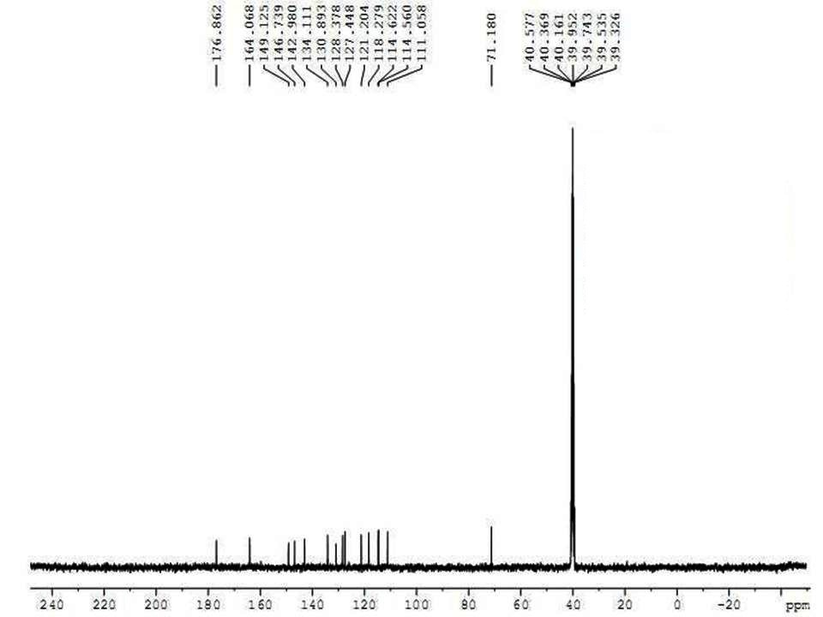



**IR of Compd. (4i)**





**1H NMR of Comp. (4i)**

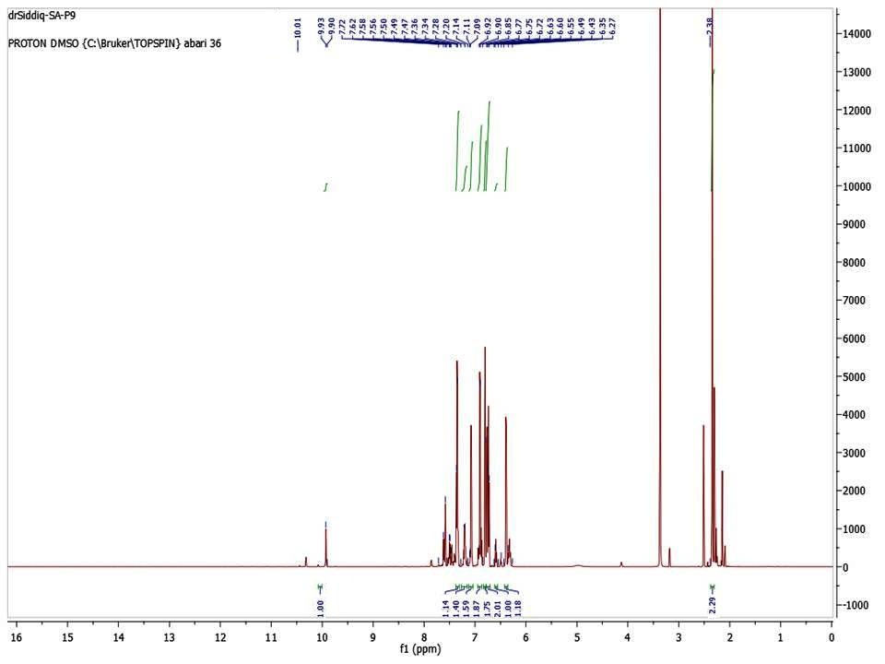



**13C NMR of Comp. (4i)**

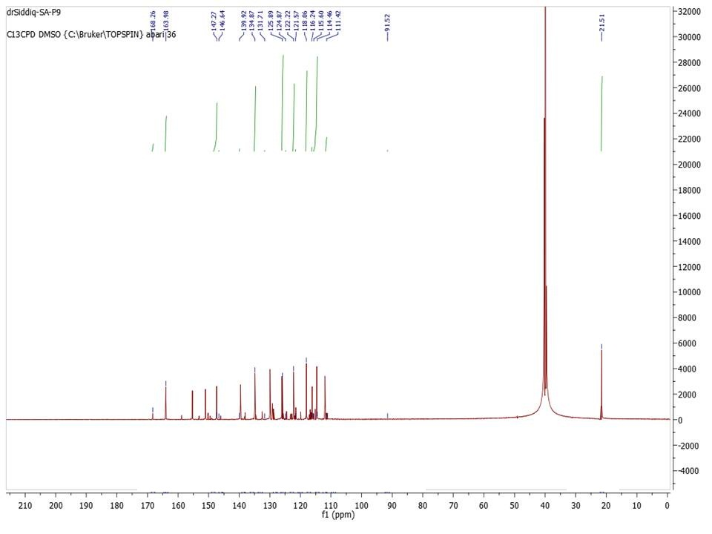



**IR of Compd. (4o)**





**1H NMR of Compd. (4o)**

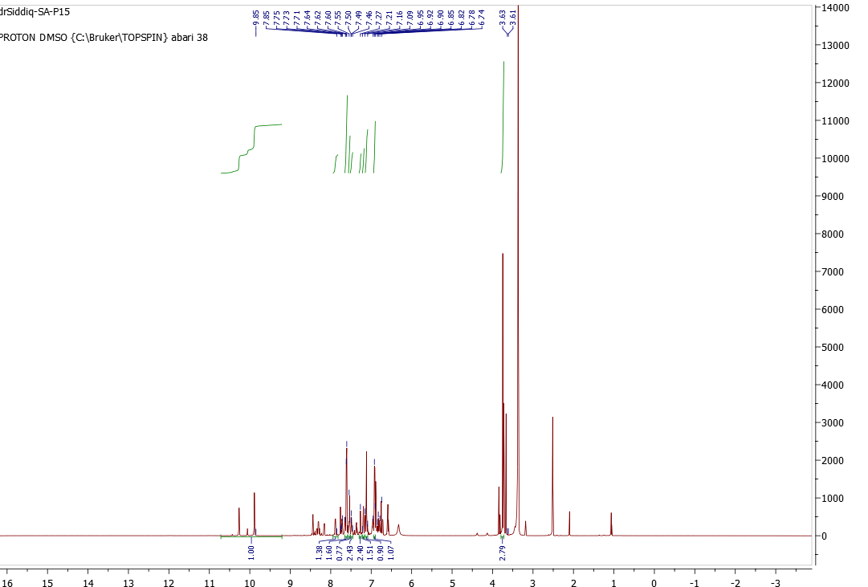



**13C NMR of Compd. (4o)**

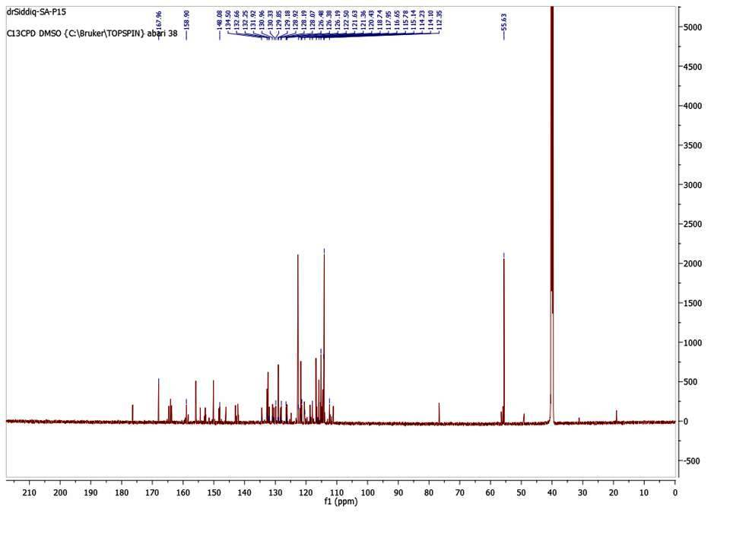



**IR of Compd. (4p)**





**1H NMR of Compd. (4p)**

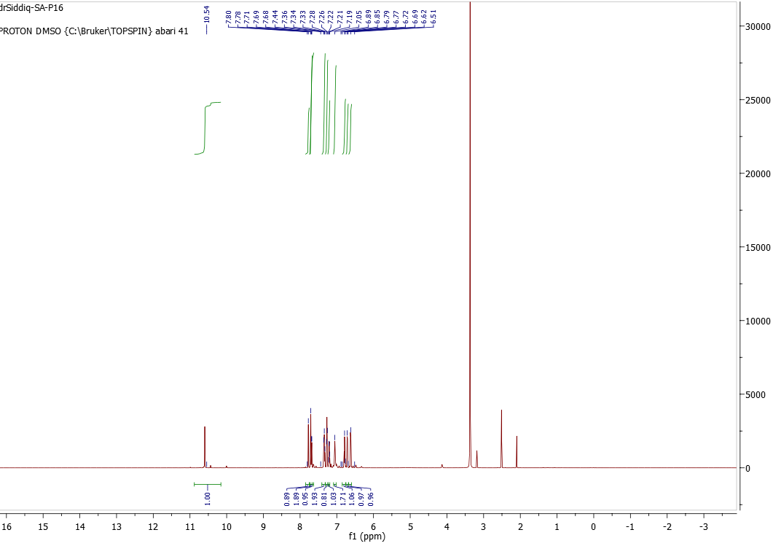



**13C NMR of Compd. (4p)**





**IR of Compd. (4q)**





**1H NMR of Compd. (4q)**

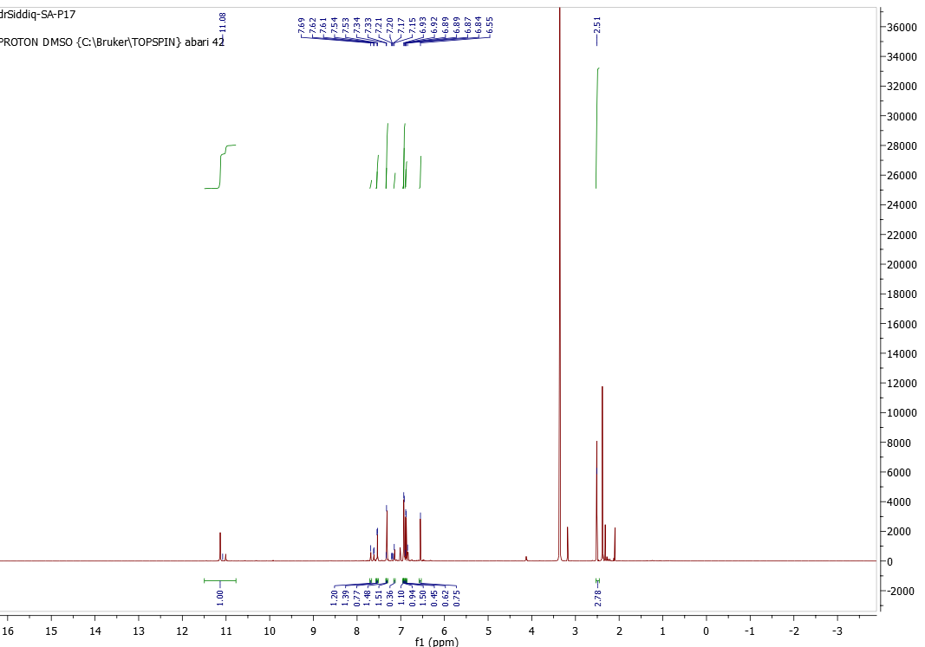



**13C NMR of Compd. (4q)**





**IR of Compd. (4r)**





**1H NMR of Compd. (4r)**

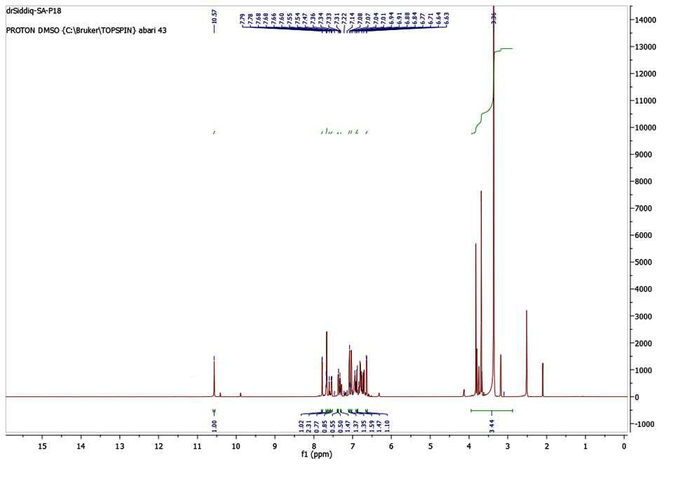



**13C NMR of Compd. (4r)**

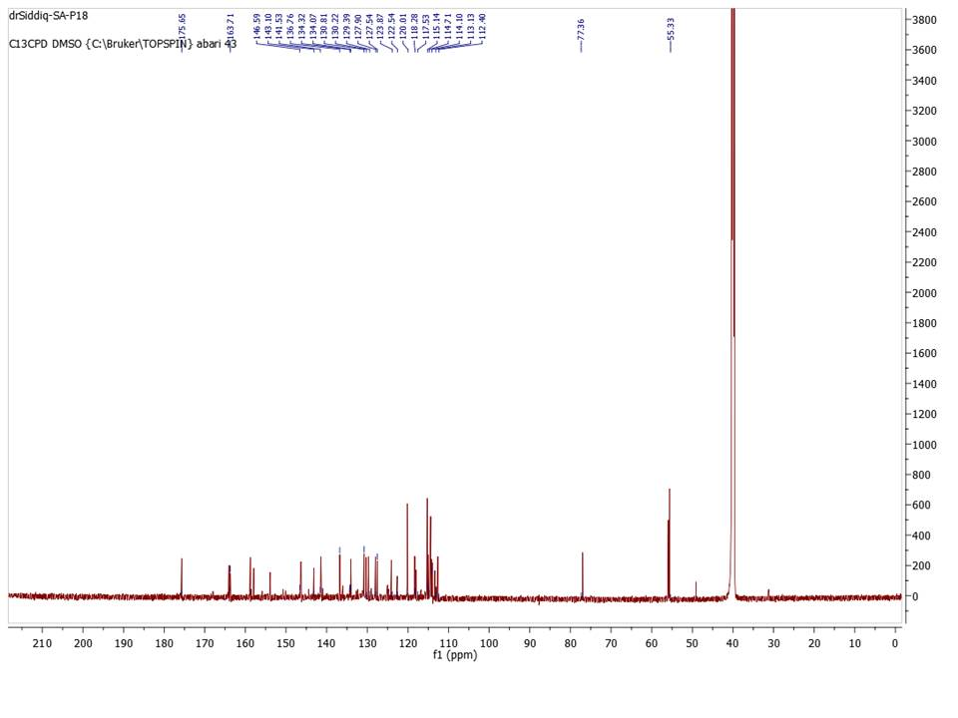



**IR of Comp. (7a)**





**1H NMR of Compd. (7a)**

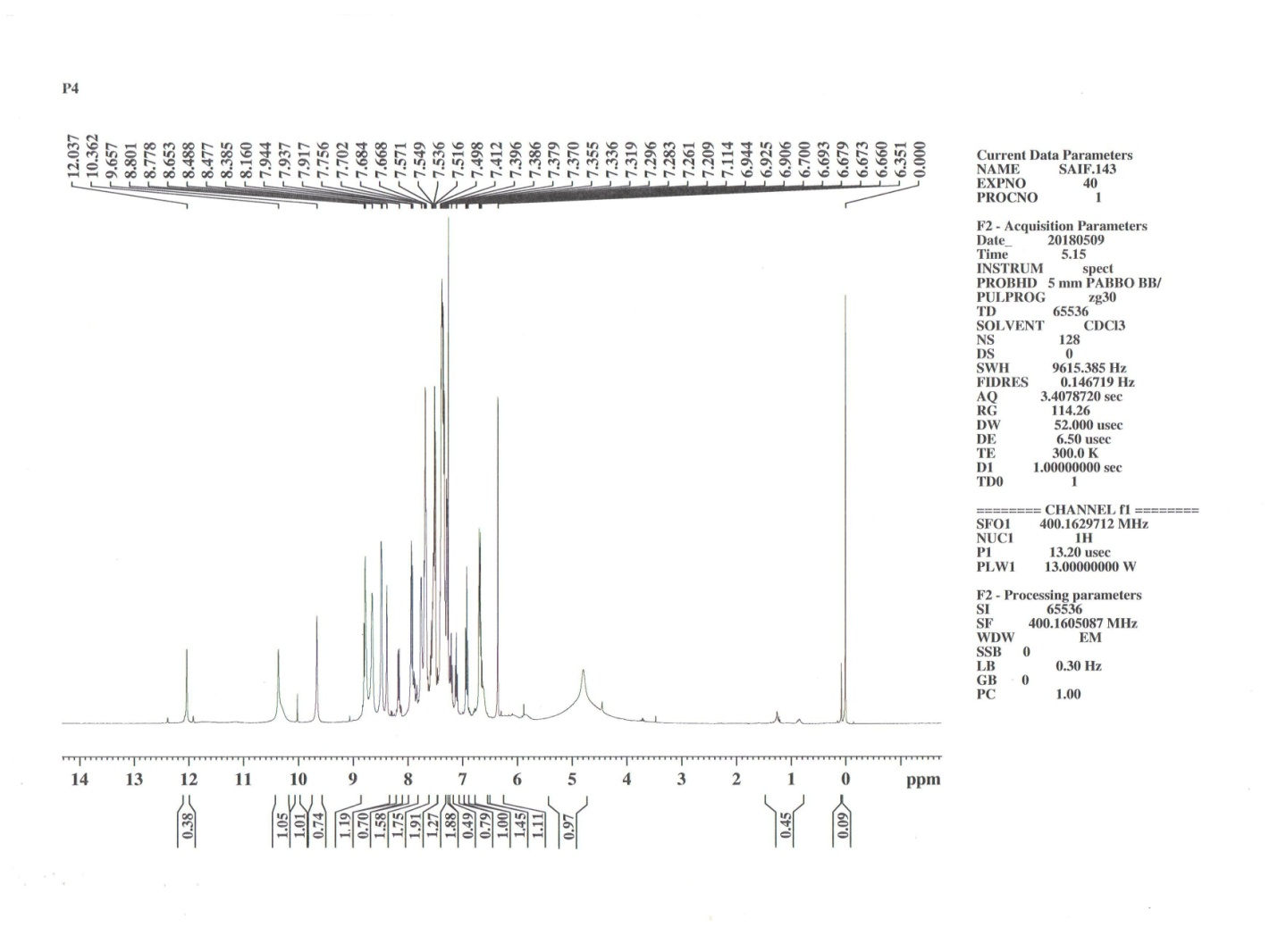



**Mass of Compd. (7a)**

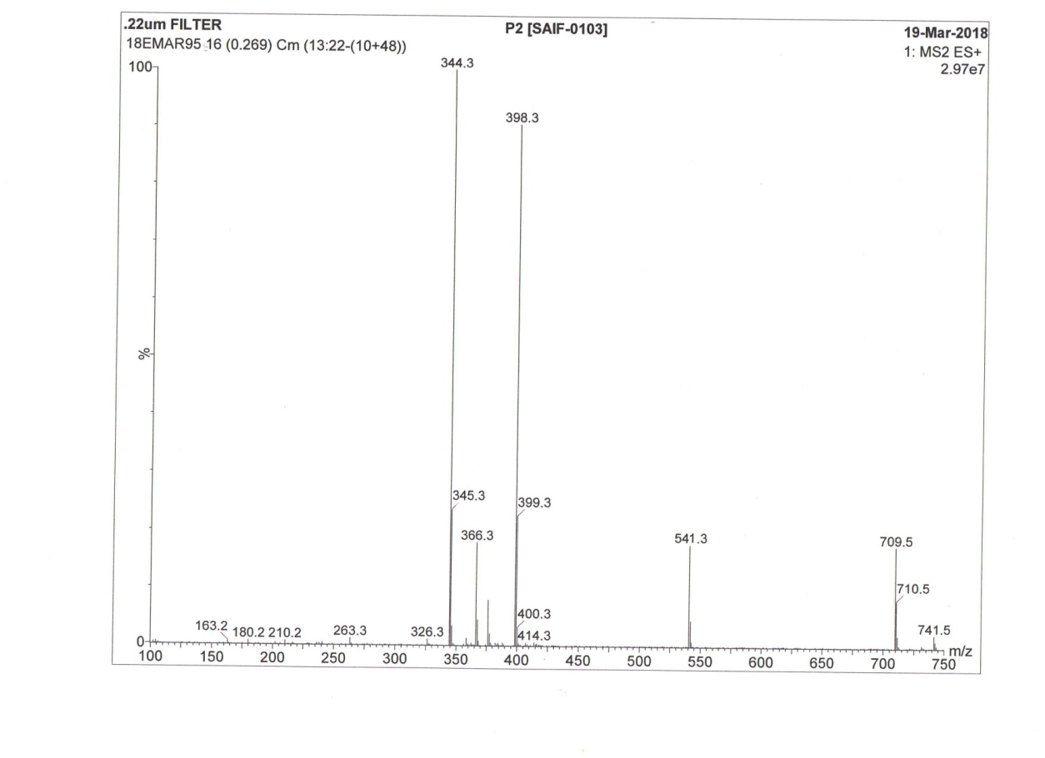



**IR of Comp. (7b)**





**1H NMR of Compd. (7b)**

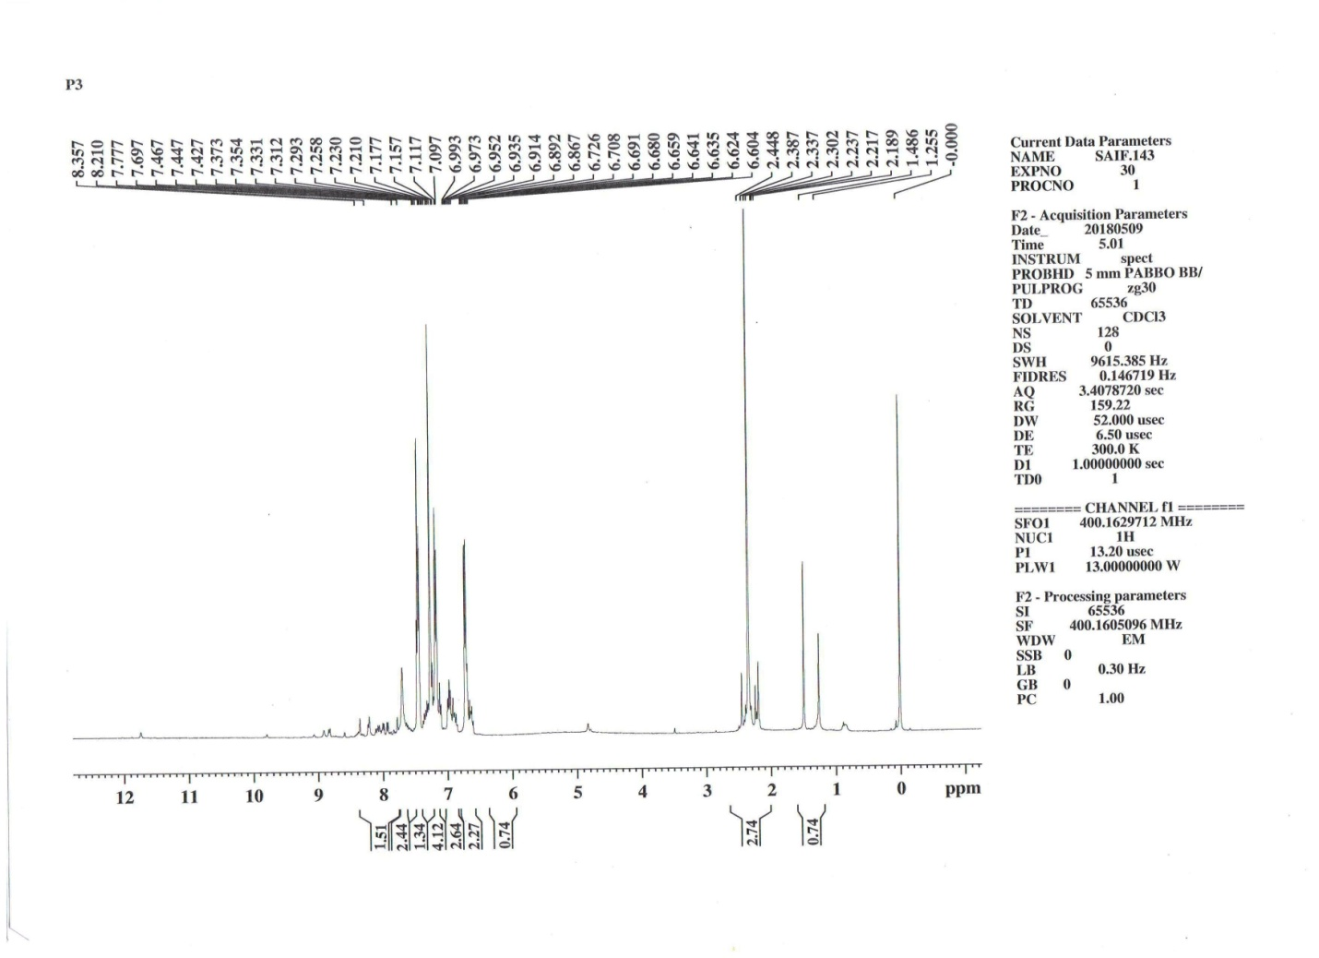



**Mass of Compd. (7b)**

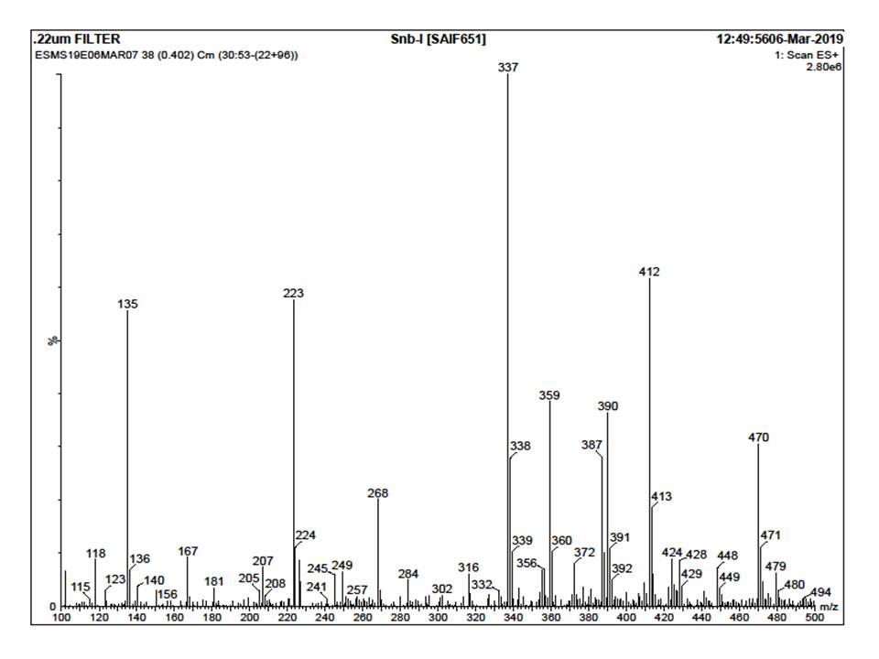



**IR of Comp. (7c)**





**1H NMR of Compd. (7c)**

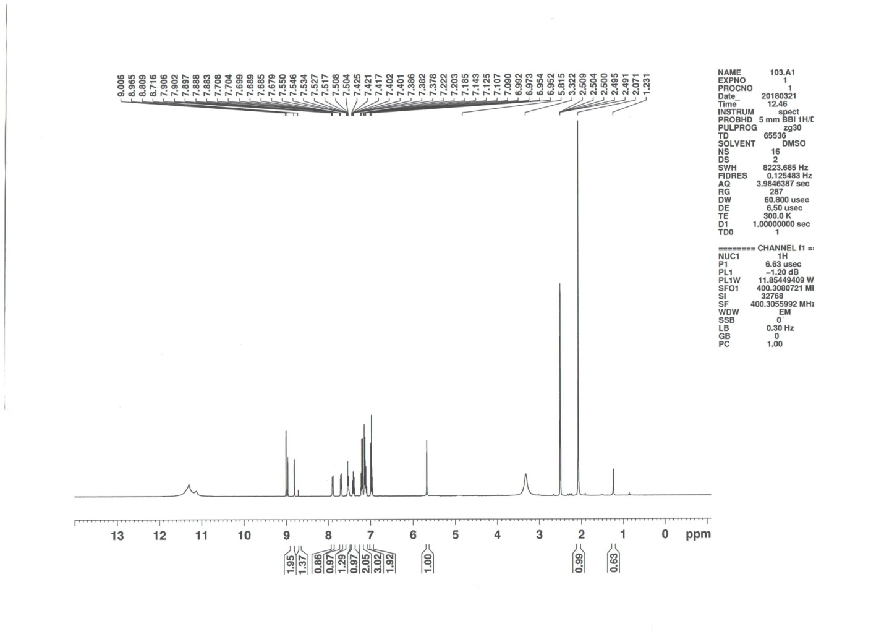



**Mass of Compd. (7c)**

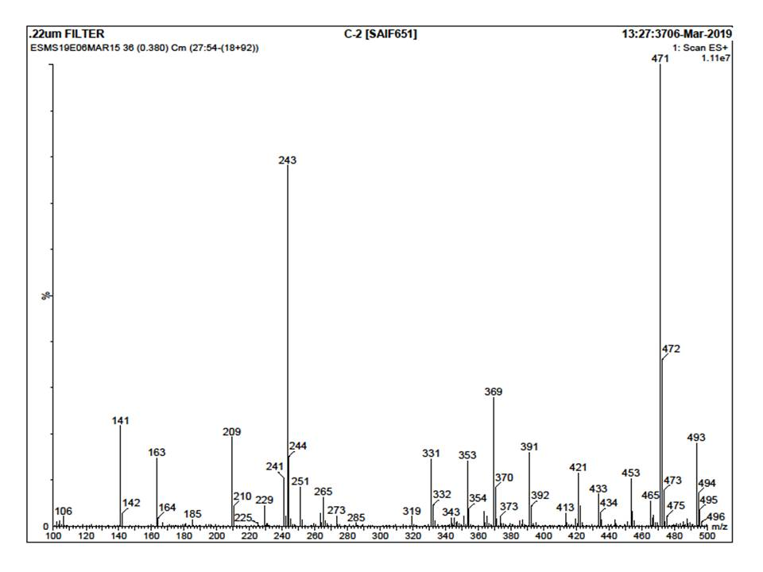



**IR of Comp. (7g)**





**1H NMR of Compd. (7g)**

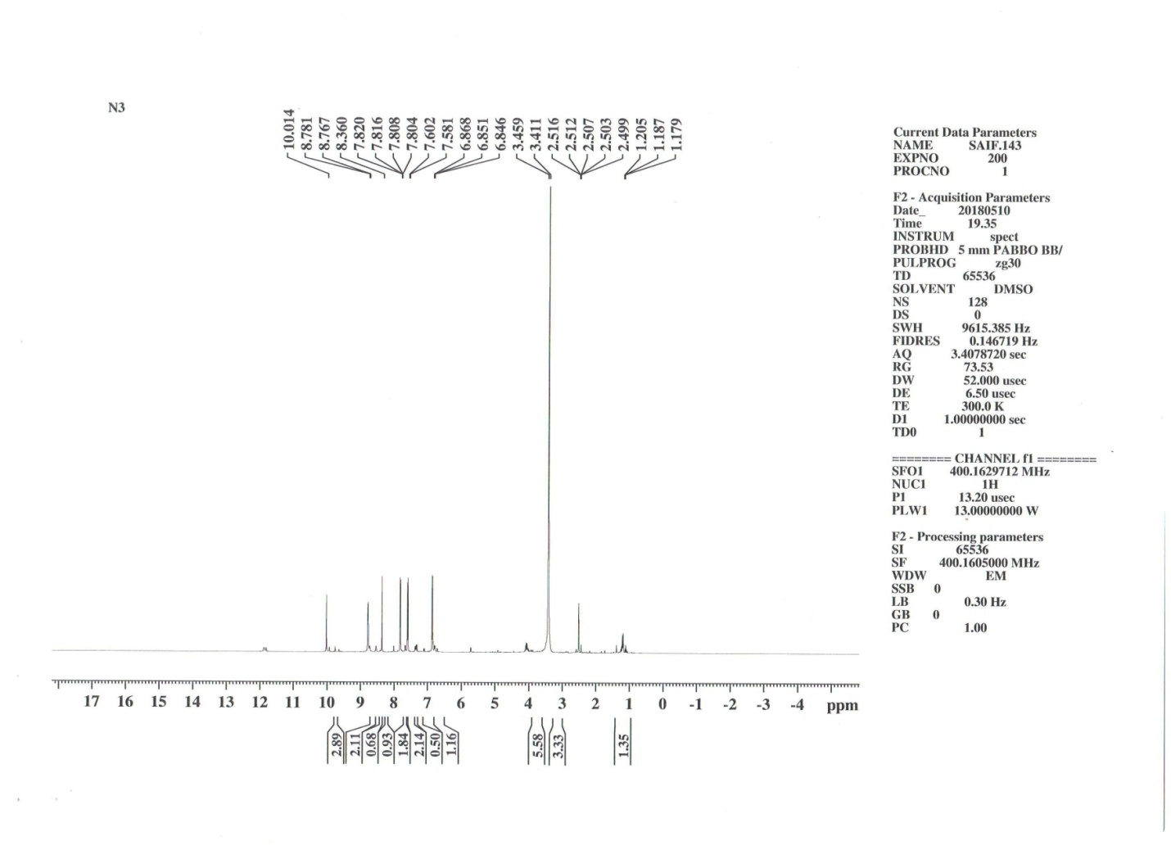



**Mass of Compd. (7g)**



