One-Pot Synthesis of Substituted Dibenzoxazepinones and Pyridobenzoxazepinones Using Octacarbonyldicobalt as an Effective CO Source
Kavitha,^{a,b} Poongavanam Baburajan,^{b,}* Nagaswarupa H. Puttappa,^{c,}* and Sujit Kumar Sarkar ^{b}
ª Bharathiar University, Coimbatore, India- 641046
^{b} Syngene International Limited, Bangalore, India- 560000
^{c} PG Department of Chemistry, Davangere University, Davangere, India- 577002
*E-mail:
baburajan29@gmail.com and nagaswarupa77@gmail.com
Table of contents
- Experimental section 2
- Analytical data 3
- References 11
- ¹H and ¹³C NMR spectra 12

1. Experimental section
1.1 General procedure for the synthesis of substituted dibenzoxazepinones: A sealed tube equipped with a magnetic stir bar was charged with the corresponding 1-bromo -2-fluoro (or chloro) benzene/ 1-fluoro-2-iodobenzene (1 mmol), amino phenol (1 mmol), Pd(OAc)₂ (5 mol%), xantphos (5 mol%) and DBU (2.5 mmol). The tube was purged with argon. Then DMF (10 V) was added followed by the addition of Co₂(CO)₈ (0.25 mmol). The tube was closed with seal plug instantly. The reaction tube was placed in a pre heated oil bath at 150 ⁰C for 16 h. On completion, the reaction mixture was cooled to room temperature, added water and ethyl acetate (1:1). Precipitated solid was filtered through a Celite bed. The bed was washed thoroughly with ethyl acetate. Organic layer was separated. Aqueous layer extracted with EtOAc. The combined organic layers were washed with water, brine, dried over anhydrous sodium sulphate. Organic layer was concentrated under reduced pressure and purified by flash column chromatography on silica gel (230-400 mesh) with ethyl acetate and petroleum ether as eluent to afford the corresponding dibenzoxazepinones.
1.2 General procedure for the synthesis of substituted pyridobenzoxazepinones:
Method A: A sealed tube equipped with a magnetic stir bar was charged with the corresponding 3-bromo-2-fluoropyridine (1 mmol), amino phenol (1 mmol), Pd(OAc)₂ (5 mol%), xantphos (5 mol%) and DMAP (2.5 mmol). The tube was purged with argon. Then DMF (10V) was added followed by the addition of Co₂(CO)₈ (0.25 mmol). The tube was closed with seal plug instantly. The reaction tube was placed in a preheated oil bath at 120 ⁰C for 8 h. On completion, the reaction mixture was cooled to room temperature, added water and ethyl acetate (1:1). Precipitated solid was filtered through a Celite bed. The bed was washed thoroughly with ethyl acetate. Organic layer was separated. Aqueous layer extracted with EtOAc. The combined organic layers were washed with water, brine, dried over anhydrous sodium sulphate. Organic layer was concentrated under reduced pressure and purified by flash column chromatography on silica gel (230-400 mesh) with ethyl acetate and petroleum ether as eluent to afford the corresponding pyridobenzoxazepinone.
Method B: A sealed tube equipped with a magnetic stir bar was charged with the corresponding 3-bromo-2-chloropyridine (1 mmol), amino phenol (1 mmol), Pd(OAc)₂ (5 mol%), xantphos (5 mol%) and DBU (2.5 mmol). The tube was purged with argon. Then DMF (10 V) was added followed by the addition of Co₂(CO)₈ (0.25 mmol). The tube was closed with seal plug instantly. The reaction tube was placed in a pre heated oil bath at 135 ⁰C for 12 h. On completion, the reaction mixture was cooled to room temperature, added water and ethyl acetate (1:1). Precipitated solid was filtered through a Celite bed. The bed was washed thoroughly with ethyl acetate. Organic layer was separated. Aqueous layer extracted with EtOAc. The combined organic layers were washed with water, brine, dried over anhydrous sodium sulphate. Organic layer was concentrated under reduced pressure and purified by flash column chromatography on silica gel (230-400 mesh) with ethyl acetate and petroleum ether as eluent to afford the corresponding pyridobenzoxazepinone.
2. Analytical data
dibenzo[b,f][1,4]oxazepin-11(10H)-one (3a)^{[1, 2, 3]}
Following the general procedure using 1-bromo-2-fluorobenzene (175 mg, 1 mmol) and 2-aminophenol (110 mg, 1 mmol) provided 188 mg (89% yield) of 3a as a white solid. ¹H-NMR (400 MHz, DMSO-d₆): δ 10.54 (s, 1H), 7.77 (dd, J = 1.60, 7.80 Hz, 1H), 7.64-7.59 (m, 1H), 7.36-7.30 (m, 3H), 7.19-7.11 (m, 3H); ¹³C-NMR (100 MHz, CDCl₃): δ 167.5, 159.7, 150.9, 134.5, 132.0, 130.6, 125.9, 125.8, 125.2, 125.1, 121.7, 121.3, 120.8; LCMS (APCI-MS) calcd. for C₁₃H₉NO₂: 211.06, found [M+H]⁺ = 212.4.
7-methyldibenzo[b,f][1,4]oxazepin-11(10H)-one (3b)^{[2]}
Following the general procedure using 1-bromo-2-fluorobenzene (175 mg, 1 mmol) and 2-amino-5-methylphenol (123 mg, 1 mmol) provided 204 mg (91% yield) of 3b as a white solid. Following the general procedure using 1-bromo-2-chlorobenzene (190 mg, 1 mmol) and 2-amino-5-methylphenol (123 mg, 1 mmol) provided 178 mg (79% yield) of 3b as a white solid. ¹H-NMR (400 MHz, DMSO-d6): δ 10.44 (s, 1H), 7.77-7.74 (m, 1H), 7.62-7.58 (m, 1H), 7.34-7.28 (m, 2H), 7.15 (s, 1H), 7.05-7.03 (m, 1H), 6.99-6.97 (m, 1H), 2.25 (s, 3H); ¹³C-NMR (100 MHz, DMSO-d₆): 166.2, 159.4, 150.8, 135.4, 134.7, 131.8, 128.9, 126.8, 126.3, 125.8, 121.9, 121.8, 121.1, 20.6; LCMS (APCI-MS) calcd. for C₁₄H₁₁NO₂: 225.08, found (M+H)⁺ = 226.4.
8-chloroldibenzo[b,f][1,4]oxazepin-11(10H)-one (3c)^{[2]}
Following the general procedure using 1-bromo-2-fluorobenzene (175 mg, 1 mmol) and 2-amino-4-chlorophenol (143 mg, 1 mmol) provided 215 mg (88% yield) of 3c as a white solid. ¹H-NMR (400 MHz, DMSO-d₆): δ 10.64 (s, 1H), 7.79 (dd, J = 1.72, 7.76 Hz, 1H), 7.67-7.63 (m, 1H), 7.40-7.33 (m, 3H), 7.21-7.19 (m, 2H); ¹³C-NMR (75 MHz, DMSO-d₆): δ 165.9, 158.9, 149.5, 135.1, 133.2, 131.9, 129.9, 126.1, 125.9, 125.2, 123.4, 121.5, 121.1; LCMS (APCI-MS) calcd. for C₁₃H₈ClNO₂: 245.02, found (M-H)⁺ = 244.4.
2-fluorodibenzo[b,f][1,4]oxazepin-11(10H)-one (3d)^{[2]}
Following the general procedure using 2-bromo-1,4-difluorobenzene (192 mg, 1 mmol) and 2-aminophenol (109 mg, 1 mmol) provided 165 mg (72% yield) of 3d as a white solid. ¹H-NMR (400 MHz, DMSO-d₆): δ 10.67 (s, 1H), 7.51-7.46 (m, 2H), 7.44-7.41 (m, 1H), 7.35-7.33 (m, 1H), 7.22-7.13 (m, 3H); ¹³C-NMR (100 MHz, DMSO-d₆): δ 165.0, 160.5, 158.1, 155.6, 150.9, 131.4, 127.7, 126.6, 125.9, 123.2, 122.2, 121.7, 117.6; LCMS (APCI-MS) calcd. for C₁₃H₈FNO₂: 229.05, found (M+H)⁺ = 230.2.
7-chloroldibenzo[b,f][1,4]oxazepin-11(10H)-one (3e)^{[4]}
Following the general procedure using 1-bromo-2-fluorobenzene (175 mg, 1 mmol) and 2-amino-5-chlorophenol (143 mg, 1 mmol) provided 208 mg (85% yield) of 3e as a white solid. ¹H-NMR (400 MHz, DMSO-d₆): δ 10.64 (s, 1H), 7.78 (dd, J = 1.64, 7.68 Hz, 1H), 7.64 (ddd, J = 1.82, 7.30, 8.20 Hz 1H), 7.52 (d, J = 2.40 Hz, 1H), 7.40-7.33 (m, 2H), 7.29 (dd, J = 2.36, 8.54 Hz, 1H), 7.18 (d, J = 8.56 Hz, 1H); ¹³C-NMR (100 MHz, DMSO-d₆): δ 165.9, 158.9, 151.1, 135.1, 131.9, 130.9, 128.8, 126.5, 126.3, 125.9, 123.2, 121.9, 121.2; LCMS (APCI-MS) calcd. for C₁₃H₈ClNO₂: 245.02, found (M+H)⁺ = 246.2.
2-methyldibenzo[b,f][1,4]oxazepin-11(10H)-one (3f)^{[2]}
Following the general procedure using 2-bromo-1-fluoro-4-methylbenzene (188 mg, 1 mmol) and 2-aminophenol (109 mg, 1 mmol) provided 206 mg (92% yield) of 3f as a white solid. Following the general procedure using 1-fluoro-2-iodo-4-methylbenzene (236 mg, 1 mmol) and 2-aminophenol (109 mg, 1 mmol) provided 202 mg (90% yield) of 3f as a white solid. ¹H-NMR (400 MHz, DMSO-d₆): δ 10.47 (s, 1H), 7.56 (d, J = 1.20 Hz, 1H), 7.40 (dd, J = 1.20, 8.20 Hz, 1H), 7.30 (d, J = 7.20 Hz, 1H), 7.22 (d, J = 8.00 Hz, 1H), 7.17-7.10 (m, 3H), 2.30 (s, 3H); ¹³C-NMR (100 MHz, DMSO-d₆): δ 166.3, 157.3, 151.0, 135.2, 135.1, 131.7, 131.6, 126.3, 125.7, 125.6, 122.0, 121.6, 120.8, 20.5; LCMS (APCI-MS) calcd. for C₁₄H₁₁NO₂: 225.08, found (M+H)⁺ = 226.4.
2, 8-dimethyldibenzo[b,f][1,4]oxazepin-11(10H)-one (3g)^{[2]}
Following the general procedure using 2-bromo-1-fluoro-4-methylbenzene (188 mg, 1 mmol) and 2-amino-4-methylphenol (123 mg, 1 mmol) provided 215 mg (90% yield) of 3g as a white solid. Following the general procedure using 2-bromo-1-chloro-4-methylbenzene (204 mg, 1 mmol) and 2-amino-4-methylphenol (123 mg, 1 mmol) provided 176 mg (74% yield) of 3g as a white solid. ¹H-NMR (400 MHz, DMSO-d₆): δ 10.42 (s, 1H), 7.56 (s, 1H), 7.40 (d, J = 7.60 Hz, 1H), 7.19 (t, J = 8.80 Hz, 2H), 6.94-6.91 (m, 2H), 2.31 (s, 3H), 2.24 (s, 3H); ¹³C-NMR (100 MHz, DMSO-d₆): δ 166.4, 157.4, 148.9, 135.5, 135.1, 134.9, 131.7, 131.3, 126.0, 125.8,122.2, 121.3, 120.7, 20.8, 20.6; LCMS (APCI-MS) calcd. for C₁₅H₁₃NO₂: 239.09, found (M+H)⁺ = 240.4.
3-methoxydibenzo[b,f][1,4]oxazepin-11(10H)-one (3h)^{[5]}
Following the general procedure using 1-bromo-2-fluoro-4-methoxybenzene (204 mg, 1 mmol) and 2-aminophenol (109 mg, 1 mmol) provided 173 mg (72% yield) of 3h as a white solid. Following the general procedure using 2-fluoro-1-iodo-4-methoxybenzene (252 mg, 1 mmol) and 2-aminophenol (109 mg, 1 mmol) provided 180 mg (75% yield) of 3h as a white solid. ¹H-NMR (400 MHz, DMSO-d₆): δ 10.34 (s, 1H), 7.72 (d, J = 8.80 Hz, 1H), 7.33 (d, J = 7.60 Hz, 1H), 7.19-7.11 (m, 3H), 6.92 (d, J = 2.40 Hz, 1H), 6.89 (dd, J = 2.40, 8.80 Hz, 1H),, 3.85 (s, 3H); ¹³C-NMR (100 MHz, DMSO-d₆): δ 165.9, 164.5, 160.7, 150.4, 133.1, 131.8, 126.4, 125.4, 121.9, 121.8, 118.2, 112.3, 105.8, 56.3; LCMS (APCI-MS) calcd. for C₁₄H₁₁NO₃: 241.07, found (M+H)⁺ = 242.4.
3-methoxy-8-methyldibenzo[b,f][1,4]oxazepin-11(10H)-one (3i)
Following the general procedure using 1-bromo-2-fluoro-4-methoxybenzene (204 mg, 1 mmol) and 2-amino-4-methylphenol (123 mg, 1 mmol) provided 194 mg (76% yield) of 3i as a white solid. ¹H-NMR (400 MHz, DMSO-d₆): δ 10.30 (s, 1H), 7.69 (d, J = 8.40 Hz, 1H), 7.18 (d, J = 8.00 Hz, 1H), 6.95-6.85 (m, 4H), 3.83 (s, 3H), 2.23 (s, 3H); ¹³C-NMR (100 MHz, DMSO-d₆): δ 166.0, 164.4, 160.8, 148.3, 135.6, 133.1, 131.4, 125.8, 122.1, 121.5, 118.3, 112.1, 105.7, 56.3, 20.8; LCMS (APCI-MS) calcd. for C₁₅H₁₃NO₃: 255.09, found (M+H)⁺ = 256.4; Anal calc. for C₁₅H₁₃NO₃: C, 70.58; H, 5.13; N, 5.49%, found C, 70.56; H, 5.14; N, 5.49%.
3-methoxy-9-methyldibenzo[b,f][1,4]oxazepin-11(10H)-one (3j)
Following the general procedure using 1-bromo-2-fluoro-4-methoxybenzene (204 mg, 1 mmol) and 2-amino-3-methylphenol (123 mg, 1 mmol) provided 204 mg (80% yield) of 3j as a white solid. ¹H-NMR (400 MHz, DMSO-d₆): δ 9.74 (s, 1H), 7.65 (d, J = 8.40 Hz, 1H), 7.19 (t, J = 4.80 Hz, 1H), 7.04 (d, J = 0.80 Hz, 2H), 6.91 (d, J = 2.40 Hz, 1H), 6.87 (dd, J = 2.40, 8.80 Hz, 1H), 3.82 (s, 3H), 2.32 (s, 3H); ¹³C-NMR (100 MHz, DMSO-d₆): δ 166.1, 164.2, 161.3, 152.5, 132.8, 131.7, 130.2, 127.9, 125.6, 119.4, 118.7, 112.4, 105.6, 56.3, 18.3; LCMS (APCI-MS) calcd. for C₁₅H₁₃NO₃: 255.09, found (M+H)⁺ = 256.4. Anal calc. for C₁₅H₁₃NO₃: C, 70.58; H, 5.13; N, 5.49% found C, 70.56; H, 5.14; N, 5.49%.
2, 9-dimethyldibenzo[b,f][1,4]oxazepin-11(10H)-one (3k)^{[2]}
Following the general procedure using 2-bromo-1-fluoro-4-methylbenzene (187 mg, 1 mmol) and 2-amino-3-methylphenol (123 mg, 1 mmol) provided 184 mg (77% yield) of 3k as a white solid.¹H -NMR (400 MHz, DMSO-d₆): δ 9.91 (s, 1H), 7.51 (d, J = 2.00 Hz, 1H), 7.37 (dd, J = 2.00, 8.40 Hz, 1H), 7.21-7.15 (m, 2H), 7.04 (d, J = 5.20 Hz, 2H), 02.31 (s, 3H), 2.29 (s, 3H); ¹³C-NMR (100 MHz, DMSO-d₆): δ 166.6, 157.9, 153.2, 135.2, 134.9, 131.9, 131.5, 130.0, 127.8, 126.3, 125.8, 120.6, 119.6, 20.6, 18.3; LCMS (APCI-MS) calcd. for C₁₅H₁₃NO₂: 239.09, found (M+H)⁺ = 240.4.
benzo[b]pyrido[3,2-f][1,4]oxazepin-5(6H)-one (7a)^{[6]}
Following the general procedure using 3-bromo-2-fluoropyridine (175 mg, 1 mmol) and 2-aminophenol (109 mg, 1 mmol) provided 161 mg (76% yield) of 7a as a white solid. Following the general procedure using 3-bromo-2-chloropyridine (190 mg, 1 mmol) and 2-aminophenol (109 mg, 1 mmol) provided 174 mg (82% yield) of 7a as a white solid. ¹H-NMR (400 MHz, DMSO-d₆): δ 10.75 (s, 1H), 8.51 (dd, J = 1.96, 4.74 Hz, 1H), 8.28 (dd, J = 1.92, 7.58 Hz, 1H), 7.47 (dd, J = 4.80, 7.56 Hz, 1H), 7.36-7.34 (m, 1H), 7.26-7.16 (m, 3H); ¹³C-NMR (100 MHz, DMSO-d₆): δ 164.4, 162.4, 152.5, 148.2, 142.5, 130.6, 126.5, 125.6, 122.6, 121.9, 121.8, 120.1; LCMS (APCI-MS) calcd. for C₁₂H₈N₂O₂: 212.05, found [M+H]⁺ = 213.2.
8-chlorobenzo[b]pyrido[3,2-f][1,4]oxazepin-5(6H)-one (7b)^{[6]}
Following the general procedure using 3-bromo-2-fluoropyridine (175 mg, 1 mmol) and 2-amino-4-chlorophenol (143 mg, 1 mmol) provided 172 mg (70% yield) of 7b as a white solid. Following the general procedure using 3-bromo-2-chloropyridine (190 mg, 1 mmol) and 2-amino-4-chlorophenol (143 mg, 1 mmol) provided 160 mg (65% yield) of 7b as a white solid. ¹H-NMR (400 MHz, DMSO-d₆): δ 10.84 (s, 1H), 8.53 (dd, J = 2.00, 4.76 Hz, 1H), 8.29 (dd, J = 2.04, 7.58 Hz, 1H), 7.49 (dd, J = 4.80, 7.58 Hz, 1H), 7.39-7.37 (m, 1H), 7.244 -7.21 (m, 2H); ¹³C-NMR (100 MHz, DMSO-d₆): δ 164.7, 162.4, 153.1, 147.2, 143.0, 132.5, 130.4, 125.6, 124.0, 123.3, 121.6, 120.3; LCMS (APCI-MS) calcd. for C₁₂H₇ClN₂O₂: 246.02, found (M+H)⁺ = 247.0.
9-chlorobenzo[b]pyrido[3,2-f][1,4]oxazepin-5(6H)-one (7c)^{[6]}
Following the general procedure using 3-bromo-2-fluoropyridine (175 mg, 1 mmol) and 2-amino-5-chlorophenol (143 mg, 1 mmol) provided 191 mg (78% yield) of 7c as a yellow solid. Following the general procedure using 3-bromo-2-chloropyridine (190 mg, 1 mmol) and 2-amino-5-chlorophenol (143 mg, 1 mmol) provided 177 mg (72% yield) of 7c as a yellow solid. ¹H-NMR (400 MHz, DMSO-d₆): δ 10.83 (s, 1H), 8.52 (dd, J = 2.00, 4.80 Hz, 1H), 8.28 (dd, J = 2.00, 7.60 Hz, 1H), 7.50-7.45 (m, 2H), 7.33 (dd, J = 2.40, 8.80 Hz, 1H), 7.20 (d, J = 8.40 Hz, 1H); ¹³C-NMR (100 MHz, DMSO-d₆): δ 164.6, 162.3, 153.0, 148.8, 143.0, 130.3, 129.2, 126.9, 123.4, 123.4, 122.4, 120.3; LCMS (APCI-MS) calcd. for C₁₂H₇ClN₂O₂: 246.02, found (M+H)⁺ = 247.2.
8, 9-dichlorobenzo[b]pyrido[3,2-f][1,4]oxazepin-5(6H)-one (7d)
Following the general procedure using 3-bromo-2-fluoropyridine (175 mg, 1 mmol) and 2-amino-4,5-dichlorophenol (177 mg, 1 mmol) provided 190 mg (68% yield) of 7d as a white solid. Following the general procedure using 3-bromo-2-chloropyridine (190 mg, 1 mmol) and 2-amino-4,5-dichlorophenol (177 mg, 1 mmol) provided 157 mg (56% yield) of 7d as a white solid. ¹H-NMR (400 MHz, DMSO-d₆): δ 10.91 (s, 1H), 8.54 (dd, J = 2.00, 4.80 Hz, 1H), 8.30 (dd, J = 2.00, 7.60 Hz, 1H), 7.72 (s, 1H), 7.53-7.42 (m, 1H), 7.42 (s, 1H); ¹³C-NMR (100 MHz, DMSO-d₆): δ 164.5, 161.9, 153.2, 147.4, 143.2, 131.6, 128.8, 127.1, 124.2, 123.5, 122.9, 120.2; LCMS (APCI-MS) calcd. for C₁₂H₆Cl₂N₂O₂: 279.98, found (M-H)⁺ = 279.4; Anal calc. for C₁₂H₆Cl₂N₂O_{2:} C, 51.27; H, 2.15; N, 9.97%, found C, 51.25; H, 2.17; N, 9.98%.
9-methylbenzo[b]pyrido[3,2-f][1,4]oxazepin-5(6H)-one (7e)^{[6]}
Following the general procedure using 3-bromo-2-fluoropyridine (175 mg, 1 mmol) and 2-amino-5-methylphenol (123 mg, 1 mmol) provided 198 mg (88% yield) of 7e as a white solid. Following the general procedure using 3-bromo-2-chloropyridine (190 mg, 1 mmol) and 2-amino-5-methylphenol (123 mg, 1 mmol) provided 183 mg (81% yield) of 7e as a white solid. ¹H-NMR (400 MHz, DMSO-d₆): δ 10.66 (s, 1H), 8.50 (dd, J = 2.00, 4.80 Hz, 1H), 8.26 (dd, J = 2.00, 7.40 Hz, 1H), 7.46 (dd, J = 4.80, 7.60 Hz, 1H), 7.17 (s, 1H), 7.09-7.05 (m, 2H), 2.27 (s, 3H); ¹³C-NMR (100 MHz, DMSO-d₆): δ 164.9, 162.9, 152.8, 148.5, 142.8, 135.9, 128.3, 127.3, 122.9, 122.6, 121.9, 120.7, 20.6; LCMS (APCI-MS) calcd. for C₁₃H₁₀N₂O₂: 226.07, found (M+H)⁺ = 227.4.
3-methylbenzo[b]pyrido[3,2-f][1,4]oxazepin-5(6H)-one (7f)^{[6]}
Following the general procedure using 3-bromo-2-chloro-5-methylpyridine (205 mg, 1 mmol) and 2-aminophenol (109 mg, 1 mmol) provided 151 mg (67% yield) of 7f as a white solid. ¹H-NMR (400 MHz, DMSO-d₆): δ 10.70 (s, 1H), 8.32 (d, J = 2.00 Hz, 1H), 8.08 (d, J = 2.00 Hz, 1H), 7.33 (d, J = 8.00 Hz, 1H), 7.23-7.14 (m, 3H), 2.32 (s, 3H); ¹³C-NMR (100 MHz, DMSO-d₆): δ 165.1, 161.1, 152.6, 148.8, 142.7, 132.4, 131.1, 126.7, 126.0, 122.3, 122.2, 119.7, 17.3; LCMS (APCI-MS) calcd. for C₁₃H₁₀N₂O₂: 226.07, found (M+H)⁺ = 227.4.
8-chloro-3-methylbenzo[b]pyrido[3,2-f][1,4]oxazepin-5(6H)-one (7g)^{[6]}
Following the general procedure using 3-bromo-2-chloro-5-methylpyridine (205 mg, 1 mmol) and 2-amino-4-chlorophenol (143 mg, 1 mmol) provided 190 mg (73% yield) of 7g as a white solid. ¹H-NMR (400 MHz, DMSO-d₆): δ 10.79 (s, 1H), 8.33 (s, 1H), 8.09 (s, 1H), 7.36 (d, J = 8.40 Hz, 1H), 7.23-7.20 (m, 2H), 2.33 (s, 3H); ¹³C-NMR (100 MHz, DMSO-d₆): δ 164.8, 160.6, 152.8, 147.4, 142.8, 132.7, 132.6, 130.2, 125.5, 123.9, 121.6, 119.5, 17.3; LCMS (APCI-MS) calcd. for C₁₃H₉ClN₂O₂: 260.03, found (M+H)⁺ = 261.2.
3,9-dimethylbenzo[b]pyrido[3,2-f][1,4]oxazepin-5(6H)-one (7h)^{[6]}
Following the general procedure using 3-bromo-2-chloro-5-methylpyridine (205 mg, 1 mmol) and 2-amino-5-methylphenol (123 mg, 1 mmol) provided 170 mg (71% yield) of 7h as a pale yellow solid. ¹H-NMR (400 MHz, DMSO-d₆): δ 10.60 (s, 1H), 8.31 (s, 1H), 8.06 (d, J = 2.40 Hz, 1H), 7.15 (s, 1H), 7.06-7.03 (m, 2H), 2.32 (s, 3H), 2.27 (s, 3H); ¹³C-NMR (100 MHz, DMSO-d₆): δ 164.6, 160.7, 152.1, 148.3, 142.2, 135.4, 131.9, 127.9, 126.8, 122.1, 121.5, 119.4, 20.2, 16.9; LCMS (APCI-MS) calcd. for C₁₄H₁₂N₂O₂: 240.09, found (M+H)⁺ = 241.4.
2-methylbenzo[b]pyrido[3,2-f][1,4]oxazepin-5(6H)-one (7i)^{[6]}
Following the general procedure using 3-bromo-2-chloro-6-methylpyridine (205 mg, 1 mmol) and 2-aminophenol (109 mg, 1 mmol) provided 158 mg (70% yield) of 7i as a white solid. ¹H-NMR (400 MHz, DMSO-d₆): δ 10.65 (s, 1H), 8.15 (d, J = 7.72 Hz, 1H), 7.35-7.30 (m, 2H), 7.25-7.14 (m, 3H), 2.49 (s, 3H, overlapped by the solvent residual peak of DMSO-d₆); ¹³C-NMR (100 MHz,CDCl₃): δ 166.3, 163.4, 162.5, 148.6, 142.8, 129.9, 126.3, 126.2, 122.7, 121.4, 121.3, 116.5, 24.3; LCMS (APCI-MS) calcd. for C₁₃H₁₀N₂O₂: 226.07, found (M+H)⁺ = 227.4.
2, 9-dimethylbenzo[b]pyrido[3,2-f][1,4]oxazepin-5(6H)-one (7j)^{[6]}
Following the general procedure using 3-bromo-2-chloro-6-methylpyridine (205 mg, 1 mmol) and 2-amino-5-methylphenol (123 mg, 1 mmol) provided 175 mg (73% yield) of 7j as a white solid. ¹H-NMR (400 MHz, DMSO-d₆): δ 10.55 (s, 1H), 8.13 (d, J = 8.00 Hz, 1H), 7.30 (d, J = 7.60 Hz, 1H), 7.17 (s, 1H), 7.07-7.01 (m, 2H), 2.50 (s, 3H, overlapped by the solvent residual peak of DMSO-d6), 2.27 (s, 3H); ¹³C-NMR (100 MHz, DMSO-d₆): δ 165.0, 162.8, 162.2, 148.4, 142.8, 135.7, 128.4, 128.3, 127.2, 122.6, 122.1, 121.9, 117.5, 24.2, 20.5; LCMS (APCI-MS) calcd. for C₁₄H₁₂N₂O₂: 240.09, found (M+H)⁺ = 241.4.
5-(4-Methylpiperazin-1-yl)-8-chloro-pyrido[2,3-b][1,5]-benzoxazepine (JL 13)^{[7]}
A solution of 8-chlorobenzo[b]pyrido[3,2-f][1,4]oxazepin-5(6H)-one 7b (100 mg, 0.41 mmol) in POCl₃ (2 mL) was heated to reflux for 16 h. On completion, the reaction mixture was cooled to RT; the excess phosphorus oxychloride was removed under reduced pressure. The residue obtained was co evaporated with toluene (2x 10 mL) to afford crude iminochloride as a brown sticky residue which was used without further purification. It was dissolved in toluene (2 mL), and an excess of 1-Methylpiperazine (406 mg, 4.1 mmol) was added. The mixture was heated to reflux for 2 h. The solvent was then evaporated under reduced pressure, and the residue was dissolved in chloroform (15 mL) and washed with water (2× 10 mL), brine (1× 10 mL), dried over anhydrous sodium sulphate filtered through a cotton plug and concentrated under reduced pressure to afford crude. Crude obtained was purified by flash column chromatography on silica gel (230-400 mesh) with MeOH and dichloromethane as eluent to afford 133 mg (75% yield) of JL 13 as beige solid. ¹H-NMR (400 MHz, CDCl₃): δ 8.51 (dd, J = 1.20, 4.60 Hz, 1H), 7.60 (dd, J = 1.20, 8.20 Hz, 1H), 7.43 (dd, J = 4.40, 8.20 Hz, 1H), 7.16 (d, J = 2.80 Hz, 1H), 7.06 (d, J = 8.40 Hz, 1H), 06.91 (dd, J = 2.40, 8.60 Hz, 1H), 3.74-3.73 (m, 4H), 2.60-2.50 (m, 4H), 2.38 (s, 3H); LCMS (APCI-MS) calcd. for C₁₇H₁₇ClN₄O: 328.10, found [M+H]⁺ = 329.0.
3. References
- Yang, Q.; Cao, H.; Robertson, A.; Alper, H. J. Org. Chem. 2010, 75, 6297.
- Shen, C.; Neumann, H.; Wu, X.-F. Green Chem. 2015, 17, 2994.
- Lu, S.-M.; Alper, H. J. Am. Chem. Soc. 2005, 127 (42), 14776
- Kathryn, R.; Holger, P. Envivo Pharmaceuticals, Inc., USA; MethylGene Inc. 2009, WO 2009137462 A2.
- Deraeve, C.; Guo, Z.; Bon, R.S.; Blankenfeldt, W.; DiLucrezia, R.; Wolf, A.; Menninger, S.; Stigter, E. A.; Wetzel, S.; Choidas, A.; Alexandrov, K.; Waldmann, H.; Goody, R. S.; Yao-Wen Wu, Y.-W. J. Am. Chem. Soc. 2012, 134 (17), 7384.
- Shen, C.; Wu, X.-F. Catal. Sci. Technol. 2015, 5(9), 4433.
- Liebgeois, J. -F.; Rogistert, F. A.; Bruhwyler, J.; Damas, J.; Nguyen, T. P.; Inarejos, M. O.; Chleide, E. M. G.; Mercier, M. G. A.; Delarge, J. E. J. Med. Chem. 1994, 37, 519.

4. ¹H and ¹³C NMR spectra
^{I}H NMR of dibenzo[b,f][1,4]oxazepin-11(10H)-one (3a)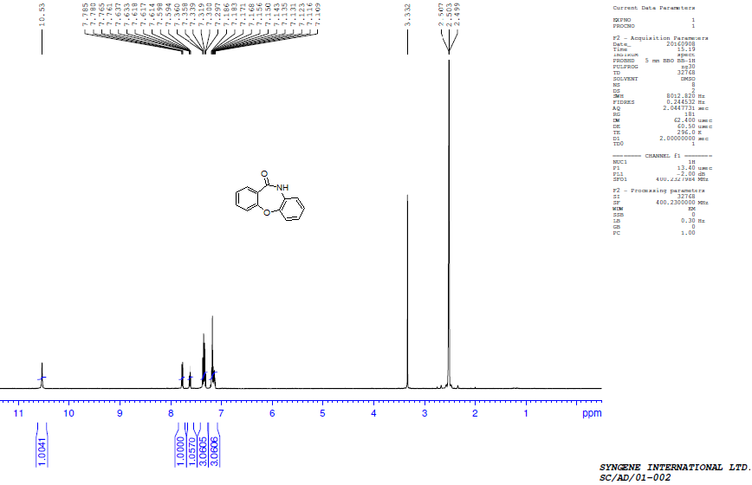
^{I3}C NMR of dibenzo[b,f][1,4]oxazepin-11(10H)-one (3a)
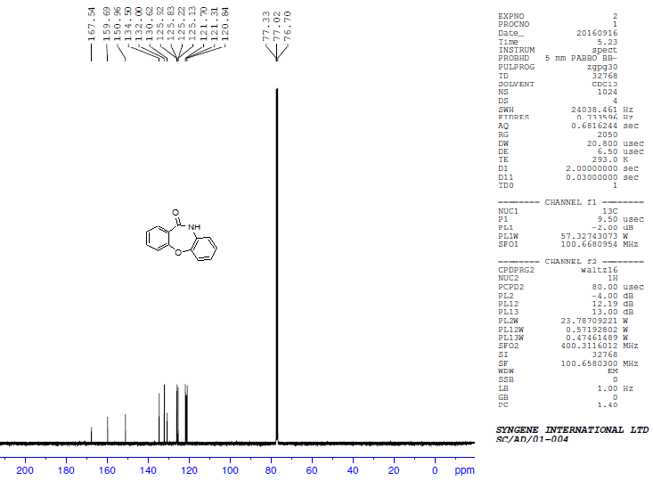
^{I}H NMR of 7-methyldibenzo[b,f][1,4]oxazepin-11(10H)-one (3b)
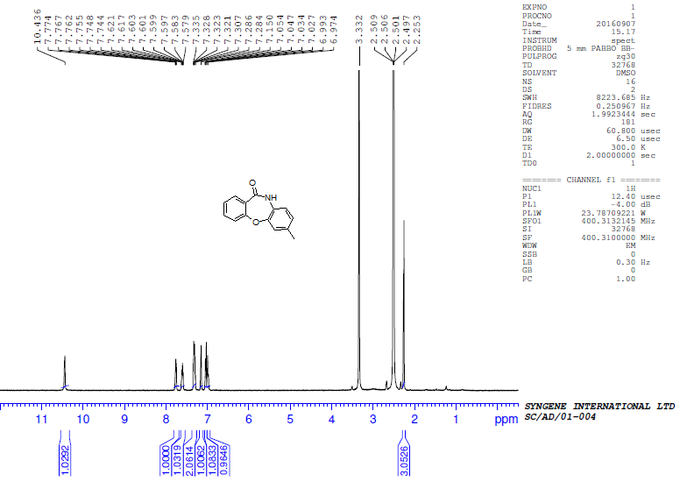

^{I3}C NMR of 7-methyldibenzo[b,f][1,4]oxazepin-11(10H)-one (3b)
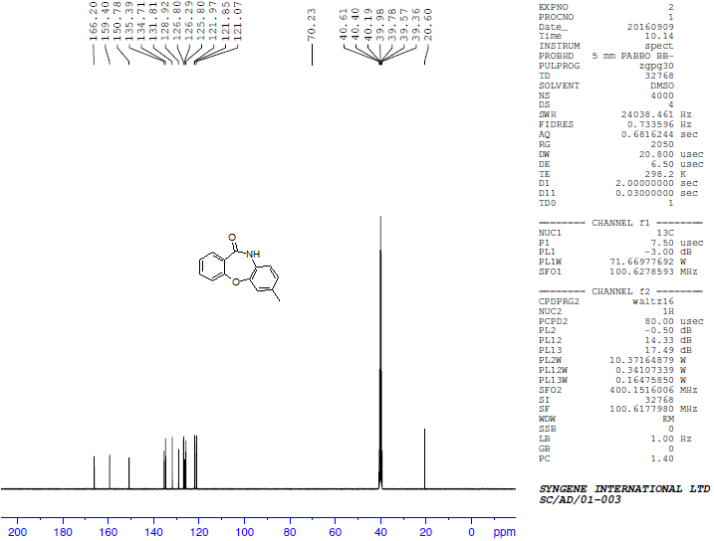

^{I}H NMR of 8-chloroldibenzo[b,f][1,4]oxazepin-11(10H)-one (3c)
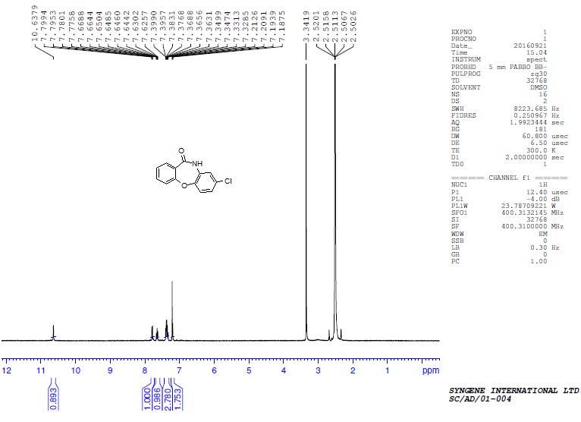
^{I3}C NMR of 8-chloroldibenzo[b,f][1,4]oxazepin-11(10H)-one (3c)
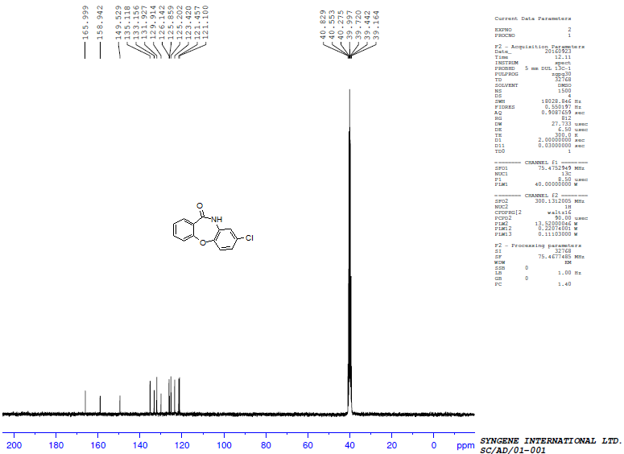
^{I}H NMR of 2-fluorodibenzo[b,f][1,4]oxazepin-11(10H)-one (3d)
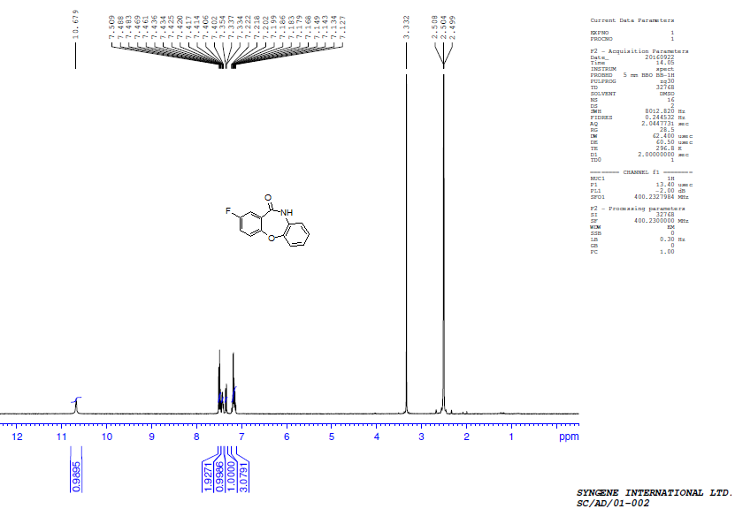
^{I3}C NMR of 2-fluorodibenzo[b,f][1,4]oxazepin-11(10H)-one (3d)
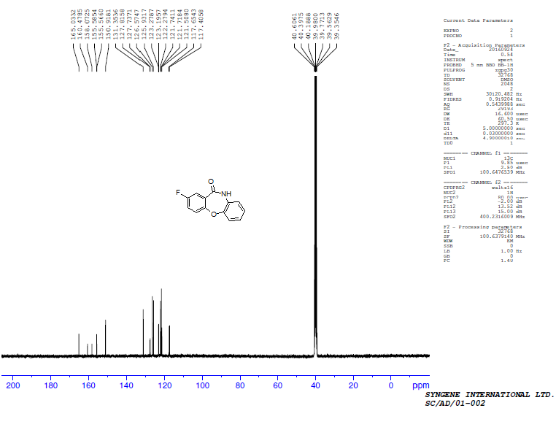
^{I}H NMR of 7-chloroldibenzo[b,f][1,4]oxazepin-11(10H)-one (3e)
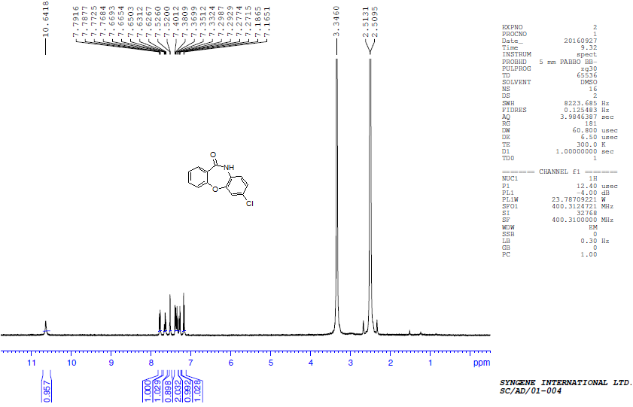

^{I3}C NMR of 7-chloroldibenzo[b,f][1,4]oxazepin-11(10H)-one (3e)
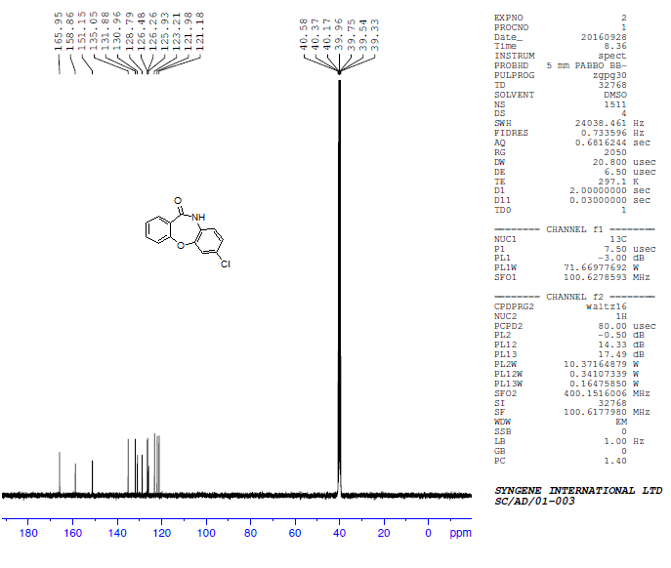
^{I}H NMR of 2-methyldibenzo[b,f][1,4]oxazepin-11(10H)-one (3f)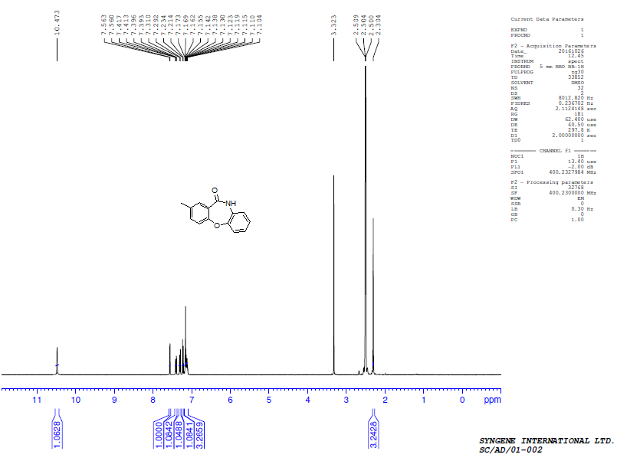
^{I3}C NMR of 2-methyldibenzo[b,f][1,4]oxazepin-11(10H)-one (3f)
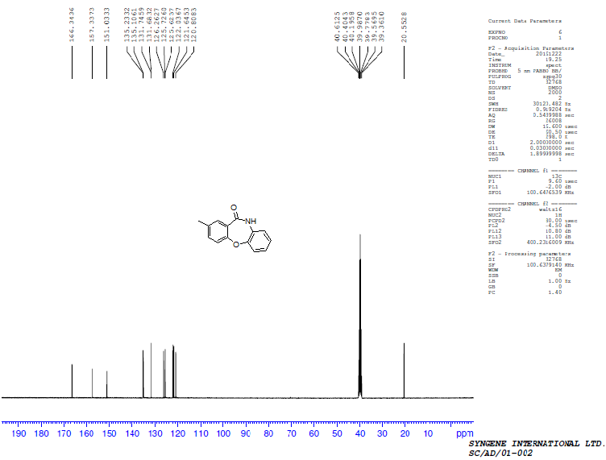
^{I}H NMR of 2, 8-dimethyldibenzo[b,f][1,4]oxazepin-11(10H)-one (3g)
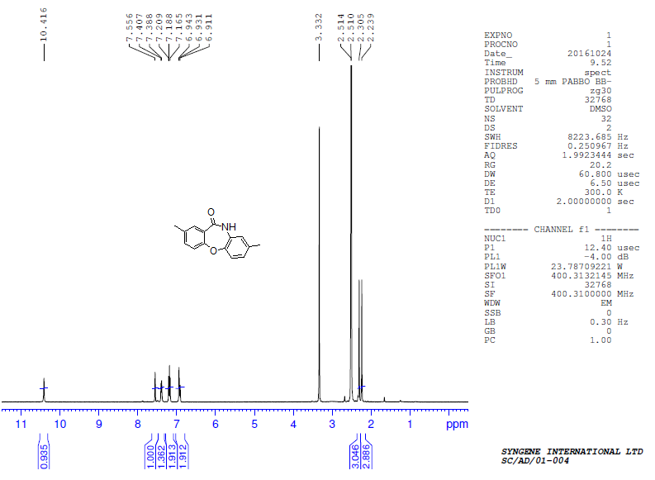
^{I3}C NMR of 2, 8-dimethyldibenzo[b,f][1,4]oxazepin-11(10H)-one (3g)
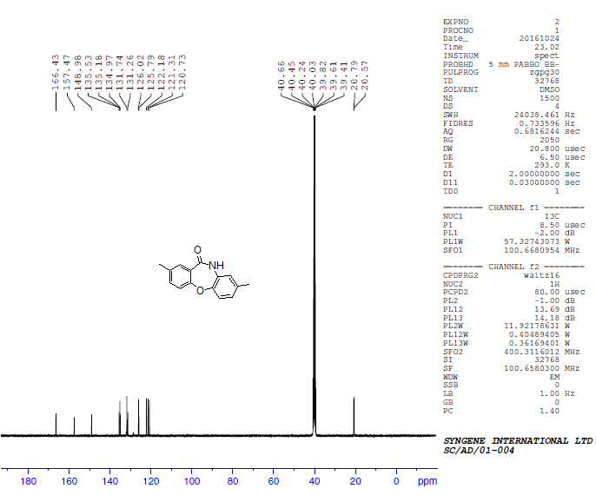
^{I}H NMR of 3-methoxydibenzo[b,f][1,4]oxazepin-11(10H)-one (3h)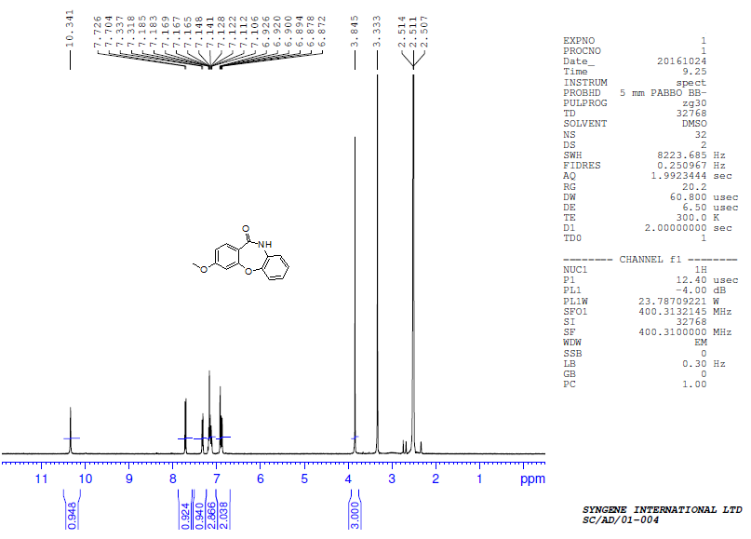
^{I3}C NMR of 3-methoxydibenzo[b,f][1,4]oxazepin-11(10H)-one (3h)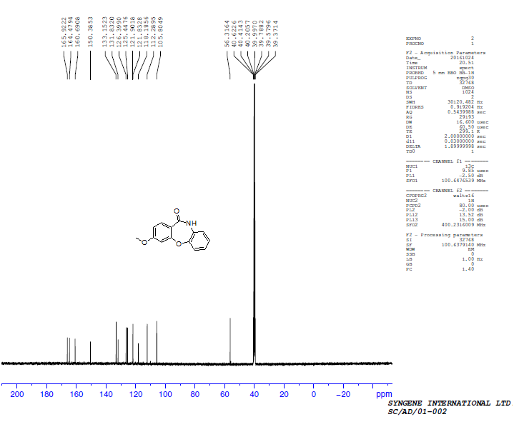
^{I}H NMR of 3-methoxy-8-methyldibenzo[b,f][1,4]oxazepin-11(10H)-one (3i)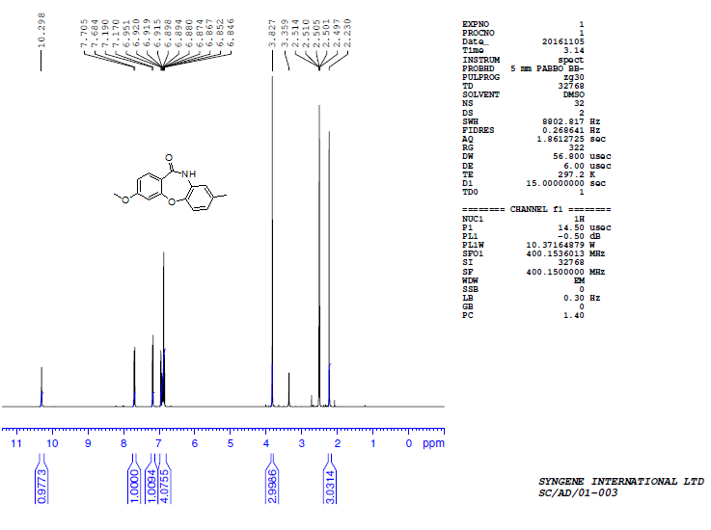

^{I3}C NMR of 3-methoxy-8-methyldibenzo[b,f][1,4]oxazepin-11(10H)-one (3i)
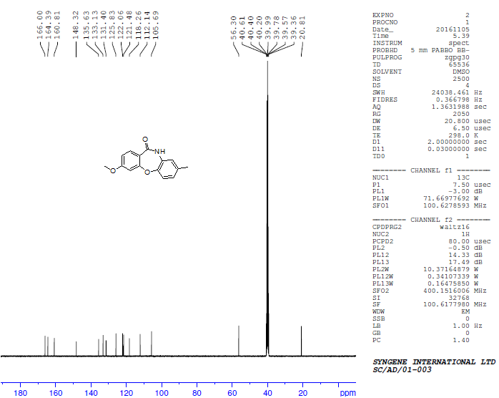
^{I}H NMR of 3-methoxy-9-methyldibenzo[b,f][1,4]oxazepin-11(10H)-one (3j)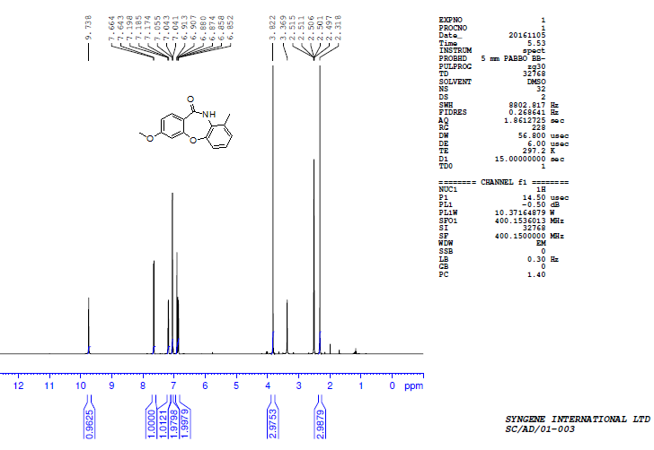

^{I3}C NMR of 3-methoxy-9-methyldibenzo[b,f][1,4]oxazepin-11(10H)-one (3j)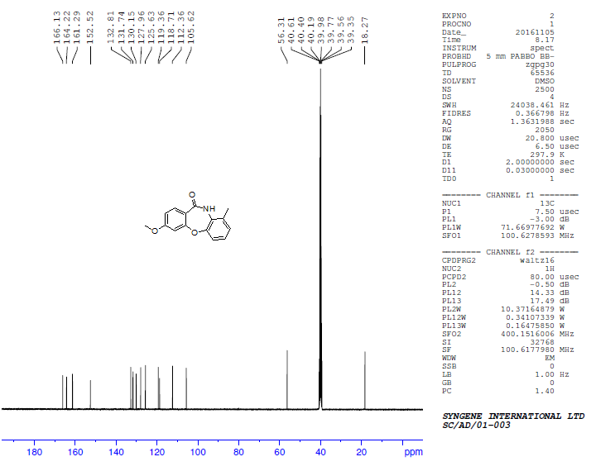

^{I}H NMR of 2, 9-dimethyldibenzo[b,f][1,4]oxazepin-11(10H)-one (3k)
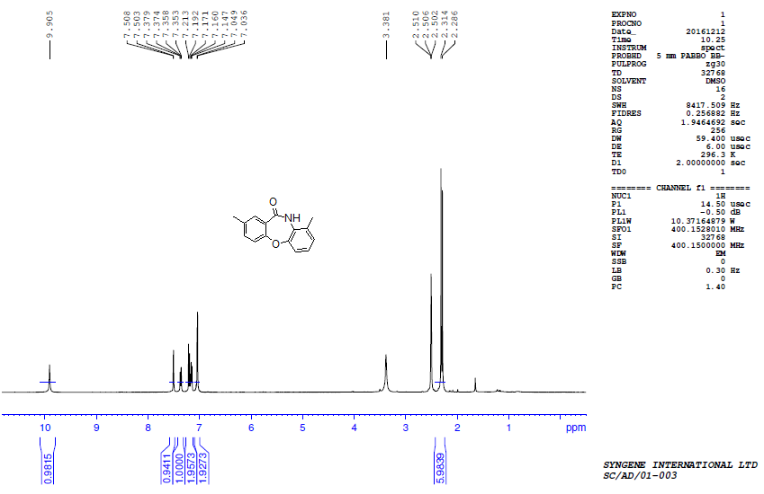

^{I3}C NMR of 2, 9-dimethyldibenzo[b,f][1,4]oxazepin-11(10H)-one (3k)
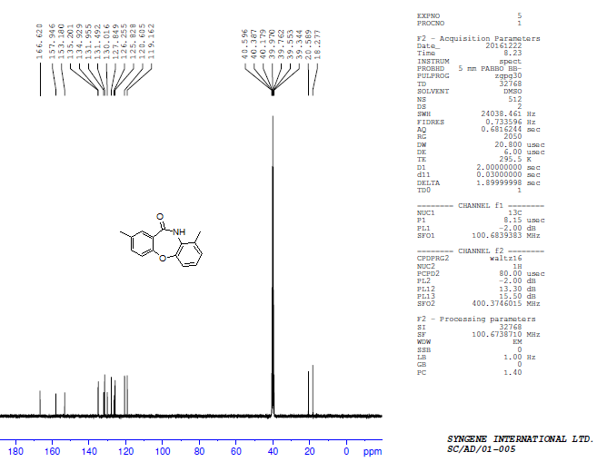

^{I}H NMR of benzo[b]pyrido[3,2-f][1,4]oxazepin-5(6H)-one (7a)
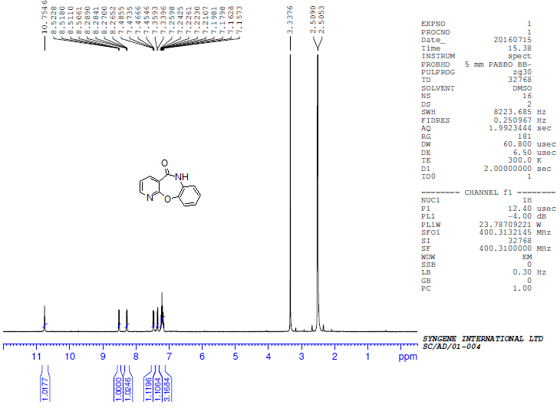
^{I3}C NMR of benzo[b]pyrido[3,2-f][1,4]oxazepin-5(6H)-one (7a)
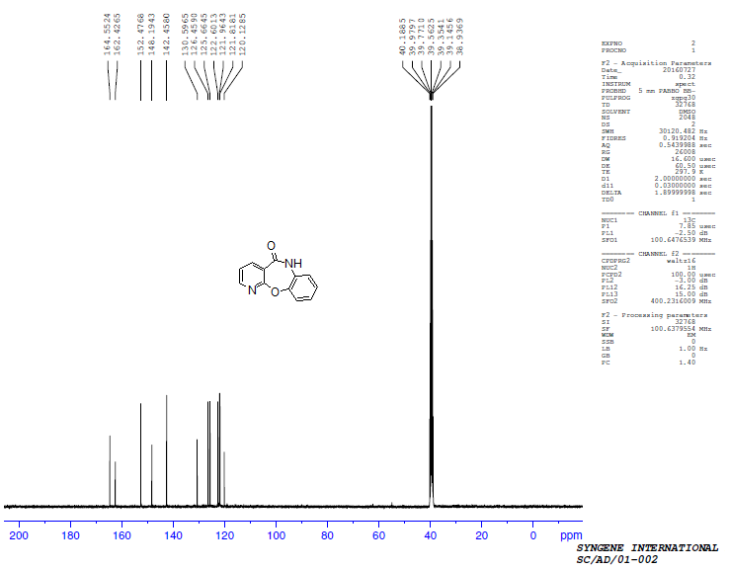
^{I}H NMR of 8-chlorobenzo[b]pyrido[3,2-f][1,4]oxazepin-5(6H)-one (7b)
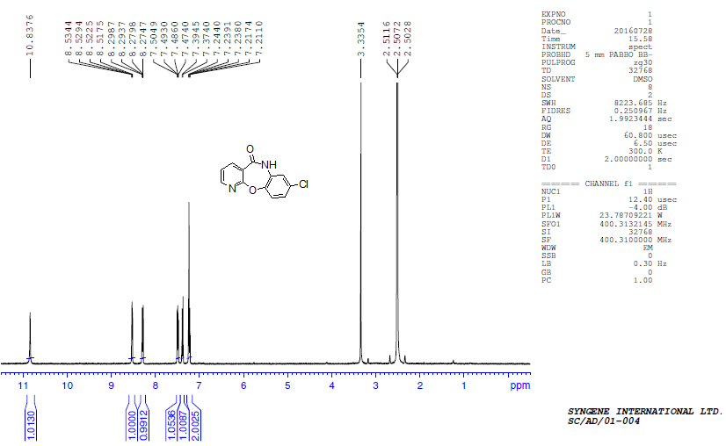

^{I3}C NMR of 8-chlorobenzo[b]pyrido[3,2-f][1,4]oxazepin-5(6H)-one (7b)
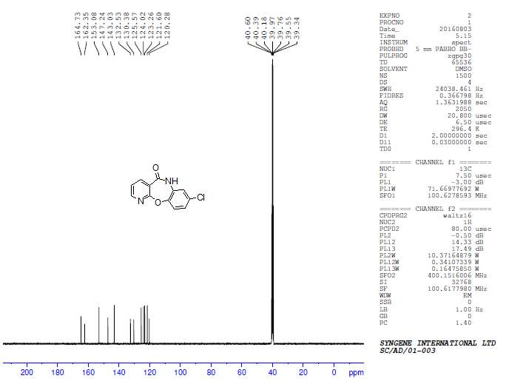

^{I}H NMR of 9-chlorobenzo[b]pyrido[3,2-f][1,4]oxazepin-5(6H)-one (7c)
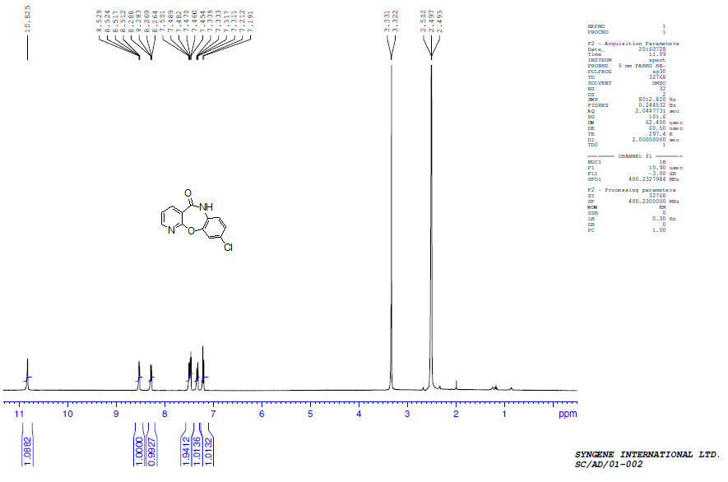
^{I3}C NMR of 9-chlorobenzo[b]pyrido[3,2-f][1,4]oxazepin-5(6H)-one (7c)
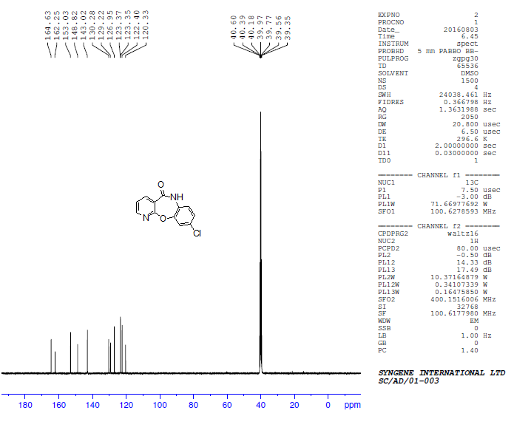
^{I}H NMR of 8, 9-dichlorobenzo[b]pyrido[3,2-f][1,4]oxazepin-5(6H)-one (7d)
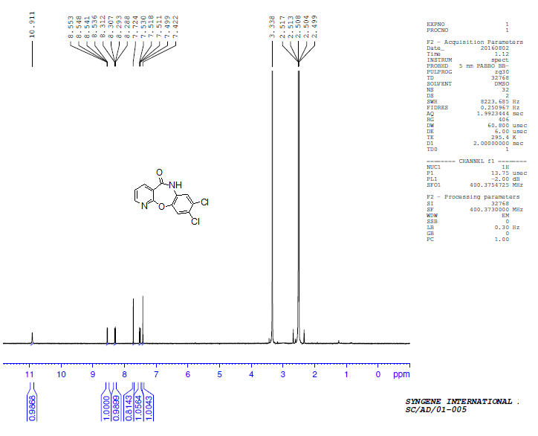
^{I3}C NMR of 8, 9-dichlorobenzo[b]pyrido[3,2-f][1,4]oxazepin-5(6H)-one (7d)
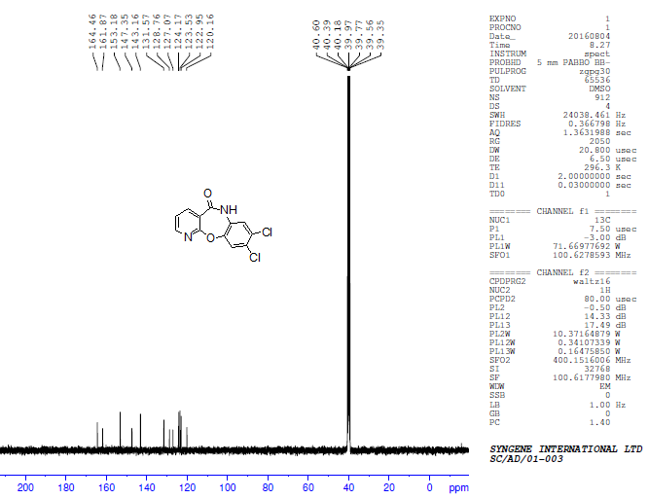

^{I}H NMR of 9-methylbenzo[b]pyrido[3,2-f][1,4]oxazepin-5(6H)-one (7e)
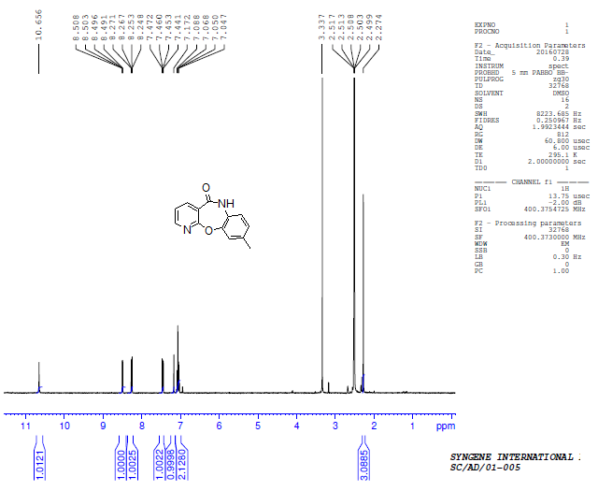

^{I3}C NMR of 9-methylbenzo[b]pyrido[3,2-f][1,4]oxazepin-5(6H)-one (7e)
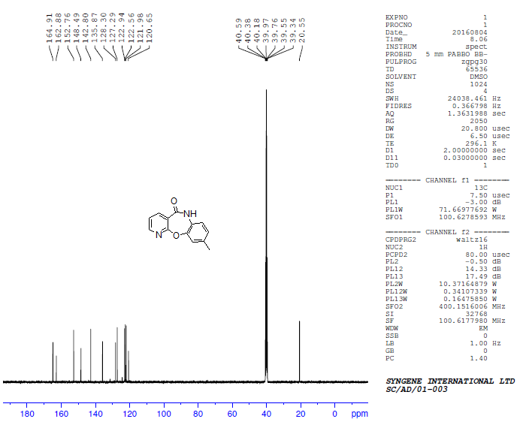
^{I}H NMR of 3-methylbenzo[b]pyrido[3,2-f][1,4]oxazepin-5(6H)-one (7f)
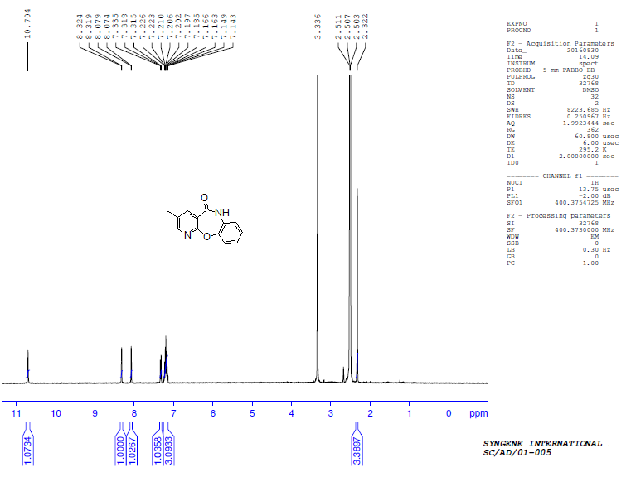
^{I3}C NMR of 3-methylbenzo[b]pyrido[3,2-f][1,4]oxazepin-5(6H)-one (7f)
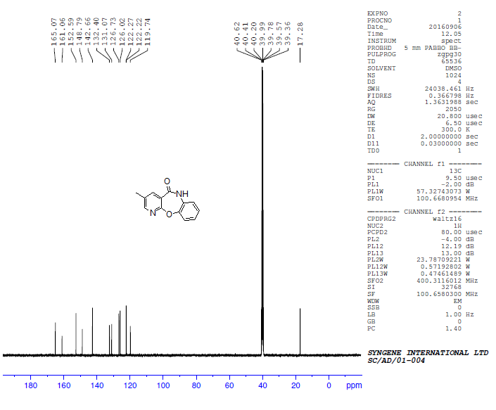
^{I}H NMR of 8-chloro-3-methylbenzo[b]pyrido[3,2-f][1,4]oxazepin-5(6H)-one (7g)
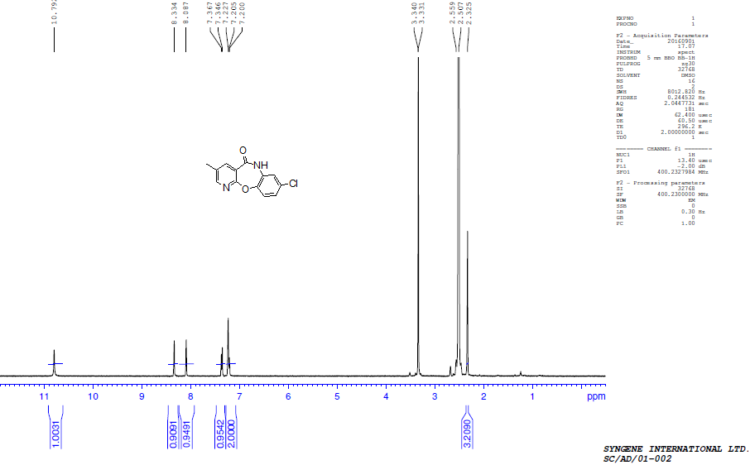
^{I3}C NMR of 8-chloro-3-methylbenzo[b]pyrido[3,2-f][1,4]oxazepin-5(6H)-one (7g)
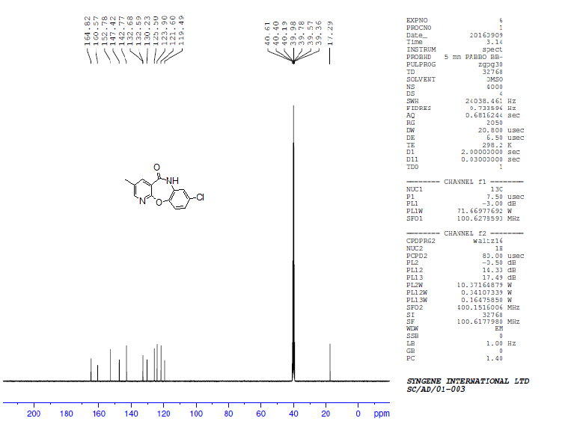
^{I}H NMR of 3, 9-dimethylbenzo[b]pyrido[3,2-f][1,4]oxazepin-5(6H)-one (7h)
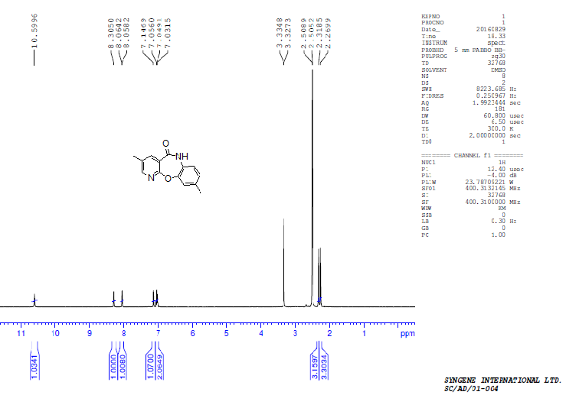

^{I3}C NMR of 3, 9-dimethylbenzo[b]pyrido[3,2-f][1,4]oxazepin-5(6H)-one (7h)
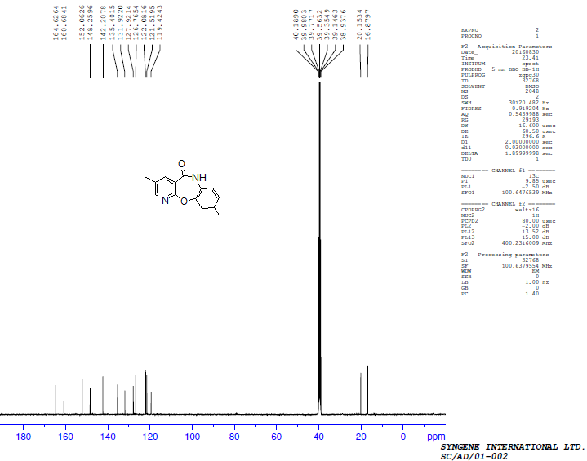
^{I}H NMR of 2-methylbenzo[b]pyrido[3,2-f][1,4]oxazepin-5(6H)-one (7i)
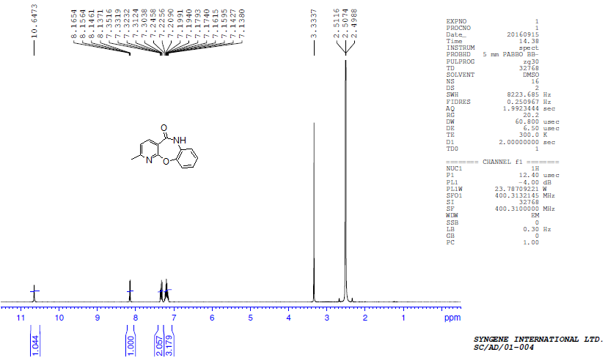

^{I3}C NMR of 2-methylbenzo[b]pyrido[3,2-f][1,4]oxazepin-5(6H)-one (7i)
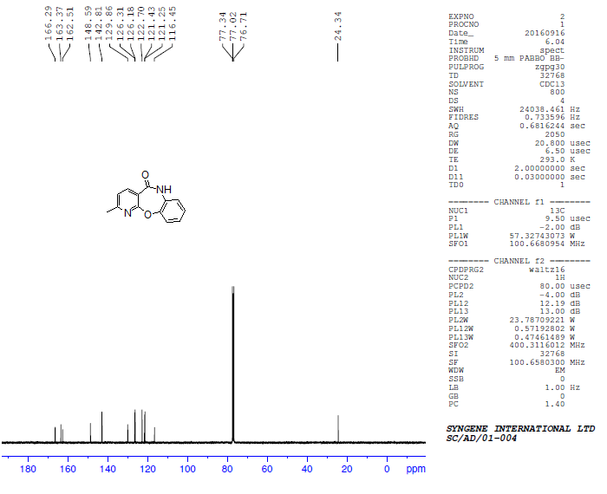
^{I}H NMR of 2, 9-dimethylbenzo[b]pyrido[3,2-f][1,4]oxazepin-5(6H)-one (7j)
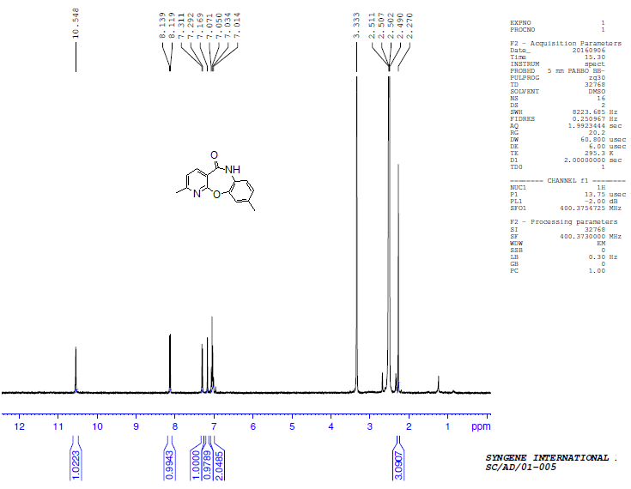
^{I3}C NMR of 2, 9-dimethylbenzo[b]pyrido[3,2-f][1,4]oxazepin-5(6H)-one (7j)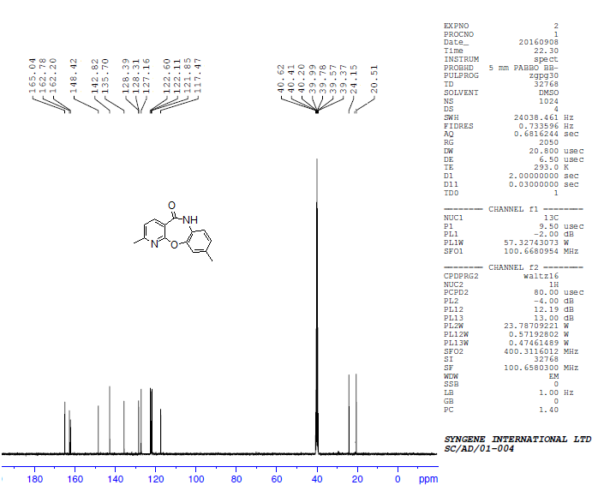
^{I}H NMR of 5-(4-Methylpiperazin-1-yl)-8-chloro-pyrido[2,3-b][1,5]-benzoxazepine (JL 13)
